STATS
CHAPTER 1
Evidence based Practice - is the conscientious use of current best evidence in making decisions about patient care
Research- is systematic inquiry that uses orderly, disciplined methods to answer questions or solve problems
Statistics- term for collection of mathematical methods od organizing, summarizing, analyzing and interpret information gathered in a study.
Statistical analysis- involves collection of mathematical methods for summarizing, analyzing, and drawing conclusions about quantitative data
Data- information collected in the study; can be gathered by asking people questions, by observing behaviour o by taking bio-physiologic measurements
Qualitative data- consists of verbal, narrative pieces information (Descriptive)
Quantitative data- consists of information in numerical form (subjected to statistical analysis)
Data Analysis- data must be organized, synthesized and interpreted
Problem >research question> concepts defined/measured> data collected>data analyzed
Research question- inquiries about the relationship between IV and DV within a population
Hypothesis- predictions about relationships among variables
Relationship- a bond or association between variables
Operational definitions- specify the set of operations or procedures required to measure them
Variable- something that varies or takes on different values (Weight, sex, BP).
Independent variable (IV)- Cause of/ influence on, an outcome
Dependent Variable (DV)- the outcome of, dependent on, caused by IV
IV-smoking >>>>>>>>DV-Lung Cancer
Discrete Variable | Continuous Variable
-indivisible/whole number of values between 2 points 1,2,3,4 (not 1.2)  Ex. Number of hospital beds | -Assumes an infinite number of values between 2 points 1.5, 1.7, 1.9

Level of measurement
Nominal, Ordinal, Interval and Ratio
Low level of Measurement
Nominal | Ordinal
- # are assigned to name categories and have quantitative meaning (0,1)  - Cannot be treated mathematically ex., category, group, religion, blood type  - Classification | - In order lowest to highest, small to large, sometimes to always  - Conveys some info  - Does not indicate distance between numbers ex., degrees of pain  - Ordering or ranking of people
High level of Measurement
Interval | Ratio
- Precision;  - # that indicate ordering on an attribute ex., F◦ 100 F and 101 F  - Distances between values is equal  - 0 does not mean 0  - Averages can be computed | - Zero means zero  - Averages can be calculated  - Distance is equal

If you start with ratio measures, you can always collapse information to a lower-level measure but not vise versa
High level of measurements usually preferred in studies
When research variables have been measured, the quantitative data can be analyzed in many ways (manual or computer software).
Description versus Inference
Descriptive Statistics | Inferential Statistics
- Describe and summarize data ex., averages and percentages (%)  - Describe>compare>characterize  - Can be communicated in 3 ways: narrative fashion, in a graph, or in a table | - Data obtained from a sample can be used to answer questions about population as long as the sample group had relevant characteristics as the population being studied  - Use “laws of probability”

Univariate Statistics | - Involve one variable at a time (average HR, men and women in the sample)
Bivariate Statistics | - Involve 2 variable simultaneously (HR of men VS, women. HR and Sex)
Multivariate Statistics | - 3 or more variable included in the same analysis (HR, sex, Weight)

Pre analytic steps
- Code and enter data
- Hot to code “missing values”
- Clean data (correct errors)
- Examine the extent of missing data
- Asses for biases
- Understand data and characterize the study sample

CHAPTER 2
Frequency distribution- simple, effective way to impose order on data; systematic arrangements of data values, with a count of how many times each value occurred in a dataset;
- Lists data set in sequence
- Tally each occurrence of the value
- Total the frequencies for each value (f)
- All data values must equal the sample size
$$\sum{f=N}$$
Absolute frequency – count of cases
Relative frequency- percentages $\%=(\frac{f}{N})x 10$
Cumulative Relative frequencies- % for a given value + % for all proceeding values
Grouped Frequency Distribution
- Involves grouping together values into class intervals
- Used when there are numerous data vales
Graphs
Bar Graph 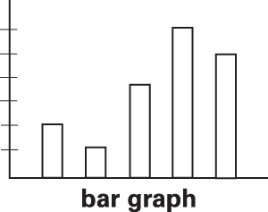 Pie Chart 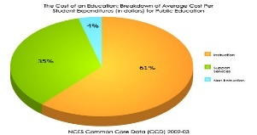
- Nominal\ordinal level scale data
Histogram 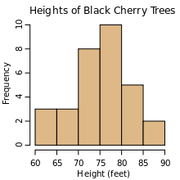 Frequency polygons 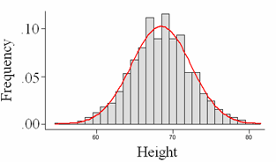
- Interval and ratio level data

Modality
- How many peaks or high points there are;
- Unimodal Distribution -single peak
- Bimodal- exactly 2 peaks
- Multimodal- 2 or more peaks
Symmetry and Skewness
Symmetrical distribution-2 halves are mirror images of one another
Asymmetrical distribution – peaks are off centre, with a bulk of scores clustering at one end, and a tail trailing off at the other end; often described as skewed
Positively skewed distribution- longer tail trails off to the right
Negatively skewed distribution- longer tail trails off to the left
Kurtosis
- Leptokurtic- sharp, thin peaks
- Platykurtic – smooth, flat peaks (platy-flaty)
Normal distribution- unimodal, symmetric and not too peaked or flat, bell-shaped curve
Becoming familiar with the dataset>cleaning data -outliers (values that lie outside the normal range of values for other cases), looking for wild codes, wild code resulting from data entry error like number 3 in 1 male and 2 male codes)> inspecting data for missing values>testing assumptions for statistical tests> obtaining information about sample characteristics> directly answering research questions

CHAPTER 3
Central Tendency- “typical” data value, the data value around which other scores tend to cluster
Mode- value in distribution that occurs more frequently 20 21 22 22 22 22 23 24 24
Median- the pint in a data distribution that dived the distribution into 2 equal halves: 50% of score values lie above the median and 50% of score values lies below the median
The Mean- arithmetic average
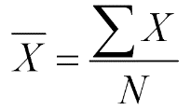 = the mean Σ= the sum of X-each individual data value N-the # of cases
The sum of the deviations of all scores from their mean always equals zero
Variability- how spread out or dispersed are the data values in the distribution
- High variability: A heterogeneous distribution (A)
- Low variability: A homogeneous distribution (B)
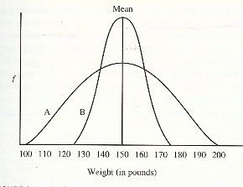
- Most widely used indexes of variability are the range, the interquartile range and the standard deviation
Range – highest scores minus the lowest scores
Interquartile Range IQR- scores at the 75th or third quartile (Q3) minus the scores at the 25th percentile or first quartile (Q1). IQR= Q3-Q1
- IQRs are most often used to define outliers.
- Mild outlier is a data values that lies between 1.5 and 3 times the IQR, below Q1 or above Q3
- Extreme outlier is a data value that is more then three times the IQR, blow Q1 or above Q3
Standard Deviation SD -index that captures how much, on average, scores deviate from the mean
- Deviation score differences between every score and the value of the mean. Deviation score formula: x=X-X
Standard deviation formula: SD=$\sqrt{\frac{Σ( X-X)}{N-1}}$
X X (X-X) (X-X)

In a normal Distribution, 95% of the scores fall within 2 SDs below and above the mean
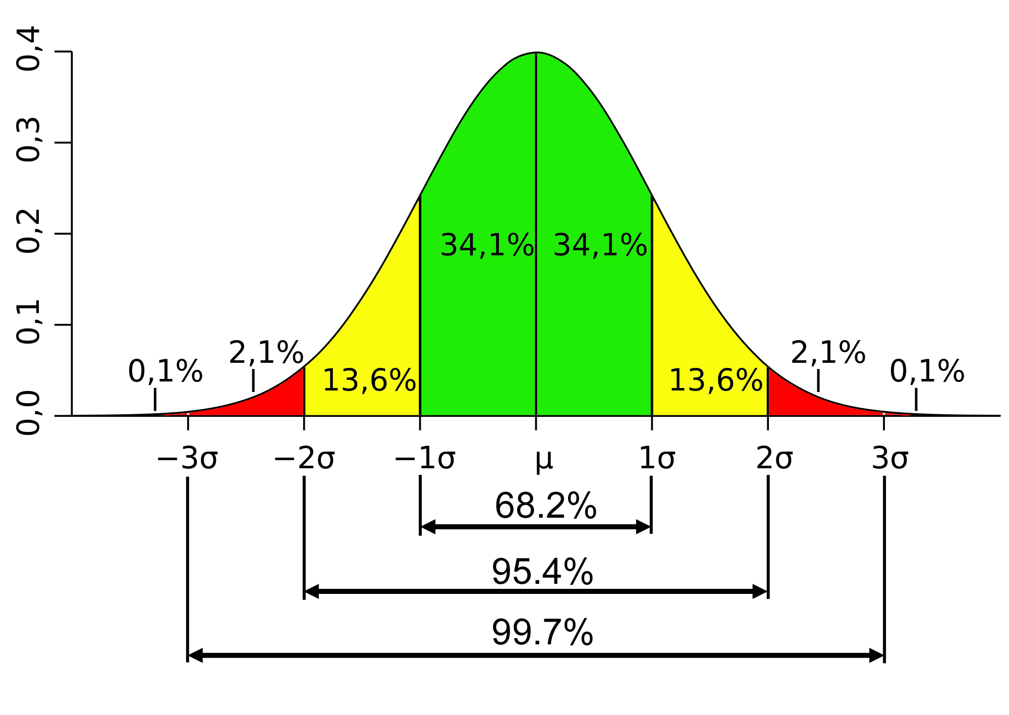
Variance- the value of the standard deviation before the square root is taken:
Var = $\frac{Σ(X-X)}{N-1}$

Relative standing
- Indicators of relative standing or position provide information about individual score values in a distribution
- The percentages of scores in a distribution that fall at or below a given value is the percentile rank of that value
- Percentile divide a distribution into hundredths, quartiles divide into fourths, and the deciles divide it into tenths
Standard scores- scores that are expressed in terms of their relative distance from the mean
- Often called a z-score
z= $\frac{X-X}{SD}$
- Standard scores have a mean of 0.0 and an SD of 1.0
- Standard scores can be transformed to have any desired mean and standard deviation
- Standard score for IQ: Mean 100 and SD 15
Standard score =
Boxplot- or box and whiskers plot- is a graph based on percentiles. It shows a box whose upper and lower ends indicate the values corresponding to 25th and 75th percentile, a horizontal line indicating the median (50th percentiles), and “whiskers’ or lines extending above and below the box indicating the range of values not considered outliers
Trimmed mean
- When there are outliers, researchers sometimes make an adjustment to the mean, such as calculating a trimmed mean, which involves calculating a mean after removing a fixed percentage of cases from either end of the distribution.

CHAPTER 4
Bivariate Descriptive statistics- used to describe relationship between 2 variables
A contingency (or crosstabs) table is a two-dimensional frequency distribution that cross-tabulates the frequencies of two nominal-level or ordinal-level variables
 | Male | Female | Total
Smoker | 10  50.0%  20.0%  10.0% | 10  50.0%  20.0%  10.0% | 20  100.0%  20.0%  20.0%
Non-smoker | 40  50.0%  80.0%  40.0% | 40  50.0%  80.0%  40.0% | 80  100.0%  80.0%  80.0%
Total | 50  50.0%  100.0%  50.0% | 50  50.0%  100.0%  50.0% | 100  100.0%  100.0%  100.0%
Shaded areas show marginal frequencies (totals)

Risk indexes
- Statistical risk indexes have been developed to describe risk exposure and intervention effects, and are useful for facilitating clinical decision.
- Most risk indexes are appropriate for 2x2 situations, such as when 2 groups (experimental versus control) are compared on dichotomous outcome (alive/dead)
Absolute risk is an index that expresses what percentage of those in a risk exposed (or control) group (ARe) experience an adverse outcome, and what percent is a non-exposed (or experimental) group (ARne) experience the bad outcome
Absolute Risk Reduction (ARR)- expresses the estimated proportion of people who would be spared from an adverse outcome by non-exposure to the risk

AR_{E}= (a ÷ (a + b)) AR_{NE}= (c ÷ (c + d)) ARR: AR_{E} – AR_{NE}
ARR: AR_{E} – AR_{NE} ARR: AR_{E} – AR_{NE} Odds_{E} = a ÷ b
Odds_{NE} = c ÷ d OR = Odds_{E} ÷ Odds_{NE} NNT = 1 ÷ ARR

Needle Length | Swelling |  | Total
Needle Length | Yes | No | Total
16 mm needle  (Control) | 20  (a) | 80  (b) | 100
25 mm needle  (exper) | 10  (c) | 90  (d) | 100
Total | 30 | 170 | 200

Relative risk (RR) is the estimated proportion of the original risk of an adverse outcome that occurs in association with the risk exposure (or receipt of intervention)
Relative Risk Reduction (RRR) is the estimated proportion of risk associated with exposure that is reduced when there is not exposure to risk factor-or, in the context of an intervention, the estimated proportion of risk that is reduced a result of intervention
The odds is the proportion of people with an adverse outcome relative to those without it, and the odds ratio (OR) is the ratio of the odds for the at-risk versus not-at-risk (or treated versus untreated)
The number needed to treat (NNT) is an estimate how many people would need to receive an intervention (or avoid risk exposure) to prevent one adverse outcome

Correlation
- Refers to a bond or connection between variables
- Correlation analysis is a useful way to describe the direction and magnitude of a relationship between two variables
- Measured on interval or ratio scale
- Can be displayed on scatterplots (Values plotted on X axis and Y axis)
- Can be positively correlated, negatively correlated, no relationship at all, curvilinear
Correlation coefficient
- Also indicate the magnitude and direction of a linear relationship between two variables
- Expressed numerically
- More precise about the magnitude hen scatterplots
- Values range from -1.0 through .00 to +1.0
- Values from -1.0 to -.01 indicate negative relationship
- Values from +.01 to +1.0 indicate positive relationship
- A correlation coefficient of .00 indicates no relationship at all between the variables
- The absolute value indicates relationship strength
- The smaller the absolute value, the weaker the relationship
- Perfectly positive correlation is always +1.0
- Perfectly negative correlation is always -1.0
The most widely used correlation coefficient is the Pearson product moment correlation, also referred as Pearson’s r Formula r =

A correlation matrix is a two-dimensional display that shows correlation coefficients between all pairs of variables

