- Organization
  - A collection of people working together to achieve a common purpose.
- Levels of management
  - Top managers — responsible for performance of an organization as a whole or for one of its larger parts.
  - Middle managers — in charge of relatively large departments or divisions.
  - Team leaders or supervisors — in charge of a small work group of non-managerial workers.
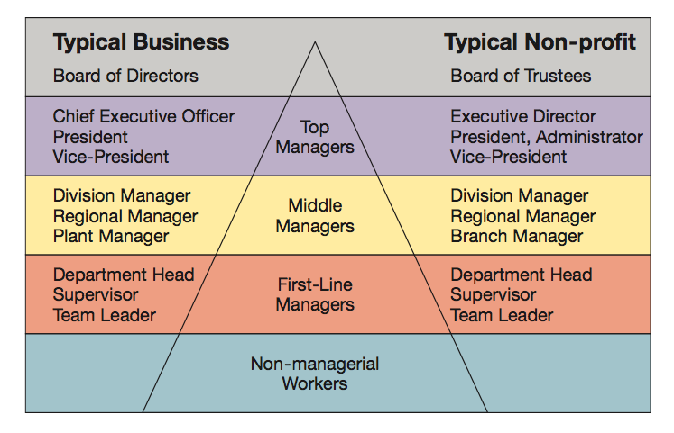
- Management is the process of planning, organizing, leading, and controlling the use of resources to accomplish performance goals.
Functions of management:
  - Planning: The process of setting objectives and determining what actions should be taken to accomplish them.
  - Organizing: The process of assigning tasks, allocating resources, and arranging the coordinated activities of individuals and groups to implement plans.
  - Leading: The process of arousing people’s enthusiasm to work hard and direct their efforts to fulfill plans and accomplish objectives.
  - Controlling: The process of measuring work performance, comparing results to objectives, and taking corrective action as needed.

Mintzberg’s 10 Managerial Roles
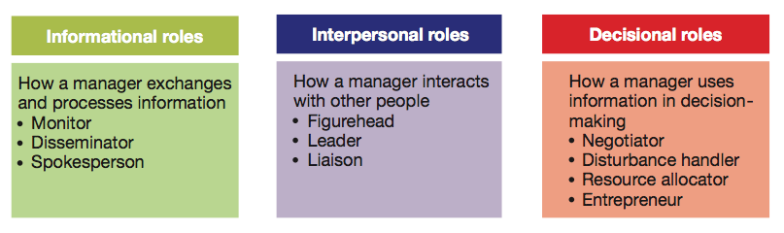
- Essential managerial skills
  - Skill — the ability to translate knowledge into action that results in desired performance.
  - Technical skill — the ability to apply a special proficiency or expertise to perform particular tasks.
  - Human or interpersonal skill — the ability to work well in cooperation with others.
    - Emotional intelligence is the ability to manage ourselves and relationships effectively
  - Conceptual skill — the ability to think critically and analytically to solve complex problems.


