PSYC340 : Midterm revision
Schizophrenia
What is schizophrenia? Broad spectrum of disturbance in thinking (delusions), perception (hallucinations), speech, emotions and behavior.
What are the criterion for a diagnostic? 2 or more positive, negative or disorganized symptoms for at least 1 month.
What is the prevalence for schizophrenia? Man develop it around 16 yo and woman around their late 20s. Represents 0,2-1,5% of the population.
What is a psychotic behaviour? Unusual behavior characterized by hallucinations, delusions and loss of contact with reality.
What are the positive symptoms?
- Hallucinations: sensory experiences not caused by actual external stimuli (more auditory, persistent over time, frightening in most cases)
- Delusions: beliefs rigidly held despite their erroneous nature (grandiose or paranoid content, often fragmented)
- They are less stable over time.
What are the negative symptoms?
- Affective and emotional disturbances: Blunted effect (failure to exhibit signs of emotion or feeling (5) ): faces are expressionless, voices lack of fluctuations, poor eye contact, reduced body language, lack of concerns for everything. Anhedonia (inability to experience pleasure (3) ): loss of interest in activities and relationship, lack of physical pleasure, EARLY WARNING SIGN
- Social withdrawal: bad interpersonal relationship, a symptom and a strategy, EARLY WARNING SIGN
- Avolition: incapacité à initier et persister dans des activités avec un but
- Alogia: impoverished thinking, speechlessness (poverty of speech, thought blocking)
What are the disorganization symptoms?
- Thinking disturbances: disorganized speech = loose association, tangentiality, perseveration, incoherence or “word salad”
- Bizarre behaviour: unusual motor behaviour (catatonia, stuporous state = reduced responsibeness), inappropriate affect (affective responses inconsistent with the situation)

What are the 4 schizophrenia subtypes?
- Paranoid: delusions, hallucinations but good cognitive skills
- Disorganized: disrupted speech and behaviour, delusions, hallucinations, flat or silly affect, self-absorbed
- Catatonic: motor disturbance, major symptoms of schizophrenia
- Residual: one episode and no more major symptoms
What are the 3 traditional types of genetic research? Family studies, twin studies, adoption studies
Prevalence in families: MZ (48%), DZ (17%), Child (13%), Bro (9%), Parents and Half siblings (6%), Heriditability (+-85%) STRESS DIATHESIS

GWAS: Genome wide association studies
What are the implications of the candidate genes? Roles in NT functions, NS devloppement and synaptic plasticity. Believed to be implicated in “endophenotypes” rather than to the full spectrum of the disease phenotype (WM impairment, sensorimotor integration, eye tracking or event-related potential)
What are the limitations of the gene research? Genes found in other psychiatric disorders, heterogeneous presentation in different patient, tendency generalize, complex interaction between genetic and environmental influenced, lack of power (for 80% we would need 483 families), poor controls
What are the 4 other psychotic disorders?
- Schizophreniform: experience symptoms of schizophrenia only a few months (up to 6)
- Schizoaffective disorder: symptoms of schizophrenia + mood disorder
- Delusional disorder: just delusion without other symptoms (onset between 40-49)
- Brief psychotic disorder: delusion, hallucination, disorganized speech or behavior that lasts less than 1 month
Mood disorders: Depression (25% vont souffrir de depression, 75% do not seek help)

 | Major Depressive Disorder | Dysthimic Disorder
Lifetime Prevalance | 21% in women, 13% in men | x
Typical Age of Onset | 20s, but can occur any time | x
Criterias of diagnosis | Peristent sad, depressed mood, loss of interest or pleasure in previously enjoyable activities.  DSM: 1 of the above + 4 additional symptoms for at least 2 weeks. | Depressed mood. Symptoms for at least 2 years, not without symptoms for longer than 2 months
Physical symptoms | Sleep disturbance (4 ex: early morning awakening), loss of energy, appetite disturbance, weight change, changes in activity level | Poor appetite or overeating, insomnia or hypersomnia, low energy or fatigue
Cognitive symptoms | Difficulty concentrating, thinking, making decisions, feelings of worthlessness, guilt or hopelesness, recurrent thoughts of death or suicide | Low self esteem, poor concentration or difficulty making decisions, feelings of hopelessness

Endogenous depression: melancholia, severe depression, what meds can work on
Reactive depression: reaction to something, stress diathesis
What is the Behavioural theory of depression? Depression is learned. No coping skills.
- Charles Ferster: depression is a result of a lack of positive reinforcement for the depressive’s actions
- Peter Lewinsohn: depression is caused by a combination of stressors in a person’s environment and a lack of personal skills.
- CRISTISISM: did not pay much attention to people’s thought, perceptions and evaluation, focused only on people’s external and directly observable behaviour.
What is the cognitive-behavioural theory? How the concept of cognition plays an important role in determining the behavioural pattern of a person. Depression results from a maladaptive, faulty or irrational cognitions, taking the form of distorted thoughts and judgements. Focus on the ways in which people respond to negative experience involving loss, failure, disappointment.
Beck’s cognitive behavioural theory: negative thoughts, generated by dysfunctional beliefs are the primary cause of depression. Depressive triad: The self, the world and the future.

Research evidence:
- Early maladaptive schemas significantly predicted concurrent depression severity, and depression severity, and episodes for major depression 9 years later.
- Hopelessness theory: depression is caused by negative casual attribution. Depressiongenic attributional styles: Internal (failing exam = I’m a loser), stable (= I’ll never graduate) and global (= bad things always happen to me).
- Inconsistent findings in children
- Vulnerability to depression is determined by the most depressogenic attributional style (The Weakest Link Hypothesis)
Major NT implicated in MDD:
- Norepinephin: use of TCa (tricyclic AD), untion of the stress response in the brain, decrease level of it = MDD
- Serotonin: individual’s anxiety, obsessions, compulsions, in the hypothalamus
- Dopamine: interest, pleasure, attention/concentration, motivation.

Bipolar disorder:
Manic episode | Depressive episode
Mood changes:  Long period of feeling “high”, “jumpy” or “wired” | Mood changes:  Long period of feeling worried or empty, loss of interest
Behavioural changes:  Talking very fast, racing thoughts  Easily distracted  Increasing goal-directed activities  Restlessness, sleeping little  Unrealistic belief in one's abilities  Impulsivity, high-risk behaviors | Feeling tired or "slowed down“  Problems concentrating, remembering,  making decisions  Restlessness/irritable  Changing eating, sleeping  Suicidal thoughts/attempted suicide

Bipolar I: Manic - non manic – manic (requires hospitalization, severe mania) or manic – depress – manic
Bipolar II: Depress – hypomanic – depress (hypomania = less sleep, less hunger, spend more money, weeks of mania, depression. Can have more fluctuation if I get older)
Cyclothymic Disorder: everyting in mild
What is the prevalence? Up to 4% of the US population, 25-50% attempted suicide, 8,6-18,8% die by suicide.
Age of symptom onset? Between 15-19 yo, but mostly late 20s. Earlier symptoms begin, the more sever the disease become.
Anxiety disorders
Anxiety: most prevalent of mental health problem (33%), highly comorbid with depression, addiction etc…
Panic Attack: a period of intense fear or physical discomfort, developing abruptly and peaking within 10 min
Agoraphobia: fear of being in situation where escape might be difficult/embarrassing or in which help might not be available in the event of having unexpected panic-like symptoms
GAD: excessive anxiety about a number of events or activated, occurring more days than not
Social phobia: afraid of being mocked etc
Obsessive Compulsive disorder: recurrent/persistent fearful though where there is an attempt to control though thoughts and actions
PTSD: exposure to trauma where physical integrity is threatened and there is intense fear, helplessness
Specific phobias: persistent fear that is excessive or unreasonable, cues by the presence or anticipation of a specific object or situation
Physical symptoms of anxiety | Psychological symptoms of anxiety
Decrease in energy  General fatigue  Racing heart/tightness in chest  Upset stomach  Headaches  Shortness of breath  Grinding teeth or clenched jaw  Cold hands or feet  Feeling fain or dizzy  Rashes/sweaty palms | Nervous, worried or fearful  Irritated or impatient  Tense or Jumpy  Hyper-vigilent  Restless  Apprehensive  Catastrophizing  Trouble concentrating  Overwhelmed by reponsability  Emotionally drained  Hypersensitive to criticism

Specific phobias:
What is the prevalence? 15% of general population, f:m = 2:1
What are the 5 subtypes of Specific Phobias? Animal, Natural Evt, Blood-injection-injury, situational, other
Freud and Little Hans: fear of hoses, due to repressed sexual wished. Displacement of ensuing anxiety onto horses
Wolpe and Rachman: criticized psychoanalytical account of phobias, widespread acceptance of the classical conditioning model. No evidence for the sexual repression, but evidences for priot traumatic experiences involving horses. Proposed: all phobias were due to traumatic Pavlovian conditioning : environmental process, either actual, vicarious experience (direct) or through information acquisition (indirect) (ex: St. Louis studies)
What are the main limitations of the classical conditioning account?
- Inextinguishable nature of phobic stimuli
- Non cognitive or irrational nature of phobic stimuli
- Distribution of common phobias (common phobic stimuli comprise a limited set o stimuli, non arbitrary nature of the limited set (evolutionary-relevant)
- Number of fears for which no conditioning, modeling or information pathways can be found (56% always afraid of heights, 77% parents think child was always afraid of water)
What is the theory behind the preparedness theory? We are more susceptible to learn a phobia if we are prepared biologically (natural selection). Proved by failures to demonstrate fear conditioning to evolutionary-neutral stimuli.
What is the main problem of the preparedness? Need for direct conditioning trials first.
What is the nonassociative perspective? Fears may appear without relevant associative learning experience. Natural selection favours the ones that display fear on first encounter. Common fears are innate and universal.
What are the two genetic/innate evidence of phobias? Parent-Reports and twin studies (Heritability = 20-40%)
What are the gender differences? Social phobia: genetic on man, animal phobia: genetic to both. More heritable in women. COMT Genotypes: DA depletion.
What are the conclusions on the gene-environment interaction? Easier to condition to certain stimuli than others due to genetic disposition to associate certain objects with more fear. Evolutional fears more correlated for MZ.
Why phobias? Role of the evt: we learn how to overcome existing predisposition. Insufficient exposure + individual differences in habituation speed
What are the limitations of the nonassociative account? Hard to assess “absence of” an event, can only account for evolutionary-relevant fears in the absence of associative learning. Minority of the evolutionart-relevant fears can be generated through associative learning. Evolutionary neutral fears = better accounted for by associative models.
Panic and agoraphobia
Panic attack: a period of intense fear in where the following symptoms seem to appear out of nowhere and rapidly peak:
- Palpitation or rapid heart rate
- Sweating
- Trembling/shaking
- Shortness of breath
- Feeling of choking
- Chest pain or discomfort
- Nausea
- Chills or heat sensation
- Paresthesias
- Feeling dizzy or faint
- Derealisation or depersonalization
- Fear of loosing control or going crazy
- Fear of dying
What is a panic disorder? Recurrent unexpected panic attacks for a period of at least one month of: persistent worry about having additional attacks, worry about the implications of the attacks, significant change in behaviour because of the attack, typically leads to agoraphobia.
What is the epidemiology? 2-3% of general population, 5-10% of primary care patients (onset in teens) f:m = 2/3:1
What is the comorbidity that comes with panic disorder? 50-60% have lifetime Major Depression, 33% with current depression, 20-25% have history substance dependence.
What is agoraphobia? Marked fear or anxiety for more than 6 months about two or more of the following 5 situations: public transportation, open space, enclosed space, standing in line, be outside of the home alone.
What do agoraphobes experience? Fear they will be ill and might need help or be embarrassed, wish to avoid these situations because help not available. They avoid situations or high anxiety, out of proportion.
History: 1871 Westphal “Agoraphobia”, recognized late 1970s, DSM III (1980), DSM III-R (1987) to DSV-IV-TR (1994) = secondary to panic disorder, DSM V = primary disorder
What is prevalence? 12 month: 1-2% and lifetime: 1.5-3%. F:M = 2:1. Low remission rate (20%). Impact: 50% unemployed, 33% financial assistance
Age of onset? Mean age: 29
Comorbidities? SAD (social anxiety) : 13-23%, GAD: 32%, PTSD: 39%, Depression: 38%-48%. Bipolar: 15-33%, Alcohol: 27=37%
What are the risk factors? Active HPA axis (stress response to chronic stress), 61% heritability, parenting: reduced warmth, increased overprotection, modeling of anxious behaviour, insecure-anxious attachement (studies: De Ruiter& Van Ljzendoorn + Stordl& Noller). Personality: negative affectivity, behavioural inhibition, anxiety sensitivity, dependent, fear of losing control, embarrassment associated with first panic attack.
What are the models?
- Behavioural: Mowrer-two-factor theory (1960)= classically conditioned fear response, place association. Agoraphobia as a phobia of certain places.
- Fear of fear: Goldstein&Chambless (1978) = fear of the panic. Fear to be unable to cope. Related to anxiety sensitivity. (have safe zones and companions)
Can extend to activites/substances similar to panic sensations: exercise, caffeine, alcohol.
GAD: Generalized Anxiety Disorder
What is a GAD? Excessive worry more days than not for at least 6 months about a number of events and they find it difficult to control the worry. Have at least 3 of those symptoms: restlessness or feeling keyed up or on edge, easily fatigues, difficulty concentrating, irritability, muscle tension, sleep disturbance.
What is the epidemiology? 4-7% of pop, 30 years onset (but large range), f:m = 2:1
What is the comorbidity? 90% have at least other lifetime Axis I disorder, 66% another current Axis 1 disorder, worse prognosis over 5 years than panic disorder
What are the genetic factors? 14-21%, m = f, higher comorbidity in MZ twins GAD/MDD, shared genetic factors with MDD, male and female twins.
What are the neurobiological factors? Serotonin and Gaba disorder, decreased activity in amygdala in response to emotional pictures, conditions of uncertainty
Evironmental factor? Maternal internalizing symptoms (I exist within my emotional state), lower SES (socioeconomic status), maltreatment before 11
Cognitive/Behavioural factors? Hypervigilance to threast, internalizing and confuct problem (ages 5-11), negative emotionality (18yo) – neuroticism
MODELS:

Avoidance model
Worry is a verbal linguistic, thought based activity. Inhibits vivid mental imagery and associated somatic and emotional activation. Prevents processing necessary for habituation and extinction.
Worry= ineffective attempt to solbe problem and remove a perceived thread. At the same time: avoiding aversive somatic & emotional experiences. Worry reinforced by positive beliefs.
Intolerance of uncertainty:
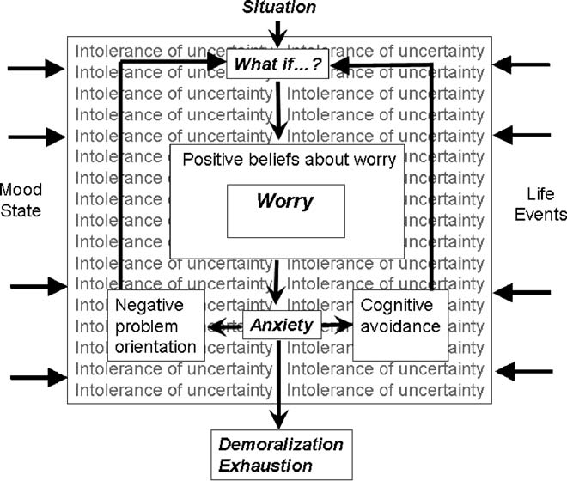
IU: uncertain or ambiguous situations are stressful and upsetting (respond with chronic worry)
Positive beliefs that worry will either help to cope with feared events, prevent feared events from occurring
It leads to: negative problem orientation, cognitive avoidance and keep of the worry. Association of my worry with positive outcome: reinforcement.
Metacognition model:
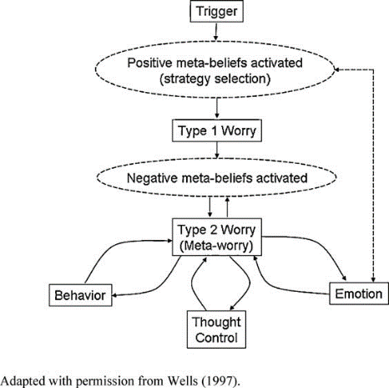
Type 1 : « what if », focuses on themes related to health, interpersonal, and other everyday concerns
Type 2: “worry about worry”, distinguishing feature of GAD

Emotional Dysregulation model
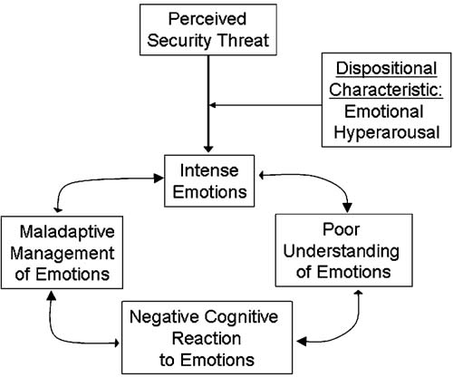
Four central components: Emotional, hyperarousal (positive and negative), poorer understanding of emotions, more negative attitudes about emotion, maladaptive emotion regulation & management strategies.
Note: lower threshold of emotion, deficits in describing & labelling and accessing & applying emotional information. Overwhelmed, creating a feedback loop
Acceptance-based model:
Four components: internal experiences, a problematic relationship with internal experiences (negatively reacting to internal experiences, fusion with internal experiences), experiential avoidance, behavioural restriction
Perceived external threat or have an unpleasant internal experience (leads to expiential avoidance
Shot term: avoidance reduces the distress
Long-term: avoidance reinforces behavioural restriction as the individual becomes less engaged in valuable activities (results in increased distress)
 | Avoidance of Internal Experiences
AMW | Avoiding emotion-laden stimuli | Integrated Model
IUM | Avoiding uncertainty | Cognitive Models
MCM | Avoiding worry about worry | Cognitive Models
EDM | Avoiding emotions | Emotional/Behavior Models
ABM | Avoiding internal experiences | Emotional/Behavior Models

OCD:
What are obsessions? Recurrent and persistent thoughts, impulses or images that are intrusive and unwanted that cause marked anxiety or distress. The person attempts to ignore or supress uch thoughts, urges or images, or to neutralize them with some other thought or action. The obsessions or compulsions cause marked distress, take more than 1h/day or cause clinically significant distress or impairment in function. Acting upon those fear on a ritual WAY.
What are compulsions? Repetitive behaviours or mental acts that the person feels driven to perform in response to an obsession or according to rigidly applied rules. Behaviours or acts = prevent or reduce distress. Increase anxiety. Thought action fusion.
Epidemiology? 2% of pop, mean onset 19,5 ans, 25% start by age 14. Males have earlier onset than female. 1:1
Comorbodities? 70% have PD, SAD, GAD, phobia. 60% have mood disorder like MDD, 30% have lifetime Tic disorder, 12% with schizophrenia/schizoaffective disorder
Subtypes:
- Cleaning contamination
- Symmetry/Order
- Checking
- Hoarding
- Purely obsessionals (sexual, harming, religious, obsessions and mental rituals)
Etiology? Under activation of the area that stop behavior (cortex lateral orbitofrontal). High response to threat (medium prefrontal cortel, baasal ganglia) and disgust (insula, Cortex cingulaire anterieur).
Family and Twin studies: Heritability = 26-47%. Multi-site family study: 5x more risk of OCD if family member. MGFD (Multi generational familial disfunction)
Cognitive behavioural Model: increase of empirical upport, person specific intrusive thoughts (my fear explains my compulsion)
What are the 5 types of dysfunctional thoughts?
- Perfectionism: mistakes are intolerable
- Overstimation of threat: occurrence of negative events are likely and especially aweful
- Thought-action fusion: thoughts, desires and impulses are equivalent to actions
- Inflated sense of responsibility: dutyto prevent negative outcomes
- Cognitive self consciousness (CSC): tendency to focus on thought
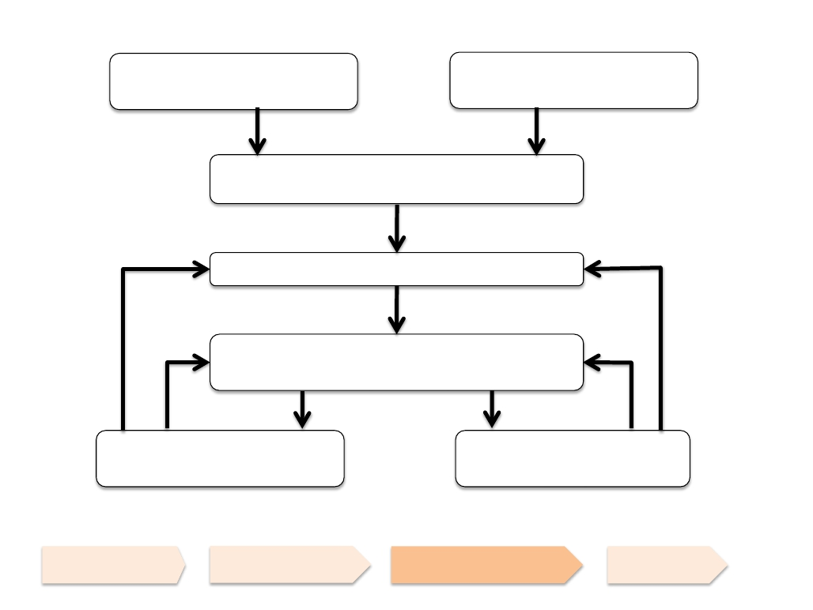
Etiology : performing compulsions – temporary removl of intrusion. Immediate stress reduction, compulsions reinforces, problematic appraisal, increase responsibility. Compulsions trigger obsessions through association (cycle repeats).
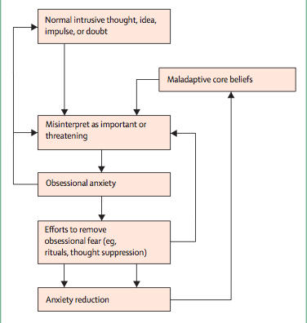
Other types? Body dysmorphic (2-4%) disorder, hoarding disorder (2-6%, F<M), trichotillomania (hair pulling)(1-2% F:M 10:1), excoriation disorder (picking your skin)(1,4%; F>M). ERP : exposure response prevented. AD might help

