Possible dates on the start of something
- 1925, Germany: the beginning of modern photojournalism ***********
- 1920-1990: modern photojournalism
- 1935- 1975: golden age of photojournalism
- 1990s: photography became digital
- 1839-1900: the beginnings of photography

Film:
- The Adventures of Photography

Terms:
- Sign: (According to Peirce) A sign is something that stands for something other than itself
    - Signs can be arbitrary because they depend on context
      - Ex. Sign of fire engine, smell of smoke = fire

Ex. Sign of “I love you” = commitment, long term love
- The smallest unit of meaning, anything that can be used to communicate

“the sign is the whole thing that results from the association of the signifier with
- the signified”

3 Classes of Signs
- Symbolic (arbitrary) sign: The relation between signifier and signified is purely conventional and culture specific
  - Meaning changes based on culture, subjective
  - Ex. Most words have different meaning based on culture
  - Every word has strong associations with other words that are “activated” whenever the word is heard or read (kitty activates: cat, fur, purr, yarn ball etc.)
  - Nothing “treeish” about the word “tree”
  - Symbols are easily removed from their context

- Iconic Signs: signs where the signifier resembles the signified
  - Ex. The printer icon for printing document

- Indexical Sign: signs where the signifier is caused by the signified
  - Ex. Smoke signifies fire

- Signified/ Connotative: The secondary, subjective meaning. Your interpretation of the sign

- Signifier/ Denotative: What you see, the literal most basic dictionary meaning

- Form:

- Peirce’s sign definition: “something which stands for something in respect or in a capacity of…”
  - Representamen – FORM which the sign takes (not necessarily material)
  - Object – to which the SIGN REFERS
  - Interpretant – IDEA, interpretation in mind

- Code: combination of semiotic systems that function as general maps of meaning which imply views/attitudes about how the world ought to be
  - No signifying code (system of signs) can be divorced from a set of social practices
  - Basic Features:
    - All codes have a paradigmatic (where signs get meaning from their association with other signs) and syntagmatic (Where signs get meaning from their sequential order…ex. Signs of suicide- not eating, not seeing friends, etc.) dimension
    - All codes convey meaning
    - Codes depend upon agreement between their users
      - Ex. Red traffic light means stop
  - Representational: codes that are used to create texts; something that stands for something else independent of its encoder
  - Presentational: limited face to face communication and concerns communication through orientation, gestures, eye movement, proximity, facial expressions, and other examples of “body language”
    - Ex. Cheating you need to wink to answer C

Extra Terms:
- Metonymy: a kind of connotation (interpretive meaning) where one sign is substituted for another with which it is closely associated, as in the use of Washington for the United States government or German Shepherds’ for police
- Synecdoche: a kind of connotation (interpretive meaning) in which a part is used for the whole (as hand for sailor).
- Myths: a combination of paradigms and syntagms that make up an oft-told story with elaborate cultural associations, e.g., the cowboy myth, the romance myth.
- Ideologies: codes that reinforce or are congruent with structures of power. Ideology works largely by creating forms of "common sense," of the taken-for-granted in everyday life.
- The two traditions: Semiology and Semiotics
  - Semiology: the study of signs based on linguistics
  - Semiotics: the study of signs based on logic
- Structuralism & Symbolism:

- Structuralism: an art focused on the language that exists between compositional elements and the conventions of art, rather than form or subject matter.
- Structural art does not inspire the viewer through aesthetic perception, but rather interpreted art like a science
- Contains binary opposites: such as love and evil, comfort and despair, pleasure and pain, harming and helping, and man and woman

- Symbolism: a literary movement spread onto painting in the 1880s
- Most pictures use signs that have both a symbolic or visual meaning
- Symbols and signs may also be a representation of the real thing
- Why study Semiotics?
  - We live in a world of signs, we have no way of understanding anything except through signs

Illusion
- Optical illusion – deceives our senses into observing an alternate reality. Seeing an object in two ways
- Ex. “rn” r & n OR m

- Three types of Optical Illusion
  - Literal: create an image with different objects in order to create illusion
    - A face made of flowers and tree branches
  - Psychological: using shapes and colors to create illusion
    - Hypnotic circle of colors
  - Cognitive: having two persecution of a graph (bunny or duck)
    - Vase and faces

Rule of Thirds
- The rule of thirds in photography: Imaginary lines cut the image horizontally and vertically each into three parts. Intersection points are chosen to place important parts of the composition instead of the center.
Visual Feature Extraction
- Our motivation for the choice of features was principled (what we would photograph), based on (1) rules of thumb in photography, (2) common intuition, and (3) observed trends in ratings.

Important People
- Ferdinand de Saussure
Ferdinand de Saussure - November 26, 1857 – February 22, 1913
  - Father of the 20th century linguists
  - Swiss linguist
  - Saussure was more worried about sign in relation to speech
- Same signifier can stand for different signifieds depending on the context
- The link between signified and signifier is arbitrary (nothing “treeish” about the word “tree’”
- “The sign is the whole thing that results from the association of the signifier with the signified”
- Saussure was more concerned about linguistic signs and speech
- Heart of semiotics is realizing that we all interpret signs differently
- The link between signified and signifier is arbitrary

Saussure’s Dyadic Semiotic System
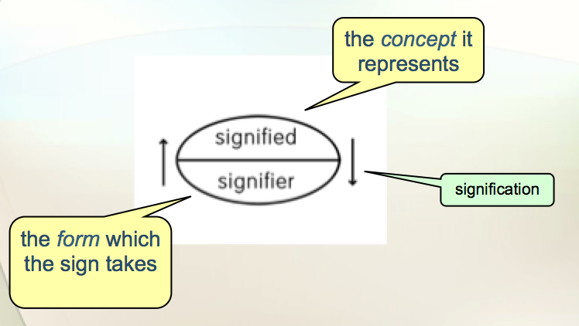
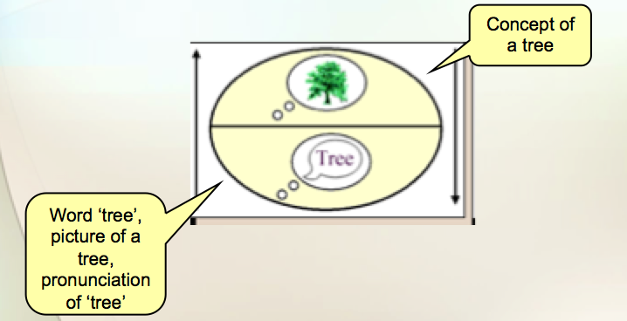

- Charles Sanders Peirce
  - American logician, philosopher, mathematician and scientist
  - Born in Camridge, Massachusetts
  - Contributions to philosophy, mathematics, logic and semiotics
- Peirce’s sign definition: “something which stands for something in respect or in a capacity of…”
- Peirce’s Triadic Semiotic System
  - Representamen – FORM which the sign takes (not necessarily material)
  - Object – to which the SIGN REFERS
  - Interpretant – IDEA, interpretation in mind
- Peirce’s Model seems to be more adequate in the High Culture Images (HCI) context
- Roland Barthes

Roland Barthes: semiology as cultural criticism
  - From the study of verbal language to that of cultural phenomena: films, photos, fashion, advertising, etc.…
  - Developing a common vocabulary and a rigorous or “scientific” method for the critical analysis of mass culture
  - Understanding the complexity and meaningfulness of all cultural artifacts despite their apparent “obviousness”
    - The “reality-effect” (Roland Barthes)

- The Reality Effect
  - So-called “realism” of the image makes it appear to be “natural” rather than socially and historically constructed
- A product or production of the image- its structure of signification as a message.
- The appeal to a belief
  - “I know very well that this is only a photograph, yet I choose to believe in its “reality”
- Arguing that the photography functions as a sign is to discredit it as an innocent o neutral representation

- “the photograph is a message without a code”
    - Message: signifier (representation), denotation, photograph, obvious or information, traumatic, “natural non-code records”, studium
    - Code: signified (meaning), connotation, caption, symbolic, ideological, cultural code transforms, punctum (significance)

- Walter Benjamin
  - Walter Benjamin posits that there are two different values to a work of art. The first is their cult value and the second is their exhibition value. He argues that along with our ability to mechanically reproduce works of art, we have shifted the emphasis from the cult value of the work of art to the exhibition value.
- Yousuf Karsh
  - One of his most famous photographs is of Winston Churchill
  - He was also known for black and white photographs, which gave a very striking image incorporating shadows to give a unique picture.
  - “The secret of a good portrait cannot be explained”
A Comparative Visual Analysis of 19th Century Iranian Photography & Persian Painting
Structure of Dissertation
- This dissertation presents an in-depth visual analysis of photographic material and subsequently a model to visually analyze and compare corpuses of photographs and paintings. This model aims to unravel images into their cultural components in a multi-layered process similarly, but in the reversed direction as the images were constructed.
- Visual Laterality
- Text
- Pose
- Space
- Western Influence

