COMM 299 – MARKETING YOURSELF

LESSON 1: The Marketing Concept and its Applications
What is Marketing?
Process of planning and executing the conception, pricing, promotion and distribution of ideas, goods, and services to create exchanges that satisfy individual and organizational objectives.
- a process that involves planning and implementing
- the conception, pricing, promotion, and distribution
- of goods, services, ideas, experiences, or persons
- to create exchanges
- that satisfy individual needs or desires
- and/or organizational goals

Evolution of Marketing
- Product
  - Limited choice
  - Intangible
  - Focus on efficiency of production and distribution
- Selling
  - Focus on identifying reasons for buying, match needs to products
  - Profits based on increased sales
- Marketing
  - Strong emphasis on identifying customers’ needs and motivation
  - All activities focus on customer satisfaction and retention
- Socially responsible marketing
  - Focus on societal issues

Purpose of Target Marketing
- Target marketing rests on the notion that organizations can achieve higher efficiency and success if they concentrate their efforts on key groups of consumers who share certain characteristics.
- As the targeted consumer groups become smaller in size, an organization moves from mass marketing to individual marketing.

Steps in Target Marketing
- Assess Customer Needs
- Identify Target Market(s)
- Develop Strategic Marketing Plan
- Evaluate Results of Plan

The Marketing Mix: the 4 Ps
- Elements of the marketing mix are under managers’ control. A useful way to remember the elements of the marketing mix is through the “four Ps” acronym:
- Product
- Promotion (Marketing communications)
- Place (distribution)
- Price

External Influences
- Economic factors
- Competitive factors
- Social and demographic factors
- Technological factors
- Legal and regulatory factors

Competitive Environment in Your Field
Monopoly
- One firm serve the entire market (there are no substitutes) and therefore theoretically controls most of the marketing mix elements
Ex.: Via Rail, electricity (Hydro-Quebec), water, cable TV within geographic areas

Oligopoly
- A few large firms dominate the market
- Firms compete on the basis of product differentiation and brand image
Ex.: Beer (Molson and Labatt control about 90% of the market), movie theatres

Monopolistic Competition
- There are many firms, large and small, each offering a unique marketing mix
- Products are clearly distinguished by brand names and there are always substitute products for consumers to turn to
Ex.: Restaurants: McDonald’s, Harvey’s, A&W, Burger King…

Pure Competition
- There are many buyers and sellers; firms market a uniform product
- No single buyer or seller has much effect on the price
Ex.: Agriculture industry (hard to distinguish one head of broccoli from another) and financial assets (stocks and bonds)

Competitive Assessment in Your Field
Direct Competition Competition from alternative products/services that satisfy the needs of a common target market
Ex.: Coca-Cola competes with Pepsi and a host of private label Colas and other branded
Colas (7up, Crush…)

Indirect Competition Competition that forms substitute products that offer customers the same end benefit
Ex.: When a consumer is thirsty, they may choose soft drink Coke or Pepsi, or they could
choose a fruit drink or iced tea. When Coca-Cola develops its marketing strategies, it
must think beyond traditional soft drinks and consider other beverages.

Trends Influencing Your Marketing Strategy
- A focus on customer relationship management
- The expanding role of database marketing
- The influence of technological advances in communications, Internet marketing and commerce
- Concern for the environment and other ethical practices and social responsibilities
- Global marketing opportunities

LESSON 2: Situation Analysis and Self-Assessment
Marketing Planning
Involves the:
- Analysis
- Planning
- Implementation
- Evaluation
- Control of marketing activities to satisfy customers' needs and firms’ objectives

Steps in Developing a Marketing Plan
- Analyze the current and future situations
- Understand the market and its customers
- Establish segmentation, targeting and positioning
- Determine objectives
- Develop marketing strategies and programs
- Track progress and activities
- Evaluate results and correct the plan as needed

Why is Analysis so Important?
To ensure that you acquire the knowledge necessary to develop and maintain an advantage over your competition in marketing yourself
Data: consist of raw facts and numbers
Information: compiled data edited to be comprehensive
Intelligence: implies some interpretation of the data and information to assist in making decisions
Analysis: consists of the gathering of data and information and then the search for patterns and insights to turn this information into intelligence

The Pitfalls of Analysis
Escalating commitment Where individuals commit more and more resources to a project even when they receive evidence that it is failing
Groupthink When a group of decision makers embarks on a poorly determined course of action without thoroughly questioning the underlying assumptions of the decision
Illusion of Control A person’s tendency to overestimate his/her ability to control events
Prior Hypotheses Bias People who have strong beliefs about the relationships between variables tend to make decisions on the basis of these beliefs even when presented with analytical evidence that contradicts them
Reasoning by analogy When individuals use simple analogies to make sense out of complex problems
Representativeness A bias that violates the statistical law of large numbers in that individuals often display a tendency to generalize from small samples

Elements of Situation Analysis
External Influences
- Economic Trends
  - Dictate the type and amount of marketing activity that need to be undertaken
  - Good times: hire more, spend more
  - Bad times: cut back, spend less
- Social and Demographic Trends
  - How do the basic trends in age, income, immigration and lifestyle affect areas in which id like to work?
- Technology Trends
- Regional Market Importance
  - Are there any regions that are more promising?
- Customer Data
  - Who are my prime customers?
- Social and Demographic Customer Behaviour
  - What customers seek?

Competitive Influences
Competition will come from:
- People from same major
- Graduates from other programs
- People re-entering workforce
- People promoted from within an organization

SWOT Analysis
It is used to assess the relationship between an organization’s
- Internal capabilities (strengths and weaknesses)
- External possibilities (opportunities and threats)

Self-Assessment
- Enables to identify your own strengths, weaknesses, skills, interests, values and ambitions
- Its an ongoing and dynamic process

LESSON 3: Setting Personal Marketing Goals
Why Study Motivation
- Goal of marketing: to satisfy customer needs
- Since reasons for product purchase vary among customers, an important step to satisfying customer needs is identifying their motives (the more you understand what motivates the target market, the more you satisfy customer’s needs)
- Motives may be obvious and overt
Ex.: a customer purchases a suit for an interview
- Motives may be unconscious and hidden
Ex.: a customer purchases a particular style and designer to satisfy his or her need for status and attention

What is Motivation?
The process of the pull towards a desirable end that leads people to behave as they do
- The pull may come from a need, desire, goal or drive
- Motivation comes from wanting to reduce tension caused when an individual perceives a difference between his/her current state and some ideal state

Various Motivational Pulls
Need
  - May be innate
  - May be acquired over time (psychological needs)
  - Want = how you satisfy a need (you are hungry but you want a green apple)
Drive
- Biological need that produces unpleasant states of arousal (thirst, hunger…)
Desire
- Dreams, wishes, a form of want that not based on need
- Luxury items, non-essential things
Goal
- Desired end state, often learned or acquired from experience
- Ex.: Goal of getting an A in a class

Understanding Needs
Levels of Needs in the Maslow Hierarchy
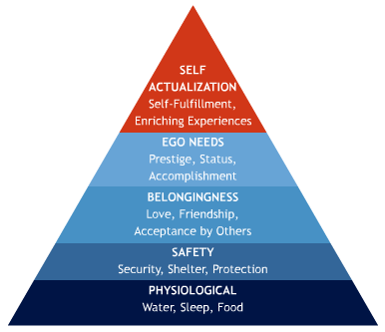

My Needs
Satisfying needs for…
- Status
A position that carries respect with friends, family and the community
- Security
Being assured of keeping your job and a steady source of income
- Helping Others
Being involved with helping other people in direct ways and contributing to the betterment of an individual/group
- Affiliation
Being recognizes as a member of a particular organization
- Power and Authority
Controlling work activities of others
Value
Central beliefs and attitudes that are strongly held by an individual, group or culture that motivate behavior
- An individual’s values are shaped over time by upbringing and surroundings (parents, friends, the community, culture)
- Cultures’ values can be described too (cultures that value materialism and seek the “good life” are more likely to value possessions that communicate power, status and appearance.
- 2 types of values
  - Instrumental Values
    - Ambitious, broad-minded, capable, cheerful, clean, courageous, forgiving, helpful, honest, imaginative, independent, intellectual, logical, loving, obedient, polite, responsible, self-controlled
- Terminal Values
    - A confortable life, an exciting life, a sense of accomplishment, a world of peace, equality, freedom, happiness, pleasure, salvation, wisdom, self-respect, family security

Consumer Involvement
All about the depth and intensity of the relationship people entertain with brands, product categories, or even communications about these brands
- Not everyone is motivated to the same extent and by the same products
- Types of Involvement
  - Enduring
    - Brands/product categories that you are involved with over extensive periods of time throughout your life
    - Ex.: as a child you collected cars, now you are still a car enthusiast and are subscribed to automotive magazines
- Situational
    - Momentary involvement with brands/products that is triggered by a specific situation
    - Ex.: you are out of gas

Motivational Conflicts
- Approach-Approach
Occurs when someone chooses between 2 alternatives
- Approach-Avoidance
Exists when we desire a goal but wish to avoid it at the same time
Ex.: I love Haagen Dazs but its so fattening
- Avoidance-Avoidance
Exists when the consumer is faced with 2 undesirable choice

Motivating Yourself
- Good attitude can bring dramatic changes in life: it promotes motivation, well-being, and improved self-esteem
- People with positive attitudes: perceived to be more appealing and agreeable
- Fear: good motivator but tend to hold people back
- Your comfort zone: where you feel most confident, but where your talends and aptitudes can stagnate as they are not challenged

Characteristics of Attainable Objectives

- Reasonable
- Believable
- Measurable
- Adaptable
- Controllable
- Desirable

LESSON 4: Creating my Marketing Strategy
The Marketing Planning Process at a Glance
OBJECTIVES ⇒ STRATEGIES ⇒ TACTICS

Objectives and The Marketing Planning Process
Objectives: Short-term performance targets
Goals: Longer-term performance targets

Characteristics of Objectives
- Specific, time-defined and measurable
- Realistic but challenging
- Consistent with the mission and goals of the organizations
- Consistent with internal resources and core competencies
- Appropriate in light of external environmental opportunities and threats

Strategies: What is it?
- Associated with direction and planning
- The guiding force behind the decision made throughout the organization and they indicate priorities and the allocation of resources (time, money, etc.)
- Not static: can be changed over time to adapt to external influences

Tactics
- Tactics/execution refer to the specific plans of action that outline in detail how your goals will be achieved
- Must support strategy
- Must be specific and concrete

Ex.: Movie industry: GOAL: secure entry position in movie industry, STRATEGY: do summer internship in production company, TACTICS: cold call small production companies

Marketing Strategy
- Selecting and describing the target market(s)
- Identifying and owning a market position
- Defining the marketing mix (How will the 4 Ps be used?)
- A budget

Selecting and Describing the Target Market(s)
- Make sure you understand who you are selling to
- Market Segmentation
  - Process of dividing a market into distinct segments of customers (who share certain characteristics) and selecting one or more segments as a target to be reached with a specific marketing mix
  - How to select a segment to market to? Collect information onpotential customers

Describing Customers
- Geo-Demographic
  - For specific geographical area
  - Includes info such as sex, marital status, income, education, occupation
- Psychographic
  - “Lifestyle” data
  - Includes listing of consumers’ activities, interests, opinions on various subjects
- Media Preferences
  - What are consumers’ media habits? Where do they prefer to get news?
- Purchase Behaviour
  - Usage rate, frequency of purchase, brand loyalty
  - How long do customers go grocery, how much do they spend…
- Benefits
  - What are the most important benefits sought by your target market?
  - Ex.: toothpaste, some people buy certain brands because of the benefits sought

Choosing Your Segment
- Now look for patterns among customers and identify groups who share certain characteristics
- Serving one big market? Large segments (large employers)? Small segments? Segments of 1? (Mass customizing)

Positioning
- Teaching customers to think of your product/service as a solution to a need in a way that is difference from your competitor
- Its about owning “mindspace” and creating a desirable image associated with your product/service

Positioning by What?

- Attributes & benefits
- Price/quality
- Product class
- Product user
- Competitor
- Cultural symbols
- On the experience of the product

Ex.: Volkswagen positioned the Beetle as “ugly but reliable”

The Marketing Mix
- Product
  - How can you differentiate from the competition?
  - What benefits does your product offer to your target market?
- Price
  - How much is your target market willing to pay for your product
  - How do you set and negotiate pricing and terms of engagement?
- Place
  - Where is the most appropriate place for your product?
  - How can you maximize the likelihood of being at the right place at the right time?
- Promotion
  - How to communicate your product and how will it benefit your target market?

LESSON 5: Personal Product Strategy I
Products: Beyond Tangibles
- Product: anything that can be offered to a market for attention, acquisition, use or consumption that might satisfy a need or want
- Some are intangible: products that cannot be touched or examined prior to purchase
- Ex.: an organization promoting safe sex, political parties attempting to maximize awareness, a country’s capital trying to attract visitors, a financial institution offering student loans
- Intangibles include people, places, ideas, and services
- Consumers often rely on the total image or impression of the product and let their emotions serve as a their guide
- Can also benefit from the use of marketing concepts

Services and Intangibles
- Services: acts, efforts, or performances exchanged from producer to user
- Includes banking, insurance, sales, professional services (law, photography, psychology), education, health care, hotels, restaurants, retailing, entertainment, etc.

Service Characteristics
- Intangibility
  - Customers cant see, touch, or smell services
  - They look for reassuring signs before purchasing (company reputation, word of mouth, testimonials from previous clients)
- Perishability
  - Services cannot be stored for future use
- Variability
  - Differences in a service provider’s performance from one day to another because it rests on human performance which cant be controlled
- Inseparability
  - Service can take place only at the time the service provider performs an act
  - (Simultaneity of production and consumption or servuction)

Thinking About the Total Intangible Product
Core Product The basic benefit or key feature of a product
- Rests on the company’s core competency (one thing its exceptionally good at doing)
  - One way to think about the core product: focus on what solves the customer’s problem at the heart of the purchase
- Companies often augment the core products to make their offering more competitive and desirable

Branding Yourself
- A brand name, term, symbol, logo, design, packaging that identifies the product
- Marketers use these features to create awareness and to distinguish the product from competitors
- The brand’s equity or value resides in the sum of associations and mental images that customers have about that brand
- Brands offer a total experience (enjoyment you get from shopping, purchasing, using and consuming the product
- Brand: not just physical product but an entire experience that extends over time

Brand Strategy
Developing a clear image for a brand so that employers or future customers feel as though they are comfortable and “know” the product
- Start by identifying the core brand values

How to establish brands
- Define the brand
  - What does the brand stand for, what experience does it offer
- Communicate the brand promise
  - Use imagery, metaphors, appropriate words to convey what the brand offers (Packaging, websites, spokespeople…)
- Deliver what you promise

Selling the Product that is You
Pure Selling Approach
- Agents present their client’s qualifications to potential buyers
Ex.: Executive Search Consultant
Product Improvement Approach
- Agent works with the client to modify certain characteristics what will increase market value
Ex.: mentor, personal coach
Market Fulfillment Approach
- Agent scans the market to identify needs that haven’t been met
Ex.: impresario or personal agent

LESSON 6: Personal Product Strategy II
Product Life Cycle
- The idea that every product has a lifespan
- 5 stages that different products will go through:
- Product Development
- Sales: non-existent, resources are invested to develop the product and elaborate strategies for the future
- Introduction
- Slow growth, many costs, profits negligible
- Growth
- Sales rapidly increasing, bringing new concerns to manage the growth and ensure product quality and integrity
- Competition likely to increase
- Maturity
- Slowdown in sales
- Product well known, profits may decrease due to higher marketing expenditures (competing with new products entering the market)
- Decline
- Sales and profits fall
- Happens because managers didn't foresee changes in the marketplace
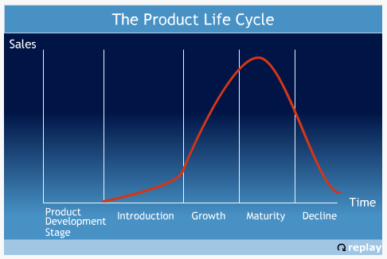

Style
Long-lasting and distinctive mode of expression
Ex.: Clothing: formal wear and casual wear
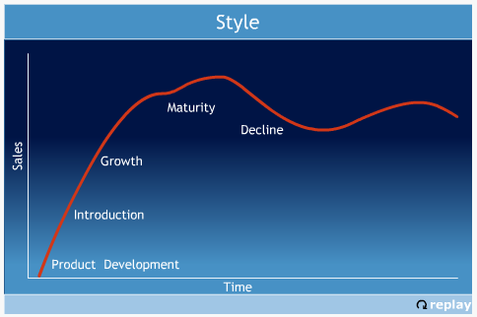

Fad
Product that goes through the 5 stages extremely quickly: sales peak as quickly as they fall
Fad products don't survive for long because they don't satisfy an important need
Ex.: Beanie Babies, Rubik’s Cube, Razor Scooters
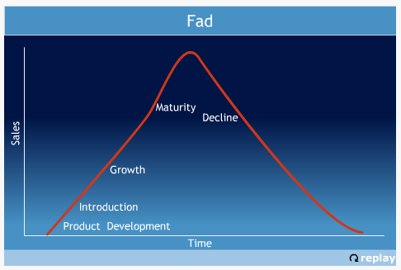

Fashion
- Currently accepted or popular style in a given field
- Grow slowly, remain popular for a while then decline slowly
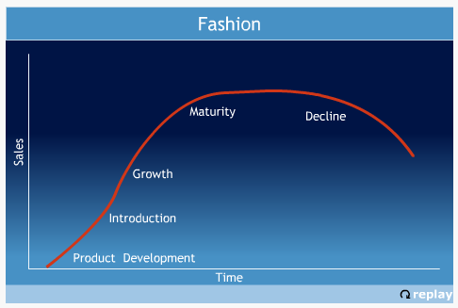

Change is Good
- Product strategies must be revised and reexamined systematically
- Key concern in product management: notion of product improvements

Product Improvement
Continuous Improvement
- Routine improvement that doesn't disrupt/conflict with established knowledge and behaviours
Ex.: low-fat dressings
Dynamically continuous improvement
- More disruptive: requires slight updating of users’ knowledge and minor changes in bahviours
Ex.: CD players, disposable diapers
Discontinuous/dramatic innovations
- Most disruptive and require considerable adaptation
Ex.: introduction of airplanes, television, pregnancy self-test kits

From Product to Customer Focus
Product-Centered organizations
- Segment their customers based on what products they have purchased intead of their customers’ characteristics
Customer-centered organizations
- Make plans and decisions based on the anticipated impact on customers
- Work to deliver positive experience and communicate consistent message
- Customer Relationship Management programs are designed

Brand Loyalty
Brand Loyalty: pattern of repeat product purchases, accompanied by an underlying positive attitude toward the brand, which is based on the belief that the brand makes products superior to its competition
- Customer-centered companies are in a better position to harvest the benefits of brand loyalty because they are continuously keeping the customer in mind when developing and implementing plans

Stimulating Word-Of-Mouth About Your Product
- Deliver on promises
- Identify and use Brand Champions (brand supporters)
- Follow up on chance meetings (from cocktails or conferences)
- Help information seekers (never turn down someone’s request for information)
- Give people something to talk about (emphasize what makes you unique)
Product Packaging
- Key indicator or cue upon which customers base their decision to purchase or not
- People evaluate each other by:
  - Visual appearance
  - Verbal
  - Voice

LESSON 7: Personal Price and Place Strategies
The Second “P”: Price
- Amount of money charged for a product/service, generates revenue
- Consumers buy the value proposition of a product, which is the function of the price but also rests with the sum of attributes and benefits

Initial Pricing
When at Introduction Stage, organizations choose between 2 strategies:
- Market Skimming
  - Setting higher price to reap maximum revenues layer by layer from the segments willing to pay the high price
- Market Penetration
  - Setting lower price to attract large number of buyers and large market share in order to move through introduction and into growth phase quickly
  - Idea: penetrate market quickly and deeply

Market Skimming
- Product’s quality & image must support the price
- Enough buyers must want the product at that price
- Competitors shouldn't be able to enter the market easily

Market Penetration
- Market must be highly price sensitive
Ex.: Zellers has customers who purchase based on price
- Production & distribution costs must decrease as sales volume increase
- Low price must help keep out the competition

Pricing Concepts
- Reference Pricing
  - Price that a customer uses to compare and judge other prices
  - Often average based on the customer’s past experiences with similar products

- Ceiling Pricing
  - Maximum a customer is willing to pay
- Floor Pricing
  - Minimum price a customer is willing to pay
- Psychological Pricing
  - Products that appeal to customers’ needs for self-esteem (designer clothing) are higher priced to convey luxury and status
Ex.: Water?

Price Perception
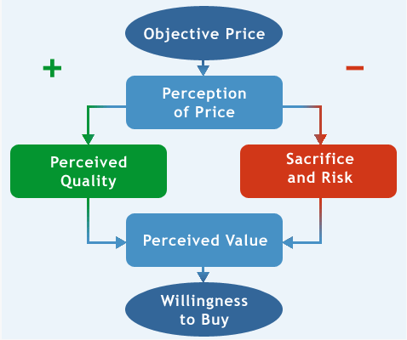

Types of Risk
- Functional
  - Risk that the product will not perform, that core product will not solve the problem at hand
- Physical
  - Risk of harm to customers
- Financial
  - Risk that the product is not worth the cost or finding a better/cheaper alternative around the corner
- Psycho-social
  - Risk that a poor choice will embarrass the customer
- Time
  - Risk of investing time in searching for the product
Dealing with Risk
- Seek additional information
- Seek reassurance (opinions of others)
- Stay brand loyal (go with trusted name)
- Select by brand image
- Rely on store image
- Buy most expensive model

The Art of Negotiating
Negotiation Interpersonal decision-making process wherein 2 or more people agree on how to allocate scarce resources

The Third “P”: Place
- Availability of the product to the customer at the desired time and location
- Channels of distribution
- MY Physical place: New York for Fashion
- The right place at the right time

LESSON 8: Personal Promotion I
Promotion (marketing communications)
Coordination of communication efforts by a marketer to inform or persuade consumers or organizations about goods, services or ideas

Promotional Tools
- Advertising
  - Non-personal, paid communication from an identified sponsor, primarily using mass media
  - Designed to stimulate a positive response from a defined target market
- Public Relations
  - Building good relations with the company’s public by obtaining favorable publicity, building up a good corporate image and handling unfavorable rumors, stories and events
- Sales Promotions
  - Activity that provides incentives to bring about immediate response from customers, distributors, and an organization’s sales force
- Personal Selling
  - Face-to-face communication involving the presentation of features and benefits of a product/service to a buyer
  - Objective: make sale and build customer relationships
- Direct Response
  - Direct communication with carefully targeted individuals to obtain an immediate response (via email, internet, telephone, fax, mail)
- Event Marketing
  - Process of integrating a variety of communication elements within a single event theme

Marketing Communications
What They Do
- Inform customers about new goods and services, as well as where they may be obtained
- Remind customers to continue to use your product
- Persuade customers to choose your product over competing ones
- Build and strengthen relationships with customers.

Inform
- Telling customers about a new product or modifications to an existing one.
- Suggesting new uses for an existing product.
- Telling customers about a price change (increase or decrease).
- Correcting false impressions.
- Building an organization's or individual's image.
Persuade
- Getting customers to prefer your brand over others.
- Creating desire for your brand.
- Getting customers to switch from their current brands to yours.
- Getting customers to purchase now (instead of delaying).
- Changing customers' perceptions of your brand.
Remind
- Getting customers to remember your brand's name and identity.
- Reminding customers that the product may be needed in the future.
- Reminding customers where to buy the product.
- Getting customers to keep the product in mind during off-seasons.
Forge Relationships
- Increasing customers' commitment to your brand.
- Getting customers involved with your communications.
- Giving customers something to talk about (foster word-of-mouth).
- Turning your satisfied customers into your best ambassador.
- Solidifying the emotional bond customers have with your brand.

Teaser ads
Inform customers about an upcoming product launch or product change

Basic Communication Model
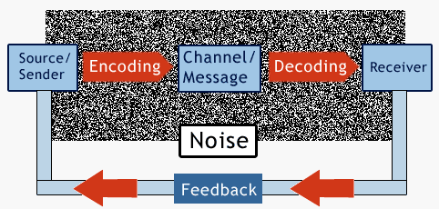

Getting Customers to ACT
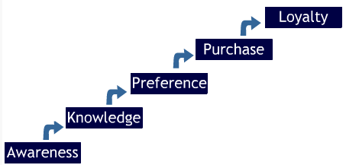

Setting Promotional Objectives
Create Awareness
- Alert customers that your product is ready
Increase Knowledge
- Provide customers with product knowledge, emphase unique features (personal selling)
Create Desire/Preference
- Make potential customers like your product and convince them that your product is more desirable than others (using status or sex appeal in ads)
Encourage Trial/Purchase
- Offer samples, coupons
Build Customer Loyalty
- Implement customer relationship management program

Push vs. Pull
Push Strategy
- Move products through channel by convincing channel members to offer them
- Provide incentives (rebates)
Pull Strategy
- Moving products through the channel by building desire for the products among consumers

Integrated Marketing Communications
Coordination of all marketing communications in a unified program that maximizes the impact on the intended target audience
Examples of long-running campaigns: Nike (Just do it), De Beers (A diamond is forever), Intel (Intel inside)
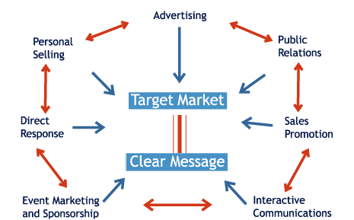

Unique Selling Proposition
Must be focused on the product benefits or features that can most uniquely distinguish the brand from the competition

Public Relations Basics
- Monitoring internal & external publics
- Providing positive information to these publics in order to develop a positive image of the company
- Reacting quick to demands from or shifts in company perceptions by these publics
Strengths of Public Relations
- Credible
- Cost-efficient
- Little Clutter
- Lead generation (PR is about providing target audience with a positive image as well as reacting to inquiries from your audience and turning them into possible leads for sales)

LESSON 9: Personal Promotion II
Influences to Consider
In order for persuasion to be effective, you must consider:
- Motivation and processing ability of the receiver
- Credibility of the persuader
- Structure of the message

Hard Facts vs. Peripheral Cues
Peripheral Cues
- non-verbal cues
- In ads: catchy jingle, sex appeal

The Credibility of the Sender
Perceived credibility is a function of:
- Expertise
- Power (CEO, lifeguard)
- Trust and Similarity

Structure of the Message
2 types of message appeals:
- Rational
- Emotional

Appeal to Reason
- Using logic is convincing, focus on hard facts (evidence or appeals from some authority figure in the field)
- Use 2-sided messages to recognize opposite point of view

Appeal to Emotion
- Ads: appeal to more basic emotions (fear, desire, respect, love)

Patterns of Persuasion
- Get receiver’s attention
- Understand sender’s motivation (needs and desires?)
- Focus on benefit to the sender (show benefits of product, phrase in compelling, emotional terms)

Direct Marketing
Data Collection Collect leads, names, addresses
Data Mining Look for patterns in this data
Design and send a message
Track responses Evaluate direct marketing program, make changes where needed

Media Relations
Helps to
- Reach large audience
- Inform people by associating your name and product with attributes such as quality, value and desirability
- Establish credibility and expertise on subjects that concern your domain or industry

LESSON 10: Resume and Cover Letter
Step 1: Planning Your Resume and Cover Letter
- Analyze purpose and audience
- Gather pertinent information
- Adapt resume to audience
Step 2: Writing Resume and Cover Letter
3 formats:
- Chronological: historical summary of education and work experience
- Functional: focuses attention on areas of competence
- Combination: chronological+functional
Skills
- Job-related: skills required for specific job
- Adaptive: personal characteristics (honestly, flexibility, self-motivation)
- Transferable: can be transferred from one job to another (communication, research and planning, human relations…)
Major Sections
- Academic credentials
- Employment history
- Extra-curricular activities
Cover Letter
- Intended to get reader interested enough to read the resume
- Tells employer what you are sending, what they can benefit from
- Serves as competitive advantage
Step 3: Completing your resume and cover letter
Proof-read
Step 4: Distributing resume and cover letter
Step 5: Follow-Up
Email or phone: people are more receptive on Fridays (good mood)

LESSON 11: MY Marketing Plan
The Marketing Planning Process
SITUATION ANALYSIS
⇓
GOALS, TARGET MARKET AND MARKETING MIX DECISIONS
⇓
IMPLEMENTATION
⇓
CONTROL (assess whether you were successful or not)
Examine previous plan and look for clues that affect current and future progress/performance

Types of Control Used by Organizations
- Annual Plan Control
- Gauge the progress towards achieving the marketing, financial, and program objectives as outlined in the marketing plan
- Profitability Control
- Gauge performance in achieving profit-related objectives (Ex.: return on investment)
- Productivity Control
- Gauge efficiency in managing the sales force, channels, marketing communications and products
- Strategic Control
- Gauge effectiveness in managing marketing, customer relationships, social responsibility and ethics
- Perform marketing audit
- Perform customer relationship assessment
- Perform social responsibility and ethics assessment

Marketing Plan Implementation
- Turning ideas, strategies and plans into action
- Always have a contingency plan
- Consider each “P” and how they interact with each other

LESSON 12: Interviewing and Presentation Strategies
Presentation Strategies
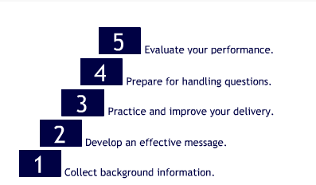

Step 1: Collect Background Information
About:
- Audience’ profile and needs (demographic make-up, motivation, objectives)
- Purpose of presentation (to inform, persuade, motivate, entertain, build goodwill)
- Location and set-up where you will be presenting

Step 2: Develop an Effective Message
SEE Principle
Seduce
- Goal: to convince audience that they should adopt your recommendations
- Get audience on your side by being engaging, passionate and sincere
Entertain
- Avoid tension and boredom
Educate
- Tell audience something they didn't know before the meeting

Step 3: Practice and Improve your Delivery
Presentation approaches:
- Memorizing
- Manuscript reading (write speech and read directly from it)
- Extemporaneous Speaking (talk planned out in detail)

Step 4: Preparing for and Handling Questions
- Prepare for their questions
- Project + attitude

Step 5: Evaluate Your Performance

Job Interviews
Types of Interviews:
Screening
- May be done in person or on the phone, will be conducted by HR rep
Selection
- Interviewer is trying to determine whether you will match the organizational culture (done in first 20 seconds of interview)
Group
- Many candidates interviewed at the same time (interviewer is looking for a particular personality trait and group setting enables him/her to identify the one who most likely possesses the desired traits)
Panel
- Single candidate interviewed by many interviewers at once
Behavioral
- Asked to describe in detail what you did in past situations

LESSON 13: Key Marketing Concepts and My Career

Broadening the Concept of Marketing
1969: Kotler and Levy
Organizational Marketing?
Some organizations didn't perceive themselves as businesses. They had to learn to use marketing tools to promote themselves (Ex.: United Way)
Corporate Presence
Museums, public transportation, etc. are now using marketing to keep in touch witht heir customers’ needs and develop products that meet their needs
Take-Away from “Broadening the Concept of Marketing”
- Organizational marketing can include marketing of tangible products, services, persons, the organization itself and ideas
- For organizational marketing, the term "consumers" really implies the organization's various stakeholders, ranging from suppliers to the general public.
- Knowing your product, its differentiating advantage(s), your target customers and their behaviours are as important to organizational marketing as they are to other forms of marketing.
- To adapt to change and to avoid becoming outdated and obsolete, organizations must make use of continuous feedback and assess long-term changes via a marketing audit.

