Chapter 1 – 10 Principles of Economics

What is Economics?
Economics is the study of how scarce resources are allocated among alternative uses to satisfy human wants.

- Resources are scarce (limited in supply) in most situations
- The price of resources reflects their value/importance and is the mechanism by which they are allocated among economic agents (consumers, firms, resource owners)
- Resources (i.e. labour, capital etc…) may be consumer or used to provided various goods in alternative uses
- Economics is concerned only with how much people are willing to pay for what they want.

What do Economists Study?
- Economist study how people make decisions:
  - How much to work and save, what to buy and how to invest their savings
  - What resources and technology to use to produce a good and what to produce
- How people interact with each other
  - How prices and quantities of goods are determined
- The forces and trends that affect the economy as a whole
  - Business cycles, growth, unemployment, inflation and events in other economies.

Micro vs. Macroeconomics
- Economics has 2 sub fields:
  - Microeconomics – studies how households and firms make decisions and interact
  - Macroeconomics – studies the overall economy
Both, however, are closely intertwined – the overall economy is composed of millions of household and firms. Any policy to promote economics growth needs to understand how it will affect households and firms.

10 Principles
economics is unified by 10 central ideas/principles:
- 4 principles relate to how people make decisions
- 3 principles relate to how people interact
- 3 principles relate to how the economy as a whole works

How People Make Decisions
Principle 1: People Face Trade-offs
All decisions involve trade offs.
Example – going to a parts the night before a mid term leaves less time for studying – can limit career choices in the futures
Example - having more money typically means working more which leaves less time for leisure
- A noted trade-off exists between efficiency and equity because these desirable goods often conflict.
  - Efficiency is getting the most from resources
  - Equity is sharing resources within a society
  - Example – a progressive tax system reduces incentive to work because it takes money from rich and gives it too poor.

Principle 2: The Cost of Something Is What You Give Up To Get It
- Making decisions requires comparing the costs and benefits of alternative choices
- The opportunity cost of any item is whatever must be given up to obtain it
- It is the relevant cost for decision making
Example – the opportunity cost of going to college for a year is not just tuitions, books, fees, etc…, but the lost wages you could have had by working.

Principle 3: Rational People Think At The Margin
Rational people:
- Systematically and purposefully do the best they can to achieve their objectives
- Make decisions by evaluating costs and benefits of marginal changes – incremental adjustments to an existing plan
Example – when a manager considers whether to increase output, he/she will compare the cost of the needed labour and materials to the extra revenue generated.

Principle 4: People Respond to Incentives
- An incentive is something that induces a person to act (i.e. the prospect of a reward or punishment)
- Rational people respond to incentives
Example – when gas prices rise, consumers buy hybrid cars and fewer gas guzzling SUV’s, when cigarette taxes increase, teen smoking drops

How People Interact
Principle 5: Trade Can Make Everyone Better Off
- Rather than being self sufficient, people can specialize in producing one good or service, and exchange it for other goods to improve their well being
- Countries also benefit from trade specialization
  - Get a better price abroad for goods they produce
  - Buy other goods more cheaply from abroad than could be produced at home
  - Access a greater variety of goods, including goods they might not be able to get at all (fresh produce year round)

Principle 6: Markets Are Usually a Good Way to Organize Economic Activity
- A market is a group of buyers and sellers of a good
- Organizing economic activity entails determining: what good to sell, how to produce them, how much of each to produce and who gets them.
- A market economy
  - Allocates resources through the free decentralized and self interested decisions of buyers and sellers as they interact in markets
  - Sets market prices that reflect each goods value to buyers and cost of production to sellers
  - Often organized economic activity in a way that maximizes economic well being
Principle 7: Government Can Sometimes Improve Market Outcomes
- Key role for government are to define property rights and enforce them (with police and courts)
  - People are less inclined to work, produce, invest or purchase if large risk of their property being stolen
- But markets can sometimes fail to allocate society’s resources efficiently
- Causes of market failure include:
  - Externalities – when the production or consumption of a good affects third parties (pollution imposes costs on society)
  - Market Power – small numbers of buyers or sellers have substantial influence on market price (i.e. monopolies)
- In such cases, public policity may promote efficiency
- Of course, government may also alter market outcomes to promote a more desirable distribution of resources (equity) – possible at the expense of efficiency

How The Economy Works As A Whole
Principle 8: A Country’s Standard of Living Depends On It’s Ability to Produce Goods and Services
- Living standards vary greatly across countries and over time
  - Average income in rich countries is more than 10 times average income in poor countries
  - Canada’s standard of living today is 8 times longer than 100 years ago
- Productivity is the most important determinant of living standards
  - It is the amount of goods produced per hour of a workers time
  - It depends on the equipment, knowledge and skills, natural resources, and technology available to workers.
- Other factors (labour unions foreign competition) have far less impact on living standards

Principle 9: Prices Rise When Government Prints Too Much Money
- Inflation is the increase in the general level of prices
- In the long run, inflation is almost always caused by excessive growth in the quantity of money, which causes the value of money to fall
- The faster the government created money, the greater the inflation rate

Principle 10: Society Faces a Short Run Trade Off Between Inflation and Unemployment
- Many economic policies push unemployment and inflation in opposite directions in the short run
Example – income tax cut can increase consumer demand and output and reduce unemployment, but will also increase the overall price level
- The costs of inflation can become huge if inflations is too high
- How policy instruments should be used to control an economy is subject to much debate.

Chapter 2 – Thinking Like An Economist

Economists Play 2 Roles:
- As scientist, economists make positive statements, which try to describe/explain the world as it is
  - To do so, they use the scientific method, the dispassionate development and testing of theories about how the world works
- As policy advisors, economists make normative statements, which try to prescribe how the world should be, to improve it
  - The government of Canada, like other governments, relies on the advice of economists.
  - They are employed in many government agencies and departments, including the bank of Canada and the department of finance
- Positive statements can be confirmed or refuted
- Normative statements cannot

Positive Statements Vs. Normative Statements
Examples:
- Prices rise when the government increase the quantity of money
  - Positive – could use data to confirm or refuted
- The government should print less money
  - Normative – this is a value judgement, cannot be confirmed or refuted
- A Tax cut is needed to stimulate the economy
  - Normative – another value judgement
- An increase in the price for burritos will cause an increase in consumer demand for video rentals
  - Positive – describes a relationship. Note that a statement does not need to be true to be positive

Models and Assumptions
- Like scientists, economists use models to study economic issues
  - To draw logical conclusions (deductions)
  - To predict real world behaviour
- A model is a highly simplified representation of a more complicated reality
  - Captures key features to be investigated
  - Uses reasonable simplifying assumptions about reality
- Assumptions simplify the complexity of the world; make it easier to understand
  - Examples – to study international trade, we often assumer 2 countries and 2 goods
  - This is unrealistic, but simple to learn and provides useful insights about the real world
  - Results can often be generalized

The Circular Flow Diagram
- A visual model of the economy that shows how dollars’ flow through markets around households and firms

- 2 markets
  - goods and services
  - factors of production – the resources the economy uses to produce goods and services (land, labour, capital, natural resources)
- 2 types of economic agents
  - households
    - own factors of production and sell/rent them to firms in exchange for income
    - buy and consumer goods and services
  - firms
    - buy/hire factors of production and use them to produce goods and services
    - sell goods and services

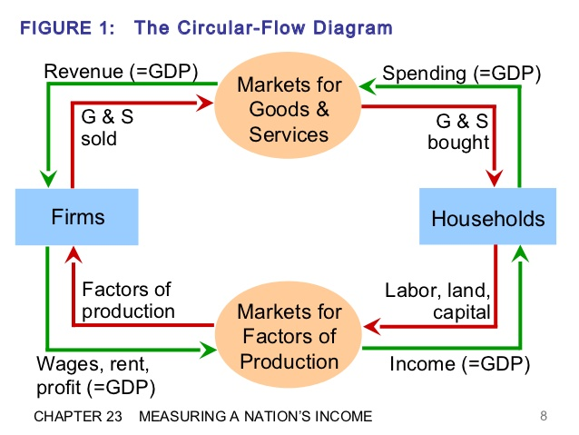

The Production Possibilities Frontier (PPF)
- a graph that shows the maximum combinations of 2 goods an economy can produce given its available resource and technology
- for example – refer to chapter 2 slides page 7 or chapter 2 textbook page 26
When looking at PPF graph, opportunity cost is lower when slope is not steep
- Any point inside the PPF is inefficient work
- Any point outside the PPF is impossible
- Any point on the PPF is the most efficient

Chapter 3 – Interdependence and The Gains From Trade
- In most countries today, many goods and services consumed are imported from abroad, and many goods and services produces are exported to foreign customers.

Absolute Advantage
The comparison amount produces of a good according to their productivity. The producer that requires a smaller quantity of inputs to produce a good is said to have an absolute advantage in producing that good

Comparative Advantage
The comparison among producers of a good according to their opportunity cost. The producer who gives up less of other goods to produce good X has the smaller opportunity cost of producing good X and is said the have a comparative advantage in producing it. (impossible for one person to have comparative advantage for both goods)
- When each person specializes in producing a good for which he or she has a comparative advantage, total production in the economy rises
For both parties to grain from trade, the price at which they trade must lie between the 2 opportunity costs

Imports: goods and services produced abroad and sold domestically
Exports: goods and services produced domestically and sold abroad.

Chapter 4 – The Market Forces of Supply and Demand

What is a Market?
- A market is a group of buyers and sellers of a particular good or service. The buyers, as a group determining the demand for the product while the sellers as a group, determind the supply of the product
- Often, markets are not organized. Sellers don’t gather and determine what prices to sell their product. Sellers will decide on a price and adjust accordingly to demand

What is Competition?
- In a market there are many sellers that compete to gain the business from the buyers. Sellers are aware that there are other firms selling essentially the same product as them while buyers are aware there are multiple places to get essentially the same product.
- The term competitive market refers to a market with so many buyers and sellers that neither group can decide what the price is. If sellers raise their price, buyers will go elsewhere and sellers have no reason to decrease their prices if it is that same price as everyone elses.

Demand and The Demand Curve
- The quantity demanded of any good is the amount of the good that the buyers are willing and able to purchase. For example, if the price of ice cream rises to $20 a scoop, the quantity demand will substantially decrease; however, if the price of ice cream lowers to $1 a scoop, the quantity demanded will increase.
Because the quantity demanded falls as the price rises and rises as the price falls, we say that quantity demanded is negatively related to price
- This is true for almost all goods in the economy and is called the law of demand.
- The law of demand states that, all other thing equal, when the price of a good rises, the quantity demanded of the good falls, and when the price falls, the quantity demanded rises

Shifts in The Demand Curve
Demand shifters that shift the curve to the right is called an increase in demand while demand shifters that shift the curve to the left are called a decrease in demand.
Demand Shifters:
- Income
  - If demand falls when income falls, the good is called a normal good
  - If demand for a good rises when income falls, the good is called an inferior good
- Prices of Related Goods
  - When a fall in the price of one good reduces the demand for another good, the 2 goods are called substitutes. When a fall in the price of one good raises the demand for another good, the 2 goods are called compliments.
- Tastes
  - Individual tastes can change over time which alter an individuals demand for a good

- Expectations
  - Your expectations for the future can influence how you purchase goods now. For example, if you forsee a higher income in the future, you might spend some of your savings on goods
- Number of Buyers
  - If mode buyers join the market, the quantity demanded will increase at every price

Supply and The Supply Curve
The quantity supplied of any good or service is the amount that sellers are willing and able to sell. Price plays a special role. When the price of a good is high, selling it is profitabl and the quantity supplied is large. Sellers work long hours, buy new machinery and hire more workers. The opposite is true when the price for a good falls.
- The law of supply states that other things equal, when the price of a good rises, the quantity supplied of the good also rises, and when the price falls, the quantity supplied falls as well.

Shifts in The Supply Curve
Like the demand curve, the supply curve has many variables that can shift it
- Input prices
  - To produce certain goods, other inputs must sometimes be present to manufacture the finished product. When the price of the inputs rises, the price of the good rises and when the price of inputs falls, the price of the good falls
- Technology
  - Advancements in technology make is more efficient to produce goods with out labour. This reduces costs and overall cost of good
- Expectations
  - If a firm predicts that their will be an increase in demand in the future, they might start manufacturing more now to prepare
- Number of Sellers
  - Market supply depends on the number of sellers. If one firm goes out of business the entire market supply would drop.

Equilibrium
The equilibrium is the demand and supply curves together. The point is located at the only point on the graph where the supply and demand curves meet. The price at this intersection is called the equilibrium price and the quantity is called the equilibrium quantity.
- If the price is about the equilibrium price then there will be a surplus of goods because the quantity demanded of the good will decrease
- If the price is below the equilibrium price, there will be a shortage of good in the market because the quantity demanded will increase.

Chapter 5 – Elasticity

Elasticity – the measure of how much buyers and sellers respond to changes in market conditions

Price Elasticity of Demand
The law of demand says that a decrease in the price of a good leads to an increase in the quantity demanded. Price elasticity of demand measures how much the quantity demanded responds to the change in price.
Elastic – demand is said to be elastic if there is a big response to the change in price
Inelastic – demand is said to be inelastic if there is only a slight response to the change in price

Availability of Close Substitutes
If a good has many close substitutes (i.e. breakfast foods), it tends to have a more elastic demand because it is easier for consumers to switch from that good to another.
Ex – butter and margarine are close substitutes meaning that it is very easy to switch between the two. Therefore, if there is a rise in price in one good, consumers will buy the other. On the other hand, eggs don’t have many substitutes meaning that it is very hard to switch between goods making the demand inelastic.

Necessities Vs. Luxuries
Because necessities are things that we need demand tends to be inelastic. No matter what price the good is at, consumers will still buy it. On the other hand, luxuries are things that we want and therefore tend to be elastic. If the price rises substantially, we will no longer buy it.
Necessities and luxuries are subjective as some people might view some things as necessities while others don’t.

Definition of the Market
Depending on how much an individual defines a market, it can be very elastic or very inelastic. For example, food is a very broad category that has no substitutes therefore there would be an inelastic demand; however, if we narrow the category to ice cream it becomes much more elastic. If the price of one flavor increases, it is very simple to switch to another.

Time Horizon
Goods tend to develop a more elastic demand over time. For example, if gasoline prices rise, not many people will change resulting in an inelastic demand; however, over time people will switch to electric cars leading to a more elastic demand

Computing the Price Elasticity of Demand
We compute the price elasticity of demand as the percentage change in the quantity demanded (Qd) divided by the percentage change in the price.

Price Elasticity of Demand = Percentage change in Quantity Demanded
Percentage change in price

Ex – a 10% increase in the price of an ice cream cone causes the amount of ice cream you buy to fall by 20%. The elasticity of demand is calculated like this:

Price Elasticity of Demand = 20% = 2
10%
In the above case, the elasticity is 2, meaning that the change in quantity demanded is proportionally twice as large as the change in price.
Absolute values are used when calculating elasticity’s forcing all answers to be positive.
A larger elasticity implies that there is a greater responsiveness of quantity demanded when the price changes.

The Mid-Point Method
When trying to find the price elasticity of demand between 2 points, the results from A to B and B to A will be different. To avoid this problem, we use the midpoint method.
The formula for the midpoint method is as follows:

Price Elasticity of Demand = (Q₂ – Q₁)/[( Q₂ + Q₁)/2]
(P₂ – P₁)/[(P₂ + P₁)/2]

the numerator is the percentage change in quantity using the midpoint method and the denominator is the percentage change in price using the midpoint method.

Variety of Demand Curves
Elastic Demand when elasticity > 1
Inelastic Demand when elasticity < 1
Unit elasticity when elasticity = 1

Rule of thumb – the flatter the demand curve that passes through a given point, the greater the price elasticity of demand. The steeper the demand curve that passes through a given point, the smaller the price elasticity of demand.

The graphs on the next page show the 5 different elasticity graphs ranging from perfectly inelastic to perfectly elastic.
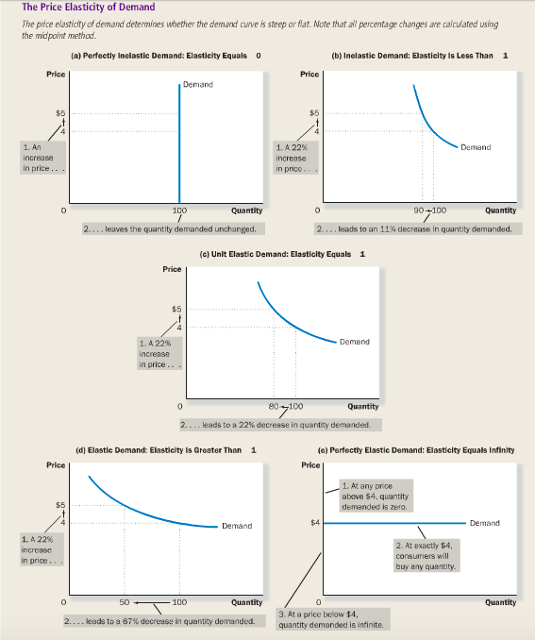

Total Revenue and the Price Elasticity of Demand
- When demand is inelastic (<1), price and total revenue move in the same direction
- When demand is elastic (>1), price and total revenue move in opposite directions
- If demand is unit elastic (=1), total revenue remains constant when the price changes

Elasticity and Total Revenue along a Linear Demand Curve
- At points with a low price and a high quantity the demand curve is inelastic
- At points with a high price and low quantity, the demand curve is elastic
Although it is a linear demand curve, the elasticity is not linear. It changes depending on the price. A constant elasticity is possible; however, it will not appear on a linear demand curve.

Other Demand Elasticity’s
The Income Elasticity of Demand – measures how the quantity demanded changes as consumer income changes. It is calculated by the percentage change in quantity demanded divided by the percentage change in income:

Income Elasticity of Demand = Percentage change in Quantity Demanded
Percentage change in Income

Normal goods – higher income raises quantity demanded. Because higher income and quantity demanded move in the same direction, normal goods have positive income elasticities.
Inferior goods – higher income lowers the quantity demanded. Because the quantity demanded and income move in opposite directions, inferior goods have negative income elasticities

Cross-Price Elasticity of Demand
The cross-price elasticity measures how the quantity demanded of one good changes as the price of another good changes. It is calculated as the percentage change in quantity demanded of good 1 divided by the percentage change in the price of good 2:

Cross-Price Elasticity of Demand = Percentage change in Quantity Demanded of Good 1
Percentage Change in Price of Good 2

Whether the number obtained from the cross price elasticity is positive or negative depends on whether the 2 goods are substitutes or compliments.

Substitutes – goods that are typically used in place of one another (i.e. hamburgers and hot dogs) cross price elasticity is positive because the increase in the price of hamburgers leads to the increase in the purchase of hot dogs
Compliments – goods that are typically used together (i.e. computers and software). Cross price elasticity is negative because the increase in the price of computers decreased the demand for software.

Elasticity of Supply
Price Elasticity of Supply
The law of supply states that higher prices raise the quantity supplied. The price elasticity of supply measures how much the quantity supplies responds to changes in the price. Supply is said to be elastic if the quantity supplied has a big response to a change in price. Supply is said to be inelastic if the quantity supplies has a little response to a change in price.
Price elasticity of supply depends on the flexibility of sellers to change the amount they produce. For example, sellers can’t produce more land while merchandise can continually be produced.
Supply is usually more elastic in the long run than in the short run because in a short period of time, firms cannot expand their factories to produce more.

Computing the Price Elasticity of Supply
The price elasticity of supply is measured by the percentage change in quantity supplies divided by the percentage change in price.

Price Elasticity of Supply = Percentage Change in Quantity Supplied
Percentage Change in Price

When computing more than 1 variable, use the midpoint method.

Variety of Supply Curves
Varieties of supply curves are the same as the varieties of the demand curves. They range form both extremes of perfectly inelastic to perfectly elastic.

The next page shows the 5 variations of supply curves ranging from perfectly elastic supply to perfectly inelastic supply
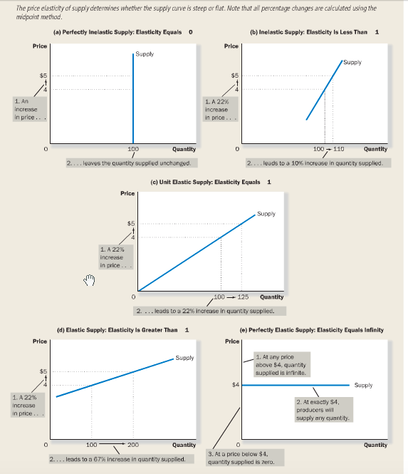

Chapter 6 – Supply, Demand and Government Policies

Controls on Prices
Price Ceiling – price of a good is not allowed to rise above this level
Price Floor – the price of a good cannot fall below this level

Price Ceiling Affect Market Outcomes
- When the price ceiling is above the equilibrium, it has no affect on prices as it will naturally reach its equilibrium.
- When the price ceiling is below the equilibrium, it can never reach the equilibrium. Therefore, the quantity demanded will always exceed the quantity supplied. There will be a shortage
When the government poses a binding price ceiling on a competitive market, a shortage of the good arises and sellers must ration the scarce goods among the large number of potential buyers.

Price Floors Affect Market Outcomes
- When the price floor is below the equilibrium, it has not affect on prices as it will naturally rise to the equilibrium.
- When the price floor is above the equilibrium, there will be a surplus of goods as the quantity supplied will be greater than the quantity demanded.

Taxes
When the government levies a tax on a good, who should bear the burden of the tax, buyers or sellers?
Tax incidence – the manner in which the burden of a tax is shared among participants in a market.

Taxes on Buyers Affect Market Outcomes
If the government passes a law requiring buyers of a good to send .50 to the government after each purchase, how will this affect the buyers and sellers of the good?
- The immediate impact of the tax is on the demand for the good. The supply is not affected; however, the demand is. Buyers now purchase less because it is more expensive.
- The direction of the shift is determined next . because the tax makes purchasing the good less attractive to buyers, they now demand a smaller quantity of the good at every price. As a result, the demand curve shifts to the left.
- Once the direction is determined we can now see the actual effect of the tax by comparing the old equilibrium with the new equilibrium
So, who bears the burden of the tax?
Buyers and sellers share the burden of the tax
- Taxes discourage market activity. When a good is taxed, the quantity of the good sold is smaller in the new equilibrium
- Buyers and sellers share the burden of taxes. In the neq equilibrium, buyers pay more for the good and sellers receive less

Taxes on Sellers Affect Market Outcomes
If the government levied a tax on sellers of a good, what will the effects be?
- The immediate impact of the tax on sellers. Because the tax is not levied on buyers, the quantity demanded stays constant; therefore, the demand curve does not change. However, the tax on the sellers makes producing less profitable therefore lowering the supply and shifting the supply curve.
- The tax shifts the supply curve to the left because the tax makes producing goods less attractive to producers.
- Having determined how the supply curve shifts, we now compare the new equilibrium with the original equilibrium to determine how the tax affects sellers.
Taxes on buyers and sellers are equivalent. In both cases, the tax places a wedge between the price that buyers pay and the price that seller receive. In both cases, the tax shifts the equilibrium where the buyers and sellers share the tax.

