The Market Forces of Demand and Supply
- another economic model of microeconomics
- purpose: to analyze the allocation of the production of goods and services across industries of the economy
- it responds to the Q question. What goods and services should be produced, and in what quantities?
- Supply and demand are the two words that economists use most often.
- Supply and demand are the forces that make market economies work
- They determine the quantity of each good produced and the price at which it is sold.
- If you want to know how any event or policy will affect the economy, you must think first about how it will affect supply and demand.
- The terms supply and demand refer to the behaviour of people as they interact with one another in competitive markets.
- Before discussing how buyers and sellers behave, we must understand what we mean by a market and competition
- Market: a group of buyers and sellers of a particular good or service
- Competitive market: a market in which there are many buyers and many sellers so that each has a negligible impact on the market price
- We begin our study of markets by examining the behaviour of buyers
Demand
- Represents the relationship between the price of a good and the quantity demanded
- Quantity demanded: the amount of a good that buyers are willing and able to purchase
- Demand schedule: a table that shows the relationship between the price of a good and the quantity demanded
- Demand curve: a graph of the relationship between the price of a good and the quantity demanded
- Market demand: the sum of all the individual demands for a particular good or service
- Law of demand: the claim that, other things equal, the quantity demanded of a good falls when the price of the good rises
  - ceteris paribus: there is an inverse relationship between price and quantity demanded.
  - as price increases, quantity demanded decreases
  - as price decreases, quantity demanded increases
  - C.P. means all other factors except price held constant
  - Geometrically, this gives us a negative slope for the demand curve
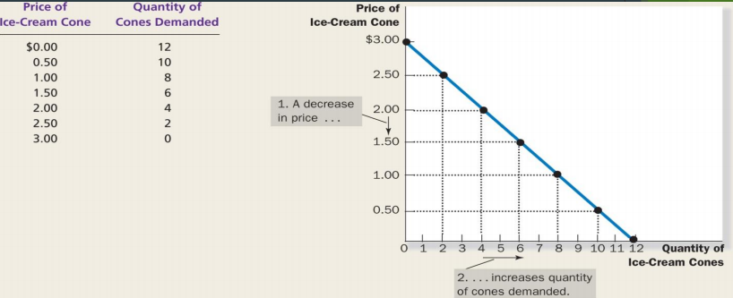
Determinants of Demand
- price; consumer preferences, income, prices of related goods, expectations of future price and/or income, number of buyers
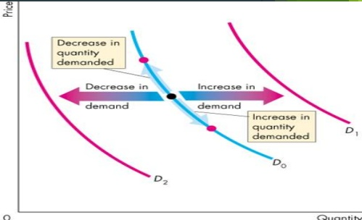
Shifts in Demand Curve
- Denotes a new relationship between Qd (quantity demanded) and P (price)
- Caused by a change in those relevant factors other than price; price causes “movement” in graph
- Any change that increases the quantities that purchasers wish to purchase at a given price shifts the demand curve to the right and vice versa
Shifts in the Demand Curve versus Movements along the Demand Curve
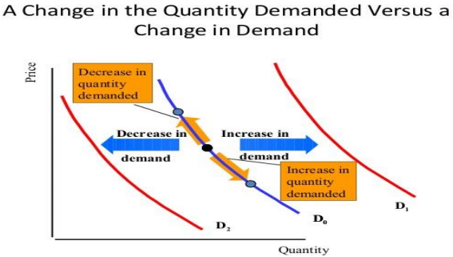
Factors that shift the demand curve
- Income
  - Normal good: a good for which, other things equal, an increase in income leads to an increase in demand
  - Inferior good: a good for which, other things equal, an increase in income leads to a decrease in demand
- Prices of related goods
  - Substitutes: two goods for which an increase in the price of one leads to an increase in the demand for the other (e.g. taxi rides versus UBER)
  - Complements: two goods for which an increase in the price of one leads to a decrease in the demand for the other (e.g. gas and automobiles)
- Tastes
- Expectations
- Number of buyers
- The demand curve shows the relationship between P and Qd holding other factors, such as preferences, incomes, and prices of related goods constant.
- If you are given a change in Price, which is the variable on the Y-axis, move along the Demand curve.
- This means that if those other factors, which do not appear on either axis are not constant, there is a new demand relationship
- If you are given a change in any of those other factors, shift the Demand curve.
- The direction depends on the particular case
Supply
- the relationship between the price of a good and the quantity supplied
- Quantity supplied: the amount of a good that sellers are willing and able to sell
- Supply schedule: a table that shows the relationship between the price of a good and the quantity supplied
- Supply curve: a graph of the relationship between the price of a good and the quantity supplied
- Market supply: the sum of supplies of all sellers
- Law of supply: the claim that, other things equal, the quantity supplied of a good rises when the price of the good rises
  - ceteris paribus: there is a positive relationship between price and quantity supplied.
  - as price increases, quantity supplied increases
  - as price decreases, quantity supplied decreases
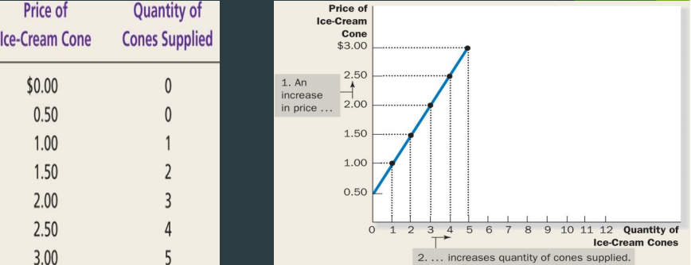
Determinants of Supply
- price; costs of production, technology of production, number of firms, expectations of future price
Shifts in Supply Curve
- Denotes a new relationship between Qs (quantity supplied) and P
- Caused by a change in those relevant factors other than Price
- Any change that increases the quantities that sellers wish to produce at a given price shifts the supply curve to the right and vice versa
- Input prices, technology, expectations, number of sellers
Shifts in the Supply Curve versus Movements along the Supply Curve
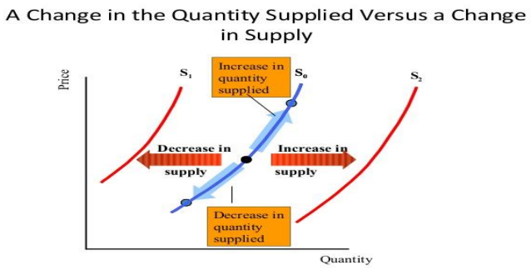
Examples
1. Indicate how you think the following would affect demand in the indicated market
a) An increase in family income on the demand for winter vacations in the Caribbean
Increase in demand, shift right
b) A study linking beef consumption to heart disease on the consumption of hamburgers
Decrease in demand, shift left
c) An increase in the price of audio cassettes on the demand for CDs
Increase in demand, shift right
d) An increase in the price of CDs on the demand for CDs
Decrease in demand, movement up
2. How would each of the following affect Canadian market for wheat?
a) A new and improved crop rotation technique is discovered
b) The price of fertilizer falls
c) The Prairies suffer a drought
*price changes → Qd or Qs
*other factors → changes in demand or supply
Supply and Demand Together
- So far, we only know about quantity demanded (Qd) and quantity supplied (Qs) at a range of possible prices
- What about the actual price that prevails?
- Need to examine both the supply side and the demand side of the market.
- The prevailing price is the equilibrium price, and it is determined by the intersection of the S & D curves
- The quantity generated on the horizontal axis from this intersection is called the equilibrium quantity.
- This gives the response to the “What?” question
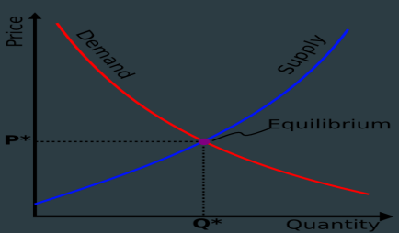
The best way to understand an equilibrium is to examine a disequilibrium situation.
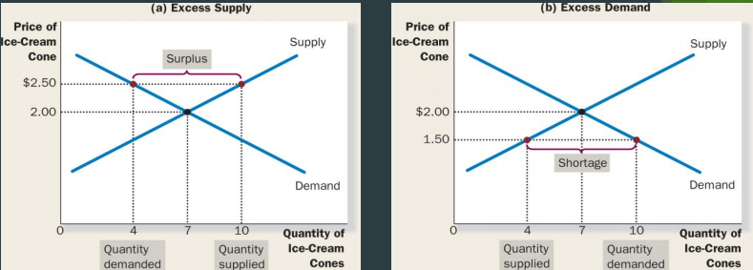
Case 1
- Suppose that the transactions price > equilibrium price Qs > Qd, and a surplus emerges.
- Surplus = Qs - Qd
- As unsold goods and inventory pile up, firms are tempted to bid down prices
- 2 effects occur
  - price falls, Qs falls due to law of supply
  - price falls, Qd increases due to law of demand
  - eventually, Qs = Qd as equilibrium is restored
  - there is no further incentive to change
Case 2
- Suppose that the transactions price < equilibrium price Qs < Qd, and a shortage emerges.
- Shortage = Qd - Qs
- As customers become irritable and aggressive, they to are tempted to bid up prices
- 2 effects occur
  - price rises, Qs rises due to law of supply
  - price rises , Qd falls due to law of demand
  - eventually, Qs = Qd as equilibrium is restored
  - there is no further incentive to change
- This is an illustration of the price system in action
  - Shows how the price system, operating through the forces of supply and demand, allocates scarce resources in a decentralized fashion
- A point to note
  - often, society judges this equilibrium, “market” price to be unfair and/or unjust
  - an equilibrium price can be ‘too low’, which is bad news for producers
  - an equilibrium price can be ‘too high’, which is bad news for consumers.
Equilibrium Analysis
- To analyze changes in equilibrium, one has to determine
  - the change, or event, that has occurred
  - the response has two parts
    - does the demand curve shift, and/or the supply curve shifts?
    - If the demand and/or the supply curve shifts, in which direction?
- Suppose that one summer the weather is very hot. How does this event affect the market for ice cream?
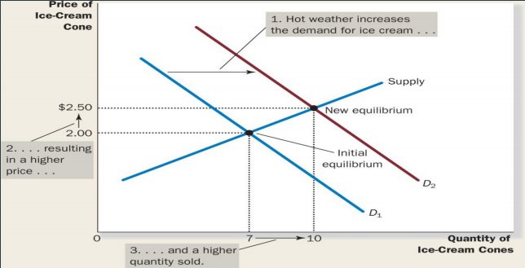
- Suppose that, during another summer, a hurricane destroys part of the sugarcane crop and drives up the price of sugar. How does this event affect the market for ice cream?
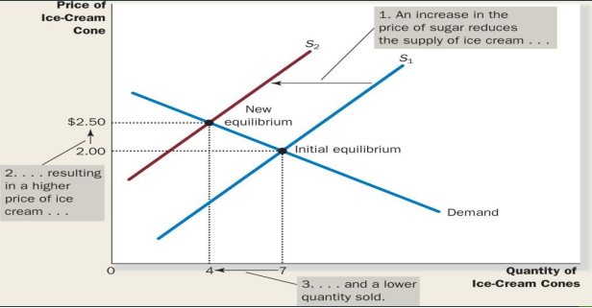
- Suppose that the heat wave and the hurricane occur during the same summer. How does these events affect the market for ice cream?
- Graphs from slides
Example
1. The demand and supply curves of T-shirts in Tourist town are given by Qd = 24,000 – 500P and Qs = 6,000 + 1000P where P is measured in dollars and Q is the number of T-shirts sold per year
a) Find the equilibrium price and quantity algebraically
A: At equilibrium, Qs = Qd
24,000 – 500P = 6,000 + 1000P
P = 12
Qd = 24000 - 500(12) = 18000
Qs = 6000 + 1000(12) = 18000 T-shirts
*If they’re not the same, you’re wrong!!
Therefore, equilibrium price = $12
b) If tourists decide they do not really like T-shirts that much, which of the following might be the new demand curve? Qd = 21,000 – 500P and Qd = 27,000 – 500P
Find the equilibrium price and quantity after the shift of the demand curve
A: Qd = 21,000 - 500P because there should be a decrease in demand
21,000 - 500P = 6,000 + 1000P
15000 = 1500P
P = 10
Therefore, new equilibrium price is $10
Qs = 21,000 - 500(10) = 16,000 T-shirts
c) If instead, two new stores that sell T-shirts open up in town, which of the following might be the new supply curve? Qs = 4,000 + 1000P and Qs = 9,000 + 1000P
Find the equilibrium price and quantity after the shift of the supply curve
A: Qs = 9,000 + 1000P because supply increases
24,000 - 500P = 9,000 + 1000P
15,000 = 1500P
P = 10
*Has to be lower. If not, you’re wrong!!
Therefore, new equilibrium price is $10
Qs = 9000 + 1000(10) = 19,000 T-shirts
More Examples
- a) What would happen to the equilibrium price and quantity of fish if it is discovered that fish oils prevent heart disease?
Increase in demand
b) What would happen to the equilibrium price and quantity of potatoes if a new higher yielding variety of potato plant is developed?
c) What would happen to the equilibrium price and quantity of corn if the price of butter increases and the price of fertilizer decreases?
d) What would happen to the equilibrium price and quantity of apples if apples are discovered to help prevent colds and a fungus kills 10% of existing apple trees?
A: Demand increases, shift to right. Supply decreases, shift left. Price increases.
e) How will a new law mandating an increase in required levels of automobile insurance affect the equilibrium price and quantity in the market for new automobiles?
A: demand would decrease
2. Market research has revealed the following information about the market for chocolate bars: The demand schedule can be represented by the equation Qd = 1600 - 300P, where Qd is the quantity demanded and P is the price. The supply schedule can be represented by the equation Qs = 1400 + 700P, where Qs is the quantity supplied
a) Calculate the equilibrium price and quantity in the market for chocolate bars.
b) Say that in response to a major industry ad campaign, the demand schedule for chocolate bars shifted to the right, as represented by the equation Qd = 1800 - 300P. What happens to the equilibrium price and quantity of chocolate bars in this case?
c) Returning to the original demand schedule, say that the price of cocoa beans, a major ingredient in the production of chocolate bars, increased because of a drought in sub-Saharan Africa, a major producer of cocoa, changing the supply schedule to Qs = 1100 + 700P. What happens to the equilibrium price and quantity in this case?
3. The demand and supply functions for hockey sticks are given by Qd = 286 -20P and Qs = 88 + 40P
a) Graph the supply and demand curves, clearly showing the intercepts.
b) Determine the equilibrium price and quantity of hockey stick.
c) Suppose that both the men’s and women’s teams win the Olympic gold medals, causing an increase in the demand for hockey sticks across the country to Qd = 328 -20P . What impact does this have on the price of hockey sticks and the quantity sold?

