Chapter 3: Interdependence and the Gains From Trade
A Parable for the Modern Economy
Production Possibilities
 | Amount of Meat or Potatoes Produced in 8 Hours
 | Meat | Potatoes
Farmer | 8 kg | 32 kg
Rancher | 24 kg | 28 kg

 | Amount of Meat or Potatoes Produced when Time is Split
 | Meat | Potatoes
Farmer | 4 kg | 16 kg
Rancher | 12 kg | 14 kg
Production possibilities frontier (PPF) - shows the various mixes of output that an economy can produce; illustrates the principle that people face tradeoffs
- If farmer and rancher choose to be self-sufficient, then the PPF is also the consumption possibilities frontier.
Specialization and Trade
- Rancher tells farmer to grow potatoes for 8 hours, producing 32 kg in total, and then trade 15 kg of potatoes for 5 kg of meat produced by rancher.
- In the end, farmer will have 17 kg of potatoes left from 32 and also 5 kg of meat vs. 16 kg of potatoes and 4 kg of meat, which is what farmer makes alone when he splits his time.
- Rancher will spend 6 hours producing meat and 2 hours growing potatoes, resulting in 18 kg of meat and 12 kg of potatoes. After trading, rancher is left with 13 kg of meat (18-5=13) and 27 kg of potatoes (12+15=27) vs. 12 kg of meat and 14 kg of potatoes when time is split.
Comparative Advantage: The Driving Force of Specialization
Absolute Advantage
- The comparison among producers of a good according to their productivity
- The producer that requires a smaller quantity of inputs to produce a good is said to have an absolute advantage in producing that good
  - In example, time is only input. Rancher takes less time to produce both foods so rancher has absolute advantage.
- Possible to have absolute advantage in both goods
Opportunity Cost and Comparative Advantage
Opportunity cost - whatever must be given up to obtain some item
Comparative advantage - the comparison among producers of a good according to their opportunity cost; the producer who gives up less of other goods to produce good X has comparative advantage; impossible to have comparative advantage in both goods
Comparative Advantage and Trade
The gains from specialization and trade are based not on absolute advantage but rather on comparative advantage. When each person specialize, total production in the economy rises.
The Price of Trade
For both parties to gain from trade, the price at which they trade must lie between the two opportunity costs.
Applications of Comparative Advantage
Should Canada Trade with Other Countries?
Imports - goods and services produced abroad and sold domestically
Exports - goods and services produced domestically and sold abroad
---------------------------------------------------------------------------------------------------------------------

- One of the ten principles of is that trade can make everyone better off.
- This principle explains why people trade with their neighbours and why nations trade with other nations.
- What exactly do people gain when they trade with one another?
- Why do people choose to become interdependent?
- It is usually advantageous for countries, firms, individuals, or other economic units to specialize in the production of one or a few, and trade the majority of their product away in exchange for those that they do not produce
- International trade is usually economically beneficial
- The Robinson Crusoe economy of total self-sufficiency, which is called autarky
- By specialization and trade, the total amount of production available for consumption is far higher than it is in autarky
- Who should specialize in what?
Absolute Advantage
- The ability of a country or a person to produce more of a good or service than the other
Comparative Advantage
- The ability of a country or a person to produce a good or service at a lower opportunity cost than the other
- When it comes to trade, absolute advantage is not as important as comparative advantage
Example
- Assume 2 producers: the rancher and farmer
  - 2 goods: meat and potatoes
  - Resources: 8 hours of labour input per day
Absolute Advantage
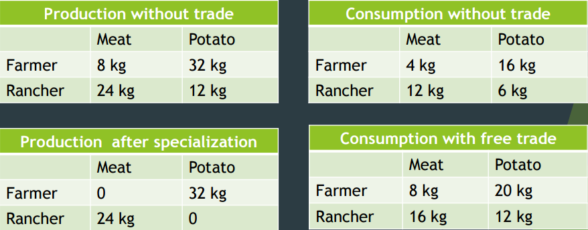

Comparative Advantage
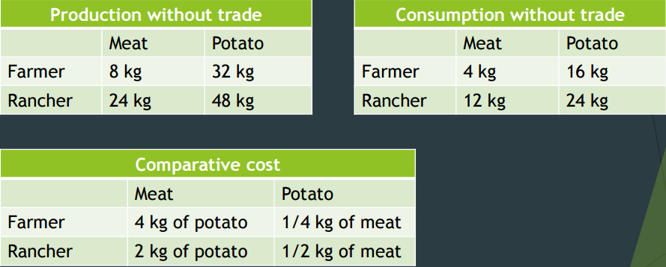
- Each economic unit should specialize in the production of the good in which they have a comparative advantage
Comparative Advantage
- the rancher has a comparative advantage in the production of meat if he produces meat with a lower opportunity cost in terms of potatoes than is the case for the farmer
- Although the rancher produces potatoes better than the farmer produces meat, he is only twice as efficient in the production of potatoes as he is in meat
- The farmer is four times as efficient in the production of potatoes (compared to meat)
- It follows that farmer has the comparative advantage in potatoes and the rancher in the production of meat
Basic Idea
- By exporting the good in which one has a comparative advantage and importing the good in which one has a comparative disadvantage, these transformation rates of one good into the other are more favorable than they would be in autarky
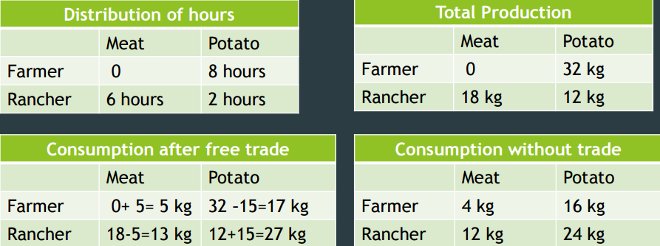
Example
- Two countries: Canada and Japan
  - Two goods: computers and wheat
  - One resource: labour (measured in hours)
- We will look at how much of both goods each country produces and consumes:
  - if the country chooses to be self-sufficient
  - if it trades with the other country
- Canada
  - 50000 labour hours available for production per month
  - Producing one computer requires 100 hours of labour.
  - Producing one ton of wheat requires 10 hours of labour
- Japan
  - 30000 labour hours available for production per month
  - Producing one computer requires 125 hours of labour.
  - Producing one ton of wheat requires 25 hours of labour
- Use the information to derive Canada and Japan PPFs
  - Graphs should measure computers on the horizontal axis 1-9 Interdependence and the Gains from
- Suppose Canada uses half its labour to produce each of the two goods, how much will it produce and consume? Draw the point representing this combination of computers and wheat on Canada’s PPF.
- Suppose Japan uses half its labour to produce each good, how much will it produce and consume? Draw the point representing this combination of computers and wheat on Japan’s PPF.
- Suppose Canada exports 700 tons of wheat to Japan and imports 110 computers from Japan.
  - (So, Japan imports 700 tons wheat and exports 110 computers.)
4. How much of each good is consumed in Canada? Plot this combination on Canada’s PPF.
5. How much of each good is consumed in Japan? Plot this combination on Japan’s PPF.
- Canada
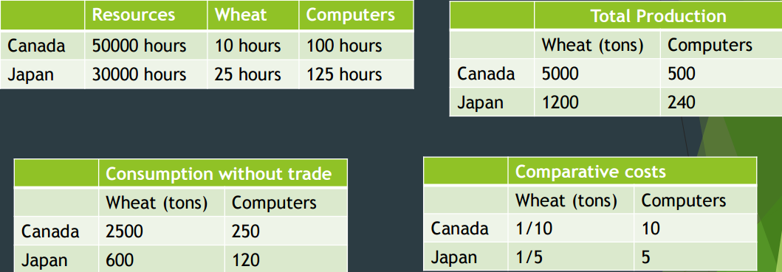
- Suppose Canada produces 3400 tons of wheat and Japan produces 240 computers
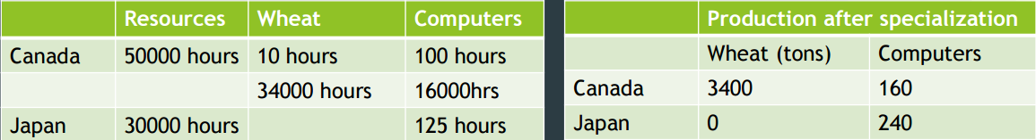
- Suppose Canada exports 700 tons of wheat to Japan and imports 110 computers from Japan
- Gains from trade
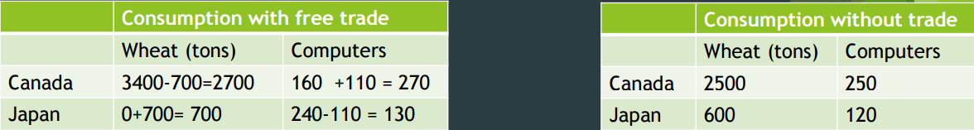
- The gains from specialization and trade are based not on absolute advantage but rather on comparative advantage.
- When each person specializes in producing the good for which he or she has a comparative advantage, total production in the economy rises.
- Each benefits from trade by obtaining a good at a price that is lower than his or her opportunity cost of that good.
- What determines the price at which trade takes place?
- How are the gains from trade shared between the trading parties?
- For both parties to gain from trade, the price at which they trade must lie between the two opportunity costs.

