Orgo Week 05 Lecture

10.04.2016-01

Bronsted-Lowry
- Acids deprotonate and bases protonate
- Conjugate acids and bases, what has to act as acid or base to regenerate original reagent
- Conjugate base must be weaker than acid it came form
- Water is amphoteric

Curved Arrows and Lewis Acids and Bases
- You can sorta say one hydrogen costs 2 e-, which makes sense if you look at the 1s orbital
- So, we can show the exchange of hydrogens as lone pairs, so we can use curly arrows to show the mechanism
- Gaining a hydrogen is the same as losing a lone pair, losing a hydrogen means you gain a lone pair, giving rise to Lewis acids and Bases
- That's why the conjugate acid gets a – charge since it gained a lone pair
- All acid base reactions must occur in one step
- Something attacks a proton, and a pair of e- ends up on the conjugate acid
- Elimination: one in two out, and acid base reactions result in the elimination of a water
- Acid base steps in organic reactions

Quantifying Acidity
- We use pKa and pKb
- The –log of the equilibrium constant of acid dissociation constant Ka, -log is more convenient and it gives us a + number
- A strong acid has the pKa<1 in general, the dissociation goes to completion, while a weak acid has significant back reaction and pKa<1
- Most organic acids and bases are weak
- The strongest organic acids we will encounter are COOHs, the electron withdrawing nature of the Os creates this esp with the first dissociation of dicarboxylic acids
- Phenol is also a good organic acid, alcohol is more acidic then ketones
- The bases we tend to encounter are amines
- Can estimate PkA of unknown if you have something similar’s pKa
- Double bonds tend to be more acidic since the double bond withdraws electrons
- Conjugate Base strength, pkb= 14-PKa
- Stronger acid, weaker conjugate base because a strong dissociation means forward dissociation very favoured, so back reaction unfavored
- Pretty basic review
- Can use structure stability to see how strong an acid or base is
- There will be a charge on the conjugate acid or base
- The more able the resulting conjugate acid base structure can minimise it’s formal charge or stablize by resonance the more favoured the dissociation

ARIO
- You can remember the factors affecting stability is ARIO
- A: The atom that will carry the charge (is it EN- or EP+)
  - Better to put a – formal charge on something that likes e- like an Oxygen
- R: Is something going to be resonance stabilized
- Induction (does it induce a charge somewhere)
- Orbital: Which orbital will the charge go in, hydroboration concerns

10.05.2016-03

Atom Effects
- If your removal of a hydrogen will put a – charge on something electronegative like an oxygen, you gain stability
- Likewise if adding a hydrogen puts a + charge on something electropositive, you’re good

Resonance
- How spread out is your formal charge
- When you have a lot of sp2 and sp hybrids and open p orbitals you can generate stability by splitting the charge

Inductive Effects
- Also spreads out charge, if you have a lot of electron withdrawing en- species like halogens, you give a + charge to your carbon, making the hydrogen easier to pull off
- Induced dipole
- PkB goes up with electron donating species, generally additive
- These are electronic effects, alters electron density

Orbital Effects
- What type of orbital is there
- Better Sp than Sp2 than Sp3,
- This is because sp hybridised has more s character, better to hold a – charge closer to the nucleus

Priority
- ARIO is in order of priority
- Good general guideline, but sometimes fails, acetylene more acidic than ammonia, opposite of prediction
- To be sure need to measure pKa
- Can also predict which hydrogen would come off, which one has the most effects

Charged Acids and Bases
- Can also be used for acids with a formal charge
- Same rules apply, expect you start with a charge and have to take that into account
- What stabilises a – charge will destablise + and vice versa save for resonance with stabilises both
- ARIO allows an estimate when you don’t have pKa, but if you have a pKa you’ve got it for sure
- The pKa can tell us which side of an acid base reaction is favoured, along with ARIO

Choosing a Reagent
- Reagents donate or remove protons
- Need to find an effective one, if yow at to depronate your reganet needs to be a stronger acid than what you are trying to deprotonate
- Leveling effect: Acids stronger than H30+ will turn into H30+ and will waste their protonation effects on the water, things that are more basic than OH- will turn into OH- and will deprotonate the water
- So if you want to use really strong acids, need to use acid dissolved in water (H30+) or anhydrous solution

Steric Effect
- ARIO fails if there is enough a steric effect (big groups repelling)
- Big bulky groups hinder solvation and thus acid dissociation
- Why tert-butoxide is less stable than ethoxide
- Teritary and primary alcohols have different effects on pKa
- The stabilisation of charge is most important
- Spectator ions Are needed to write full equation, but are often left out because they do not changes
- Remember your NIES and TIES

More on Lewis Acids and Bases
- Broader definition, e- donors and acceptors as mentions
- Does not need protons
- Can work in organic solvents
- Includes Brosted acids

10.07.2016-05

Podcast: Carbon NMR

Introduction to Carbon NMR
- NMR uses radio waves
- Very powerful can give structure in more cases
- But it’s a bit more involved
- There are a lot of things you have to look for
- Measuring Carbon 13 using NMR

Using NMR
- Looking at a carbon and scoping out what its neighbours are, can also do this with hydrogen proton NMR
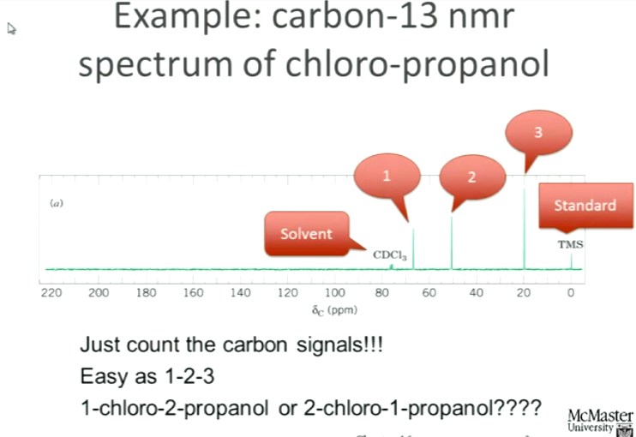
- How do we use this to distinguish the isomers? We will see how
- Spectrum, opposite of IR, peaks are absorption not troughs
- ∂c is the chemical shift, measured in ppm (WHY) to standardize per spectrometer
- C13 NMR runs from 0- 220 ppm, most molecules in this ran
- ppm is an energy axis, but with nice numbers
- Different energies and carbon nuclei, TMS calibrates spectrum and defines 0
- ∂0 is the energy at which TMS undergoes NMR
- TMS is not part of compound, it’s a common mistake to think the molecule has a C-Si bond (C-Si bonds are rare in orgo so that's what makes this a good calibration to avoid ambiguity)

How to do NMR
- Need to dissolve compound first, preferably one with no H so we can do proton DMR or for Carbon NMR no C so they don’t mess up your signal
- We know where the solvent signals will be, so mark them and ignore them
- Peaks at 65 ppm, know molecular weight of compound, want a formula
- Molecular formula telling us what sorts of structures are possible
- Molecular weight + number of Carbons or H from proton NMR
- Difference between molecular weight and C and H weight can tell us what heteroatoms can be there
- Usually, in Carbon NMR the number of peaks is your no of C (but in a symmetrical molecule may not be the case)
- Frequency: position on axis tells us environment of hydrogen and carbon atoms
- When you throw radio waves on Carbons and hydrogen the nuclei absorb energies based on nuclear environment
- It's a large magnet and we put our compounds in the machine and blast them with radio waves
- Absorption is measured since they absorb at certain frequencies only
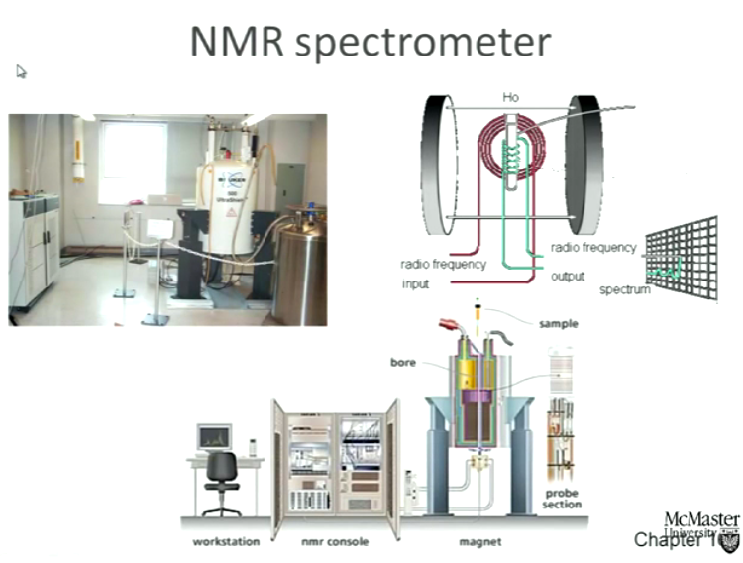
- Carbon 13 is only 1.1% of naturally occurring Carbon
- Carbon 12 though has no magnetic spin (it is an even nucleus and the spins of the neutrons and protons cancel out) and cannot give an NMR signal
- TMS Standard resonates at same frequency 0 ppm
- Figure out what your solvents peak is at (can be CDCl3)
- Remaining signals are from compound, and peaks come where you have carbons
- Where your carbon makes a peak depends one what is next to it

Chemical Shift
- Nuclei in different environments make peaks in different places
- But similar environments make similar frequencies a
- A C next to an OH usually gives a specific chemical shift, as to a C=O (usually in a high ppm 190-200 ppm)
- Methyl groups are to the right (10-20)
- The corollary to this is if you see a signal in a certain place you can deduce what is attached to the carbon making that signal
- Like with IR we can make a chart, you will be provided that chart on a test
- Decreased e- density causes deshielding signal to move downwards (usually something very e- withdrawing or sp and sp2 hybridization)
- Can also figure out hybridization in this way
- ∂77 is the CDCl3, so can ignore that, but if you have another solvent they will give you where it’s peak is
- So, when we go back to the chloropropanol , we have a peak at the far right (methyl), 50 and 66 tells us something EN- is attached to the carbon, the C-Cl and C-OH
- So, we know that the Cl and O are on different carbons, if they were on the same Carbon they would move down together and you’d get something at 90 ppm ~ additive
- Question: what is y axis, Don't need to label y axis, just absorption
- But where are all these Carbons located relative to each other ? How do we know which isomer we have?

DEPT
- One thing we can do is play magnetic billiards with DEPT, make some signals go away, others to stay in place
- Bounce the nuclei off one another, tune it only show us where CH CH2 or CH3
- Can sort spectrum if from methyls or what, so we can see how many hydrogens are attached to the Carbon of the group we are interested in, can tell us that Carbon’s hybridization and can tell us if that carbon may be bonded to something else
- Furthest to left is methyl group in example, when we tune out to see only CH, the Hydroxy carbon peak is still there, so we know that this Carbon is probably on the end, has the OH group and is double bonded to the next carbon over
- The carbon with the Cl shows up in the CH2 tuning, so that shows us that is our central carbon, and there is a methyl at the end on the other side
- So this sketches out for us a 2-chloro prop-1-en-ol
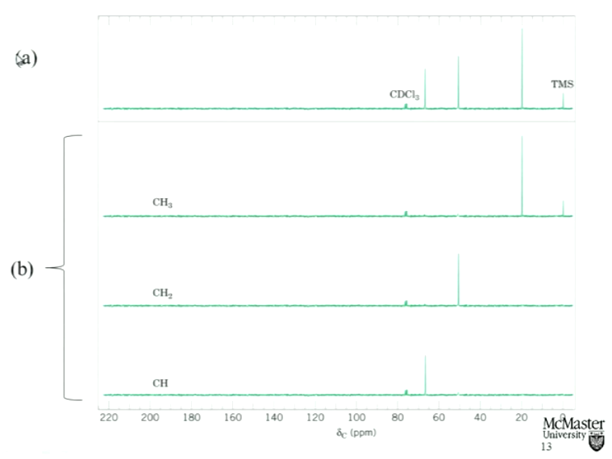
- But you can’t see quartnary problems like in neopentane

Symmetry
- If we have carbons in the same kind of environment they will make same peaks (or just peaks really close together)
- So we get fewer signals that number of carbons
- So we need another way—Mass Spec!
- We need multiple methods
- So, C13 NMR tells us about the types of carbons we have, not necessarily the number all the time
- We need mass spec to be conclusive
- We can also use both together to figure out the type of symmetry

NMR Spectroscopy
- Protons and neutrons have a spin, if there is an odd number of them combined we have a net spin and can induce a magnetic moment with radio waves
- This creates a magnetic field
- Its like an MRI
- Exists perp to axis of nuclear spin
- We get the spins to align at the quantum level
- If the total number of protons and Neutrons is even, then the spins cancel out and we cannot induce a magnetic moment
- Alpha nuclei align with field, lower energy than beta nuclei against field
- Now energy gap
- delta E
- Stronger mag field = greater energy gap
- More shielded nucleus= less gap because electrons take some of the nuclear spin
- Same with electron withdrawing, creates the distributes of ppm values

