FORMAT
2 sections – essay (weight 60%) and multiple choice (weight 40%)
- The exam is comprehensive – but more weight on material after the midterm (about two-thirds)
- Among material covered before the mid-term, study only Chs. 3, 5, 6, 10, 11
- After midterm: study Ch. 18 only up to p.551, Exhibit 18.2
- Essay questions may be:
  - Application type, such as end of chapter questions
  - Advantage & disadvantage
  - Comparative – you are asked to compare two methods
  - Evaluation – you are asked to evaluate a statement
- Computation questions (if any) will be a small proportion of total no. of questions
  - If you are asked to compute something, you will be given several formulae and you will have to pick the right formula
  - Bring a calculator
- You should know which statistical tests are appropriate for different kinds of questions/data
  - E.g., no Pearson correlation possible between gender and no. of movies seen per month
- You should know how to interpret statistical output from software (e.g., what p values mean)
- You can practice answering end-of-chapter questions

CHAPTER 3, PROBLEM DEFINITION, EXPLORATORY RESEARCH, AND THE RESEARCH PROCESS
STEPS IN DEFINING A PROBLEM
- RECOGNIZE THE PROBLEM
- FIND OUT WHY INFORMATION IS BEING SOUGHT
- UNDERSTAND THE DECISION MAKING ENVIRONMENT
- USE SYMPTOMS TO CLARIFY THE PROBLEM
- TRANSLATE THE MANAGEMENT PROBLEM
- DETERMINE WETHER INFORMATION ALREADY EXISTS
- DETERMINE WETHER QUESTION CAN REALLY BE ANSWERED
- STATE THE RESEARCH OBJECTIVES.

EXPLORATORY RESEARCH: Preliminary research conducted to increase understanding of a concept, to clarify the exact nature of the problem to be solved, or to identify important variables to be studied.
A.K.A I research something to see why something is actually a problem and to make the research project more interesting in the future.
- TYPES OF EXPLORATORY RESEARCH
- PILOT STUDIES: Survey using limited amount of respondents.
- EXPERIENCE SURVEYS ANALYSIS: Talk with smart people.
- CASE ANALYSIS: Review info with similar situations.
- FOCUS GROUPS: In depth discussions with 8-12 groups of people.
RFP: Request for proposal.

CHAPTER 5 QUALITATIVE RESEARCH
IDI: Individual Depth Interviews.

Differences between Quantitative and Qualitative Reseach?
Qualitative | Quantitative
Small sample  Subjective, analytical  Generally needs an interviewer with strong communication skills.  Covers emotion, feelings and opinions  More probing  Goes more with exploratory research.  Low replicability | Bigger sample size  Statistical  Needs mathematical skiils.  Data, closed numbers,  Less probing  Goes more with descriptive data.  High replicability.

Disadvantages of using focus groups?
More expensive, time consuming, needs more people, more times. It cost at least $2,000. Not enough availability of participants. People could get peer pressured and biased. Shy people.

CHAPTER 6 TRADITIONAL SURVEY RESEARCH
DELIBERATE FALISIFICATION: Respondent selects an answer but really isn’t true. They tend to select it to look a bit more intelligent or what not.
CATI: Computer - Assisted Telephone Interviews.
SAMPLING FRAME: List of population elements or members from which units to be sampled are selected.
AD HOC MAIL: Questionnaire sent to selected names and addresses without prior contact by the researcher; sometimes called one-shot-mal surveys.

Discuss the various types of sample design errors and give examples of each.

SAMPLES DESIGN ERRORS: (3)
- Selection Error Incomplete or improper sample selection. Skip houses when they appear dirty.
- Population Specification Error Incorrect definition of population. i.e: Choosing 35 year old people when 20 year olds would have been better.
- Frame Error Inaccurate or incomplete sampling frame. (Telephone directory containing not everyone needed)

CHAPTER 8 PRIMARY DATA COLLECTION: OBSERVATION

Natural | Contrived
More realistic | More control  Artificial, could be different from the real world.  Faster

Open | Disguised
Person knows he is being watched | Does not know  One-way mirror

ETHNOGRAPHIC RESEARCH: Study of human behavior in its natural context, involving observation of behavior and physical setting.
Advantages:
- Real time
- Know when, what and where
- Discover things that people don’t usually say
- It can test products
- You can see who buys a product

EEG: AKA ELECTROENCEPHALOGRAPH: Machine that measures electrical pulses on the scalp and generates a record of electrical activity on the brain. i.e: ad attractiveness.
GSR: AKA GALVIN SKIN RESPONSE. Change in the electric resistance of the skin associated with activation responses. i.e: Rises when exposed to a woman in a bikini image.
PEOPLE READER: Machine that simultaneously records the respondent’s reading material and eye reactions.

What are the biggest drawbacks of observation research?
It is time consuming
Costly
Sometimes it can be generalized based on one respondent.
Missing: only physical behavior can be observed, not private or feelings, emotions and or attitudes.

Advantages and disadvantages of observation research with those of survey research.

Advantages | Disadvantages

Do you think that virtual marketing will replace other forms of marketing research? No

CHAPTER 9 PRIMARY DATA COLLECTION: EXPERIMENTATION AND TEST MARKETS
CAUSAL RESEARCH: Research designed to determine weather a change in one variable likely caused an observed change in another.
EXPERIMENTAL VALIDITY: Degree to which an experiment actually measures what the researcher was trying to measure.
INTERNAL VALIDITY: Competing explanations can be ruled out.
EXTERNAL VALIDITY: Causal relationships can be generalized to outside persons, settings and times.
Note: Field studies offer a higher degree of external validity.
TESTING EFFECTS:
EXTRANEOUS VARIABLES:
- HISTORY intervention of someone/thing else over time. i.e compet.
- MATURATION People getting old, tired, uncapable over time.
- INSTRUMENT VARIATION change of instrument/survey
- SELECTION BIAS differences between test and control group.
- MORTALITY someone passes away
- TESTING EFFECTS Effect that is a by-product of R-Process itself.
- REGRESSION TO THE MEANPeople with extreme behavior to move toward the average.
HOW TO CONTROL EXTRANEOUS VARIABLES? (4)
- RANDOMIZATION Assign random control and test groups.
- PSYSICAL CONTROL match subjects to conditions
- DESIGN change the way the experiment is designed
- STATISTICAL CONTROL change numbers so it can be even

4 FACTORS OF AN EXPERIMENT
- Variable
- Subject
- Dependent Variable
- Procedure
What are the limitations of experimental research?
Costly
Long
Biased
Security issues (for competitors)
Contamination: Outsiders can interfere.
EXPERIMENTAL DESGINS
ONE-SHOT CASE STUDY
- EXPOSURE + MEASUREMENT OF EFFECT
XO
- ONE-GROUP PRETEST-POST TEST DESIGN
OXO
TRUE EXPERIMENTAL DESIGNS.
- BEFORE AND AFTER WITH CONTROL GROUP DESIGN
R OXO
R O O
- AFTER ONLY WITH CONTROL GROUP DESIGN
R XO
R O
QUASI-EXPERIMENTS
DEF: No control on scheduling of independent variables and thus assign to non-random variables.
Better for field experiments. Creation of artificial environments.
- INTERRUPTED TIME-SERIES DESIGN
R OOOOOXOOOOOO
R OOOOO OOOOOO

- MULTIPLE TIME-SERIES DESIGN
R OOOOOOOOOOOOO
R OOOOOOOOOOOOO

TEST MARKETS
TYPES:
- TRADITIONAL
- SCANNED
- CONTROLLED

COSTS:
DIRECT COSTS: Coupons, ads, research
INDIRECT COSTS: Failure

STEPS:
- Objectives
- Approach market
- Develop procedures
- Select Test
- Execute
- Analyze

CHAPTER 10
MARKETING CONSTRUCT: Specific types of variables more abstract or hard to define. (ex brand loyalty and personality)
LEVELS OF MEASUREMENT:
- ORDINAL
- NOMIMAL
- INTERVAL
- RATIO

OPERATIONAL DEFINITION: Statement of which will be measured and how the value will be put.
*RELIABILITY AND VALIDITY
RELIABLITY: consistent

ASSEMENTS
- TEST-RETEST-> Test many times(same instrument)
- EQUIVALENT FORM-> Test with 2 similar instruments
- INTERNAL CONSISTENCY-> two different samples.

VALIDITY: Measure what actually wanted to be measured.
4 TYPES:
- FACE judgment
- CONTENT actual questions
- CRITERION RELATEDone can predict another (GPA)
a) PREDICTIVE B) CONCURRENT
- CONTRUCT VALIDITY love of coffee vs. smell of coffee.
a) CONVERGENT b) DISCRIMINANT

CHAPTER 11
SCALING: Procedures for assigning numbers to properties of an object in order to impact some numerical characteristics to the properties in question.

ATTITITUDE MEASUREMENT SCALES (WITH VISUAL REPRESENTATION)

- GRAPHING RATING SCALES
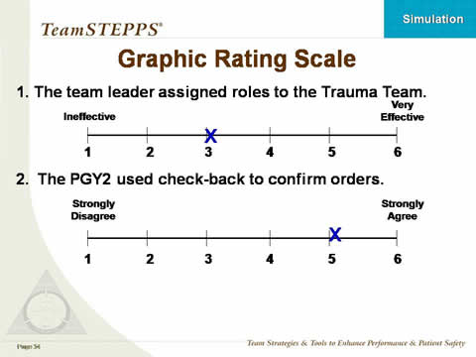
- ITEMIZED RATING SCALES

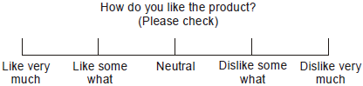
- TRADITIONAL ONE-STAGE FORMAT
- TWO-STAGE FORMAT
- RANK-ORDER SCALES
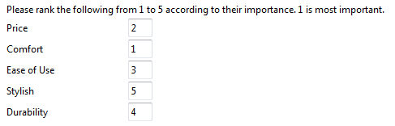
- PAIRED COMPARISONS
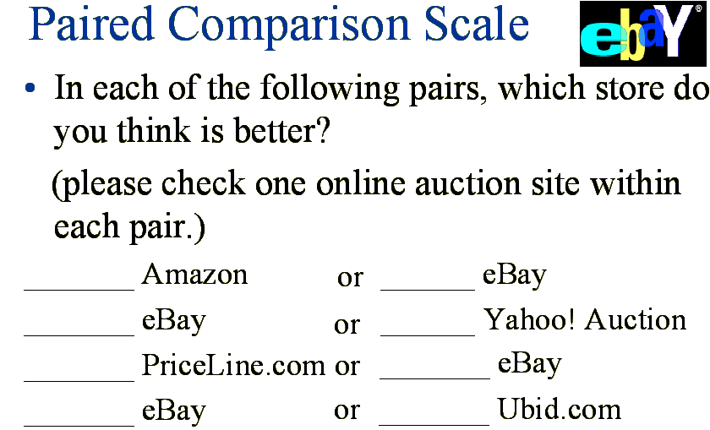
- CONSTANT SUM SCALES
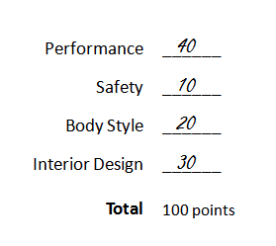

- SEMANTIC DIFFERENTIAL SCALES (RATING OF SERVICE OR I.E GLOBAL)
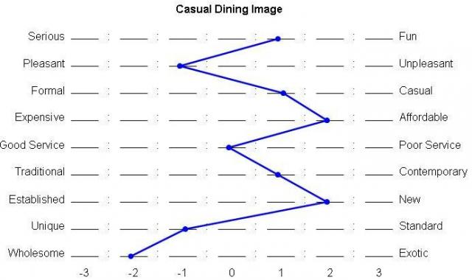
- STAPEL SCALES
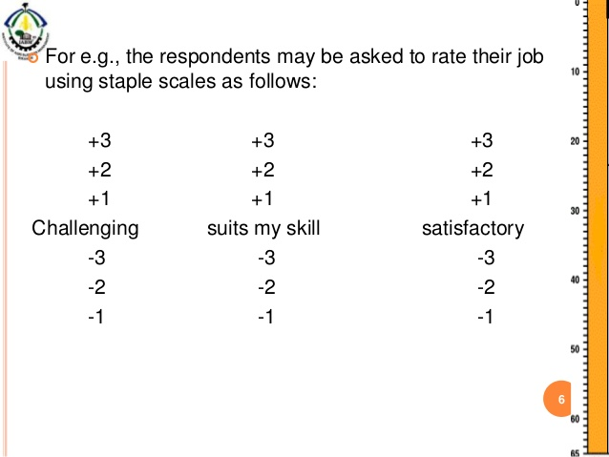

- LINKERT SCALES (NORMALLY SAYS AGREE)
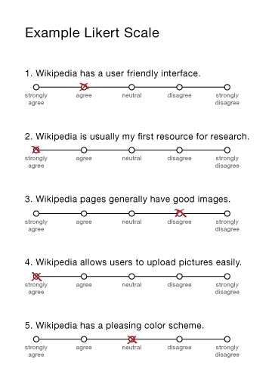
- PURCHASE INTENT SCALES
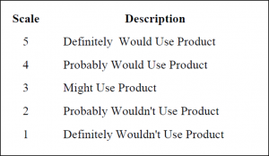
DIRECT VS. INDIRECT QUESTIONING

CHAPTER 12
DICHOTOMOUS: Closed ended questions that ask respondents to chose between two answers.

CHAPTER 13 BASIC SAMPLING ISSUES
Most widely used probability sampling method: SIMPLE RANDOM SAMPLING
CLUSTER SAMPLE: (Small geographic area)
PROBABILITY SAMPLING METHODS:
- SIMPLE RANDOM SAMPLING Purest.* Probablity=(sample size/ population size)
- SYSTEMATIC SAMPLINGEntire population is numbered.
Skip interval : (population/sample size)
- STRATEFIED SAMPLINGmore specific/ subsets
- CLUSTER SAMPLING small portion
NON PROBABITY SAMPLING METHODS
- CONVENIENCE
- JUDGMENT
- QUOTA Demographics/classifications
- SNOWBALL
CHAPTER 14
CENTRAL LIMIT THEOREM? The distribution of sample means approaches a normal distribution as sample size increases.
NORMAL DISTRUBUTION MEAN: ZERO
STANDARD DEVIATION: ONE
The standard error of the mean equals the: standard deviation divided by the square root of the sample size.
The probability of not making a Type II error is called statistical power
CI
CHAPTER 15 DATA ANALYSIS
PROCEDURE
- VALIDATION Process of ascertaining that interviews actually were conducted as specified. ( to make sure it was not made up)
- EDITING Make sure the questionnaires were filled our properly ( global example)
a) maker failed to ask or record questions. b)Record properly and not paraphrase an open ended answer.
- CODING Grouping and assigning numeric codes to the answers.
Automatic Coding Answers.
- DATA ENTRY better to do it automatic rather than manually. SCANNING: Better than scantron!
- LOGICAL CLEANING OF DATA
- TABULATION AND STATISTICAL ANALYSIS last check.

SIMPLEST FORM OF GRAPHS: LINE CHARTS
ONE-WAY FREQUENCY TABLE: Table showing the number of respondent choosing each answer to a survey question.
DESCRIPTIVE STATS: CHARTS

CHAPTER 16
CHAPTER 17
CHAPTER 18
MULTIPLE REGRESSION ANALYSIS: Procedure for predicting the level of magnitude of a (metric) dependent variable based on the levels of multiple independent variables.
GOAL: Examine the relationship between two or more metric predictors.
Fits a plan to observations in a multidimensional space.
APPLICATIONS OF REGRESSION ANALYSIS:
Estimation the effects of mark. Mix variables on sales.
Relationship between demographics and service businesses.
CONCLUSION: UNDERSTAND RELATIONSHIPS!

DUMMY VARIABLE: GROUP AS 0 OR 1

- VALITITY: EVERY KIND!
- RELIABILITY
- CHAPTER 8
- CHAPTER 8 AND 9!!!
- KNOW HOW TO CRITIQUE A QUESTIONNAIRE.
- 12, 11, 9
- DO EVERYTHING ON CONFIDENCE INTERVALS
- SAMPLING ERRORS, INCLUDING TYPE 1, TYPE 2
- SURVEY METHODS
- OBSCURE METHODS.
- STATISTICAL TESTS
- REGRESSION ANALYSIS
- INVERSE RELATIONSHIP VS DIVERSE
- FOCUS GROUP, DEPTH INTERVIEW: CHAPTER 5
- MORE FORMAL REVIEW
- PROBABILITY, NON PROBABILITY SAMPLING TYPES!
- Z MIDDLE LEFT

