MCV4U Grade 12 Calculus and Vectors

Assessment 3

Task 1: Knowledge and Understanding Questions
1. Find the first derivative of each of the following functions. (10 marks: 2 marks each)
a) f(x) = x⁴ − 3^{x} + e^{x} – 7
Solution
f$'$(x) = 4x³ – 3^{x} $∙$ln 3 + e^{x}

b) g(x) = 5 sin² x
Solution
g'(x) = 5(2sin x)(cos x) = 5sin 2x.
c) h(x) = e^{cos x}
Solution
h'(x) = e^{cos x} (cos x)' = e^{cos x} (– sin x) = – sin x$∙$ e^{cos x}
d) y = (2^{x} + 1)^{0.5}
Solution
y' = 0.5$∙$ (2^{x} + 1)^{-0.5} $∙$(2^{x} + 1)' = $\frac{0.5}{\sqrt{2^{x}+ 1}}$ $∙$ 2^{x}$∙$ ln 2 = $\frac{2^{x-1} ∙\ln{2}}{\sqrt{2^{x}+ 1}}$
e) f(x) = 4^{3x} + e^{2x}
Solution
y' = 4^{3x}$∙$ ln 4 $∙$ (3x)' + e^{2x} $∙$ (2x)' = 3ln4 $∙$4^{3x} + 2e^{2x}

2. Find the first derivative of each of the following functions. (9 marks: 3 marks each)
a) f(x) = sin ($e^{x^{2}+ 3x}$)
Solution
f$'$(x) = cos ($e^{x^{2}+ 3x}$)$∙$($e^{x^{2}+ 3x}$)$'$
= cos ($e^{x^{2}+ 3x}$)$∙$($e^{x^{2}+ 3x}$) (x² + 3x)$'$
= (2x + 3) ($e^{x^{2}+ 3x}$) cos ($e^{x^{2}+ 3x}$)

b) g(x) = $\frac{3x^{2}- 7}{e^{2x}}$
Solution
g'(x) =$\frac{{\left(3x^{2}- 7\right)}^{'}\left(e^{2x}\right)- (3x^{2}- 7){(e^{2x})}^{'}}{{(e^{2x})}^{2}}$
= $\frac{(6x)\left(e^{2x}\right)- (3x^{2}- 7)({2e}^{2x})}{{(e^{2x})}^{2}}$
= $\frac{\left(e^{2x}\right)(6x - 6x^{2}+ 14)}{{(e^{2x})}^{2}}$ = $\frac{ - 6x^{2}+ 6x + 14}{e^{2x}}$

c) h(x) = x²$e^{{3x}^{4}}$
Solution
h'(x) = (x²)$'$($e^{{3x}^{4}}$) + (x²)($e^{{3x}^{4}}$)$'$
= (2x) ($e^{{3x}^{4}}$) + (x²)($e^{{3x}^{4}}$) (3x⁴)$'$
= (2x)($e^{{3x}^{4}}$) + (x²)($e^{{3x}^{4}}$) (12x³)
= 2x (1 + 6x⁴) $e^{{3x}^{4}}$

3. Find the first and second derivatives of f(x) = $\frac{1}{x^{2} + 6}$. (6 marks)
Solution
f$'$(x) = – $\frac{1}{{\left(x^{2} + 6\right)}^{2}}$ $∙$(x² + 6)$'$ = – $\frac{2x}{{\left(x^{2} + 6\right)}^{2}}$,
f$''$(x) = – $\frac{{(2x)}^{'}{\left(x^{2} + 6\right)}^{2}- (2x){[{\left(x^{2} + 6\right)}^{2}]}^{'}}{{\left(x^{2} + 6\right)}^{4}}$
= – $\frac{2{\left(x^{2} + 6\right)}^{2}- \left(2x\right) ∙ 2\left(x^{2} + 6\right){(x^{2} + 6)}^{'}}{{\left(x^{2} + 6\right)}^{4}}$
= – $\frac{2{\left(x^{2} + 6\right)}^{2}- \left(4x\right) ∙ \left(x^{2} + 6\right)(2x)}{{\left(x^{2} + 6\right)}^{4}}$
= – $\frac{2{\left(x^{2} + 6\right)}^{2}- \left(8x^{2}\right) ∙ \left(x^{2} + 6\right)}{{\left(x^{2} + 6\right)}^{4}}$
= $\frac{ 2\left(x^{2} + 6\right)(4x^{2}-x^{2}- 6) }{{\left(x^{2} + 6\right)}^{4}}$
= $\frac{ 2(3x^{2}- 6) }{{\left(x^{2} + 6\right)}^{3}}$
= $\frac{ 6(x^{2}- 2) }{{\left(x^{2} + 6\right)}^{3}}$.

Task 2: Thinking Questions
4. Find the slope of the tangent at x = 0 for the function f(x) =$\frac{\cos{x}}{1 - x}$. (5 marks)
Solution
f$'$(x) =$\frac{{\left(\cos{x}\right)}^{'}\left(1 -x\right)- (\cos{x}){\left(1-x\right)}^{'}}{{\left(1 - x\right)}^{2}}$
= $\frac{(-\sin{x})\left(1 -x\right)- (\cos{x})(-1)}{{\left(1 - x\right)}^{2}}$
= $\frac{\left(x -1\right)\sin{x }+ \cos{x}}{{\left(1 - x\right)}^{2}}$
f$'$(0) =$\frac{\left(0 -1\right)\sin{0 }+ \cos{0}}{{\left(1 - 0\right)}^{2}}$ = $\frac{\left(-1\right)\left(0\right)+ 1}{1}$ = 1.
The slope of the tangent at x = 0 is 1.

5. Find the slope of the tangent to the function f(x) = $4^{x^{2}- 1}$ − x⁵ at the point (2, 32). Round your answer to two decimal places. (4 marks)
Solution
f$'$(x) = $4^{x^{2}- 1}$ $∙$ ln 4 $∙$ ${(x^{2}- 1)}^{'}$ – 5x⁴ = (2x ln 4) $∙$ $4^{x^{2}- 1}$ – 5x⁴,
f$'$(2) = (4 ln 4) $∙$ $4^{2^{2}- 1}$ – 5(2)⁴ = 256 ln 4 – 80 $≈$ 274.89.
m = f$'$(2)$≈$ 274.89.
The slope of the tangent is 274.89.

6. If f(x) = $e^{x^{2}}$, find f ′′(−2). Round your answer to two decimal places. (7 marks)
Solution
f$'$(x) = $e^{x^{2}}$ $∙$ ${\left(x^{2}\right)}^{'}$ = 2x$e^{x^{2}}$
f$''$(x) = 2 $∙$ [${\left(x\right)}^{'}∙e^{x^{2}}+x{∙\left(e^{x^{2}}\right)}^{'}$]
= 2 $∙$ [$e^{x^{2}}$ + ${x ∙e}^{x^{2}}∙$ (x²)$'$]
= 2 $∙$ ($2x^{2}e^{x^{2}}$+${ e}^{x^{2}}$)
= 2 $e^{x^{2}}∙$ ($2x^{2}$+ 1).
f$''$(−2) = 2 $∙$ e⁴ $∙$ ($2∙4$+ 1)
= 18 e⁴ $≈$ 982.76.

7. Find the equation of the tangent to the function f(x) = (x³ − 2x) sin x at x = 1. Round all decimal answers to two decimal places. (9 marks)
Solution
f (1) = − sin 1$≈$ − 0.84
f$'$(x) = (x³ − 2x)$'$ sin x + (x³ − 2x) (sin x)$'$
= (3x² − 2) sin x + (x³ − 2x) cos x
f$'$(1) = sin 1 – cos 1$≈$ 0.30 $∴$ m = 0.30
Equation of the tangent line:
y = m(x – x₁) + y₁
y = 0.30(x – 1) − 0.84
y = 0.30x − 1.14

Task 3: Communication Questions
8. Briefly explain why the base of an exponential function y = a^{x} does not equal to 1: a $≠$ 1 (4 marks)
Solution
By the definition of the exponential function, its base satisfies the following inequalities: a > 0, a $≠$ 1. If a = 1, then a^{x} = a¹ = 1 and the function is a constant function y = 1.

9. Explain the difference between a periodic and a sinusoidal function. (5 marks)
Solution
f(x) is called a periodic function if there exists a positive real number P such that f(x $±$ P) = f(x) for all x $∈$ D_{f}. Every sinusoidal function y = a sin [k(x – d)] + c (or y = a cos [k(x – d)] + c) is a periodic function with a period of P = $\frac{2π}{k}$, but not every periodic function is a sinusoidal function.
A periodic function which not a sinusoidal function:
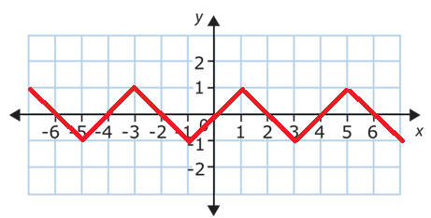
10. Define the word “concavity,” and describe how you would find the intervals of concavity on a graph, given the equation of a function. (8 marks)
Solution
A differentiable function y = f(x) defined on the interval (a, b) is concaved upward on this interval if for any c$∈$ (a, b) the graph of y = f(x) lies above its tangent line at the point (c, f(c)).
A differentiable function y = f(x) defined on the interval (a, b) is concaved downward on this interval if for any c$∈$ (a, b) the graph of y = f(x) lies below its tangent line at the point (c, f(c)).
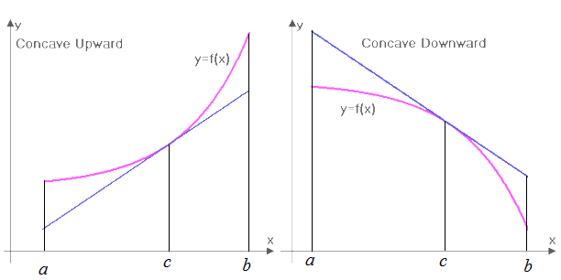
If a continuous function y = f(x) defined on a line segment [a, b] is concaved upward on the interval (a, b) then its graph lies below the secant tine joining the points (a, f(a)) and (b, f(b)).
If a continuous function y = f(x) defined on a line segment [a, b] is concaved downward on the interval (a, b) then its graph lies above the secant tine joining the points (a, f(a)) and (b, f(b)).
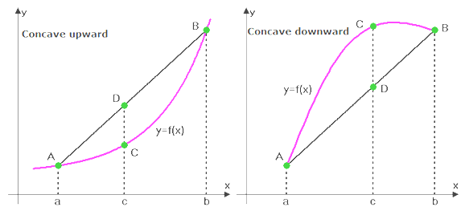
If a function y = f(x) is concaved upward on the interval (a, b) then slopes of its tangent lines increase on (a, b).
If a function y = f(x) is concaved downward on the interval (a, b) then slopes of its tangent lines decrease on (a, b).
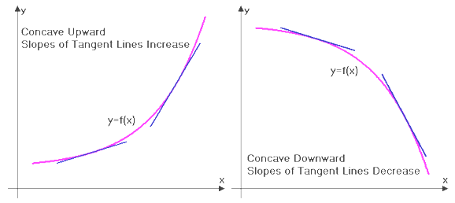
To determine the intervals of concavity on a graph of y = f(x) find the second derivative of f(x). The intervals where f$''$(x) > 0 would be the intervals where y = f(x) is concave upward, and the intervals where f$''$(x) < 0 would be the intervals where y = f(x) is concave downward.
11. Define the following mathematical terms. (8 marks: 2 marks each)
a. Euler’s number
Answer
The Euler’s number is the limit of the sequence t_{n} = ${\left(1+ \frac{1}{n}\right)}^{n}$ :
e = $\lim_{n→∞}{\left(1+ \frac{1}{n}\right)}^{n}$ $≈$ 2.718.
The number e was first studied by the Swiss, German and Russian mathematician Leonhard Euler in the 1720s. The Euler’s number could be defined as a base of the exponential function f(x) = a^{x} such that f$'$(0) = 1.

b. second derivative
Answer
The derivative of the function y = f$'$(x) is called the second derivative of the function y = f (x).

c. natural logarithm
Answer
A logarithm which base is the Euler’s number e is called a natural logarithm. Notation: ln x.

d. exponential growth
Answer
A growth which could be modeled by the exponential function y = ab^{x}, where b > 1, is called an exponential growth.

Task 4: Application questions
12. The following is a graph of f(x).
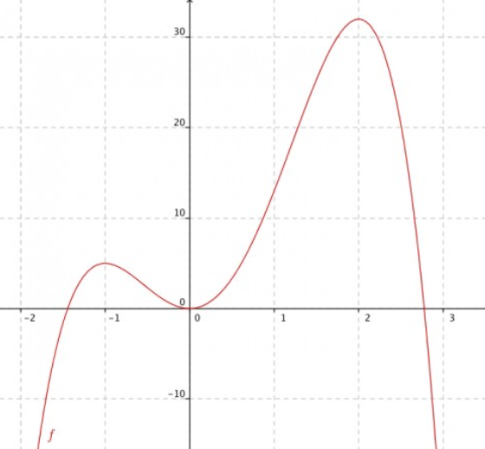
a. State the degree of f ′(x). (1 mark)
Answer
deg f(x) = 4, since f(x) has 2 max points, 1 min point, and
$\lim_{x→+∞}$ f(x) = $\lim_{x→-∞}$ f(x) = – $∞$.
Therefore, deg f ′(x) = deg f(x) – 1 = 3.
Note: f(x) = –3x⁴ + 4x³ + 12x², f ′(x) = – 12x(x + 1)(x – 2).
b. State the x -intercepts of f ′(x). (3 marks)
Answer
The x -intercepts of f ′(x) are the extrema points of f(x). Therefore, the x -intercepts of f ′(x) are –1, 0, 2.

c. Where will the graph of f ′(x) be positive? Where will it be negative? (2 marks)
Answer
The graph of f ′(x) will be positive where the graph of f(x) is increasing: (–$∞$, –1) and (0, 2)
The graph of f ′(x) will be negative where the graph of f(x) is decreasing: (–$1$, 0) and (2, +$∞$).

d. Draw a sketch of f ′(x). (2 marks)
Answer
f ′(x) = – 12x(x + 1)(x – 2)

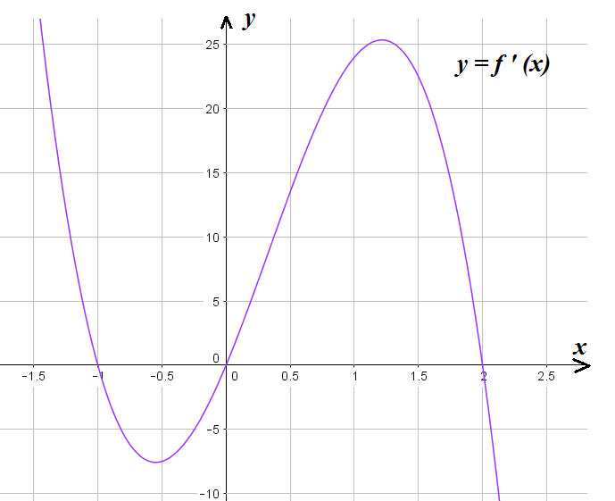

13. The following is a graph of f ′(x)
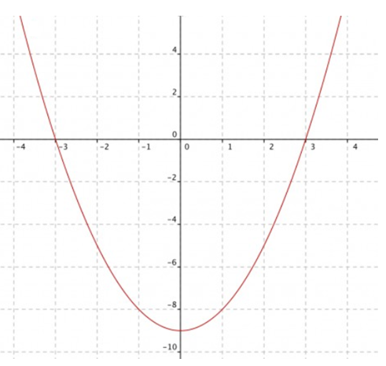
a. State the degree of f(x). (1 mark)
Answer
deg f ′(x) = 2 ⟹ deg f (x) = deg f ′(x) + 1= 3.
b. For what x -values do the maximum and minimum points occur on the graph of f(x)? (2 marks)
Answer
At x = – 3 f ′(x) changes sign from “+” to “–” ⟹ x = – 3 is a maximum point.
At x = 3 f ′(x) changes sign from “–” to “+” ⟹ x = 3 is a minimum point.

c. What are the intervals of increasing and decreasing on the graph of f(x)? (2 marks)
Answer
f ′(x) > 0 when x$∈$ (–$∞$,–3) $∪$ (3, +$∞$) ⟹ f(x) is increasing on the intervals (–$∞$,–3) and (3, +$∞$).
f ′(x) < 0 when x$∈$ (–3, 3) ⟹ f(x) is decreasing on the interval (–3, 3).

d. What is the x -value of the inflection point on f(x)? (1 mark)
Answer x = 0, since at this point the second derivative changes sign from “–” to “+”,

e. Sketch a possible graph of f(x). (2 marks)
Answer
f ′(x) = x² – 9 ⟹ f (x) = $\frac{1}{3}$ x³ – 9x
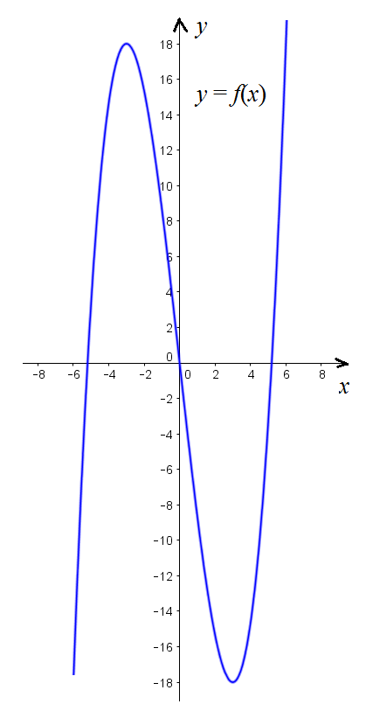
f. Sketch the graph of f ′′(x). (4 marks)
Answer
f ′(x) = x² – 9 ⟹ f ′′(x) = 2x.
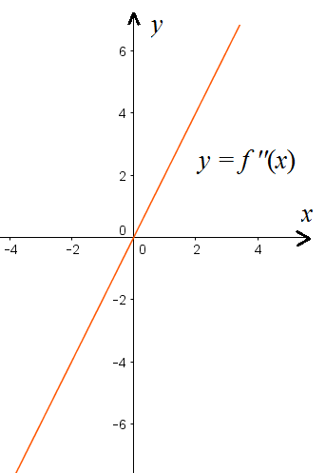

14. The following is a graph of f(x). (5 marks: 1 mark each)
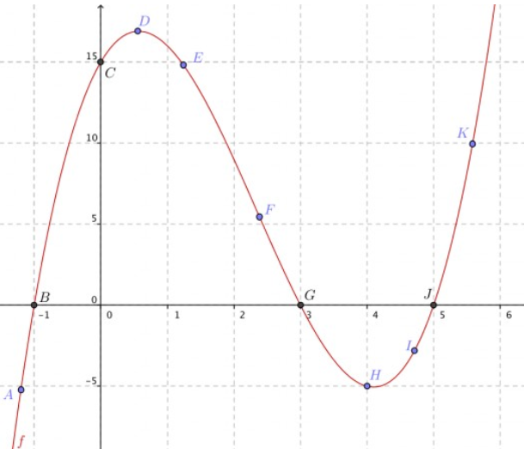
At which point on the graph is
a. f(x) positive, f ′(x) positive, and f ′′(x) negative?
Answer C

b. f(x) positive, f ′(x) negative, and f ′′(x) negative?
Answer E

c. f(x) zero, f ′(x) positive, and f ′′(x) positive?
Answer J

d. f(x) positive, f ′(x) zero, and f ′′(x) negative?
Answer D

f. f(x) zero, f ′(x) positive, and f ′′(x) negative?
Answer B

Notes on ILC teacher’s solution
1. Question 1b: The answer is not in simplest form. Should be 5 sin 2x.
2. Question 1d: The answer is not in simplest form. Should be $\frac{2^{x-1} ∙\ln{2}}{\sqrt{2^{x}+ 1}}$.
3. Question 8. Bad knowledge of English: the question should be stated as follows.
Briefly explain why the base of an exponential function y = a^{x} does not equal to 1: a $≠$ 1 (4 marks).
The answer is not completely correct: a $≠$ 1 BY THE DEFINITION of the exponential function.
4. Question 11 a: The definition of e is not given.
5. Question 13: the graph of f ′(x) is signed as f (x).
6. The graph of f(x) =$\frac{1}{3}$ x³ – 9x is incorrect.
Overall mark for teacher’s solution: 90%.

