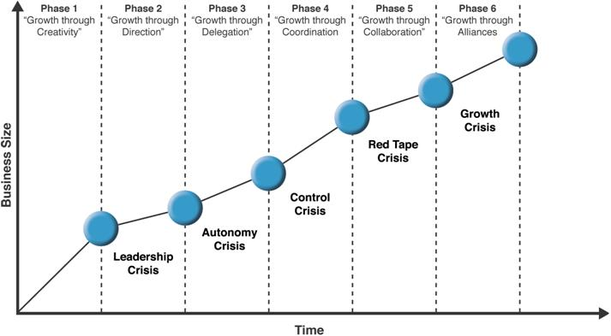
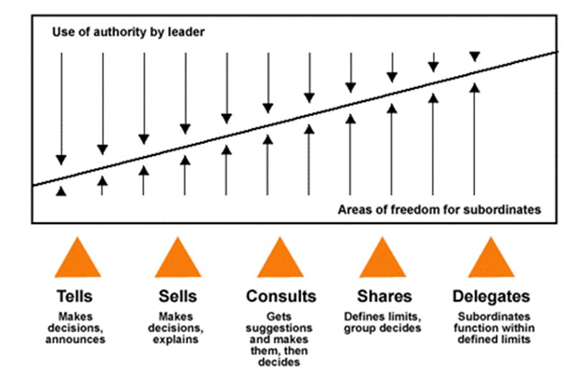
Tannenbaum & Schmidt
Continuum leadership model shows the relationship between the level of freedom that a manager chooses to give to a team and the level of authority used by the manager.
Team’s freedom ↑ manager’s authority ↓
3 forces that impact the choice of managerial style
1. Forces in the manager: (a) Their value system (how they feel about individuals making decisions). (b) Their confidence in subordinates (can they be trusted?). (c) Their leadership indicators (how they feel about giving orders). (d) Their feelings of security in an uncertain situation.
2. Forces in the subordinate: (a) High need for independence. (b) Readiness to assume responsibility to decision making. (c) Likes receiving orders VS likes more freedom. (d) Importance they put via company problems (their interest). (e) Have necessary knowledge and experience to deal with problems. (f) Expectations in decision making.
3. Forces in the situation: (a) Types of organization (values & traditions). (b) Group effectiveness. (c) The problem itself (determine how much authority to give). (d) Pressure of time. (e) Long-run strategy (shift thinking from tactics to large-scale strategy). (f) Objectives to be attained.

Secondary claim:
- Organizations should not try to skip phases.
- Top managers whose style in no longer appropriate should remove themselves.
- Growth is not inevitable.
Solutions to crises:
1. Find strong manager with knowledge & skill to lead.
2. Work
3. Special coordination
4. Collaboration
5. ?
CONTINUUM LEVELS
Major Claim:
Successful firms capitalize on economies of scale and scope; they have a functional management structure and invest in research and development and grow from related diversification. This will allow them to stay ahead of competition.

Economies of scale: doing things at a bigger scale reduces costs.
Economies of scope: use the same raw materials to produce various products.
Managerial enterprise: Making necessary investments in management, production and distribution in order to capitalize in economies of scale and scope.
Research and development: New technologies, improving quality (innovation)
Management hierarchy: separation of upper and lower level management.
Chandler
Greiner
Major Claim:
Organizational growth is done in 5 phases and by implementing the right strategies and managerial structures, they can resolve the crisis and move on.
* Each phase begins with a period of evolution and has its moments of stability and growth but eventually ends with a revolutionary period.
* Management practices that work well in one phase can bring crisis and chaos in another.

Vision: provides guidance about what core to preserve and what Future to simulate progress toward.
Collin & Porras

Core ideology
Discovering Core Ideology:

(You do not set it, you discover it)

Needs to be authentic. Its role is to guide and inspire.
Needs to be meaningful and inspirational only to people inside the organization because they need to commit to the ideology over the long term.

* A clear and well-articulated ideology attracts people whose personal values are compatible with the company’s core values.

Core values & core purpose: attract & retain those people.

Core ideology ≠ core competence
Enduring character of an organization and is the source of guidance and inspiration. It is the glue that holds the organization together as it grows, diversifies, and expands globally. It is the consistent identity of the organization that transcends the product or market life cycles.

Core values:
Beliefs about what is important. Small set of timeless guiding principles. Company should not change core values in response to market change.

Core purpose: (reason for existing)
The organization’s reason for being people’s idealistic motivations for working at the company. Not a goal or business strategy.
Core purpose is to guide and inspire.

Envisioned future:
1. BHAG (big hairy audacious goal).
2. Vivid Description (what it will be like to achieve goal).
BHAG: Engages people- it reaches out and grabs them. It is tangible, energizing, highly focussed.
Vision level BHAG:
- Applies to the entire organization and requires 10- 30 years to complete
- Setting the BHAG that far into the future requires thinking beyonf the current capabilities of the organization and the current environment.
BHAG should not be a sure bet, 50-70% success rate. Organization must believe that it can reach the goal.

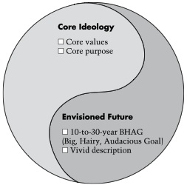
Vivid description
Vibrant, engaging, and specific description of what it will be like to achieve BHAG. Must translate the vision from words to image that people can carry around in their heads. Passion, emotion, and conviction are essential parts of the vivid description.

Zaleznik
Main claim:
Managers embrace process, seek stability and control, and instinctively try to resolve problems quickly- sometimes before they truly understand the problems significance. Leaders, in contrast, tolerate chaos and lack of structure and are willing to delay closure in order to understand the issue more fully.
Business leaders have much more in common with artists, scientists, and other creative thinkers than they do with managers.

Organizations require both managers & leaders in order to succeed; but developing both requires a reduced focus on logic and strategic exercise in favor of an environment where creativity and imagination are permitted.

Leaders
Managers
Attitude towards goals:
- Take a personal, active outlook.
- Shape rather than respond to ideas.
- Change how people think about what’s desirable and possible.
- Set company direction.

Conceptions of work:
- Develop fresh approaches to problems. Increase options, turn ideas into exciting images. See risk when opportunities seem promising.

Relations with others:
- Attracted to ideas.
- Related to others directly and intuitively.
- Focus on substance of event and decisions, including their meaning for participants.
- Subordinates describe them with emotionally rich adjectives. Yet motivation intensifies, and unanticipated outcomes occur.

Sense of self:
- Comes from struggles to profoundly other human and economic relationships.
- Feel separate from the organization

Attitude towards goals:
- Takes an impersonal, passive outlook. Goals arise out of necessities not desires.

Conceptions of work:
- Negotiate and coerce.
- Balance opposing views.
- Design compromises, limit choices.
- Avoid risk.

Relations with others:
- Prefer working with people, but maintain minimal emotional involvement.
- Lack empathy.
- Focus on process, how decisions are made rather than what decisions to make.
- Communicate by sending ambiguous signals, subordinates perceive them as detached & manipulative.
- Organization accumulates bureaucracy and political intrigue.

Sense of self:
- Comes from perpetuation and strengthening existing institutions
- Feel part of the organization

Henry Mintzberg
The Nature of Managerial Work (6 characteristics)
1. The manager’s job is a mixture of regular programmed jobs and unprogrammed jobs/tasks.
2. A manager is both a generalist and a specialist.
3. Managers rely on information from all sources but show a preference for that which is orally transmitted.
4. Managerial work is made up of activities that are characterized by brevity, variety, fragmentation.
5. Management work is more an art than a science and is reliant on intuitive processes and a feel for what is right.
6. Management work is becoming more complex.

Talks about the importance of the manager’s role and the need to understand its property and thoroughly before attempting to train and develop more managers.

3 categories of manager roles/expectations

1. Informational: managing by information
a) Figurehead: head of an organization, and must perform some ceremonial duties. Role may sometimes be routine, involving little serious communication.
b) Leader: Establish the atmosphere and motivate the subordinates. Are responsible for the work of its people
c) Liason: developing and maintaining webs of contacts outside the organization.

3. Decisional: managing through action
a) Entrepreneur: seeks to improve organization and to adapt it to changing conditions in the environment.
b) Disturbance: deals with disputes or problems and takes corrective action.
c) Negotiator: negotiates with individuals and dealing with other organizations. Defends business interests.
2. Interpersonal: managing through people
a) Monitor: collecting all types of info that is relevant and useful to the organization.
b) Dissemination: transmit some privileged information directly to subordinates, who would otherwise have no access to it.
c) Spokesperson: transmit info from within the organization to outsiders.

Becoming a more effective manager:

- Be aware of the roles you prefer. Stretch beyond those you’re most comfortable with, depending on what the situation demands.
- Reduce workload by giving subordinates the information they need to be more self-sufficient.
- Avoid superficial decision making by taking advantage of expert analysts.
- Force yourself to do things you believe are important.

Theory that identifies 5 bases or sources of social organizational power.

French & Raven

5. Expert power: is the ability to influence others based solely on one’s in-depth knowledges, superior skills and experience.

4. Referent power: is the influence one has on others from being well liked or respected by others.
3. Legitimate power: is based on the perception that people have the formal right to make demands, and to expect compliance and obedience from others.

1. Reward power: is the ability to compensate another for their compliance and work.

2. Coercive power: is the understanding that one has the ability to punish other for not complying.

Jay Barney
A frim will have a sustained competitive advantage if its resources and capabilities are valuable, rare, inimitable, and organized in a way that allows to exploit potential opportunities.
A firm will be successful if it has resources with the right attributes and characteristics.

* A firm’s resources and capabilities include all of the financial, physical, human and organizational assets used by a firm to develop, manufacture, and deliver products or services to its customers.
- Financial: debt, equity, retained earnings
- Physical: machines, manufacturing facilities.
- Human; experience, knowledge, judgement, wisdom.
- Organizational: history, relationships, trust, culture, formal reporting structure, patents.

A complete understanding of sources of competitive advantage requires the analysis of a firm’s internal strengths and weaknesses as well.

4. The Question of Organization: Is a firm organized to exploit the full competitive potential of its resources and capabilities?

c. The importance of socially complex resources: The resources and capabilities that are based on a company’s culture or interpersonal relationships (reputation, trust, friendship, teamwork, and culture) (patents are much harder to imitate).

a. Historical conditions: Valuable and rare resources acquired of developed through unique historical circumstances can be costly to imitate and thus a source of sustained competitive advantage.

b. The importance of numerous small decisions: A firm’s competitive advantage seems to depend on numerous “small decisions” through which a firm’s resources and capabilities are developed and exploited in developing, nurturing and exploiting resources.

3. The Question of Imitability: Do firms without a resource or capability face a cost disadvantage in obtaining it compared to firms that already possess it?
There are 3 reasons why resources can be hard to imitate:

2. The Question of Rareness: How many competing firms already possess these valuable resources and capabilities?

1. The Question of Value: Does a firm’s resources and capabilities enable it to exploit an opportunity, and/or neutralize it?
Four Important questions about resources and capabilities
Kaplan and Norton
The balanced scorecard is a strategic planning and management system that is used extensively in business to align business activities to the vision and strategy of the organization, and monitor organization performance against strategic goals.

4 perspectives for a balanced scorecard

1. The Financial Perspective:
Timely and accurate funding data will always be a priority, they must ensure profitability for the shareholders. These measures indicate whether or not the company’s strategy, implementation, and execution are contributing to the bottom line.

4. The custom perspective:
The importance of customer focus and customer satisfaction in any business. If customers are not satisfied, they will eventually find other suppliers that will meet their needs.

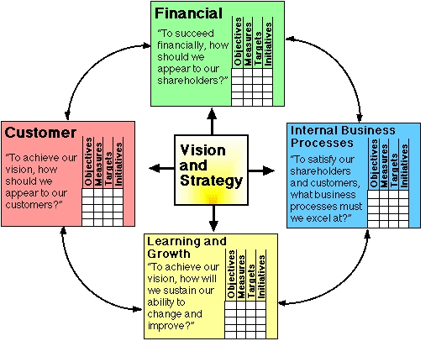
2. The internal business perspective:
Refers to the internal business process. Metrics based in this perspective is running, and whether its products and services conform to customer requirements. Metrics must develop and be designed by people within the company that knows these processes well.

3. Innovation & learning perspective:
Refers to the importance of individual and corporate self-improvement. In a knowledge-worker organization, people are the main resource, and with the rapid technological change, it is necessary for these knowledge-workers to be in a continuous learning mode. Certain metrics can be put into place to help guide managers in allocation resources where they can help most.
Learning and growth are the essential foundation to success of any knowledge-worker organization.

Sigmoid curve:
The secret to constant growth is to start a new sigmoid curve before the first one begins to diminish. When a company is left at a point B, new people will be able to lift the organization to the second curve.

The second curve: (proceed by guess and assumption)
The discipline of the second curve requires that you always assume that you are near the peak of the first curve, at point A, and should therefore be starting to prepare for second curve.
If assumption turns out to be wrong, nothing has been lost. Only the exploration phase of the second curve has been done. No major commitments will have been done until curve 2 overtakes curve 1, which won’t happen if curve 1 is on the rise.
* Keeping the 2 curves going will become a habit.
* While making second curve, it is common to challenge the assumption understanding the first curve.
The discipline of the second curve keeps one skeptical, curious, and inventive- attitudes that are essential in a time of change.

The second curve follows the traditional four-stage cycle of discovery:
- Questions start it off! Ideas, possibilities, hypotheses.
In the second curve it is important to not re-invent the same life because that would perpetuate the first curve. Let go of the past. The second curve is always different, although it builds on and grows out of the first curve.

Handy and the Sigmoid curve

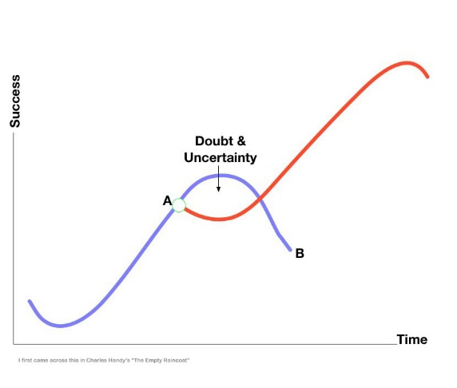
* Entrust the Curvilinear thinking to the next generation. Can see more clearly where the first curve is heading and what the next curve might look like.
The elders of the organization must allow change, give permission to be different, and then when the next curve is established, they must get out of the way. For that to happen there must me a curve for them, outside.

What got you where you are won’t keep you where you are.
Curvilinear logic.
Paradox of success
By the time you know where you need to go, it is already too late.
Curvilinear logic: means starting life over again, something that gets harder the older you get.
Paradox of time
2-factor theory:
1. Hygiene factors: Needed to ensure an employee does not become dissatisfied. They do not lead motivation, but without them, there is possibilities of dissatisfaction.
Ex. Working conditions, qulity of supervision, status, security, salary, company policies, interpersonal relations.

2. Motivation factors:
Needed to motivate an employee into higher performance motivators are the primary source of satisfaction.
Ex. Achievement, responsibility, growth, advancement for higher level task, interest in job, recognition for achievement.

Hertzberg

Combining hygiene & motivation factors
1. High hygiene & high motivation: Ideal situation where employees are highly motivated and have few complaints.
2. Hygiene & low motivation: Employees have few complains but are not motivated. Job seen as paycheck.
3. Low-hygiene: Employees are motivated but have lots of complaints. A situation where job is exciting and challenging but salaries and work conditions are poor.
4. Low-hygiene & low motivation: Unmotivated employees with lots of complaints.

Job enlargement
Job Loading

Job rotation
Horizontal job loading:
- Adding tasks to a job but not responsibilities.
- The meaning of the job is simply increased.

Vertical job loading:
- Adding meaningful tasks that will lead to growth.
- Additional tasks that permit growth and provide motivating factors.

Planned rotation of staff between jobs to alleviate monotony (lack of interest and variety) and provide a fresh job challenge. Hertzberg says it is likely to improve job satisfaction but unlikely to create positive motivation.

Horizontal job enlargement: Widening the range of jobs at the same level in the organization and adding them to the existing job. Hertzberg says there is little motivation value in this approach.

Vertical job enlargement (Job enrichment): Provides employees with more task to do as a part of the job and gives them the responsibility and authority needed to complete the task.
- Gives people responsibility for the complete process of the task.
- Make information directly available to employees rather than send it through their managers.
- Enable people to take on new, more difficult tasks they haven’t before.
Employees gain an enhanced sense of responsibility and achievement, along with new opportunities to learn and grow.

