PAP2300 Midterm 1 Study Guide
What is public administration?
- Field of study
- Interested in “the managerial practices and institutional values by which officials will enact the will of sovereign authority”
- Set of administrative practices
- Towards providing services through the public service.
Politics is about POWER
- The authoritative allocation of values
- WHO gets what, where, when, how
Classical Theorists
Marx
- Capitalist society is marked by class conflict
- The state (of which the bureaucracy is a key part) is “relatively autonomous” from the capitalist class, but the state ultimately serves capitalist class interest in long-term
- Both society and bureaucracy struggle from hierarchical nature of bureaucracy
- Class struggle → Revolution → State withers away
Neo-Marxists
- Capitalist state functions to:
- State passes policies to make it possible for capitalist to make profits (Accumulation)
- State passes policies to appease working class without interfering with accumulation of profits (legitimation)
Ideal- Type Weberian Bureaucracy
**Reaction to spoils- system**
- Hierarchy
  - Each office has a clearly defined sphere of competence and answers to superior
- Continuity
  - Full time work
- Impersonality
  - Behavior based on pre-determined written rules
- Expertise
  - Personnel are selected on the basis of merit, written records, access to info
    - Efficiency

- Prior to Weberian, there was a lack of permanence and expertise → inefficient, immoral
Criticisms of Weberian Model
- Hierarchy can generate lack of initiative and individual responsibility
- Limited ability for individual to understand the value of their contributions in relation to the whole organization (just become cogs in a machine)
Political- Administration Dichotomy
Politics | ADM
Elected | Appointed
Objectives (what) | Means of realizing objectives (how)
Normative (values) | Empirical (quantifiable goals)

Comparing Public & Private Sectors
- Mandate + Goals
- Temporal: Time frames dictated by elections
- Temporal: Top-level public officials switch positions more than private
- Intangible goals vs. Private sector: e.g. financial performance
- Hiring process: Public has to be very fair/equitable/high standards
- Equity: Promoted by public whereas private promotes competitiveness
- Scrutiny: Public errors magnified, private less attention
- Provision of public goods: Not a private sector matter
- Accountability: Standards that don’t exist in private
- Efficiency: In private, leads to enhanced profits, not always true in public

- Efficiency + Service
  - Public motivations:
    - More department funding
    - Re-election
  - No competition in public sector gives rise to new definition of efficiency
Restructuring Public Sector
- Minimalist State
  - 1800-1930s
  - Role of state: National defense, infrastructure, business expansion
  - Little to no government intervention/ role in provision of social welfare services
- Keynesian Welfare State
  - 1930-1970s
  - Post-depression state left charities/the Church strained
  - More activist/interventionist state
  - Commitment to full employment and social safety net
- Neoconservative State
  - Privatization, contracting out services
Pluralism
- Recognition and affirmation of diversity within a political body, which permits the peaceful coexistence of different interests, convictions and lifestyles
- Economic equality to express democratic equality
Unitary States
- Majority of countries
- One unitary government
- Central government: controls regions
- Pluralism: Unitary State → Richer participation
Federal State
- 2 levels
  - Coordinate but are separate
Federalism
  - High input legitimacy
  - Radical outcomes difficult to achieve
  - Interest groups
    - Need more resources (CON)
    - Offers more possibilities (PRO)
      - Can take issues to municipal, provincial, and federal tiers
Asymmetric federalism
  - Example: Quebec having its own revenue agency & immigration department
Executive Federalism
  - Executives of different governments within federal government working together
  - Ex: Cooperation of Provinces: Intergovernmental first ministers conference
Decentralized Unitary
- Central government accepts to share certain powers
- Example: Devolution of UK
Mutual Partisan Adjustment
- Governments serve to check and balance each other
- Decisions reflect compromise
- Decisions are often incremental adjustments from status quo

Canadian System
- Parliamentary system of government
- Westminster (inherited British Model)
- Fusion of powers between legislative and executive
Whitehall Model
- Used by Westminster Political System countries (Parliament)
- Practice a separation between politics and administration (Bureaucracy)
**Citizens vote on legislative**
**Majority makes executive**
- PM appoints ministers → Ministers make up cabinet
- PM is a member/head of cabinet
Executive (cabinet) Legislative
- Decides - Passes
- Formed from HOC
- Responsible to the legislative branch
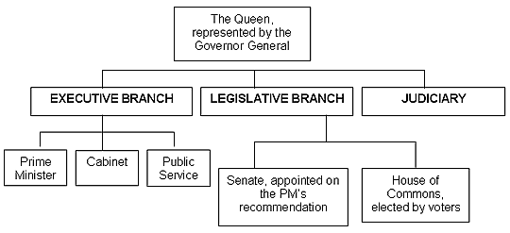
House of Commons Senate
- MPs voted to represent riding - Appointed by PM
- Serve until next election - Serve until the age of 75
Coalition Government
- Cabinet is from other parties, not just majority
Motion of Confidence
- Failing to have a majority of votes leads to the motion to dissolve the HOC
Political Culture
- Attitudes towards political symbol
- Attitudes towards others in political system
- Knowledge of political system, values of citizens
- Acquisition of political beliefs (generation to generation?)
Subjectively oriented
- Scientific Positivism
  - “I can understand the world as it is”
- Post-Positivism
  - “We can never remove ourselves completely, all interpretations are bias”
Democracy: The rule of the people (legal-rational)
- Direct Democracy
  - Entire population assemblies to vote/govern themselves
- Representative Democracy
  - Citizens elect persons to represent them/make decisions on their behalf
- Equality: Political Democracy
How Bureaucracy Complements Democracy
  - Accountability
  - Citizens have equal rights
  - One person, one vote
  - Impersonal relationship with state
- Equality: Economic Democracy
  - Ability to participate is limited by financial capacity

Legitimacy
Weber’s 3 Types
- Traditional
  - Inherited based - Monarchy
- Charismatic
  - Projection/perception of extraordinary personal qualities - Hitler
- Legal-rational
  - Rule of law dictates if authority is granted/can be exercised
  - **Canada’s government*

Systems Theory
Input → Blackbox → Output
Voting Economic growth, healthcare
Town hall meetings
Assemblies

Executive Branch
- Technically, first the crown, then PM & Cabinet
- Formed from House of Commons, head of government not elected
- Executive responsible to legislative branch:
- ** Motion of Confidence **
- Party discipline
  - Party members must vote as dictated by the party leader
Bureaucracy: Rules of the Office
- An organizational structure
- The professional institution carrying out the government’s policy decisions
  - Public ADM
    - Set of administrative practices towards providing services through public service
Advantages
- Efficient
- Accumulation of knowledge
- Accountable
- Universal treatment of citizens
Disadvantages
- Temporal Differences
  - Stability leads to bureaucracy forming its own identity/interests
  - Interest in increasing department budget
  - Trained incapacity: Lose sight of objective
- Asymmetry of Information
  - Bureaucracy knows a lot of information about certain topics whereas politicians may not know so much
Rule of the people vs Rule of the Desk
Bureaucracy Complements Democracy
- Ideal democracy
- Impersonality
Bureaucracy Problematic to Democracy
- Info asymmetry
- Bureaucracy develops own interests
- Red tape
  - Question legitimacy of input

Tensions
Bureaucracy | Democracy
Obedience | Participation
Written procedures | Will of the people
Dehumanizing | Empowering individuals

Politicization
Good or Bad? Corruption vs Governance
- Spoils system: Negative politicization diminishes power
- Lack of politicization creates autonomy and promotes people to be more honest
- Today: Positive influence, allows government to move in a direction they want
Formal Politicization
- Replacement of merit with political considerations in the appointment, nomination, and careers of civils servants
Functional Politicization
- Civil servants adopt a politically responsive behavior
- May exist because we have formal politicization
Administrative Politicization
- Partisan advisors interfere with civil servant work

Protection Against Politicization: Public Service Commission
- Only Deputy Minister exempt

Politicization as Corruption | Politicization as Governance
- Capture support of specific group  - Not merit based (cronyism)  - Particularistic/promotion of own interests  - Repayment of votes/ loyalty  - Not perceived as democratically legit | - Demonstrate governing competence  - Merit-based  - Universal public interest  - Perceived as democratically legit

Institutions
Departments (Ministries)
- Line departments: Vertical
  - Spending departments
  - Delivery of goods/services to citizens
  - Large staff + number of sub-units
- Central agencies: Horizontal
  - Support decision making of cabinet (executive)
  - Supple
  - Coordinate with line departments
Prime Minister: Political head of department
Deputy Minister: Administrative head of department
- HIGHEST civil service position
- Not elected
- ***Prime minister appoints***
- If the government changes, DMs do not lose their position
- Embraces:
  - Neutrality
  - Anonymity
  - Loyalty

Central Agencies
- Department of Finance
  - Sets annual budget
  - Macroeconomic policy
- Privy Council Office (PCO)
  - Cabinet’s secretariat
  - Head: Clerk of the Privy Council
- Prime Minister’s Office (PMO)
  - Staffed by partisan supports
  - PM’s personal staff
  - Partisan perspective of policy
- Treasury Board Secretariat
  - Administrative arm of treasury board
  - Only central agency with a statutory basis (grounded in legislation)
  - 1. Review of government expenditure budget
  - 2. General manager and employer of public service

Alternative Service Delivery (ASD)
Bodies created by:
- Restructuring already existing institutions
- Partnering with actors from other departments, other governments, or parties completely outside of government
Created to provide more responsive services to the people
- Held less accountable than typical department
- Help acquire more citizen participation
Crown Corporations
- Non-department bodies
- Enterprises that are 100% owned by the government
- Also known as government business enterprises (GBEs)
- E.g. Canada Post
- Accountable to government in some form
Exempt Staff
- Partisan advisors
- Do not have authority to give direction to public servants

Regulatory Agencies
- Ensure private sector conforms to laws and regulations
- Investigative powers
- Quasi-judicial powers
- e.g. National Energy Board

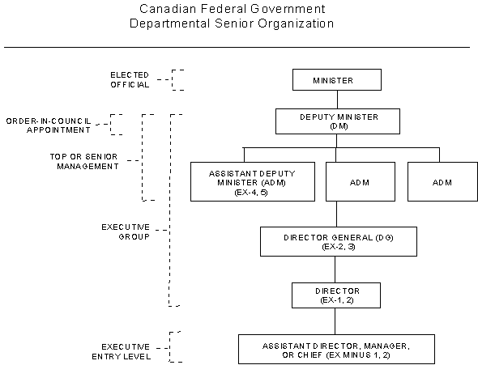
Bureaucratic neutrality
- Officials at work do not express a partisan opinion
- Officials work loyally regardless of party in power
- Work of officials are protected from political interference
- Careers based off merit
Street Level Civil Servants
- See/physically interact with the people
- Police officers, doctors, teachers
Organization
- Formal, deliberate kind of cooperation
Structuralist
- Individuals are motivated my money
- Individuals are replaceable
- Objective: Maximize output by sum of individuals
Scientific Management
  - Unit of Direction
    - Smaller activities should be grouped together in a single unit
    - e.g. Department by function
  - Job criteria: Less impersonal
Taylorism
  - Identify most efficient way to perform task – Time & motion studies
  - Division of labor controlled by hierarchy of authority driven by efficiency

POSDCORB – Luther Gulick
  - By subdividing all the tasks along these lines, efficiency could be maximized
Planning
Organizing
Staffing
Directing
Coordinating
O
Reporting
Budgeting

Humanist Theories
- Humans motivated by needs that go beyond economic incentives
- Maximizing efficiency meant paying attention to individual
Human Relations Approach
- Altruistic response to structuralism
- Sense of belonging, identity, norms + values of groups
- Not machines, but social beings

- Hawthorne experiments

  - Observer effect
    - Workers responding to presence of researchers, not changes in light
  - Informal group: Dominant factor in employee productivity
    - Social norms/values + manager’s ability to lead in modifying norms
    - On the job workers act as members of a group
    - Elton Mayor
- Maslow’s Hierarchy of Human Needs
- Physiological: Food, shelter, sleep
- Safety: Stability
- Love
- Esteem
- Self-Actualization
- Iron law of Oligarchy
  - All forms of organization will eventually and inevitably develop oligarchic tendencies, thus making true democracy practically and theoretically impossible
Critique of Human Relations Approach
- Individual workers are not a unitary actor but a single member
New Public Management (NPM) (aka Managerialism)
- Origins: Thatcher/Reagan
  - 1. Rising government debt
  - 2. Citizens discontent with governance/ bureaucrats had too much power
  - 3. ‘New Right’ – Political ideology – Market mechanisms favored
- Rational Choice
  - Individuals have ranked preferences which motivate them
  - Preferences are transitive
  - Individuals maximize utility
- **Efficiency, effectiveness, economy**
- Public Choice Theory: Apply microeconomic theories to non-market environments
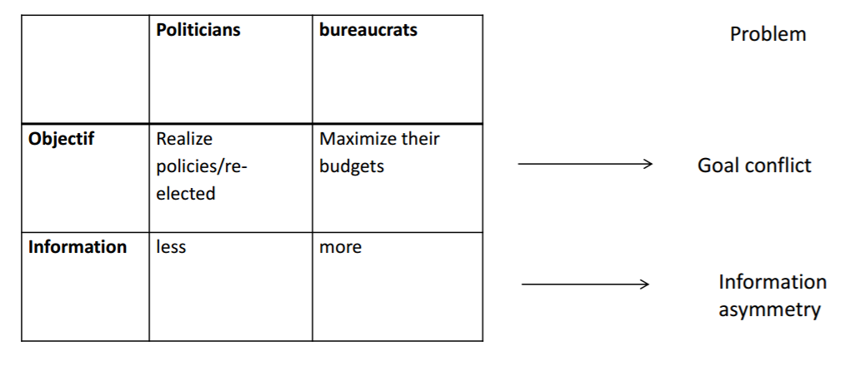
NPM Administrative reforms:
- Privatization
- Decentralization
- De-regulation
- Results based governance
NPM Expectations
- Governments should make policy decisions
- Administrators should be given greater autonomy to manage resources towards realizing policy objectives

Criticisms of NPM
- We are not customers of the government we are citizens
- Profit maximization is not the goal
- Accountability in private sector
- Difficulties measuring efficiency
- Led to corrupt behavior
- Harming neutrality and independence of civil
- Not as many people wanted to work for bureaucracy
Participatory Management (Mary Parker Follett)
Management by Objective (MBO)
  - Specialization and hierarchy are overemphasized
  - Too much subdivision leads to conflicting goals
Organization Development
  - Increasing organization effectiveness by through interpersonal communication
Total Quality Management
  - Quality control is a core part of what an organization does

