Macroeconomics 1022B Notes

Chapter 20: GDP

GDP (Gross Domestic Product) – Market value of all final goods and services produce in a country in a given time period

4 Parts:
- Market Value
- Final Goods & Services
- Produced Within a Country
- In a Given Time Period

Market Value
- GDP is a market value
- Goods/Services are valued at their market prices
- Ex. to add apples and oranges, add the market values to get the total value of output in dollars

Final Goods & Services
- GDP is the value of final goods/services
- Final Good/Service – item bought by final user during specified time period
- Intermediate Good/Service – item produced by one firm, bought by another firm, and used as a component of final good/service
- Exclude intermediate goods/services to avoid double counting

Produce Within a Country
- GDP measures production within a country – domestic production

In a Given Time Period
- GDP measures production during a specific time period, normally a Year or a Quarter
-
GDP and the Circular Flow of Expenditure and Income

- GDP measures the value of production, which also equals total expenditure on final goods and total income
- Equality of income and value of production shows the link between productivity and living standards
- This diagram below illustrates the equality of income and expenditure

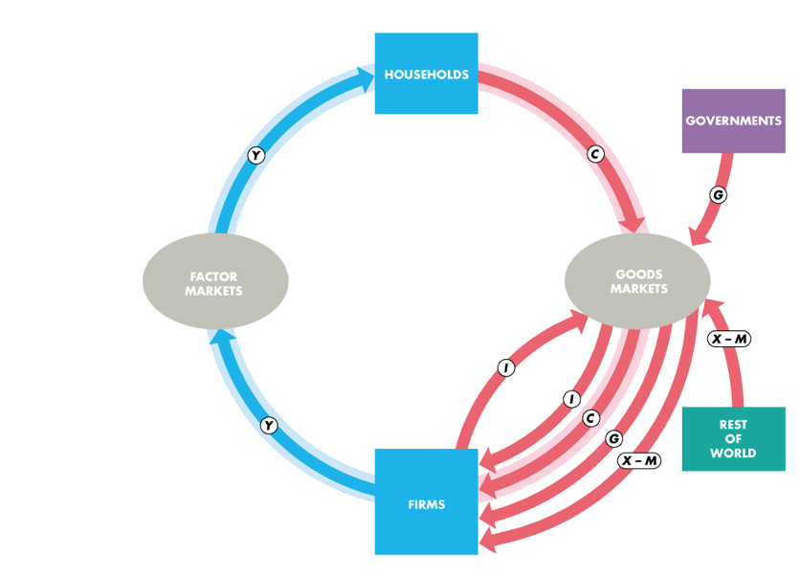

Y = C + I + G + (X – M)
- The blue and red flows are the circular flow of expenditure and income
- The sum of red flows = blue flows

Y = GDP
C + I + G + (X – M) = Total expenditure on final goods/services

Depreciation is the decrease in the value of a firm’s capital that results from wear and tear and obsolescence.

Gross investment is the total amount spent on purchases of new capital and on replacing depreciated capital.

Net investment is the increase in the value of the firm’s capital.
- Net investment = Gross investment − Depreciation.

Measuring GDP
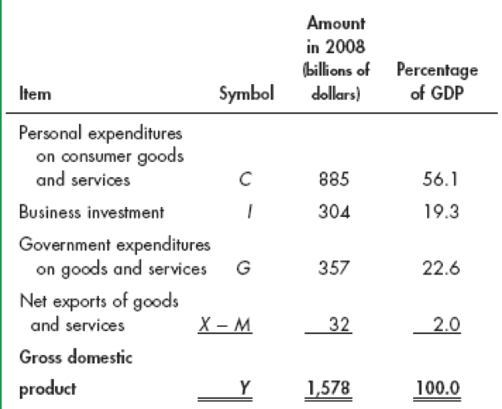
The Expenditure Approach
- Measures GDP as Y = C + I + G + (X – M)
- Y = GDP
- C = Consumption Expenditure
- I = Investments
- G = Government Expenditure on goods/services
- X – M = Net Exports

GDP = $885 + $304 + $357 + $32
GDP = $1,578 billion

The Income Approach
- Measures GDP by summing the incomes firms pay households for the factors of production they hire

Income 5 Categories:
- Wages, Salaries, and Supplementary Labour Income
- Corporate Profits
- Interest and Misc. Investment Income
- Farmers’ Income
- Income from Non-Farm Unincorporated Businesses
These 5 income components sum to net domestic income at factor cost

2 Adjustments to get GDP:
- Indirect taxes minus subsidies are added to get from factor cost to market prices
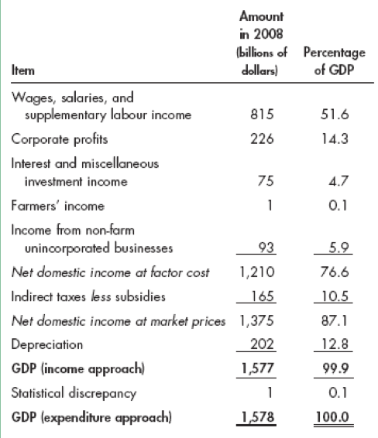
- Depreciation (or capital consumption) is added to get from net domestic product to gross domestic product

Nominal GDP and Real GDP
Real GDP (Includes inflation)
- Value of final goods produced in a given year when valued at the prices of a reference base year
- Reference Base Year: 2000
- Describe real GDP as measured in 2000 dollars

Nominal GDP
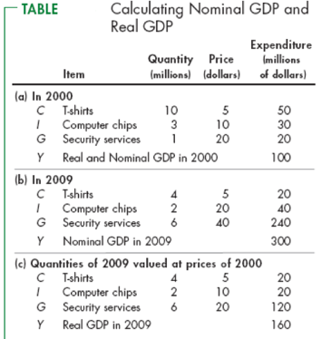
- Value of goods produced during a given year valued at the prices that prevailed in that same year
- Nominal GDP is GDP

Chapter 21: Employment and Unemployment
Why Unemployment is a Problem
Unemployment results in:
- Lost Incomes and Production
- Lost Human Capital

Labour Force Survey
Every month Statistics Canada conducts a survey which asks 54,000 households
The population is divided into 2 Groups:
- Working-Age Population – People 15+yrs not in institutional care
- People to Young to Work – Under 15yrs or in institutional care

Working-Age Population
2 Groups:
- People in labour force
- People not in labour force
Labour Force = Employed workers + Unemployed workers

Unemployment has 3 categories:
- Without work but has made specific efforts to find job within the previous 4 weeks
- Waiting to be called back to a job from which he/she has been laid off
- Waiting to start new job within 4 weeks

4 Labour Market Indicators
- Unemployment Rate
- Involuntary Part-Time Rate
- Labour Force Participation Rate
- Employment-To-Population Ratio

The Unemployment Rate
- Percentage of the labour force that is UNEMPLOYED
- Rate increases in recession and reaches peak after recession ends
- Unemployment Rate = (# people unemployed / labour force) x 100
Ex. 2010 Labour Force was 18.52 mil and 1.48 mil unemployed
(1.48 mil unemployed / 18.52 mil labour force) x 100
= 8%

The Involuntary Part-Time Rate
- Percentage of Labour Force who work part time but want full-time jobs
- Involuntary Part-Time Rate = (# involuntary part-time workers / labour force) x 100
Ex. 2010 labour force was 18.52 mil and involuntary part-time workers was 920,000
(920,000 / 18.52 mil) x 100
= 5%
The Labour Force Participation Rate
- Percentage of working-age pop. that are part of the Labour Force
- Labour Force Participation Rate = (Labour Force/ Working-Age Pop.) x 100
Ex. 2010 labour force was 18.52 mil and working-age pop. was 27.66 mil
(18.52 mil / 27.66 mil) x 100
= 67%

The Employment-To-Population Ratio
- Percentage of working-age pop. who have jobs
- Employment-to-Population Ratio = (Employment / Working-Age Pop.) x 100
Ex. 2010 employment was 17.04 mil and working-age pop. was 27.66 mil
(17.04 mil / 27.66 mil) x 100
= 61.6%

Other Definitions of Unemployment
- Unemployment Rate is to measure underutilization of labour resources
- Measure in imperfect because it excludes:
  - Marginally Attached Workers
  - Part-Time Workers Who Want Full-Time Jobs

Marginally Attached Workers
- Person who is neither working nor looking for work but has indicated that they want and is available for a job and has looked for work sometime recently
  - Discouraged Worker:
    - Marginally attached worker who stopped looking for a job due to repeated failure to find one

Part-Time Workers Who Want Full-Time Jobs
- Called economic part-time workers and are partly unemployed

Unemployment
Unemployment Classified into Three Types:
- Frictional
- Structural
- Cyclical

Frictional Unemployment
- Arises from normal labour market turnover
- # people enter/reenter labour force and increases in unemployment benefits raise frictional unemployment
- Permanent and Healthy of a growing economy

Structural Unemployment
- Created by changes in technology and foreign competition that change skills needed to perform jobs or the locations of jobs
- Lasts longer than frictional

Cyclical Unemployment
- Higher than normal at business cycle TROUGH
- Lower than normal at business cycle PEAK
- Worker laid off due to recession and rehired when expansion begins

“Natural” Unemployment
- Frictional and Structural Combined
- Natural Unemployment Rate = Natural as a percentage of labour force
- FULL EMPLOYMENT = (Unemployment Rate = Natural Rate)
- NO CYCLICAL EMPLOYMENT

Natural unemployment rate changes over time and is influenced by many factors such as:
- The age distribution of the population
- The scale of structural change
- The real wage rate
- Unemployment benefits

Real GDP and Unemployment Over the Cycle
Potential GDP – Quantity of Real GDP produced at full employment
Output Gap = Real GDP – Potential GDP

Price Level
- Average level of prices and the value of money
- Rising price level is Inflation
- Falling price level is Deflation
- Unpredictable inflation and deflation is a problem because it:
  - Redistributes income and wealth
  - Lowers real GDP and employment
  - Diverts resources from production
- Hyperinflation – inflation rate extremely rapid

Consumer Price Index (CPI)
- Measures average of the prices paid by urban consumers for a ‘fixed’ basket of consumer goods/services

Reading the CPI Numbers
- CPI is defined to equal 100 for the reference base period (2002)
- Average CPI of 12 months of 2002 equals 100
EX. July 2011 CPI = 120
This means that the average of the prices paid by urban consumers for a fixed basket of goods was 20% higher in July 2011 than it was during 2002

Constructing the CPI
Involves 3 stages:
- Selecting the CPI basket
- Conducting a monthly price survey
- Calculating CPI

The CPI Basket
- Based on consumer expenditure survey conducted by Statistics Canada
- CPI basket today is based on data from consumer expenditure survey of 2008
- Today’s CPI basket is based on data gathered in a 2009 survey

The Monthly Price Survey
- Every month, Statistics Canada employees check the prices of the 80,000 goods in the CPI basket in 30 metropolitan areas

Calculating CPI
- Find the cost of CPI basket at base-period prices
- Find the cost of CPI basket at current-period prices
- Calculate CPI for the current period
CPI = (Cost of Basket at current period prices / Cost of Basket at base-period prices) x 100
CPI = ($70 / $50) x 100
CPI = 140
Therefore, CPI is 40 percent higher in the current period than it was in the base period

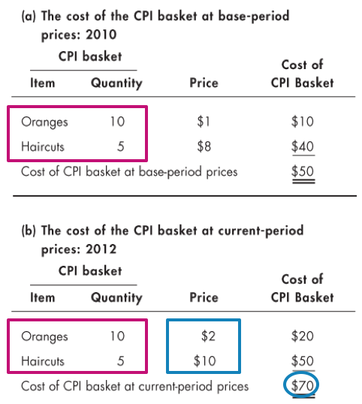

Measuring Inflation Rate
Inflation Rate – Percentage change in the price level from one year to the next
Inflation Rate = [(CPI this year - CPI last year) / CPI last year)] x 100

The Biased CPI
The CPI might overstate the true inflation for four reasons:
- New goods bias
- Quality change bias
- Commodity substitution bias
- Outlet substitution bias

New Goods Bias
- New goods not available in base year appear
- If they are more expensive than the goods they replace, they put an upward bias into CPI

Quality Change Bias
- Quality improves every year
- Part of rise in price is due to improved quality not inflation
- CPI counts all the price rise as inflation

Commodity Substitution Bias
- Market basket of goods is fixed, doesn’t account consumers’ substitutions away from goods whose relative prices increase

Outlet Substitution Bias
- People switch to buying from cheaper sources
- CPI does not take account of this outlet substitution

Magnitude of Bias
- Estimates say CPI overstates inflation by 1.1% per year
- 1.1% is small but over a decade adds up to $1 trillion of additional expenditure
- Consequences of Bias:
  - Distorts Private Contract
  - Increases government outlays (close to a third of federal government outlays are linked to the CPI)

Alternative Price Indexes
GDP Deflator
GDP Deflator = (Nominal GDP / Real GDP) x 100
- Broader method than CPI to measure price level because it includes all C, I, G, (X – M)
- But, for a cost of living GDP deflator is too broad

Chained Price Index for Consumption (CPIC)
- Index of the prices of all the items included in C in GDP
- CPIC = (Nominal C / Real C) x 100

Core Inflation Rate
- Inflation rate excluding the volatile elements (of food and fuel)
- Attempts to reveal the underlying inflation trend
- Most common measure of core inflation is the core CPI inflation rate

The Real Variable in Macroeconomics
We can use the GPD Deflator to deflate nominal variable to find their real values (except real interest rate)
Ex. Real Wage Rate = (Nominal Wage Rate / GDP Deflator) x 100

Chapter 22: Growth

Economic Growth
- Economic growth occurs when Real GDP increases
- But, a one shot increase or a recovery from recession is NOT economic growth
- Economic growth is sustained, year by year increase in potential GDP

Determining Potential GDP
- Potential GDP is the quantity of real GDP produced when the quantity of labour employed is the full-employment quantity
- To determine potential GDP, we use a model with two components:
  - An aggregate production function
  - An aggregate labour market

Aggregate Production Function
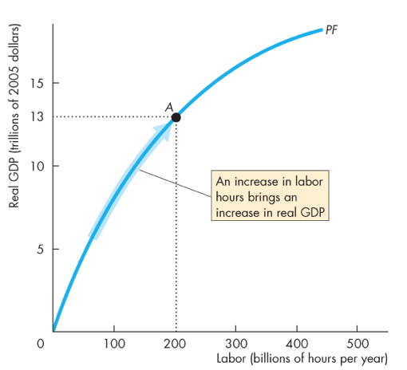
- Shows how Real GDP changes as the quantity of labour changes when all other influences on production remain the same
- Increase in labour increases Real GDP

