Business management study notes
Business: All profit-seeking activities and enterprises that provide goods and services necessary to an economic system
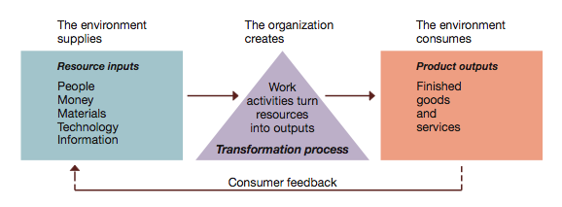
Tacit knowledge: learn over time from being at the same company, something you pick up on from experience and time
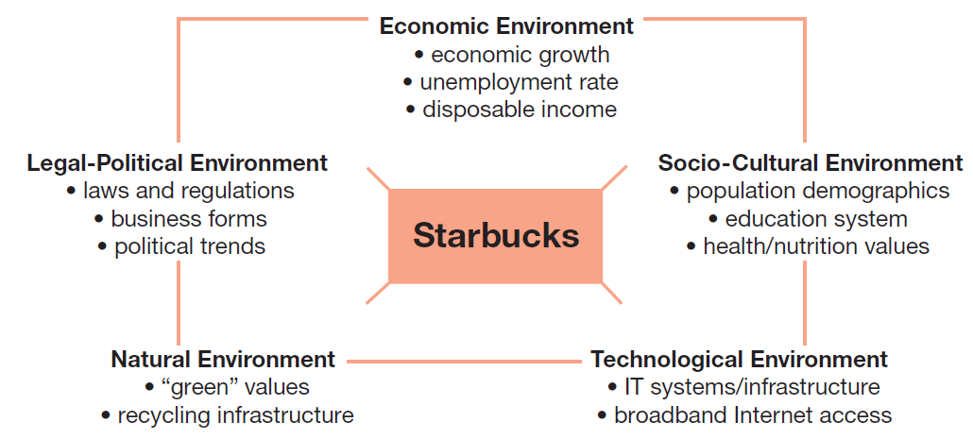
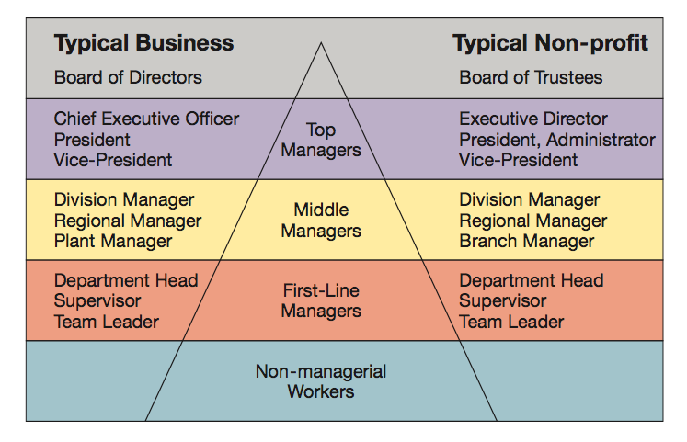
Management: Defined as the art and science of getting things accomplished through others in organizations
Different roles of management
- First level – mobilization
- Second (middle) – coordination
- Third level - strategic
Management is the process of planning,
organizing, leading, and controlling the use
of resources to accomplish performance
goals
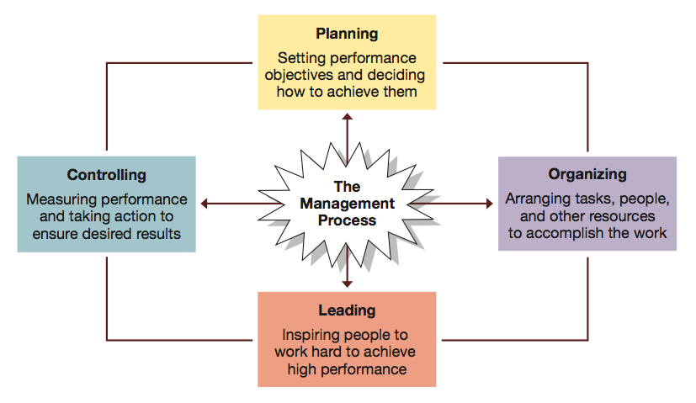

Mintzbergs 10 managerial roles:
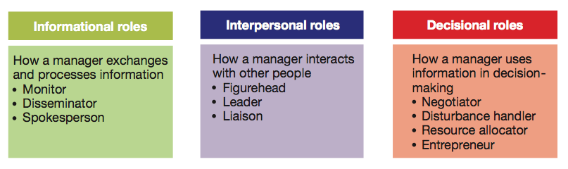
Robert Katz’s Managerial Skills
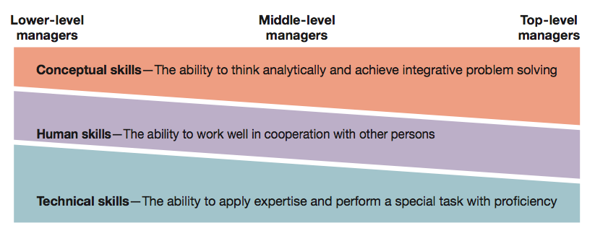
Classical Mangement: (old school approach)
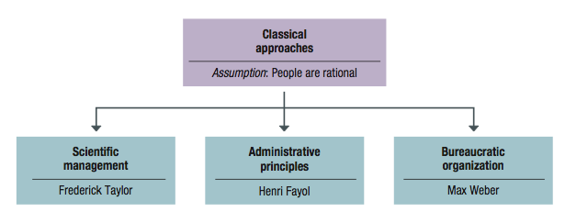
Behavioural approaches, started in 1920’s. Emphasis on the human side.

Competencies:
- “High Concept” and “High Touch”
- Communication: Sharing ideas and findings
- Teamwork: Working effectively
- Self-Management: Evaluating and modifying actions
- Leadership: Influencing and supporting others
- Critical Thinking: Gathering and analyzing information
- Professionalism: Impression management and career advancement

Global economy: Resource supplies, product markets, and business competition are worldwide, rather than local
Globalization: The process of growing interdependence of these components in the global economy

Market Entry Strategies:
Global sourcing: Process of purchasing materials or services around the world for local use
Exporting: Selling locally made products in foreign market
Importing: Buying foreign-made products and selling them domestically
Licensing Agreement: One firm pays fee for rights to make or sell another company’s products
Franchising: Fee is paid for rights to use another firm’s name and operating methods
Direct Investment Strategies:
Joint Ventures: Operates in a foreign country through co-ownership by foreign and local partners
Global Strategic Alliances: A partnership in which foreign and domestic firms share resources and knowledge for mutual gains
Foreign Subsidiaries: Local operation completely owned by a foreign firm
Greenfield Investment: Builds an entirely new operation in a foreign country

Potential Issues:
Political risk: Potential loss in value of a foreign investment due to instability and changes in host country
Local legal systems: Complex and unfamiliar laws can create problems
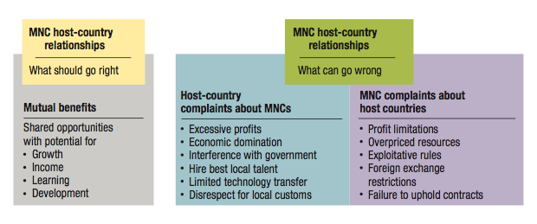
Ethical Issues:
Corruption, Sweatshops, Child Labour, Sustainable Development

Ethnocentrism: Tendency to consider one’s own culture as superior to others

Values and National Cultures (Geert Hofstede)
Power Distance, Uncertainty avoidance, Individualism – Collectivism, Masculinity – Femininity, Time Orientation
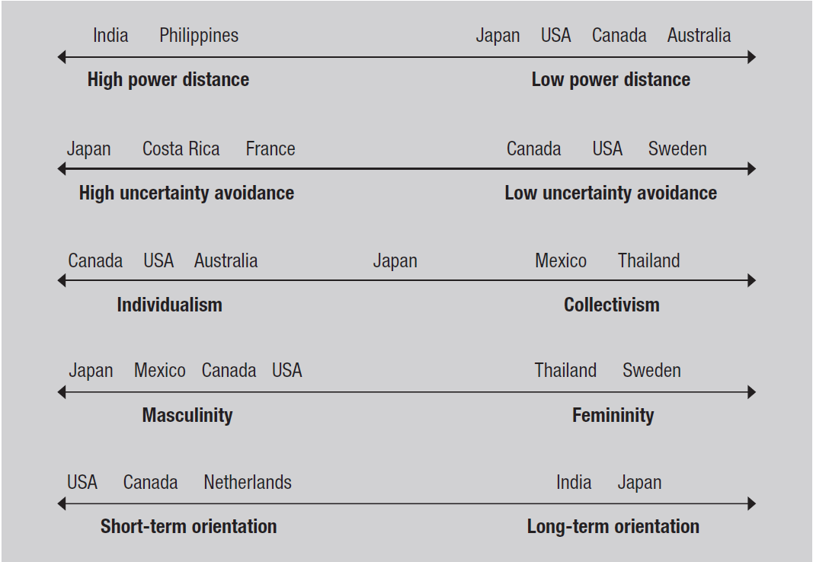
The Globe Project:
- Global Leadership and Organizational Behaviour Effectiveness)
- Researches the leadership, organizational practices, and diversity among world cultures

- Readiness for global organizational learning varies based on managerial attitudes.
    - Ethnocentric attitudes
    - Polycentric attitudes
    - Geocentric attitudes

Ethics:
Three criteria:
  - Antiquity: The older the more apt it is to be correct
  - Numbers - How many hold it (the majority is always right – the bandwagon effect)
  - Prestige – How many important prestigious persons hold this viewpoint
Ethical Development (Kohlberg)
Preconventional: acts in own best interest (few people operate here)
Conventional: upholds moral and legal laws, does what is expected
Principled: lives by an internal set of moral codes, values and ethics (i.e., the Golden Rule - upheld regardless of consequences)

Social entrepreneurship: a unique form of entrepreneurship that seeks novel ways to solve pressing social problems at home and abroad
    - Housing and job training for homeless
    - Bringing technology to poor families

Corporate Social Responsibility: Obligates organizations to act in ways that serve both its own interests and the interests of society at large.

Entrepreneur: A person who seeks a profitable opportunity and takes the necessary risks to set up and operate a business
Social entrepreneurs:
- Represents a unique form of ethical entrepreneurship that seeks novel ways to solve pressing social problems
- Social enterprises have a social mission to help make lives better for underserved populations
People choose entrepreneurship for many reasons:
- Dissatisfaction with traditional work
- Their ideas fulfill customer needs
- Freedom to make own decisions
- Being Your Own Boss: Self-management is the motivation that drives many entrepreneurs
- Financial Success: Entrepreneurs are wealth creators and idea generators
- Job Security: Over the past several years, large companies have eliminated more jobs than they have created
- Quality of Life: Starting a business gives the founder some choice over when, where, and how to work

Financing
- Seed capital: The initial funding needed to launch a new venture
- Debt Financing
    - Credit cards
    - Family and friends
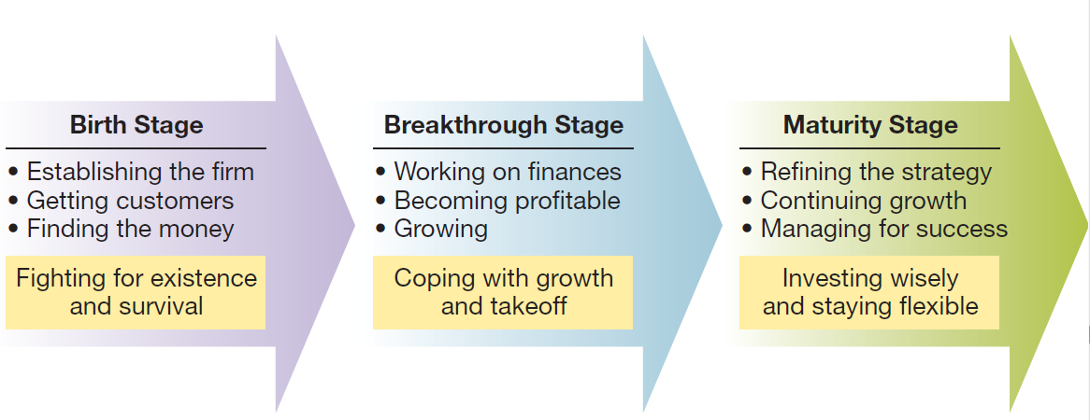
    - Bank loans
    - Finance companies
- Equity Financing
    - Venture Capitalists
    - Angel Investors
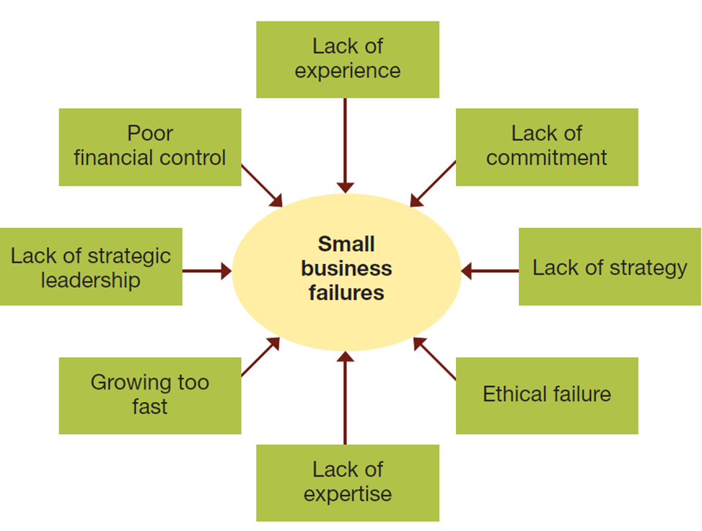
Intrapreneurship:

The process of promoting innovation within the structure of an existing organization

Skunkworks: a project initiated by an employee who conceives of an idea and then recruits resources from within the company to turn it into a commercial product

Pacing Programs: company-initiated projects that focus on a few products and technologies in which company sees potential for rapid marketplace winners

Planning:
Short-range plans = 1 year or less
Intermediate-range plans = 1 to 2 years
Long-range plans = 3 or more years
- Strategic plans: Set broad, comprehensive, and longer-term action directions for the entire organization
- Tactical plans: Define what needs to be done in specific functions to implement strategic plans
Effective goals are SMART:
  - Set Specific goals
  - Make sure goals are Measurable
  - Ensure goals are Attainable
  - Goals must be Referred to Regularly
  - Goals must be Timely

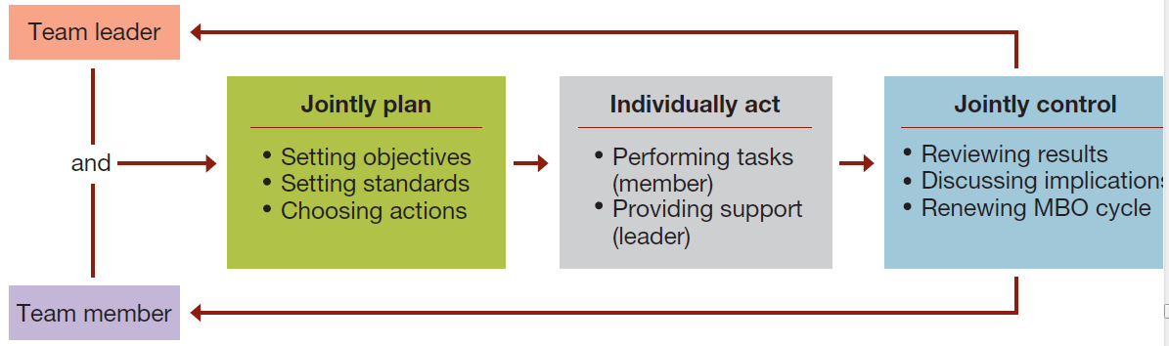
Management by Objectives as an integrated planning and control framework (MBO)

Types of MBO performance objectives
  - Improvement
  - Personal development
  - Maintenance
Pitfalls to avoid in using MBO
  - Tying MBO to pay
  - Focusing too much attention on easily quantifiable objectives
  - Requiring excessive paperwork
  - Having managers tell workers their objectives
Advantages of MBO
  - Focuses workers on most important tasks and objectives
  - Focuses supervisor’s efforts on important areas of support
  - Contributes to relationship building
  - Gives workers a structured opportunity to participate in decision making

Organizing:
The system of tasks, workflows, reporting relationships, and communication channels that link together diverse individuals and groups
An Organization Chart identifies the following aspects of formal structure:
  - The division of work
  - Supervisory relationships
  - Communication channels
  - Major subunits
  - Levels of management

Three major types of traditional organization structures:
Functional Structures
  - People with similar skills and performing similar tasks are grouped together into formal work units
  - Members work in their functional areas of expertise
  - Are not limited to businesses
  - Work well for small organizations producing few products or services
Divisional Structures
  - Group together people who work on the same product or process, serve similar customers, and/or are located in the same area or geographical region
  - Common in complex organizations
  - Avoid problems associated with functional structures
Matrix Structure: Combines functional and divisional structures to gain advantages and minimize disadvantages Used in:
    - Manufacturing
    - Service industries
    - Professional fields
    - Non-profit sector
    - Multi-national corporations
Horizontal Organization Structures:
Team Structures
  - Permanent and temporary teams to solve problems, complete special projects, and accomplish day-to-day tasks
  - Often use cross-functional teams composed of members from different functional departments

Nature of a Leader
- Ability to get someone else to do something you want done or make things happen the way you want
- Power should be used to influence and control others for the common good rather seeking to exercise control for personal satisfaction
- Two sources of managerial power:
Position power:
- Based on a manager’s official status in the organization’s hierarchy of authority
Personal power
- Based on the unique personal qualities that a person brings to the leadership situation
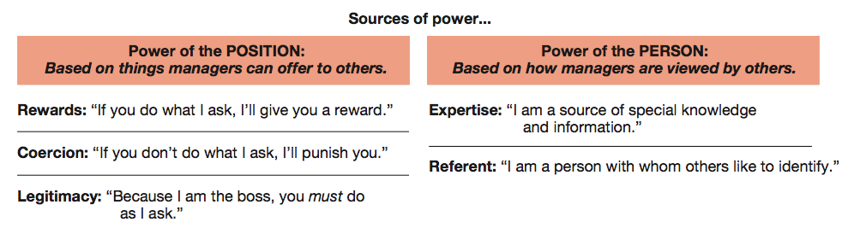
Classic leadership styles:
Laissez-faire style
    - Shows little concern for task, lets the group make decisions, and acts with a “do the best you can and don’t bother me” attitude
Democratic style
    - Committed to task and people, getting things done while sharing information, encouraging participation in decision making, and helping people develop skills and competencies
Autocratic style
- Emphasizes task over people, keeps authority and information within the leader’s tight control, and acts in a unilateral command-and-control fashion
Human Relations style
- Emphasizes people over work

Contingency Approaches
Hersey-Blanchard Situational Leadership model
  - Leaders adjust their styles depending on the readiness of their followers to perform in a given situation
- House’s Path-Goal leadership theory:
  - Effective leadership deals with the paths through which followers can achieve goals
  - Leadership styles for dealing with path-goal relationships:
    - Directive leadership
    - Supportive leadership
    - Achievement-oriented leadership
    - Participative leadership

