Social Context Mid-Term Review
-We currently need 1.5 earths to sustain us.

-Since 2008, Unilever eco-efficiency programs have avoided more than $395M of costs

Ethics of business: is a form of applied ethics or professional ethics that examines ethical principles and moral or ethical problems that arise in a business environment

Stakeholder: An individual, or group, who can influence and/or is influenced by the achievement of an organization’s purpose

Corporate social responsibility (CSR): The way a corporation achieves a balance among its economic, social, and environmental responsibilities in its operations so as to address shareholder and other stakeholder expectations.
CSR linked to profitability

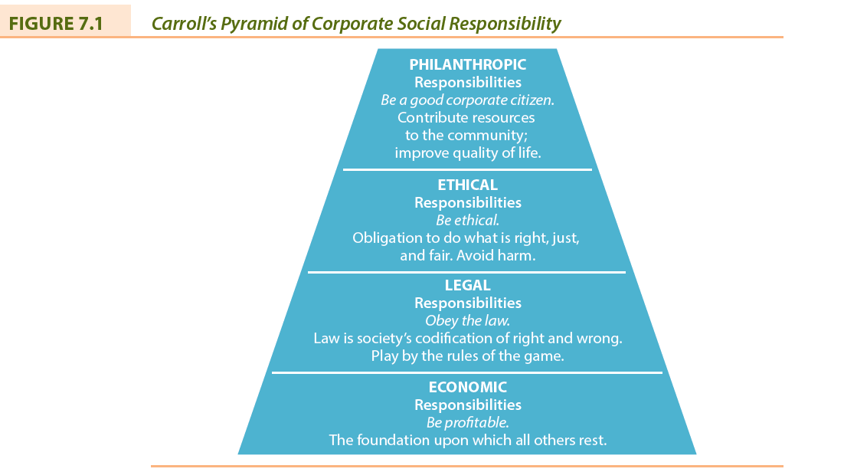
Corporate sustainability: Creating green strategy and taking into consideration every dimension of how a business operates in the social, cultural, and economic environment.

Triple bottom line (economic, ethical, and environmental): Evaluates a corporation’s performance according to a summary of the economic, social, and environmental value the corporation adds or destroys

Corporate citizenship: occurs when a corporation demonstrates that it takes into account its complete impact on society, environment and economy.

Economic system: is a system of production, resource allocation, and distribution of goods and services in a society

Capitalism: an economic and political system in which a country's trade and industry are controlled by private owners for profit

Free enterprise system: is a type of economy where products, prices, and services are determined by the market

Laissez-faire capitalism: is an economic system in which transactions between private parties are free from government interference such as regulations, privileges, tariffs, and subsidies

Responsible enterprise system: serve the needs of customers while making a profit for its owners. It does so by cooperating well with its key stakeholders: employees, suppliers, and many others

Stakeholder capitalism: that a company is there to produce something, and pay people a wage high enough that they could become your customers

Clean capitalism: as an economic system in which prices incorporate social, economic and ecological benefits and costs, and participants know the full impacts of their marketplace actions

Legitimacy: belief in the rightness of an institution, in this case the appropriateness of our business system to supply the goods and services wanted by Canadian society.

Social license: is the privilege of operating in society with minimal formalized restrictions based on maintaining public trust by doing what is acceptable to stakeholders in the business and society relationship.

Three Approaches to Ethical Thinking:
Deontological or Rule Based: is the normative ethical position that judges the morality of an action based on the action's adherence to a rule or rules.
Teleological or Consequential theories: theory of morality that derives duty or moral obligation from what is good or desirable as an end to be achieved.
Virtue Ethics: It may, initially, be identified as the one that emphasizes the virtues, or moral character

Pluralistic society: is one where influence or power is decentralized by dispersing it among a variety of institutions

Issues Management: A systemic process by which the corporation can identify, evaluate, and respond to those economic, social, and environmental issues that may impact significantly upon it.
- Identification of issues
- Analysis of issues
- Ranking or prioritizing of issues
- Formulating issue response
- Implementing issue response
- Monitoring and evaluating issue response
Benefits of Issues Management:
• Maintain a competitive advantage over rivals
• Corporate behaviour is more likely to be consistent with societal expectations
• Less likely to make a serious social or ethical mistake
• Detect issues earlier and develop appropriate responses much sooner

Stakeholder Identification and Salience:
Salience: The degree to which priority is given to competing stakeholders
Power: The ability to get a firm to do something that it would not otherwise do based
on force, threat, incentives, etc.
Legitimacy: Perception or assumption that the actions of an entity are desirable, proper,
or appropriate
Urgency: The degree to which a stakeholder’s claim or relationship calls for immediate attention

Stakeholder Engagement: efforts by a corporation to understand and involve relevant individuals, groups, or organizations by considering their moral concerns in strategic and operational initiatives.
Social Capital: Any aspect of a corporation’s organizational arrangement that creates value and facilitates the actions of stakeholders within and external to the corporation.

Six Stages of Crisis Management:
• Stage 1—Avoiding the Crisis
• Stage 2—Preparing to Manage the Crisis
• Stage 3—Recognizing the Crisis
• Stage 4—Containing the Crisis
• Stage 5—Resolving the Crisis
• Stage 6—Profiting from the Crisis

NGO: An NGO is any group that holds shared values or attitudes about an issue confronting society and advocates for changes relating to the issue.

62% of global business leaders think that integrating sustainability into business operations is their company’s most important leadership challenge.
However, just 21% report that their companies are close to fully integrating sustainability into the core of their company.
Barriers to CSR Implementation:
- 52% say immediate financial goals are more urgent
- 44% say absence of a business case
- 31% say lack of consensus on ultimate ESG goals
- 30% say inadequate budget
- 27% say insufficient clarity concerning responsibilities of the company
- 26% say lack of clarity on legal or regulatory obligations to meet sustainability standards
Corporate Philanthropy:
For:
- Means to express CSR to community
- Promotes image of good citizenship
- Business benefits from volunteer sector
- Benefits from corporate community investment program
- Company’s success linked to community’s health
Against:
- Funds given belong to shareholders
- Social welfare is the job of government
- Corporation might become accountable for actions of charity
- No guidelines or standards to measure, evaluate, or monitor corporate giving

Methods of CSR:
Corporate Philanthropy, Social Venture Philanthropy, Corporate Voluntarism, Corporate sponsorship, Reputation Management, Corporate Citizen, Corporate Sustainability

Social Enterprise: A model of business operation where some or all profits are deliberately used to further social aims.
- Two Types: Non-Profits and for Profits.

Social Responsibility Theories:
Amoral view: Traditional view of business as merely profit-making entity
Personal view: Corporations are like people and can therefore be held accountable for their actions
Social view: Corporations are social institutions with social responsibilities
-74% of CEOs agree that measuring and reporting their total (non-financial) impacts contributes to their long-term success
-Only 25% do

Global Reporting Initiative (GRI):
- A non-profit organization that works toward a sustainable global economy by providing guidance in sustainability reporting.
- Strategy and Profile
- Economic
- Environmental
- Social

UN Global Compact: A strategic policy initiative for businesses that are committed to aligning their operations and strategies with ten universally accepted principles in the areas of human rights, labor, environment and anti-corruption.
Principles:
- Support and respect the protection of human rights
- Do not be complicit in human rights abuses
- Uphold the freedom of association and the effective recognition of the right to collective bargaining
- Eliminate all forms of forced and compulsory labor
- Abolish child labor
- Eliminate discrimination re employment and occupation
- Support a precautionary approach to environmental challenges
- Promote greater environmental responsibility
- Encourage the development and diffusion of environmentally friendly technologies
- Work against corruption, including extortion and bribery
The 5-Stage Sustainability Journey:
- Pre Compliance
- Compliance: Avoid fines, prosecution and bad PR
- Beyond Compliance: Save with eco-efficiencies, avoid PR crisis, Avoid new regulations
- Integrated Strategy: Enhance company value/ prosperity
- Purpose/Passion: Create a better world

