272 Final Notes
When: Monday 25 April 2016 from 19h00 to 22h00 (7 PM to 10 PM)
Where: H-937

PRECIPITATION
Forms of precipitation: rain, snow, hail, dew, frost, and fog drip. Freezing rain.
Types of precipitation: convectional, cyclonic, and orographic. Precipitation characteristics
RAIN (water droplets)
- Forms by collision-coalescence and Bergeron-Findeisen (a.k.a. ice crystal process).
- Raindrops evaporate when falling.
- Raindrops vary in size according to strength of updraft
Bergeron-Findeisen: Commonly called the ice process of precipitation, and formerly.. The Wegener-Bergeron-Findeisen process refers to the rapid growth of ice crystals at the expense of surrounding cloud droplets, which frequently occurs in atmospheric mixed-phase clouds. The process is a result of the difference in saturation vapor pressures with respect to liquid and ice, and may in some circumstances lead to abrupt and complete cloud glaciation at temperatures between −40 °C and 0 °C in the Earth’s atmosphere
Rain develops when growing cloud droplets become too heavy to remain in the cloud and as a result, fall toward the surface as rain. Rain can also begin as ice crystals that collect each other to form large snowflakes. As the falling snow passes through the freezing level into warmer air, the flakes melt and collapse into rain drops.
Supercooled Water Droplets: Remain liquid at T < 0ºC.
Freeze if:
-------T cooler than -40ºC.
-------Contact with a freezing nucleus.
-------Sufficiently agitated.
ICE CRYSTALS:
Deposition or adhesion or interwinning of ice crystals causes them to rapidly increase in size
Freezing of supercooled water droplets or splintering of ice crystals causes them to increase in number
SNOW
-Hexagonal mass of ice crystals.
-Formed by Bergeron-Findeisen.
-Low moisture content.
-Low density.
-Variable storage period
HAIL
-Composed of lumps of ice, called hailstones.
-Concentric layers of alternating clear and opaque ice.
-Forms only in cumulonimbus clouds.
-Repetitive rising and falling
Hail is a large frozen raindrop produced by intense thunderstorms, where snow and rain can coexist in the central updraft. As the snowflakes fall, liquid water freezes onto them forming ice pellets that will continue to grow as more and more droplets are accumulated. Upon reaching the bottom of the cloud, some of the ice pellets are carried by the updraft back up to the top of the storm. As the ice pellets once again fall through the cloud, another layer of ice is added and the hail stone grows even larger. Typically the stronger the updraft, the more times a hail stone repeats this cycle and consequently, the larger it grows. Once the hail stone becomes too heavy to be supported by the updraft, it falls out of the cloud toward the surface. The hail stone reaches the ground as ice since it is not in the warm air below the thunderstorm long enough to melt before reaching the ground.
Cumulonimbus: is a dense towering vertical cloud ^{[1]}associated with thunderstorms and atmospheric instability, forming from water vapor carried by powerful upward air currents. Cumulonimbus can form alone, in clusters, or along cold front squall lines. These clouds are capable of producing lightningand other dangerous severe weather, such as tornadoes. Cumulonimbus progress from overdeveloped cumulus congestus clouds and may further develop as part of a supercell.
Sleet
-/Raindrops fall through a thick bottom layer of cold air.
-/Raindrops then completely or partially freeze
Dew and Frost
- Forms at night when radiational cooling → ↓ saturation specific humidity → condensation.
- Evaporates rapidly.
- Same process → frost if sufficiently cold.
Fog Drip
- Deposition of water droplets on vegetation from fog or low cloud.
- Droplets coalesce and enlarge then fall to ground.
- Important on forested mountain ridges.
Freezing Rain
- Rain falls through cold bottom layer of air → supercooled.
Supercooled raindrops freeze after striking frozen surface
Convectional Precipitation
- Due to rising of moist heated air.
- Strong updrafts + cumuliform clouds.
- High intensity + local distribution + short duration.
- Most frequent in warm, humid areas and during summer in midlatitudes.
- Also occurs at cold fronts.
- Thunderstorms are convectional.
- Convectional precipitation results from the heating of the earth's surface. The warm ground heats the air over it. As the air warms, the air molecules begin to move further apart.
- With increased distance between molecules, the molecules are less densely packed. Thus, the air becomes “lighter” and rises rapidly into the atmosphere.
- As the air rises, it cools. Water vapour in the air condenses into clouds and precipitation. This type of precipitation is common in the Prairies and Ontario
Convectional precipitation results from the heating of the earth's surface. The warm ground heats the air over it. As the air warms, the air molecules begin to move further apart. With increased distance between molecules, the molecules are less densely packed. Thus, the air becomes “lighter” and rises rapidly into the atmosphere. As the air rises, it cools. Water vapour in the air condenses into clouds and precipitation. This type of precipitation is common in the Prairies and Ontario
Cyclonic Precipitation
- Weak updrafts → stratiform clouds.
- Low intensity + wide distribution + long duration.
- Dominant type of precipitation in midlatitude and subpolar regions.
- Also occurs at warm fronts.
Cyclonic or Frontal precipitation results when the leading edge of a warm, moist air mass (warm front) meets a cool and dry air mass (cold front). The molecules in the cold air are more tightly packed together (i.e., more dense), and thus, the cold air is heavier than the warm air. The warmer air mass is forced up over the cool air. As it rises, the warm air cools, the water vapour in the air condenses, and clouds and precipitation result. This precipitation is common in Atlantic Canada. This type of system is called Frontal Precipitation because the moisture tends to occur along the front of the air mass. A cyclonic storm is a large, low pressure system that forms when a warm air mass and a cold air mass collide. This collision often occurs under the polar-front jet stream which spreads cold, dry arctic air near warm, moist tropical air. The rotation of the earth causes the air to circulate in a counterclockwise direction around an area of low pressure. The figure illustrates the patterns of wind flow, surface pressure, fronts, and zones of precipitation associated with cyclonic precipitation in the Northern Hemisphere. Around the low pressure (L), winds blow counterclockwise and inwards. NOTE: the direction of air flow would be in the opposite direction in the Southern Hemisphere. (clockwise but still inward). Can you explain why? HINT: Earth rotational spin and prevailing wind direction. West of L, cold air traveling from the north and northwest creates a cold front extending from the cyclone's centre to the southwest. Southeast of L, northward moving warm air from the subtropics produces a warm front. Precipitation occurs at the centre of the low pressure AND along the fronts where air is being uplifted.
Orographic Precipitation
Orographic precipitation results when warm moist air moving across the ocean is forced to rise by large mountains. As the air rises, it cools. Why? A higher elevation results in cooler temperatures. Cold air cannot hold as much moisture as warm air. As air cools, the water vapour in the air condenses and water droplets form. Clouds forms and precipitation (rain or snow) occurs on the windward side of the mountain (see diagram). The air is now dry and rises over top the mountain. As the air moves back down the mountain, it collects moisture from the ground via evaporation. This side of the mountain is called the leeward side. It receives very little precipitation.

Low Annual Precipitation Areas
- Tropical deserts.
- Midlatitude deserts and steppes.
- Arctic/Antarctic and polar deserts.
- Coastal areas near cool ocean currents.

End of Precipitation

Interception

- storage of water above the ground surface, mostly in vegetation
- where vegetation is present, precipitation consists of
  - gross rainfall measured above the canopy or in openings in a forest
  - throughfall: water that falls between plants,
  - drippage: of water from the plants to the grounds, and
  - stemflow: flow of water down stems and trunks
- therefore, interception significantly reduces precipitation intensity as water is first temporarily sorted and much is lost

interception loss: that part of the precipitation on the canopy that doesn't reach the ground, because it evaporates from the canopy (canopy interception loss) and from near-ground plants and leaf litter (litter interception loss) or, to a lesser extent, is absorbed by plant
Throughfall
- Precipitation that reaches ground surface directly without being intercepted.
- Precipitation that reaches ground surface directly without being intercepted and indirectly as leaf drip and canopy drip.
- Precipitation that reaches ground surface directly without being intercepted and indirectly as leaf drip, canopy drip and stem flow.

Flow and Fall
- Flow: continuous with low impact.
- Fall, whether drop or drip, is intermittent with high impact.
Factors Influencing Interception
- Precipitation.
  - Intensity.
  - Duration.
  - Total volume.
- Vegetation.
  - Species assemblage.
  - Density.
  - Vertical stratification.
  - Dormancy state.
Importance of Interception
- Amount of water reaching the ground surface.
- Rate water reaches the ground surface.

nterception^{[1]} refers to precipitation that does not reach the soil, but is instead intercepted by the leaves and branches of plants and the forest floor. It occurs in the canopy (i.e. canopy interception), and in the forest floor or litter layer (i.e. forest floor interception ^{[2]}). Because of evaporation, interception of liquid water generally leads to loss of that precipitation for the drainage basin, except for cases such as fog interception.
Intercepted snowfall does not result in any notable amount of evaporation, and most of the snow falls off the tree by wind or melts. However, intercepted snow can more easily drift with the wind, out of the watershed. Conifers have a greater interception capacity than hardwoods. Their needles gives them more surface area for droplets to adhere to, and they have foliage in spring and fall, therefore interception also depends on the type of vegetation in a wooded area.

Stemflow - is the process that directs precipitation down plant branches and stems (red arrows in Figure 8k-2). The redirection of water by this process causes the ground area around the plant's stem to receive additional moisture. The amount of stemflow is determined by leaf shape and stem and branch architecture. In general, deciduous trees have more stemflow than coniferous vegetation.
Canopy drip - some plants have an architecture that directs rainfall or snowfall along the edge of the plant canopy (purple arrows in Figure 8k-1). This is especially true of coniferous vegetation. On the ground, canopy drip creates areas with higher moisture content that are located in a narrow band at the edge of the plant canopy.
Throughfall - describes the process of precipitation passing through the plant canopy (yellow dashed lines in Figure 8k-2). This process is controlled by factors like: plant leaf and stem density, type of the precipitation, intensity of the precipitation, and duration of the precipitation event. The amount of precipitation passing through varies greatly with vegetation type.

Evapotranspiration
Transformation of water into vapour. Most of it occurs from oceans..some also from land..rain water on land is subject to evaporation
Transpiration: Microscopic pores on plans. (stomata)
These are either open or close..Water in leaves is heated from solar rediation. So we have water vapor in these pores. When stomata opens this vapor escapes into the atmosphere
This water vapor that escapes from the leaf turns this leaf dry. Then water from the roots goes to this leaf transpiration stream

Diffusion pressure deficit: moisture gradient within plant
Transpiration stream: unbroken column of water
When water moves from the roots to the dry leaves. Water moves from More dilute to were it is more concentrated. So when root gets dry the fluids inside it gets concentrated and thus water in the soil moves to the root and replenish it.
Importance of ET
- Replenishes atmospheric moisture.
- Mechanism of latent heat transfer.
- Transfer of water and nutrients from soil into and through plant.
- Maintains cell turgidity.
- Cools plant.
- Precipitation removes water from atmosphere. Evapotranspiration (ET) brings water back into the atmosphere

Requirements for ET; 4 requirements for ET; This only occurs specific humidity of atmosphere is less that the specific humidity of surface (atmoshpere dried than surface)
- Water is available.
- Atmosphere is drier than evapotranspiring surface.
- Atmosphere is unsaturated.
- Energy is available

Potential Evapotranspiration; Potential Evapotranspiration---a theoretical maximum amount of ET that could occur under given conditions (energy, wind and energy). The greater energy input the greater the potential
- Measure of amount of evapotranspiration that could occur with no limit on water supply.
- Refers to water need.
- Primary determinant = energy input.
- Secondary influences = wind and specific humidity gradient
1_ Energy Input and POTET
Up in latitude = less potet
Up in photoperiod = higher
Up in cloudiness = lower
Season temp = max in summer
Season precipitation = max in dry season.. Because more energy reaches the surface in the dry season

2_ Wind and POTET
- Wind removes water vapour.
- Moisture content, temperature, & velocity of wind affect POTET
- Depends on mois
- Up in wind dryness (continental air-mass is dry) == higher potet
- Up in wind temp == higher
- Un in wind velocity (faster winds) == faster water vapor being romoved from plants so higher potet

3_ Specific Humidity Gradient and POTET;; The drier the atmosphere the higher the potet
- Difference between specific humidity of atmosphere and specific humidity of evapotranspiring surface.
- ET only if atmosphere is drier than evapotranspiring surface.

Actual Evapotranspiration
- Measure of amount of water that is transformed into water vapour through evapotranspiration.
- Refers to water use.
- Sufficient water available → ACTET = POTET.
- Insufficient available water → ACTET < POTET.
- Actual Evapotranspiration – the actual amount of water that got transformed into vapor
- Deficit = potet – actet
- Actet never > potet
ACTET Under Different Conditions
No vegetation = no transpiration = only evaporation
Forest changes micro climate because of shade in trees so vapor sticks around in the forest. So less specific heat in forest than in fields
- No vegetation → no transpiration.
  - Oceans: major evaporative losses.
  - Bare soil: initially at soil surface and progresses downward.
- Vegetation → transpiration + evaporation. Also affects microclimate.

As long as there is water in soil ET will continue

Effects on Plant of ↓ Soil Water
- Inadequate water absorption.
- Nutrient deficiencies.
- ↓ cell turgidity → plant wilts.
- ↑ plant temperature.
- ↑ soil temperature.
- → permanent wilting point

Transpiration
Transpiration consists of the vaporization of liquid water contained in plant tissues and the vapour removal to the atmosphere. Crops predominately lose their water through stomata. These are small openings on the plant leaf through which gases and water vapour pass (Figure 1). The water, together with some nutrients, is taken up by the roots and transported through the plant. The vaporization occurs within the leaf, namely in the intercellular spaces, and the vapour exchange with the atmosphere is controlled by the stomatal aperture. Nearly all water taken up is lost by transpiration and only a tiny fraction is used within the plant.
Transpiration, like direct evaporation, depends on the energy supply, vapour pressure gradient and wind. Hence, radiation, air temperature, air humidity and wind terms should be considered when assessing transpiration. The soil water content and the ability of the soil to conduct water to the roots also determine the transpiration rate, as do waterlogging and soil water salinity. The transpiration rate is also influenced by crop characteristics, environmental aspects and cultivation practices. Different kinds of plants may have different transpiration rates. Not only the type of crop, but also the crop development, environment and management should be considered when assessing transpiration.

Evapotranspiration (ET)
Evaporation and transpiration occur simultaneously and there is no easy way of distinguishing between the two processes. Apart from the water availability in the topsoil, the evaporation from a cropped soil is mainly determined by the fraction of the solar radiation reaching the soil surface. This fraction decreases over the growing period as the crop develops and the crop canopy shades more and more of the ground area. When the crop is small, water is predominately lost by soil evaporation, but once the crop is well developed and completely covers the soil, transpiration becomes the main process. In Figure 2 the partitioning of evapotranspiration into evaporation and transpiration is plotted in correspondence to leaf area per unit surface of soil below it. At sowing nearly 100% of ET comes from evaporation, while at full crop cover more than 90% of ET comes from transpiration.

Soil Water
Plants are dependent on soil water
- Used by plants for:
  - Transpiration.
  - Absorption of nutrients.
  - Cell turgidity.
  - Tissue.
  - Metabolism.
  - Agent in diverse soil processes
Types of Soil Water
- Gravitational soil water.
- Capillary soil water (a.k.a. cohesion soil water).
- Hygroscopic soil water (a.k.a. adhesion soil water).

Three Key Soil Water Levels
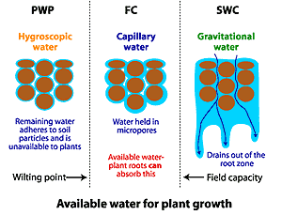

PWP:
permanent wilting point
FC:
field (storage) capacity
SWC:
Saturated water content

Field capacity– maximume amount of water soil can hold against gravity. This is through the Matric Force--- Matric force consists of cohesion and adhesion Adhesion– water held by soil
Cohesion- water held by water molecules
Matric force holds 0.06mm

1----Gravitational Soil Water
- Water that percolates down through and out of soil.
- Percolation ceases varying with:
  - Amount of input.
  - Soil texture.
Unavailable to plants

---------free water that moves through the soil due to the force of gravity.
- Gravitational water is found in the macropores. It moves rapidly out of well drained soil and is not considered to be available to plants.
- It can cause upland plants to wilt and die because gravitational water occupies air space, which is necessary to supply oxygen to the roots.

----Capillary water: Water in the micropores, the soil solution.
  - Most, but not all, of this water is available for plant growth
  - Capillary water is held in the soil.against the pull of gravity
Forces Acting on Capillary Water
micropores exert more force on water than do macropores
Capillary water is held by cohesion (attraction of water molecules to each other) and adhesion (attraction of water molecule to the soil particle).
The amount of water held is a function of the pore size (cross-sectional diameter) and pore space (total volume of all pores)
This means that the tension (measured in bars) is increasing as the soil dries out.
- A.k.a. cohesion water.
- Water held by cohesion.
- Moves from wetter soil to drier soil in any direction.
- Movement is quite slow.
- Available to plants
- Moves from where soil is wetter to where it is drier
- Only type that is available to plans

-----------Hygroscopic Soil Water
- A.k.a. adhesion water.
- Water held by adhesion.
- Removed only by evaporation.
- Unavailable to plants.
- Held soo strongly by soil that plants cant absorb it
This water forms very thin films around soil particles and is not available to the plant. The water is held so tightly by the soil that it can not be taken up by roots.
  - not held in the pores, but on the particle surface. This means clay will contain much more of this type of water than sands because of surface area differences.
  - Hygroscopic water is held very tightly, by forces of adhesion. this water is not available to the plant.
  - Gravity is always acting to pull water down through the soil profile. However, the force of gravity is counteracted by forces of attraction between water molecules and soil particles and by the attraction of water molecules to each other.

Soil Water Balance
PRECIP = ACTET + ∆STRGE + SURPL
PRECIP = precipitation.
ACTET = actual evapotranspiration.
∆STRGE = change in soil water storage.
SURPL = runoff.
These are in order priority
Only used Evapotranspiration untill potential
This ∆ means change
Need to know 4 things to calculate this.
1- amount precipitation
-storage capacity-storage content

Storage in the hydrologic cycle: Oceans. Cryosphere. Groundwater. Lakes. Atmosphere.

Ocean Size
- Glacial period → ↓ size.
  - Thermal contraction.
  - ↓ input.
- Interglacial period → ↑ size.
  - Thermal expansion.
  - ↑ input
- When water get colder it contracts---- so thermal contraction
Activity Intense at Ocean Surface
- Heat exchange.
- Evaporation.
- Input of water.
- Dissolution of oxygen and carbon dioxide.
- Most marine life. Exception = hydrothermal vent communities

Higher values in coastal regions because high nutrients concentration

hydrothermal vent is a fissure in a planet's surface from which geothermally heated water issues. Hydrothermal vents are commonly found near volcanically active places, areas where tectonic plates are moving apart, ocean basins, and hotspots

Ocean Circulation
- Current = oceanic equivalent of wind.
- Most large-scale surface currents initiated by movement of surface winds.
- Deep currents derive from density differences.
- Global surface pattern dominated by gyres →
  - Western intensification.
  - Strong warm currents (e.g. Gulf Stream).
  - Sporadic eastward-flowing, equatorial counter-current.
Surface ocean currents are primarily affected by wind patterns. Trade winds can push water along the top of the ocean and aid in the formation of surface currents. One example of a wind-driven circulation affecting an ocean current is the Gulf Stream. The Gulf Stream takes very warm water from the Gulf of Mexico and parts of the Caribbean Sea and transports it northward. During the winter, the Gulf Stream can have a great effect on storm systems along the East Coast of the United States. For example, nor’easters can strengthen and grow over the Gulf Stream and bring heavy snow or rain, strong winds, and damaging beach erosion to the East Coast. It used to be thought that the flow of the Gulf Stream alone helped keep Europe warm in winter, but it has been recently shown that the temperate climate of Great Britain comes from warm air moving along with the Gulf Stream over the Atlantic Ocean. This keeps temperatures along the western coast of Europe milder than continental areas farther east away from the coast.

Vertical Transport of Ocean Water
- Upwelling:
  - Cold, nutrient-rich bottom water rises to surface.
  - Replaces diverging surface water.
- Downwelling:
  - Sinking of surface water.
  - Occurs with ↑ amount or ↑ density of surface water.
- Downwelling occurs when surface waters converge (come together), pushing the surface water downwards. Regions of downwelling have low productivity because of the nutrients get used up and are not continuously resupplied by the cold, nutrient-rich water from below the surface.
- Upwelling occurs when surface waters diverge (move apart), enabling upward movement of water. Upwelling brings water to the surface that is enriched with nutrients important for primary productivity (algal growth) that in turn supports richly productive marine ecosystems. Upwelling regions are often measured by their productivity due to the influx of nutrients to the surface mixed layer and euphotic zone (sunlit layer) by upwelling currents.

Cryosphere
- Consists of glaciers.
- Large, natural accumulation of land ice subject to movement.
- Two basic types of glacier.
  - Ice sheet.
  - Alpine glacier
The cryosphere is the frozen water part of the Earth system. Beaufort Sea, north of Alaska. One part of the cryosphere is ice that is found in water. This includes frozen parts of the ocean, such as waters surrounding Antarctica and the Arctic.

Types of Glacier
- Ice Sheets: In arctic and polar regions with cold air temperature → ice accumulates over wide areas. E.g. Greenland and Antarctica.
- Ice Cap: Small ice sheet.
- Alpine Glacier: In mountains with cold air temperature and heavy orographic precipitation. Typically long and narrow.

Groundwater
- ≈ 25% of global freshwater.
- Subsurface water in saturation zone.
- Upper surface = water table.
- Unsaturated zone is above water table
- Groundwater (or ground water) is the water present beneath Earth's surface in soil pore spaces and in the fractures of rock formations. A unit of rock or an unconsolidated deposit is called an aquifer when it can yield a usable quantity of water.

Lakes
- Bodies of water that occupy depressions in land surface.
- Vary in origin, size, and salinity.
- All lakes: terrestrial, interface with atmosphere, level.
- Diverse geologic and human processes → depressions or obstructions → lakes.
Disappearance of Lakes:
- Erosion of the outlet channel.
- Accumulation of sediments.
- Excessive evaporation.
  - E.g. Lake Bonneville, a pluvial lake.

Atmosphere
- Minute proportion of global freshwater, insufficient to sustain global precipitation without replenishment by ET.
- Oceans: ACTET > precipitation.
- Continents: precipitation > ACTET
- Although the atmosphere may not be a great storehouse of water, it is the superhighway used to move water around the globe. Evaporation and transpiration change liquid water into vapor, which ascends into the atmosphere due to rising air currents. Cooler temperatures aloft allow the vapor to condense into clouds and strong winds move the clouds around the world until the water falls as precipitation to replenish the earthbound parts of the water cycle. About 90 percent of water in the atmosphere is produced by evaporation from water bodies, while the other 10 percent comes from transpiration from plants.
- There is always water in the atmosphere. Clouds are, of course, the most visible manifestation of atmospheric water, but even clear air contains water—water in particles that are too small to be seen.

Transfers in the hydrologic cycle
- Infiltration
- Percolation
- Overland flow
- Interflow
- Stream flow

Infiltration
- Entry of water into soil surface.
- Varies with both:
  - Infiltration capacity of surface.
  - Intensity and duration of rainstorm.
Infiltration Capacity:
- Ability of a surface to absorb water.
- Varies with number and size of openings in soil.
- Coarse-textured soils → rapid infiltration.
- Fine-textured soils → slow infiltration.
- Kinetic force of raindrops may cause rainsplash.
- Litter layer facilitates infiltration.
Antecedent moisture content

====--infiltration capacity is the maximum rate at which water can be absorbed by a given soil per unit area under given conditions.

Intensity and Duration of Rainstorm
- Intensity of the rainfall > infiltration capacity of surface→ overland flow.
- ↑ intensity → ↑ risk of rainsplash
- ↑ duration → ↑ probability of soil becoming saturated → infiltration rate ≈ percolation rate.

Percolation
After run-off comes the last step of the water cycle: percolation!
Percolation occurs when the water on the earth's surface in the run-off stage seeps underground.
That is why in the old days they used wells to retrieve water! It was under the Earth's surface!
A well is an example of an aquifer.
An aquifer stores water underground.
Water under the Earth's surface also helps plants grow
- Downward drainage of water through soil.
- With saturated soil (muddy): faster in coarse-textured soil.
- With unsaturated soil: faster in fine-textured soil.

Overland Flow
- Water that forms puddles on ground surface or moves downslope without infiltrating surface.
- Arises only with a wetting event.
- Intensity of rain > infiltration capacity.
- Hortonian overland flow (a.k.a. unsaturated overland flow).
- Saturated overland flow.
Four Types of Overland Flow
- Depression storage.
- Sheetwash.
- Rill flow.
- Gully flow.
There are four main types of soil erosion by water: splash erosion, sheet erosion, rill erosion and gully erosion. Splash erosion is the result of mechanical collision of raindrops with the soil surface: soil particles which are dislodged by the impact then move with the surface runoff. Sheet erosion is the overland transport of sediment by runoff without a well defined channel. Soil surface roughness causes may cause runoff to become concentrated into narrower flow paths: as these incise, the small but well-defined channels which are formed are known as rills. These channels can be as small as one centimeter wide or as large as several meters. If runoff continue to incise and enlarge rills, they may eventually grow to become gullies. Gully erosion can transport large amounts of eroded material in a small time period.

Interflow
- A.k.a. throughflow.
- Water that infiltrates soil, but flows laterally beneath soil surface.
- Interflow moves more slowly than overland flow.
interflow, the water that infiltrates the soil surface and travels by means of gravity toward a stream channel (always above the main groundwater level) and eventually empties into the channel

Stream Flow
- Water flowing in a channel on ground surface, from higher to lower elevation under influence of gravity.
- Dry weather flow.
- Stream discharge.

Global Energy System
- Energy and the global system.
- Solar radiation.
- Solar and terrestrial radiation.
- Insolation and its temporal variation.
- Insolation loss in the atmosphere.
- Longwave radiation.
- Net radiation and its variation.

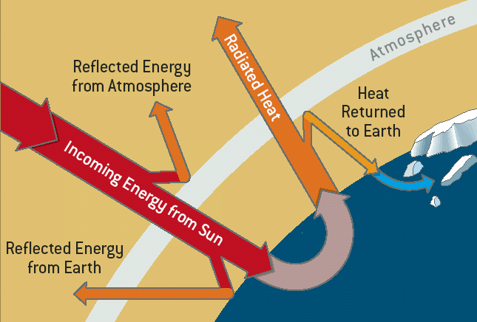 -only absorbed radiation is considered heat
-reflection is output, absorption is input

Sun emits shortwave radiation (low frequencies)
Earth emits longwave radiation (high frequencies)
4 micro meters separates longwave from shortwave
The more elliptical the more distant
Total Solar Irradiance
- A.k.a. solar constant.
- Amount of solar radiation received by Earth at altitude of 480 km.
- Averaged over entire planet.
- About 1367 Wm⁻².
- Earth receives tiny amount of Sun's total energy output.

Perihelion is point when earth is nearest the to sun (january3-4) , Aphelion is farthest (july 3-4)
Apsidal Precession; Change in dates of perihelion and aphelion. Cycle ≈ 108,000 years

Eccentricity
↑ elliptical → :
↓ duration of perihelion season
↑ duration of aphelion season
↑ difference in solar energy input between perihelion and aphelion
The more elliptical the more distant
-the lower the angle the more reflection..higher the angle the less reflection = more absorbtion

Wien’s Displacement Law
- ↑ temperature → ↓ wavelength.
Stefan-Boltzmann Law
---------↑ temperature → ↑ emissive power.

Insolation
- Incoming solar radiation.
- Varies with:
  - Angle of incident radiation.
  - Photoperiod.
- Diurnal and annual cycles.
Two factors that influence insolation:
- Photoperiod= time of sunset to sunrise
- Angle
---Diurnal=24h day time....active during day time.. Opposite of nocturnal

-Why is there seasonal variance in isolation? Earth is tilted not straight up and down
-the lower the angle the more reflection..higher the angle the less reflection = more absorbtion

-As you can see, the length of a day changes far more during the year at higher latitudes than at lower latitudes. The graph runs from one winter solstice to the next, with the two equinoxes clearly visible in March and September.
-Equinox the time or date (twice each year) at which the sun crosses the celestial equator, when day and night are of equal length (about September 22 and March 20).
-At higher latitudes the length of day changes quite noticeably in early January and mid-November

Equinoxes:
As the Earth moves around its orbit, it reaches two points during the year where the tilt of its axis causes it to be straight relative to the Sun. These days are known as equinoxes. During these equinoxes the rays of the Sun shine directly on the equator. This happens on approximately March 20th and September 22nd.

June Solstice
The June solstice is the Summer Solstice in the Northern Hemisphere and the Winter Solstice the Southern Hemisphere.
It is the winter solstice in the Northern Hemisphere, where it is the shortest day of the year.
In the Southern Hemisphere, it is the summer solstice and the longest day of the year.
Solstices:
-----At two points throughout the year, the tilt of the Earth’s axis reaches its maximum angle compared to the Sun, and begins to move back the other direction. This usually happens around June 21st and December 21st. These days are known as solstices. On these solstices, the rays of the Sun shine directly on one of the two Tropics. During the June Solstice the rays of the Sun shine directly on the Tropic of Cancer. During the December Solstice the Sun’s rays shine on the Tropic of Capricorn.

Atmospheric Loss of Insolation
- Absorption.
- Scattering.
    - Rayleigh.
    - Mie.
- Reflection.
-Scattering by particles similar to, or larger than, the wavelength of light is typically treated by the Mie theory
-Process that produces blue sky===Rayleigh Scattering
-Solar radiation can be absorbed by objects such as molecules, water...these objects thus heat up

Dark particles absorb solar radiation
Light particles reflect and scatter solar radiation
Clouds can absorb, scatter, or reflect (all of which effect isolation)

Factors Influencing Albedo
- Angle of incident radiation.
↓ angle → ↑ albedo.
- Colour of the surface.
↑ light colour → ↑ albedo.
- Surface texture.
↑ smooth texture → ↑ albedo.
Albedo % of insolation that gets reflected at given time and space.
---Reflectivity of surface
Albedo is the fraction of solar energy (shortwave radiation) reflected from the Earth back into space. It is a measure of the reflectivity of the earth's surface. Ice, especially with snow on top of it, has a high albedo: most sunlight hitting the surface bounces back towards space.

The higher the Albedo, the less absorbant the surface is, therefore the less heated it gets

Longwave Radiation: -Ground Radiation= radiation emitted from earth’s surface.
-Longwave Radiation (OLR) is the energy radiating from the Earth as infrared radiation at low energy to Space. OLR is electromagnetic radiation emited from Earth and its atmosphere out to space in the form of thermal radiation.
Longwave occurs after earth absorbs shortwaves from sun

Radiation Balance: NET R = SW↓ - SW↑ + LW↓ - LW↑
Earth's net radiation, is the balance between incoming and outgoing energy at the top of the atmosphere. It is the total energy that is available to influence the climate.
-* Greenhouse gases that naturaly occur do NOT absorb shortwave radiation
DO absorb longwave radiation
Counter radiation = when greenhouse gases reflect the naturally emitted radiation (from the planet) back to the planet.

Atmospheric moisture
- Lapse rates.
  - Environmental lapse rate.
  - Dry adiabatic lapse rate.
  - Saturated adiabatic lapse rate.
- Stability and instability.
- Condensation.
  - Specific and relative humidity.
  - Causes of condensation.
- Clouds.

- Specific humidity - measures mass of water vapor in a fixed total mass of air. In general it is greater in the tropics (16 g/kg) than in the polar regions (4 g/kg). This definition is used when we are interested in the actual amount of water that is in the atmosphere as a gas. The specific humidity remains constant as long as you do not add or take out water vapor molecules from the volume of air.
- Mixing ratio - mass of water vapor in a fixed mass of remaining dry air. Since there are so few molecules of water vapor in a volume of air, as compared to N2 and O2, the value of the mixing ratio is similar to the specific humidity. Changing the temperature of the air parcel does not affect the parcels mixing ratio.
- Absolute humidity - mass of water vapor in a fixed volume of air, or the water vapor density. We don't ever use this definition so don't bother memorizing it!
- Actual vapor pressure - the amount of water vapor in terms of the amount of pressure that the water vapor molecules exert. It is expressed in units of mb. We use the actual vapor pressure when discussing evaporation and condensation. It is therefore of use when we discuss clouds.
- Saturation vapor pressure - pressure that water vapor molecules would exert if the air were saturated at a given temperature, its units are mb. Saturation vapor pressure increases with rising temperature. Saturation vapor pressure just above liquid water is greater than that over ice. At temperatures below freezing it takes more vapor molecules to saturate air directly above water than it does to saturate air directly above ice. This is important for precipitation.
- Relative humidity - ratio of the amount of water vapor actually in the air compared to the amount of water vapor required for saturation at that particular temperature and pressure. This is one method that nightly weather persons report. It is expressed as a percentage. Increasing or decreasing the amount of water vapor in the air changes the relative humidity. A change in temperature will also bring about a change in relative humidity.
- Dew point temperature - the temperature to which air would have to be cooled (with no change in air pressure or water content) for saturation to occur. When the dew point is below 32F (0C) it is called the Frost point
- The Heat Index - combines air temperature with relative humidity to determine an 'apparent' temperature - what the temperature ‘feels like’

Methods of Heat Transfer
- Radiation.
- Conduction.
- Convection.
  - Sensible heat transfer.
  - Latent heat transfer (may or may not involve convection).
-Convection is the way heat is transferred from one area to another when there is a "bulk movement of matter." It is the movement of huge amounts of material, taking the heat from one area and placing it in another. Warm air rises and cold air replaces it. The heat has moved. It is the transfer of heat by motion of objects. Convection occurs when an area of hot water rises to the top of a pot and gives off energy. Another example is warm air in the atmosphere rising and giving off energy. They are all examples of convection. The thing to remember is that objects change position.
-When the transfer of energy happens by radiation, there is no conductive medium (such as in space). That lack of medium means there is no matter there for the heat to pass through. Radiation is the energy carried by electromagnetic waves (light). Those waves could be radio waves, infrared, visible light, UV, or Gamma rays. Heat radiation is usually found in the infrared sections of the EM spectrum. If the temperature of an object doubles (in Kelvin), the thermal radiation increases 16 times. Therefore, if it goes up four times, it increases to 32 times the original level.

- Conduction is a situation where the heat source and heat sink are connected by matter. As we discussed before, the heat flows from the source down the temperature gradient to the sink. It is different from convection because there is no movement of large amounts of matter, and the transfers are through collisions. The source and the sink are connected.

Sensible Heat
Sensible heat is the energy required to change the temperature of a substance with no phase change. The temperature change can come from the absorption of sunlight by the soil or the air itself. Or it can come from contact with the warmer air caused by release of latent heat (by direct conduction). Energy moves through the atmosphere using both latent and sensible heat acting on the atmosphere to drive the movement of air molecules which create wind and vertical motions.

Latent heat is the energy absorbed by or released from a substance during a phase change from a gas to a liquid or a solid or vice versa. If a substance is changing from a solid to a liquid, for example, the substance needs to absorb energy from the surrounding environment in order to spread out the molecules into a larger, more fluid volume. If the substance is changing from something with lower density, like a gas, to a phase with higher density like a liquid, the substance gives off energy as the molecules come closer together and lose energy from motion and vibration.
Latent heat fuels thunderstorms and hurricanes

Environmental Lapse Rate ELR
- Rate temperature of troposphere changes with increasing altitude.
- Heating of troposphere is greatest near surface and ↓ with ↑ altitude.
- Normal lapse rate: 6.4°C / 1000m.
- ELR is highly variable.
- environmental lapse rate (ELR) The rate at which the air temperature changes with height in the atmosphere surrounding a cloud or a rising parcel of air. The overall average rate is a decrease of about 6.5°C/km, but the rate varies greatly in different regions of the world, in different airstreams, and at different seasons of the year. Where the lapse rate of temperature is negative (temperature increases with height), an inversion is said to exist

LIFTING MECHANISMS:
Orographic lift occurs when an air mass is forced from a low elevation to a higher elevation as it moves over risingterrain. As the air mass gains altitude it quickly cools down adiabatically, which can raise the relative humidity to 100% and create clouds and, under the right conditions, precipitation.

Frontal Lift
As mentioned in previous topics, fronts on weather maps represent the leading edge of either warm or cold air. Both kinds of fronts can provide lift for rain showers and thunderstorms, but they do not have the same characteristics as discussed below.
Cold Fronts
Cold air is more dense than warm air, and as a result, it undercuts and pushes the warm air vertically ahead of it as it moves. The slope of the cold air with a cold front is very steep, so the air is rapidly pushed up and can sometimes result in strong to severe thunderstorms if ample moisture and instability are available.

Warm Fronts
At first, it may seem counter-intuitive that warm fronts can provide lift; however, warm fronts can produce widespread precipitation. Unlike a cold front that undercuts the air at the surface, the warm air of a warm front will rise over the cooler air at the surface due to its lower density. This provides lift for clouds and showers to form along and ahead of the warm front. The slope of the cold/warm air in a warm front is not as steep as a cold front. As a result, thunderstorms are more likely to form with cold fronts rather than warm fronts.

Convergence
In the center of low pressure areas, winds converge toward the center of the low due to the effects of friction. Since the air cannot go down into the earth, it must rise up. This lift due to convergence leads to the presence of clouds and precipitation near low pressure centers. The stronger the convergence, the stronger the vertical motion and the more clouds and precipitation are likely to form.

Convective Lift
When the sun heats the ground, the warmed air at the surface will rise under the influence of convection. The rising thermals are similar to the hot bubbles of water that rise from the bottom of a boiling pot. If the air is stable, then the bubbles of warm air will form scattered fair weather cumulus clouds and not much else. If the air is unstable, then the lifting from convection will lead to rapid growth of clouds into deep cumulonimbus clouds, or thunderstorms. The higher the surface temperatures, the more convection can occur.
Causes of Cooling
- Energy consumed in expansion.
- Energy consumed in rising.
- Less molecular friction.

Dry Adiabatic Lapse Rate – Cooling
Dry adiabatic lapse rate
Since the atmospheric pressure decreases with altitude, the volume of an air parcel expands as it rises. Conversely, if a parcel of air sinks from a higher altitude to a lower altitude, its volume is compressed by the higher pressure at the lower altitude. An adiabatic lapse rate is the rate at which the temperature of an air parcel changes in response to the expansion or compression process associated with a change in altitude, under the assumption that the process is adiabatic (meaning that no heat is added or lost during the process).
Earth's atmospheric air is rarely completely dry. It usually contains some water vapor and when it contains as much water vapor as it is capable of, it is referred to as saturated air (i.e., it has a relative humidity of 100%). The dry adiabatic lapse rate refers to the lapse rate of unsaturated air (i.e., air with a relative humidity of less than 100%). It is also often referred to as the dry adiabat, DALR or unsaturated lapse rate. It should be noted that the word dry in this context simply means that no liquid water (i.e., moisture) is present in the air ... water vapor may be and usually is present.

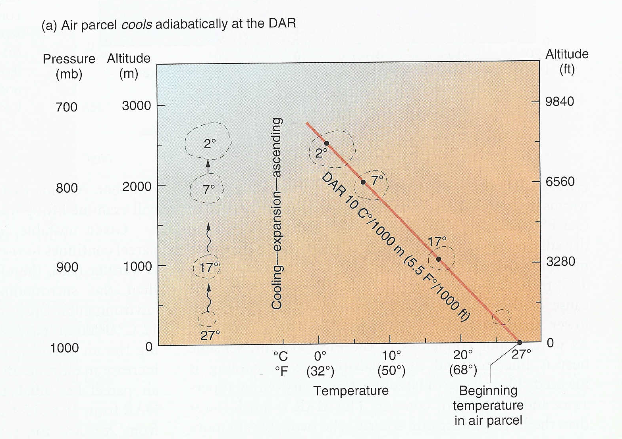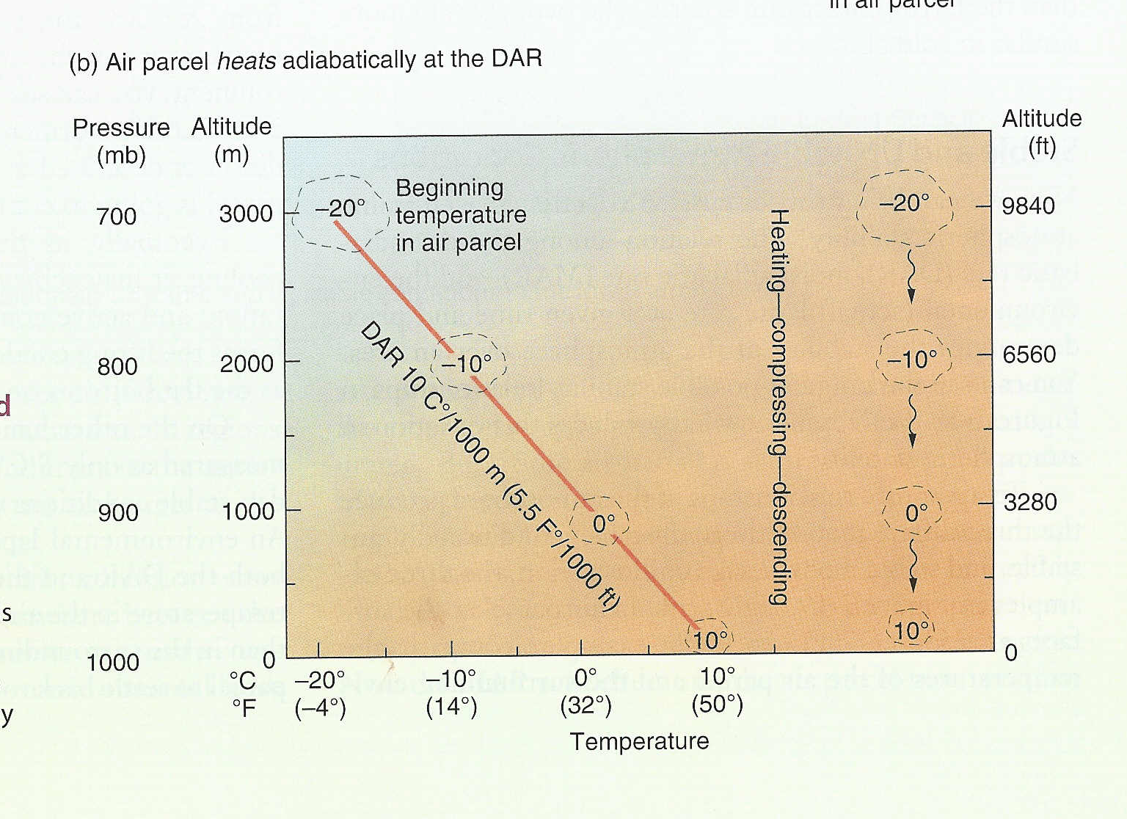

Specific humidity, mass of water vapour in a unit mass of moist air, usually expressed as grams of vapour per kilogram of air, or, in air conditioning, as grains per pound. The specific humidity is an extremely useful quantity in meteorology. For example, the rate of evaporation of water from any surface is directly proportional to the specific humidity difference between the surface and the adjoining air.
Furthermore, the specific humidity does not vary as the temperature or pressure of a body of air changes, as long as moisture is not added to or taken away from it. (Certain other indices of humidityare sensitive to the pressure and temperature.) This stability of the specific humidity makes it useful as an identifying property of a moving air mass. The specific humidity of saturated air (i.e., that in equilibrium with a vapour source, either water or ice) increases rapidly with increasing temperature.

Saturation Specific Humidity Table
Temperature  (ºC) | Saturation Specific Humidity  (g/kg)
40 | 47
30 | 26
20 | 15
10 | 7
0 | 4
-10 | 2

Adiabatic Cooling: is the process of reducing heat through a change in air pressure caused by volume expansion.

Lifting Condensation Level
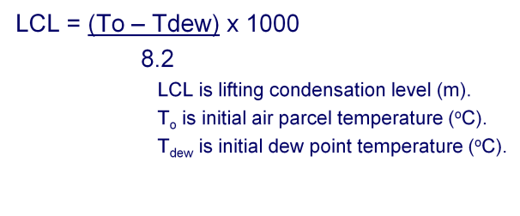
The lifted condensation level or lifting condensation level (LCL) is formally defined as the height at which the relative humidity (RH) of an air parcel will reach 100% when it is cooled by dry adiabatic lifting.

Saturated Adiabatic Lapse Rate
saturated adiabatic lapse rate (SALR) The adiabatic cooling rate of a rising parcel of air which is saturated (see SATURATED AIR), and in which condensation is taking place as it rises, so that the energy release of the latent heat of vaporization moderates the adiabatic cooling. The reduction of the rate of cooling below the dry adiabatic lapse rate of 9.8 °C/km varies with temperature. This results from the greater energy release by condensation from air at higher temperatures. Thus at a given atmospheric pressure, air at 20°C may have an SALR as low as 4°C/km, whereas at −40°C the SALR may be close to 9°C/km. The stability or instability of the atmosphere at any given time for vertical motion is determined by whether the environmental lapse rate of temperature within it is less than or greater than the adiabatic lapse rate (i.e. less than or greater than the rate of decrease of temperature of rising parcels of air).

- SALR (a.k.a. wet and moist).
- < DALR, usually 4 to 9 ºC/1000m.
- Varies with moisture content and initial temperature of parcel of air.
  - ↑ vapour → ↓ SALR (slower cooling).
  - ↓ vapour → ↑ SALR (faster cooling).
  - ↑ T_{o} → ↓ SALR (slower cooling).
  - ↓ T_{o} → ↑ SALR (faster cooling).

- Environmental lapse rate (ELR) depends on many factors - highly variable
- Parcel cooling rate depends only on whether parcel is saturated or not
  - Unsaturated parcel cools at constant dry adiabatic lapse rate (DALR)
  - Saturated parcel cools at slower saturated adiabatic lapse rate (SALR)
- Absolute stability: ELR < SALR
  - Rising parcel always cools more rapidly than environment
    - Whether rising unsaturated and cooling at DALR
    - Or saturated and cooling at SALR
  - Becomes denser than the environment and sinks
  - Environment becomes more stable when lower levels cooled or upper levels warmed
    - Diabatic cooling by surface, either radiative or advective
    - Relative advection: cold air advection at low levels, warm advection at upper levels
    - Subsidence aloft
- Absolute instability: DALR < ELR
  - Rising parcel always cools more slowly than environment
    - Whether rising unsaturated and cooling at DALR
    - Or unsaturated and cooling at SALR
  - Becomes less dense than environment and continues to rise
  - Typically only occurs in boundary layer with strong surface heating
  - Self correcting since triggers spontaneous uplift that mixes warm air upward and cold air downward
    - Vertical mixing reduces environmental lapse rate
- Conditional instability: SALR < ELR < DALR
  - Unsaturated parcel cooling at DALR cools more rapidly than environment
  - Saturated parcel cooling at SALR cools more slowly than environment
  - Stability or instability conditional on whether parcel is saturated or not
  - Forced uplift can trigger instability if parcel cooled to saturation
  - Environment becomes less stable when warmed at low elevations or cooled aloft
    - Surface heating, either radiative or advective
    - Relative advection: warm air at low levels or cold air aloft
    - Radiative cooling from cloud tops, especially in tropics at night
Specific Humidity
- Mass of water vapour (grams) in mass of air (kg).
- Independent of variations in temperature and pressure.
- Used to describe moisture characteristics of air masses.
Relative Humidity
specific humidity x 100
saturation specific humidity
- Temperature dependent.
- Changes by altering:
  - Amount of water vapour in air.
  - Temperature of air.
Variation in Relative Humidity
- ↑ vapour same T → ↑ relative humidity.
- ↓ vapour same T → ↓ relative humidity.
- ↑ T same SH → ↓ relative humidity.
- ↓ T same SH → ↑ relative humidity.
Causes of Condensation
- Addition of water vapour to air.
- Cooling of air.
  - Adiabatic cooling.
  - Mixing.
  - Contact cooling → advection fog.
  - Radiational cooling → radiation fog.

There are three main measurements of humidity: absolute, relative and specific. Absolute humidity is the water content of air at a given temperature expressed in gram per cubic metre.^{[2]} Relative humidity, expressed as a percent, measures the current absolute humidityrelative to the maximum (highest point) for that temperature. Specific humidity is a ratio of the water vapor content of the mixture to the total air content on a mass basis.

Clouds
- Composed of miniscule suspended water droplets and/or ice crystals.
- Condensation nucleus natural or anthropogenic.
- Water droplets can be supercooled.
- Four families by altitude of cloud base: low clouds, middle clouds, high clouds, and vertically developed clouds.
- Three main types by shape: cirrus (cirroform), stratus (stratiform), and cumulus (cumuliform).

HIGH CLOUDS
-- Cirrus
Detached clouds in the form of white, delicate filaments, mostly white patches or narrow bands. They may have a fibrous (hair-like) and/or silky sheen appearance.
Cirrus clouds are always composed of ice crystals, and their transparent character depends upon the degree of separation of the crystals.
As a rule when these clouds cross the sun's disk they hardly diminish its brightness. Before sunrise and after sunset, cirrus is often colored bright yellow or red. These clouds are lit up long before other clouds and fade out much later.
-- Cirrostratus
Transparent, whitish veil clouds with a fibrous (hair-like) or smooth appearance. A sheet of cirrostratus which is very extensive, nearly always ends by covering the whole sky.
A milky veil of fog (or thin Stratus) is distinguished from a veil of Cirrostratus of a similar appearance by the halo phenomena which the sun or the moon nearly always produces in a layer of cirrostratus.
-- Cirrocumulus
Thin, white patch, sheet, or layered of clouds without shading. They are composed of very small elements in the form of more or less regularly arranged grains or ripples.
In general Cirrocumulus represents a degraded state of cirrus and cirrostratus both of which may change into it and is an uncommon cloud. There will be a connection with cirrus or cirrostratus and will show some characteristics of ice crystal clouds.

MID CLOUDS
-- Altostratus
Gray or bluish cloud sheets or layers of striated or fibrous clouds that totally or partially covers the sky. They are thin enough to regularly reveal the sun as if seen through ground glass.
Altostratus clouds do not produce a halo phenomenon nor are the shadows of objects on the ground visible.
Sometime virga is seen hanging from Altostratus, and at times may even reach the ground causing very light precipitation.
-- Altocumulus
White and/or gray patch, sheet or layered clouds, generally composed of laminae (plates), rounded masses or rolls. They may be partly fibrous or diffuse.
When the edge or a thin semitransparent patch of altocumulus passes in front of the sun or moon a corona appears. This colored ring has red on the outside and blue inside and occurs within a few degrees of the sun or moon.
The most common mid cloud, more than one layer of Altocumulus often appears at different levels at the same time. Many times Altocumulus will appear with other cloud types.
-- Nimbostratus
The continuous rain cloud. Resulting from thickening Altostratus, This is a dark gray cloud layer diffused by falling rain or snow. It is thick enough throughout to blot out the sun. The cloud base lowers into the low level of clouds as precipitation continues.
Also, low, ragged clouds frequently occur beneath this cloud which sometimes merges with its base.

LOW CLOUDS
-- Cumulus
Detached, generally dense clouds and with sharp outlines that develop vertically in the form of rising mounds, domes or towers with bulging upper parts often resembling a cauliflower.
The sunlit parts of these clouds are mostly brilliant white while their bases are relatively dark and horizontal.
Over land cumulus develops on days of clear skies, and is due diurnal convection; it appears in the morning, grows, and then more or less dissolves again toward evening.
-- Stratus
A generally gray cloud layer with a uniform base which may, if thick enough, produce drizzle, ice prisms, or snow grains. When the sun is visible through this cloud, its outline is clearly discernible.
Often when a layer of Stratus breaks up and dissipates blue sky is seen.
-- Cumulonimbus
The thunderstorm cloud, this is a heavy and dense cloud in the form of a mountain or huge tower. The upper portion is usually smoothed, fibrous or striated and nearly always flattened in the shape of an anvil or vast plume.
Under the base of this cloud which is often very dark, there are often low ragged clouds that may or may not merge with the base. They produce precipitation, which sometimes is in the form of virga.
Cumulonimbus clouds also produce hail and tornadoes.
-- Stratocumulus
Gray or whitish patch, sheet, or layered clouds which almost always have dark tessellations (honeycomb appearance), rounded masses or rolls. Except for virga they are non-fibrous and may or may not be merged.
They also have regularly arranged small elements with an apparent width of more than five degrees (three fingers - at arm's length).

Clouds and Global Energy System
- Low clouds:
  - Reflect and absorb insolation.
  - Net cooling effect.
- High clouds:
  - Reflect and absorb less insolation.
  - Absorb ground radiation.
  - Net warming effect.

