WEEK 11: Acquiring Information Systems through projects (Chapitre 10 PS&I)

- How can information systems be acquired?

Acquiring a new software application is similar to buying a car. And if we apply this idea to organizations, we can identify 5 basic ways to acquire a software application:
  - Buy it and use it as is
  - Buy it and customize it (most common)
  - Rent or lease it
  - Build it yourself
  - Outsource it
- Acquiring new software application is NOT the same as acquiring new information systems, because there is a lot more to think about in systems than just software. The model of information systems suggested that systems combine hardware, software, data, procedures and people. Acquiring an information system, therefore, involves more than just obtaining and installing software. It involves incorporating the software into the current technological infrastructure and integrating the software into the data and procedures people use to make things happen in an organization.

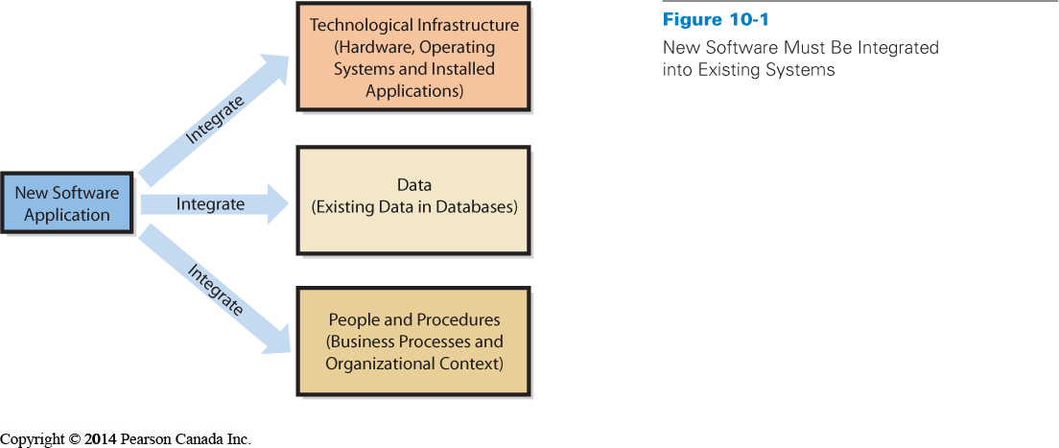`
- What are IT projects and what does PMBOK mean?

When an organization acquires an information system, it has embarked on a project. But what exactly is a project? To answer that question we refer to the Project Management Body of Knowledge (PMBOK), which was developed by the project management institute (www.pmi.org)
A project consists of a temporary endeavor undertaken to create a unique product, service or result
- Projects often begin with a set of goals or objectives
- From these, a scope is developed for the project and project managers are given resources, such as people, money, and working space, to complete the project.
- Projects usually have a start and an end date

Projects that have a large IT component (in terms of budget or personnel) are often referred as IT projects, and these include such things as the installation of a new email application, a CRM system, or an enterprise resource planning (ERP) system. Projects that require some fundamental changes to business processes are often also referred as IT Projects because the new IT supports the change in business processes. IT projects are never exclusively about technology: they affect data, people, and processes.

Information technology project management (ITPM) is the collection of techniques and methods that project managers use to plan, coordinate, and complete IT projects. The tools of ITPM are basically the same tools used in any project management including:
  - Planning tools
  - Budgeting methods
  - Graphical scheduling methods
  - Risk management techniques
  - Communication planning
  - High-tech team development
Application Extension 10a provide some introductory information about these tools

The guide to the PMBOK suggest that there are five process groups in any projects:
(1) Initiating (2) planning (3) executing (4) controlling and monitoring (5) Closing
These process groups should not be viewed as independent entities.
The increasing importance of projects, in particular, IT projects has led to a rapid increase of PMPs: Project management professionals.

- What should you know about IT operations and IT projects?

The IT department is generally responsible for providing IT services to an organization. There are two basic activities required to provide these services. The first is maintaining the current IT infrastructure; the second is renewing and adapting the infrastructure to keep IT working effectively in the future.

1- The delivery of service, maintenance, protection, and management of IT infrastructure are often accomplished as part of IT operations. These services demand a large portion of the IT department’s operational budget. Industry professionals often refer to this as “keeping the lights on,” or KTLO.
2- The renewal and adaptation of IT infrastructure is normally accomplished through projects. IT projects come in all shapes and sizes. Large IT projects are often high-profile, high-cost changes to the status quo of the organization, and can often be funded outside of the IT operations budget.
The distinction between operations and projects is important for several reasons.
For one, operational work and project work tend to attract two different types of IT professionals. IT people who prefer to work in operations often want to specialize in particular technologies. Networking specialists, operating systems specialists, database administrators, and hardware technicians are examples of these types of positions.
These workers continually seek ways to improve the efficiency and security of the entire set of systems that support operations. These active systems are often referred to as production systems. Stability, predictability, accountability, reliability, and security are the key words in IT operations.

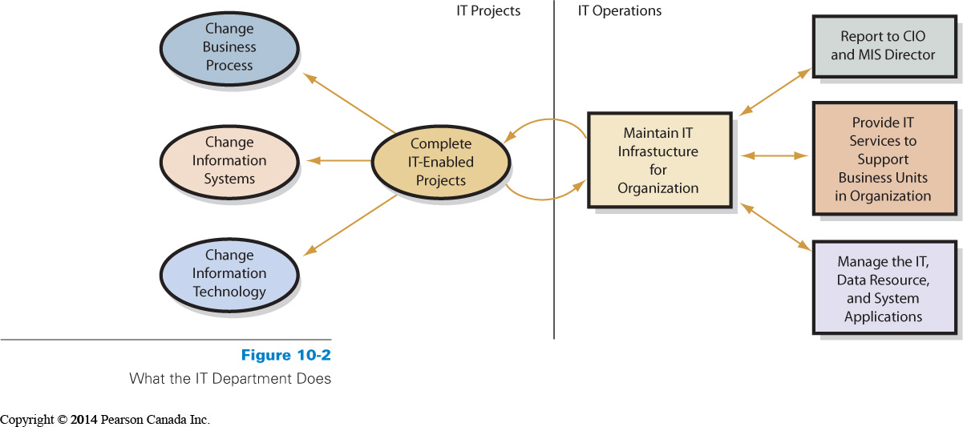Beyond the people involved, there are also differences in the core practices of
IT professionals. Within IT operations, the Information Technology Infrastructure Library (ITIL) is a well-recognized collection of books that provide a framework of best-practice approaches to IT operations. ITIL offers a large set of management procedures that are designed to help businesses achieve value from IT operations.
What is important is that you recognize that a well-developed set of best practices that can support IT operations has been established. It is important to note that while operations and IT projects are separate fields, they rely on each other for success. Projects come to an end and must be maintained, and infrastructure must eventually be replaced. So, there is always a natural balance between projects and operations within any IT department.
Let’s notice that the web plays an increasingly important role in the delivery of IT services in many organizations.

- Why are IT projects so risky?

- Most IT project definitions are not easy to graphically represent. How would you draw the hardware, software, people, procedures and data?
- The lack of a good model is an important risk to recognize in IT projects
- Good estimates about the cost are difficult to develop because the technology is continually changing Computers get cheaper and faster, programming languages, OS, and databases are more complex…
- Being able to monitor progress is another challenge for IT projects, it is difficult to estimate how far an IT projects has come and how far it needs to go. The risks does not necessarily emerge from the technology:
Lack of experience in the team, Lack of support from top management, Lack of participation from system users, Unclear and uncertain project requirements, A high level of technical complexity, and changes in the project environments…

- What is the SDLC?

The systems development life cycle (SDLC) is the classic process used to acquire information systems. The IT industry developed SDLC in the “school of hard knocks”: Many early projects met with disaster, and companies and systems developers sifted through the ashes of those disasters to determine what went wrong. By the 1970s, most seasoned project managers agreed on the basic tasks that need to be performed to successfully acquire and maintain information systems. These basic tasks are combined into phases of systems development.
- Classical SDLC process with five phases:
  - Systems definition
Management’s statement defines new system
Define goals and purpose for new system
  - Must facilitate organization’s competitive strategy
  - Supports business processes
  - Improves decision making
Defining project’s scope
  - Simplifies requirements determination and other subsequent development work
Assess feasibility of project
  - Cost
  - Schedule
  - Technical (refers to whether existing information technology is likely to be able to meet the needs of the new system)
  - Organizational (concerns whether the new system fits within the organization’s customs, culture, charter, or legal requirements)

  - Requirements analysis
Identify features and functions, to form the project team and develop the requirements.
- Management of scope in an IT project
- Determine and document specific features and functions of the new system
- Approve requirements
- Less expensive to change system in this phase

  - Component design
Based on approved user requirements (explain after)

  - Implementation
Implement, test, and install new system (explain after)

  - System maintenance
Repair, add new features, maintain (explain after)

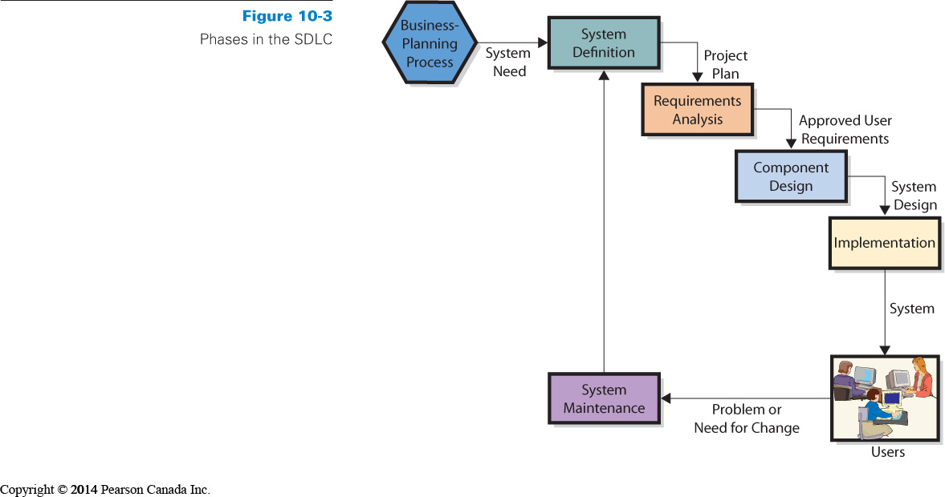

- How are Information Systems designed, implemented, and maintained?

Seen previously to acquire an information system:
  - Buy it and use it as is
  - Buy it and customize it (most common)
  - Rent or lease it
  - Build it yourself
  - Outsource it
For options 1-3, the information system is already build so the organization must match its requirements with the capabilities of the available software application:
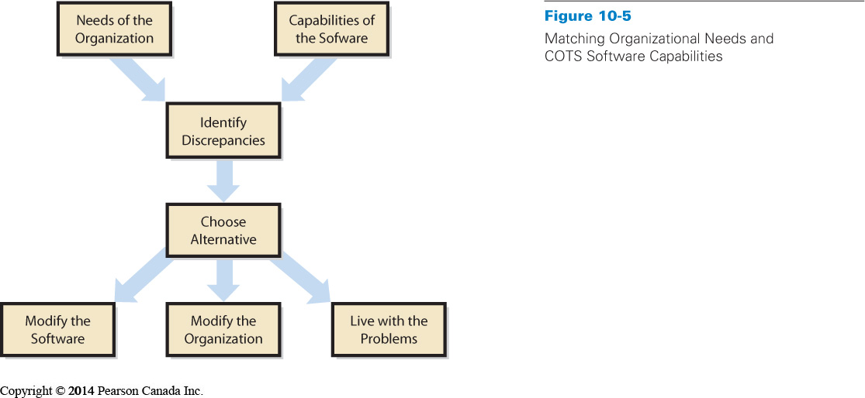

- Component design
Based on approved user requirements
- Develop and evaluate alternatives
Accurate requirements are critical, if they are incomplete or wrong then they will be poor guides for evaluation.
- Hardware specifications design determined by project team
- Software design depends on source
  - Off-the-shelf: the team must determine candidate products and evaluate them against the requirements.
  - Off-the-shelf with alterations software: the team identifies products to be acquired off the shelf and then determines the alterations required.
  - Custom-developed programs: the team produces design documentation for writing program codes.
- Data model converted to database design
- Procedures designed for BI system
- Job descriptions created for users and operations personnel if the new information system requires new jobs.

- Implementation
Once the design is complete Implement, test, and install new system
- System must be built
  - Components constructed independently by developers: they obtain, install, and test hardware.
  - They document and review and test procedures and they create training programs. Finally the organization hires and trains needed personnel.
- System testing
  - Individual components tested
  - System integrated and tested
A test plan consists of sequences of actions that users take when using the new system. Both normal and incorrect actions should be considered.
Testing or Product quality assurance (PQA) consists of constructing the test plan with the advice and assistance of users.
Beta testing is the process of allowing future system users to try out the new system on their own.
- Users must be converted to new system
Converting business activity from the old system to the new
4 ways of implementing a system conversion:
- Pilot
    - The organization implements the entire system on single, limited unit
    - If systems fails, it only affects limited boundary so it reduces exposure
2- Phased
    - New system installed in phases
    - Tested after each phase
    - Continues until installed at entire organization
    - Can’t be used in tightly integrated systems
3- Parallel
    - New system runs in parallel with old system during testing
    - Expensive and time consuming
    - Data must be entered twice
    - Provides easy fall back position
- Plunge
    - Direct installation
    - Install new system and discontinue old
    - There is no backup position

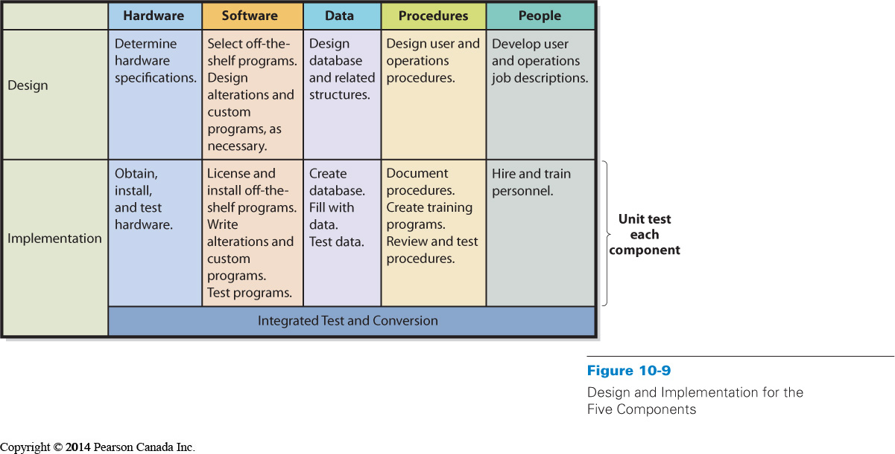
- System maintenance
Repair, add new features, maintain
Fixing the system so that it works correctly or adapting system to changes in requirements
  - Need method to track system failures and enhancements
  - Corrections usually prioritized based on severity
Creation and installation of patches (high priority failures) & service packs (low priority problems)
  - Enhancements usually prioritized based on business decision
Must generate reasonable rate of return

Problems with the SDLC:
- SDLC waterfall
Phases are not supposed to be repeated but, often, teams need to repeat requirements and/or design phases
- Difficulty in documenting requirements
Analysis paralysis or uncertain requirements
- Scheduling and budget difficulties
Multiyear projects difficult to properly schedule
Estimations on labour often produce insufficient budgets

- What is outsourcing, and what are application service providers?

Outsourcing is the process of hiring another organization to perform a service
Just about any business activity in the value chain can be outsourced, from marketing and sales to logistics, manufacturing, or customer service.
- The outsourced vendor can be domestic or international
Offshoring is when vendor is overseas (ex: China, India, and Russia)

WHY?
First, outsourcing can be an easy way to gain expertise. Other common reasons for choosing to outsource concern cost reductions. Another reason for outsourcing might be to reduce development risk. Outsourcing can cap financial risk by setting specific prices on components of the system. I addition, outsourcing can reduce risk by ensuring a certain level of quality or avoiding the risk of having substandard quality. Organizations also choose to outsource IS activities to reduce implementation risk.
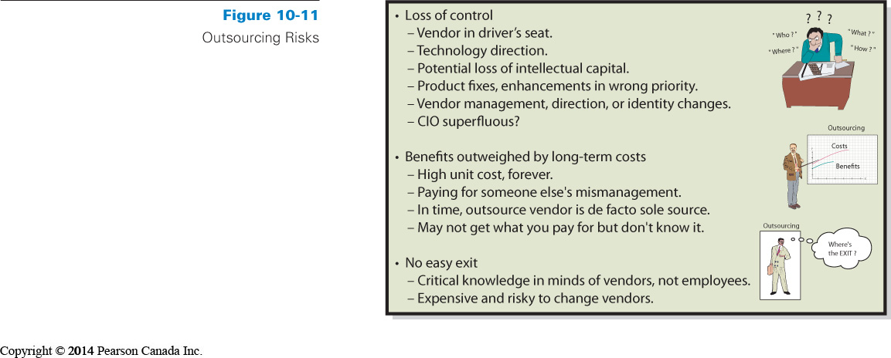 Application Service Providers
Application service providers (ASPs) are a special form of outsourcing

ASP agreement: Organization contracts with a vendor to “rent” applications from the vendor company on a fee-for-service basis
Vendor maintains the system at its own web location and the client organization accesses the application on the vendor’s website
Payments
  - Monthly or yearly
  - Based on number of employees or “users”

Application extension 10a: Introduction to Microsoft Project

- What is project management software?

- There are many types of project management software:
  - Focusing on organizing tasks
  - Managing resources or schedules
  - Tracking employee work hours on different projects
  - Providing repositories for storing and providing access to project documentation
- MS Project provides full-service product for the project management process
  - Contains largest number of installed users in project management software
  - Provides an excellent entry point into how project management software differs from other applications

MS project looks like a spreadsheet
  - A Database Product
- Has a sophisticated relational database that stores information about tasks, resources, schedule, baselines, and budgets
- Allows you to enter information into the database through specifically designed forms
- Presents the project data through specially designed “views” that often focus on one or two aspects of the project

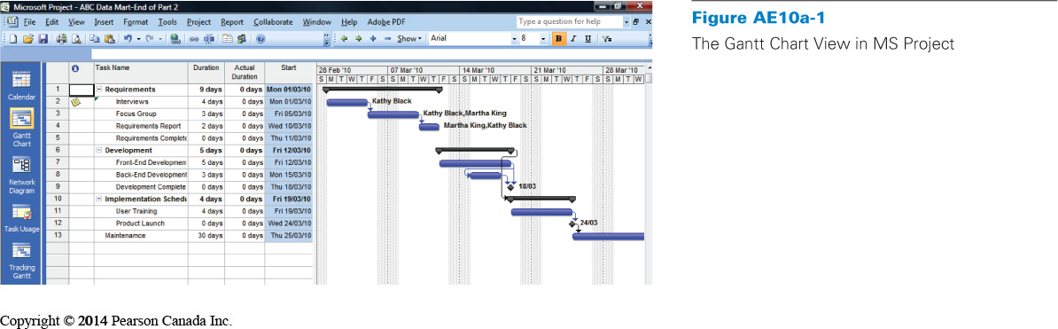
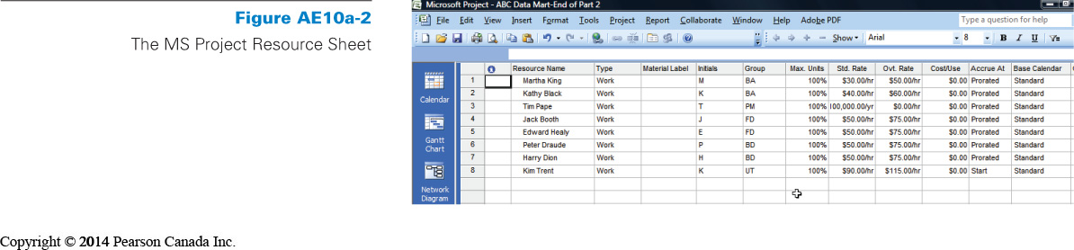
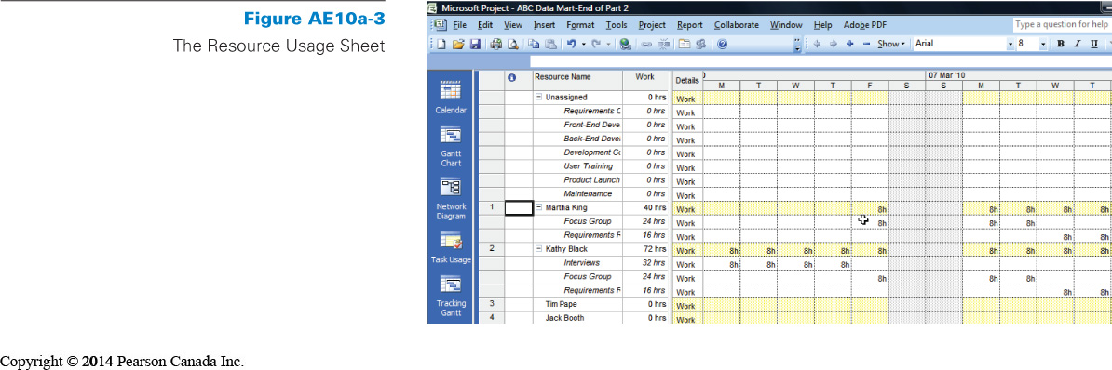

- How do I create and manage tasks?

We begin with a brand-new file
- Open MS Project
- Select New File
- Create a blank project
- Now save this project as “Intro to MS Project”
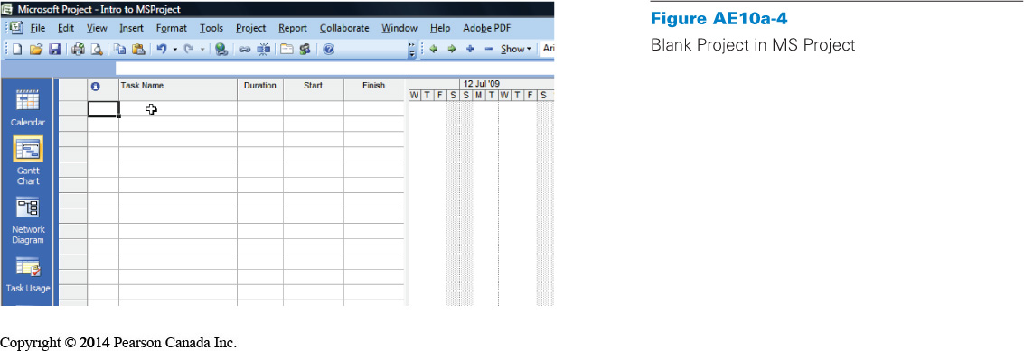
Adding a task:
- Click in the first row of Task Name column
- Type “Requirements”
- Press Enter
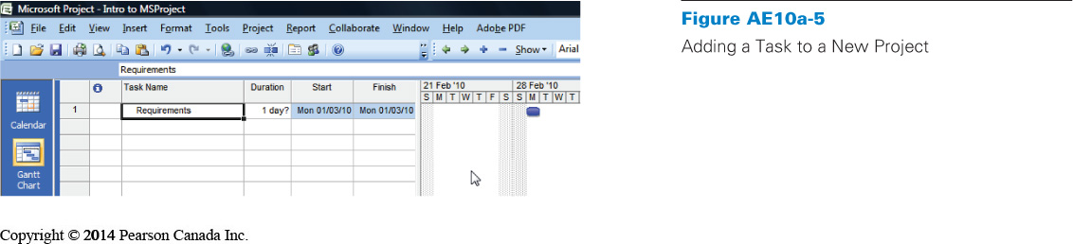Creating subtasks:
- Select one or more tasks
- Then click the right tab button
- The three selected tasks then become subtasks
- The opposite happens when you select a task and click on the left tab button
- The higher-level tasks are given a different icon, which envelops all the subtasks within it
- The duration time for the tasks is equal to the largest subtask duration
- This happens automatically when you create tasks and subtasks

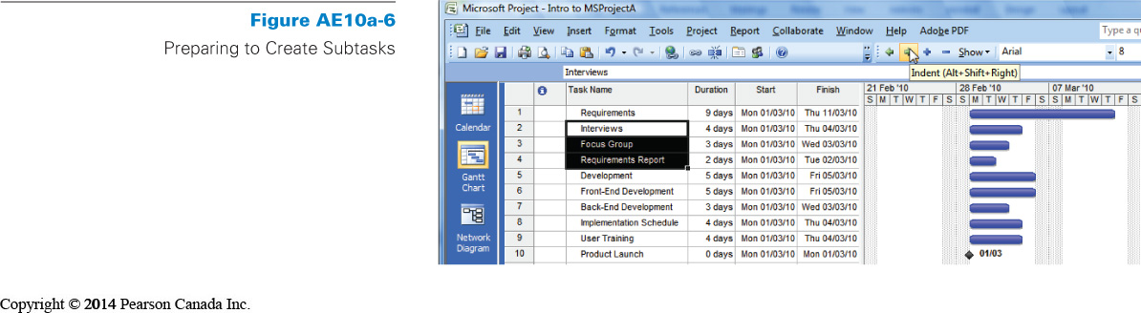
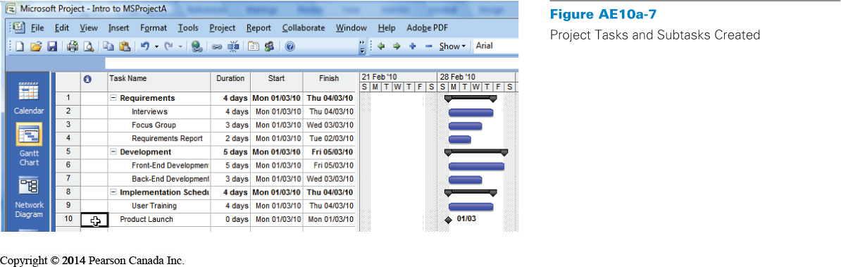
Creating dependencies:
- Some tasks cannot be completed until other tasks are completed
- There is often a dependency between two tasks
- One task therefore becomes the predecessor
- The other task is the successor
- These dependencies are crucial for creating a meaningful schedule
- To assign predecessors, we use the task window in MS Project

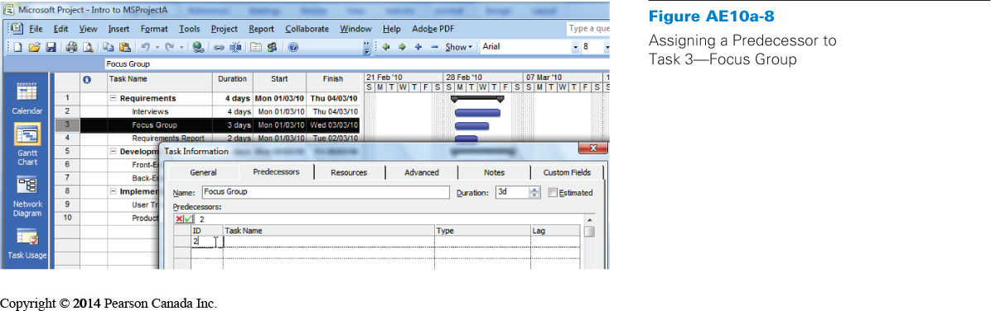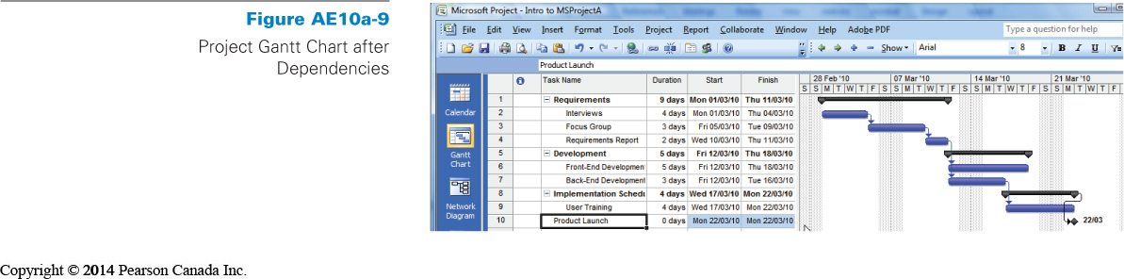

- How do I manage resources?

- We use the Resource Sheet view in MS Project
- The view can be selected by clicking on the View menu and highlighting the Resource Sheet view
- Once the Resource Sheet is selected, a blank resource sheet pops up
- The resource sheet is empty, because no one has filled in the information about the people who may be working on your project
- Enter information into the resource sheet
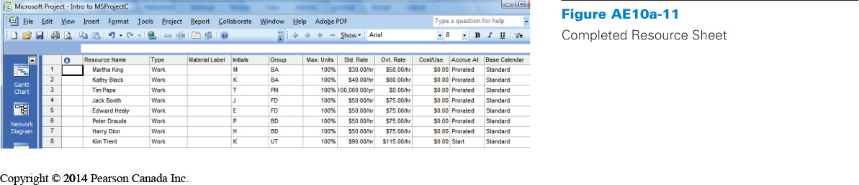

Adding resources to tasks:
- Assign people on resource sheet to the tasks defined earlier
- Click on the View menu and highlight the Gantt Chart view
- Start by assigning resources to Task 2, Interviews
- To add a resource, double click on the Task 2, Interviews row
- Click on the Resource tab and you will get a form that allows you to add resources to the task
- Click in the top box in the resource table and you will see a drop-down box appear


