WEEK 10: E-commerce, Social Networking and Web 2.0 (Chapitre 9 E-MIS)

- What is e-commerce, and how is it used?

E-commerce: Buying and selling of goods and services over public and private computer networks and is a subset of electronic business.
- This definition restricts e-commerce to buying and selling transactions
- Checking the weather at Yahoo.ca is not e-commerce, but buying a weather service subscription that is paid for and delivered over the Internet is.
E-commerce has a number of implications:
1- Technology perspective: Defines the need for additional infrastructure
- Management and governments’ perspective: Coordination for smooth business operations, Security must be enabled
The e-commerce is just a subset of e-business but there is still many varieties:

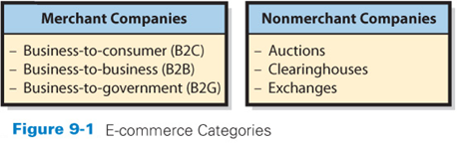
E-commerce categories:
- Merchant companies
  - that take title to the goods they sell
  - buy goods and resell them
  - sell services that they provide
- Non-merchant companies (intermediaries)
  - arrange for the purchase and sale of goods without ever owning or taking title to those goods
  - sell services provided by others

E-commerce Merchant Companies:
- Business-to-consumer (B2C)
  - Sales between a supplier and a retail customer (the consumer) A typical information system for B2C provides a web-based application or web storefront by which customers enter and manage their orders.
Ex: EBAY
- Business-to-business (B2B)
  - Sales between companies
Ex: Walmart
- Business-to-government (B2G)
  - Sales between companies and governmental organizations
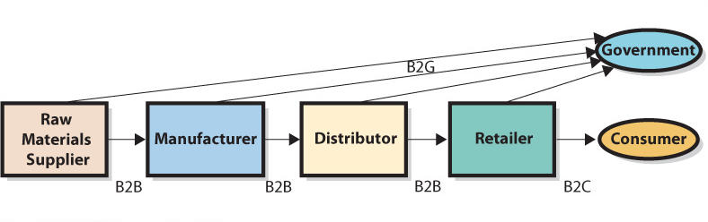
Non merchant E-Commerce:
- The most common nonmerchant e-commerce companies are auctions and clearinghouses
  - E-commerce auctions match buyers and sellers by using an e-commerce version of a standard auction (such as EBay and Ritchie Bros. for largest industrial auctioneers). This e-commerce application enables the auction company to offer goods for sale and to support a competitive-bidding process.
  - Clearinghouses provide goods and services at a stated price and arrange for the delivery of the goods, but they never take title; One division of Amazon for example operates as a non merchant clearinghouse and sells books owned by others, matches the seller and the buyer and then takes payment from the buyer and transfers the payment to the seller, minus a commission.
  - Other examples of clearinghouse businesses are Electronic exchanges: match buyers and sellers; the business process is similar to that of a stock exchange. Sellers offer goods at a giver price through the electronic exchange, and buyers make offers to purchase over the same exchange. Price matches result in transaction from which the exchange takes a commission.
Ex: priceline.com

Benefits of E-commerce:
Lead to greater market efficiency
- Disintermediation (manufacturer direct to consumer), removal of intermediaries between parties. This lead to higher revenue for manufacturers and lower consumer price.
- Improve the flow of price information (websites with product price comparisons)
- E-commerce, from the seller’s side, produces information about price elasticity.
Losing bidder-auction prices, price experimentation, more accurate information obtained directly from customers.
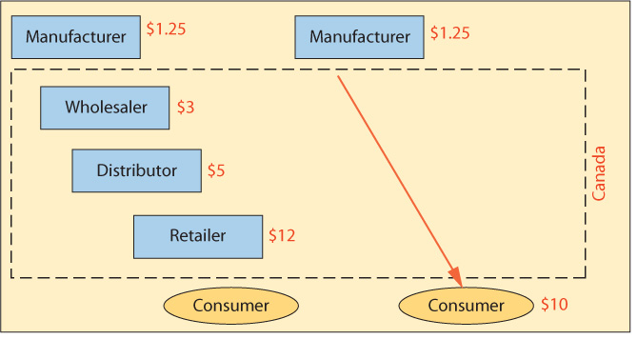

Some problems:
- Channel conflict: due to disintermediation or online-offline operations
- Price conflict: when online offers a lower price
- Logistics expense: DC, Wholesalers may efficiently distribute than online stores
- Customer service expense: may increase with online operations
- Showrooming: cost when customers shop offline, buy online
- Taxation: Location of production/consumer, can buy in countries without taxes.

- What is social networking, and how is it enabled and affected by IS/IT?

- A social network is a structure of individuals and organizations that are related to each other in some way (facebook, twitter…)
- Social networking is the process by which individuals use relationships to communicate with others in a social network

What is social capital?
- Business literature defines three types of capital:
  - Physical: the investment of resources for future profit (factories, machines, manufacturing equipment…)
  - Human: the investment in human knowledge and skills for future profit (by going in class for example)
  - Social: investment in social relations with the expectation of returns in the marketplace (going to meetings, join Linkedin)
Social Capital adds value in four ways:
- Information about opportunities, alternatives, problems…
- Opportunity to influence decision makers in one’s employer or in other organizations who are critical to your success.
- Being linked to a network of highly regarded contacts is a form of: Social credentials
- Personal reinforcement of your personal image and position in an organization/industry.
The value of social capital is determined by the number of relationships in a social network, by the strength of those relationships and by the resources controlled by those related.

Strong & weak relationships
- Strong relationships create the most social capital in a social network
- Weak relationships, ironically, contribute the most to the growth of social networks
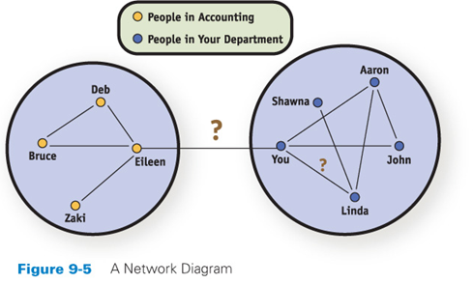
If you introduce yourself to Eileen, you open up an entirely new network of acquaintances. So, considering just network building, you use your time better by meeting Eileen and other people who are not part of your current circle. It opens up many more possibilities. The connection from you to Eileen is called a weak tie in social network theory. Weak tie: the people you know the least but they contribute the most to your network
Weak links add the greatest number of new connections to your social network

How do Social networks add value to business?
- Organizations have social capital just as humans do
Social capital is measured using: number of relationships, strength of relationships, and resources controlled by “friends”
Historically, organizations have created social capital via salespeople, via customer support, and via public relations.
- Endorsements by high profile people are a traditional way of increasing social capital
- Many organizations maintain a presence on Facebook, LinkedIn, Twitter, and possibly other sites. They include links to their social networking presence on their websites and make it easy for customers and interested parties to leave comments. In most cases, such connections are positive, but they can backfire or occasionally result in unintended consequences, as has happened, for example, when a large number of strangers or friends of friends show up at what was supposed to be a small house party.

How is social networking enabled by IS/IT?
Besides the ubiquity of computers and the relative low cost, three other considerations and benefits of technology are:
  - Improved search capabilities: is important to social networking because it enables us to quickly sort through large amounts of data and find the specific people or relationship that we are interested in.
  - Reduction in the trade-off of richness and reach: is the ability to keep track of many more people and enhance personalization. For example, the more people that we connect with; the lower is the level of interaction that can exist with each connection.
  - Network effects: a network of 10 people is five times more valuable than a network of two people. As a network grows, the benefit or utility that each person adds tends to increase. This can accelerate the speed at which networks grow and how useful they become.

3. What is Web 2.0?

  - Describe applications and platforms on the web
  - Tim Reilly is noted for helping to establish the concept of Web 2.0
Ex: include smartphones, user created content, social networking, location and context-based services and dynamic marketplaces.
  - Google, Amazon.com, and eBay exemplify Web 2.0

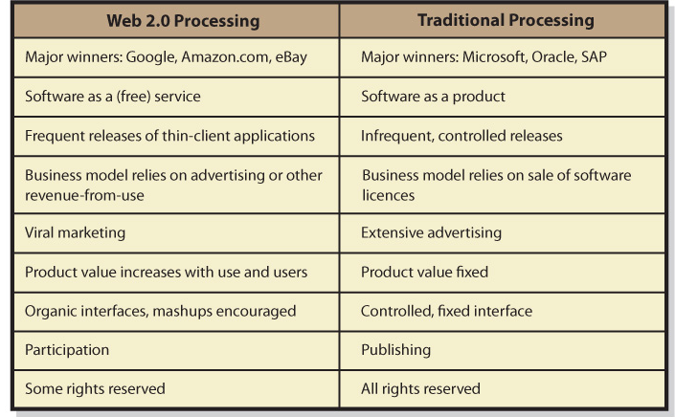

Software as a Service (SAAS) Web 2.0 companies do not sell software licenses because software is not their product
- Instead, they provide software as a service (SAAS)
- Some software items are in a thin-client browser, with the bulk of the processing occurring in the cloud
- The Web 2.0 business model relies on advertising or other revenue obtained when SAAS is used
- Traditional software vendors depend on software license fees

Use increases revenue Web 2.0 builds on network effects: the value of the site increases with users and use
Ex: Amazon.com gains more value as more users write more reviews
- User-generated content (UGC) refers to website content that is contributed by users (objectivity is often questionable)
- On some sites, users can provide customer support to one another or even participate in the creation of product specifications, designs, and complete products in a process called crowdsourcing
Crowdsourcing is a combination of social networking, viral marketing, and open-source design, saving considerable cost while cultivating customers. With crowdsourcing, the crowd performs classic in-house market research and development and does so in such a way that customers are being set up to buy.

The traditional software model carefully controls user’s experience. The user interface can change from day to day. Further, Web 2.0 encourages mashups, which results when the output from two or more websites is combined into a single user experience. (Google My Maps for example). Traditional sites are about publishing; Web 2.0 is about participation. Users provide reviews, map content, discussion responses, blog entries, and so forth. A final difference concerns ownership.

How can Businesses benefit from Web 2.0?
- Amazon.com, Google, eBay, and other Web 2.0 companies pioneered Web 2.0 technology and techniques to their benefit.
- Businesses use Web 2.0 as follows:
- use it for advertising
- Mashups: while watching a movie, necklace may interest few viewers, then on the side, an Ad can help; Google maps allows users to make changes and let them use for a purpose.
- Not for all applications
Note that not all business information systems benefit from flexibility and organic growth (user extendable) and there is need for some level of control: SOX, Bill 198 that will prescribe much information that you can provide and how it is to be displayed.

  - Is there a Web 3.0?

- Web 2.0 is thought to be preceded by Web 1.0, and that it will be followed by Web 3.0
- It is hard to predict the future as some changes are discontinuous and the invention and use of technology are hard to predict as well
- Web 2.0 is a broad overarching term
- We cannot predict what Web 3.0 will look like (or even if it will be called “Web 3.0”)
- Nobody knows what the next generation of inventors and entrepreneur will invent
Henry Ford famous statement about “faster horses”: where until we are presented with a technology, our mental models, how we seen the world, often prevent us from imagining radically different ideas.


