WEEK 8: APPLICATION EXTENSION 5b (E-MIS)

- How do I create tables?

Open Access
- From New Blank Database in the centre of the screen
- Select Blank database
- Provide file name
- Give location
- Click Create
Creating a table means: designing the table. Once the table is designed, data can be entered.
- Access opens the new database by creating a default table, Table1
- To modify the design of the table, check the upper left-hand corner for a pencil and right-angle square
  - Click View and Select Design View
  - Provide a name to the table
AutoNumber means, the system automatically generates a unique number (it is a data type but you can change it depending of your field)
- Enter Field Names
- Enter Data Types
- Establish length of a text data type.
- Select primary key
- Save table
- Name table

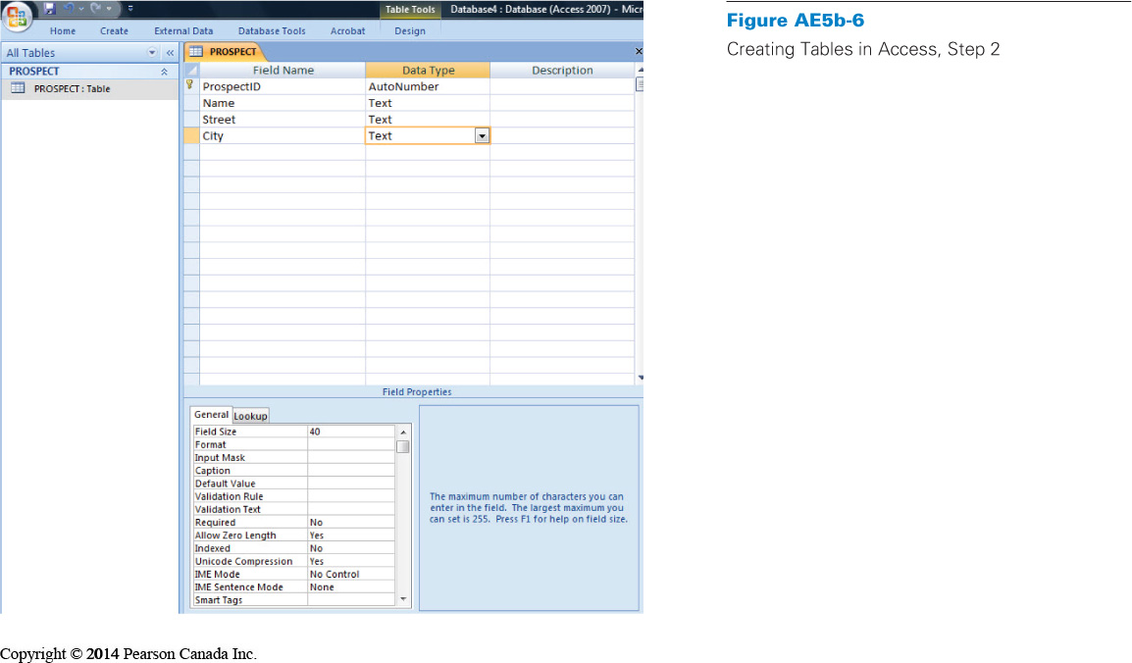

For ex : (create PROSPECT and WORK tables)
Before someone has become a volunteer, he or she is a prospect.
Prospect has past volunteer experience, who is now a prospect to volunteer again.
PROSPECT table identifies.
WORK table provides info about hours worked.

- ProspectID is the primary key in PROSPECT table little key icon next to it
ProspectID, Date, and Hour together is primary key in WORK table.
- ProspectID is the foreign key across tables.

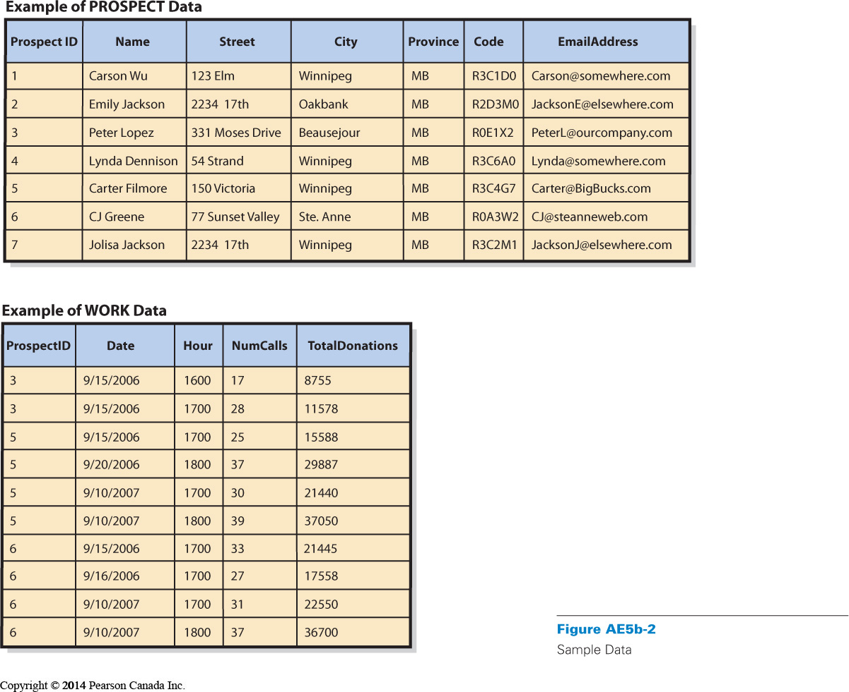

- How do I create relationships?

Defining relationships:
  - Click Database Tools tab in the ribbon
  - Select Relationships icon
    - Window opens
    - Show Table dialog box displayed
    - Double-click on names of tables
    - Tables added to Relationships window
    - Close Show Table dialog box
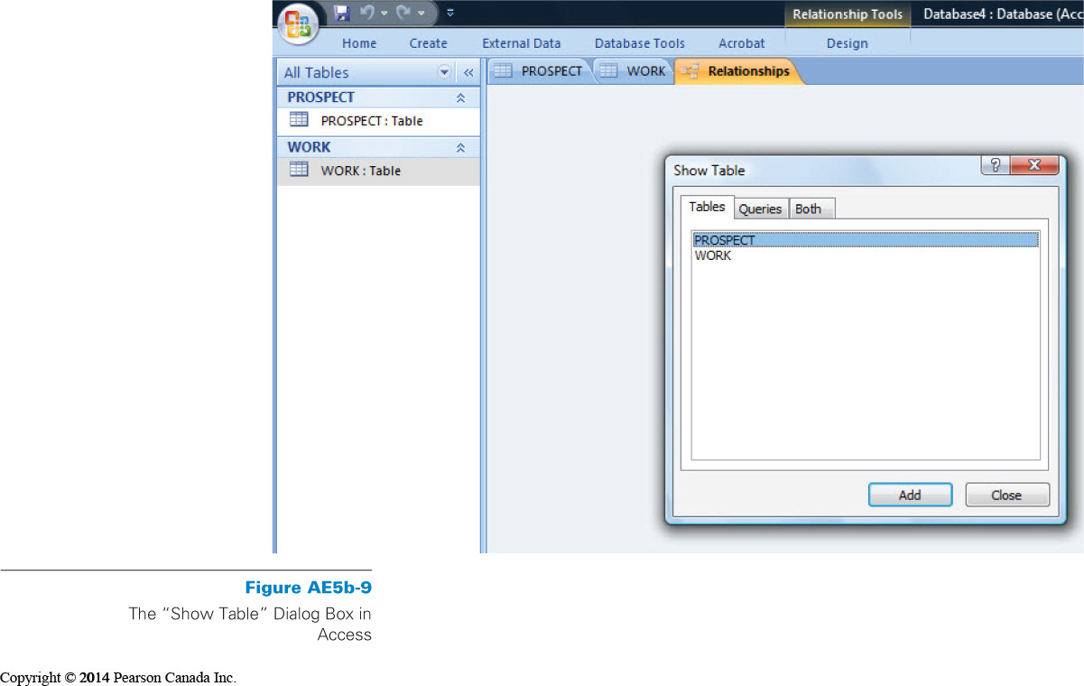
- Click on the attribute in one table
- DRAG it on top of the attribute in the second table
- A dialog box appears
- Click Enforce Referential Integrity
(for preventing data integrity issues automatically)
- Click Cascade Update Related Fields
- Click Cascade Delete Related Fields
(for automatic update or delete related records)
- Close Relationships window
- Save changes

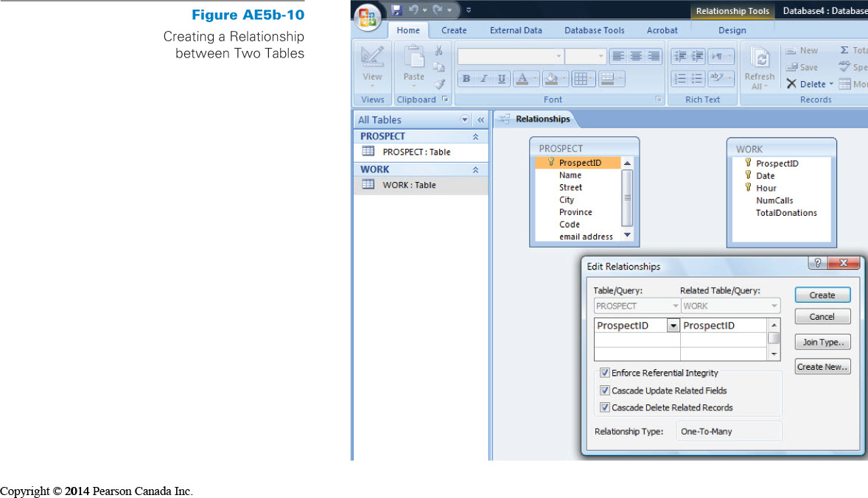
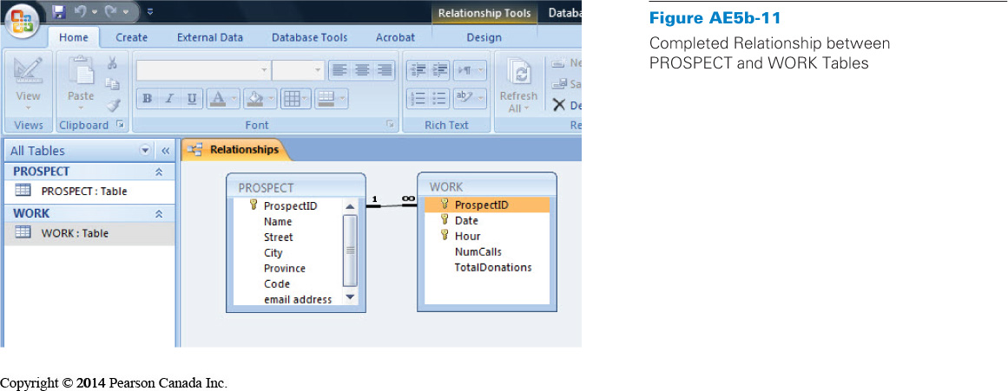

Entering data :
- Double-click on table name in All Tables pane
- Table appears
- Enter values into cells

- How do I create a data entry form?

Use the default table display: display related record. This display, although convenient is limited in its capability, it also does not provide a very pleasing user interface.
For more generality and better deign, you can use Access Form Generator
  - Click on Create tab to open the Create ribbon
  - Click on the table (here the prospect table so it creates a form for prospect) to create a form
  - Click on Form

- You can use the form to modify, add data and delete record
- To add data: Click in the last row of the work grid (=grille)
- To delete a record: Click the Home tab, and then in the Records section click the down arrow next to Delete and Select Delete Record. This action will delete the prospect data and all related work data.
The are many options for customizing Access Forms (select design view and for example you can reduce the width of the fields, resize subforms…)

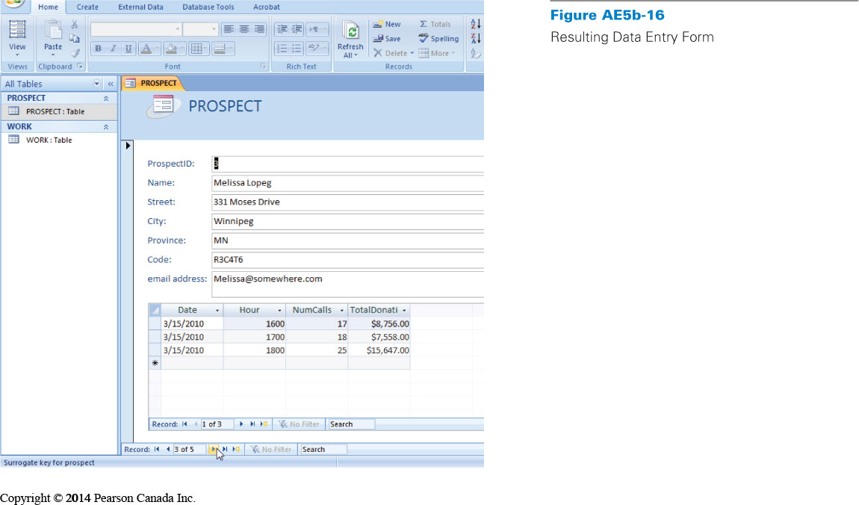

- How can I create queries using the query design tool?

- Like all modern DBMS products, Access can processes SQL query (structured query language) to display for ex only name, email, date and subject.
- Access does provide a graphical interface that we can use to create queries
  - Will generates SQL statement for us
- Creating queries
  - Click the Create Tab in the ribbon
  - Click the Query Design button
  - Double-click on tables’ names (here prospect and work)
  - Close the Show Table window
  - Access places tables into query design form
  - Access remembers relationship between the two tables
- Drag columns out of the PROSPECT and WORK tables into the grid in the lower part of the query definition form
- Click on RUN (red exclamation point) icon: left side of the ribbon
- Access will show rows that have value matches in all tables
- Save

- How do I create a report?

- Use Report Wizard (process similar to that for forms but the report will not include the work data)
- Click the Create Tab
- In the Report Section, click on Report wizard
- Select table in Table/Queries combo box
- Highlight for ex Name in the available fields list
- Double-click on the single chevron (>) to add Name to the report
- You can add additional items the same way
- Click Finish



