WEEK 7: Database and Content Management (Chapitre 5 E-MIS)

- What is content?

Content is closely related to intellectual property it is a form of creative endeavour that may be protected through a trademark, patent, copyright, industrial design, or integrated circuit topography. Content varies by industry.
Organizations have databases that store large amounts of data related to customers, employees, and orders… Organizations also store a lot of other content: documents, spreadsheets, presentations, web pages, text from blogs, Twitter, or discussion boards, graphics, video files and video logs, audio files, etc.

- How can content be organized?

> Content management
  - Content structuring and representation
  - Data management focuses on how to efficiently and effectively store and process these bytes (all data in computing systems are represented by bytes)
  - Handled by organizational databases management systems (DBMS)
  - Retrieval and presentation (Content management system CMS help companies to present the contents)
  - Security
> Challenges
  - Processing and storing the right content
  - Getting the right content to the right person in the right format at the right time
  - Providing secure access

- What is the purpose of a database?

A database keeps track of things: Store data
Spreadsheets vs. databases:
- Spreadsheets
If the structure of the list is simple enough (for example: a list of student grades)
Store lists of single concepts
Single-user oriented
Manual linkages
* Databases
Multiple lists of complex and multiple concepts (example: not only grades but emails and office visits too)
Multi-user
Automated linkages

- What does a database contain?

- A database is a self-describing collection of integrated records, a collection of tables.
- Data hierarchy
- A byte is a character of data
- Bytes are grouped into columns also called fields (such as student number, name…)
- Columns/fields are grouped into rows, which are also called records
- The collection of data for all columns is called a row or a record
- A group of similar rows or records is called a tables or a file.

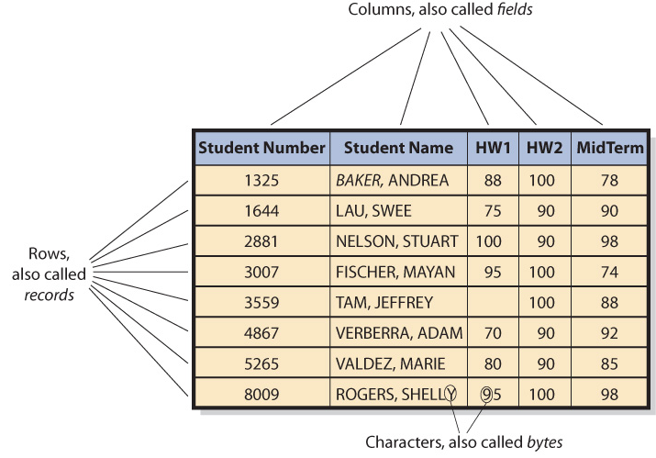

A database is a collection of tables plus relationships among the rows in those tables plus metadata, which describes the structure of the database.

Relationships:
- Values in one table may relate to rows in other table(s)
- Primary keys
  - Column(s) that identify a unique row in table
  - Each table has a key (helps to search in a table)
- Foreign keys
  - Keys in a different table than the one in which they reside (helps to search across tables)
- Relational database
  - Databases using tables, keys, and foreign keys

Metadata:
- Databases are self-describing
  - Database is a collection of integrated records
  - Contains, within itself, a description of its contents
- Metadata
  - Data that describe data (field name, data type, description)
  - Makes databases more useful than spreadsheets
  - Makes databases easier to use

- What is a DBMS, and what does it do?

- Database Management System (DBMS)
Program that creates, processes, and administers a database. Almost no organization develops its own DBMS; instead companies license DBMS products from vendors:
- Microsoft Access and SQL Server
- Oracle Corporation Oracle
- IBM DB2
- MySQL (open-source: free for most applications)

DBMS and DATABASE are two different things:

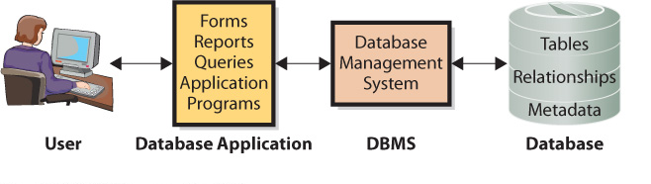

DBMS functions:
- Creating the database and its structures
  - Use the DBMS used to create tables, relationships and other structures in the database
  - Use to define a new table or modify tables
- Processing the database
  - DBMS processes database
  - Applications use DBMS to read, insert, modify, or delete data
  - Structured Query Language (SQL): International standard for processing a database
- Administering the Database
  - DBMS provides tools to assist in administration of database
  - Can be used to set up a security system
  - Used to back up data
  - Add structure to improve performance
  - Remove data

- What is a database application?

A database application is a collection of forms, reports, queries, and application programs that process a database. A database may have one or more applications and each application may have one or more users.

- Forms, Reports, and Queries
- Forms: used to read, insert, modify, and delete data.
- Reports: Show data in structured context, may compute values.
- Queries: means of getting answers from database data/
Forms, reports, and queries work for standard functions
- Database application programs
- Application programs process logic specific to business need; enables database processing over Internet; serves as intermediary between Web server and database; responds to events; reads, inserts, modifies and deletes database data.

- Multiuser Processing
- Some multiuser processing is common, but it does pose unique problems that you, as a future manager, need to be aware of. This problem, known as the lost-update problem exemplifies one of the special characteristics of multiuser database processing. To prevent this problem some type of locking must be used to coordinate the activities of users who are unaware of each other. But locking brings its own complexity and problems.
- Data conflicts produce inaccurate results

- What is the Difference between an Enterprise and a Personal DBMS?

- Enterprise DBMS
- Process large organizational and workgroup databases
- Support many users and many database applications
Examples: DB2, Microsoft’s SQL Server, Oracle

- Personal DBMS
- Designed for smaller, simpler database applications
- Supports fewer than 100 users
Examples: MS Access, dBase, FoxPro, Paradox, R:Base

APPLICATION EXTENSION 5a

      - Who Will Volunteer?

Suppose you are a manager of fundraising for a local public television station. Twice a year, you conduct fundraising drives, during which the station runs commercials that ask viewers to donate. One of your jobs is to find volunteers to staff the phones during these drives. Finding volunteer for each drive is a perpetual headache. You would like to know before calling potential volunteers if: some volunteers have been helping for years, who is more effective, some who have a particular knack for increasing the callers’ donations… although those data are available, the information is not in the format that you can use when calling your volunteers.
You know you can use a computer database to keep better track of prior volunteers’ service and performance but you are not sure how to proceed. You will know by the end of this application extension.

      - How Are Database Application Systems Developed?

* Database application system consists of a database, a DBMS and one or more database applications.
* Database application, in turn, consists of: Forms, Reports, Queries and possibly application programs.

Database application system development process:

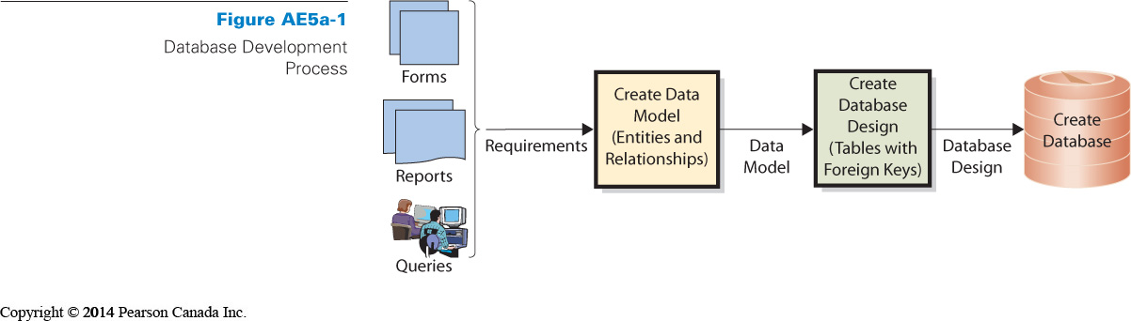
- First, the developers interview users and develop the requirements for the new system during this process they analyze existing reports, forms, queries and other user activities.
- Requirements for the database are then summarized in something called the data model, which is a logical representation of the structure of the data; The data model contains a description of both the data and the relationships among the data.
- The users validate and approve the data model and it is transformed into a database design
- The design is implemented in a database and that database is then filled with user data

The database must include all data necessary for users to perform jobs, Contains only that amount of data, and no more.
Developers rely on users to: Tell them what to include, Check data model, Verify correctness and completeness.

      - What Are the Components of the Entity-Relationship Data Model?

Techniques for creating data model:
Entity-relationship (E-R) diagram: data model the most popular
Unified Modeling Language (UML): Object oriented less popular

E-R data model components:

  - Entities: something that users want to track
Ex: Order, Customer, Salesperson, and Item
Some entities represent a physical object (ex: Item or Salesperson) other represent a logical construct or transaction (ex: Order or Contract)
* Entity names are always singular (jamais au pluriel)
Entities have:
- Attributes that describe the characteristics of the entity (ex: order number, order date, subtotal, tax…)
- Identifier which is an attribute (or group of attributes) whose value is associated with one and only one (unique) entity instance (ex: Order Number is an identifier of order because only one order instance has a given value of order number)

  - Relationships among those entities
Entities have relationships to each other:
1:1 relationship: One-to-one; single entity to single entity
1:N relationship: One-to-many, Single entity to many entities
N:M relationship: Many-to-many

E-R Diagrams (ERD)

- Rectangles represent entities (with attributes under and the first one is the PK-identifier)
- Relationships shown by line
- Crow’s foot: Forks at end of lines, Indicate more than one relationship, Read “many”
- Vertical line means at least one entity of that type
- Small oval means entity is optional

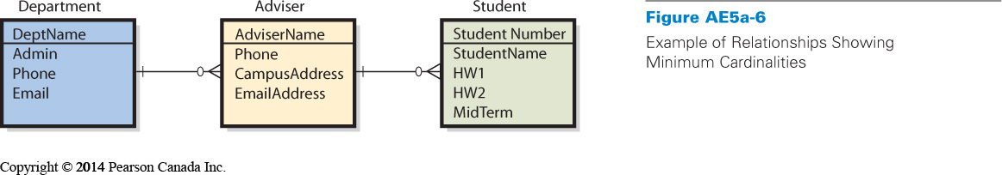

Cardinality
Relationships like one-to-many, many-to-many is referred to as cardinality. One-to-one is like splitting a big table into smaller and concise ones.
# of entities that can be involved in relationship:
  - Maximum cardinality: maximum number involved (1:N, N:M)
  - Minimum cardinality: constraints on minimum requirements (0 if oval, 1 if vertical bar)
User knows the cardinality better than a designer.

      - How Is a Data Model Transformed into a Database Design?

Database design is the process of converting a data model into tables, relationships, and data constraints
We are going to introduce two important database design concepts:

- Normalization is the process of converting poorly structured tables into two or more well-structured tables

- Data integrity problems: Different names for the same entity
It will produce incorrect and inconsistent information. Its is even a more serious problem in large databases.
We can resolve it by eliminating duplicated data
      ⬇
- Normalizing for Data Integrity
Normalized tables eliminate data duplication but they can be slower to process
The general goal is to construct tables such that every table has single topic or theme.

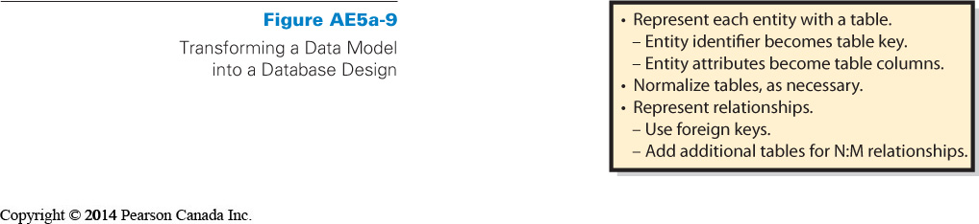
- – Representing relationships
- Designer creates a table for every entity
- Entity identifier becomes primary key of table
- Attributes of entity become columns
- Tables normalized to single theme
- Represent relationships between tables
- Add foreign key to one or more tables

      - What Is the User’s Role?

As stated, a database is a model of how the users view their business world. Meaning he:
- Finally judges as to what data should contain
-Determine how records are related to each other
- Need to review data model
- Must ensure that model reflects an accurate view of business

      - Who Will Volunteer? (Continued)

After knowing that, the manager can hire a consultant and expect the consultant to creates a data model based on interviews with users.
Data model reviewed and approved
Database tables constructed (Primary and foreign keys selected based on interviews)
Microsoft Access database created: Relationships indicated and forms and reports constructed



