WEEK 6: Supporting the Procurement process with SAP
(Chapitre 7 PS&I)

- What are the fundamentals of a procurement process?

Procurement is the process of obtaining goods and services (raw material, cafeteria services…). Procurement is an operational process executed hundreds or thousands of times a day in large organization.
- Main procurement process activities and roles: Purchase order (purchasing manager) receives goods (Warehouse manager) pay the supplier (accounting).
For services, supplier provides services as needed.
- Supporting the Inbound Logistics Process in the value chain: focus on how procurement supports the Inbound Logistics process
Procurement of raw materials needed for production

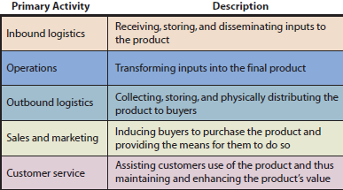

- How did the Procurement process at CBI work before SAP?

Six Roles
  - Two roles performed by people: Warehouse Manager and Accountant
  - Four roles performed by separate computer applications with separate databases (DB): Sales DB; Purchase Order DB; Warehouse DB; and Accounting DB
- Information Systems Silos
  - Sales DB: Monitor demand for materials
  - Purchase Order DB: Manage purchase order information
  - Warehouse Database: Manage inventory levels
  - Accounting DB: Manage payables
The process involved several roles, some of which were separate database systems that resulted in information silos. In the end, CBI was able to perform the procurement process, but with much inefficiency.

- What were the problems with the Procurement process before SAP?

- Warehouse Problems
  - Growth in finished goods inventory (to quickly response to demand, creates spaces issue when same warehouse is used for raw materials as well)
  - Limited space for raw materials
  - Lack of visibility into price discounts

- Accounting Problems
  - Three-way match for payment was a challenge (match invoice with purchase order and goods received)
  - Correcting discrepancies were labor intensive
  - Time delays in updating accounting data (accounting always lagged, never up-to-the-date)

- Purchasing Problems
  - Purchasing wasn’t centralized (demand data, warehouse space, purchase price discount, selling price discounts etc. were unknown)
  - Inexperienced users
  - Errors in data entry
  - Pressure for greater financial controls

ERP provides solutions to CBI’s problems, CBI selected SAP to provide ERP solutions.

- How does CBI implement SAP?

CBI wanted to use SAP not only to overcome these problems but also to better achieve its competitive strategy. Thus, CBI began the SAP project by examining and focusing its strategy. They could then use the revised strategy to guide its managers when making various SAP configuration decisions. For CBI, the strategy examination process has three activities:
- Determine industry structure (findd position in their industry)
To help determine the industry structure, CBI turned to Porter’s Five Forces Model. Using this model, CBI discovered the wholesale bike industry has strong rivalry with low switching costs. For CBI, this means a retailer could easily switch from one bike maker to another.

- Commit to a specific competitive strategy (define a competitive strategy)
Differentiation strategy of responsiveness, focus on high-end bikes.
CBI’s commitment to a more focused product will allow them to continue to improve their responsiveness to customers while resulting in fewer inventories of finished goods in the warehouse (entrepôt).

- Develop objectives and measures for processes (create them)
Supported by an IS consulting firm to assist them in identifying objectives and measures for processes that support their competitive strategy.

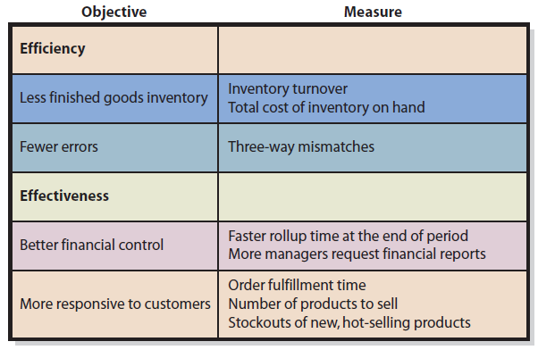

- How does the Procurement process work at CBI after SAP?

Maintained same three major activities: Order; receive; and Pay
- Single shared database where all data and information is stored together.

Solutions to prior problems:
- Purchasing:
  - New purchasing department centralized purchasing activities
  - Data entered in a single, shared database
  - Automated internal company document: Purchase Requisition (PR)
  - Easy conversion of PR’s to Purchase Orders (PO): Reduces errors

- Warehouse:
  - Goods receipts entered into same database as PO’s
  - SAP verifies the goods received against the PO
  - Immediate update to inventory
  - Accounting impacts automatically updated in the same database
  - SAP documents this in the database

- Accounting:
  - Three-way match completed by SAP: Less labor intensive, Incoming invoices are compared to PO and Goods Receipt for verification
  - Payment simplified
  - Accounting updated automatically in SAP
  - SAP will create a document that will track this step in the process.

Benefits of SAP for CBI’s procurement process:
- Single database
- Shared information in real time
- Reduction of errors
- Improved financial controls
- Increased responsiveness to its customers

- How can SAP improve the integration of supply chain processes at CBI?

- Supply chain processes:
Procurement (discussed before)
Supplier Relationship Management (SRM) is geared to reducing costs of procurement while building stronger relationships with suppliers
Returns Management process focuses primarily on all aspects of handling customer returns in an efficient manner
Supplier evaluation is used to determine criteria for sourcing decisions for procurement.

- Supply Chain process integration:
Supply chain management: SCM is also a technology available by SAP which provides the tools, techniques to support management activities that help integrate the supply chain processes. It provides visibility into what is taking place in the supply chain and support organization strategies by providing clear and accurate information.

- Improving supply chain process integration by sharing data
- Process integration improves with sharing data
- Sharing data with suppliers (enables push process: suppliers gain visibility into CBI’s inventory levels and be able to respond quicker to inventory needs)
- Returns management helps (supplier evaluation)

- Improving supply chain process integration by increasing process synergy (relationships etc.)
- Processes are mutually supportive, This means when one process is done well, it supports the objectives of another process
- Synergy can span across organizations
Ex: we see how improvements in the shipping process supported by SW Trucking positively influence other process internal to CBI, like Production and Procurement.

- Other IS that improve supply chain processes
- Radio frequency identification: RFIDs: improved visibility into movements of materials in an operation
- Sensors: vehicle tracking and transport activities
- 3D printing: additive manufacturing, making 3D objects via a digital model
- Robotic: pick and put away material
- Augmented reality: uses computer graphics for presenting locations of products

- How does the use of SAP change CBI?

- New skills are needed (need to train employees)
- It also forced CBI to be more focused on processes and less on individual activities (Real time data to various users and integrated processes)
- More data sharing
- Outsourcing

