WEEK 4: Using IS to improve Processes (Chapitre 5 PS&I)

- What are the Fundamental Types of Processes in Organizations?

- A business process is a sequence of activities for accomplishing a function
- Activity: a tasks within a business process
- Resources: the Items necessary to accomplish an activity (such as people, computers, data, document collection…)
- Actors: Resources who are either human or computers
- Role: Subset of activities in a business process performed by a particular actor

Scope of processes:

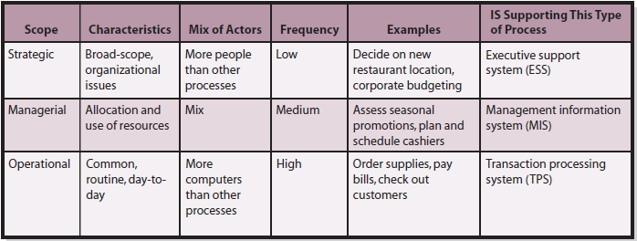

Objectives of processes :

It’s also of value to understand the objectives of business processes. We measure these objectives based on effectiveness and efficiency. Effectiveness deals with evaluating a process on how well it meets the organizational strategies. Efficiency is used to measure a process on how well it conserves limited resources. It looks at whether or not a process creates more output with the same input, or the same output with less input.

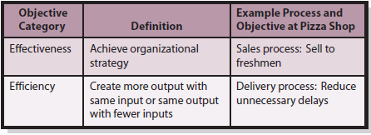

- What are Examples of Common Business Processes?

There are primary activities and supporting activities:
Primary activities
What is inbound logistics? Inbound logistics receives, stores, and disseminates product input. Examples include procurement (operational, acquire goods and services), inventory management (managerial, uses past data for stocking levels and reordering) and evaluation of potential suppliers (strategic).

What are operations? Operations transform inputs into outputs. Operations processes schedule the equipment, people, and facilities necessary to build or assemble a product or provide a service. Managerial operations can be the scheduling maintenance on the ovens. Strategic operations can be to decide to open a new location or change the menu.

What is outbound logistics? Outbound logistics processes collect, store, and distribute products to buyers. Outbound logistics concern the management of finished-goods inventory and the movement of goods from that inventory to the customer. Examples of outbound logistics processes are sales (operational: record, ship and bill), award a refund (managerial) and determine payment policy (strategic, decide what methods are accepted).

What is sales and marketing? Sales and marketing provide the means and incentives for customers to purchase a product or service. The primary objective of sales and marketing processes is to find prospects and transform them into customers by selling them something. The end of sales and marketing is the beginning of the sales part of outbound logistics. Examples include mailing promotion (operational), evaluate promotional discounts (managerial) and launching of a new product (strategic).

What is customer service? Customer service processes is to provide support to enhance or maintain the value of a product. Examples include track orders (operational), evaluating customers' complaints (managerial) and evaluating outsourcing options (strategic).

Supporting activities
What is human resources? Human resources processes assess the motivations and skills of employees, create job positions, investigate employee complaints, and staff, train and evaluate personnel. Examples include recruitment (operational), training of workforce (managerial) and determine pay scales (strategic).

What is technology development? Technology development processes include designing, testing, and developing technology in support of the primary activities. Examples include testing of software (operational), estimating the time for software development (managerial) and the decision to purchase a new technology (strategic).

- How Can Organizations Improve Processes?

OMIS Model: Objectives; Measures; and Information Systems
- The first step in the OMIS model are objectives. Specify and improve the objectives for the process. Each process has one or more objectives. They can be efficiency or effectiveness objective. They also can be stated and unstated, but the OMIS model required them to be stated. In order to be appropriate, objectives need to be matched with strategy and have a consensus. In the OMIS model, objectives need to be specific and to improve a process.
- The second step of the OMIS model are process measures. Each measurement needs to be specific and improve the process. Specify and improve how each objective is measured. The best measures are reasonable, accurate and consistent.
- The third step of the OMIS model is the implementation of IS, which will be developed in the next section.

- How Can Organizations Use IS to Improve Processes?

- Three Ways IS Improve Processes
  - Improve efficiency or effectiveness or activities (using GPS for pizza delivery to achieve the goal of better delivery)
  - Provide linkages across activities (students using Moodle to collaborate to submit evaluation material)
  - Improve control of the process (making sure that activities are done correctly)

- Non-IS Process Improvements
  - Add more resources (hire more drivers to reduce unnecessary delays)
  - Change the process structure (specialize cooks to reduce unnecessary delays)

What is the Six Sigma model?
The Six Sigma model seeks to improve process outputs by removing causes of defects and minimizing variability in the process. They follow a very structured sequence of steps with quantified financial measures. As a result, 99.99966 percent of process outputs would be free from defects.

Participants and Diagrams in Process Improvement:
Participants in the process improvement almost always include a team, especially in medium-to-large- enterprises. Unless it is a very simple task, diagramming is essential to understand every step of the process. The two most common types of diagrams are as-is diagrams (current situation) and ought-to-be diagrams (what the process should be). The gold standard is BPMN.
- How Can an IS Hinder a Process?

The key disadvantage of maintaining data in multiple places is that the data is difficult to share. Information silos are a condition that exists when data are isolated in separated information systems or when data are duplicated in various files and databases. It can make the process inefficient and ineffective, due to duplicates and missing information in some places
Data stored in different databases. Information silos are caused by each branch not being connected to each other and tasks databases not being linked to each other (CRA and OAS databases to manage OAS). Departments like to control their own places and databases (petty king syndrome) . The legitimate reasons for this are sensitive data not needed in other processes (such as health care claims in HR department) and the efficiency of implementation (one office versus the entire company).

- How Can SOA Improve Processes?
SOA (Services-oriented architecture) is a new IS approach designed to make it easier to share data among process activities. SOA enables the development of middleware, software that sits between two computers programs and facilitates communication and data sharing. SOA is a design philosophy in which every activity is modeled as an encapsulated service and exchanges among those services are governed by standards.
- A service is a repeatable task that a business needs to perform, similar to an activity in a process. It needs access to data to be efficient (similar to an activity in a process).
- Encapsulation hides details inside a container. It allows devices to communicate containers (packets) of data without being concerned about the data inside. Because of encapsulation, service implementations can be readily adapted to new requirements, technologies, and methodologies.
- SOA standards are the standardized file types, formats and techniques that allow data and messages to be exchanged. Those standards eliminated the need to proprietary designs (which means reduced costs) and expanded the scope and importance of SOA. SOA can improve processes in the same ways as IS.

