WEEK 2: Hardware and Software (Chapitre 4 E-MIS)

- Why do you need to know about information technology?

At your next family gathering, ask your older relatives about the technologies that existed back then, depending on their ages, socioeconomic status, and where they grew up, their answers will vary.
Technologies such as mobile phones, tablets, MP3 players, and Internet-enabled services that include Youtube, Facebook, Foursquare and Google are now current but your grandparents grew up being familiar with cars, the telephone, the television, and air travel (all of these technologies are only 100 years old).
Knowing the basics about modern information technology (IT), including hardware, software, and networking, will help you consider how it can be used in business; recognize its positive and negative effects on society; and think about what its future can be. You have to understand and apply IT to everyday life because it is a fundamental building block for success.

- Where did all of this information technology stuff come from?

The history of IT is recent and rich, brief history:

- Early Computers: 1939–1952
ENIAC (Electronic Numerical Integrator and computer) designed in 1946 was large, comlex, expensive, single user and only ran one program at a time.
They were housed at universities

- Mainframes: 1952–Present
The first commercial digital computer, which were large, room-sized devices based on now obsolete vacuum tube technology (first generation) and were mainly used by businesses and government. In the late 1950s transistors were introduced (second generation) which made them smaller, easier to maintain and more reliable.
Then the third generation of mainframe machines were introduced in the mid 1960s, included operating systems and multiprocessing capability (cost millions of dollars).

- Microcomputers: 1975–Present
It incorporated a CPU and some short-term memory into a single silicon “chip” using integrated circuits (ICs). The microprocessors were small.
Theses microcomputers had monitors, keyboards, portable floppy disks, and word processors, spreadsheets and others software. The were easier to use and became immediately popular = PC revolution was born.

- Networking Personal Computers: 1985–Present
The lack of networking capability was solved by the next computing development:
Local Area Networks (LAN) technology that allowed connected devices to communicate and share information. Ethernet’s simplicity and popularity provided the ability to connect many PCs together. Sharing data, printers and other peripheral devices was possible.
Wide Area Networks (WAN) technology exemplified by the Internet was developed as a robust network of mainframe systems. Building on email, the web browser and access to a worldwide network of computers.

- Mobile and Tablet computing: Late 1990s-Present
Lowering of costs for cellular technology and mobile telephones so they became commonplace. MP3 iPod, iPad arrived with Apple’s success and a lot of various companies announced similar devices. Small, lightweight, fast, powerful and easy-to-use network devices have become important.

- Price and performance advances
- Small is powerful
- The Network is the thing

- What does a manager need to know about computer hardware?

Hardware consists of the physical electronic components and related gadgetry that input, process, output, and store data according to instructions encoded in computer programs or software.
Basic hardware categories:

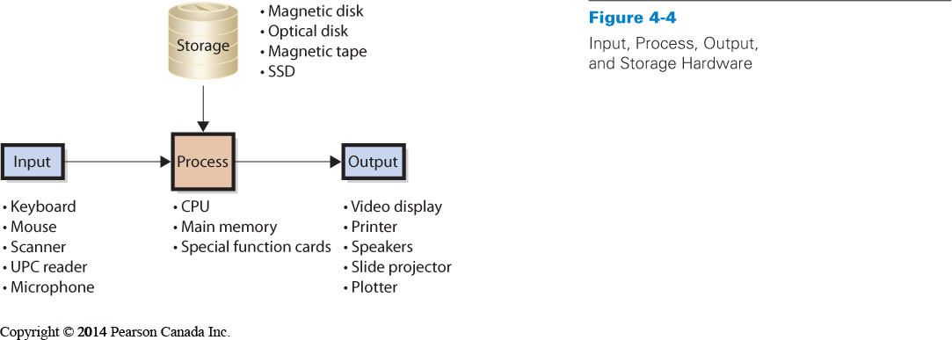

*Input devices: most visible/familiar parts of the computer.
*Processing devices: including the Central Processing Unit (CPU) which is sometimes called the « brain » of the computer, it selects instructions, processes them, performs arithmetic and logical comparisons and stores results of operations in memory (measured in Hertz). It works in conjunction with the computer’s main memory, often referred to as random access memory (RAM).
*Output hardware: most physical interaction with the computer.
*Storage hardware: Saves data and programs.
Finally computers may have special functions cards that can be added to augment each of its components (video cards, extra storage..)

- COMPUTER DATA

Computers represent data using Binary Digits (bits) Represented as either zero or one
Sizing Computer Data: Bits are grouped into 8-bit chunks called bytes

    - K kilobyte 1024 bytes
    - MB megabyte 1024 K
    - GB gigabyte 1024 MB
    - TB terabyte 1024 GB

How Does a Computer Work?
The CPU transfers the program or data from a disk to the main memory, then execute an instruction, it moves the instruction from the main memory into the CPU via the data channel or bus. The CPU has a small amount of very fats memory, called a cache. The CPU keeps frequently used instructions in the cache. Having a large cache makes the computer faster, but this is expensive.
The computer main’s memory contain program instructions for excel, acrobat, and even a browser. It also contains instructions for the operating system (OS), which is a program that controls the computer resources as well as a block of data but the main memory is too small to hold all data so the OS will direct the CPU to attempt to place the new program or data into unused memory, if there is not enough memory, the CPU will remove something and then it will place the just-requested program or data into the vacated space. This process is called memory swapping.

Why Should a Manager Care How a Computer Works?
- Too little memory means constant memory swapping so it will run slowly.
- Needs more memory if processing many programs
- Cache and main memory are volatile = Contents lost when power is off
- Magnetic, optical disks and USB sticks are nonvolatile = Saved contents survive after power is turned off.
- Computes can be bought with a number of different configurations (types, models, types of chips and CPUs…)

- What’s the difference between a client and a server, and what is cloud computing?

- Client computers are used for word processing, spreadsheets, database access and most client computers have software that enables them to connect to a network (private or public networks).
- Servers as their name implies provide services. Facebook, Google… all use servers that are accessed by other computers (used to publish websites, sell goods, host databases…). They are faster, larger and more powerful than client computers. May or may not have video displays.
- Cloud computing: Similar to the concept of servers that supply applications and data. Customer does not necessarily own the computer they use. Instead, hardware, software, and applications are provided as a service, through a web browser. The cloud is a metaphor for the Internet, which makes software and data services available from any location at any time. It builds upon the concept of grid computing (several computers are used to address a single problem at the same time).
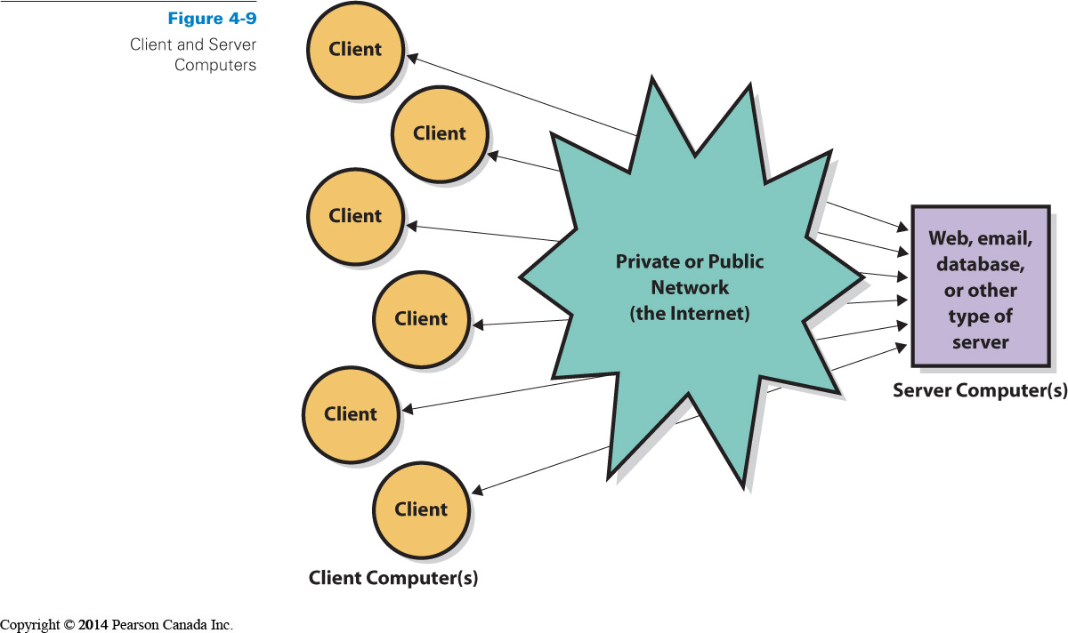

- What does a manager need to know about software?

* Computer Software are of two types:
- Operating System (OS): program that controls computer’s resources ATTENTION a particular version of an operating system is written for a particular type of hardware
- Application Programs: perform specific user tasks ATTENTION application programs are written to use a particular operating system

The four major OS:
Windows:
  - Used by 85% of the world’s desktops
  - 95% of business users
  - Many different versions (Some run on user computers and some support server computers)
  - Current version is Windows Vista
  - Windows runs the Intel instruction set.
Mac OS:
  - Apple Computer, Inc. developed its own OS for Macintosh computers
  - Easy-to-use interfaces
  - Used primarily by graphic artists and art community
  - Current version is Mac OS X
  - After 2006 they moved to Intel-based architecture allowing apple computers to also run Windows.
Unix:
  - Developed by Bell Labs
  - More difficult so workhorse of scientific and engineering community
  - Instruction set: Sun Microsystems is a major vendor of computers employing this operating system (but also others)
Linux:
  - A version of Unix
  - Developed by open-source community
  - This community is a loosely coupled group of programmers, no fee for it
  - Volunteers - contribute code to develop and maintain Linux
  - IBM is a primary proponent (because does not have to pay a licence fee)

Owning versus licensing:
- Users buy license to use program (for example Microsoft selling you the right to use Windows)
- But Linux is owned by an open-source community so there is no license fee, Companies such as IBM make money by offering support.

Application programs:
Application Software consists of programs that perform a business function.
Some are general purpose such as Excel or Word. Some are specific such as QuickBooks (application program that provides general ledger and other accounting functions).

Categories of Application Programs:
Horizontal-market application software:
  - Provides capabilities common across all organizations and industries. (Word, Excel, PowerPoint, Acrobat, Photoshop, Paint Shop Pro)

Vertical-market application software:
  - Serves the need of a specific industry.
  - Usually altered or customized (appointment scheduling software, tracking system for mechanics)
One-of-a-kind application software:
  - Designed for a specific, unique need (IRS software).
    - Other dual-category application software (CRM software).

How to acquire application software?
  - Buy off-the-shelf: may be a great fit or may be a disaster
  - Buy off-the-shelf with alterations
  - Tailor-made: custom-developed software for organization but difficult and risky/ Staffing and managing teams of software developers is challenging/ they may be developed in-house or by outside developer.

ATTENTION: Browsers have characteristics of both OS and application software. Can fit into one of these solely Utility software

What Is Firmware?
Firmware is computer software that is installed into such devices as Printers, print servers and communication devices
- Coded like other software
- But installed into the special read-only memory of the device so becomes part of device’s memory
- Can be changed and upgraded

Basic Input/output System (BIOS)
- Is an important piece of firmware
- Used when a computer is initially booted up
- Required because all volatile memory is lost when the computer is shut down, the only way to get the computer running again is to provide a set of instructions in non-volatile read-only memory (ROM).

What is the difference between a Thin and a Thick Client?
The terms thin and thick refer to the amount of code that must run on the client computer
- An application that requires nothing more than a browser on the client is called a thin client
- An application such as Microsoft Outlook that requires programs other than a browser on the user’s computer is called a thick client

- What Buying Decisions Do You Need to Make?

Manager’s role depends on organization’s policies
- Large organizations usually have IS department that sets specifications
- Medium to small organizations less formal so managers take more active role and usually standardized to single client operating systems. Managers and employees may have role in specifying horizontal application software such as Microsoft office and vertical too but a business manager usually has no role in server specifications, it’s a computer technician who do that.

- What are Viruses, Worms and Zombies?

Virus: A virus is a computer program that replicates itself. The program code that causes unwanted activity is called the payload. The payload can delete programs and data or modify data. It propagates through files.

Macro viruses: Macro-viruses attach themselves to an application. When a contaminated file opens in the application, the macro-virus places itself into the start up files of the application and it contaminates every file opened or created with it.

Worm: A worm is a virus that propagates using the Internet or other computer network.
Computers infected with the worm are called "zombies". A compromised machine is only one of many in what is termed as a "botnet", which is a set of computers and applications that are coordinated through a network and used to perform malicious tasks.

Measures to Prevent Virus:
In order to prevent viruses, users should download patches, which are updates made to correct security holes. Moreover, users should also install a complete antivirus program and update it frequently.
Several types of evil programs exist and we must take the appropriate actions to protect from them.

