MARK 453 MIDTERM SUMMARY:

CHAPTER 1: IMC

Communication: Transmitting, receiving an processing information
COMMUNICATION PROCESS:
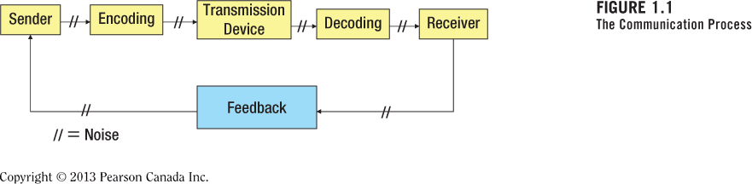
Sender: person sending message
Encoding: forming/encoding verbal or non-verbal cues. Aimed at being an “attention getting message” from an idea
Transmission device: communication channel. (television, newspaper, social media, billboard, internet)
Decoding: understanding the message given in one’s own way. (Perception)
Receiver(s): potential customer(s)
Feedback: Receiver’s response to the sender. (purchase history, inquiries, complaints, questions, store visits, blogs, website hits)

Noise: anything distracting or distorting message. It can occur at any stage in the communication process. Clutter is the most common form of noise.

IMC (INTEGRATED MARKETING COMMUNICATIONS):
Coordination & Integration of all forms of marketing communication tools, avenues ad sources of a company into a seamless program designed to maximize customer and stakeholder impact. covers all of the company’s B2B, market channel, customer-focused & internally directed communications.
Focuses on the PROMOTION aspect of the 4 P’s in the marketing mix.
Unified strategy & uses MULTIPLE communication channels.
(Advertising, digital marketing, social media, sales promotion, direct marketing, public relations, personal selling, etc.)

TRENDS IN MARKETING COMMUNICATIONS:
- Accountability & Measurable Results: in order to see and measure progress: sales, market share, levels of brands awareness, etc.
- Digital Media: The presence of social media, blogs, interactive ads, using smartphones and tablets, etc. is continuously increasing.
- Integration of Media Platforms: Consumers use multiple devices in multiple ways, spending many many hours of their day in front of a screen whter it’s infront of a TV or a smartphone or a computer.
Content grazing: looking at 2 or more screens at the same time
Investigative spider webbing: investigates specific content on several media platforms
Quantam journey: completing a specific task (ex: looking it up, locating the prod and placing an order
Social spider webbing: sharing content across several platforms
- Shift/Changes in Channel Power: Internet sales vs. in-store sales. Consumer relationships are changing. Consumers have more channel power than companies due to the internet.
- Increase in Global Competition: Leads to an emphasis on Quality vs. Price
- Brand Parity: Some products are so identical (similar product attributes) that a price difference or a question of availability can influence the purchase decision. (low goodwill value)
- Customer Engagement: builds brand loyalty.

OTHER INFORMATION:
GIMC: Globally Integrated Marketing Communications. Employs standardization (uniform product and message across countries; one option) OR adaptation (message specifically designed for and adapted to a specific country).

CHAPTER 2: BRANDING
BRAND: - Name, logo, or other symbol.
- Made of tangible and intangible elements.
- Creates value for the customer and the firm.
- Not always the same thing as the corporate entity

Brand Image: What the company stands for and how it is known in the marketplace. It is the sum of consumers’ experiences with the brand.
Creates a specific impression in the minds of clients and consumers.
Consumer Beliefs > Company’s Beliefs
The company’s goal is to MATCH these beliefs and to identify the GAP between these beliefs.
Negative perceptions > Positive perceptions

Brand image elements:
Tangible:
- Goods or services sold
- Retail outlets where the product is sold
- Advertising
- Marketing communications
- Name and logo
- Package and labels
- Employees
Intangible:
- Corporate personnel: ideals, beliefs, conduct
- Environment policies
- Corporate culture
- Country location
- Media reports

ROLES OF BRAND IMAGE:
For the Consumer: (BRAND EQUITY)
Brand Equity: helps fight the brand parity problem. Consumers view products as better, different and one that can be trusted
- Expectations: Creates a positive assurance about what to expect.
- Familiarity: Less risk is involved when choosing a familiar brand.
- Faster decision: Brand image makes it easier to make a decision
- Psychological: Purchasing from highly recognized brands provides psychological reinforcement: feeling that a wise choice was made and that the good or service will perform well

For the Firm:
- Brand extensions: Using an established brand name on new goods or services. (Nike was successful in extending its brand name into a line of clothing, Black and Decker succeeded in extending its brand name onto different power tools but failed at extending its brand to small kitchen appliances)
- Price premium: The difference in price of a certain brand in comparison the benchmark price.
- Consumer loyalty: more frequent purchases. Loyal customers are less inclined to make substitute purchases when other companies offer discounts, sales and similar enticements.
- Corporate equity

Challenge with brand image:
- Consumers can perceive or create different brand images.
- Competitors can change the brand image of another company

Solution:
- Creating a clear, consistent and unified message. Requires a good understanding of the brand.

IN GENERAL, for branding, IMC helps generate:
- Awareness
- Meaning
- Associations
- Usage
- Loyalty
CHAPTER 3: BUYER BEHAVIOURS

Note: WHAT IS THE ULTIMATE GOAL OF AN IMC CAMPAIGN?
To sell products or services and generate profits ($$$).
Who takes part in the purchase decision-making process? Example (my first PC)
- User: Primary user; individual using the product/service. (Me)
- Buyer: Person or entity responsible for purchasing product/service. (Father)
- Influencer: people who shape purchasing decision by providing information. (Peers, reviews, ratings…)
- Decider: individuals who authorize the purchase decision. (Me and father)
- Gatekeeper: individuals who control the flow of information to the members in the buying center. (Salesperson)
Note: textbook shows this applies in B2B buyer behaviours. See p. 73-76

CONSUMER PURCHASING PROCESS:
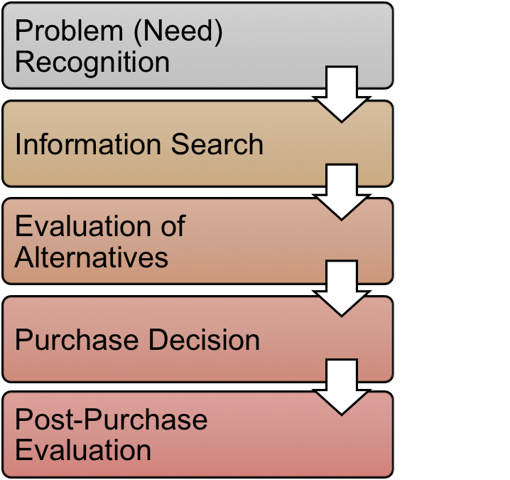
STEP 1: PROBLEM (NEED) RECOGNITION.
- Needs can be physical (hunger), social (meeting society’s expectations ex: HDTV), psychological (desire for love or protection from fear: Maslow’s hierarchy of needs)
- Occurs when there is a gap between your current state and your desired state
- Communicating this need can come in several ways (in-class example: snickers commercial).

STEP 2: INFORMATION SEARCH
- Consumers recall information based on attitudes, values and cognitive mapping.

- Internal Search:
- Product recall: person remembers past brands that he/she used.
- Previous experience: evaluates past experiences and eliminates the bad.
- Consideration set: lists top brand(s)that he/she considers to purchase.
- External Search:
Can come from: Personal sources, Public sources, Marketer controlled sources, Others’ personal experiences
Depends on:
- Ability to search (educational level),
- Prior knowledge (of the product),
- Motivation (level of involvement, need for cognition, level of shopping enthusiasm),
- Cost vs. benefit (dependent on the cost of the good, costs associated with the search, and the opportunity cost of forgoing other activities)
Note: external sources try to influence consumers’ attitudes: Cognitive (think), Affective (feel), Conative (act)

Sequence of attitudes:
- Think – Feel – Act
- Feel – Act – Think
- Act – Think – Feel
Values frame attitudes and lead to the judgments that guide personal actions.

STEP 3: EVALUATION OF ALTERNATIVES

Consumers evaluate the alternatives in their Consideration (Evoked) Set.
Example: when choosing a fridge; Whirpool, LG, Frigidaire, GE, etc…

Approaches to evaluate alternatives:

- Multi attribute approach: Based on a numeric score based on product’s attributes and their importance. Highest total score = best alternative
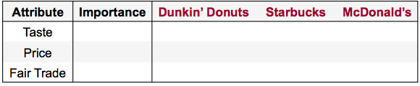

- Affect referral:
Based on an emotional connection to a brand.
Selects brand that incites the most positive feelings.

STEP 4: PURCHASE DECISION

Forming an intention
Still needs to act on this intention
Marketers need to ease the purchasing process

STEP 5: POST PURCHASE EVALUTATION

Compare level of performance with expectations: Satisfied or dissatisfied?

Cognitive dissonance: Feeling of doubt right after the purchase. Caused by conflicting attitudes.

Trends in the Consumer Buying Environment:
- Age: younger kids “grow up” at a earlier age. Older adults refuse to grow old
- Gender: Gender roles are shifting and becoming more complex.
- Active & Busy Lifestyles: people want more free time with family; demand for convenience products continues to increase.
- Diversity: diverse lifestyles; due to changing mentality (views on marriage, genders, ethnicities, sexual orientation, etc.)
- Communication: communication revolution due to advances in telecommunications; social media, smartphones.
- Experience pursuits: people are preferring more “experiences” over “things”
- Health: emphasis on nutrition, exercise and staying active.

CHAPTER 4: THE IMC PLANNING PROCESS
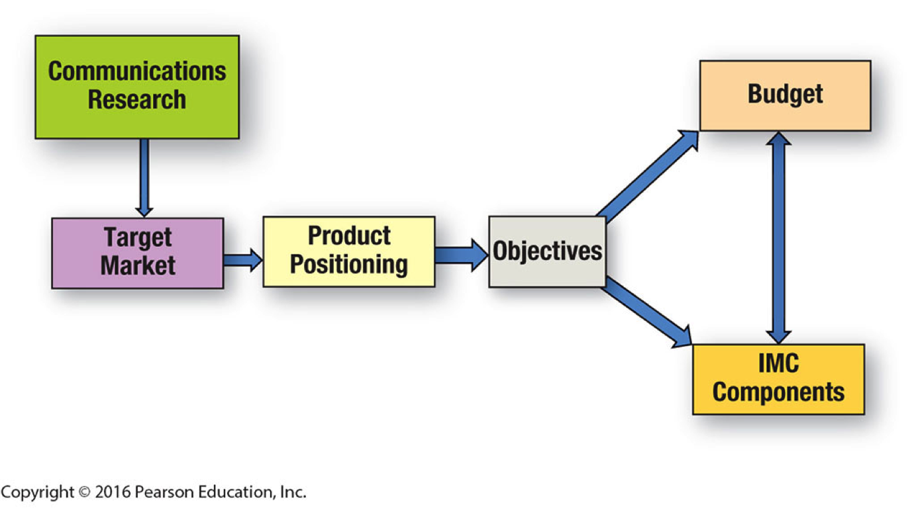
1. Communications Research: (3 approaches)
- Product specific research: identifying key product characteristics that become selling points. Understanding the benefits provided by the product.
- Consumer-oriented research: identifies the context of the product’s use. Anthropological, sociological and psychological approaches to find the motives for the product purchase
- Target market research: who will be the recipient of the planned communications campaign? Looks at the best market for a particular benefit.

- Identify target market using market segmentation
Market segmentation: identifying specific consumer and business groups that are most likely to purchase product based on needs, attitudes and interests.
Market segment: Group of individual consumers with distinct characteristics:
- Homogeneous: same interests, attitudes, needs, opinions.
- Differentiated: differs from the general population.
- Size: big enough to be financially viable through its separate campaign.
- Reachable: through some type of media / marketing communications method
How to identify market segments:
- Demographics: gender, age, income, ethnicity.
- Psychographics: VALS Typology categorizes respondents into 8 categories: innovators, thinkers, achievers, experiencers, believers, strivers, makers, survivors.
- Generations: Millennials, Gen X, Young Boomers, Old Boomers, Seniors
- Geographic: area
- Geodemographic: Geographic, Demographic and Psychographic info. (PRIZM)
- Benefit: advantages consumers receive > consumers’ characteristics. Demographic and Psychographic info can be combined wit benefit information to identify viable segments.
- Usage: based on usage or purchases (heavy users, average users, casual or light customers, non-users) highest level of service given to the heavy users and attempts to bring consumers to the next usage group with promotions.
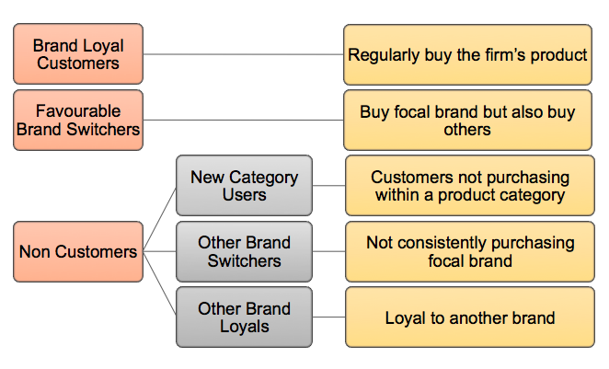

3. Product Positioning: consumer’s perception of the nature of the company and its products relative to competitors.

Approaches to positioning:
- Product attributes: trait or characteristic that sets the product apart from the others
- Competitors: contrasting product against others
- Use or Application: creating a memorable set of uses for a product (Arm & Hammer)
- Price-Quality Relationship: offering a product at the extremes of price range (high price emphasises on quality, low price price or value)
- Product user: Specifying who might use this product (go-daddy with small business)
- Product class: positioning a brand within a category (beverages energy drinks)
- Cultural symbol: (difficult) Focusing on a cultural element that people can idetify themselves with (Chevrolet Silverado pickup focusing on American Patriotism)

4. Objectives: MAXIMIZING: Sales volume, Market Share, Profits and/or Return on investment. Benchmarks can be helpful tools to reach goals/objectives.
These Marketing Communications objectives:
- Guide the development and delivery of message
- Are aligned with overall marketing objectives
- Supported by other marketing functions
MUST BE SPECIFIC in terms of:
- Target audience
- Tasks to accomplish
- Changes to make
- Time Needed
CRITERIA
- Specific
- Measurable
- Achievable/Realistic

5. Budgets: budgets allocated to communications can be calculated in several ways.
TYPES OF BUDGETS
- Percentage of sales: allocating a percentage of last year’s sales or expected sales.
- Competition (Meet the competition): Matching competitors’ budget to prevent losing market share. May be raised or lowered.
- Affordability (“What we can afford”): marketing expenditures decided after most of the other expenditures (kept for last and spend “what they can afford”)
- Objective and task: Setting objectives and calculating costs to accomplish each one.
- Payout planning: establishes a ratio of advertising to sales or market share and reducing this ratio one brand awareness has risen.
- Quantitative models: Computer simulations developed to model relationship between advertising/promoting expenditures to sales and profits.

Communication budget and schedule
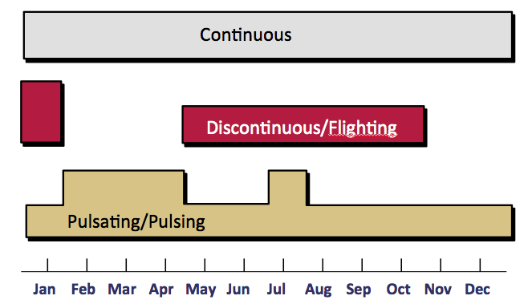
Continuous (ex: McDonald’s)
- Regular continuous pattern
- Every [day/week/month]
- Products consumed on an ongoing basis

Discontinuous/Flighting (Christmas lights.)
- On and off
- During peak times
- Seasonal products

Pulsating/Pulsing (Dietary products; more in January due to diet as new year resolutions)
- Combination of continuous and flighting
- Increase number of advertisement around high buying times

CHAPTERS 5 & 6 (MIXED): CREATIVE STRATEGY
Main challenge of a creative strategy: CONFLICTING VIEWS
- Manager vs. creative team
- Strategy vs. execution:
Creative Strategy
- Target market
- Positioning
- Objectives
- Big idea
Creative Execution
- Message strategies
- Appeals
- Executional frameworks

Parameters of an IMC Campaign:
- Goals: Advertising goals from the firm’s overall communications objectives.
- Media selection: by understanding the media usage habits of target market.
- Tagline: memorable and unique that conveys special meaning (“Always fresh”)
- Consistency: Repeatedly seeing something helps embed it into long-term memory.
(*Variability theory*: seeing same ad in varied environments increase ad recall)
- Positioning: Consistently positioning a product throughout its life. Keep one trait.
- Campaign duration: must be identified must be changed/removed before ad becomes stale/annoying (Wear-out effect). BUT changing ads too frequently impedes retention. (Typically lasts 6 months, but there are exceptions.)

Impact of Advertising Expenditures:
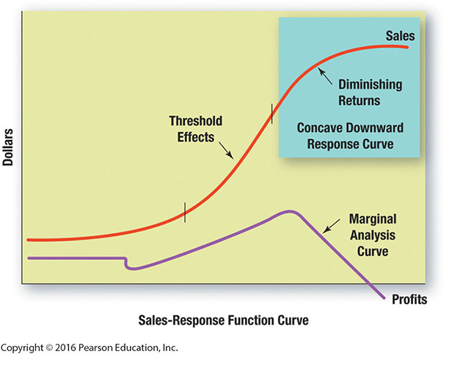
- Communications goal: based on the stage in ‘hierarchy of effects” model.
- Threshold effects: point in which the advertising program begins to have significant impact on consumer responses.
- Diminishing returns: Promotional campaign has saturated the market. Further expenditures will produce minimal impact.
- Carryover effects: Happens when someone experiences brand recall due to so much ad exposure in the past. Usually with products that are purchased infrequently (ex: buying a bed Dormez-Vous)
- Wear-out effects: Advertisement or campaign becomes boring, old. Leads to ignoring.
- Decay effects: After a company stops advertising, people forget the message.

Advertising Theories:
Hierarchy of Effects: helps clarify the objectives of an advertising campaign. 6 steps a consumer moves through when making a purchase:
- Awareness
- Knowledge
- Liking
- Preference
- Conviction
- The actual purchase
This 6-step sequence is linked to the formation of attitudes:
Most likely: Cognitive (Think) Affective (Feel) Conative (Act)
But there are other sequences: (sometimes this sequence can change in its order due to impulse buying or because of a really good deal (coupons, discounts, other incentives))
- Feel Act Think
- Act Think Feel

Means-End Theory: Suggest that an advertisement should contain a message or means that leads the consumer to a desired end state. End states are personal values. Basically, means-end theory says that someone can connect a consumer’s personal values to a product’s attributes through these attributes’ functional and psychological consequences.
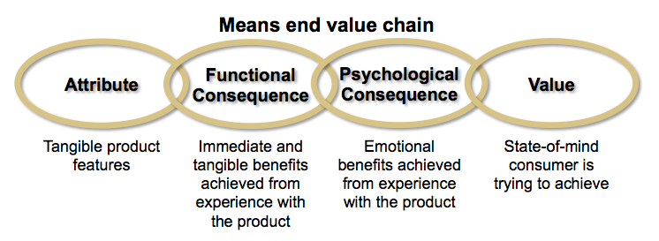ex: chips means-end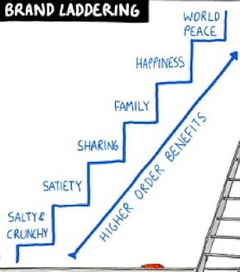

Creative brief: clear instructions to the creative team to create an advertising campaign or a specific commercial.
- Objective: What do we want to accomplish?
- Target Audience: Who are we talking to?
- Research: What do we know about them?
- Message Theme: What are we trying to tell them?
- Support: Why should they believe us?
- Execution: How will we convey the message?
- Constraints: What are our mandatories?
- Approval: Has the creative been tested with the target? Do we approve the creative?

Who can be in charge of executing creative strategy?
- Creative team (in-house or external)
- Crowdsourcing
CROWDSOURCING (p.132)
- Outsourcing the creative to the public.
Pros | Cons
- Increased involvement  - Generates buzz  - Customer retention  - Relatedness | - Costly  - Stable consumer base  - Lack of consistency  - Lack of linkage

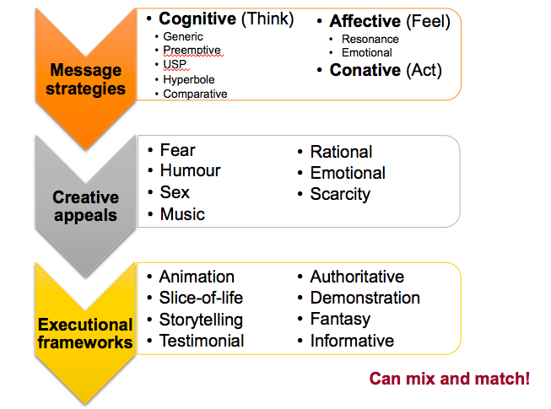
CHAPTER 6
We can turn an abstract creative strategy into a tangible executional framework WITH THE USE OF:
(***Read illustration carefully!***)
- Message strategies
- Creative appeals
- Executional frameworks
- Sources and spokespersons
MESSAGE STRATEGIES: How the message is delivered, related to the IMC objective.
- Cognitive Message Strategies:
- Generic: direct promotion of product attributes
- Preemptive: claim of superiority based on attribute / benefit
- Unique Selling Proposition: explicit, testable claim of uniqueness
- Hyperbole: untestable claim based on an attribute or benefit (ex: it’s the best…)
- Comparative advertising: Comparing with the competition

Comparative: pros | Comparative: cons | Other
- Captures attention  - Increases awareness  - Message retention | - Believability  - Negative attitudes  - Trait transference | - Viable Competition  - Misleading claims  - Market Share

- Affective Message Strategies:
- Resonance: Connecting brand with consumer’s experiences builds stronger ties between product and consumer.
- Emotional: Eliciting powerful emotions leading to product recall.
- Conative Message Strategies: Leads directly to a consumer response. Goal of eliciting behaviours by “acting now”. Coupon redemption programs, cash-back rebates, encouraging to access a website. (Ex: call toll-free now and get 50% off…)

CREATIVE APPEALS:
Types: Fear, Humour, Sex, Music, Rational, Emotional, Scarcity.
The type of creative appeal that is most appropriate is dependent on:
- Creative brief
- IMC objectives
- Means-end chain
- Message strategy
- Type of product/service
- Target market
- Communications preferences

EXECUTIONAL FRAMEWORKS:
Manner in which a creative appeal is presented and a message strategy is conveyed
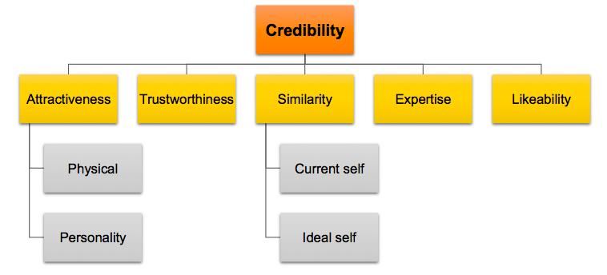
Types: Animation, Slice of Life, Story-telling, Testimonial, Authoritative, Demonstration, Fantasy, and Informative.

SOURCES AND SPOKESPERSONS:
Types of sources/spokespersons:
- Celebrities: Unpaid, Voiceovers, Dead, Social media
- CEOs
- Experts
- Typical persons
RISKS with sources:
- Overexposure (ex: DJ Khaled, Britney Spears)
- Inappropriate behaviour (ex: Tiger Woods)
Sources characteristics:
- Needs to be credible given the message
- Different sources have different characteristics

CHAPTER 7- ADVERTISING: MEDIA STRATEGY
Elements of a media strategy:
Media planning: Analyzes the media usage of the target market and the role of media in their purchasing process. (What influences their final decisions, what media choices they make at different times during the day...)
Media Plan:
- Marketing analysis
- Advertising analysis
- Media strategy
- Media schedule
- Justification and summary

Advertising Terminology
- Reach: Number of people, households, or businesses in a target audience exposed to a media vehicle or message schedule at least once during a given time period, normally consisting of four weeks.
- Frequency: Average number of times a person household, or business within a target market is exposed to a media vehicle or message schedule during a given time period, normally consisting of four weeks.
- Opportunities to see (OTS): Cumulative exposures achieved in a given time period (usually 4 weeks). Example: 4 shows x 2 ads per show = 8 OTS
- Gross rating points (GRPs): Measures the impact or intensity of a media plan. Calculated by multiplying the vehicle’s rating by the OTS or number of advertisment insertions. Example: advertisement in each weekly issue of People during a 4-week period is more likely to be seen than one appearing in a monthly periodical.
- Cost per thousand (CPM): Measures dollar cost of reaching 1000 members of the media vehicle’s audience. CPM = (cost of media buy / total audience) x 1000
- Cost per rating point (CPRP): CPRP = Cost of media buy / Vehicle’s rating
*Rating: percentage of a firm’s target market exposed to a tv show or magazine
- Continuity: Exposure pattern or schedule used in a campaign.
* Continuous: steady stream
* Pulsating: ads are placed throughout the year but increasing # of ads in small and short bursts during peak times to sell the product such as Christmas, Thanksgiving, Labour Day, etc.
* Flighting (discontinuous): run advertisement only at certain times of the year.
- Impressions: Number of gross impressions = total exposures of the audience to an advertisement. Total circulation X # of times the ad was inserted = gross impressions.

What is the minimum amount of exposures necessary to make a lasting impression?
THEORIES:
- Three-exposure hypothesis: Belief that an advertisement requires a minimum of three exposures for it to be effective. This is also believed to make an impact regardless of individual needs and wants,
Intrusion value of an advertisement: the ability of the ad to capture the attention of a viewer without her voluntary effort. leads to reason that it takes 3 exposures to grab attention.
***Note: currently, many believe that clutter has diminished viability of the three-exposure hypothesis.
- Recency Theory: Consumer exhibits selective attention and focuses on personal needs and wants. The closer the commercial is to the consumer’s purchasing decision, the more powerful the related ad becomes. (One ad exposure may be enough)

Effective reach: Identifies the percentage of an audience that must be exposed to a particular message to achieve a specific objective.

Effective frequency: The number of times a targer audience must be exposed to a particular message to achieve a specific objective. Minimum number of exposures will be needed to achieve outcome.

Determining optimal reach and frequency depends on:
- Objective: Brand recognition goals will need a different optimal mix than brand recall goals.
- Size and placement of ad: smaller or shorter ads may need more frequency. Ads placed in the middle of an ad sequence have a smaller impact than ads placed at the beginning and end of the sequence.
- Number of media used: Campaigns using 2 types of media will generate more reach than campaigns with 1 media type.
- Synergy between various media: Companies design computer models to optimize reach, frequency and advertisement money allocation by finding the appropriate mix of media using probability theory

Brand recognition: emphasis on visual presentation of the product and/or logo.
Strengthening or creating links between the brand and the information in the person’s knowledge structure becomes the goal. Reach is the priority.

Brand recall: Frequency becomes more important than reach. Repetition helps embed a brand in a consumer’s cognitive memory.

Media Selection
- Television:
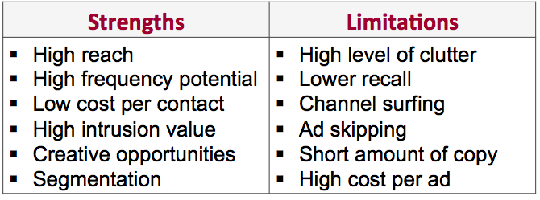

- Radio:
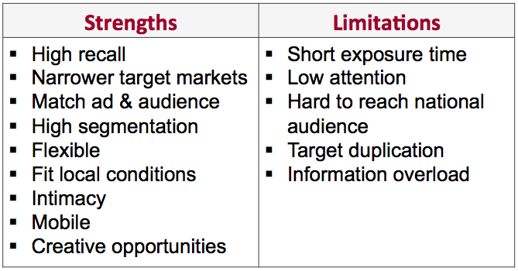
- Newspapers:
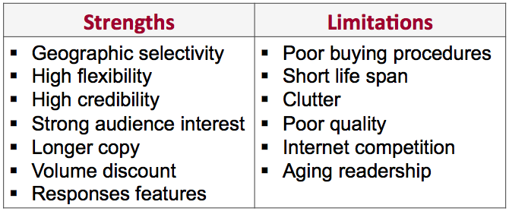
- Magazines:
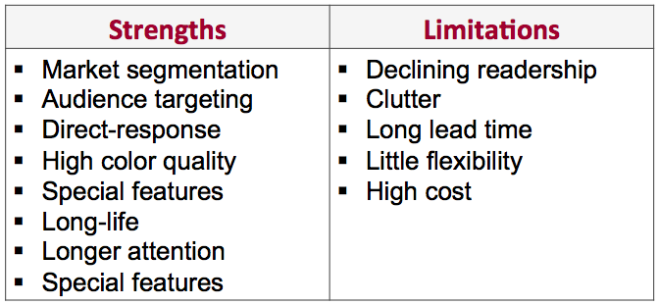
- Out-of-Home:
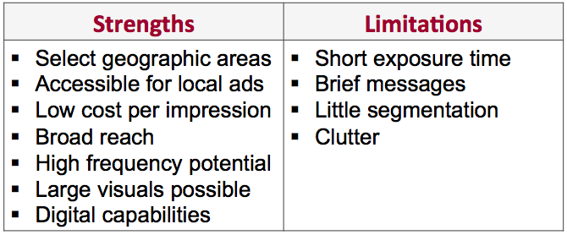

Media Mix: Selecting the proper blend of media outlets is crucial. Must find appropriate media mix.
Media Multiplier Effect: combined impact of using two or more media outlets will be stronger than using either media alone.
Conclusion:


