Intelligence
Intelligence: the ability to acquire knowledge, to think and reason effectively, and to deal adaptively with the environment.
Sir Francis Galton (1822-1911): Quantifying mental ability
- Strongly influenced by his cousin, Charles Darwin, theory of evolution
- His book, Hereditary Genius (1869), showed through the study of family trees that eminence and genius seemed to occur within certain families.
- Eminent people had “inherited mental constitutions” which made them more fit for thinking than others without it.
- He ignored the fact that the more successful people he studied almost invariably came from privileged environments.
- Also tried to prove biological bases for eminence by showing that people who were more socially and occupationally successful would also perform better on a variety of laboratory tasks thought to measure the “efficiency of the nervous system”.
- His approach to mental skills measurement was disfavoured because his measures of nervous-system efficiency proved unrelated to socially relevant measures of mental ability.
Alfred Binet (1857-1911): Mental tests
- French psychologist, Alfred Binet, commissioned by France’s Ministry of Public Education to develop the test that was to become the forerunner of all modern intelligence tests.
- Trained with Galton. Although Binet was interested in solving a practical problem instead of supporting a theory.
- Tasked with developing an objective intelligence test for school children.
- Two assumptions about intelligence:
  - Mental abilities develop with age
  - The rate at which people gain mental competence is a characteristic of the person and is fairly consistent over time
  - i.e. a child who is less competent than expected at age 5 should also be lagging at age 10
- If majority of children of a given age can complete a task, the task requires that mental age
- i.e. if an 8-year old can solve a 10-year old task, their mental age would be 10 years old.
William Stern
- Expanded the concept of Mental Age (MA) to a relative score (IQ) for different age
  - IQ (Intelligence Quotient) = ratio of mental age to chronological age, multiplied by 100 (IQ = MA/CA X 100)
- This allows comparisons across age groups

Today
- Today’s tests no longer use the concept of mental age. This is because the concept works well for children but not for adults as most of the skills required are gained by age 16. Some mental skills decline with age.
- Today’s IQ is not a quotient at all. It is based on a person’s performance relative to the cores of other people the same age.
Binet’s legacy: an Intelligence-testing industry emerges
- Lewis Terman, a professor at Stanford University, revised Binet’s test and rewrote some of it to make it more relevant to American culture.
- Stanford-Binet Scale
- Contained mostly verbal items
- Early group-administered intelligence tests were used by the Army for recruiting during World War 1
  - Army Alpha (verbal)
  - Army Beta (non-verbal)
- New group tests of intelligence emerged, i.e. Lorge-Thorndike Intelligence Test and the Otis-Lennon School Ability Test
David Wechsler (1896-1981)
- David Wechsler challenged the SB test:
  - Stanford-Binet (SB) relied too much on verbal skills
  - SB items suitable for children not adults
  - SB had lots of timed tests, which made it difficult for older adults
  - SB did not consider that intellectual performance can deteriorate as a person grew older
  - SB produced only 1 score
- He thought that intelligence should be measured as a group of distinct but related verbal and non-verbal abilities
  - He believed in a single factor of intelligence, but thought that it consisted of specific, interrelated elements
- Verbal Scale IQ
- Performance Scale IQ
  - Less affected by language and culture
- Full Scale IQ
  - to get a measure of overall intelligence, simply aggregate the capabilities on each of the separate elements
- Wechsler-Bellevue Scale
- Wechsler Adult Intelligence Scale (WAIS) and WISC (children’s version)
- Wechsler Preschool and Primary Intelligence Scale (WPPSI)
- Today, The Wechsler scales have gone through many revisions
  - Latest: WAIS IV released in 2008
- The WISC-IV has four specific cognitive domains (Indexes) which together contribute to the Full Scale IQ
Processing
Speed
Working
Memory
Perceptual
Reasoning
Verbal
Comprehension
FULL Scale IQ

- Each of the four Index scores is derived from a number of subtest scores.
- There are five supplemental subtests which can be substituted for a specified number of core subtests if needed.
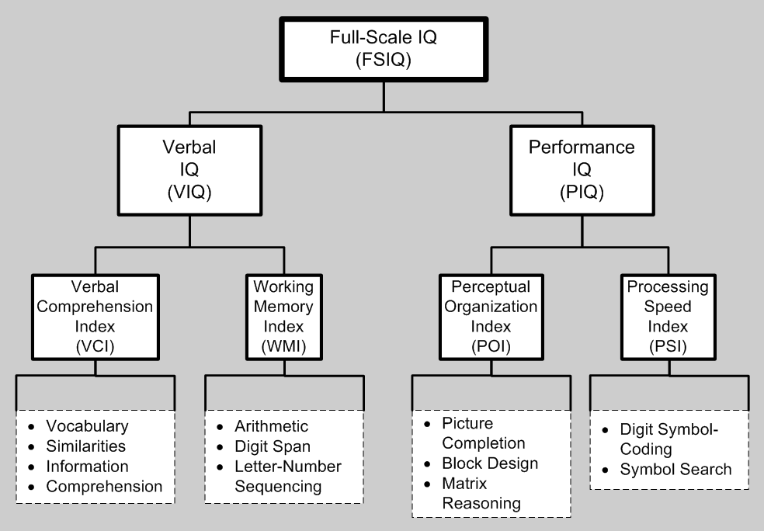
Verbal Comprehension Subtests
- SIMILARITIES (SI)
Individuals are presented with two words that represent common objects or concepts and asked to say how they are similar.
- VOCABULARY (VC)
Younger individuals are shown pictures and asked to name them. Then individuals are asked to give definitions for words presented orally and visually.
- COMPREHENSION (CO)
Individuals are asked to respond to questions requiring an understanding of social situations, reflecting common sense, social judgment, behaviour and conventional standards.
- INFORMATION (IN) (Supplemental subtest)
- WORD REASONING (WR) (Supplemental subtest)
Perceptual Reasoning Subtests
- BLOCK DESIGN (BD)
Individuals use up to nine red and white blocks to re-create a model or a picture of a design within a specific time limit.
- PICTURE CONCEPTS (PCn)
The individual is presented with two or three rows of pictures and chooses one picture from each row with common characteristics.
- MATRIX REASONING (MR)
Individuals look at an incomplete matrix (made up of pictures or designs) and selects the missing item from five options.
- PICTURE COMPLETION (PCm) (Supplemental subtest)
Individuals have to point to or name an important part missing from a picture within a specific time
Working Memory Subtests
- DIGIT SPAN (DS)
Digit Span requires the individual to do two distinct tasks; the first is to repeat orally presented numbers in the same order. Then the individual is asked to repeat orally presented numbers in reverse order.
- LETTER-NUMBERING SEQUENCING (LN)
Individuals are read a sequence of numbers and letters and are asked to recall the numbers in ascending order and the letters in alphabetical order.
- ARITHMETIC (AR) (Supplemental subtest)
Individuals solve a series of orally presented arithmetic problems within a specific time limit.

Processing Speed Subtests
- CODING (CD)
Individuals copy symbols that are paired with simple geometric shapes or numbers within a specific time limit.
- SYMBOL SEARCH (SS)
Individuals scan a search group (of abstract symbols) and indicate if a target symbol/s matches any of the symbols inthe search group within a specific time limit.
- CANCELLATION (CA) (Supplemental subtest)
Individuals scan both a random and structured arrangement of pictures and marks target pictures within a specific time limit.

The nature of intelligence
Two major approaches in study of intelligence:
- Psychometric approach- attempts to map the structure of intellect and to discover the kinds of competencies that underlie test performance
- Cognitive processes approach- studies the specific thought processes that underlie those mental competencies
The psychometric approach: the structure of intellect
Psychometrics is the statistical study of psychological tests
Factor Analysis
- Psychometric researchers have long sought to identify the mental abilities of the human mind.
- Researchers administer diverse measures of mental abilities and correlate them with one another
- If certain tests are correlated highly with one another (if they ‘cluster’ mathematically) then performance on these tests probably reflects the same underlying mental skill.
- When large numbers of tests are correlated with one another, many correlation coefficients result. Difficult to determine by visual examination the actual patterning.
- A statistical technique called factor analysis reduces a large number of measures to a smaller number of factors with each cluster containing variables that correlate highly with one another but less highly with variables in other clusters.
- A factor allows us to infer the underlying characteristic that presumably accounts for the links among the variables in the cluster.
The g-factor: Intelligence as General Mental Capacity
  - Charles Spearman (1923) concluded that intellectual performance is determined partly by a general intelligence factor (‘g’)
    - Also determined partly by whatever special (specific) abilities might be required to perform a particular task (‘s’)
  - ‘g’ constitutes the core of intelligence
    - Important predictor of both academic and job performance.
    - G is clearly the most important dimension uncovered in the study of cognitive abilities (Lubinski, 2004)
Primary Mental Abilities:
  - Louis Thurstone was unimpressed by the moderate correlations between different mental tasks (weak evidence for ‘g’)
  - Proposed that human mental performance depends on seven distinct primary mental abilities
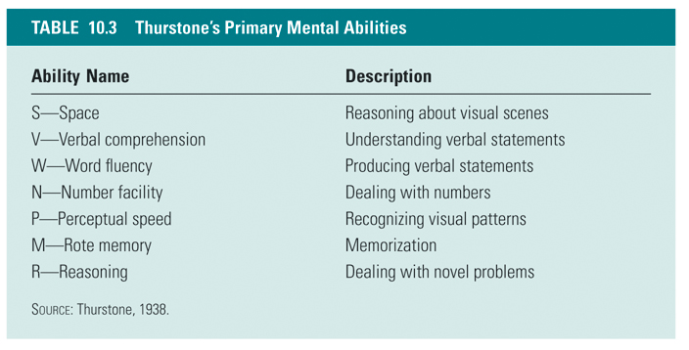
Crystallized and Fluid Intelligence
- Raymond Cattell and John Horn proposed a new model of intelligence
- The broke down Spearman’s general intelligence into two distinct but related subtype of g
- Crystallized Intelligence (gc)
  - The ability to apply previously acquired knowledge to current problems
  - Vocab and information tests are good measures
  - Basis for expertise
  - Depends on ability to retrieve previously learned information and problem-solving schemas from long-term memory
  - Dependent on previous learning and practice
- Fluid Intelligence (gf)
  - The ability to deal with novel problem-solving situations for which personal experience does not provide a solution
  - Involves inductive reasoning and creative problem-solving skills
  - Dependent primarily on the efficient functioning of the central nervous system rather than on prior experience and cultural context
  - Requires the abilities to reason abstractly, think logically, and manage information in working memory
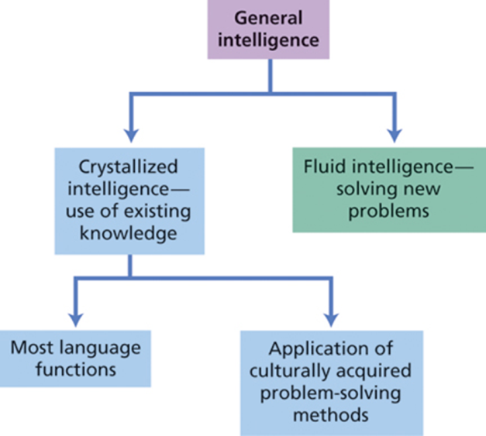
- Performance on crystallized intelligence tests tends to improve during adulthood and remain stable into late adulthood
- Performance on fluid intelligence tests begins to decline as people enter late adulthood

John B. Carroll (1916-2003): Three-Stratum Model: A Modern Synthesis
- Based on factor analysis of more than 460 data sets (1935 – 1980)
- Integrative model of intelligence that contains elements of Spearman’s, Thurstone’s and Cattell-Horn’s models.
- Establishes three levels of mental skills arranged in a hierarchical model
  - General: g factor
  - Broad: includes crystallized and fluid intelligence plus 6 other basic cognitive functions
  - Narrow: nearly 70 specific skills
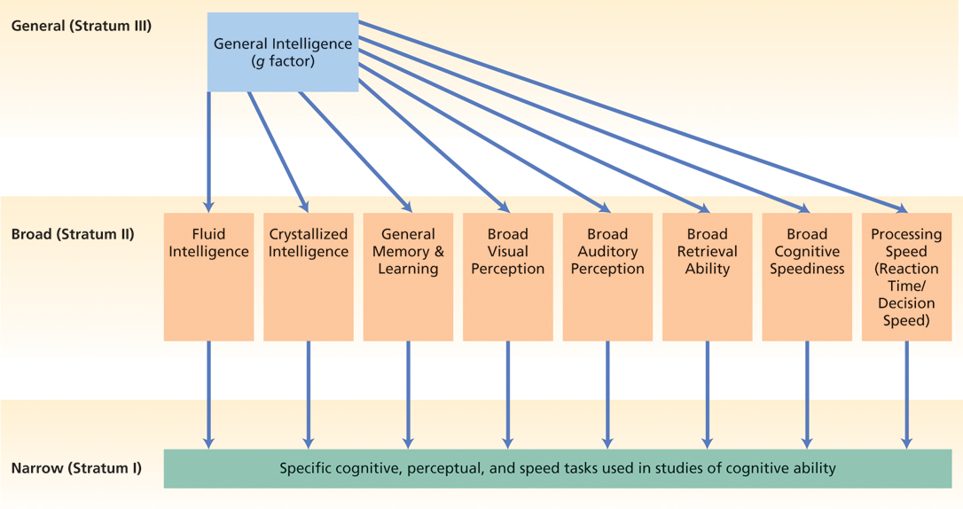

Cognitive process approach: the nature of intelligent thinking
- Explore the specific information-processing and cognitive processes that underlie intellectual ability.
  - Explain why people differ on intelligence or how they process information.
Robert Sternberg
Triarchic Theory of Intelligence:
- addresses both:
  - the psychological processes involved in intelligent behavior
    - Metacomponents (the higher-order processes used to plan and regulate task performance)
      - Include problem-solving skills
      - Sternberg argued that differences in metacomponents underpin differences in fluid intelligence
    - Performance components (the actual mental processes used to perform the task
      - Include perceptual processing, retrieving memories, response generation etc.
    - Knowledge acquisition components (allow us to learn from our experiences, store information in memory, and combine new insights with previously acquired information)
      - Underlie individual differences in crystallized intelligence
  - And the diverse forms that intelligence can take
    - Analytical
      - the kinds of academically-oriented problem-solving skills measured by traditional intelligence tests
    - Practical
      - the skills needed to cope with everyday demands and to manage oneself and other people effectively
    - Creative
      - the mental skills needed to deal adaptively with novel problems
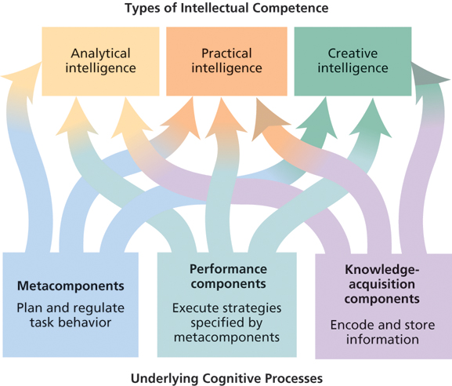

Broader conceptions of intelligence: Beyond mental competencies
Traditionally, intelligence has been viewed as mental competence. Some psychologists think this is too limited a definition to capture the range of human adaptations. They believe that intelligence may be more broadly conceived as relatively independent intelligences that relate to different adaptive demands.
Gardner’s Multiple Intelligences
- Inspired by observations from brain damaged patients
- Proposes eight distinct varieties of adaptive abilities
  - Linguistic: the ability to use language well
  - Logical-Mathematical: the ability to reason mathematically and logically
  - Visuospatial: the ability to solve spatial problems or to succeed in a field such as architecture
  - Musical: the ability to perceive pitch and rhythm and to understand and produce music
  - Bodily-Kinesthetic: the ability to control body movements and skillfully manipulate objects
  - Interpersonal: the ability to understand and relate well to others
  - Intrapersonal: the ability to understand oneself
  - Naturalistic: the ability to detect and understand phenomena in the natural world
Gardner has also speculated about a 9th possible intelligence
  - Existential: meaning of existence, life & death
- Gardner’s critics suggest that these other abilities are not part of the traditional concept of intelligence but are rather seen as talents.
Emotional Intelligence
- According to Mayer and Salovey emotional competence involves the abilities to:
  - read others’ emotions accurately
  - respond to them appropriately
  - motivate oneself
  - be aware of one’s own emotions
  - regulate and control one’s own emotional responses
The Mayer-Salovey-Caruso Emotional Intelligence Test (MSCEIT)
- Four Components of Emotional Intelligence:
  - Perceiving Emotions
    - perceive emotions in oneself and others as well as in objects, art, stories, music, etc
  - Using Emotions to Facilitate Thought
    - generate, use, and feel emotion as necessary to communicate feelings or use in other cognitive processes
  - Understanding Emotions
    - understand emotional information, how emotions combine and progress through relationship transitions, and appreciate such emotional meanings.
  - Managing Emotions
    - to be open to feelings, modulate them in oneself and others so as to promote personal understanding and growth
- Emotional intelligence may have evolutionary roots
  - People high in Emotional Intelligence may enjoy more success in different spheres of (inter)personal life
- Criticized for moving the focus away from mental ability
- Emotional Competence: a term preferred by critics of EI; distinguishes between traditional mental skills and emotions
Biological models
- Speed of processing/ mental speed
  - Reaction time tasks
- Working memory – holding things in mind
  - Frontal cortex (activated by some IQ tests)
  - Electrical - speed of conduction of neural impulses
- Metabolic
- Prenatal factors
- Nutrition
- Teratogens eg
  - Lead
  - Alcohol
- Hormones
Measurement of Intelligence
- Theory-Based Intelligence Tests:
  - Several tests specifically designed to measure crystallized and fluid intelligence separately
  - Sternberg Triarchic Ability Test (STAT) measures analytic, practical, and creative intelligence
- Achievement Tests:
  - designed to find out how much a person has learned so far
  - Usually a good predictor of future performance in a similar situation
    - People who learned a lot in school are likely to also learn a lot at university
  - Assumes that everyone has had the same opportunity to learn the material being tested
- Aptitude Tests:
  - contain novel puzzle-like problems that go beyond prior learning
  - Designed to measure the person’s potential for future learning and performance
  - Supposedly fairer (depends less on prior knowledge)
    - NB* Its difficult to construct a test that is truly independent of prior learning
    - May not be relevant to success in real-world situations
- Psychological Testing: a method for measuring individual differences related to some psychological concept, based on a sample of relevant behavior in a scientifically designed and controlled situation
- Key measurement concepts:
  - Reliability
  - Validity
  - Standardisation
- Reliability: consistency of measurement
- Test-Retest Reliability: consistency of measurement over time
  - Assessed by administering the measure to the same group of participants on two or more separate occasions and correlating the sets of scores
  - If the construct being measured is stable, scores should be consistent over time
- Reliability:
  - Internal Consistency: consistency of measurement within the test itself
    - All the items on a test should measure the same thing
    - Items should correlate highly with each other
- Interjudge Reliability: consistency of measurement when different people observe the same event or score the same test
- Validity: how well a test actually measures what it is designed to measure
  - Construct Validity: a test successfully measures the psychological construct it is designed to measure
    - Assessed by looking at the relationship between test scores and other behaviors that it should be related to.
  - Content Validity: whether the items on a test measure all the knowledge or skills that are assumed to underlie the construct of interest
  - Criterion-Related Validity: the ability of test scores to correlate with meaningful criterion measures
    - Test should predict present or future outcomes that are influenced by the construct being measured
- Examining Criterion-Related Validity:
  - Intelligence tests correlate with school grades (r = .60)
  - SAT scores predict university grades (r = .50)
  - Intelligence correlates with the level of socioeconomic status that people attain (r = .50 to .70)
  - Higher intelligence is associated with a longer life span, especially in women
- Standardisation: involves the development of norms and rigorously controlled testing procedures
  - Norms: test scores derived from a large sample that represents particular age segments of the population
    - Provide a basis for interpreting individual scores
  - Normal Distribution: a bell-shaped curve with most scores clustering around the center of the curve
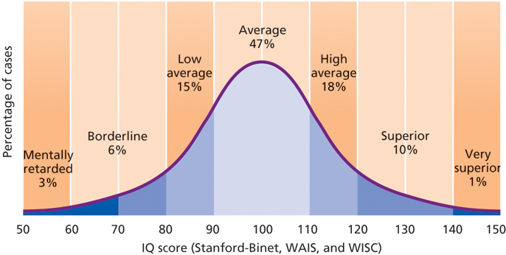
The Flynn Effect: Are we getting smarter?
- A “rising curve” phenomenon, suggesting that much of the world’s population is scoring progressively higher on intelligence tests
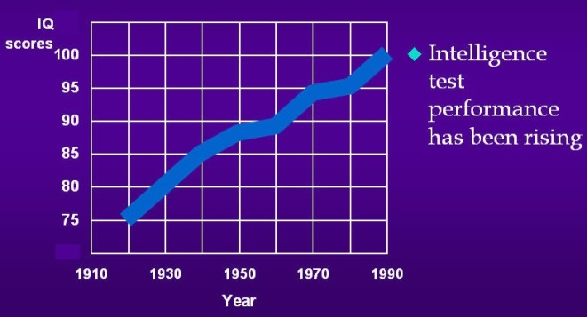

- Testing Conditions:
  - Static Testing: traditional approach to testing; emphasizes similarity in testing conditions
  - Dynamic Testing: standard testing is followed up with an interaction with the examiner
    - Examiner gives the respondent guided feedback on how to improve performance
    - Examiner then observes how the person utilizes the information
Cultural variation
- Traditional tests draw heavily on skills needed to succeed in Western society
- Sternberg’s Theory of Successful Intelligence: intelligence is whatever is required to meet the adaptive demands of a given culture
- Two main approaches:
  - Choose reasoning problems that are not tied to any particular culture
  - Create measures that are tailored to a specific culture
- Difficult to compare concepts of intelligence across cultures eg.,
  - Wise, sensible, smart, bright, clever
vs
  - kuchenjera, kungwara, kuziva, hunyanzvi, hugweregwere
Heredity and Environment
- Genetic factors can influence the effects produced by the environment
  - Accounts for 1/2 to 2/3 of the variation in IQ
  - No single “intelligence gene”
- Environment can influence how genes express themselves
  - Accounts for 1/3 to 1/2 of the variation in IQ
  - Both shared and unshared environmental factors are involved
  - Educational experiences are very important
- Gene X Environment interaction
- Twin Studies
  - Monozygotic = Same genes + same environment
  - Dizygotic = different genes + same environment
  - Intelligence has a strong generic component
    - Heritability coefficients ranging between .50 to .70 being reported consistently in both twin and adoption studies.
    - This indicates that more than half of the within-group variation in IQ is attributable to genetic factors
    - The more genes in common, the more similar they tend to be in intelligence
- Although genes are important foundations of the g factor, there is clearly not a single ‘intelligence gene’.
- The diverse abilities measured in intelligence tests are influenced by a variety of interacting genes.
- Twins raised together and twins raised apart have different correlations, with twins living together having a higher IQ correlation.
  - Thus ruling out entirely genetic explanation
- Environment plays a major role
Group differences in intelligence
Gender Differences in Intelligence
- Gender differences in performance on certain types of intellectual tasks, not general intelligence
  - Men generally outperform women on spatial tasks, tests of target-directed skills, and mathematical reasoning
  - Women generally outperform men on tests of perceptual speed, verbal fluency, mathematical calculation, and precise manual tasks
- Gender differences are small but consistent
  - Socialisation experiences
  - Evolutionary sex role specialisation
  - Effects of sex hormones on brain development
  - Beliefs about our own abilities
Stereotype Threat and Cognitive Performance:
- Stereotype threat: The belief that engaging in certain behaviors would confirm a negative stereotype in the minds of others
  - Evokes anxiety and undermines performance
- Influences performance in a number of domains
  - Women and math problems
  - African-Americans and “intelligence” tasks
Extremes of Intelligence
- The Intellectually Gifted:
  - An IQ of 130 or higher places in the top 1% of the population
  - Many individuals are enormously talented in one area but average in others
  - Achieving eminence:
    - Highly developed mental abilities specifically related to one’s chosen field
    - Ability to engage in creative problem solving
    - Motivation and dedication
  - Many intellectually gifted children may need special educational opportunities as they may become bored in regular classrooms.
- Mental Retardation:
  - Four-level classification system based on IQ scores
    - Mild
    - Moderate
    - Severe
    - Profound
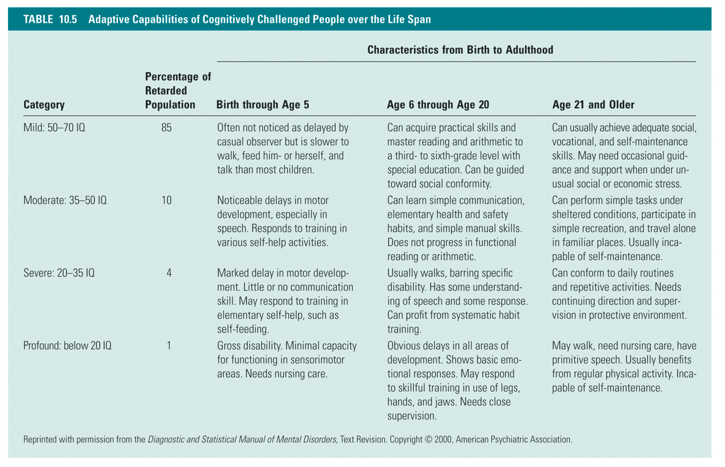

- Potential Causes of Mental Retardation:
  - Biological/Genetic abnormalities account for approximately 28% of all cases
    - Profound retardation is more likely to be caused by genetic accidents and does not run in families
  - Accidents at birth (oxygen deprivation, etc.)
  - Drugs/alcohol intake by the mother
  - Diseases (rubella, syphilis, etc.)
  - Undetectable environmental causes

