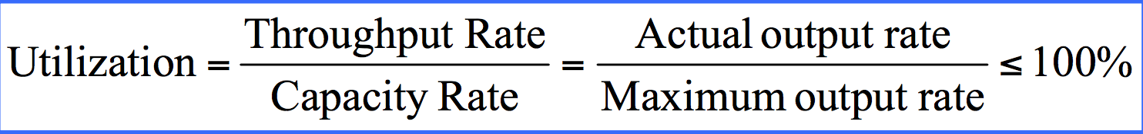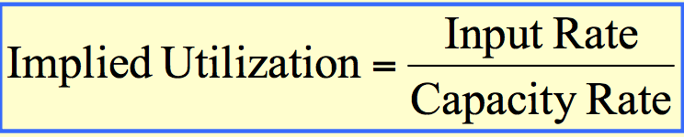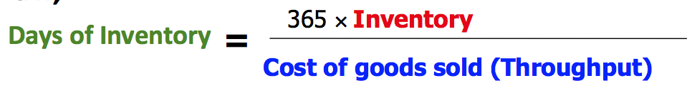
I=R*T (AVG inventory= AVG throughput rate* AVG flow time) Coefficient of Variation: C_{V=} δ/ μ
Discrete: sum of inventory for each period/ # of periods Continuous: AVG inventory=(srarting inventory+ending inventory)/2
Variability: +buffer (otherwise input lost, increase AVG inventory& flow time) +Capacity (add server& decrease service time)
- Reduce variability by improving info.(Demand:better forecasting&scheduling, Process:better quality, process variance
- Manage variability (Choose appropriate buffer(adequate inventory&capacity) Reduce impacts of variance by risk pooling
Distribution: to pool variability of many retail outlets| Finance: to reduce variability| Marketing: to reduce the risk of missing our target demographic| Production: to smooth out the risk of depending on just one
Lower throughput means - Lost customers; lost revenue; Customer dissatisfaction; Less utilization of resources
Safety: protect unpredictable variability in demand (prevent stock out) Cycle: periodic process/ production cycle (order at fixed time, producing in batch De-coupling: WIP up &downstream activities operate in an unsynchronized manner (variability in processing time) Anticipate: predictable variation in demand (Christmas tree, Valentines, pumpkin, back to school, seasonal)
Pipeline: in transit Speculative: prices are likely+, reasonable to stockpile (gold, truffles, expensive materials)
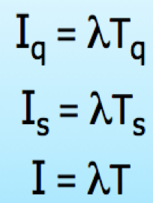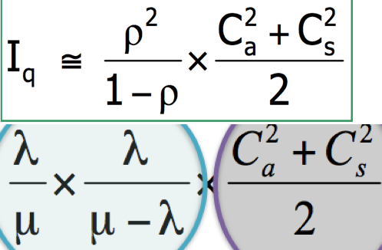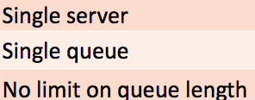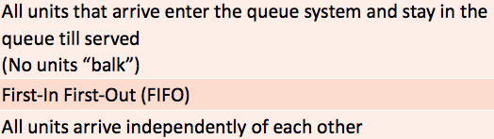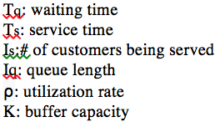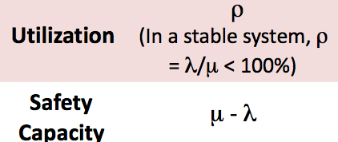
G/G/1: arrival/service time follow a “general” (prob.) distribution/ single server
M/M/1: arrival/service time follow an exponential distribution/ 1 server
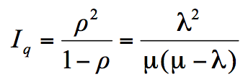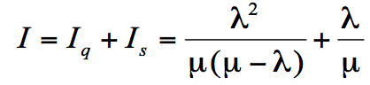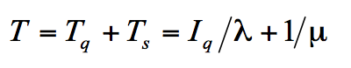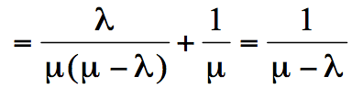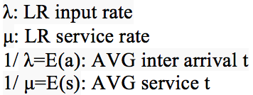
M/D/1: exponential distribution/constant/single server
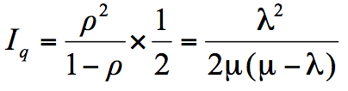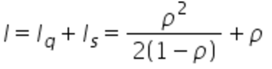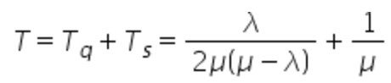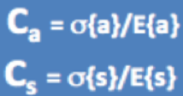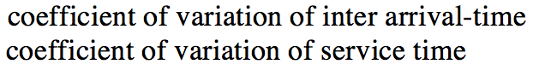
Multiple-server PK: “pooling”减queue length (－wait time& variability, b/c independent demand streams impose ＋variability
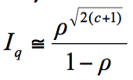
G/G/C: 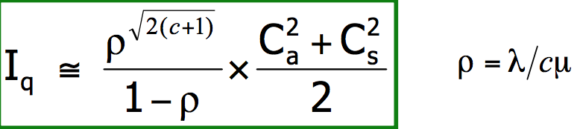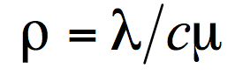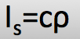
M/M/C: arrival/ service time follow an exponential distribution/ C server
M/M/∞: AVG # of ppl waiting&Avg waiting time:0 AVG # of ppl in the system:I=Is=入/ µ AVG time in system=avg service time:0
Risk Pooling: reduces variability and uncertainty, such as, across locations, across products or even across time. if demand is aggregated across different locations, it becomes more likely that high demand from one customer will be offset by low demand from another.
Psychology of Waiting: Occupied time feels shorter/ Anxiety makes wait seem longer/ Uncertain &Unexplained wait feel longer/ More valuable the service; the longer ppl will wait/ solo wait feel longer than group/ unfair wait feels longer
Mass Customization: tries to reduce the impact of demand variability by demand aggregation.
Postponement: delays the task of differentiating a product for a specific customer until the latest possible point by creating a more generic product and adding some of the details once demand is revealed. [Fan-out point(initial process starts diverge) Downstream] Push-pull: the initial stages of the supply chain are operated on push while the final stages are operated on pull. Dell Direct where the components are ready and assembled only after the order is received from the customer. [Inventory-order interface (after buffer) Upstream]
CPM(critical path magt): MAX path time, to shorten duration focus on critical path, may change
EF=ES+t LS=LF-t Critical Path: LS=ES and LF=EF Activity slack: LS-ES=LF-EF
PERT program evaluation review techique: (beta dist) Independence assumption & NO other near critical paths in the network
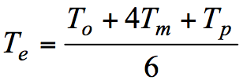 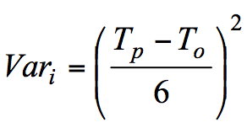 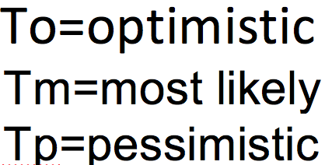 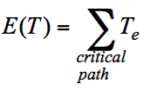 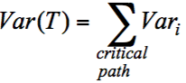 Z=(T-E(T))/ σ(E)
EOQ:economic oder quantity: deterministic & constant demand & immediate replenishment
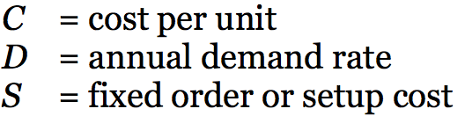 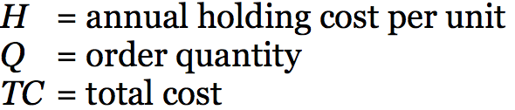 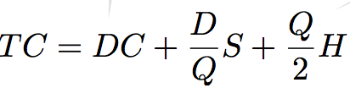 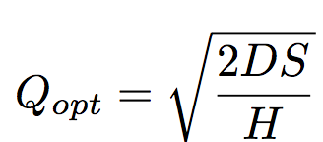ROP=D*LT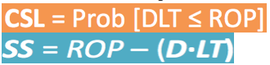
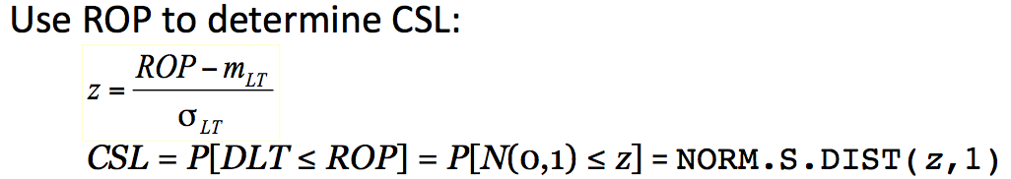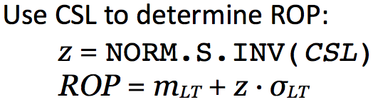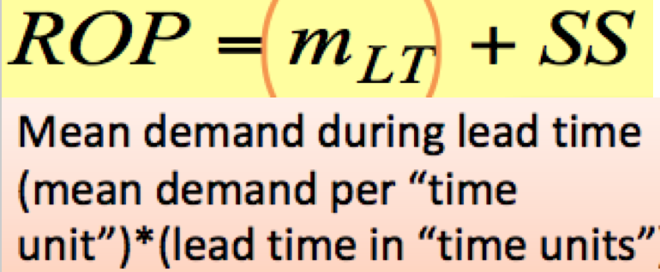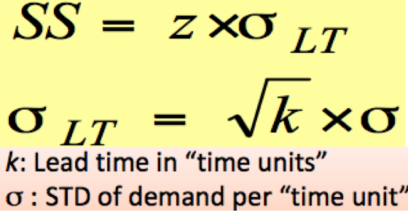
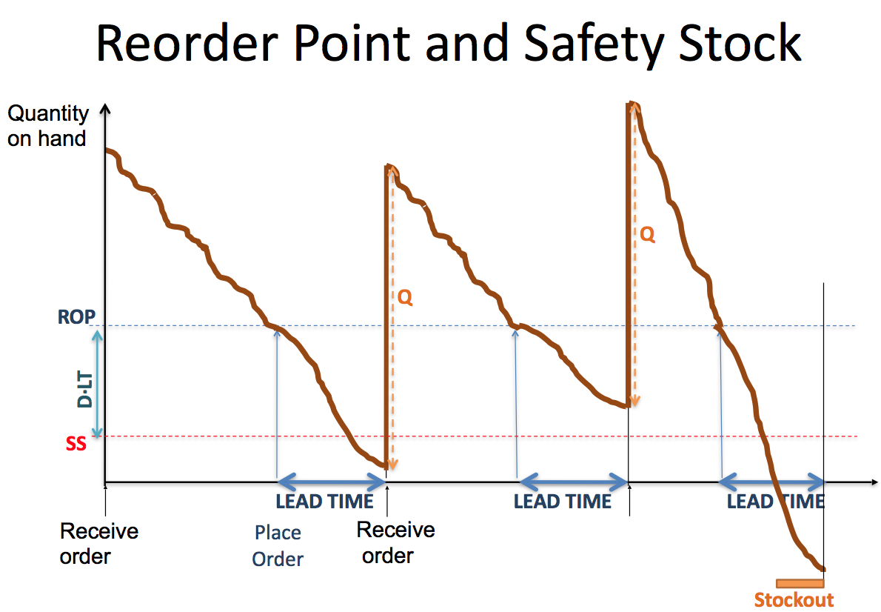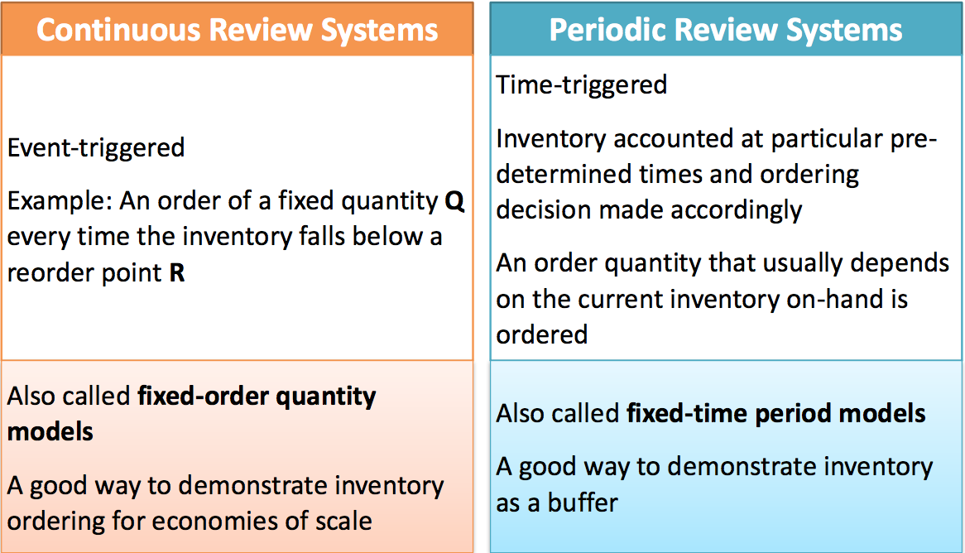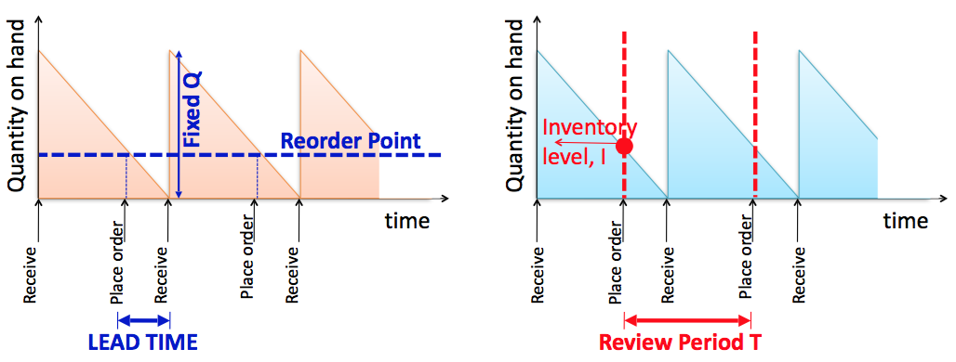
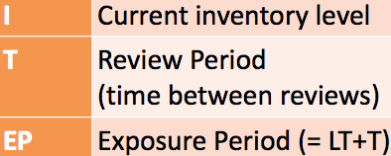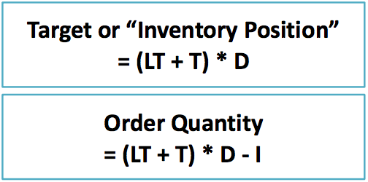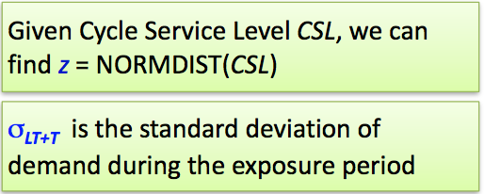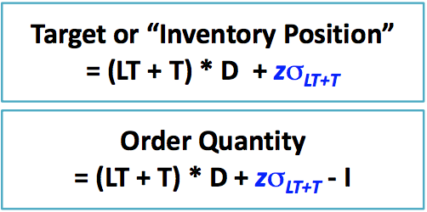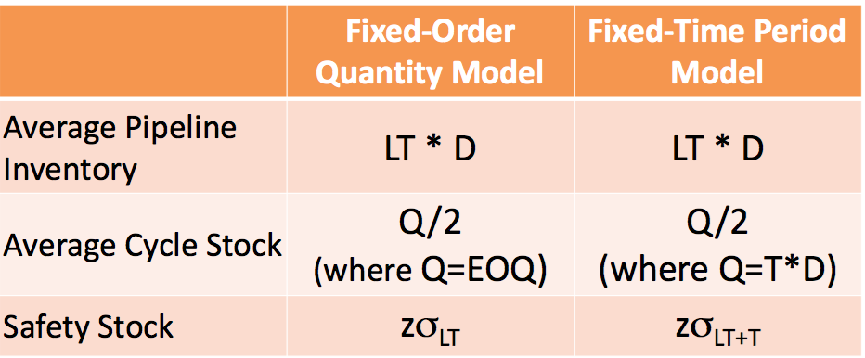
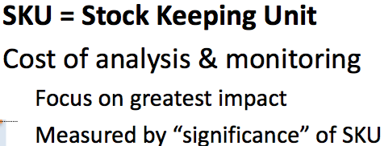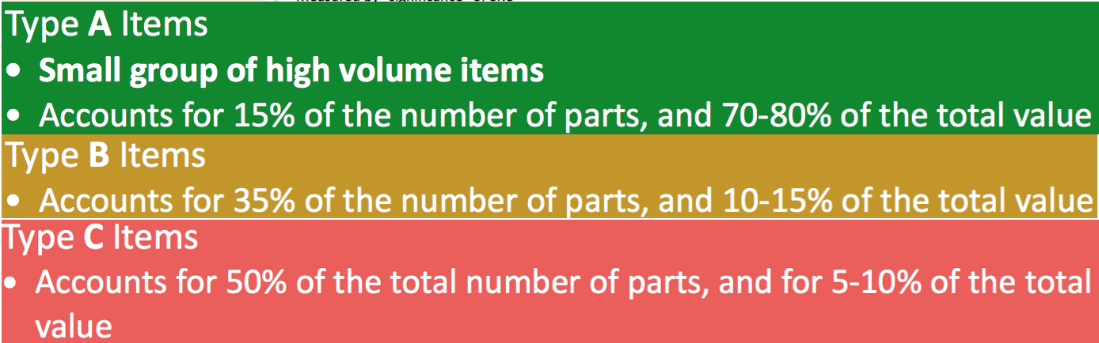
ABC: classifying items into groups is to establish the appropriate degree of control over each item/ absence of cirtical items creats sizable loss/ sufficiently large stocks should be kept on hand to prevent runout
Newsvender:random demand/ one chance to order / NO inventory-hold for beginning of the period (limited shelf-life)
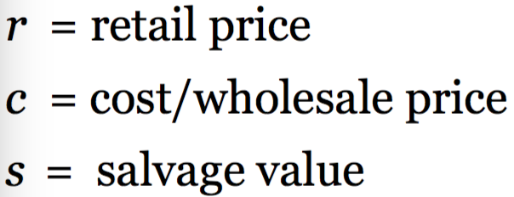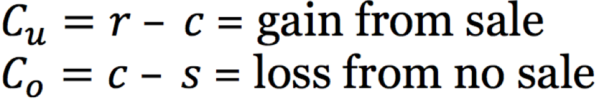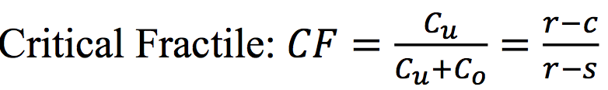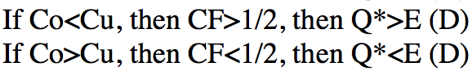
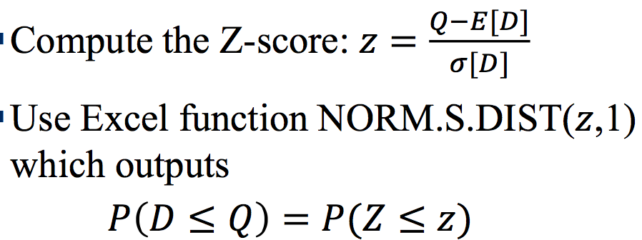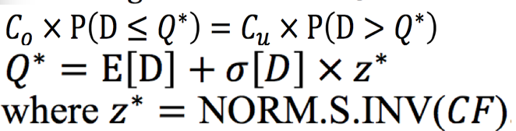
Vertical Integation: owns multiple parts of supply chain. Might own by single corporation:raw materials, component manufacturing, finish goods assembly, disrtibution centers, retail
Virtual Integration: partnership between up/downstream companies to achieve intergration across a supply chain, without actually being the same company

6 Key Attributes of products: Cost, Quality, Speed of delivery, Flexibility(variety, customerized), Volume, Capital intensity
MSE (mean squared error)= 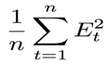 MAD (mean absolute deviation)= 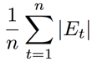 MAPE (mean absolute percentage error)= 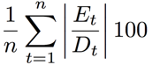
SMALL variation from forcast: extra capacity, inventory/rescheduling orders LARGE variation from forcast: inventory /employment may be cut to －production level | capacity is strained, extra ppl may be added in a rush/ lost sales
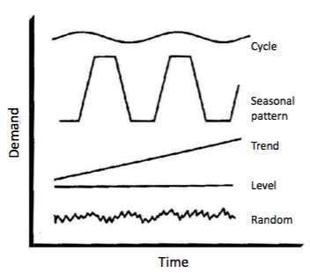
Typical time-series:
Sales of Florist-seasonal
Sales of milk- level
Telephone calls-
Newspaper- downward trend
Accurate response:make the relatively predictable category in advance in order to reserve capacity for unpredictable products closer to selling season, while make smaller quantity of unpredictable products in advance to test the market response, then use the INFO to determine which products to make more Benefits of accurate response: take into account missed sales opportunities/distinguish between predictable and unpredictable products/lower costs inaccurate forecast and prices
Strategic(2-5yrs): [Strategic Planning]-Capacity planning(process design, facilities) medium accuracy, use Qualitative&Causal
Qualitative:Executive Judgment(experience&history) MRKT Research(surveys, panels, interview, tests) Panel Consensus(meeting of executive salespeople&cutomer) Life-Cycles Analogy (growth curves of similar products)
Quantitative: Time Series Analysis-predict future based on past data(moving AVG, exponential smoothing) Causal Method- relate the demand for newspapers to population, economic activity & per captia income
Sensitivity analysis-vary inputs (individually or together) to see how the solution changes Scenario analysis-what if questions
Inputs Outputs Consideration:Data Granularity/Timescale/Pertinence&Accuracy of INFO (exchangeR/Organizational &political
Tactical(1-2yrs): [Supply Planning]-more detailed data, balance supply&demand, -cost] aggergating plannig-high accuracy, Quantitative
Inputs Outputs Consideration:Granularity of data/Timescale/Operational issue/Inventory/Accuracy of INFO (forecasted D
S&OP(monthly: agree on demand/forecast; balance supply&demand; implication for manufacturing, materials, key customers, finances, etc
Inputs-forecast/demand plan; inventory plan/SS(soft constraint); capacities, transportation costs, times; bill of materials; Outputs-production plan; raw material requirement; plan for promotions/price discount; transportation; any unsatisfied demand
- PROCESS: 1)receive forecasts 2)agree on single forecast 3)agree on inventory target 4)create initial supply plan next 6-12months 5)examine supply plan(meet demand/variab/warning 6)refine supply plan/repeat through E-F as needed 7)reach consensus on single plan
Exponential smoothing(forecast method) F_{t}= α*D_{t-1}+(1- α)*F_{t-1} [F_{t-1}: forecast in period t-1] [D_{t-1}: actual demand in period t-1]
Moving AVG in MORE Periods: more data give better estimate/ reduce effect of randomness/ lower error when no trend
- CONs: moving average slowly respond to α(permanent) changes due to a large # of obervation/ more error when there’s a trend
Operational(日-月):[Scheduling-based on future planning, cascade down level GOAL:minmize WIP &#of jobs, meed due date] Timeserise
Flow Time: completion time–started time; AVG measure responsiveness Lateness:behind schedule(+); ahead schedule(-){Flow time - Due} Tardiness: time after due day job was complete/behind(+); ahead(-)/ MAX lateness=0 Makespan:(processing time)takes to finish batch of job; measure efficiency AVG # of Job in system(minimize):=Total flow time/Makespan; amount of WIP; measure responsiveness
FCFS: AVG performance on most scheduling criteria/“fair” & reasonable to customers (important to service organization)
SPT(shortest processing time):minimize # of jobs in system; AVG flow time &lateness/CONs-long jobs may be pushed back in the queue
EDD(earliest due date):perform poorly on many criteria but minimizes MAX laten and MAX tardiness/do relatively well on AVG tardiness
LPT (longest processing time): least effective for sequencing jobs in single machine
AVG completion time=Total Flow Time/ #Job AVG # jobs in system=Total Flow Time/ Total Processing Time
Revenue Management-WHEN:Fixed capacity/High FC low VC/Product cannot be inventoried/can be sold in advance and demand evolves/MRKT can be segmented &Willing to pay different prices(flight, hotels, restaurant, ads & sales, theaters, car rental) How: Segmenting (advance booking vs. last-min; distribution channel, time of day; route), Promotion; Different price
Overbooking flight ticket: underestimating # of cancellation is losing revenue. Cost of overestimating is the reward, ex. free flight, cash back
Matrix multiplication =MMULT(multiplying row and column) & Matrices Command+Shift+Enter
{=AVERAGEA((IF(ISBLANK(damand), Moving AVG ,demand))} (Use in forecast error& moving {AVG (ABS))}

