Government and Business

Ch. 2 - 4 Useful Economic Concepts
- Opportunity Cost
  - VALUE of the best-forgone alternative. Resources are scarce = tradeoffs. Take project if value > OC
  - Investment generates more benefits then possible with alternative uses of resources
- Marginalism (MR=MC, P=MC)
  - Paradox of value: price of water is low because the MV of a liter of water is low
  - Marginalist Principle: If MB>MC, project/policy should be carried out. Optimal where MB=MC
- Incentives
  - Law of unintended consequences Ex/ Retirement buyouts good workers will quit and go elsewhere
  - Peltzmen effect - people adjust behavior to a regulation that counteract the intended effects it
- Efficiency
  - Pareto efficiency: Resources are allocated so that you cannot make anyone else better off without making someone else worse off “Allocation Efficiency”
    - Requires management efficiency (least cost, lowest input usage production)
  - Pareto Improvement: We can make A better off without making B worse off
    - Gainers gain more then losers lose, creates incentive for mgmt. efficiency
    - Potential Pareto exists if re-allocation of resources allows net gainers to fully compensate net losers, and still be better off

Ch. 3 - Market Efficiency
- Economic Freedom: Goods are supplied by firms pursuing profitable opportunities
  - Consumer Sovereignty: demand represents aggregate preferences of consumers
- Adam Smith’s Invisible Hand
  - People pursue self interest, the market is self-regulating without Gov. intervention
  - Competitive private markets harness private incentives so that they can best serve public interest
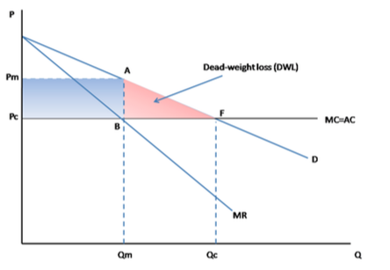
- The First Welfare Theorem (assuming no externalities)
  - Under perfect competition markets achieve Pareto efficiency
    - We cannot gain from reallocating resources: No DWL
  - DWL from sub-optimal output of a Monopoly - Deviation from PE
    - Wasteful because money was left on the table
- Market Failure: Private markets fail to achieve Pareto Efficiency
  - Imperfect Competition
    - Market Power (P>MC), firms have control over price
    - Barriers to entry, inefficiently low output
    - Monopoly, Cartels (collude on price), Oligopoly, Monopolistic Competition (same but differentiated product), Monopsony (single buyer, prices lower then competitive equilibrium)
  - Public Goods
    - Non-Rival: Even though one person consumes it, another can also
    - Non-Excludable: Impossible to exclude anyone from consuming the good
      - No consumer has incentive to pay = Freeriding
1. Rival in use? | Excludable | Non-Excludable
Yes | Private Good | Commons (Tragedy of)
No | Club Good | Public

  - Externalities: Failure of property rights - Direct, negative, un-priced external effects
    - Person/group is affected by the economic activity of others, without markets to price the effects
  - Asymmetric Information
    - Consumers do not know true MB to be derived from transaction as clearly as informed party
  - Efficiency losses to market failure
    - IC causes too little output produced (monopoly) and too little labor employed (monopsony)
    - Public goods are underprovided by the market
    - Negative externalities are overprovided
    - Positive externalities are underprovided
    - Bad products are overprovided when quality is not known, good products under-provided

Ch. 9 - Externalities & The Environment
- Externalities as Market Failure
  - Failure of the marginalist principle for social efficiency - MSB does not equal MSC
  - Firms producing ignore MSC and produce at PMB=PMC
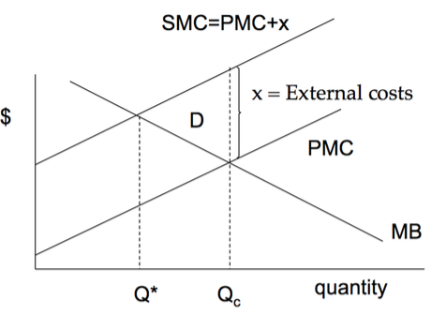
- Backwards inefficiency, we are producing too much

- Pollution should be reduced only so far that the costs of doing so are less then the benefits

- Pollution is a byproduct of activities that create desired goods

t

- Economics of Pollution Abatement
  - Examples: Installing scrubbers, waste treatment, carbon capture & storage
  - PMB of abatement = safer employee environment, carbon credits can be sold off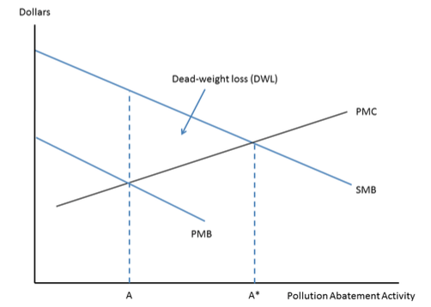
- PA generates positive external benefits that are not captured by the party undertaking the abatement activity

- PA will be underprovided if left to private incentives (PMB of PA is much less then SMB of PA, will only go to PMB=PMC)

- Socially efficient level at A* where SMB=SMC

- Causes of externalities: High transaction costs & Incomplete property rights
  - Coase Theorem: If the only externality problem is incomplete property rights (transaction costs are not an issue), then it can be solved or removed by establishing property rights, leading to an efficient outcome
- Policy Solutions to Externality Problems
  - Internalization of the Externality - via unified ownership (Mergers)
    - Mergers: Could increase combined profits if the Pulp mill acquires the fishery
  - Quantity Control and Standards
- Non-binding quota: Not allocated optimally

- Binding Quota: Will reduce output, reducing inefficiency

  - Incentive to conform but go no further
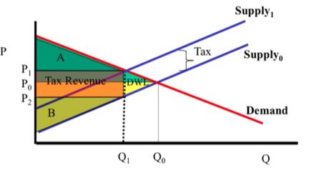
    - 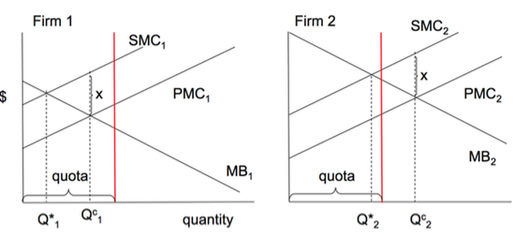
  - Taxes and Subsidies: Market solution; exploit market based incentives
    - Taxing goods, gov. gets revenue but at the cost of DWL
    - Taxing bads, gov. gets revenue while reducing DWL
    - Setting the right Tax - SMC=PMC + x (set t=x)
  - Cap & Trade Systems - assignment of property rights
    - Creation of a market, tradable permits allocate “pollution rights” that can be priced and traded
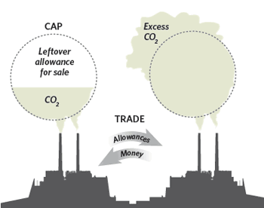
- Combine quantity controls with market incentives

- Cap=max allowable quantity of pollutant
  - Quota is divided into permits, which can be traded
  - Min the cost of achieving a given pollution target because private sector decides best way
  - Price of permits converges on MC of abatement

  - Social Responsibility & Utilitarian ethics
- NIMBY Problem: Locating hazardous waster facilities
  - Small # of people who live near to a toxic waste dump bear high costs
  - But benefits accrue to much larger, spread out group who are far from the waste site

    - Locate waste where generates lowest cost
    - Those who bear costs should be compensated, economics: should be incorporated in product price
- Larry Summers Memo
  - Argue for dirty industries that generate pollution + toxic waste to be relocated to poor countries
    - Low income gives them a “comparative advantage” in dirty industries
    - If it is not economical to relocate (internalizing as much as possible), then the rich pay the poor
- No incentive to reduce garbage because its not in front of you
- Renewable Resource Dynamics
  - G (S)=rS (1-S/K) where S=stock of rr, r=intrinsic growth rate, K=carrying capacity (max supported)
  - Growth is zero when S=0 or S=K. Growth declines as crowding effects occur
  - Growth is maximized at G when S=M=K/2 (induces crowding effects)
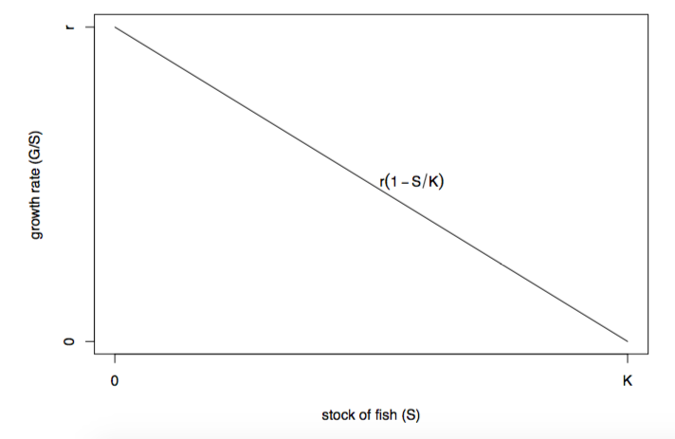
  - 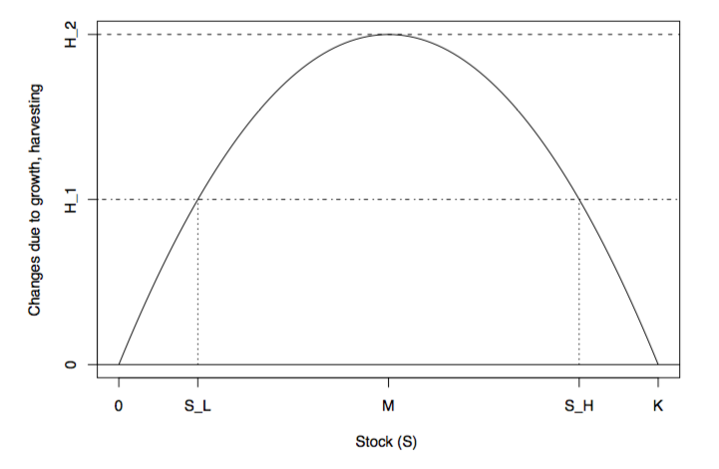
    - G=H is a steady state, harvest is sustainable, amount harvested is exactly = to amount of growth
    - S_L is unstable steady state (disturbances are not self correcting), S_H is stable state
  - M = Maximum sustainable yield
    - When H<G the harvest is below growth, stock increases
    - When H>G the harvest is above growth, stock decreases
    - Stocks are hard to measure, harvests hard to control, keep H<<G + S>>M
- Open Access Resource Problem
  - Common Pool resources face tragedy of the commons
  - W/O property rights, holding back on harvest does not help you since stock will be harvested by others
    - If harvest remain persistently over the “tipping point” the resource stock will collapse
  - 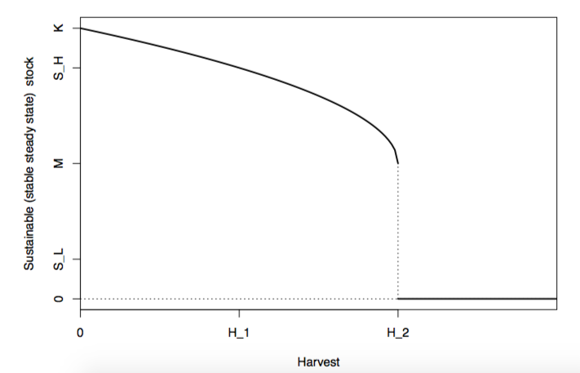
- Non-Renewable Resources: Cannot be used on a sustainable-yield basis, time scale beyond human activity
  - Hotelling: A resources real price will rise with the rate of interest reflecting increasing scarcity
    - Efficient exploitation of a NRR would lead to gradual depletion
  - Intergenerational Equity: resources management is critical to prevent discrimination across generations
    - Whose welfare is considered in our objectives, future gens preferences don’t enter into current prices

Ch. 4 - Fairness, Ethics, and Public Policy
- Principles of Fairness
  - Consequentialist: An ethical action is one that produces good consequences
    - The Benefits Principle: Focus on the benefits & costs experienced by affected parties
    - Utilitarianism: Ethical if it increases total utility (for all), weak protection of individual rights
  - Duty Based
    - Categorical Imperative: Without exception a duty or obligation that people who are rational and ethical are required to follow
      - Is it logically possible for everyone to act in this way? Would I want everyone to?
      - People have a duty to be honest, treat others with dignity, work hard, avoid cruelty
  - Distributive Fairness: Final allocation of goods across individuals is just
    - Egalitarianism or Rawls VOI (Maximin - policies maximize the welfare of least advantaged)
  - Procedural Fairness: Rules of the game are just, regardless of the final allocation that results
    - Non-coercion (not forced) and equality of opportunity (evaluate behind veil)
- Fairness and Efficiency Trade-offs: because of incentive effects
  - Dist. fairness comes at a cost, even outcomes remove/distorts incentives. People who make different levels of effort still get the same payoffs
- The Veil of Ignorance
  - To decide on what’s fair, put yourself in the original position, behind a veil, evaluate all possible outcomes
- Sens Critics to Rawls
  - Interests of non-contractors can be neglected, pursuing justice is about comparisons
  - We measure one possible policy against another possible policy, and not against an ideal
  - What would an impartial spectator observing from the outside make of the affairs?

Ch. 5 - Voting & Interest Groups
- Hoteling’s theory of political parties
  - Median-voter principle says the policy platforms will closely match the preferences of the median voter
  - 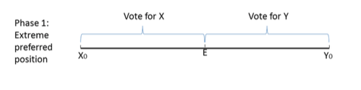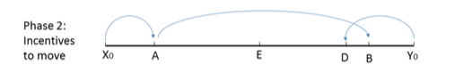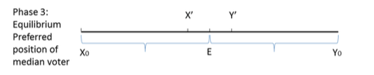
  - Important failure of democracy: agenda manipulation
- Interest Groups & Lobbying
  - Economic EIG (unions, industries) Social (values, views) activities benefit group but cost all
  - Transfer seeking: the process of devoting resources trying to obtain or retain economic benefits through the distribution of wealth of others, rather then by creating new wealth
    - 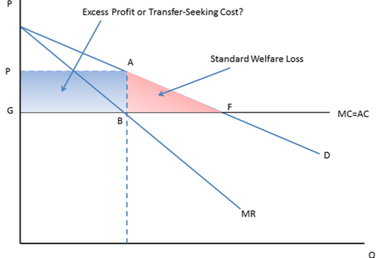
  - TS Cost are the resources devoted by the EIG to obtain transfers from others

  - Can add to the DWL of a policy
- 3 Main sources of government failure
  - Unelected decision makers pursue own self interest at expense of public interest
  - Voting Outcomes depend on process, and need not give appropriate weight to everyone
  - Interest group activity: may convey useful info, but also reflect transfer seeking

Ch. 15 - Corporate Social Responsibility - The pursuit of social objectives by private sector firms
- Milton Friedman
  - Firms only responsibility is to use its resources and engage in activities designed to increase it profits
    - You only have a duty to those that employ you (agency issue)… which generally is to make as much $$$ as possible
    - Taxation without representation, who decides target group to be chosen?
      - Undemocratic
      - Unwise because business person has no expertise on social problems
      - Ineffective for profit maximization ideal
  - Arrow: Friedman ignores market failures, profit max fails to get efficient results
    - Negative externalities - pollution by the firm
    - Asymmetric information - the firm knows more than customer about product, and work safety
- Stakeholder theory: Managers have obligations to several groups in addition to shareholders
  - Departure from duty to increase profits only for shareholders, need to go beyond Friedman
  - CSR survival bias: Cannot jeopardize the survival of the company with costs of initiative
- Value for money
  - Donors paying attention to “impact driven” philanthropy aim for same efficiency in their giving as in work
  - But may have short term focus, rather then more meaningful long term success (worthy but risky)
- Potential Solutions to market failure
  - Regulation
  - Taxation
  - Legal Responsibility
  - Social Responsibility
- Markets don’t always get things right and ethics can play a role in making them work better

Ch. 8 - Trade Policy - Free trade is beneficial because it allows countries to exploit their comparative advantage
- Comparative Advantage - A country will have CA if in the production of x the OC (not producing good y) of producing more x is lower in that country then it is in others
  - Sources through technology, resources, factor endowments (capital + labor, relative abundance of factors)
- Import Restricting Policies (Protective)
  - Tariffs: Taxes that are applied only to goods obtained from abroad
  - Quota’s: physical limits on quantity imported
  - Preferential Government Procurement: Ex. “buy American” policies
  - Administrative Barriers to Trade: Forms and procedures at customs, “Red Tape”
  - Other: Disguised protection, often involve safety of food or other consumer products
- Rationales for Trade Policy
  - Raising Revenue: Better to tax bads, property, income
  - Non-Economic Objectives (Military/Culture): Better to subsidize production
  - Exploiting Market Power in World Markets
  - The Infant Industry Argument
  - Domestic Redistribution: Use the income tax/transfer system instead
  - Increasing Employment: Use monetary and fiscal policy
  - Improving the Trade Balance: Use exchange rate
- DWL of Protection 1
  - An imported good not produced at home - Canada is a price taker, supply curve perfectly elastic
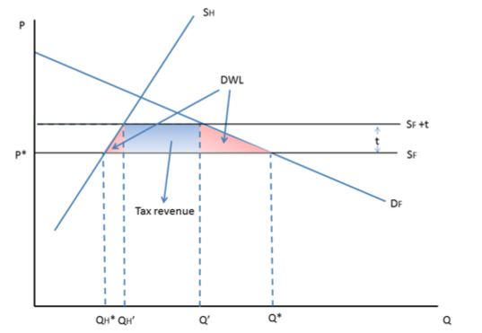
  - 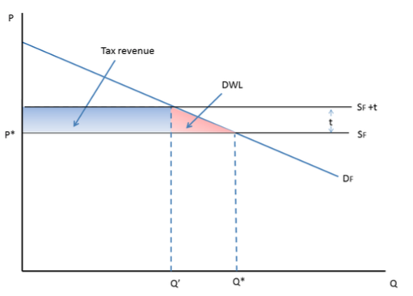1 2
- DWL of Protection 2
  - DWL associated with Pareto inefficiency from buying from a less efficient supplier
- Infant Industry Protection
  - If domestic producers lack expertise, they may face current high costs
  - If domestic market is served by imports, then the domestic suppliers gain no experience and costs stay high
  - If imports are temporarily kept out, price would rise enough to allow for profitable domestic production
    - Get enough cost reductions to be able to beat import prices, without help from protection
      - Even with protection, these industries might never group, creating a DWL
  - To be effective: need a lot of information to make correct assessment of OC and incentives
- The Questionable Jobs Rational - job creation not free, high OC
  - Negative effects on downstream sectors (higher costs for inputs)
  - Jobs moved rather then created (unemployed with wrong place/skills)
  - Export jobs reduced by foreign retaliation
  - Export jobs reduced by exchange rate appreciation
  - Protections DWL shrinks overall economy
    - Trade Balancing Rational: Trade deficits, importing more than you export, are not that bad in general. If you need lower trade deficit, let the exchange rate depreciate

Ch. 11 - Competition Policy the “Rules of the Game”
- Imperfect Competition - With market power, dominating firms charge excessive high prices, under providing goods.
  - Creates a DWL that government has a role to limit such abuse
- Canadian Competition Policy
  - Prevent firms from colluding (cartel’s) by fixing prices or anti competitive arrangements
  - Prevent undue reductions in competition arising from mergers
  - Prevent abuse of power from market power firms
  - Prevent misleading advertising and deceptive marketing practices
- Competition Law - Long History in Canada: Competition act is Carried out by Competition Bureau
  - The tradeoff: How tough a penalty vs. how hard to prove guilt
    - Civil law has less tough penalties (just money) but higher probability of guilt. (80% enough)
    - Criminal law has tough penalty but needs beyond a reasonable doubt (too high, heavy burden)
  - Ie. Using criminal code requires higher standard of proof
Criminal code violations: fines + prison | Civil Matters: fines up to $10mil for 1st offences
- Cartels and bid rigging (conspiracy to raise prices)  - Intentionally deceptive practices (telemarketing) and pyramid schemes  - Until 2009: price discrimination (not prosecuted), predatory pricing (now in AoD), retail price maintenance (in RTP) | - Mergers that lessen competition  - Abuse of dominance  - Restrictive trade practices  - Misleading advertising

  - Competition Bureau: Enforcement agency
    - Refers criminal cases to attorney general for prosecution, argues cases before CT
  - Competition Tribunal: Adjudication body
    - Experts in appropriate areas that handle civil matters, faster and more flexible then courts
  - Collusion: Conspiracies (Illegal under Competition Act)
    - Bid-rigging is fixing bids, agreeing with suppliers not to compete
    - Incentives under collusion: earn monopoly level profits
      - Ensure firm maintains agreement (prisoners dilemma, incentive to cheat)
Firms face problems {
      - Avoid prosecution (Claiming immunity)
  - Mergers are a more direct method to increase market power: internalize coordination to restrict supply
    - Unlike collusion, we can have efficiency gains in economies of scale
    - Horizontal - combine 2 or more firms in the SAME industry
      - Benefit: synergies, economies of scale
      - Cost: reduction in competition leads to higher prices for consumers
    - Vertical - Takeover of a supplier (upstream) by a customer (downstream) or vice versa (Ex. bread)
      - Benefit: reduction in double marginalization (# of times monopoly price is applied), increase in relationship specific investment
      - Cost: Negative effects on competition up/downstream?
    - Double marginalization: there is a firm that is a monopolist supplier of an intermediate input of another firm that is a monopoly power with respect to the final consumer
    - Williamson’s Diagram
      - 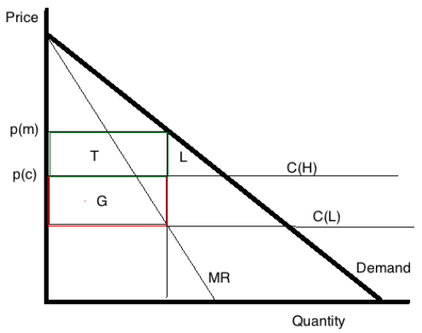
- C(H) is MC of both firms pre-merger, QS is quantity split under perfect competition pre-merger.
- C(L) is lower MC post merger
  - Costs are lower because of efficiency gains
  - Higher production, DWL lower
  - Gains to producer are G+T
  - Consumers lose T+L
QS
      - What would happen if the reduction if the reduction cost/efficiency gains were smaller?
        - Smaller, G, larger L - Net Social Welfare Gains = G - L
        - T is transfer from consumer surplus to producer surplus
    - Mergers evaluated if there is still room for competition
  - Section 45: Conspiracy - Every person commits an offence who, with xx conspires or agrees or arranges
    - To fix, maintain, increase or control the price for the supply of the product
    - To allocate sales, territories, customers or markets for the production/supply of a product
    - To fix, maintain, control, prevent, lessen or eliminate the production/supply of a product
      - Liable for indictment, 14 years and/or a fine up to $25 million
  - Collusion Dilemma
- M is total monopoly profit (due to prices of p^{m}) divided by # of members M>N
- D is the short term gain from defecting (taking advantage of rivals high price to steal whole market)
- N=normal profits N>0, better operating
- The sum of Ps + Cs is higher when both firms undercut
My price | Rivals Price
My price |  | Collude (p^{m}) | Undercut
My price | Collude (p^{m}) | M (m) | 0(M+D)
My price | Undercut | M+D(0) | N(N)

    - Dominant strategy you will do no matter what rival does
    - Condition necessary to ensure the only Nash Equilibrium of this game is for both to undercut: D>0

  - Abuse of Dominance: Dominant firms should not take actions that eliminate competitors or make them unable to compete effectively. Examples of policies that could be challenged:
    - Vertical price squeeze
    - Vertical foreclosure
    - Adopting incompatible product specifications to prevent entry
    - Using fighting brands to eliminate a competitor
    - Selling articles below cost to eliminate a competitor
  - Deceptive Practices: Policing misleading advertising & deceptive marketing
    - When seller pretends product is high quality when in reality it is low quality, lemons problem arises
      - Good products cannot be not sold at true worth
      - Bad products may be sold at above their value to the customer
      - Bad products may drive out good products
    - Deceptive practices lead to Pareto inefficiency of asymmetric information, creating bad utility
- The primary justification of Competition policy is to correct market failures associated with imperfect competition and imperfect information

Ch. 13 - Regulation and Public Enterprise
- Natural Monopoly - Level of demand can be met at lower cost by a single firm than others
  - High Fixed costs IE. Utilities, mail services, telecommunications
  - Declining average costs throughout the area covered by/under the demand curve
  - Associated with market failure - imperfect competition
- Characteristics of Natural Monopolies
  - Capital Intensive: Capital-to-output ratio 3-4x higher than typical firm
    - High fixed costs relative to MC, declining AC over a considerable range of output
    - Capital requirements proportional to output do not lead to natural monopoly
  - Physical Network: Linking the producer/distributor to the consumer requires a lot of capital investment to create, duplication by competing firms would be inefficient
    - Suppose there are fixed costs of $1200 and VC of $3 per unit
    - C=1200+30, AC then = 1200/Q +3 and we have AC declining across all range of output
- Policy Solutions to Natural Monopoly Market Failure
  - To prevent monopoly pricing NM are either
    - regulated private enterprises (Fortis BC),
    - government owned and operated (CP),
    - or government owned, semi independently managed AND regulated (BC Hydro)
  - 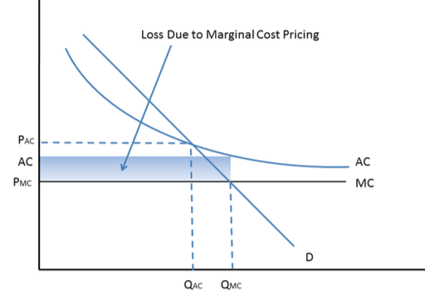
AC or MC Pricing?
- Regulators need to provide the loss due to MCP
- DWL triangle is an undersupply of goods
- Bottom rectangle is recoverable
  - We don’t price at MC and let Gov. cover the loss because of: Fairness, Incentive problems, and OC
- Two-Part Pricing
  - Producer charges a customer an access fee for the “right”: to buy the good
    - Implies that expenditure is a linear function of quantity (E=A+PQ)
    - It is justified when the good is socially desirable
  - 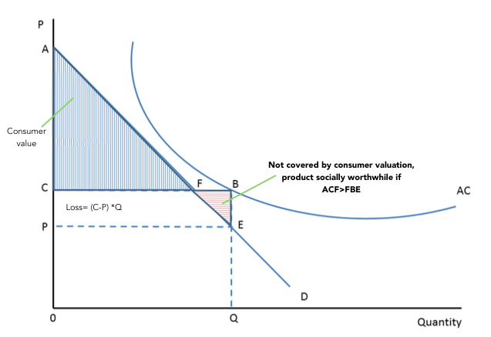
- Regulation beyond natural monopoly
  - Dairy production - ensuring ample and secure food supplies, farmers income, stabilization
  - Financial Intermediation - macroeconomic stabilization, asymmetric information
  - Marketing Boards - milk, eggs, poultry, to restrict output through a quota system. Cause up to 25% rents
  - 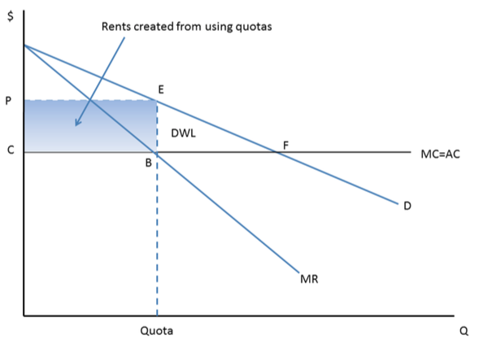
  - Regulators usually require prices to be close to AC, and AC>MC

- Public Enterprise

  - Directors and senior management appointed by government (not shareholders)
  - Debit is a liability of the government (no bankruptcy protection)
  - The public enterprises mandate goes explicitly beyond profit maximization

    - State Provision of public goods (police, science, research)
- Government Departments should be mainly used
    - Publicly owned natural monopolies (Private goods, but declining AC curve, competitive supply not an option)
- Regulated investor owned monopoly normally works best (avoid soft budget constraint)
- Crown Corporation when…
  - There is a mixed objective i.e. efficiency + another,
  - Or when capital costs are extraordinarily high (so that gov’t lowering costs of borrowing matters)
    - Publicly provided “private” and “club” goods (potentially be competitively supplied, i.e. public schools)
- Goal of Universal Access (inclusivity)
  - Positive externality argument, social returns to literacy or fairness in Medicare
  - Free market alternative for health & schooling is a voucher system
- Goal of Revenue
  - BC lottery adds $1bn to gov’t revenues, Liquor & hydro adds $1.4bn
  - Alternative is to sell the franchise or Privatize
- Union Capture? BC Liquor pays workers $21-23per hour as compared to $11.50

Ch. 13 - Innovation Policy & Intellectual Property

- Market Failure: Innovation as a Public Good
  - Example: Develop a new drug, each pill is a private good, the knowledge required is a public good
    - Non-rival: anyone else can use that same knowledge to produce more pills
    - Non-exclusive: once pills are available in the market it is easy for another company to copy it
  - Free rider Problem: Innovation will be underprovided
    - Failure of property rights
    - Little chance of recovering its development cost, less innovation
- Market Failure: Innovation has Positive Externalities
  - Positive: researchers knowledge is shared, we have knowledge spillovers
    - Training by one firm has positive external effect on other firms, changing jobs
    - SMB will be above PMB
- Market Failure: Asymmetric Information on Innovation Finance
  - Large firms are able to finance using their own revenues, smaller firms cannot
  - Outside investors know less about innovation process than innovator
    - Adverse selection: High quality unable to obtain financing
    - Moral Hazard: difficult for investors to see if appropriate decisions/efforts are being made
- Regulation of Intellectual “Property”

  - Patent Law: Right granted by government, giving investor exclusive control over an invention (trade-off)
    - Promotes innovation by reducing market failures (PG, externality and AI)
    - Create monopoly power over patented invention
Innovation maxed at an intermediate level of PP, not at the highest possible level
    - Too strong PP will hinder innovation
- Prevent others from innovating in the area
- Holder of patent less incentive to innovate further, immune to competition
Tragedy of the anti-commons because of excessive property rights
Patent Trolls: Firms using patent system to obtain rents, impose tax on innovative firms

  - Trade Secret Law: Protects commercially valuable info to conceal from competitors (monopoly power)
    - Economic espionage, a method of imitating and obtaining IP that is protected by “secrets”
  - Copyright Law: Protects various “original forms of expression”
    - Protects innovative work from the free-rider problem
    - Fair dealing will give exceptions to copyright for specific purposes
  - Trademark Law: Protects words/symbols that identify for consumers goods supplied by particular firms

- Government Support for R& D
  - University research is a public good and generates positive externalities
    - Funding applied vs. basic research, tradeoff
  - Tax concessions and subsidies for private sector R&D
    - Patents help correct the public good problem, and do not internalize all + externalities
  - Financing Innovation - 10% of venture capital in Canada done by the government

Ch. 14 - Macroeconomics: Recessions and Policy Responses

      - Unemployment Rate = U / U + E … ( L = U + E )
      - Employment Rate is the ratio of employed to the population = E / N | Labor force participation rate = L / N
- Demographic change that could raise E/N without changing the U/U+E?
  - Greater female participation, lower college attendance, or delayed retirement ^ E/N
  - New entrants would need same UE rate
- Discouraged workers lower UE rate without affecting E rate
Frictional: # of vacancies matches # of applicants, have to search and match
Structural: Mismatch bt the skills of the unemployed and the skills needed for available jobs (# matches)
Natural: Sum of frictional, structural, and seasonal UE
Cyclical: UE higher than normal (several quarters) resulting from smaller aggregate # of jobs than job-seekers

Keynesian - Large-scale (cyclical) UE is attributed to deficient demand
- Investors have low “animal spirits” (pessimistic) they delay purchases of machinery & equipment
- Consumers delay durable goods purchases
- Construction declines
Anti-Keynesians - downplay cyclical UE, attribute to supply side decisions
- Taxes on employers too high, UE benefits too high
- Voluntary UE, when worker productivity falls, they choose more leisure
Why is labor demand curve downward sloping? (Doesn’t clear)
- The demand for labor is the marginal productivity
  - If the MP is decreasing we will hire more only if we can pay less
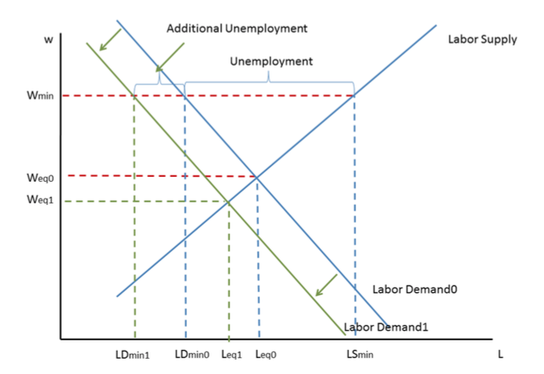
- Labour supply curve reflects trade-off bt work for wages and non-compensated activities “leisure”
- Min wage and unemployment:
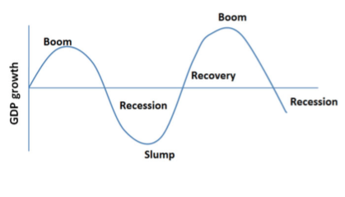

Fluctuations in National Output
- GDP is the sum of all goods & services produced domestically
  - Seasonal adjustments
  - Long run: Developed countries grow 2-3% per year. Important to distinguish between real and nominal growth trends
  - Cyclical: Deviations form the trend are often referred to as the business cycle
    - Recessions often defined as 2 consecutive quarters of -GDP growth

Keynesian Economics II
- AD = C + I + G + (X - M) - For various reasons AD can fall
  - C = f (r,Yd) can fall if disposable income (Yd) decreases or interest rates (r) increases
  - I = f(r) can fall if r increases
  - G is the government demand for g&s, if taxes fixed the sign will determine the sign of the deficit
  - X - M = f(E,Y) can fall if exchange rate “E” decreases or income increases
  - G, r and E are affected by macroeconomic policies
  - Since Y = C + I + (X - M) + G, GDP will fall
- Lower level of GDP will be UE and under utilized capacity
  - Policy Responses:
- Monetary policy to lower interest rates to raise AD
- Fiscal policy in the form of lower taxes to increase C, and/or raise G holding taxes constant (deficit spending or stimulus)

Ch. 14 - Macroeconomics: How Macro Policy Works and Fails

- Interest Rates - High: reduces AD, makes costly for households to pay off debts (discourage home buying), hard for firms to justify investments, make life good for savers, causes recessions
- Krugman’s Gas Pedal Metaphor: think of employment growth as the speed of the car, IR as the gas to the engine, monetary policy as the gas pedal/brake
  - Expansionary Monetary Policy “Loose $” - Central bank holds IR down (push down gas)
  - Contractionary Monetary Policy “Tight $” - Central bank takes actions to raise IR (brakes)
    - Inflation is the % change in the CPI over some period
- Consumer Price Index gives us the price of a “market bundle” today relative to a base year (100)
  - Weights prices according to their share in average expenditure
  - You cannot compare the Vancouver CPI to the Toronto CPI to see which city is cheaper
  - The core CPI excludes food & fuel bc highly volatile, stocks are always excluded
- Consequence of inflation: correcting for it in our variables of interest
  - Real GDP is the nominal GDP “current dollars” divided by the price level from a base year, when real GDP increases we say output has grown
  - Real Wages divide wages by the price index
  - Real Interest Rates IR minus inflation rate, tells us how much purchasing power the $ in our savings account is accumulating
  - Real Exchange Rates the relative price of foreign goods expressed in our currency, determines how competitive domestic goods are with foreign goods
- Causes of Inflation
  - Inertia: past rates of inflation are usually a good predictor of future inflation
  - High UE tends to lower the inflation rate, vice versa
  - Expansionary monetary policy increases inflation except in deep recessions
  - Rising oil prices affect gas prices, short term effect on total inflation but usually not on core
  - Rising wheat prices have a very small effect, even in the short run
- Quantity Theory of Money: Velocity = volume of transactions T/year/$ of the stock of money M
  - V= T / M… Approximate volume of transactions with GDP, Y…
  - Y = P x Q (Nominal GDP)
  - M_{t} x V_{t} = P_{t} x Q_{t}
- Why is inflation bad?
  - Hidden tax on money holdings, Decline in purchasing power
  - Bad for lenders, Confounds microeconomic signals embedded in relative price changes
  - If everyone anticipates the price changes, then all wages change too
- What can government do to keep its currency from depreciating (appreciating)?
  - Raise interest rates (lower interest rates)
  - Buy home currency using reserves (sell home currency)
  - Ration currency: restrict people from converting home into foreign currency
- Debts and Deficits
  - G: Government spends on g&s, GOC one of the largest public buyers of g&s ($16bn)
    - Public procurement (from the private sector)
    - Public employee salaries
  - S: Social safety net spending to unemployed, elderly, disabled, etc.
  - T: Government Taxes (+): personal and corporate income taxes
  - Interest payments, rD on past debt, D_{t-1}
  - Government deficit is d_{t}= G_{t} + S_{t} + rD_{t-1} - T_{t}
  - Debt is accumulated deficits: D_{t+1} = D_{t} + d_{t}
- Public Debt
  - Debt for infrastructure (with high social return) could be good investment, pay for itself via future taxes
  - Public debt should not get too high relative to GDP
  - Interest payments on internally-held debt are transfers which do not affect total income and expenditure

