RESPIRATORY SYSTEM PHYSIOLOGY
6.3 deine and explain the following: Intrapulmonary, intrapleural and transpleural pressures
o | PO2 in the alveoli is 104
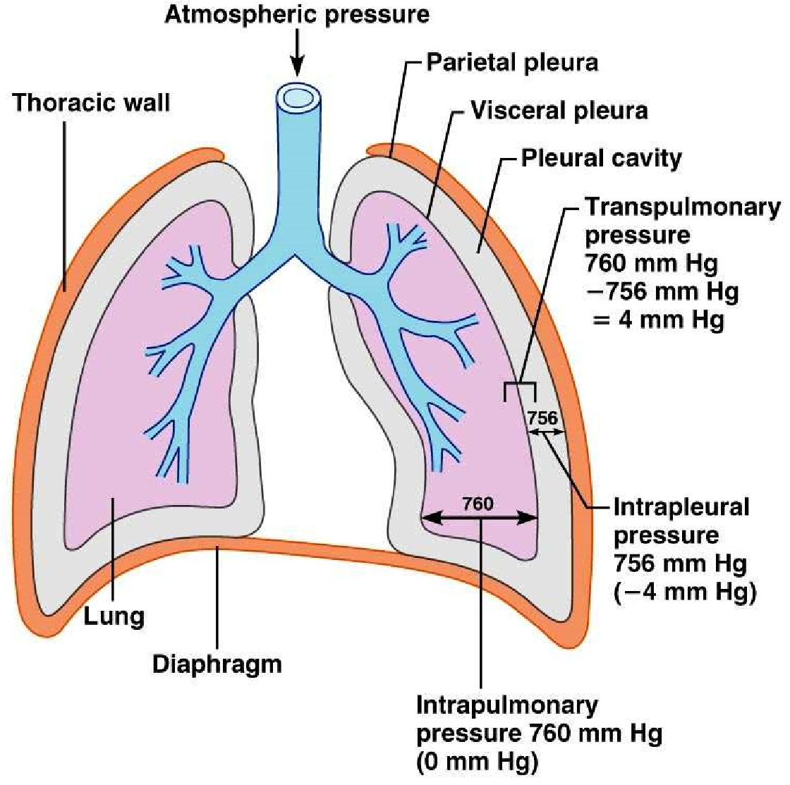
 Intrapulmonary Pressure
(alveolar) o (Ppul) is the pressure in the ALVEOLI of the lungs
o Rises and falls with breathing but always eventually equalizes with atmospheric

mmHg
 Intrapleural Pressure (Pip) o Pressure in the pleural cavity
- ~4 mm HG less than pressure in alveoli
- Lung collapsing pressure o negaive
- Interacion of 3 factors
    - Natural tendency of lungs to recoil
    - Surface tension of alveolar luid
    - Surface tension of pleural luid and elasicity of chest wall o Lungs in separate pleural caviies, one can collapse and not the other
 Transpleural pressure: KEEPS THE AIR SPACES IN THE LUNG OPEN o Intrapulmonary – intrapleural
6.4 Explain the roles of the diaphragm and accessory muscles during inspiraion and expiraion( quiet and forced)

RESPIRATORY SYSTEM PHYSIOLOGY
6.3 deine and explain the following: Intrapulmonary, intrapleural and transpleural pressures
o | PO2 in the alveoli is 104
 Intrapulmonary Pressure
(alveolar) o (Ppul) is the pressure in the ALVEOLI of the lungs
o Rises and falls with breathing but always eventually equalizes with atmospheric

mmHg
 Intrapleural Pressure (Pip) o Pressure in the pleural cavity
- ~4 mm HG less than pressure in alveoli
- Lung collapsing pressure o negaive
- Interacion of 3 factors
    - Natural tendency of lungs to recoil
    - Surface tension of alveolar luid
    - Surface tension of pleural luid and elasicity of chest wall o Lungs in separate pleural caviies, one can collapse and not the other
 Transpleural pressure: KEEPS THE AIR SPACES IN THE LUNG OPEN o Intrapulmonary – intrapleural
6.4 Explain the roles of the diaphragm and accessory muscles during inspiraion and expiraion( quiet and forced)
⬇ Resistance determined by diameters of conducing tubes
⬇ Usually insigniicant in healthy individuals because
    - Airway diameter decreases, number of branching pathways increases, so the total cross secional area is sill huge
    - Gas low stops at terminal bronchioles (difusion)
⬇ Greatest resistance is at the level of medium bronchi
Neural inluences
  - Parasympatheic (ex. Inhaled irratants, histamines): constricts bronchioles, also occurs during acute asthma atack
  - Sympatheic dilates bronchioles
  - Disease: ex. Mucus, infecious material, tumours can be sources of airway resistance
- Alveolar Surface Tension
- at any gas and liquid boundary, molecules of liquid more strongly atracted to each other than to the gas soooo this makes tension at the liquid surface
⇨ Liquid molecules drawn closer, reduce contact with dissimilar gas molecules
⇨ Resists any force to increase surface area
 Water has a very high surface tension, water only in alveoli would cause collapse
 Surfactant: detergent like lipoprotein produced by type 2 cells, interferes with cohesiveness of water molecules, so there is less energy to overcome surface tension
6.5.3 Lung Compliance
- healthy lungs are really stretchy and that is called lung compliance
- 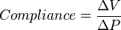
- The more a lung expands for a given rise in transpulmonary pressure, the greater its compliance
- Lung compliance is determined by 2 factors o Dispensability of lung issue o Alveolar surface tension
- Compliance is diminished by any factor that: o Reduces natural resilience of lungs (ex ibrosis) o Increases surface tension of alveolar luid o Impairs lexibility of thoracic cage
- The elasicity of lungs is important for inspiraion and expiraion
6.6 Describe how lung volumes and capaciies are measured and indicate their physiological signiicance
- Respiratory volumes
Here are the normal values for a health 20 year old male
    - Tidal volume: 500 ml/breath
    - Inspiratory reserve volume: volume FORCIBLY inspired ater TIDAL volume
    - Expiratory reserve volume: volume FORCIBLY expired ater TIDAL volume
    - Residual volume: 1200 ml air remains in lungs (keeps alveoli open and prevent lung collapse)
- Respiratory Capaciies
Always consist of two or more lung volumes!
    - Inspiratory capacity: air that can be inspired AFTER TIDAL EXPIRATION
(Tidal volume + Inspiratory reserve volume)
    - Funcional residual capacity: the amount of air sill in lungs ater a normal idal volume expiraion (Residual volume + Expiratory reserve volume)
    - Vital capacity: total amount of exchangeable air (TV + IRV + ERV)- the LARGEST
    - Total lung capacity: the sum of all lung volumes, ~ 6000 ml

