Lec 7 : Membranes and Transport (Feb 2)
Readings : 5.3-5.6

Readings :

5.4 - Passive Membrane Transport
-diffusion of molecules from one compartment to the other

Passive Transport : transport/movement of substances across cell membranes without using chemical energy such ATP
ex. diffusion- net movement of ions/molecules from a region of higher concentration to a region of lower concentration, primary mechanism of solute (molecules of a substance dissolved in water) movement within a cell
-driving force of diffusion : increase in entropy
-initial state : molecules are more concentrated in one region/side of membrane (energy more localized)
-as diffusion occurs : entropy increases as the energy spreads out until molecules are evenly distributed (highest entropy)
-as distribution proceeds max disorder : molecules release free energy, can accomplish work
(free energy = work)
-simple diffusion : no proteins used
-equilibrium : same concentration inside and outside cell , molecules move at equal rates in both directions
-osmosis : diffusion of water molecules

Rate of Diffusion
-depends on concentration difference (concentration gradient) between two areas/across membrane
- larger gradient = faster rate of diffusion
- equilibrium : same concentration inside and outside cell , molecules move at equal rates in both directions, but no change in concentration

Simple Diffusion :
-movement of small substances through the lipid part of a biological membrane
-no transporter needed
-rate depends on : molecular size and lipid solubility
-diffuse through phospholipid bilayer : nonpolar molecules (O₂, CO₂ are soluble), small uncharged polar molecules
-don't diffuse through : large, uncharged polar molecules, ions

Facilitated Diffusion
-transport of polar/charged molecules across membrane with the help of transport proteins
-relies on specific transport complexes for rapid transport
-transport depends on concentration gradient across the membrane (when gradient falls to zero, facilitated diffusion stops)
-two types of proteins carry out facilitated diffusion : channel and carrier proteins

Channel Proteins :
-form a hydrophilic channel in a cell membrane through which ions, water, molecules can pass
-provides avenue that is shielded from hydrophobic core of bilayer
Aquaporin :
-water-specific transport protein, facilitate diffusion of water
-found in organisms as diverse bacteria, plants, humans
-very narrow channel, allows for single-file movement of a billion water molecules/second
-does not allow for diffusion of ions/protons
-positive charge in the center of channel, repel transport of protons
-discovered by Peter Agre
Gated Channel :
-can switch between open, closed, and intermediate states
-critical to the movement of most ions (Na, K, Ca, Cl)
-gates may be opened/closed by changes in voltage across the membrane or by binding signal molecules
-opening/closing involves changes in the protein's 3D shape

Carrier Proteins :
-binds to specific single solute (ex.sugar/a.a) and transports it across the lipid bilayer
-transfer is called : uniport transport (carrier-mediated fashion)
-carrier protein undergoes conformational changes that progressively move solute binding site from one side of the membrane to the other, thereby transporting the solute

Determining which diffusion is used :
-facilitated : faster, can be saturated, reach plateau : represents state when all transporters are occupied by substrate , so increasing the concentration has no effect on rate of transport
-simple : slower, whole membrane surface is the transporter, therefore the rate of transport never reaches a plateau
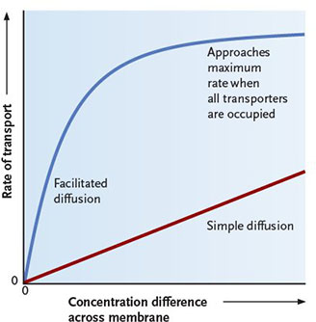

Osmosis - Passive Diffusion of Water (5.4d)
-diffusion of water across a selectively permeable membrane from solute of lower concentration to solution of higher solute concentration
-membrane must allow water molecules to pass, but not the solute molecules
-occurs constantly in living cells
-inward/outward movement of water by osmosis develops force that swells/shrinks cells
-occurs in cells b/c they contain a solution of proteins and molecules that are retained in the cytoplasm by membrane impermeable to them, but permeable to water
-can be simple diffusion or facilitated (aquaporins)
-dictated by solute concentration
hypotonic :
-solution containing dissolved substances at lower concentrations than the cells it surrounds (water enters by osmosis and cell swells)
-red blood cells can burst, plant cells won't due to protective cell wall
hypertonic :
-solution containing dissolved substances at higher concentrations than the cells it surrounds
-water leaves by osmosis, and cell shrinks
isotonic :
-concentration of water inside/outside cell is equal
-no net movement of water in/out
-energy costly, pump ions from one side to other

-above absolute zero, molecules always in motion, results in molecules becoming uniformly distributed in space

5.5 - Active Membrane Transport
-movement of molecules through the membrane against the concentration gradient (low to high)
-requires expenditure of energy (ATP), about 25% of a cell's atp is used for active transport
-pumps
-two classes : primary and secondary
three main functions:
1.uptake of essential nutrients from the fluid surrounding cells (even if their concentration is lower outside cell)
2.removal of secretary/waste materials from cells/organelles (even if their concentration is lower inside cell)
3. maintenance of essentially constant intracellular concentrations of H, Na, K, Ca (since ions are charged, active transport of ions may contribute to voltage(electrical potential difference) across the plasma membrane = membrane potential

Membrane Potential
-electrical difference across the plasma membrane is important in neurons and muscle cells
- -50 to -200 mV(charge inside cell is negative)
Electrochemical Gradient :
-difference in chemical concentration and electric potential across a membrane
-store energy that is used for transport mechanisms (ex. nerve impulse transmission)

Primary Active Transport
- the same protein that transports a substance also hydrolyzes ATP to power the transport directly
-pumps move positively charged ions (H, Ca, Na, K)
-proton (H) pumps : pumps H ions across membrane, pushes H ions from cytoplasm to cell exterior
-calcium (Ca) pumps : in eukaryotes, pushed Ca from cytoplasm to cell exterior, from cytosol into vesicles of the ER, used as control of secretion, microtubule assembly, muscle contractions
-sodium-potassium (Na/K) pumps : in plasma membrane of animal cells, 3Na out : 2K ions in

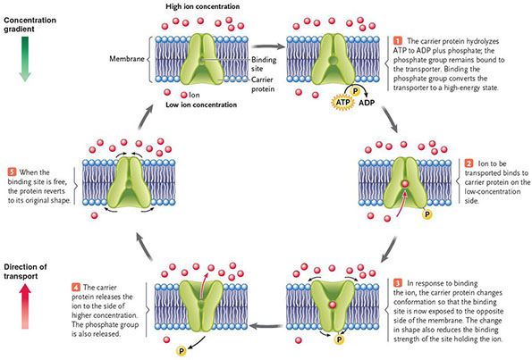

Secondary Active Transport
- transport is indirectly driven by ATP, transport proteins use a favourable concentration gradient of ions built up by primary active transport as the energy source to drive the transport of a dif molecule
-occurs by two mechanisms : symport and antiport
Symport
-transport of two molecules in the same direction across a membrane (cotransport)
-contransported solute moves through the membrane channel in the same direction as the driving ion
-ex. glucose, amino acids
Antiport :
-molecule moves through a membrane channel into a cell and powers the active transport of a second molecule out of the cell (exchange diffusion)
-driving ions move in one direction, providing energy for the active transport of another molecules in the opposite direction
-ex. red blood cells, chloride ions
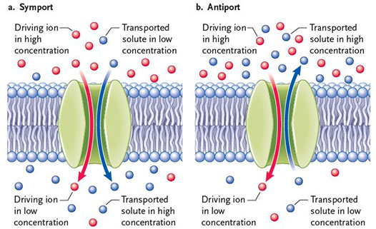

Passive Transport
Characteristic | Simple Diffusion | Facilitated Diffusion | Active Transport
Membrane component responsible for transport | Lipids | Proteins | Proteins
Binding of transported substance | No | Yes | Yes
Energy source | Concentration gradients | Concentration gradients | ATP hydrolysis or concentration gradients
Direction of transport | With gradient of transported substance | With gradient of transported substance | Against gradient of transported substance
Specificity for molecules or molecular classes | Nonspecific | Specific | Specific
Saturation at high concentrations of transported molecules | No | Yes | Yes

5.6 - Exocytosis and Endocytosis
-in eukaryotic cells , import and export of larger molecules (larger than a.a/monosach)
-exocytosis export :carries secretary proteins, waster material from cytoplasm to outside cell
-endocytosis import : carry proteins, molecules, cells from outside cell into cytoplasm
-contribute to back & forth flow of membranes b/w endomembrane system & plasma membrane
-require energy (ATP), stop if cell cannot make ATP

Exocytosis :
-vesicles join plasma membrane, release contents
-secretary vesicles move through cytoplasm to the plasma membrane
-vesicle membrane fuses with the plasma membrane, releasing vesicle's contents to the cell exterior
-all eukaryotic cells (plants-secrete carbs to build strong cell wall, animals - secrete hormones)

Endocytosis :
-vesicle imports specific molecules from outside cell
-proteins and other substances are trapped in pitlike depressions that bulge inward from plasma membrane
-depression pinches off as endocytic vesicle
Bulk-phase endocytosis/Pinocytosis :
-extracellular water is taken into a cell with molecules in the water solution
-no binding of cell receptors
Receptor-Mediated Endocytosis :
-selective uptake of macromolecules that bind to cell surface receptors concentrated in clathrin-coated pits
-receptors : integral proteins of membrane, recognize and bind only specific molecules (proteins) from the solution surrounding the cell
-after binding to molecule, receptors collect into a depression (coated pit) due to clathrin(network of proteins that reinforce cytoplasmic surface of cell membrane)
-pits deepen and pinch free from membrane to form endocytic vesicles
-once in cytoplasm , endocytic vesicle loses clathrin and fuses with lysosomes, where they get broken down into smaller, useful molecules
Phagocytosis :
-certain cells engulf bacteria/cellular debris to break them down
-begins when surface receptors bind to molecules
-cytoplasmic lobes extend, surround, and engulf the materials, forming a pit that pinches off and sinks into cytoplasm as large endocytic vesicle
-digested within the cell through lysosomes, remaining residue goes to storage or is expelled as waste
-ex, white blood cells
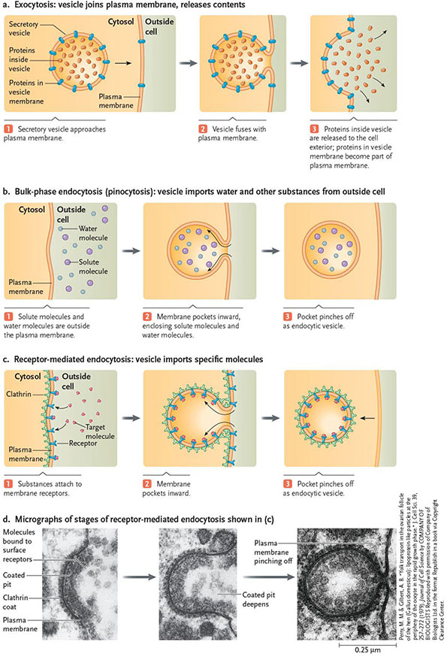

Lecture Notes :
Membrane Fluidity
-saturation of hydrocarbon chain
-fatty acids can be short or long, rarely the same length/ same degree of saturation, this influences fluidity
-mix of short and long tails = gaps,
-unsaturated double bonds = kinks/gaps b/w phospholipds, so they won't be able to pack as tightly, making membrane more fluid

Changing Degree of Saturation
-enzymes (desaturases) introduce double bonds, level of activity changes according to the cell environment/cells's needs
-if cell needs to increase fluidity, the enzyme becomes more active ,and introduces more double bonds
-increase/decreasing the temperature influences vibrations of phospholipids, which influences how they pack together, which influences the fluidity

Cholesterol
-adding cholesterol at high temp, reduces fluidity
-adding cholesterol at low temp, increases fluidity
-buffer effect, depending on temp/state/amount the fluidity can change by adding/removing cholesterol
-presence of rigid cholesterol : prevents the phospholipids from packing as tightly and forces the membrane to become more fluid

Polarity of Phospholipid
-polar heads,
-depending which phospholipid, the polarity influences the level of polarity in that area
-a change in one area of the cell, impacts a change elsewhere

Changing Proportion of Phospholipids :
-flexion : happens when you change temp, increase in temp, makes phospholipids move, increasing fluidity
-to change amount of phospholipids present in a given area : lateral diffusion
-
-flipase : translocation in a given area, require input of energy

Factors that affect membrane fluidity :
-saturation/double bonds, chain length, temperature, cholesterol, polarity of phospholipid head
-cell tries to maintain the membrane dynamic so it utilises a mix of these factors
-changing fluidity

Homeoviscous Adaptation :
-ability to change the membrane's lipid composition in response to the environment in order to maintain membrane fluidity

Fish Example
-start in tanks with different temperatures
-in order to be comfortable/ membrane dynamic to be optimal (asymmetry and fluidity is such that all processes (membrane transport) work best)
-switch the fish to different extremes, observe the change in constitution of membranes so fluidity stays optimal and transport works well
-observe PE/PC ratio (high PC/PE ratio : membrane less fluid, low PC/PE ratio : membrane more fluid)
-qs: to adjust change in temperature (hot to cold) : The membrane will become more fluid , cholesterol will increase and the PC/PE ratio will decrease
increase in PE - fluid

Proteins in Membrane
Functions :
1.Transport
2.Enzymes (catalytic activity)
3.Signal Transduction
-signalling b/w cells
4.Attachment/Recognition
-being able to bind cells, recognizing if healthy/unhealthy cell or if pathogen/host

Different types of Membrane Proteins

Integral Proteins:
-ion channels, transporters, receptors
-integrated inside membrane, cross both layer of membrane (one or more)
-shape allows them to interact with both hydrophilic and phobic enviro
-create isolated channels to allow solutes to pass through
-transmembrane proteins
*polarity of a.a determines where they can reside within the membrane, r group is key
-all proteins : start and stop codon, therefore all a.a have orientation (N and C terminal)
-the terminals can face inside or outside cell

Peripheral Proteins
-do not span/anchored to membrane, but they do interact with proteins in membranes
-spectrin, anykrin
-can be on inside/outside of cell
-interact through interactions, without covalent bonds, therefore easy to move and bind somewhere else
-don't embed themselves in membrane, instead they bind to cytoskeleton, integral proteins, lipid-anchor proteins
- advantage that they hover around membrane and interact with other components : b/c it gives them ability to contribute to structure, support, and elasticity
-ex. red blood cells - squeeze into capillaries, in addition to microfilaments helping them , peripheral proteins interact with them to give extra supports/elasticity to help red blood cells change shape to travel through narrow capillaries

Lipid-anchored Proteins
-anchored to one leaflet of the membrane
-which leaflet they're attached to determines what they use as anchors
-extracellular protein : anchored to outside leaflet (upper layer), use glycosyl phosphatidyl inositiol (phospholipid ) , this anchors to another protein which interacts with the outside of the cell, used for cell adhesion (binding cells to enviro/other cells)
-intracellular protein : anchored to inside leaflet (inner layer), use a fatty acid or prenyl group, interact with inside of cell, used for mediating cell division and cell growth
-GPI, prenyl , fatty acid

Techniques to Study Membranes :

Microscopy

Freeze Fracture
-useful to study inside the membrane
-"freeze" the cell using liquid nitrogen (-196℃) (flash freeze, no crystallization)
-split using knife (separate the two leaflets)
-view under electron microscope
-disadvantage : cell gets killed, not able to see things in action

Fluorescence Recovery after Photobleaching (FRAP)
-useful to study the ability of molecules to move within membrane
-still stays alive, can observe things moving
-add fluorescence dye to phospholipid polar head
-emits green light
-follow the phospholipids, observe membrane dynamic, labelling cells by colors
-use laser to bleach area, cancels fluorophores, observe what happens next
-fluorescence recovers b/s neighbouring phospholipids move into bleached area, making everything look green again

What if bleaching membrane proteins were anchored (covalently bound)
-no recovery stage, bleached area would stay bleached for much longer since the phospholipids wouldn't be moving around a lot

Membrane Transport
-relies on potential energy becoming kinetic energy, this depends on the two gradients
-2 categories : with the concentration gradient OR against the concentration gradient
-small nonpolar/hydrophobic molecules : passive transport
Principles :
1. Relative permeability of molecules
2. Concentration gradients vs electrochemical gradients
3. Gradients store potential energy

Passive/Simple Diffusion
-getting across membrane unassisted
-along the concentration gradient
-no carriers/channels
-no energy
-small hydrophobic/np molecules
-different types of gradients

Facilitated Diffusion
-no energy, not part of active transport !
-carrier or channel required
-along the concentration gradients
-channel open/closes due to changing its shape
-change shape due to charge of membrane, charge of environment, concentration of the solute
-channel closed to prevent things from getting in

Carrier Channels
-integral proteins
-change shape by changing orientation, facing outwards /inwards
-allow carrier proteins or solutes got through
-depend on something binding to them, still along concentration gradient

Glucose Transport
-required in cell
-to make atp and to keep it out of blood and into storage in form of glycogen

