Lec 6 : Membranes (Jan 29)
Readings : 5.1-5.3

Readings :
5.1-5.3
Plasma membrane :
-outer limit of the cytoplasm responsible for regulation of substances moving in & out of cells
-selectively permeable barrier
-allows for the uptake of key nutrients and elimination of waste, while maintaining a protected enviro for cellular processes to occur
-internal membrane resulted in compartmentalization of processes and increased complexity

fluid mosaic model :
-proposes that the membrane consists of fluid phospholipid bilayer in which proteins are embedded and float freely
-proteins attached at the cytoplasmic side
-carbohydrates face the cell exterior

membrane asymmetry
-proteins and components in one half of the lipid bilayer are different than the other half
-reflects differences in functions performed by each side of the membrane
-freeze-fracture technique : block of cell is rapidly frozen by dipping it into liquid nitrogen, fractured with knife splitting the bilayer into inner and outer halves, exposing membrane interior
-particles visible in the exposed membrane interior are integral membrane proteins

Membrane bilayer is fluid :
-frey-edidin experiment proved this
-membrane proteins rapidly migrate over surface of hybrid cell

Phospholipids
-phospholipids are the dominant lipids in the membranes
-head attached to two long chains of carbon and hydrogen (hydrocarbon) called a fatty acid
-head (polar): consists of glycerol linked to alcohols/amino acids (organic molecule choline) and a phosphate group
-tail (nonpolar) : 2 fatty acid chain (18 carbons long)
-amphipathic : molecule contains a hydrophobic region (np) and a hydrophilic region (polar)
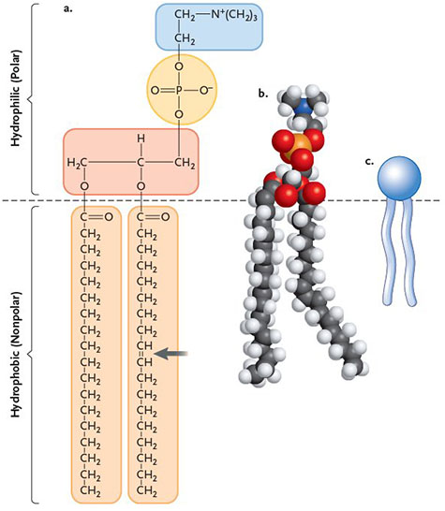
-the fatty acid chains can be saturated or unsaturated depending on the way the C bond
-fully saturated : all carbons are bound to max # of H atoms
-unsaturated : carbon-carbon double bond present, makes a kink/bend to the chain

-when added to water, phospholipids assemble into one of three structures :
-micelle (sphere composed of a single layer of lipids), liposome, or bilayer
-the structure they assemble into depends on the phospholipid concentration
-hydrophobic effect : tendency of polar molecules (water) to exclude hydrophobic molecules (fatty acids)
-results in aggregation of lipid molecules in structures where fatty acid tails interact with each other, polar head associate with water
-these arrangements preferred, b/c they represent the lowest energy state and are more likely to occur
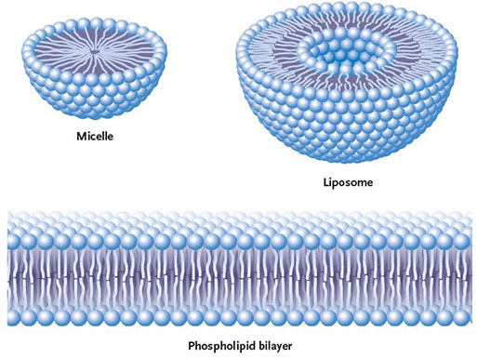

Fatty Acids
-affect fluidity of lipid bilayer (depends on type of fatty acid and temperature)
-saturated fatty acids : linear, allows lipid molecules to pack tightly
-unsaturated fatty acids : prevent from packing closely, b/c double bonds present form kinks/bends in fatty acid backbone
-therefore, the more unsaturated the fatty acids, the more fluid the membrane
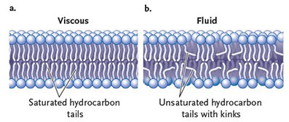

Temperature
-lower temps : random molecular motion of lipids slows down, fluidity is lost, semisolid gel forms, inhibiting enzyme and receptor functions
-high temps : random molecular motion increases, membranes becomes more fluid, loss of structure can occur
-normal fluid state : mixed pop of saturated and unsaturated fatty acids
-ETC requires molecules to migrate rapidly within membrane, if less fluid rate of ETC will decrease and eventually stop
-too high temps can result in membrane leakage (ions begin to freely diffuse), results in irreversible disruption of cellular ion balance, leads to cell death

Fatty Acids
-unsaturated fatty acids are produced during fatty acid biosynthesis through enzymes (desaturases), removes 2 H, makes a carbon double bond
-desaturase abundance is regulated at the level of gene transcription
-by regulating desaturase abundance, organisms can closely regulate the amount of unsaturated fatty acids in the membrane, therefore maintaining proper membrane fluidity

Sterols (steroid with single polar OH group linked to np hydrocarbon chain)
-influence membrane fluidity
-ex. cholesterol, found in membrane of animal cells
-at high temp : help restrain the movement of lipids, reducing the membrane fluidity
-at low temp : disrupt fatty acids from associating by occupying space b/w lipids, slowing the transition to nonfluid gel state

Trans Fat
-
-
-

Membrane Proteins

Key Functions :
1. Transport :
-protein that provides a hydrophilic channel that allows movement of a specific molecule
-protein membrane can change shape to shuttle molecules from one side of membrane to other

2. Enzymatic Activity
-some enzymes are membrane proteins
-enzymes associated with respiratory and photosynthetic ETC

3.Signal Transduction :
-membranes contain receptor proteins on outer surface that bind to specific chemicals such as hormones
-receptors trigger changes on the inside surface of the membrane , leads to transduction of the signal through cell

4. Attachment/ Recognition
-proteins exposed to both internal and external membrane surfaces act as attachment points for cytoskeleton elements, and components involved in cell-cell recognition

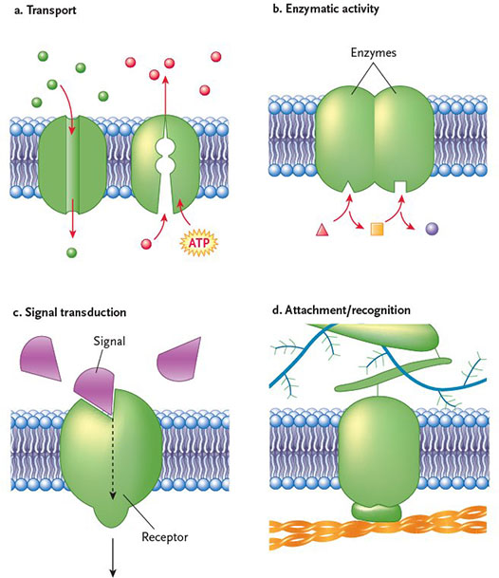

integral membrane proteins : proteins embedded in the phospholipid bilayer
transmembrane proteins : traverse entire lipid bilayer at least once
-have distinct regions of polarity (b/c interact with both hydrophobic and hydrophilic enviro)
primary structure : sequence of a.a in a protein
secondary structure : regions of alpha helix, beta strand, and random coil in a polypeptide chain

transmembrane protein identification
-presence of stretches of a.a that are primarily nonpolar (hydrophobic)
-usually 17-20 a.a

Peripheral Membrane Proteins
-held to membrane surfaces by noncovalent bonds formed with the polar parts of integral membrane proteins/lipids
-positioned on surface of membrane
-do not interact with the hydrophobic core of the membrane
-held to surface by noncovalent bonds (H and ionic) through interactions with exposed portions of integral proteins and with lipids
-found on cytoplasmic side of plasma membrane and form part of the cytoskeleton
-made up of polar and nonpolar a.a

Lecture Notes
Reasons for membrane
-boundary : selective permeability
-organize and scaffold
-regulate solute transport
-receive signals
-communication

Types of membrane :
-diversity in a lipid/protein content
-dif types of lipids and proteins

phospholipids
-move all the time
-need to move around
-fluid and dynamic
-held together
-lateral diffusion - happens quickly

Fluid Mosaic
-phospholipids affect fluidity of membrane
-thickness depends on length of fatty acid chain

Fluidity
-lateral diffusion :
-flexion :reates gaps, ions can sneak through
-flip-flop : flipase : take phospholipid in one layer and flip it with another, use energy
-rotation

-two layers of membrane are not the same (asymetrical) contain dif phospholipds, proteins, ions
-important that asymetrical :

Phospholipids
-most abundant lipid in membrane bilayer
-one polar head, 2 hydrocarbon tails (saturated vs unsaturated- bends)
-contain glyceral
-4 main :
-head : contains functional groups, polar (hydrophilic), interacts with outside of cell

Glycolipids
-1 or 2 fatty acid chains with single/multiple sugar groups, sticking out of the membrane
-important for recognition, found on the outer layer

Sterols
-4-ring hydrocarbons
-hormones
-important role in fluidity
-phospholipids react to temp change, changes the fluidity, the amount of sterol can change to compensate to change of temp/change of fluidity

Membrane layers different because
-different functions
-different enviro, different interactions, different functions

Membrane Asymmetry
-translocation from one layer to the other is rare and required ATP
-reducing fluid, change ratio
-puts phospholipids on outer layer, sos signal
------------------------------------------------------------------------------
cilia and flagella, different movement technique, due to dif structures
-flagella : projecting a long s-wave, propel
-cilia : whip back and forth
-help move cell from one point to another

9 doublets are hold together by the doublets (anchor - ex. nexin)
-molecular motors walking toward to the minus end
-minus end at the plasma membrane of the flagella
-dynein walks toward the negative/minus end, walks on a single doublets, carrying the other doublet, since its attached, it bends. if the doublets were not attached/anchored together they would slide instead of bending
-linker proteins hold the doublets together
-kinesin walks the other way (towards the positive)

Centrioles
-starting point for microtubule
-centrsome made of 2 centrioles making an L shape
-centrioles made of 9 microtubule triplets

Junctions : cell to cell interactions

Gap Junctions
-more dynamic -
-six proteins that span the membrane, present in hydrophobic enviro, allow passage of small ions, must create hydrophylic channel (polar enviro), exterior portion interacts with membrane
-amount of calcium present determines if closed (nothing gets through) or open (small ions get through)

Axon
-cell can grow to reach a target cell
-membrane stretches, microfilaments support the stretch,
-ubules grow through addition of dimers, support the microfilaments which extend and form networks, membrane is fluid therefore it extends
------------------------------------------------------------------------------

