Lec 5 : Cytoskeleton and Cellular Interactions/Extracellular Matrix (Jan 26)
Readings : 2.3f, 2.3g, 2.5, 8.4, 39.2, 42.6 a, b

Readings :

2.3f - Cytoskeleton

Cytoskeleton :
-maintains shape and internal organization of each type of cell
-interconnected system of protein fibres and tubes that extend throughout the cytoplasm
-reinforces plasma membrane and functions in movement
- 3 major components : microtubules, intermediate filaments, microfilaments
-assembled from proteins (tubulins, i.f. proteins [8 protein chains wound together], actins[2 linear polymers])

Microtubules :
-largest (outer diameter : 25nm, inner d :15 nm)
-assembled from tubulins (dimers of alpha and beta tubulin)
-dynamic structure, can change their lengths
-plus end (alpha) and minus end (beta) provides orientation, useful for motor proteins to travel
-radiate outward from centrosome
-at midpoint : centriole
-provide tracks along which vesicles move (cell interior ↔ plasma membrane)
-separate and move chromosomes during cell division, move cells, maintain cell shape
-motor proteins push against microtubules = animal cell movement
-atp = energy supply for movement
-dyneins (towards neg) & kinesins(towards pos): walk along microtubules (antergrade vs retrograde)

intermediate filaments :
-fibres
-assembled from intermediate filament proteins (8 protein chains wound together)
-occur singly, in parallel bundles
-interlinked networks
-only found in multicellular organisms
-provide structural support in cells/tissues

microfilaments :
-smallest (5-7 nm d)
-thin protein fibres
-2 linear polymers of actins subunits wound together
-long helical spiral
-have a plus and minus end (polarity/orientation)
-present in muscle fibres of vertebrates
-involved in cytoplasmic streaming (flowing motion of cytoplasm = transports nutrients, proteins, organelles)
- myosins : walk along microfilaments
-in animal cell - responsible for dividing cytoplasm

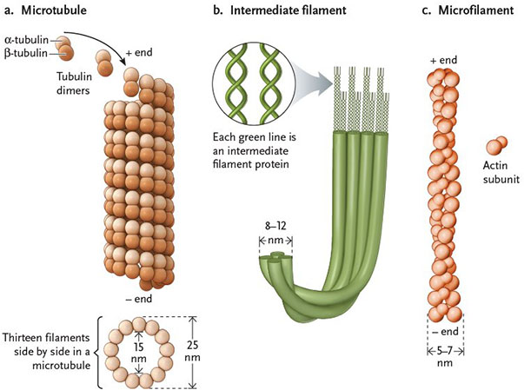

2.3g - Flagella & Cilia
Flagella / cilia :
-elongated structure that extend from cell surface, arise from centrioles
-cilia shorter than flagella, occur in greater numbers
-whiplike motion of flagellum propels a cell through a medium, 9 + 2 structure of microtubules
-cilia move fluids over the cell surface
-flagella beat in standing waves, cilia beat oar-like one way & recovery stroke
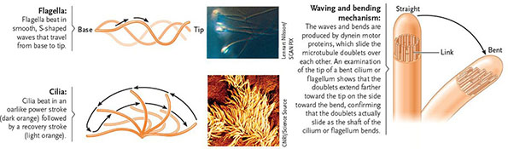

basal body : structure that anchors cilia and flagella to the surface of a cell

Centrioles
-in cell, the pair of centrioles lie perpendicular to each other
-gives rise to the 9+2 system of a flagellum

2.5 - Animal Cell Surface

Cell Adhesion Molecules :
- bind cells together
-glycoproteins embedded in plasma membrane
-help maintain body form and structure
-bind to specific molecules on other cells
-hold together most cells in solid body tissues
-make attachments in embryonic development, attachments are remade and reinforced by cell junctions in adult body
*cancer cells lose the adhesions and can migrate to new locations forming additional tumors
-bacteria and viruses target cell adhesion molecules as attachment sites during infection
-responsible for the ability of cells to recognize one another as being part of the same individual or foreign (ex. rejection of organ transplants)

Cell Junctions : (anchoring, tight, gap)

Anchoring junctions :
-reinforce cell-to-cell connections made by cell adhesion mol
- form button like spots/belts that run around cell (weld cells together)
-desmosomes -intermediate filaments anchor junction in the underlying cytoplasm
-adherens junctions - microfilaments are the anchoring cytoskeletal component
Tight junctions :
- tight connections b/w membranes of adjacent cells
- seal spaces b/w cells, stop leaking of fluids into other tissues
-seal spaces b/w cells in cell layers that cover internal organs and the outer surface of the body
-formed by direct fusion of proteins on surface of plasma membrane of adjacent cells
-ex. line the stomach, intestine, bladder keeping the contents of these body cavities from leaking into surrounding tissue

Gap junctions :
-create direct channels of communication b/w animal cells
-allow exchange of ions, small molecules b/w cells
-hollow protein cylinders in plasma membrane create pipeline that connects the cytoplasms of adjacent cells
-provide instant communication in animal cells (similar to plasmosesmata in plant cells)

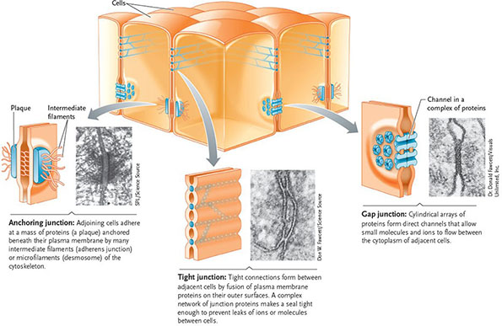

extracellular matrix (ECM) :

-supports and protects cells, provides mechanical linkages
-consists of proteins and polysaccharides secreted by the cells
-forms the mass of skin, bones, tendons, cornea
-glycoproteins (collagen) : main component, form fibres
-consistency of matrix (soft to hard/elastic) depends on a network of proteoglycans that surround the collagen fibres

-proteoglycons : small proteins attached to long polysaccharide molecules, matrix consistency depends on number of interlinks (regulate how much water can be trapped in it)
-ex. cartilage (lots of interlinked glycoproteins) = soft
tendons (pure collagen) = tough and elastic
bones (collagen with mineral crystals) = dense and hard, but still elastic

fibronectins : glycoproteins that help in organizing the ECM, and help attach cells to it
-bind to receptor proteins (integrins - act as chemical signal, span the membrane)
-integrins bind to microfilaments of the cytoskeleton, integrate changes by communicating changes from the ECM to the cytoskeleton

8.4
Formation and Action of Mitotic Spindle
-central to both mitosis and cytokinesis
-made of microtubules and their proteins
-function depends on their changing patterns of organization during cell cycle

Microtubules :
-form a major part of the interphase cytoskeleton of eukaryotic cells
-mitosis : microtubules disassemble from their interphase arrangement and reorganize into the spindle, which grows until it fills almost the entire cell
-reorganization has two pathways (one with centrosome, other without) - interphase
-basic function of spindle is the same, regardless of presence of centrosome

Centrosome :
-main microtubule organizing centre of a cell, organizes the microtubule cytoskeleton during interphase and positions many cytoplasmic organelles
-near the nucleus from which microtubules radiate outward in all directions
-main microtubule organizing centre (MTOC) of the cell
-anchors microtubule cytoskeleton and positions organelles in cytoplasm
-contains a pair of centrioles (cylindrical structure consisting of nine triplets of microtubules in the centrosome), function : generate the microtubules needed for flagella/cilia (whiplike extensions that provide cell motility)

Asters : radiating array produced as microtubules (extending from centrosomes of cells) grow in length and extent

Kinetochore Microtubules:
-connect the chromosomes to the spindle poles
-motor proteins present help chromosomes walk to poles
-tubulin subunits disassemble as kinetochores pass along them (making microtubules shorter as movement progresses)

Nonkinetochore Microtubules :
-extend between the spindle poles without connecting the chromosomes
-at spindle midpoint, microtubules from one pole overlap with microtubules from opposite pole

39.2 - Animal Tissues

Four Basic Tissue Groups :
-epithelial, connective, muscle, nervous
-each tissue is assembled from individual cells
-properties of these cells determine the structure, therefore the function of the tissues
-the structure and function depend on the a) structure and organization of the cytoskeleton within the cell, b) the type and organization of the extracellular matrix (ECM) surrounding the cell, and c) the junctions holding the cells together

ECM :
-molecular system that supports and protects cells and provides mechanical linkages
-non living material secreted by cells consisting of a variety of proteins and glycoproteins
-provides support and shape for tissues and organs
-ex. plant cell walls, cuticles of arthropods

Junctions :
-link cells into tissues
-anchoring junctions : form button like spots/belts that weld cells together, most abundant in tissues subject to stretching (ex. heart,skin)
-tight junctions : seal spaces between cells, keeping molecules/ions from leaking between cells (ex. tight junctions lining urinary bladder - prevent waste molecules/ions from leaking out of bladder to other body tissues)
-gap junctions : open channels between cells in same tissue, allowing ions/small molecules to flow freely form one cell to another (ex. help muscle cells in muscle tissue to function as a unit)

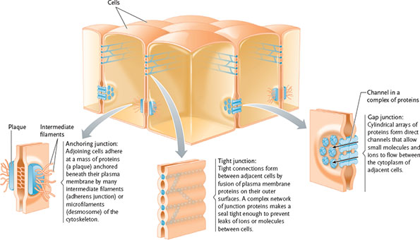

42.6 a, b - Cellular Basis of Development
*orientation and rate of mitotic cell division have a special significance in the development of the shape, size, and location of organ systems of the embryo

Orientation of cell division :
-refers to angles at which daughter cells are added to older cells as development proceeds
-determined by the location of the furrow separating the cytoplasm after mitotic division of the nucleus
-furrow forms in alignment with the spindle midpoint (furrow leads to symmetrical division of cell), when spindle displaced to one end - furrow leads to asymmetrical division into smaller cell)

Rate of Cell Division :
-reflects the time spent in G1 period of interphase
-once dna replication begins, the rest of the cell cycle takes place as the same time on all cells
-as embryo develops and cells differentiate, the time spent in interphase increase and varies in dif cell types

a - Microtubules and Microfilaments : Movement of Cells

Embryonic cells undergo changes in shape that generate movement (ex. infolding of surface layers to produce meso/endoderm)
-entire cells move during embryonic growth
-movements produced by changes in rates of growth or by breakdowns of microtubules/
microfilaments
-changes in cell shape/movement impact cleavage, gastrulation, and organogenesis

b - Change in Cell Shape : Adjusting to New Roles

-changes in cell shape typically result from reorganization of the cytoskeleton
- microfilaments slide over each other, tightening the ring like a drawstring and narrowing the top of the cell

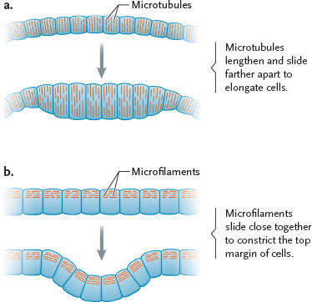

Lecture Notes :

Polarity
-influences structure
-influences function
-influences location
-influences rigidity (structure)

Primary Structure

Amino acids
-sequence of amino acids contributes to secondary structure
-the R-group influences
-polar a.a : more alpha helix, flexible, round structures
-nonpolar a.a : more jagged, beta-pleated sheets, not so flexible

-proteins have seq/groups mix of alpha and beta

different areas in proteins that are alpha/beta : domains
-can be identified from gene sequence on rna/dna
-protein can have mix of polar/nonpolar areas
-np a.a , happy in plasma membrane
-p a.a happy in cytoplasm

Secondary Structure
-as it grows it folds over onto itself

Tertiary Structure
-can be final structure
- most of binding, hydrogen and sulphide bonds

Quaternary
-contain many subunits that contain tertiary, sec, and primary structure

-ex. hemoglobin, needs to be soluble, needs to have a pocket to bind oxygen, mostly alphahelix
-if change primary seq, then the whole structure is dif , and the function changes
-genetic disease : a single change in a.a seq (one polar for np)(glu for val), changes the entire structure, the shape of red blood cells gets completely changed into elongated, crescent shaped , transport oxygen poorly, - sickle cell anemia

Functions of Proteins
Hormonal Proteins :
Receptor Proteins :
Contractile and Motor Proteins :
Structural Proteins : keratin, need some flexibility, but still strong
Defensive :
Storage : storage of a.a
Transport : transport of substances
Enzymatic

Fatty Acids
-used in membrane

organelles do not float around - proven by fluorescence microscopy
-used with special dyes

Cytoskeleton
-functions : structure, contributes during cell division (centrioles form and retract microtubules , microtubules, centrioles replicate so that both daughter cells have centrioles which lead to cytoskeleton, organisation of microtubules at the poles, membrane pinches to cleavage the cell into two daughter cells, the cytoskeleton contributes to that), anchoring organelles, transporting organelles, vesicles transported by motor proteins

Cytoskeleton Functions :
1. Provide structure and support
2.Intracellular transport
3. Position organelles within the cell
4.Generate force for cell movement
5.Contribute to cell division

Assembly of cytoskeletal Fibres
-speed at changing shape, length, orientation
-no covalent bonds b/w subunits

Weak bond, no covalent bonds, bonds that don't require a lot of energy to break bong
-need to be able to change structure/ shape quickly (to engulf particles), and be able to return to initial state, need to be efficiently dynamic, therefore no covalent bonds in the cytoskeletal fibres

3 Cytoskeletal Fibres :

Microtubules
-largest, microglobular proteins
-hollow, tube
-made with tubulin (globular structure with alpha helix, and beta, tertiary structure held together by bonds), spherical protein, ability to bind gtp (guamin triphosphate- energy molecule, similar to atp), tubulin can bind to it at specific area forming dimers (building blocks to form microtubules)
-each tubulin has gtp bound to it, as dimer forms b/w alpha and beta tubulin, one gtp becomes exposed at one end, and one gtp is buried b/w the two dimers
-this results in the dimer in two different ends, therefore can have orientation (no charge, plus means exposed gtp, minus end means no exposed gtp)
-dimers stack on top of each other where the gtp is exposed, forming protofilaments, they attach, forming sheets, which make the tubulin structure
-at base : protofilaments with minus end that serve as anchor
-at other end : beta tubulins with exposed gtp forming the plus end
-25nm in diameter (fairly large)
-these microtubules have orientation/polarity - this allows the motor proteins to travel in a specific direction and arrive at the correct destination
-microtubules radiate through entire cell
-"large highway"
-don't make it all the way to the membrane
-from the end of the microtubule to membrane : microfilaments

Microfilaments
-made of actin and atp (2 strands of actin) - microglobular proteins
-smallest, not hollow
-assembled in a staggered manner, looks like two threads being wrapped around each other
-+ end : barbed end
- - end : pointed end
-"arrow shape"
-because of shape and location of atp, they also have polarity/orientation
-contribute to transport
-cover entire of cell , all the way up to the cell membrane

Intermediate Filaments
-formed by assembly of various fibrous proteins (keratins)
-keratins are coiled/ braided with each other
-the different strands are woven with each other
-can become very flexible, if you pull on them, they're strong (protect against tension)
-fibrous proteins allow them to be flexible
-wrapped around nucleus, protecting it against compression and torsion
Built
-start with monomers of keratin , coil to form dimer
- coil two dimers in a staggered manner, making a tetramer
-attach two identical tetramers making a larger structure (antiparallel, so no polarity/orientation)
-8 tetramers twisted together into a ropelike filament
-at ends : amino and carboxyl group
-no energy molecule , spontaneous assembly, does not store energy

Importance of Polarity in Microtubules and Micro filaments :
-polarity contributes to direction/ orientation, direction contributes to transport of molecules, allows for cell to organize where things are going
ex. allowing for motor proteins to travel in specific directions to get to their desired areas
-some motor proteins designed to only travel in one direction
-intermediate filaments not involved in transport b/c no polarity/orientation

Transport and Travel on Cytoskeletal Fibres
-ex. color patterns on frogs (morphology)
-pigments are deposited along microtubules, in smaller or larger concentrations, resulting in different color patterns on frogs
-microtubules carrying pigments and depositing them in different/same areas

Motor Proteins
-mechanoenzymes - use ATP
-allow to drive motion in cells along cytoskeletal fibers
-use ATP, when they consume atp, they get energy to propel the protein/enzyme forward onto the cytoskeletal fibres
-Kinesins : forward transport (anterograde) to the plus end of mictotubules (towards cell membrane)
-Dynesins : inward transport (retrograde) toward the minus end of microtubules (towards inside of cell)
-motor protein walking on microtubule, hands of cargo to other motor protein walking/transporting on the microfilament

