Lec 2 : Intro to Cell Biology (Jan 15)
Readings : 2.3-2.5, 3.5

Readings :

2.3 - Eukaryotic Cell
eukaryotes : protists, fungi, animal, plants
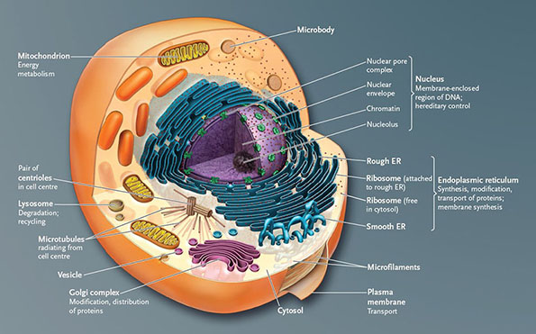
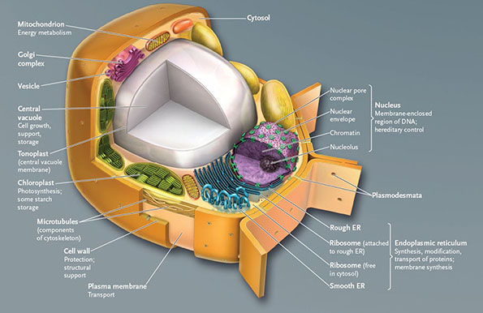
Nuclear Envelope :
-membranes separating the nucleus from the cytoplasm
-consists of two membranes, separated by a narrow space
-lamins (protein filaments) line and reinforce inner surface
nuclear pore complexes :
-embedded in the nuclear envelope
-octagonally symmetrical cylindrical structure
-protein structures, creating a channel
-control transport of molecules b/w nucleus and cytoplasm
nuclear pore :
-opening in nuclear envelope through which large molecules (rna/proteins) move b/w the nucleus and the cytoplasm
nucleoplasm :
-liquid/semiliquid substance within the nucleus

Ribosome :
-consists of large and small subunit
-contain 4 types of rRNA molecukes and more than 80 proteins
-function : use info in mRNA to assemble a.a into proteins
-attached to endoplasmic reticulum (ER)
-some attached to membrane, others freely suspended in cytosol , most attached to ER
-proteins made on free ribosomes can remain in cytosol, pass through nuclear pores into nucleus, or becomes part of mitochondria/chloroplast/cytoskeleton

Endomembrane system :
-collection of interrelated internal membranous sacs that divide cell into functional/structural components
-functions : synthesis/modifications/transport of proteins, synthesis of lipids, detoxifying
-membranes connected directly or through vesicles (small, membrane-bound compartment that transfers substances b/w parts of em. sys)

Endoplasmic Reticulum (ER)
- interconnected network of membranous channels & vesicules called cisternae
-smooth (synthesis of lipids for cell membrane, enzymatic conversion of toxic molecules)
- rough ER(synthesis of proteins to enter lumen where they get chemically modified)(ribosomes stud its surface)

Golgi Complex :
- stack of flattened, membranous sacs = cisternae (3-8 typically)
-not interconnected
-located b/w the ER and plasma membrane
-receives proteins made in the ER , fuse with golgi membrane, and release their contents into cisternae
-within golgi : proteins are chemically modified (a.a chain, adding functional groups, lipid/carb units)
-modified proteins are transported within golgi and sorted into vesicles

Exocytosis :
-process by which a secretory vesicle fuses with the plasma membrane and releases the vesicle contents to the exterior

Endocytosis :
-process by which molecules are brought into the cell from the exterior
-involves a bulging in of the plasma membrane that pinches off to form an endocytic vesicle

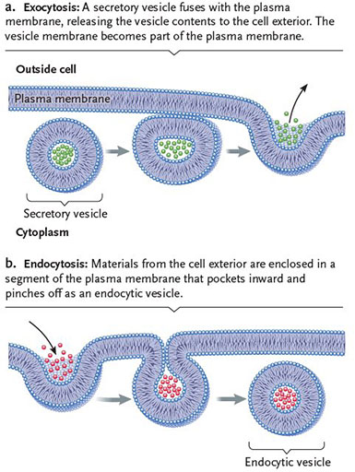

Lysosomes :
-small membrane-bound vesicles
-contain more than 30 hydrolytic enzymes for digestion
-found only in animals
-formed by budding from golgi complex
-digest food : autophagy

Phagocytosis :
-cells engulf bacteria or cellular debris to break them down
- produces a large vesicle that contains the engulfed materials until lysosomes fuse with the vesicle and release the hydrolytic enzymes necessary for degrading them

Vesicle Traffic in Cytoplasm :

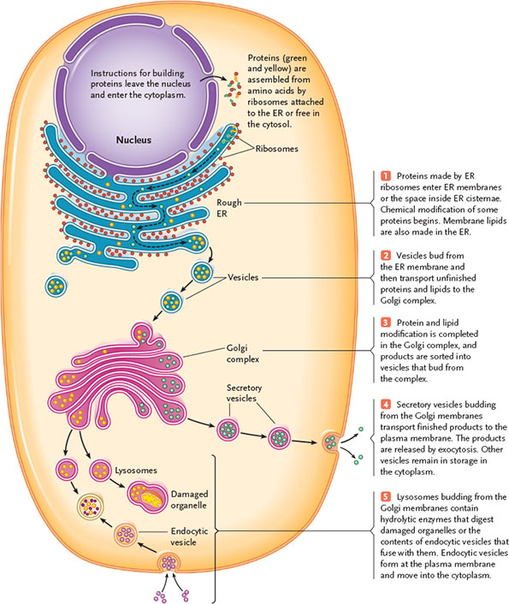

Mitochondria :
-responsible for synthesis of most of the ATP in eukaryotic cells
-energy metabolism
-location of cellular respiration
-enclosed by 2 membranes (outer-smooth, inner -folds/cristae)
-outer mitochondrial membrane : smooth, covers outside of mitochondria
-inner m.m : expanded by folds (cristae)
-mitochondrial matrix : innermost compartment
-atp-generating rxns occur in cristae and matrix
-contains DNA and ribosomes
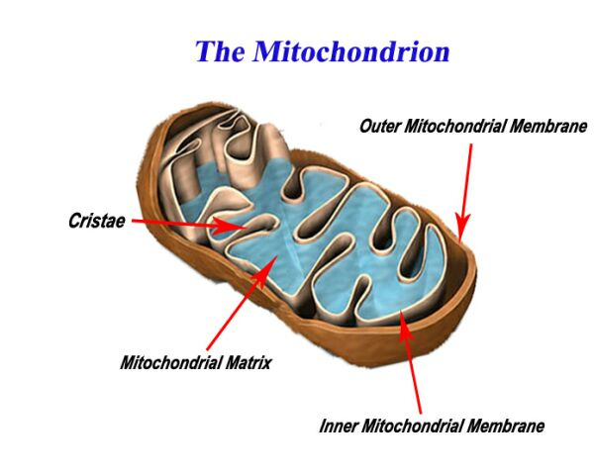

2.3f - Cytoskeleton

Cytoskeleton :
-maintains shape and internal organization of each type of cell
-interconnected system of protein fibres and tubes that extend throughout the cytoplasm
-reinforces plasma membrane and functions in movement
- 3 major components : microtubules, intermediate filaments, microfilaments
-assembled from proteins (tubulins, i.f. proteins [8 protein chains wound together], actins[2 linear polymers])

Microtubules :
-largest (outer diameter : 25nm, inner d :15 nm)
-assembled from tubulins (dimers of alpha and beta tubulin)
-dynamic structure, can change their lengths
-plus end (alpha) and minus end (beta) provides orientation, useful for motor proteins to travel
-radiate outward from centrosome
-at midpoint : centriole
-provide tracks along which vesicles move (cell interior ↔ plasma membrane)
-separate and move chromosomes during cell division, move cells, maintain cell shape
-motor proteins push against microtubules = animal cell movement
-atp = energy supply for movement
-dyneins (towards neg) & kinesins(towards pos): walk along microtubules

intermediate filaments :
-fibres
-assembled from intermediate filament proteins (8 protein chains wound together)
-occur singly, in parallel bundles
-interlinked networks
-only found in multicellular organisms
-provide structural support in cells/tissues

microfilaments :
-smallest (5-7 nm d)
-thin protein fibres
-2 linear polymers of actins subunits wound together
-long helical spiral
-have a plus and minus end (polarity/orientation)
-present in muscle fibres of vertebrates
-involved in cytoplasmic streaming (flowing motion of cytoplasm = transports nutrients, proteins, organelles)
- myosins : walk along microfilaments
-in animal cell - responsible for dividing cytoplasm

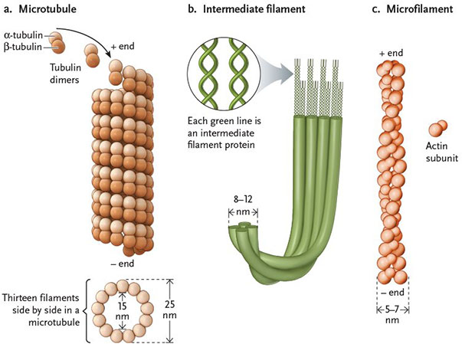

2.3g - Flagella & Cilia
Flagella / cilia :
-elongated structure that extend from cell surface, arise from centrioles
-cilia shorter than flagella, occur in greater numbers
-whiplike motion of flagellum propels a cell through a medium, 9 + 2 structure of microtubules
-cilia move fluids over the cell surface
-flagella beat in standing waves, cilia beat oar-like one way & recovery stroke
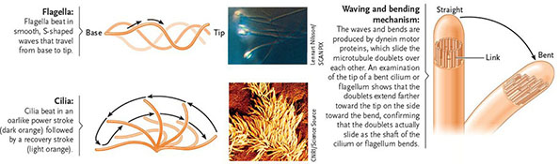
basal body : structure that anchors cilia and flagella to the surface of a cell

Centrioles
-in cell, the pair of centrioles lie perpendicular to each other
-gives rise to the 9+2 system of a flagellum

2.4 - Specialized Structures of Plant Cells

Chloroplasts :
-site of photosynthesis in plant cells
-member of plastids family
-lens/disk shaped, surrounded by smooth outer and inner boundary membrane
-contain stroma : inner compartment, containing thylakoids (flat, closed sacs that make up membrane system within stroma) stacked thylakoids : grana

Amyloplasts :
-colourless plastid that stores starch (product of photosynthsis) in plants (ex. in roots)

Chromoplasts :
-contain red and yellow pigments
-responsible for colours of ripening fruit/leaves
- rigid cell wall : made of cellulose fibres, network of highly branched carbs

Central Vacuole :
- large vesicle
-storage for water and nutrients
-osmotic pressure keeps shape and strength of cell
-tonoplast : central vacuole membrane, contains transport proteins
-store salts, organic acids, sugars, storage proteins, pigments
- cell growth, support, storage
-maintains turgor of cell, controls movement of molecules b.w cytosol and sap

Cell Wall :
-located outside the plasma membrane
-provide support to individual cells
-protect cells against invading bacteria and fungi
-consist of cellulose fibres embedded in a network of highly branched carbs
-perforated by plasmodesmata : minute channels connecting cells , allow ions to move directly to another cell through the cytosol
-some contain chitin

2.5 - Animal Cell Surface

Cell Adhesion Molecules :
- bind cells together
-glycoproteins embedded in plasma membrane
-help maintain body form and structure
-bind to specific molecules on other cells
-hold together most cells in solid body tissues
-make attachments in embryonic development, attachments are remade and reinforced by cell junctions in adult body
*cancer cells lose the adhesions and can migrate to new locations forming additional tumors
-bacteria and viruses target cell adhesion molecules as attachment sites during infection
-responsible for the ability of cells to recognize one another as being part of the same individual or foreign (ex. rejection of organ transplants)

Cell Junctions : (anchoring, tight, gap)

Anchoring junctions :
-reinforce cell-to-cell connections made by cell adhesion mol
- form button like spots/belts that run around cell (weld cells together)
-desmosomes -intermediate filaments anchor junction in the underlying cytoplasm
-adherens junctions - microfilaments are the anchoring cytoskeletal component
Tight junctions :
- tight connections b/w membranes of adjacent cells
- seal spaces b/w cells, stop leaking of fluids into other tissues
-seal spaces b/w cells in cell layers that cover internal organs and the outer surface of the body
-formed by direct fusion of proteins on surface of plasma membrane of adjacent cells
-ex. line the stomach, intestine, bladder keeping the contents of these body cavities from leaking into surrounding tissue

Gap junctions :
-create direct channels of communication b/w animal cells
-allow exchange of ions, small molecules b/w cells
-hollow protein cylinders in plasma membrane create pipeline that connects the cytoplasms of adjacent cells
-provide instant communication in animal cells (similar to plasmosesmata in plant cells)

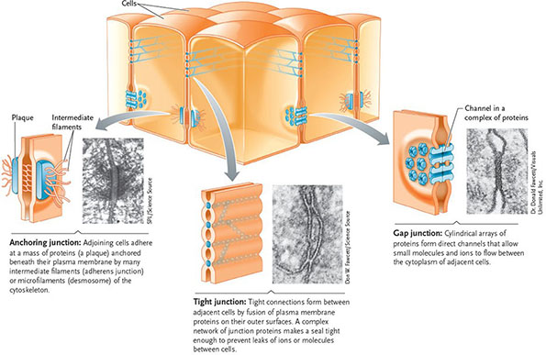

extracellular matrix (ECM) :
-supports and protects cells, provides mechanical linkages
-consists of proteins and polysaccharides secreted by the cells
-forms the mass of skin, bones, tendons, cornea
-glycoproteins (collagen) : main component, form fibres
-consistency of matrix (soft to hard/elastic) depends on a network of proteoglycans that surround the collagen fibres

-proteoglycons : small proteins attached to long polysaccharide molecules, matrix consistency depends on number of interlinks (regulate how much water can be trapped in it)
-ex. cartilage (lots of interlinked glycoproteins) = soft
tendons (pure collagen) = tough and elastic
bones (collagen with mineral crystals) = dense and hard, but still elastic

fibronectins : glycoproteins that help in organizing the ECM, and help attach cells to it
-bind to receptor proteins (integrins - act as chemical signal, span the membrane)
-integrins bind to microfilaments of the cytoskeleton, integrate changes by communicating changes from the ECM to the cytoskeleton

3.5 -Eukaryotic Cell

Eukaryotes
-2.5 bya
-separation of dna and cytoplasm by a nucleaur envelope
-presence in cytoplasm of membrane-bound compartments with metabolic and synthetic functions (mitochondria, chloroplasts, ER, golgi complex)

Theory of Endosymbiosis :
-mitochondrion originated from aerobic prokaryotic bacteria that lived as an endosymbiont within an anaerobic prokaryote
-chloroplast originated from photosynthetic prokaryotic cyanobacteria
-symbiosis : mutually advantages relationship, overtime host cell and endosymbiont became inseparable parts of the same organism

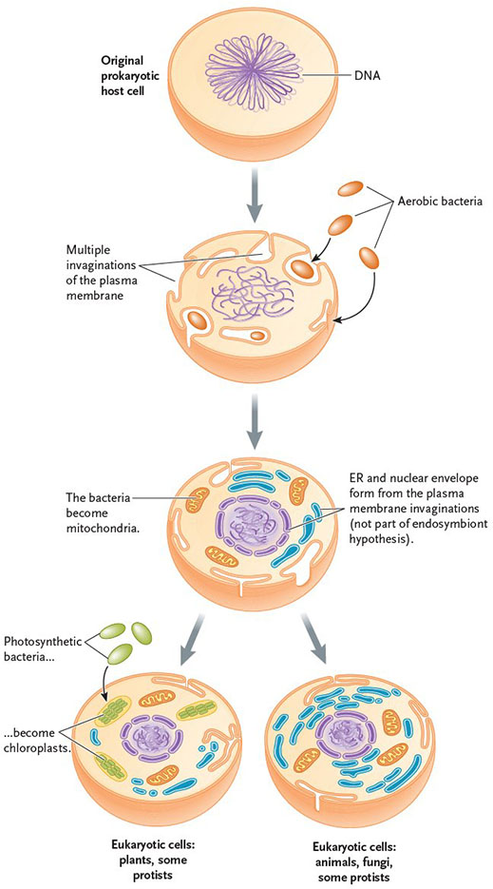

Evidence for Endosymbiosis :

1. Morphology
-form and shape is similar to primitive bacteria and archea

2.Reproduction
-cell cannot synthesize mitochondria/chloroplast
-derived from pre-existing mit/chl
-divide by binary fission

3.Genetic Information
-contain their own dna
-contain protein-coding genes that are essential for organic function
-circular dna

4.Transcription & translation
-contain complete transcription and translation machinery
-genes → mRNA →trna→dna
5. Electron Transport
-contain ETC (electron transport chain)
-double membranes, etc is in inner membrane

6.Sequence Analysis
-sequencing of rna that makes up ribosomes , firmly establishes that they belong on bacterial branch of tree of life

Horizontal Gene Transfer :
-not a change in gene function, only a change in the location of gene
-genome : complete dna sequence for given organism
Following endosymbiosis :
-early eukaryotic cell would have contained 2 or 3 compartments (nucleus, protomitochondria, protochloroplast), each with its own complete genome
-each compartment would have functioned independently
-some genes in the proto-m and - c were lost
-many of the genes were redundant, since nucleus already had those genes
-many genes proto-m and - c were relocated to the nucleus
-occurred b/c evolutionary advantage to keep genetic info in one place (nucleus)
-in typical eukaryotic cell : 90% of proteins required for mitochondrias/chloroplasts are found in nucleus

Endomembrane System :
-collection of internal membranes that divide the cell into structural and functional regions
-nuclear envelope, ER, golgi complex
-origin : infolding of the plasma membrane

Eukaryotic cells generate more ATP, which allows them to become larger, more complex, larger genome which codes for more proteins
-variety of genes led to eukaryotic-specific traits (cell cycle, sexual reproduction, phagocytosis, nucleus)

Multicellular Eukaryotes
-1.2 bya
-division of labour
-cells not structurally/functionally identical
-increased specialization
-cells cooperate with each other for the benefit of the entire organism

Lecture Notes :

-cells can group to form tissues, which form organs
-types of tissues : connective, epithelial, muscle, nervous
-communicate through gap junctions (allow electrical impulses to get through using ions)
-cytokins : chemical messengers

Tree of life : 3 domains (bacteria, archaea, eukarya)
ribosomal dna : used to classify into phylogenetic trees
-first macromolecule of life associated with the genome
-need to make proteins, different types of ribosomes in dif organisms, all made of ribosomal rna and protein
-similar species will have similar structures of ribosomes

E.coli
-three layers of membrane
-cilia or pilli
-plasma membrane made of phospholipids
-some have additional layer - capsule (sugar or slime (glycocalyx)), useful to stick
-no nucleus, just dna , neatly packed
-ribosomes (made of rna and protein, no membrane) not organelles ! but are exception !

Golgi Complex :
-stack of flattened, membranous sacs = cisternae (3-8 typically)
-not interconnected
-located b/w the ER and plasma membrane
-receives proteins made in the ER , fuse with golgi membrane, and release their contents into cisternae
-within golgi : proteins are chemically modified (a.a chain, adding functional groups, lipid/carb units)
-modified proteins are transported within golgi and sorted into vesicles

