Winter 2013 FINAL EXAM
Part I: Multiple Choice Questions. (Total=35 marks).

1. Amy is thinking about going to the movies tonight. A ticket costs $7 and she will have to cancel her baby-sitting job that pays $30. The cost of seeing the movie is therefore:
a. $7.
b. $30.
c. $37.
d. $37 minus the benefit of seeing the movie.

2. All the following conditions will cause an outward shift of the production possibilities frontier except:
a. an improvement in the overall technology of production.
b. existing factors of production become more productive.
c. the quantity of the factors of production increases.
d. previously unemployed factors of production are put back to work.

This production possibilities schedule shows how many combines and tractors
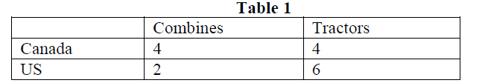
can be produced in Canada and US with one unit of equivalent resources.

3. Refer to Table 1. Without trade, both countries divided their resources equally between the production of tractors and combines. Suppose that each country specializes according to its comparative advantage. Compared to the case without trade, the production of tractors will increase by _____units and the production of combines will increase by _____ units due to the specialization and trade.
a. 1;1.
b. 1;2.
c. 2;1.
d. 2;2.

4. Normative economics reflect:
a. society's laws.
b. economic analysis based on facts and evidence.
c. empirical and significant economic observations.
d. value judgements.

5. Time series data:
a. are used very infrequently in economic analysis.
b. measure different variables for different economic units at a point in time.
c. measure a given variable for different economic units at a point in time.
d. measure a variable or variables at different points in time.

6. If the nominal annual wage of a worker has increased from $30,000 to $50,000 during a five year
interval, and the consumer price index has risen from a value of 130 to 150 for the same period,
then the real wage increase of the worker is approximately:
a. 0%.
b. 15%.
c. 44%.
d. 67%.

7. Assume that spinach is a normal good. Assume further that medical research has proven that eating spinach will reduce the risks of cancer. Due to economic recession:
a. there will be a leftward shift of the demand curve.
b. there will be a rightward shift of the demand curve.
c. the demand curve may remain the same or may shift to the right or may shift to the left.
d. there will be lower price of spinach.

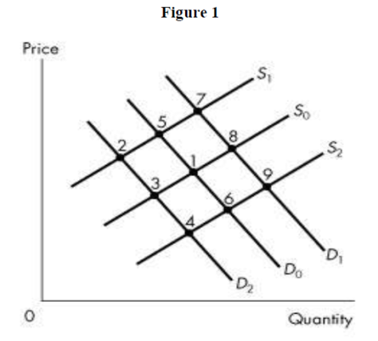

8. Figure 1 represents the market for laptops and the original equilibrium is at 1. If the price of desktops decreases and the cost of producing laptops increases, what is the new laptop equilibrium, ceteris paribus?
a. 2.
b. 4.
c. 7.
d. 9.

9. Nancy's income has just risen from $950 per week to $1,050 per week. As a result, she decides to
double the number of movies she attends each week. Nancy's demand for movies is
a. income elastic.
b. price elastic.
c. price inelastic.
d. income inelastic.

10. Suppose the per-unit tax on cars decreased. If the demand for cars is inelastic and the
supply curve is upward sloping then this will cause tax revenue to ___.
a. rise.
b. fall.
c. stay constant.
d. rise if the supply elasticity is less than one and fall if the supply elasticity is greater than one.

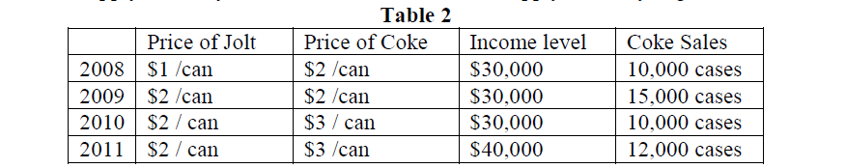

11. Refer to Table 2. The arc cross-price elasticity of demand for Coke with respect to the price of Jolt is
a. -0.6.
b. -1.7.
c. 1.7.
d. 0.6.

12. Firms will bear a larger burden of a specific tax if
a. demand is relatively inelastic and supply is relatively elastic.
b. demand is relatively elastic and supply is relatively inelastic.
c. both demand and supply are relatively inelastic.
d. the tax is collected by firms rather than remitted directly to the government by consumers.

13. The deadweight loss from taxation in the absence of externalities can be determined by
a. subtracting the competitive level producer surplus from the producer surplus associated with less output.
b. subtracting the consumer surplus from the producer surplus associated with less output.
c. summing the consumer and producer surplus associated with less output.
d. summing the change in the total consumer and producer surplus, and the change in government
revenue, from moving from the competitive level of output to less output.

14. In a free market, goods with positive externalities will:
a. be overproduced in the market place.
b. have the marginal valuation of the externality reflected in their price.
c. be produced to the point at which the marginal social benefit equals the marginal social cost of the last unit produced.
d. be under-produced at the market equilibrium.

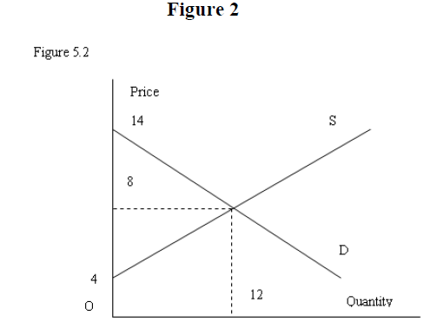
15. In Figure 2, the dollar value of the total economic surplus is:
a. 24.
b. 36.
c. 48.
d. 60.
16. Suppose that Yuri buys soy milk and oranges and has not yet exhausted his budget. His MU of an additional carton of soy milk is 20 and its price is $1.25, whereas his MU for an additional orange costing 50 cents is 7. From this situation, we can deduce that he should:
a. buy more oranges.
b. reduce his consumption of soy milk.
c. buy more soy milk.
d. divide his budget equally between soy milk and oranges.
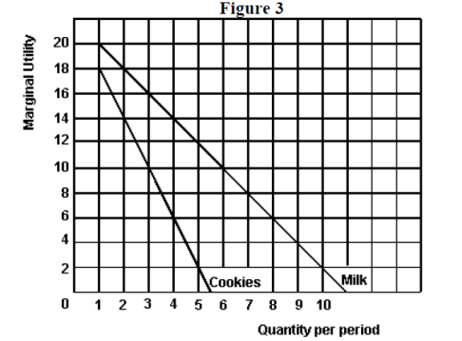

17. Referring to Figure 3, if the price of milk is $2, the price of cookies is $1 and the budget is $7, how many will be purchased if the consumer wishes to maximize total utility.
a. 0 milk and 7 cookies.
b. 1 milk and 5 cookies.
c. 2 milk and 3 cookies.
d. 3 milk and 1 cookie.

18. A demand curve slopes downward because
a. since the marginal utility increases with increased consumption, people will be eager to buy more at lower prices.
b. since the marginal utility decreases with increased consumption, the price must fall in order to
induce people to buy more.
c. since total utility increases with increased consumption, a lower price is necessary to encourage increased production.
d. lower prices mean a lower consumer surplus which will encourage increased consumption.

19. If you are a risk-averse person and have the chance to play a game where the odds of winning $2.00 are 20% and the odds of losing $1.00 are 80%:
a. you will be willing to play the game because of the even odds.
b. you will be willing to play the game because this is a fair gamble.
c. you may or may not play the game, depending on how you balance the love of risk with the probability of loss on average.
d. you will not play the game as it is not a favorable one.

20. It is frequently difficult to buy natural disaster insurance because:
a. the insurance companies are unfair to people living in areas which are natural disaster prone.
b. the individual risks are not independent.
c. insurance companies do not like to do business with risk averse people.
d. the individual risks are independent.

21. A fair coin is to be tossed. If it lands heads up, the player wins $2; if it lands tails up, the player loses $2. Out of the three following people:
• Person A is indifferent between playing and not playing the game.
• Person B is willing to pay 15 cents to participate in each coin toss.
• Person C must be paid 10 cents to participate in each coin toss.
Which person characterizes a risk-averse individual?
a. person A only.
b. person B only.
c. person C only.
d. none of the persons.

22. It is almost always the case that initial plant size expansion leads to a decrease in cost. This is due to:
a. technological improvement.
b. increase in capital stock.
c. economies of scale.
d. none of the above.

23. Which of the following statements about the relationship between marginal product and average product is correct?
a. when average product exceeds marginal product, marginal product must be rising.
b. when marginal product is falling, average product is falling.
c. average product equals marginal product at marginal product's lowest point.
d. when marginal product exceeds average product, average product must be rising.

24. Assuming marginal product increases at the initial level of production and starts to decrease eventually after reaching its peak implies:
a. average variable cost curve increases initially then reaches a peak and after that starts to decline.
b. average variable cost curve initially declines, reaches a minimum and then will steadily rise up.
c. average cost curve pattern has nothing to do with marginal cost curve.
d. both B and C are correct.

25. A perfectly competitive firm, assuming all fixed cost to be sunk cost, will produce output in the short run even if P<ATC because
a. as long as P ≥ MC, it can minimize it losses.
b. as long as P ≥ AVCmin, it can minimize its losses.
c. profits are positive.
d. none of the above.

26. If firms enter a competitive industry, the
a. the new firms make negative profit.
b. industry supply curve shifts outward.
c. output of the industry decreases.
d. profits of the old firms stay the same.

27. Excess capacity in monopolistically competitive firms is caused by
a. The fact that rival firms enter the industry and reduce the demand for the products of the firms already in the industry.
b. Cost curves being higher than they are under perfect competition.
c. The waste associated with many slightly differentiated products serving almost the same purpose.
d. The fact that each firm faces a demand that is not perfectly elastic.
28. When average total cost is falling, marginal cost must be
a. above average cost.
b. below average cost.
c. constant.
d. below variable cost.

29. If a profit-maximizing firm's marginal revenue is greater than its marginal cost, the firm
a. must be making an economic/supernormal profit.
b. will increase its output.
c. must be experiencing economic losses.
d. will close down.

30. In the short run, a monopolist with a loss, along with marginal revenue of $15, and marginal cost of $10, should
a. Expand output and raise price.
b. Expand output and cut price.
c. Cut output and raise price.
d. Cut output and price.

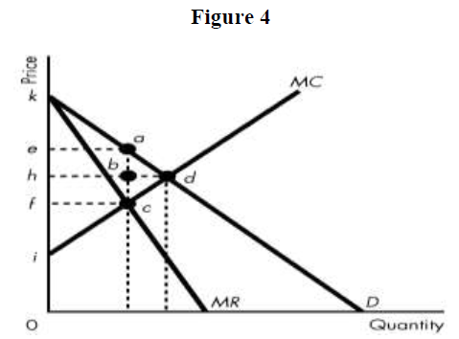

31. Consider Figure 4. If the industry is operated by a single-price monopolist, what area is producer surplus?
a. kea.
b. ieac.
c. khd.
d. none of the above.

32. Once a cartel determines the profit-maximizing price,
a. each member will face the temptation to cheat on the cartel price in order to increase its sales and
profits.
b. changes in the output of any member firms will have no impact on the market price.
c. entry into the industry of rival firms will have no impact on the profit of the cartel.
d. all members of the cartel have a strong incentive to abide by the agreed-upon price.

33. Suppose that the typical firm in a monopolistically competitive industry earns an economic/supernormal profit and
new firms enter. This causes:
a. the firm's demand curve to shift to the right.
b. the industry demand curve to shift to the left.
c. the firm's demand curve to shift to the left.
d. none of the above.

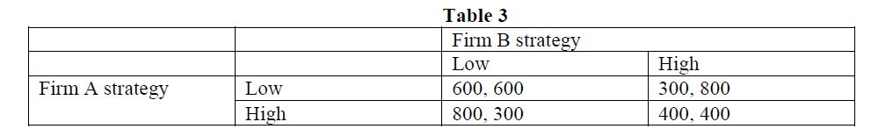

Table 3 describes the profits accruing to each firm in a game. The first figure in any box is firm A’s profit, and the
second is firm B’s profit. High and low refer to the strategy of having a high or low advertising budget.

34. Referring to Table 3 above, which of the following statements is correct if B and A reach a secret agreement between themselves concerning advertising budgets and this agreement holds because neither cheats?
a. Both will have a low advertising budget and both will earn profits of $600.
b. Both will have a low advertising budget and both will earn profits of $400.
c. Both will have a high advertising budget and B will earn a profit of $300 and A will earn a profit of $800.
d. None of the above.



35. Referring to Table 4 above, which defines the cost of producing wine and generators per unit in France and Germany, we can conclude:
a. France has a comparative advantage in wine and Germany has a comparative advantage in generators.
b. Germany has a comparative advantage in wine and France has a comparative advantage in
generators.
c. Germany has a comparative advantage in both goods.
d. None of the above statements are true.

Part II: Answer FIVE of the following SIX questions. (Total=65 marks).

Question # 1 (13 marks)
Consider the labor market in Quebec. If W (wage rate) is the price of labor (dollars per hour) and L is the quantity of labor (measured in hours worked). Suppose that the demand and supply curves for labor are given by: Demand: W = 15 - L
Supply: W = 5 + L

(i) Suppose there are no interventions in the labor market. Find the equilibrium W and L, consumer and producer surplus, the total income of the workers. Also calculate the point price elasticity of demand at equilibrium. (3 marks).

(ii) Now suppose the government decides to have a “price support program” with a minimum wage set at
W = $ 12 per hour and promises to buy any excess supply of labor services. Find the new quantity of labor traded on the market, the wage paid by employers, the wage received by workers and the quantity of labor services the government would be buying. (3 marks).

(iii) Given this policy of price control, find the new consumer surplus, producer surplus, the cost to the government and the deadweight loss. (3 marks).

(iv) Suppose, instead, the government decides to have a “government subsidy program” with a guaranteed (or target) wage of W= $ 12. Find the amount of the subsidy per unit of labor required such that the total income of workers is the same as under the price floor (minimum wage). Also find how much the employers pay per unit of labor and the total cost to the government. (4 marks).

Question #2 (13 marks)
Suppose the prices of hamburger (H) and coke (C) are PH = $2 and Pc = $1, and we observe the consumer to purchase exactly two hamburgers and one coke every day.

(i) Graph the resulting budget constraint on a diagram (hamburger on the vertical axis and coke on the horizontal axis), with intercepts clearly marked, explaining how you arrive at the answers. What is the consumer’s total income? (3 marks).

(ii) Calculate the slope of the budget line and explain what it stands for. If the MU from coke consumption at thechosen bundle is equal to 50, find the MU obtained from consuming hamburger. (3 marks).
(iii) Now suppose the government imposes a 25% ad valorem tax on coke so its price rises to 1.25. Illustrate graphically and explain what happens to the MRS and the quantity consumed of coke, if coke is a normal good. (3 marks).

(iv) Instead of the tax in (iii), assume now that the consumer experienced a drop in income to $4 per day. Illustrate the new budget constraint and the new optimal bundle on a diagram, assuming that the new quantity consumed of hamburgers is 1 burger. Specify whether hamburgers are a normal/inferior good. (4 marks).

Question #3 (13 marks)
In a competitive market the supply and demand functions are given by:
P = 1 +Q/400 and P = 21 - Q/100.

(i) Solve for the equilibrium price and quantity in the marketplace. (2 marks)

(ii) Now let's look at a representative firm in this competitive industry. It has a marginal cost curve given by MC = 1 + q/4 and it has an average total cost curve given by ATC = 2/q + 1 + q/8. This is a regular U-shaped ATC curve. There is no difference here between the long run and short run. Calculate the break-even level of output (where the ATC is at a minimum). (3 marks)

(iii) Draw the ATC and MC curves on a diagram. (2 marks)

(iv) Now use the price you got in part (i) and determine the output level of each of these representative firms using the profit maximizing rule for choice of output. (3 marks)

(v) Once you have determined how much each firm produces, using the result from part (i) calculate how many firms there must be in the industry. (3 marks)

Question #4 (13 marks)
A monopolist faces a demand curve defined by P = 100 – 1Q. He has a marginal cost curve defined by MC = 4 and an average total cost defined by ATC = 4 + 48/Q

(i) Determine his profit-maximizing output and price. (4 marks)

(ii) Illustrate graphically his MC and ATC curves. (2 marks)

(iii) Illustrate on a diagram, and compute numerically the deadweight loss (DWL) associated with not producing at the efficient output (where MC = P). (3 marks)

(iv) If the monopolist produced at the efficient output and sold that output in the marketplace, what is the numerical value of the profit or loss per unit of output? (4 marks)

Question #5 (13 marks)
Consider a market with the following demand: P=172-3Qd
On the production side, we know that Marginal Revenue is MR=172-6Qd, and the Production Costs are given by MC=ATC=10 for all output levels.

(i) Find the equilibrium price, quantity and profit for a monopolist (3 marks).

(ii) Suppose there are two firms A and B and each firm produces output Q1 and Q2, respectively. In the duopoly game, each firm sets its quantity as follows:
Firm A: Q1=(27-Q2/2)
Firm B: Q2=(27-Q1/2)
Assume both firms have the same cost functions as before, and therefore are identical firms. Assume that if the firms collude, they jointly behave as a monopolist. Notice that Q1+Q2=Qd, and P1=P2=P.

(a) Find Q1=Q2 for each firm in the absence of collusion (1 mark).

(b) Find P1=P2=P for each firm (1 mark).

(c) Find π1=π2 for each firm (1 mark).

(iii) Compare their individual profits under (ii), part (c) with the π under collusion. Should they collude or not? Explain (3 marks).

(iv) Would you expect these firms to be able to collude and behave like a monopolist, given that explicit written contracts to cut output and raise prices are illegal in Canada? Use the quantity setting equations to show that the firms have an incentive to cheat (2 marks)

(v) Suppose now that the market is in a state of perfect competition. Find the competitive price, the quantity produced by a firm in competition, and the profits. (2 marks)

Question #6 (13 marks)
Suppose that both Tom and Sara like to grow tomatoes and green peppers in their backyards. In a 30-day month, Tom can grow in his backyard either 80 tomatoes and 0 peppers or 0 tomatoes and 40 peppers or any other combination lying on the line between these two points. In the same amount of time, Sara can grow in her backyard either 40 tomatoes and 0 peppers or 0 tomatoes and 8 peppers or any other combination lying on the line between these two points.

(i) No trade: Assume that Tom and Sara both spend half of their time to produce tomatoes and the other half of their time to produce peppers. How many tomatoes and peppers can each consume? Draw two separate graphs for their PPFs, with tomatoes (T) on the vertical axis and peppers (P) on the horizontal axis (3 marks).

(ii) If they start trading with each other, what should Tom sell and what should Sara sell? Explain by calculating the opportunity costs of producing peppers and tomatoes for Tom and Sara, respectively (3 marks).

(iii) Following from (ii): Suppose Tom and Sara each specializes in producing only the good in which she/he has a lower opportunity cost. Also suppose Tom and Sara exchange 5 peppers for 15 tomatoes with each other (you have to determine who sells peppers and who sells tomatoes). Calculate the new consumption bundles of Tom and Sara and plot them on your graphs in (i) (3 marks).

(iv) Following from (iii): Show that given Tom’s and Sara’s consumption quantities of tomatoes, they could not have produced/consumed the corresponding quantities of peppers you have found in (iii) in the

