OPS MGMT Mid Term Review 1:
Operations Management
Chapter 6: Managing Quality

Quality and Strategy

Quality: the ability of a product or service to meet customer needs.

- Managing quality supports differentiation, low cost and response strategies
- Quality helps firms increase sales and reduce costs
- Building a quality organization is a demanding task

Quality Improves Profitability In Two ways:
Sales Gains Via:
- Improved response
- Flexible pricing
- Improved reputation
Reduced Costs via:
- Increased productivity
- Lower rework and scrap costs
- Lower warranty costs

Flow of activities that are needed to achieve total quality management

- Organizational Practices:
- Leadership, Mission Statement, Effective Operating Procedures, Staff Support, Training
- Yields: What is important and what is to be accomplished
- Quality Principles:
- Customer focus, Continuous Improvement, Benchmarking, Just-in-Time, Tools of TQM
- Yields: How to do what is important and to be accomplished
- Employee Fulfillment
- Empowerment, Organizational Commitment
- Yields: Employee attitudes that can accomplish what is important
- Customer Satisfaction
- Winning Orders, Repeat Customers
- Yields: An effective organization with a competitive advantage

Different Views

User based: better performance, more features
Manufacturing-based: conformance to standards, making it right the first time
Product-Based: specific and measurable attributes of the product

Key Dimensions of Quality:

- Performance
- Features
- Reliability
- Conformance
- Durability
- Serviceability
- Aesthetics
- Perceived quality
- Value

Implications of Quality:
- Company Reputation: An organization can expect its reputation for quality- whether good or bad- to follow it.
- Product Liability: The courts hold organizations accountable for damages or injuries resulting from their products use.
- Global Implications: Quality is an international concern as well as an OM concern. Products should meet global quality, design, and price expectations.

Cost of Quality

- Prevention Costs: Reducing the potential for defects.
- Appraisal Costs: evaluating products, parts and services.
- Internal Failure: producing defective parts or service before delivery.
- External Costs: defects discovered after delivery.

Leaders in quality
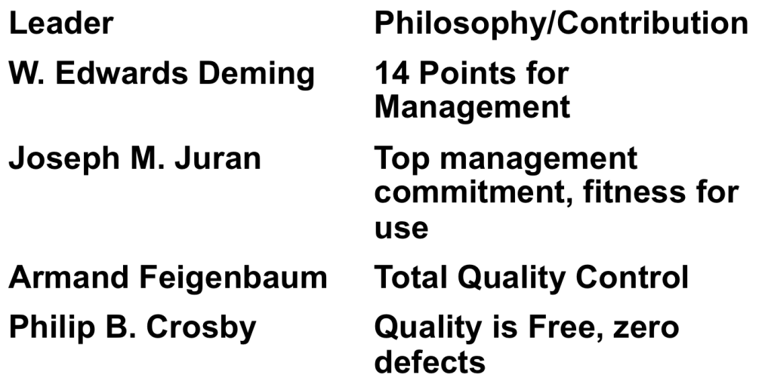

Ethics and Quality Management
- Must deliver healthy, safe quality products and services
- Poor Quality risk injuries, lawsuits, recalls, and regulation
- Organizations are judged by how they respond to problems
- All stakeholders must be considered

International Quality Standards

ISO 9000 series: A set of quality standards developed by the International Organization for Standardization (ISO)
- Common quality standards for products sold in Europe
- 2008 update places greater emphasis on leadership and customer requirements and satisfaction

ISO 14000 series: A series of environmental management Standards established by the international Organization for Standardization (ISO)

Core Elements:
- Environmental management
- Auditing
- Performance evaluation
- Labeling
- Life cycle assessment
Advantages:
- Positive public image and reduced exposure to liability
- Systematic approach to pollution prevention
- Compliance with regulatory requirements and opportunities for competitive advantage
- Reduction in multiple audits

Total Quality Management

Total Quality Management: Management of an entire organization so that it excels in all aspects of products and services that are important

Deming’s 14 points for implementing Quality Improvement

- Create consistency of purpose
- Lead to promote change
- Build quality into the product; stop depending on inspections
- Build quality long-term relationships based on performance instead of awarding business on price
- Continuously improve product, quality, and service
- Start training
- Emphasize leadership
- Drive out fear
- Break down barriers between departments
- Stop haranguing workers
- Support, help, and improve
- Removing barriers to pride in work
- Institute education and self-improvement
- Put everyone to work on the transformation

Seven Concepts of TQM
- Continuous improvement
- Represents continual improvement of all processes
- Involves all operations and work centers including suppliers and customers
  - People, Equipment, Materials, Procedures
- Six Sigma
- Two meanings
  - Statistical definition of a process that is 99.9997% capable, 3.4 defects per million opportunities (DPMO)
  - A program designed to reduce defects, lower costs, and improve customer satisfaction
- Originally developed by Motorola adopted and enhanced by Honeywell and GE
- Highly structured approach to process improvement
  - A strategy
  - A discipline- DMAIC
- DMAIC Approach
- Define critical outputs and identify gaps for improvement
- Measure the work and collect process data
- Analyze the data
- Improve the process
- Control the new process to make sure new performance is maintained
- Six Sigma Implementation:
- Emphasize defects per million opportunities as a standard metric
- Provide extensive training
- Focus on corporate sponsor support (champions)
- Create qualified process improvement experts (Black belts, Green Belts, etc.)
- Set Stretch objectives
- Employee empowerment
- Getting employees involved in product and process improvements
  - 85% of quality problems are due to process and material
- Techniques
  - Build communication networks that include employees
  - Develop open, Supportive supervisors
  - Move responsibility to employees
  - Build a high-morale organization
  - Create formal team structures
- Quality Circles
  - Group of employees who meet regularly to solve problems
  - Trained in planning, problem solving, and statistical methods
  - Often led by a facilitator
  - Very effective when done properly
- Benchmarking
- Selecting best practices to use as a standard for performance
- Determine what to benchmark
- Form a benchmark team
- Identify benchmarking partners
- Collect and analyze benchmarking information
- Take action to match or exceed the benchmark
- Just-in-time
- Relation ships to quality:
  - JIT cuts the cost of quality
  - JIT improves quality
  - Better quality means less inventory and better, easier-to-employ JIT system
- ‘Pull’ system of production scheduling including supply management
  - Production only when signaled
- Allows reduced inventory levels
  - Inventory cost money and hides process and material problems
- Encourages improved process and product quality
- Taguchi Concepts
- Engineering and experimental design methods to improve product and process design
  - Identify key component and process variables affecting product variation
- Taguchi Concepts
  - Quality robustness
  - Quality loss function
  - Target-oriented quality
- Knowledge of TQM tools
- Tools for Generating Ideas
  - Check sheets
  - Scatter Diagrams
  - Cause-and-effect diagrams
- Tools to Organize the Data
  - Pareto charts
  - Flowcharts
- Tools for identifying Problems
  - Histogram
  - Statistical process control chart

Quality Robustness:
- Ability to produce products uniformly in adverse manufacturing and environmental conditions
  - Remove the effects of adverse conditions
  - Small variations in materials and process d not destroy product quality

Statistical Process Control (SPC) :

Statistical Process Control: A process used to monitor standards, make measurements, and take corrective action as a product or service is being produced.

Control Chart: Graphic presentations of process data over time, with predetermined control limits

- Uses statistics and control charts to tell when to take corrective action
- Drives process improvement
- Four Key Steps
  - Measure the process
  - When a change is indicated, find the assignable cause
  - Eliminate or incorporate the cause
  - Restart the revised process

Inspection

Inspection: A means of ensuring that an operation is producing at the quality level expected.

- Involves examining items to see if an item is good or defective
- Detect a defective product
  - Does not correct deficiencies in process or product
  - It is expensive
- Issues
  - When to inspect
  - Where in process to inspect

When and Where?
- At the supplier’s plant while the supplier is producing
- At your facility upon receipt of goods from the supplier
- Before costly or irreversible processes
- During the step-by-step production process
- When production or service is complete
- Before delivery to your customer
- At the point of customer contact

- Many problems
  - Worker fatigue
  - Measurement error
  - Process Variability
- Cannot inspect quality into a product
- Robust design, empowered employees, and sound processes are better solutions

Source Inspection: Controlling or monitoring at the point of production or purchase- at the source.
- Also known as source control
- The next step in the process is your customer
- Ensure perfect product to your customer

Poka-Yoke: Literally translated, “foolproof”; it has come to mean a device or technique that ensures the production of a good unit every time.

Service Industry Services

Attribute Inspection: An inspection that classifies items as being either good or defective.

Variable Inspection: Classifications of inspected items as falling on a continuum scale, such as dimension or strength.

- Service quality is more difficult to measure than the quality of goods
- Service quality perceptions depend on
  - Intangible differences between products and services
  - Intangible expectations customers have of those products and services

The operations manager must recognize:
- The tangible component of services is important
- The service process is important
- The service is judged against the customer’s expectations
- Expectations will occur

Determinants of Service Quality
- Reliability
  - Consistency of performance and dependability
- Responsiveness
  - Willingness or readiness of employees
- Competence
  - Required skills and knowledge
- Access
  - Approachability and ease of contact
- Courtesy
  - Politeness, respect, consideration, friendliness
- Communication
  - Keeping customers informed
- Credibility
  - Trustworthiness, believability, honestly
- Security
  - Freedom from danger, risk, or doubt
- Understanding/ Knowing the Customer
  - Understand the customer’s needs
- Tangibles
  - Physical evidence of the service

Service Recovery: Training and empowering frontline workers to solve a problem immediately.

- Managers should have a plan for when services fail
- Marriott Hotel’s LEARN routine
  - Listen
  - Empathize
  - Apologize
  - React
  - Notify

Operations Management
Supplement 6: Statistical Process Control

Statistical Process Control (SPC)

Statistical Process Control (SPC): A process used to monitor standards by taking measurements and corrective action as a product or service is being produced.
- Variability is inherent in every process
  - Natural or common Causes
  - Special or assignable causes
- Provides a statistical signal when assignable causes are present
- Detect and eliminate assignable causes of variation
Control Chart: A graphical presentation of process data over time.
- Constructed from historical data, the purpose of control charts is to help distinguish between natural variations and variations due to assignable causes.

Natural Variation: Variability that affects every production process to some degree and is to be expected; also known as common cause.
- Also called common cause
- Affect virtually all production processes
- Expected amount of variation
- Output measures follow a probability distribution
- For any distribution there is a measure of central tendency and dispersion
- Characterized by two parameters
  - Mean
  - Standard deviation

Assignable Variation: Variation in a production process that can be traced to specific causes.
- Also called special causes of variation
  - Generally this is some change in the process
- Variations that can be traced to a specific reason
- The objective is to discover when assignable causes are present
  - Eliminate the bad causes
  - Incorporate the good causes
Samples:
See Slides or page 221 of the text.

Types of Data
- Variables
  - Characteristics that can take any real value
  - May be in whole or in fractional numbers
  - Continuous random variables
- Attributes:
  - Defect-related characteristics
  - Classify products as either good or bad or count defects
  - Categorical or discrete random variables

Control Charts for Variables:
- For variables that have continuous dimensions
  - Weight, speed, length, strength, etc.
- X bar- Chart: A quality control chart for variables that indicates when changes occur in the central tendency of a production process
- R-chart: A control chart that tracks the “range” within a sample; it indicates that a gain or loss in uniformity has occurred in dispersion of a production process.
- These two charts must be used together

Central Limit Theorem: The theoretical foundation for x bar-charts, which states that regardless of the distribution of the population of all parts or services, the distribution of x bars tends to follow a normal curve as the number of samples increases.
$\overset{̿}{x}=μ$ AND $σ_{\overline{x}}=\frac{σ}{\sqrt{n}}$

Setting Mean Chart Limits

$$For \overline{x}-charts when we know σ$$
$$Upper Control Limits\left(UCL\right)=\overset{̿}{x}+zσ_{\overline{x}}$$
$$Lower Control Limits\left(LCL\right)=\overset{̿}{x}-zσ_{\overline{x}}$$

$$\overset{̿}{x}=mean of the sample means or a targeted value set for the process$$
$$z=The number of standart deviation$$
$$σ_{\overline{x}}=standard deviation of the sample means=\frac{σ}{\sqrt{n}}$$
$$σ=population \left(process\right) standard deviation$$
$$n=sample size$$

$$For \overline{x}-charts when we don^{'}t know σ$$
$$Upper Control Limit\left(UCL\right)=\overset{̿}{x}+A_{2}\overline{R}$$
$$Lower Control Limit\left(LCL\right)= \overset{̿}{x}-A_{2}\overline{R}$$

$$\overline{R}=average range of the samples$$
$$A_{2}=Control Chart factor found in table S6.1$$
$$\overset{̿}{x}=mean of the sample means$$

Control Chart Factors
See Slides or Textbook page 225

R-Chart
- Type of variable control chart
- Shows sample ranges over time
  - Difference between smallest and largest values in sample
- Monitors process variability
- Independent from process mean

Setting Chart Limits:

For R-charts:
$$Upper Control Limit\left(UCL_{R}\right)=D_{4}\overline{R}$$
$$Lower Control Limit\left(LCL_{R}\right)=D_{3}\overline{R}$$

$$\overline{R}=average range of the samples$$
$$D_{3} and D_{4}=control chart factors from table S6.1$$

Steps In Creating Control Charts
- Take samples from the population and compute the appropriate sample statistic
- Use the sample statistic to calculate control limits and draw the control chart
- Plot sample results on the control chart and determine the state of the process (in or out of control)
- Investigate possible assignable causes and take any indicated actions
- Continue sampling from the process and reset the control limits when necessary

Managerial Issues and Control Charts:

Three major management decisions:
- Select points in the processes that need SPC
- Determine the appropriate charting technique
- Set clear policies and procedures

Patterns in Control Charts
See Slides or Page 232 in the Text

Process Capability

Process Capability: The ability to meet design specifications.

- The natural variation of a process should be small enough to produce products that meet the standards required
- A process in statistical control does not necessarily meet the design specifications
- Process capability is a measure of relationship between the natural variation of the process and the design specifications

Process Capability Ratio:

$$C_{p}=\frac{Upper Specification-Lower Specification}{6σ}$$

- A capable process must have $C_{p}$ of at least 1.0
- Does not look at how well the process is centered in the specification range
- Often a target value of $C_{p}=1.33$ is used to allow for off-center processes
- Six Sigma quality requires a $C_{p}=2.0$

Process Capability Index:
$$C_{pk}=minimum of \left(\frac{Upper specification-\overline{x}Limit}{3σ}\right),\left(\frac{\overline{x}-Lower Specification Limit}{3σ}\right)$$

- A capable process must have a $C_{pk}$ of at least 1.0
- A capable process is not necessarily in the center of the specification, but it falls within the specification limit at both extremes

To interpret the $C_{pk}$
See slides or page 35 of the text

Acceptance Sampling

Acceptance Sampling: A method of measuring random samples of lots or batches of products against predetermined standards

- Form of quality testing used for incoming materials or finished goods
  - Take samples at random from a lot (shipment) of items
  - Inspect each of the items in the sample
  - Decide whether to reject the whole lot based on the inspection results
- Only screens lots; does not drive quality improvement efforts

Operations Management
Chapter 1: Operations and Productivity

What is Operations Management?

Production: The creation of goods and services

Operations Management (OM): Activities that relate to the creation of good and services through the transformation of inputs to outputs

Activities that creating goods and services take place in all organizations.
- In manufacturing firms the processes of taking inputs and creating outputs can be quite obvious.
  - We can see the different steps taken to create a Sony TV or a bicycle, etc.
- In organizations that do not create large tangible goods, the processes can be harder to separate and less obvious
  - These products could vary from the transfer of funds from one account to another, to the transplant of a kidney, filing an empty seat on an airplane, etc.

Organizing to Produce Goods and Services

To create goods and services all organizations must preform three functions:
- Marketing: Which generates the demand, or at least takes the order for a product or service.
- Production/Operations: Which creates the product.
- Finance/Accounting: Which tracks how well the organization is doing, pays the bills, and collects the money.

Example charts:
See Page 4 of Text

Why Study OM?

- OM is one of the three major functions of any organization.
- We want to know how goods and services are produced.
- To understand what operations managers do.
- OM is a costly part of an organization.

What Operations Managers Do

Management Process: The application of planning, organizing, staffing, leading, and controlling to the achievement of objectives.

Ten Decision Areas:
- Design of Goods and Services
- What good or service should we offer?
- How should we design these products?
- See chapter 5
- Managing quality
- How do we define the quality?
- Who is responsible for quality?
- See chapter 6, supplement 6
- Process and Capacity design
- What process and what capacity will these products require?
- What equipment and technology are necessary for these processes?
- See chapter 7, supplement 7
- Location strategy
- Where should we put the facility?
- On what criteria should we base the location decision?
- See chapter 8
- Layout Strategy
- How should we arrange the facility?
- How large must the facility be to meet our plan?
- See chapter 9
- Human Resources and job design
- How do we provide a reasonable work environment?
- How much can we expect our employees to produce?
- See Chapter 10
- Supply-Chain Management
- Should we make or buy this component?
- Who should be our suppliers and how can we integrate them into our strategy?
- See chapter 11, supplement 11
- Inventory, Material requirements planning, and JIT(just-in-time)
- How much inventory of each item should we have?
- When do we reorder?
- See chapters 12, 14, and 16
- Intermediate and short-term scheduling
- Are we better off keeping people on the payroll during slowdowns?
- Which job do we preform next?
- See chapter 13, and15
- Maintenance
- Who is responsible for maintenance?
- See chapter 17

The following Organizations provide various certifications
- APICS
- Standards Council of Canada
- Institute for Supply Management
- Project Management Institute
- Council of Supply Chain Management Professionals

Job titles used:
- Plant Manager
- Operations Analyst
- Quality Manager
- Supply Chain Manager and Planner
- Process Improvement Consultants

The Heritage of Operations Management

Eli Whitney (1800) –Credited to the early popularization of interchangeable parts. This achieved through standardization and quality control.

Fredrick W. Taylor (1881) – Father of Scientific Management, contributed to personnel selection, planning and scheduling, motion study, and now the popular field of ergonomics.
- Matching employees to the right job
- Providing the proper training
- Providing proper work methods and tools
- Establishing legitimate incentives for work to be accomplished

Henry Ford and Charles Sorensen (1913)- Took what they knew about standardized parts with the quasi-assembly lines or the meatpacking and mail order industries and added the revolutionary concept of the assembly line. Men stood still but the material moved.

Walter Shewhart (1924) – Combined knowledge of statistics with the need for quality control and provided the foundations for statistical sampling in quality control.

W. Edwards Deming (1950)- believed, as did Fredrick Taylor , that management must do more to improve the work environment and processes so that quality can be improved.

OM will continue to progress with contributions of other disciplines such as:
- Industrial Engineering
- Management Science
- Statistics and Economics
- Physical Sciences (biology, anatomy, chemistry, and physics)
- Information Technology (computer-aided design, enterprise resource planning, computer integrated manufacturing)
- Flexible manufacturing system
- Globalization
- Internet

Operations in the Service Sector

Services: Economic activities that typically produce an intangible product (such as education, entertainment, lodging, government, financial, and health services.)

Differences between goods and services:
- Services are Intangible as opposed to tangible
- Services are often produced and consumed simultaneously: no stored inventory
- Services are often unique- services for you are not necessarily the same for me
- Services have high customer Interaction
- Services have inconsistent product definition
- Services are often knowledge based
- Services are frequently dispersed

Service Sector: The segment of the economy that includes trade, financial lodging, education, legal, medical, and other professional occupations.

Exciting New Trends in Operations Management

Operations Managers operate in an exciting and dynamic environment. This because of a variety of different forces such as Globalization, world trade, transfer of ideas, products and money at electronic speeds.

- Ethics: Roles of buying from suppliers, transforming resources into finished goods, and delivering to customers places them at critical junctures where they must frequently make ethical decision
- Global Focus: The rapid decline in communication and transportations costs has made markets global. Similarly, resources in the form of capital, materials, talent, and labor are now also global. Operations managers are rapidly responding with creative designs, efficient production and quality goods.
- Rapid product development: Rapid international communication of news, entertainment, and lifestyles is dramatically chopping away at the lifespan of products. Operations managers are responding with management structures, technology and alliances that are more responsive and effective.
- Environmentally sensitive production: Operations Managers’ continuing battle to improve productivity is increasingly concerned with designing products and packaging that minimize resource use, are biodegradable, can be recycled and are generally environmentally friendly.
- Mass Customization: Once managers recognize the world as the market place, the cultural and individual differences become quite obvious. In a world where consumers are increasingly aware of innovation and options, substantial pressure is placed on firms to respond. And operations managers are responding with creative product designs and flexible production processes that cater to the individual whims of consumers. The goal is to produce customized products, whenever and wherever needed.
- Empowered employees: The knowledge explosion and more technical workplace have combined to require more competence in the workplace. Operations managers are responding by moving more decision making to individual workers.
- Supply-chain partnering: Shorter product life cycles, demanding customers and fast changes in technology, material, and processes require supply-chain partners to be more in tune with the needs of end users. And because suppliers can contribute unique expertise, operations managers are outsourcing and building long-term partnerships with critical players in the supply chain.
- Just-in-time performance: Inventory requires financial resources and impedes response to rapid changes in the marketplace. These forces push operations managers to viciously cut inventories at every level, from raw materials to finished goods.

The Productivity Challenge

Productivity: The ratio of outputs (goods and services) divided by one or more inputs (such as labor, capital, or management)

The operations managers job was to improve the ratio of outputs to inputs. Improving productivity means improving efficiency.

Improvement can be achieved by:
- Keeping the level of outputs constant while lowering the amount of inputs
- Keeping the level of inputs constant while raising the level of outputs

Single-factor productivity: Indicates the ratio of one resource (input) to the goods and services produced (outputs)

Multifactor productivity: Indicates the ratio of many or all resources (inputs) to the goods and services produced (outputs)

Single Productivity Equation:
$$Productivity=\frac{Units Produced}{Input Used}$$

Multifactor Productivity Equation:
$$Productivity=\frac{Output}{Labour+Material+Energy+Capital+Miscellaneous}$$

Some measurement problems are:
- Quality may Change while inputs and outputs remain constant.
- External Elements may cause an increase or a decrease in productivity for which the system under study may not be directly responsible.
- Precise units of measure may be lacking.

Productivity Variables: The three factors critical to productivity improvement- capital and the art and science of management.
- Labor, contributes about 10% of the annual increase
- Improvement in the contribution of labor to productivity is the result of a healthier, better-educated and better-nourished labor force.
- Key variables for improved labor productivity
  - Basic education appropriate for an effective labor force
  - Diet of the labor force
  - Social overhead that makes labor available, such as transportation and sanitization
- Capital, contributes about 38% of the annual increase
- Management, contributes about 52% of the annual increase

Knowledge Society: A society in which much of the labor force has migrated from manual work to work based knowledge

Productivity of the service sector has proven difficult to improve because service-sector work is:
- Typically Labor intensive
- Frequently focused on unique individual attributes or desires
- Often an intellectual task preformed by professionals
- Often difficult to mechanize and automate
- Often difficult to evaluate for quality

Ethics and Social Responsibility
- Efficiently developing and producing safe, quality products
- Maintaining a sustainable environment
- Providing a safe workplace
- Honoring stakeholder commitments

Operations Management
Chapter 7: Process Strategy and Sustainability

Four Process Strategies

Process Strategy: An Organization’s approach to transforming resources into goods and services.
- How to produce a product or provide a service that
  - Meets or exceeds customer requirements
  - Meets costs and managerial goals
- Has long term effects on
  - Efficiency and production flexibility
  - Costs and quality

All goods or services is made by using one of four process strategies:
- Process Focus: A production facility organized around processes to facilitate low-volume, high-variety production.
  - High variety, low volume, low utilization (5% to 25%) General-purpose equipment
  - Facilities are organized around specific activities or processes
  - General purpose equipment and skilled personnel
  - High degree of product flexibility
  - Typically high costs and low equipment utilization
  - Product flows may vary considerably making planning and scheduling a challenge
- Repetitive Process: A product-oriented production process that uses modules
  - Flexible people and equipment
  - Modules: Parts or components of a product previously prepared, often in a continuous process
  - Facilities often organized as assembly lines
  - Characterized by modules with parts and assemblies made previously
  - Modules may be combined for many output options
  - Less flexibility than process-focused facilities but more efficient
- Product Focus: A facility organized around products; a product-oriented, high volume, low-variety process.
  - Low variety, high volume, high utilization (70% to 90%) specialized equipment
  - Facilities are organized by product
  - High volume but low variety of products
  - Long. Continuous production runs enable efficient processes
  - Typically high fixed cost but low variable cost
  - Generally less skilled labor
- Mass Customization: Rapid low-cost production that caters to constantly changing unique customer desires.
  - The rapid, low-cost production of goods and service to satisfy increasingly unique customer desires
  - Combines the flexibility of a process focus with the efficiency of a product focus
  - Build-to-Order (BTO): Produce to customer order rather than to a forcast.

Making mass customization work:
  - Imaginative and fast product design
  - Rapid process design
    - Postponement: The delay of any modifications or customization to a product as long as possible in the production process.
  - Tightly controlled inventory management
  - Tight Schedules
  - Responsive supply chain partners

Requirements to Achieve Mass Customization

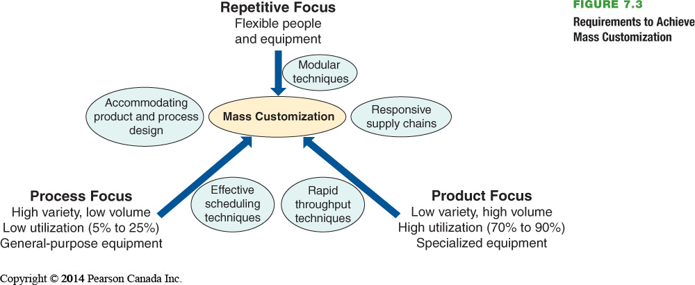

Comparison of Processes:
See Topic 2 Slides or on Page 258 of the text

Crossover chart: A chart of costs at the possible volumes for more than one process
- See Page 259 - Example 1

Focused Processes:

- In the ongoing quest for efficiency, industrialized societies continue to move toward specialization. This specialization contributes to efficiency.

- The focus could be
  - Customers
  - Products
  - Service
  - Technology

Changing Processes
- Changing the production system from one process model to another is difficult and expensive.
- May involve starting over
- Process strategy determines transformation strategy for an extended period
- Important to get it right
- Changes may be necessary in:
  - Purchasing
  - Quality standards
  - Equipment
  - Layout
  - Training

Process Analysis and Design
- Is the process designed to achieve competitive advantage in terms of differentiation, response, or low cost?
- Does the process eliminate steps that do not add value?
- Does the process maximize customer value as perceived by the customer?
- Will the process win orders?

Flowchart: A drawing used to analyze movement of people or material
- Provide a view of the big picture
Time-Function Mapping: A flowchart with time added on the horizontal axis
- Adds rigor and a time element
Value-Stream mapping (VSM): A process that helps managers understand how to add value in the flow of material and information through the entire production process.
- Analysis extends to customers and suppliers
Process Charts: Charts that use symbols to analyze the movement of people or material.
- Show Detail
Service Blueprinting: A process analysis technique that lends itself to focus on the customer and the provider’s interaction with the customer.
- Focuses on customer interaction

Special Considerations for Service Process Design
- Interaction with customers affects process performance
- Service implies that some interaction and customization is needed.
- Customer’s unique desires tend to play havoc with a process.

Production Technology
- Machine Technology
  - Increased precision
  - Increased productivity
  - Increased flexibility
  - Improved environmental impact
  - Reduced changeover time
  - Decreased size
  - Reduced power requirements
- Automatic Identification Systems (AISs) and RFID
  - Improved data acquisition
  - Reduced data entry errors
  - Increased speed
  - Increased scope of process automation
- Process Control
  - Real-time monitoring and control of processes
    - Sensors collect data
    - Devices read data on periodic basis
    - Measurements translated into digital signals then sent to a computer
    - Computer programs analyze the data
    - Resulting output may take numerous forms
- Vision System
  - Particular aid to inspection
  - Consistently accurate
  - Never bored
  - Modest cost
  - Superior to individuals preforming the same tasks
- Robots
  - Perform monotonous or dangerous tasks
  - Preform tasks requiring significant strength or endurance
  - Generally enhanced consistency and accuracy
- Automated Storage and Retrieval Systems (ASRSs)
  - Automated placement and withdrawal of parts and products
  - Reduced errors and labor
  - Particularly useful in inventory and test areas of manufacturing firms
- Automated Guided Vehicles (AGVs)
  - Electonically guided and controlled carts
  - Used for movement of products and/or individuals
- Flexible Manufacturing Systems (FMSs)
  - Computer controls both the workstation and the material handling equipment
  - Enhance flexibility and reduced waste
  - Can economically produce low volume at high quality
  - Reduced changeover time and increased utilization
  - Stringent communication requirement between components
- Computer-Integrated Manufacturing (CIM)
  - Extension of flexible manufacturing systems
    - Backwards to engineering and inventory control
    - Forward into warehousing and shipping
    - Can also include financial and customer service areas
  - Reducing the distinction between low-volume/high-variety, and high-volume/low-variety production

Computer numerical control (CNC): Machinery with its own computer and memory.

Automatic identification system (AIS): A system for transforming data into electronic form; for example bar codes.

Radio Frequency Identification (RFID): A wireless system in which integrated circuits with antennas send radio waves.

Process Control: The use of information technology to control a physical process.

Vision Systems: Systems that use video cameras and computer technology in inspection roles.

Robot: A flexible machine with the ability to hold, moves, or grab items. It functions through electronic impulses that activate motors and switches.

Automated Storage and Retrieval System (ASRS): Computer-Controlled warehouses that provide for the automatic placement of parts into and from designated places within a warehouse.

Automated guided vehicle (AGV): Electronically guided and controlled cart used to move materials.

Flexible Manufacturing System (FMS): A system that uses an automated work cell controlled by electronic signals from a common centralized computer facility.

Computer-integrated manufacturing (CIM): A manufacturing system in which CAD, FMS, inventory control, warehousing, and shipping are integrated.

Technology in Services

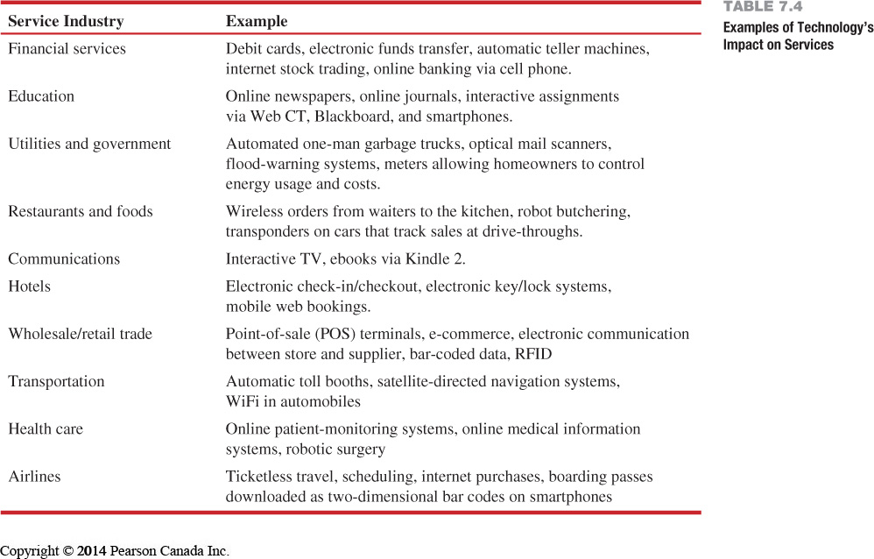

Process Redesign

Process Redesign: The fundamental rethinking of business processes to bring about dramatic improvements in performance.

Sustainability

- Sustainability in production processes
  - Resources
    - Operations is primary user
    - Reducing use is win-win
  - Recycle
    - Burn. Bury, or reuse waste
    - Recycling begins at design
  - Regulations
    - Laws affect transportation, waste, and noise
    - Increasing regulatory pressure
  - Reputation
    - Leadership may be rewarded
    - Bad reputation can have negative consequences

Operations Management
Chapter 9: Layout Strategies

Strategic Importance of Layout Decisions

The objective of layout strategy is to develop an effective and efficient layout that will meet the firm’s competitive requirements

Layout Design Considerations
- Higher utilization of space, equipment, and people
- Improved flow of information, materials, or people
- Improved employee morale and safer working conditions
- Improved customer/client interaction
- Flexibility

Types of Layout
- Office Layout: The grouping of workers, their equipment, and spaces. Offices to provide for comfort, safety, and movement of information.
- Objectives:
  - Locate workers requiring frequent contact close to one another
- Retail Layout: An approach that addresses flow, allocates space, and responds to customer behaviour.
- Objectives
  - Expose customers to high-margin items
- Warehouse Layout: A design that attempts to minimize total cost by addressing trade-offs between space and material handling.
- Objectives
  - Balance low-cost storage with low-cost material handling
- Fixed-position Layout: A system that addresses the layout requirements of stationary projects.
- Objectives
  - Move material to the limited storage areas around the site
- Process-oriented Layout: A layout that deals with low-volume, high-variety production in which like machines and equipment are grouped together.
- Objectives
  - Manage varied material flow for each product
- Work-cell Layout: An arrangement of machines and personnel that focuses on making a single product or family of products.
- Objectives
  - Identify a product family, build teams, cross train team members
- Product-oriented Layout: Seeks the best personnel and machine utilization in repetitive or continuous production.
- Objectives
  - Equalize the task time at each workstation
Good Layouts to Consider
- Material handling equipment
- Capacity and space requirements
- Environment and aesthetics
- Flows of information
- Cost of moving between various work areas
Office Layout
- Grouping of workers, their equipment, and spaces to provide comfort, safety, and movement of information
- Movement of information is main distinction
- Typically in state of flux due to frequent technological changes

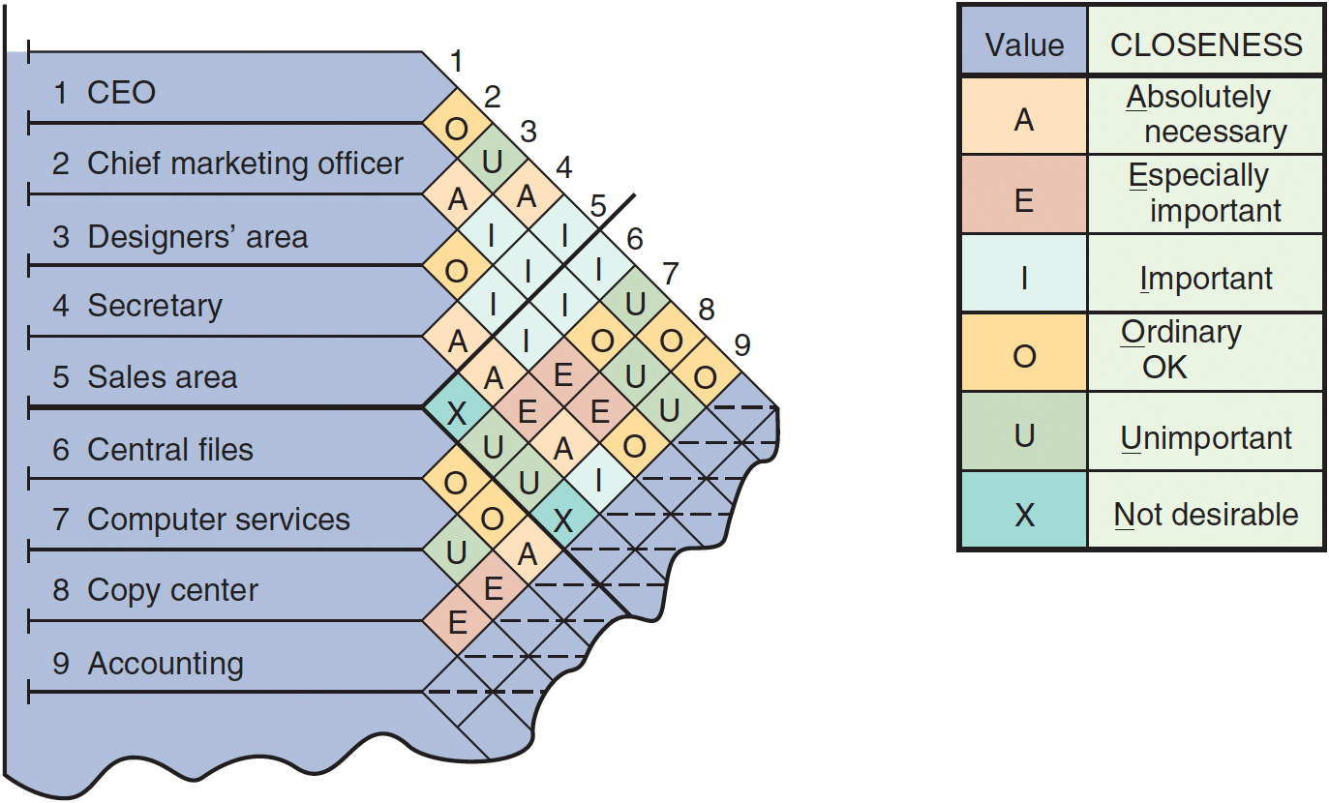

Retain Layout
- Objective is to maximize profitability per square foot of floor space
- Sales and profitability vary directly with customer exposure.
- Helpful ideas for retail layout
- Locate high-draw items around the periphery of the store
- Use prominent locations for high-impulse and high-margin items
- Distribute power items to both sides of an aisle and disperse them to increase viewing of other items
- Use end-aisle locations
- Convey mission of store through careful positioning of the lead-off department

Slotting Fees: Fees manufacturers pay to get shelf space for their products.
- Contributing factors
  - Limited shelf space
  - An increasing number of new products
  - Better information about sales through POS data collection
  - Closer control of inventory

Servicescapes: The physical surrounding in which a service takes place, and how they affect customers and employees.

In order to provide a good service layout a retailer must follow three elements:
- Ambient conditions, background characteristics such as lighting, sound and smell.
- Spatial Layout and Functionality, involves the customer path planning, space and products grouping.
- Signs, Symbols and artifacts, characteristics of a building design that carry social significance.

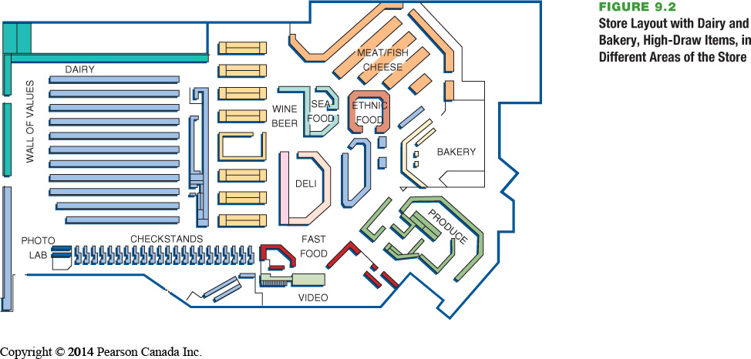

Warehousing and Storage Layouts

- Objective is to optimize trade-offs between handling costs and costs associated with warehouse space
- Maximize the total “cube” of warehouse- utilize its full volume while maintaining low material handling costs
- All costs associated with the transaction
  - Incoming transport
  - Storage
  - Finding and Moving material
  - Outgoing transport
  - Equipment, people, material, supervision, insurance, depreciation
- Minimize damage and spoilage
- Warehouse density tends to vary inversely with the number of different items stored
- Automated storage and retrieval systems (ASRSs) can significantly improve warehouse productivity by and estimated 500%
- Dock location is a key design element

Cross-Docking: Avoiding the placement of materials or supplies in storage by processing them as they are received for shipment.
- Materials are moved directly from receiving to shipping and are not placed in storage in the warehouse
- Requires tight scheduling and accurate shipments, bar code or RFID identification used for advanced shipment notification as materials are unloaded

Random Stocking: Used in warehousing to locate stock wherever there is an open location.
- Typically requires automatic identification systems (AISs) and effective information systems
- Random assignment of stocking locations allows more efficient use of space
- Key tasks
- Maintain list of open locations
- Maintain accurate records
- Sequence items to minimize travel, pick time
- Combine picking orders
- Assign classes of items to particular areas

Customizing: Using warehousing to add value to a product through component modification, repair, labeling, and packaging.
- Value-added activities preformed at the warehouse
- Enable low cost and rapid response strategies
  - Assembly of components
  - Loading software
  - Repairs
  - Customized labeling and packaging

Fixed-Position Layout
- Product remains in one place
- Workers and equipment come to site
- Complicating factors
  - Limited space at site
  - Different materials required at different stages of the project
  - Volume of materials needed is dynamic

Alternative Strategy
- As much of the project as possible is completed off-site in a product-oriented facility
- This can significantly improve efficiency but is only possible when multiple similar units need to be created

Process-Oriented Layout
- Like machines and equipment are grouped together
- Flexible and capable of handling a wide variety of products or services
- Scheduling can be difficult and setup, material handling, and labor costs can be high
- Arrange work centres so as to minimize the costs of material handling
- Basic cost elements are
  - Number of loads (or people) moving between centers
  - Distance loads (or people) move between centers

$$Minimize Cost=\sum_{i=1}^{n}{\sum_{i=1}^{n}{X_{ij}}}C_{ij}$$
Where
n= total number of work centers or departments
i,j= individual departments
$X_{ij}$= Number of loads moved from department i to department j
$C_{ij}$= Cost to move a load between department i to department j

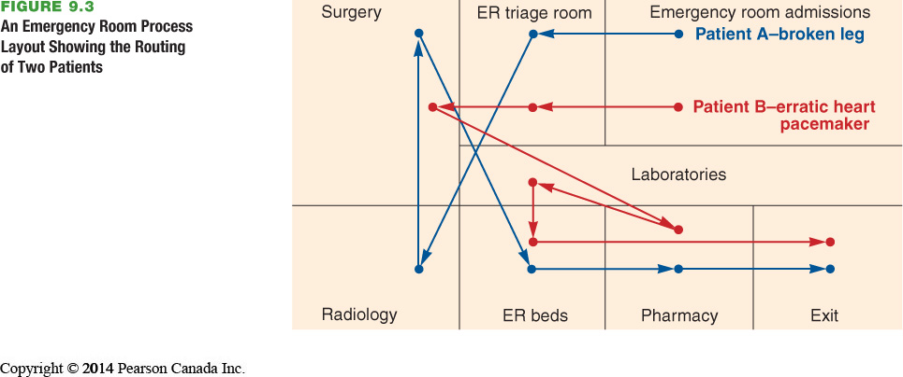

Work Cells
- Reorganizes people and machines into groups to focus on single products or product groups
- Group technology identifies products that have similar characteristic for particular cells
- Volume must justify cells
- Cells can be reconfigured as designs or volume changes

Advantages to work cells
- Reduced work-in-progress inventory
- Less floor space required
- Reduced raw material and finished goods inventory
- Reduced direct labor
- Heightened sense of employee participation
- Increased use of equipment and machinery
- Reduced investment in machinery and equipment

Requirements of Work Cells
- Identification of families of products
- A high level of training, flexibility, and empowerment of employees
- Being self-contained, with its own equipment and resources
- Test (poka-yoke) at each station in the cell

Staffing and Balancing Work Cells

Takt time: Pace of production to meet customer demands

$$Takt time=\frac{Total work time available}{Units Required}$$

$$Workers required=\frac{Total operation time required}{Takt time}$$

Focused Work Center: A permanent or semi-permanent product-oriented arrangement of machines and personnel.

Focused factory: A facility designed to produce similar products or components.

Repetitive and Product-oriented Layout

Fabrication line: A machine-paced, product-oriented facility for building components.
- Builds components on a series of machines
- Machine-paced
- Require mechanical or engineering changes to balance

Assembly line: An approach that puts fabricated parts together at a series of workstations; used in repetitive processes.
- Puts fabricated parts together at a series of workstations
- Paced by work tasks
- Balanced by moving tasks

The assumption that:
- Volume is adequate for high equipment utilization
- Product demand is stable enough to justify high investment in specialized equipment
- Product is standardized or approaching a phase of life cycle that justifies investment
- Supplies of raw materials and components are adequate and of uniform quality

Advantages:
- Low variable cost per unit
- Low material handling costs
- Reduced work-in-process inventories
- Easier training and supervision
- Rapid throughput

Disadvantages:
- High volume is required
- Work stoppage at any point ties up the whole operation
- Lack of flexibility in product or production rates

Assembly-Line Balancing:
- Objective is to minimize the imbalance between machines or personnel while meeting required output
- Starts with the precedence relationships
  - Determine cycle time
  - Calculate theoretical minimum number of workstations
  - Balance the line by assigning specific tasks to workstations

Cycle Time: The maximum time that a product is allowed at each workstation.

Steps to obtaining a specific production rate:
- $Cycle time=\frac{Production time available per day}{Units required per day}$
- $Minimum number of workstations=\frac{\sum_{i=1}^{n}{Time for task i}}{Cycle Time}$

Heuristic: Problem solving using procedures and rules rather than mathematical optimization.

$$Efficiency=\frac{\sum{Task times}}{\left(actual number of workstations\right)(Largest assigned cycle time)}$$

