Multiple Choice Questions. Please use the computerized answer sheet to answer the questions in this section. Any answers on this question sheet will NOT be considered.

- A situation in which the unregulated competitive market outcome is inefficient because prices fail to provide proper signals to buyers and sellers is known as:
- an imperfectly competitive market.
- a market failure.
- a deadweight loss.
- a disequilibrium.

- Although the U. S. airline industry has only a relatively small number of sellers, the market is nevertheless highly competitive. The reason is that:
- the number of buyers is very large.
- due to fierce competition, no firm has significant control over prices.
- due to fierce competition, no firm has significant control over the quantity supplied.
- most airline routes are served by relatively many sellers.

- Since last year, the price of gold has risen from $1100 to $1420. What annual inflation rate would leave the real price of gold unchanged over the last twelve months?
- Approximately 29%
- 40%
- Approximately 71%
- 320%
- none of the above

- Plastic and steel are substitutes in the production of body panels for certain automobiles. If the price of plastic increases, with other things remaining the same, we would expect:
  - the price of steel to fall.
  - the demand curve for steel to shift to the right.
  - the demand curve for plastic to shift to the left.
  - nothing to happen to steel because it is only a substitute for plastic.
  - the demand curve for steel to shift to the left.

- Coffee and cream:
  - are both luxury goods.
  - are complements.
  - are both more inelastic in demand in the long run than in the short run.
  - have a positive cross price elasticity of demand.

- The demand for books is: Qd = 120 - P
The supply of books is: Qs = 5P

What is the equilibrium quantity of books sold?
- 25
- 50
- 75
- 100
- none of the above

- Suppose the observed annual quantity of steel exchanged in the European market is 30 million metric tons, and the observed market price is 90 euros per ton. If the linear demand function for steel takes the form Q = a - 0.9P, what is an appropriate value for the intercept coefficient a?
- a = -51
- a = 51
- a = 111
- a = -111

- When the government controls the price of a product, causing the market price to be below the free market equilibrium price,
- some consumers gain from the price controls and other consumers lose.
- all producers gain from the price controls.
- both producers and consumers gain.
- all consumers are better-off.

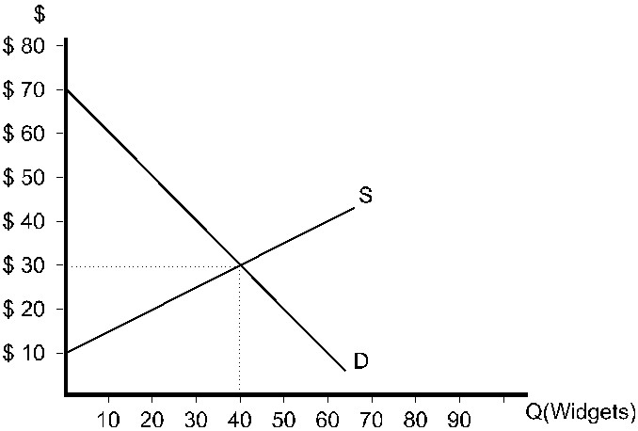

Figure 1

- Refer to Figure 1. If the market is in equilibrium, the producer surplus earned by the lowest cost seller is ________.
  - $5.00
  - $10.00
  - $15.00
  - $20.00
  - $40.00

- Refer to Figure 1. If the market is in equilibrium, total consumer surplus is
- $30.
- $70.
- $400.
- $800.
- $1200.

- Refer to Figure 1. Suppose the market is currently in equilibrium. If the government establishes a price ceiling of $20, producer surplus will
- fall by $200.
- fall by $300.
- remain the same.
- rise by $200.
- rise by $300.

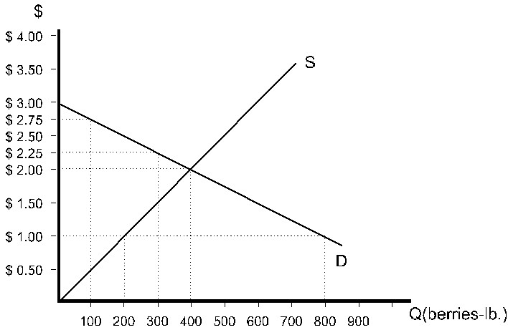

Figure 2

- Refer to Figure 2. If the government establishes a price floor of $2.50, how many pounds of berries will be sold?
  - 200
  - 300
  - 400
  - 600
  - 800

- Refer to Figure 2. If the government establishes a price floor of $2.50 and farmers grow only the amount of berries that will be sold, the resulting deadweight loss will be
- $1.50.
- 200 pounds of berries.
- $150.
- $250.
- $300.

- A minimum wage policy induces an:
- excess demand for labor.
- excess supply of labor.
- efficient market outcome.
- elastic labor supply response.

- Suppose the government raises the price of cheese above the market equilibrium level (P0) by imposing a high minimum price and purchasing all of the excess supply from the market, and these quantities are destroyed. Based on the areas in the figure below, what is the change in producer surplus after this policy is adopted?

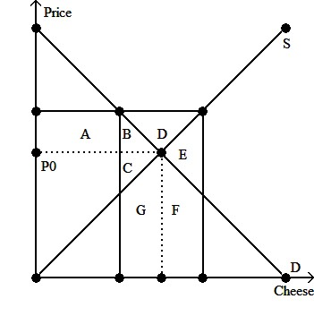
- Producers lose area C but gain area A.
- Producers lose area C but gain area A+B.
- Producers gain A.
- Producers gain area A+B+D.

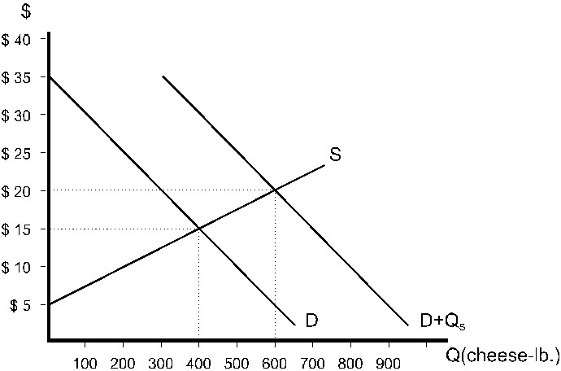

Figure 3

- Refer to Figure 3. The government policy pictured is
- a price ceiling of $20.
- a price support of $20.
- a price ceiling of $15.
- a price support of $15.
- A quota of 600.
- Refer to Figure 3. Before this policy was implemented, producer surplus was
- $10.
- $2000.
- $4000.
- $6000.
- $12000.

- Refer to Figure 3. As a result of this policy, consumer surplus will
- fall to $15.
- fall to $2250.
- rise to $2500.
- fall to $5000.
- rise to $5000.

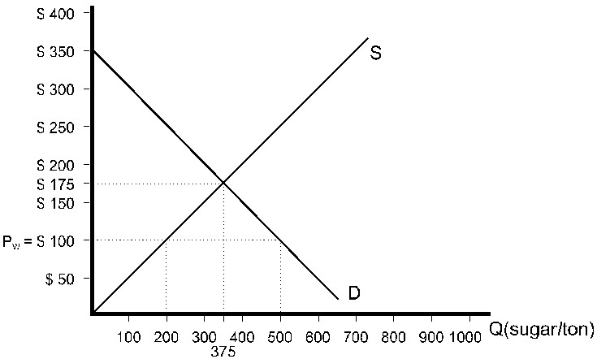

Figure 4

- Refer to Figure 4. With no government interference, the country pictured will
- import 500 tons of sugar.
- import 300 tons of sugar.
- import 200 tons of sugar.
- import no sugar.
- export sugar.

- Refer to Figure 4. In order to eliminate international trade in sugar altogether, this country would have to impose a quota of
- 0 tons.
- 200 tons.
- 300 tons.
- 350 tons.
- 500 tons.

