Multiple Choice Questions. Please use the computerized answer sheet to answer the questions in this section. Any answers on this question sheet will NOT be considered.

- Plastic and steel are substitutes in the production of body panels for certain automobiles. If the price of plastic increases, with other things remaining the same, we would expect:
- the price of steel to fall.
- the demand curve for steel to shift to the right.
- the demand curve for plastic to shift to the left.
- nothing to happen to steel because it is only a substitute for plastic.
- the demand curve for steel to shift to the left.

- Coffee and cream:
- are both luxury goods.
- are complements.
- are both more inelastic in demand in the long run than in the short run.
- have a positive cross price elasticity of demand.

- A situation in which the unregulated competitive market outcome is inefficient because prices fail to provide proper signals to buyers and sellers is known as:
- an imperfectly competitive market.
- a market failure.
- a deadweight loss.
- a disequilibrium.

- Although the U. S. airline industry has only a relatively small number of sellers, the market is nevertheless highly competitive. The reason is that:
- the number of buyers is very large.
- due to fierce competition, no firm has significant control over prices.
- due to fierce competition, no firm has significant control over the quantity supplied.
- most airline routes are served by relatively many sellers.

- The price of a taco was $0.29 in 1970 and $1.09 in 2000. The CPI was 38.8 in 1970 and 172.2 in 2000. The 2000 price of a taco in 1970 dollars is:
- $0.25.
- $0.29.
- $1.09.
- $4.84.

- The demand for books is: Qd = 120 - P
The supply of books is: Qs = 5P

What is the equilibrium price of books?
- 5
- 10
- 15
- 20
- none of the above

- Suppose the observed annual quantity of steel exchanged in the European market is 30 million metric tons, and the observed market price is 90 euros per ton. If the price elasticity of demand for steel is -0.3 in Europe, what is an appropriate value for the price coefficient (b) in a linear demand function Q = a - bP?
- b = 0.9
- b = -0.9
- b = 0.1
- b = -0.1

- When the government controls the price of a product, causing the market price to be above the free market equilibrium price,
- all producers gain.
- both producers and consumers gain.
- only consumers gain.
- some, but not all, sellers can find buyers for their goods.

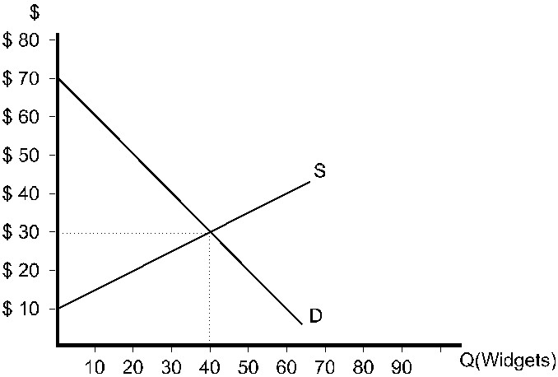

Figure 1

- Refer to Figure 1. If the market is in equilibrium, the consumer surplus earned by the buyer that values widgets the most ________.
- $5.00
- $15.00
- $22.50
- $40.00

- Refer to Figure 1. If the market is in equilibrium, total producer surplus is
- $30.
- $70.
- $400.
- $800.
- $1200.

- Refer to Figure 1. Suppose the market is currently in equilibrium. If the government establishes a price ceiling of $20, consumer surplus will
- fall by $200.
- fall by $300.
- remain the same.
- rise by $200.
- rise by $300.

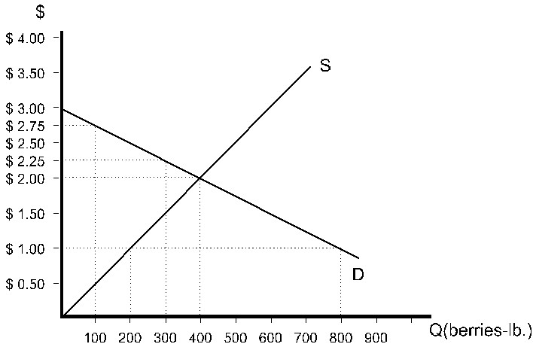

Figure 2

- Refer to Figure 2. If the government establishes a price floor of $2.50, how many pounds of berries will be sold?
- 200
- 300
- 400
- 600
- 800

- Refer to Figure 2. If the government establishes a price floor of $2.50 and farmers grow only the amount of berries that will be sold, total consumer and producer surplus will be
- $1.50.
- $300.
- $450.
- $500.
- $600.

- A minimum wage policy induces an:
- excess demand for labor.
- excess supply of labor.
- efficient market outcome.
- elastic labor supply response.

- Suppose the government raises the price of cheese above the market equilibrium level (P0) by imposing a high minimum price and purchasing all of the excess supply from the market, and these quantities are destroyed. Based on the areas in the figure below, what is the change in consumer surplus after this policy is adopted?

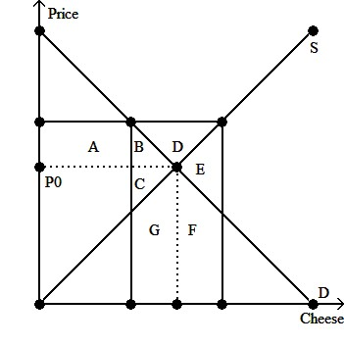
- Consumers lose area B.
- Consumers lose area A+B.
- Consumers lose area A but gain area B.
- Consumers gain area A+B.

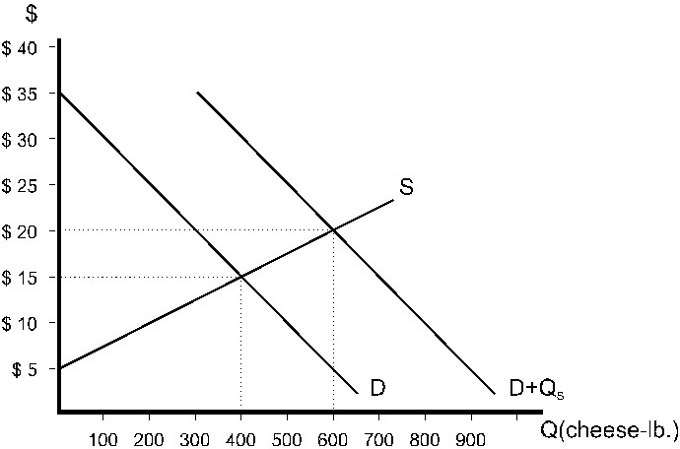
Figure 3
- Refer to Figure 3. The government policy pictured is
- a price ceiling of $20.
- a price support of $20.
- a price ceiling of $15.
- a price support of $15.
- A quota of 600.
- Refer to Figure 3. Before this policy was implemented, consumer surplus was
- $20.
- $4000.
- $6000.
- $8000.
- $12000.

- Refer to Figure 3. As a result of this policy, producer surplus will be
- $2000.
- $3375.
- $4500.
- $6000.
- $12,000.

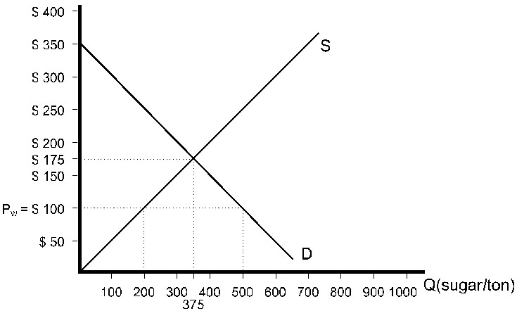

Figure 4
- Refer to Figure 4. With no government interference, the country pictured will
- import 500 tons of sugar.
- import 300 tons of sugar.
- import 200 tons of sugar.
- import no sugar.
- export sugar.

- Refer to Figure 4. In order to eliminate international trade in sugar altogether, this country would have to impose a tariff of
- $25.
- $50.
- $75.
- $150.
- $175.

