Week 3 (May 16-22): Chapter 3: Neural Processing and Perception

- Every signal leaving a receptor travels through a complex network of interconnected neurons, often meeting, and being affected by, other signals along the way.
- Neural processing—the interaction of the signals in many neurons.
Lateral Inhibition and Perception
- Lateral inhibition—inhibition that is transmitted across the retina—
  - The pioneering work on lateral inhibition was carried out on a primitive animal called the Limulus, more familiarly known as the horseshoe crab
- Lateral Inhibition in the Limulus
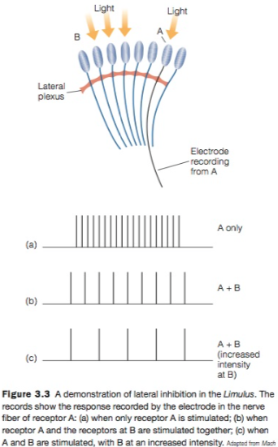
  - Used the Limulus to demonstrate how lateral inhibition can affect the response of neurons in a circuit. (Discoverers: Hartline, Wagner, R)
  - They chose the Limulus because the structure of its eye makes it possible to stimulate individual receptors.
  - The Limulus eye is made up of hundreds of tiny structures called ommatidia
  - Illumination of the neighboring receptors at B inhibited the firing caused by stimulation of receptor A. This decrease in the firing of receptor A is caused by lateral inhibition that is transmitted from B to A across the Limulus’s eye by the fibers of the lateral plexus.

- Lateral Inhibition and Lightness
  - Perception of lightness—the perception of shades ranging from white to gray to black.
  - The Hermann Grid: Seeing spots at intersections
    - Notice the ghostlike gray images at the intersections of the white “corridors” in the Hermann grid
    - Perception is determined not by the response of the receptors, but by the response of neurons farther down the system, in the retina or the brain.

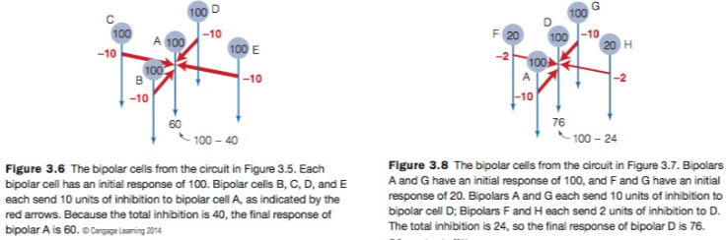
Although the initial responses of bipolars A and D are the same, their final responses are different, because D receives less lateral inhibition than A.
(Herman Grid)

- Mach Bands (Illusion): Seeing Borders more Sharply
  - Another perceptual effect that can be explained by lateral inhibition is Mach bands, illusory light and dark bands near a light–dark border.
  - Mach bands can be demonstrated using gray stripes or by casting a shadow
  - When you do this, you will see a dark Mach band near the border of the shadow and a light Mach band on the other side of the border
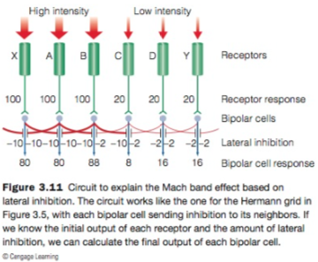
  - Mach bands are another test showing lateral inhibition
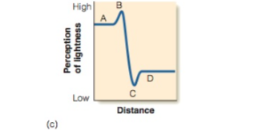

  - Receptors A and B correspond to A and B which are on the light side of the border and so receive intense illumination
  - Receptors C and D are on the darker side and receive dim illumination.
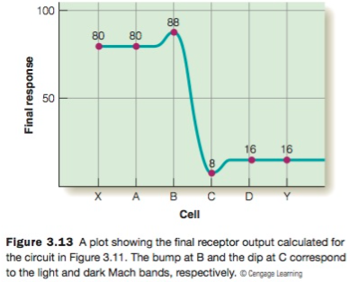
  - Receptors X and Y have been added to this circuit for the purposes of this calculation, so A and D will receive inhibition from both sides.
  - Assume that receptors X, A, and B result in an initial response of 100 in their bipolar cells, and C, D, and Y cause an initial response of 20 in their bipolar cells.
  - The lateral inhibition in our circuit has therefore created a neural pattern that looks like the Mach bands we perceive.

- Lateral Inhibition and Simultaneous Contrast
  - Simultaneous contrast occurs when our perception of the brightness or color of one area is affected by the presence of an adjacent or surrounding area.
  - This perception occurs because the two small squares are actually identical shades of gray. The illusion that they are different, which is created by the differences in the areas surrounding each square, is the simultaneous contrast effect (same color but on light vs. dark background)

- A Display that cannot be explained by Lateral Inhibition
  - White’s illusion
    - Can’t be explained by lateral inhibition
    - Our perception of lightness in influenced by a principle called belongingness, which states that an area’s appearance is influenced by the part of the surroundings to which the area appears to belong.
    - Regardless of whether the idea of belongingness turns out to be the correct explanation, there is no question that some mechanism other than lateral inhibition is involved in our perception of White’s illusion

Processing from Retina to Visual Cortex and Beyond
- Responding of single fibers in the Optic Nerve
  - Hartline called the area that caused the neuron to fire the nerve fiber’s receptive field
    - The region of the retina that must receive illumination in order to obtain a response in any given fiber.
  - The fact that a fiber’s receptive field covers hundreds or even thousands of receptors means that the fiber is receiving con- verging signals from all of these receptors.
  - Finally, Hartline noted that the receptive fields of many different fibers overlap. This means that shining light on a particular point on the retina activates many ganglion cell fibers.
  - Each optic nerve fiber monitors a small area of retina, and all of them together take in information about what is happening over the entire retina.
  - Researchers after Hartline, who studied the responses of neurons in the cat and the monkey at different levels of the visual system, bring us closer to the neural responses that are associated with perception.
    - The cat receptive fields, it turns out, are arranged in a center-surround organization, in which the area in the “center” of the receptive field responds differently to light than the area in the “surround” of the receptive field
    - Presenting a spot of light to the center increases firing, so it is called the excitatory area of the receptive field.
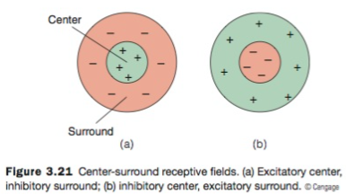
    - In contrast, stimulation of the surround causes a decrease in firing, so it is called the inhibitory area of the receptive field.
    - This receptive field is called an excitatory-center, inhibitory-surround receptive field.
    - The receptive field, which responds with inhibition when the center is stimulated and excitation when the surround is stimulated, is an inhibitory-center, excitatory- surround receptive field.
  - The discovery that receptive fields can have oppositely responding areas made it necessary to modify Hartline’s definition of receptive field to the retinal region over which a cell in the visual system can be influenced (excited or inhibited) by light
  - The discovery of center-surround receptive fields was also important because it showed that neural processing could result in neurons that respond best to specific patterns of illumination.
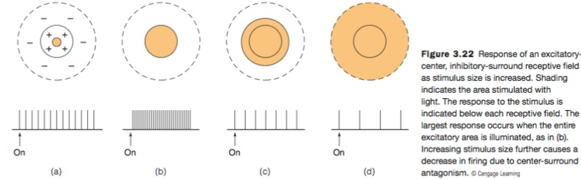

  - Center-surround antagonism comes into play when the spot of light becomes large enough that it begins to cover the inhibitory area, as in (c) and (d). Stimulation of the inhibitory surround counteracts the center’s excitatory response, causing a decrease in the neuron’s firing rate.
  - Thus, because of center-surround antagonism, this neuron responds best to a spot of light that is the size of the excitatory center of the receptive field.
  - Center-surround receptive fields are created by the interplay between excitation and inhibition.
- Hubel and Wiesel’s Rationale for Studying Receptive Fields
  - David Hubel and Thorsten Wiesel extended the study of receptive fields into the cortex.
  - A neuron’s receptive field is determined by presenting a stimulus, such as a spot of light, to different places on the retina to determine, which areas result in no response, an excitatory response, or an inhibitory response.
  - The receptive field is always on the retina because that is where the stimuli are received
  - Signals leaving the eye in the optic nerve travel to the lateral geniculate nucleus (LGN), and then from the LGN to the occipital lobe of the cerebral cortex, the 2–4 mm thick covering of the brain that plays a central role in determining perception and cognition
  - The occipital lobe is the visual receiving area—the place where signals from the retina and LGN first reach the cortex
  - Viewing the under-side of the brain shows the pathway from eye to cortex, plus the superior colliculus, which receives some signals from the eye.
    - This structure plays an important role in controlling movements of the eyes.
  - The visual receiving area is also called the striate cortex, because it has a striped appearance when viewed in cross section, or area V1 to indicate that it is the first visual area in the cortex.
  - The pathway from the eye to the LGN to the visual cortex was the staging ground for Hubel and Wiesel’s pioneering experiments.
- Receptive Fields of Neurons in the Visual Cortex
  - Cells with these side-by-side receptive fields are called simple cortical cells. (striate cortex)
  - The relationship between orientation and firing is indicated by a neuron’s orientation tuning curve, which is determined by measuring the responses of a simple cortical cell to bars with different orientations.
  - Hubel and Wiesel (1965) discovered that many cortical neurons respond best to moving bar-like stimuli with specific orientations.
  - Complex cells, like simple cells, respond best to bars of a particular orientation.
    - However, unlike simple cells, which respond to small spots of light or to stationary stimuli, most complex cells respond only when a correctly oriented bar of light moves across the entire receptive field.
    - Further, many complex cells respond best to a particular direction of movement
  - Another type of cell, called end-stopped cells, fire to moving lines of a specific length or to moving corners or angles.
  - Hubel and Wiesel’s finding that some neurons in the cortex respond only to oriented lines and others respond best to corners was an extremely important discovery because it extended the idea first proposed in connection with center-surround receptive fields that neurons respond to some pat- terns of light and not to others.
  - Thus, Hubel and Wiesel’s discovery that neurons respond selectively to oriented lines and stimuli with specific lengths was an important step toward determining how neurons respond to more complex objects.
  - Because simple, complex, and end-stopped cells fire in response to specific features of the stimulus, such as orientation or direction of movement, they are sometimes called feature detectors.
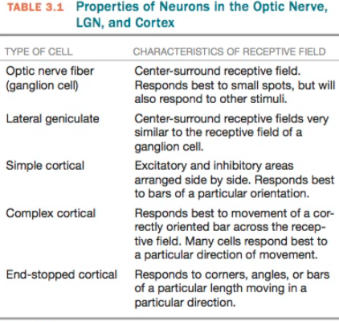

Do Feature Detectors Play a Role in Perception?
- Neural processing endows neurons with properties that make them feature detectors that respond best to a specific type of stimulus.
- To demonstrate a link between physiology and perception, it is necessary to measure the physiology–perception relationship.
  - One way this has been accomplished is by using a psychophysical procedure called selective adaptation.
- Selective Adaptation
  - The idea behind selective adaptation is that this firing causes neurons to eventually become fatigued, or adapt.
  - This adaptation causes two physiological effects: (1) the neuron’s firing rate decreases, and (2) the neuron fires less when that stimulus is immediately presented again.
  - A grating’s contrast threshold is the minimum intensity difference between two adjacent bars that can just be detected.
  - When vertical feature detectors are adapted, it is necessary to increase the difference between the black and white vertical bars in order to see them.
  - The important result of this experiment is that our psychophysical curve shows that adaptation selectively affects only some orientations, just as neurons selectively respond to only some orientations.
  - The near match between the orientation selectivity of neurons and the perceptual effect of selective adaptation supports the idea that orientation detectors play a role in perception.
  - The selective adaptation experiment is measuring how a physiological effect (adapting the feature detectors that respond to a specific orientation) causes a perceptual result (decrease in sensitivity to that orientation).
  - This evidence that feature detectors have something to do with perception means that when you look at a complex scene, such as a city street or a crowded shopping mall, feature detectors that are firing to the orientations in the scene are helping to construct your perception of the scene.
- Selective Rearing
  - Further evidence that feature detectors are involved in perception is provided by selective rearing experiments.
  - The idea behind selective rearing is that if an animal is reared in an environment that contains only certain types of stimuli, then neurons that respond to these stimuli will become more prevalent.
  - This follows from a phenomenon called neural plasticity or experience-dependent plasticity—the idea that the response properties of neurons can be shaped by perceptual experience.
    - According to this idea, rearing an animal in an environment that contains only vertical lines should result in the animal’s visual system having neurons that respond predominantly to verticals.
  - This result may seem to contradict the results of the selective adaptation experiment just described, in which exposure to verticals decreases the response to verticals.
    - However, adaptation is a short-term effect.
    - Selective rearing is a long-term effect.
  - One way to describe the results of selective rearing experiments is “Use it or lose it.”
    - This effect was demonstrated in a classic experiment by Colin Blakemore and Grahame Cooper
    - The parallel between the orientation selectivity of neurons in the cat’s cortex and the cat’s behavioral response to the same orientation provides more evidence that feature detectors are involved in the perception of orientation.

- Higher Level Neurons
  - Psychologist Charles Gross, who decided that the inferotemporal (IT) cortex in the temporal lobe was ripe for study
  - He based this decision on research that showed that removing parts of the IT cortex in monkeys affected the monkeys’ ability to recognize objects, as well as on research on a human condition called prosopagnosia, in which people with temporal lobe damage were unable to recognize faces.
  - The underside of the temporal lobe of the human cortex was named the fusiform face area because it responded strongly to faces.

The Sensory Code
- Sensory coding: how the firing of neurons represents various characteristics of the environment.
- Specificity Coding: Representation by the Firing of a Specialized Neuron
  - Specificity coding proposes that a particular object is rep- resented by the firing of a neuron that responds only to that object and to no other objects.
  - One of the requirements of specificity coding is that there are neurons that are specifically tuned to each object in the environment.
  - The idea that there are single neurons that each respond only to a specific stimulus was proposed in the 1960s by Jerzy Konorski and Jerry Lettvin.
    - A grandmother cell, according to Lettvin, is a neuron that responds only to a specific stimulus.
  - Most researchers feel that specificity coding is an unlikely possibility.

- Distributed Coding: Representation by Firing of Large Groups of Neurons
  - Distributed coding is the representation of a particular object by the pattern of firing of a large number of neurons.
  - An advantage of distributed coding is that a large number of stimuli can be represented, because groups of neurons can create a huge number of different patterns.
- Sparse Coding: Representation by Firing of Small Groups of Neurons
  - Sparse coding occurs when a particular object is represented by a pattern of firing of only a small group of neurons, with the majority of neurons remaining silent
  - Given the likelihood that even these special neurons are likely to fire to more than one stimulus, Quiroga and coworkers (2008) suggested that their neurons are probably an example of sparse coding.
  - Features or objects are represented by the pattern of firing of groups of neurons. Sometimes the groups are small (sparse coding), sometimes large (distributed coding).

The Mind-Body Problem
- Mind–body problem: How do physical processes such as nerve impulses or sodium and potassium molecules flowing across membranes (the body part of the problem) become transformed into the richness of perceptual experience
- Research on sensory coding, which focuses on the relationship between stimuli in the environment and how neurons fire, is often referred to as research on the neural correlate of consciousness (NCC), where consciousness can roughly be defined as our experiences.
- Researchers often call finding the NCC the easy problem of consciousness because it has been possible to discover many connections between neural firing and experience
- How do physiological responses become transformed into experience?
  - We can appreciate why this is called the hard problem of consciousness

