Week 2(May 9-15) Chapter 2: The Beginnings of Perception
The figure shows the beginning of the visual process, when light enters the eye and becomes transformed in a number of ways.
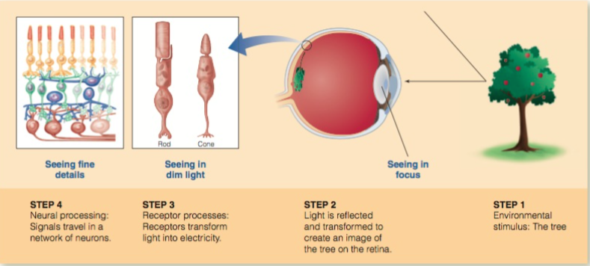

Light and Focusing:
- The ability to see a tree, or any other object, depends on information contained in light reflected from that object into the eye.
- Light: The stimulus for Vision
  - The electromagnetic spectrum is a continuum of electromagnetic energy that is produced by electric charges and is radiated as waves
  - The energy in this spectrum can be described by its wavelength—the distance between the peaks of the electromagnetic waves.
  - Visible light, the energy within the electromagnetic spectrum that humans can perceive, has wavelengths ranging from about 400 to 700 nanometers
- The Eye
  - The eyes contain the receptors for vision.
  - Light reflected from objects in the environment enters the eye through the pupil and is focused by the cornea and lens to form sharp images of the objects on the retina, the network of neurons that covers the back of the eye and that contains the receptors for vision
  - These visual receptors, the rods and cones, contain light- sensitive chemicals called visual pigments that react to light and trigger electrical signals.
  - The retina lining the backs of the eye shape what we see by creating two transformations: (1) the transformation from light reflected from an object into an image of the object; and (2) the transformation from the image of the object into electrical signals.
- Light is Focused by the Eye
  - Light reflected from an object into the eye is focused onto the retina by a two-element optical system: the cornea and the lens.
  - Accommodation is the change in the lens’s shape that occurs when the ciliary muscles at the front of the eye tighten and increase the curvature of the lens so that it gets thicker
  - The distance at which your lens can no longer accommodate to bring close objects into focus is called the near point.
- Loss of Accommodation with Increasing Age
  - The distance of the near point increases as a person gets older, a condition called presbyopia
  - This loss of the ability to accommodate occurs because the lens hardens with age and the ciliary muscles become weaker. These changes make it more difficult for the lens to change its shape for vision at close range.
- Myopia
  - Myopia, or nearsightedness, an inability to see distant objects clearly.
  - The myopic optical system brings parallel rays of light into focus at a point in front of the retina, so the image that reaches the retina is blurred. This problem can be caused by either of two factors: (1) refractive myopia, in which the cornea and/or the lens bends the light too much, or (2) axial myopia, in which the eyeball is too long. Either way, images of faraway objects are not focused sharply, so objects look blurred.
  - The distance at which light becomes focused on the retina is called the far point. (Objects behind the “far point” = out of focus)
  - Laser-assisted in situ keratomileusis (LASIK) surgery: LASIK involves sculpting the cornea with a type of laser called an excimer laser, which does not heat tissue.
- Hyperopia
  - A person with hyperopia, or farsightedness, can see distant objects clearly but has trouble seeing nearby objects.

Receptors and Perception:
- Light entering visual receptors triggers electrical signals when light-sensitive visual pigment molecules in the receptors absorb light. This step is crucial for vision because it creates electrical signals that eventually signal the properties of the tree to the brain.
- Transforming Light Energy into Electrical Energy
  - Transduction is the transformation of one form of energy into another form of energy
    - For vision—the transformation of light energy into electrical energy—occurs in the receptors for vision: the rods and cones
  - Visual pigments have two parts: a long protein called opsin and a much smaller light-sensitive component called retinal.
    - When the retinal and opsin are combined, the resulting molecule absorbs visible light
  - When a visual pigment molecule absorbs one photon of light, the retinal changes its shape, from being bent, to straight, this change of shape, called isomerization, creates a chemical chain reaction that activates thousands of charged molecules to create electrical signals in receptors.
    - The chain reaction amplifies the effect of isomerization.
  - Isomerizing one visual pigment molecule triggers a chain of chemical reactions that releases as many as a million charged molecules, which leads to activation of the receptor
- Adapting to the Dark
  - An important feature of the visual system is its ability to adapt to the dark by increasing its sensitivity to light.
  - This process of increasing sensitivity in the dark is called dark adaptation.
  - The ratio of rods and cones depends, however, on the location in the retina.
    - One small area, the fovea, contains only cones.
    - The peripheral retina, which includes the entire retina outside of the fovea, contains both rods and cones.
      - More rods than cones
  - A condition called macular degeneration destroys the cone- rich fovea and a small area that surrounds it.
    - This creates a blind region in central vision, so when a person looks directly at something, he or she loses sight of it
  - Retinitis pigmentosa, is a degeneration of the retina that is passed from one generation to the next
    - This condition first attacks the peripheral rod receptors and results in poor vision in the peripheral visual field
  - There is one place in the retina where no receptors are and due to the absence of receptors, this place is called the blind spot.
  - The first step in the study of dark adaptation is to measure the dark adaptation curve, which is the function relating sensitivity to light to time in the dark, beginning when the lights are extinguished.
    - The dark adaptation curve shows that as adaptation proceeds, the observer becomes more sensitive to the light.
  - Such people, who have no cones due to a rare genetic defect, are called rod monochromats.
  - As soon as the light is extinguished, the sensitivity of both the cones and the rods begins increasing.
    - However, because the cones are much more sensitive than the rods at the beginning of dark adaptation, we see with our cones right after the lights are turned out.
    - After about 3 to 5 minutes in the dark, the cones have reached their maxi- mum sensitivity, as indicated by the leveling off of the dark adaptation curve.
    - Meanwhile, the rods are still adapting and by about 7 minutes in the dark, the rods’ sensitivity finally catches up to the cones’. The rods then become more sensitive than the cones, and rod adaptation, indicated by the second branch of the dark adaptation curve, becomes visible.
    - The place where the rods begin to determine the dark adaptation curve is called the rod–cone break
  - Visual pigment regeneration occurs more rapidly in the cones than in the rods. Which is the reason why they reach maximum sensitivity before rods.
  - Light causes the retinal part of the visual pigment molecule to change its shape. Eventually, after this shape change, the retinal separates from the opsin part of the molecule. This change in shape and separation from the opsin causes the molecule to become lighter in color, a process called visual pigment bleaching.
  - When the pigments are in their lighter bleached state, they are no longer useful for vision. In order to do their job of changing light energy into electrical energy, the retinal needs to return to its bent shape and become reattached to the opsin. This process of reforming the visual pigment molecule is called visual pigment regeneration.
  - William Rushton demonstrated this relationship between pigment concentration and sensitivity.
    - When he compared the course of pigment regeneration to the dark adaptation curve, he found that the rate of cone dark adaptation matched the rate of cone pigment regeneration and the rate of rod dark adaptation matched the rate of rod pigment regeneration.
    - These results demonstrated two important connections between perception and physiology: 1. Our sensitivity to light depends on the concentration of a chemical—the visual pigment.2. The speed at which our sensitivity increases in the dark depends on a chemical reaction—the regeneration of the visual pigment.
  - When a person’s retina becomes detached from the pigment epithelium, a layer that contains enzymes necessary for pigment regeneration. This condition, is called detached retina
  - Rods and cones also differ in the way they respond to light in different parts of the visible spectrum
    - The differences in the rod and cone responses to the spectrum have been studied by measuring the spectral sensitivity of rod vision and cone vision, where spectral sensitivity is the eye’s sensitivity to light as a function of the light’s wavelength.
Spectral Sensitivity:
- How well can we see different wavelengths in the visible spectrum? To answer this question we need to measure spectral sensitivity curves—the relationship between wavelength and sensitivity
- Measuring a Spectral Sensitivity Curve
  - Using special filters or a device called a spectrometer we can create light of a single wavelength, called monochromatic light.
  - We measure the cone spectral sensitivity curve by having an observer look directly at a test light so that it stimulates only the cones in the fovea.
  - We measure the rod spectral sensitivity curve by measuring sensitivity after the eye is dark adapted (so the rods control vision because they are the most sensitive receptors) and presenting test flashes in the peripheral retina, off to the side of the fixation point.
- This enhanced perception of short wavelengths during dark adaptation is called the Purkinje shift after Johann Purkinje, who described this effect in 1825.
- We can trace the difference in the rod and cone spectral sensitivity curves to another property of the visual pigments: the rod and cone absorption spectra.
- A pigment’s absorption spectrum is a plot of the amount of light absorbed versus the wavelength of the light.
- There are three absorption spectra for the cones because there are three different cone pigments, each contained in its own receptor. The short-wavelength pigment (S) absorbs light best at about 419 nm; the medium-wavelength pigment (M) absorbs light best at about 531 nm; and the long-wave- length pigment (L) absorbs light best at about 558 nm.
- It is clear from the evidence we have presented that sensitivity in the dark (dark adaptation) and sensitivity to different wavelengths (spectral sensitivity) are determined by the properties of the rod and cone visual pigments.
- We have now traveled through the first three steps in the perceptual process. The tree (Step 1) reflects light, which is focused onto the retina by the eye’s optical system (Step 2). The visual receptors shape perception because of the concentration and absorption properties of their visual pigments as they transform light energy into electrical energy (Step 3).

Electrical Signals in Neurons:
- Electrical signals occur in structures called neurons
  - The key components of neurons, are the cell body, which contains mechanisms to keep the cell alive;
  - Dendrites, which branch out from the cell body to receive electrical signals from other neurons;
  - The axon, or nerve fiber, which is filled with fluid that conducts electrical signals.
- Especially important for perception are sensory receptors, which are neurons, specialized to respond to environmental stimuli.
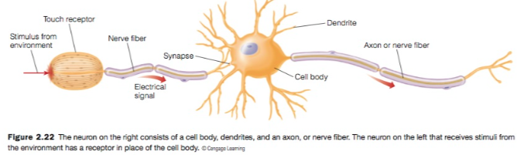

- Recording Electrical Signals in Neurons
  - This value, which stays the same as long as there are no signals in the neuron, is called the resting potential. In other words, the inside of the neuron is -70 mV and it remains that way as long as the neuron is at rest.
  - An action potential is a short-lasting event in which the electrical membrane potential of a cell rapidly rises and falls, following a consistent trajectory (up to +40 mV)
  - –70 mV to +40 mV and then a decrease back to –70 mV.
- Basic Properties of Action Potentials
  - An important property of the action potential is that it is a propagated response—once the response is triggered, it travels all the way down the axon without decreasing in size
    - This is an extremely important property of the action potential because it enables neurons to transmit signals over long distances.
  - Changing the stimulus intensity does not affect the size of the action potentials but does affect the rate of firing.
  - Although increasing the stimulus intensity can increase the rate of firing, there is an upper limit to the number of nerve impulses per second that can be conducted down an axon. This limit occurs because of a property of the axon called the refractory period—the interval between the time one nerve impulse occurs and the next one can be generated in the axon.
  - Action potentials that occur in the absence of stimuli from the environment are called spontaneous activity.
- Chemical Basis of Action Potential
  - Neurons are bathed in a liquid solution rich in ions, molecules that carry an electrical charge
  - The solution outside the axon of a neuron is rich in positively charged sodium (Na+) ions, whereas the solution inside the axon is rich in positively charged potassium (K+) ions.
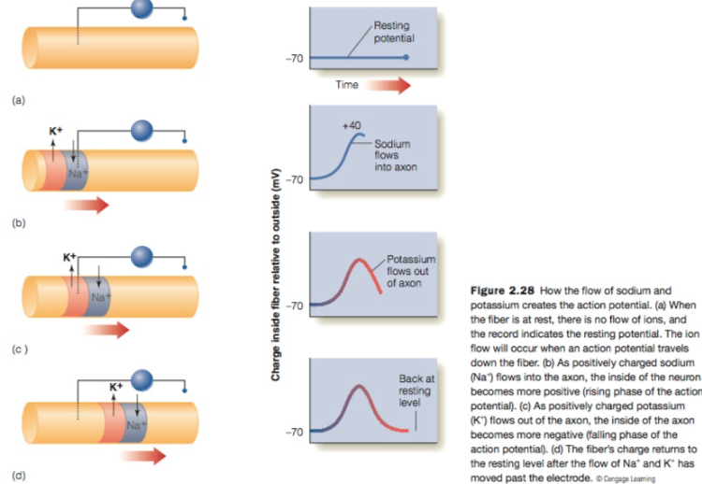

When the fiber is at rest, there is no flow of ions, and the record indicates the resting potential. The ion flow will occur when an action potential travels down the fiber. (b) As positively charged sodium (Na+) flows into the axon, the inside of the neuron becomes more positive (rising phase of the action potential). (c) As positively charged potassium (K+) flows out of the axon, the inside of the axon becomes more negative (falling phase of the action potential). (d) The fiber’s charge returns to the resting level after the flow of Na+ and K+ has moved past the electrode.

  - This opening of sodium channels represents an increase in the membrane’s permeability to sodium,
  - This increase in potential from –70 mV to +40 mv is the rising phase of the action potential
  - This increase in negativity from +40 mV back to –70 mV is the falling phase of the action potential
- Transmitting Information Across a Gap
  - There is a very small space between neurons, known as a synapse
  - Early in the 1900s, it was discovered that when action potentials reach the end of a neuron, they trigger the release of chemicals called neurotransmitters that are stored in structures called synaptic vesicles in the sending neuron.
  - The neurotransmitter molecules flow into the synapse to small areas on the receiving neuron called receptor sites that are sensitive to specific neurotransmitters
    - When a neurotransmitter makes contact with a receptor site matching its shape, it activates the receptor site and triggers a voltage change in the receiving neuron.
  - Two types of responses can occur at these receptor sites, excitatory and inhibitory.
As inhibition becomes stronger relative to excitation, firing rate decreases, until eventually the firing rate becomes zero.
    - An excitatory response occurs when the inside of the neuron becomes more positive, a process called depolarization.
      - To generate an action potential, enough excitation must occur to increase depolarization to the level indicated by the dashed line. Once depolarization reaches that level, an action potential is triggered
      - Depolarization is an excitatory response because it causes the charge to change in the direction that triggers an action potential.
    - An inhibitory response occurs when the inside of the neuron becomes more negative, a process called hyperpolarization.
  - Excitation increases the chances that a neuron will generate action potentials and is associated with increasing rates of nerve firing.
  - Inhibition decreases the chances that a neuron will generate action potentials and is associated with lowering rates of nerve firing.
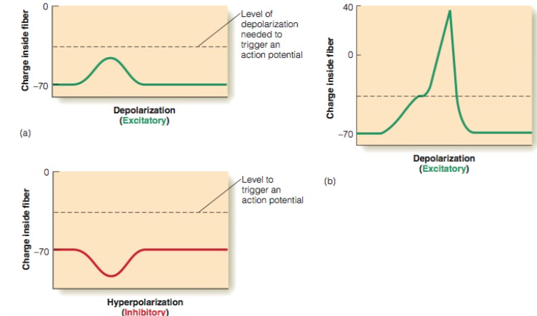

Neural Convergence and Perception
- Five types of neurons make up the layers and create neural circuits—interconnected groups of neurons— within the retina.
- Signals generated in the receptors (R) travel to the bipolar cells (B) and then to the ganglion cells (G).
- Other types of neurons that connect neurons across the retina: horizontal cells and amacrine cells.
- Signals can travel between receptors through the horizontal cells, and between bipolar cells and between ganglion cells through the amacrine cells.
- Neural convergence
  - Convergence occurs when a number of neurons synapse onto a single neuron.
  - A great deal of convergence occurs in the retina
  - An important difference between rods and cones is that the signals from the rods converge more than do the signals from the cones
  - This difference between rod and cone convergence becomes even greater when we consider the cones in the fovea (which contains only cones).
  - The greater convergence of the rods compared to the cones translates into two differences in perception: (1) the rods result in better sensitivity than the cones, and (2) the cones result in better detail vision than the rods.
- Convergence Causes the Rods to be More Sensitive than the Cones
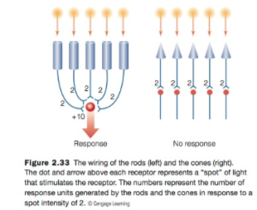
  - In the dark-adapted eye, rod vision is more sensitive than the cone vision
  - The rods have greater convergence than the cones.
  - When intensity = 1, the rod ganglion cell receives more excitation than the cone ganglion cells because of convergence
  - Meanwhile, at the same intensity, the cones’ ganglion cells are each receiving only 1 unit of excitation.
  - The operation of these circuits demonstrates how the rods’ high sensitivity compared to the cones’ is caused by the rods’ greater convergence.
  - Many rods sum their responses by feeding into the same ganglion cell, but only one or a few cones send their responses to any one ganglion cell
- Lack of Convergence Causes the Cones to have better Acuity than the Rods
  - The cones have better visual acuity because they have less convergence.
  - Acuity refers to the ability to see details
  - Acuity is better in the fovea than in the periphery.

  - We now consider the cones, each of which synapses on its own ganglion cell. When we separate the spots two separate ganglion cells fire. This separation between two firing cells provides information that there are two separate spots of light. Thus, the cones’ lack of convergence causes cone vision to have higher acuity than rod vision.
  - High convergence results in high sensitivity but poor acuity (rods)
  - Low convergence results in low sensitivity but high acuity (cones)

Developmental Dimension: Infant Visual Acuity
- Infants have lower visual acuity than adults and that this lower acuity is related to the structure of the infant’s cones.
- One method that has been used to measure infant visual acuity is the preferential looking (PL) technique.
- In the preferential looking (PL) technique, two stimuli are presented, and the experimenter watches the infant’s eyes to determine where the infant is looking.
  - If the infant looks at one stimulus more than the other, the experimenter concludes that he or she can tell the difference between them.
- The reason preferential looking works is that infants have spontaneous looking preferences; that is, they prefer to look at certain types of stimuli.
- Acuity determined by measuring an electrical signal called the visual evoked potential (VEP), is recorded by disc electrodes placed on the infant’s head over the visual cortex.
- If the stripes or checks are large enough to be detected by the visual system, the visual cortex generates an electrical response called the visual evoked potential.
- Thus, the VEP provides an objective measure of the visual system’s ability to detect detail
- The VEP usually indicates better acuity than does preferential looking, but both techniques indicate that visual acuity is poorly developed at birth
- Although the rod-dominated peripheral retina appears adult-like in the newborn, the all-cone fovea contains widely spaced and very poorly developed cone receptors
- Visual pigments are contained in the receptor’s outer segments
- The small size of the outer segment means that the newborn’s cones contain less visual pigment and therefore do not absorb light as effectively as adult cones.
- Most of the light entering the newborn’s fovea is lost in the spaces between the cones and is therefore not useful for vision.
- Thus, adults have good acuity because the cones have low convergence compared to the rods and the receptors in the fovea are packed closely together.
- In contrast, the infant’s poor acuity can be traced to the fact that the infant’s cones are spaced far apart.

