Week 1 (May 2-8): Chapter 1 Introduction to Perception
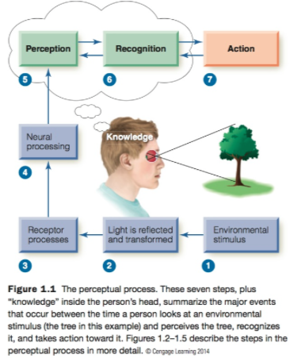
This picture describes the perceptual process.
- The process begins with a stimulus
in the environment (a tree in this example) and ends with the conscious experiences of perceiving the tree, recognizing the tree, and taking action with respect to the tree. (It is important to note that it is a simplified version of what happens. First, many things happen within each “box.”)
- Another reason we say the series of boxes in Figure 1.1 is simplified is that steps in the perceptual process do not always unfold in a one-follows-the-other order.

Stimuli (steps 1&2):
- The environmental stimulus, the tree that the person is observing (Step 1). The person’s perception of the tree is based not on the tree getting into his eye, but on light reflected from the tree (Step 2). The reflection of light from the tree introduces one of the central principles of perception, the principle of transformation
  - Which states that stimuli and responses created by stimuli are transformed, or changed, between the environmental stimulus and perception.
- When this reflected light reaches the eye, it is transformed as it is focused by the eye’s optical system, which is the cornea at the front of the eye and the lens directly behind it. If these optics are working properly, they form a sharp image of the tree on the receptors of the person’s retina.
- The fact that an image of the tree is focused on the retina introduces another principle of perception, the principle of representation
  - Which states that everything a person perceives is based not on direct contact with stimuli but on representations of stimuli that are formed on the receptors and on activity in the person’s nervous system.

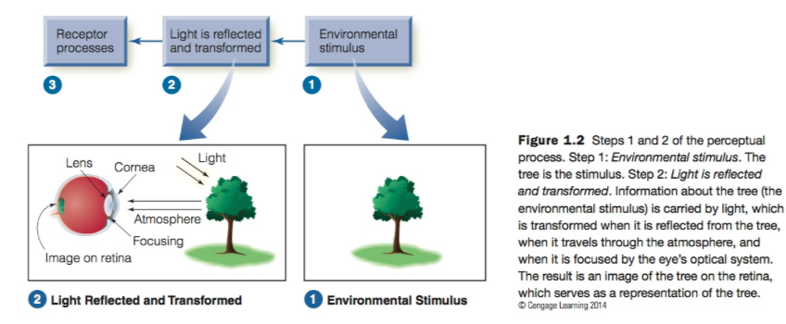

Receptor Processes/Transduction:
- Sensory receptors: are cells specialized to respond to environ- mental energy, with each sensory system’s receptors specialized to respond to a specific type of energy.
- When the visual receptors that line the back of the eye receive the light reflected from the tree, they do two things: (1) They transform environmental energy into electrical energy; and (2) they shape perception by the way they respond to stimuli
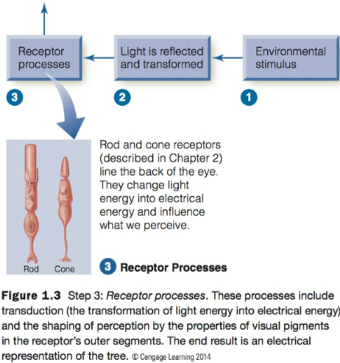

- Visual receptors transform light energy into electrical energy because they contain a light-sensitive chemical called visual pigment, which reacts to light.
- The transformation of one form of energy (light energy in this example) to another form (electrical energy) is called transduction.

Neural Processing (Step 4):
- Once transduction occurs, the tree is represented by electrical signals in thousands of visual receptors, and these signals enter a vast interconnected network of neurons
- This complex network of neurons (1) transmits signals from the receptors, through the retina, to the brain, and then within the brain; and (2) changes (or processes) these signals as they are transmitted.
- The changes in these signals that occur as they are transmitted through this maze of neurons is called neural processing
- Electrical signals from each sense arrive at the primary receiving area for that sense in the cerebral cortex of the brain.
- The primary receiving area for vision occupies most of the occipital lobe;
- The area for hearing is located in part of the temporal lobe
- The area for the skin senses—touch, temperature, and pain—is located in an area in the parietal lobe.
- The frontal lobe receives signals from all of the senses, and it plays an important role in perceptions that involve the coordination of information received through two or more senses.
- It is important to note, however, that although these signals have changed, they still represent the tree.
- The changes that occur as the signals are transmitted and processed are crucial for achieving the next step in the perceptual process, the behavioral responses.
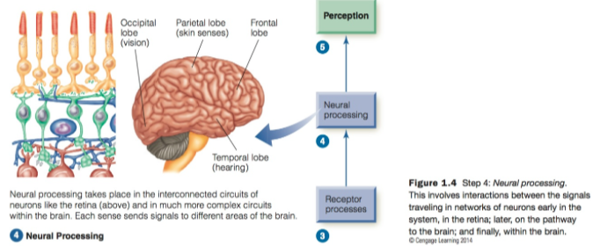
Behavioral Responses (Steps 5-7):
- The electrical signals from Step 4 are transformed into conscious experience: The person perceives the tree (Step 5) and recognizes it (Step 6).
- We can distinguish between perception, which is conscious awareness of the tree, and recognition, which is placing an object in a category.
- Dr. P.’s problem was eventually diagnosed as visual form agnosia—an inability to recognize objects—that was caused by a brain tumor.
  - He could perceive the object and recognize parts of it, but he couldn’t perceptually assemble the parts in a way that would enable him to recognize the object as a whole.
- The final behavioral response is action (Step 7), which involves motor activities.
  - Some researchers see action as an important outcome of the perceptual process because of its importance for survival.
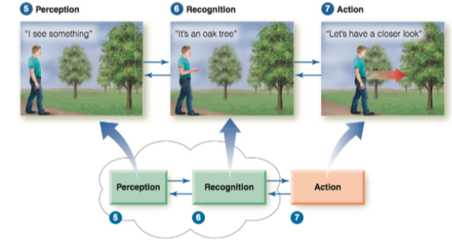

Knowledge:
- Knowledge is any information that the perceiver brings to a situation.
- The rat–man demonstration, shows how recently acquired knowledge (“that pattern is a rat”) can influence perception.
- Another way to describe the effect of information that the perceiver brings to the situation is by distinguishing between bottom-up processing and top-down processing.
  - Bottom-up processing is processing that is based on the stimuli reaching the receptors.
    - These stimuli provide the starting point for perception because, with the exception of unusual situations such as drug-induced perceptions or “seeing stars” from a bump to the head, without receptor activation there is no perception.
  - Top-down processing refers to processing that is based on knowledge.
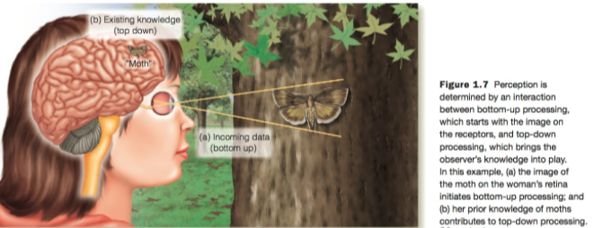
- The woman sees the moth on the tree in Figure 1.7 because of processes triggered by the moth’s image on her retina. The image is the “incoming data” that is the basis of bottom-up processing.
- When the woman labels what she is seeing as a “moth” or perhaps a particular kind of moth, she is accessing what she has learned about moths. Knowledge such as this isn’t always involved in perception, but as we will see, it often is—sometimes without our even being aware of it. (Top-down processing)

How to Approach the Study of Perception:
- The goal of perceptual research is to understand each of the steps in the perceptual process that lead to the behavioral responses of perception, recognition, and action.
- Perception has been studied using two approaches: the psychophysical approach and the physiological approach.
- The psychophysical approach, also called psychophysics, measures the relationship between the stimuli (Steps 1–2 in our perceptual process of Figure 1.1) and the behavioral response (Steps 5–7 in Figure 1.1).
  - An example of research using the psychophysical approach is an experiment in which subjects were tested to see how well they could see the fine lines in stimuli like the ones in Figure 1.9 that were presented at different orientations.
  - This better detail vision for verticals or horizontals compared to slanted lines is called the oblique effect.
- The physiological approach involves measuring two relationships, the relationship between stimuli (Steps 1–2) and physiological responses (Steps 3–4) and the relationship between physiological responses (Steps 3–4) and behavioral responses (Steps 5–7)
  - Used to study the physiological reasons for the oblique effect
- How the knowledge, memories, and expectations that people bring to a situation influence their perceptions. These factors, which we have described as the starting place for top-down processing, are called cognitive influences on perception
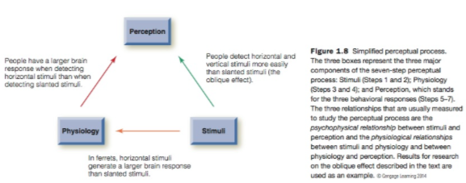

Measuring Perception:
- The minimum stimulus energy necessary for an observer to detect a stimulus is called the absolute threshold.
- Measuring Thresholds
  - These methods are called the classical psychophysical methods because they were the original methods used to measure the relationship between stimuli and perception.
    - Founded by Gustav Fechner
  - Method: Determining Threshold
    - Fechner’s classical psychophysical methods for determining the threshold are the methods of limits, adjustment, and constant stimuli.
    - In the method of limits, the experimenter presents stimuli in either ascending order (intensity is increased) or descending
order (intensity is decreased), as shown in Figure 1.15, which indicates the results of an experiment that measures a person’s threshold for hearing a tone.
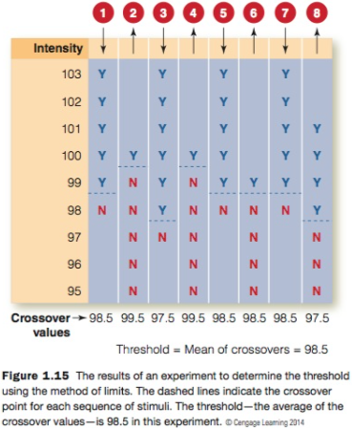

    - In the method of constant stimuli, the experimenter presents five to nine stimuli with different intensities in random order.
      - The threshold is usually defined as the intensity that results in detection on 50 percent of the trials.
      - The method of constant stimuli is the most accurate method because it involves many observations and stimuli are presented in random order, which minimizes how presentation on one trial can affect the observer’s judgment of the stimulus presented on the next trial.
      - The disadvantage of this method is that it is time-consuming. (Method of adjustment = faster)
    - The method of adjustment is similar to the method of limits in that the stimulus intensity is either increased or decreased until the stimulus can just be detected. However, in the method of adjustment, the observer (not the experimenter) adjusts the stimulus intensity continuously until he or she can just barely detect the stimulus.
  - A minimum difference that must exist between two stimuli before we can tell the difference between them. This just detectible difference is the difference threshold
  - The ratio DL/Standard for lifting weights is 0.02, which is called the Weber fraction
    - The fact that the Weber fraction remains the same as the standard is changed is called Weber’s law.

Estimating Magnitude:
- S. S. Stevens developed a technique called scaling, or magnitude estimation
- Method: Magnitude Estimation
  - The experimenter first presents a “standard” stimulus to the subject (let’s say a light of moderate intensity) and assigns it a value of, say, 10. He or she then presents lights of different intensities, and the subject is asked to assign a number to each of these lights that is proportional to the brightness of the original light. This number for “brightness” is the perceived magnitude of the stimulus.
  - The result in which the increase in perceived magnitude is smaller than the increase in stimulus intensity, is called response compression.
  - Increasing the intensity from 20 to 40 increases perception of shock magnitude from 6 to 49. This is called response expansion. (Opposite of compression)

  - The beauty of the relationships derived from magnitude estimation is that the relationship between the intensity of a stimulus and our perception of its magnitude follows the same general equation for each sense. These functions, which are called power functions, are described by the equation P = KS^n.
    - Perceived magnitude, P, equals a constant, K, times the stimulus intensity, S, raised to a power, n. This relationship is called Stevens’s power law.
  - The exponent of the power function, n, tells us something important about the way perceived magnitude changes as intensity is increased. Exponents less than 1.0 are associated with response compression (as occurs for the brightness of a light), and exponents greater than 1.0 are associated with response expansion (as occurs for sensing shocks).
Beyond Thresholds and Magnitudes:
- One common technique is the phenomenological method, in which a person is asked to describe what he or she perceives or to indicate when a particular perception occurs.
- Another method used to study perceptual mechanisms is visual search, in which the observer’s task is to find one stimulus among many, as quickly as possible.
- Response criterion. Julie’s response criterion is low (she says “yes” if there is the slightest chance a light is present), whereas Regina’s response criterion is high (she says “yes” only when she is sure that she sees the light).
(SEE FIGURE^)
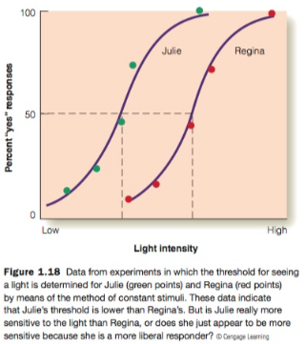

Appendix: Signal Detection Theory

A Signal Detection Experiment:
- Signal detection theory is utilized in cases where there are differences in response criterion.
- A signal detection experiment differs from a classical psychophysical experiment in two ways: in a signal detection experiment, (1) only one stimulus intensity is presented, and (2) on some of the trials, no stimulus is presented.
- Saying “yes” when a stimulus is present—is called a hit in signal detection terminology.
- Saying “no” when a stimulus is present—is called a miss.
- When no tone is presented…
  - Saying “yes” when there is no stimulus—is called a false alarm.
  - Saying “no” when there is no stimulus—is called a correct rejection.
- The beauty of signal detection theory is that the shape of the ROC curve indicates the person’s sensitivity, so if experiments on two people result in identical ROC curves, their sensitivities must be equal.
- Determine whether differences in the responses of different persons are due to differences in threshold or to differences in response criteria.
- (1) The percentage of hits and false alarms depends on a per- son’s criterion, and (2) a person’s sensitivity to a stimulus is indicated by the shape of the person’s ROC curve.

Signal and Noise:
- The signal is the stimulus presented to the person.
- Signal detection theory describes this procedure not in terms of presenting a signal or no signal, but in terms of presenting signal plus noise (S 􏰀 N) or noise (N).
Probability Distributions:
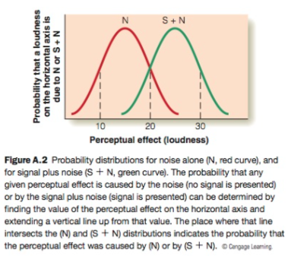

Other 2 have same sensitivity

The Criterion:
- The reason the (N) and (S 􏰀 N) distributions are important is that, according to signal detection theory, the person’s sensitivity to a stimulus is indicated by the distance (d􏰘) between the peaks of the (N) and (S 􏰀 N) distributions, and this distance affects the shape of the ROC curve.

The Effect of Sensitivity on the ROC Curve:
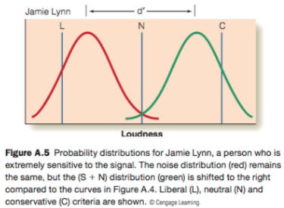

Jamie Lynn’s sensitive = higher, therefore S+N cure is shifted further right than the above^^ figure

- In signal detection terms, we would say that Jamie Lynn’s high sensitivity is indicated by the large separation (d􏰘) between the (N) and the (S 􏰀 N) probability distributions.
- When the person’s sensitivity (d􏰘) is high, the ROC curve is more bowed.


