January 7, 2014
Applications of Information Technology for Business
Overview of Information Systems
Purpose of Information Systems – provides accurate, timely and useful information
- All elements must be present and all of the elements must work together
Information Systems Consist of FIVE PARTS:
- People
- Procedures
- Software
- Hardware
- Data
Information System (IS) = IT + Procedures + People (that produce and utilize information)
IT = Hardware + Software + Data
(Products, Methods, Inventions, and Standards)
Common Mistake: You cannot buy IS because you cannot buy people or processes.
However, you can buy IT: Buy or lease hardware, license programs and databases, even obtain predesigned procedures. Ultimately, people execute those procedures to employ that new IT.
New systems require training tasks, overcoming employees’ resistance to change, and managing employees as they utilize new systems.
Social Media and Business
Social media allows people to get social online by sharing opinions, news, content, photos, and more.
Social media gives people power – it empowers customers to have their opinions heard and influence businesses.
Information is the biggest asset a business has. It defines and impacts their success as a business.
Digital Persona and Business
One of the biggest challenges (but ways of being innovative) is defining the digital persona of social media mediated business. This is the ultimate objective that businesses face.
Information Systems Elements: Data and Information
Information System:
- Set of interrelated components
- Collect, process, store, and distribute information
- Support decision-making, coordination, and control

Data vs. Information:
- Data streams are raw facts
- Information is data shaped into meaningful form
Example: Raw data from a supermarket checkout counter can be processed and organized to produce meaningful information, such as the total unit sales of dish detergent or the total sales revenue from dish detergent for a specific store or sales territory
Big Data – how we go about analyzing data (the facts) and converting it into information
Information – data that are processed to be useful; provides answers to “who”, “what”, when”, and “where”.
Knowledge – application of data and information; answers “how”
Understanding – appreciation of “why”
Wisdom – evaluated understanding
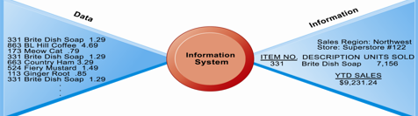
Data and Information
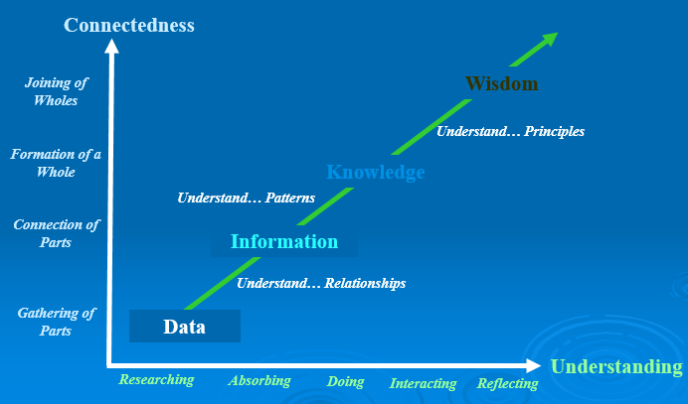
A “Systems” Perspective of IS
Three Core Activities of Information Systems:
- Input – captures raw data from organization or external environment
- Processing – converts raw data into meaningful form
- Output – transfers processed information to people or activities that use it
Advanced Information Systems also Incorporate One Additional Functionality…
Feedback – output returned to appropriate members of organization go help evaluate or correct input stage
These functionalities are not limited to technologies.
Computer/Computer Program vs. Information System
Computers and software are technical foundation and tools, similar to the material and tools used to build a house.
Using information systems effectively requires an understanding of the organization, management, and information technology shaping the systems. An information system creates value for the firm as an organizational and management solution to challenges posed by the environment.
Why Study Information Systems?
Benefits of an IS education for a management student:
- In today’s workplace, it is imperative that IS work effectively and reliably
- IS managers DO NOT only work with the IT department (IS will be a part of your job in other business functions such as marketing, operations, HR, finance, accounting, etc.)
- As an IS manager for your business function, you will play a vital role in the implementation and administration of technology within your divisions and for the benefit of your organization
(You will plan, coordinate, and direct research on the computer-related activities of firms. You will consult with other managers, help determine the goals of an organization and then implement technology to meet those goals. You will coordinate with pertinent people about the technical aspects such as software development, network security, and internet operations.)
Digital Persona
A business’ digital persona is the way that people conduct processes.
Conducting business electronically enables new levels of efficiency, competitiveness, and profitability (ie strategy).
Remember
Digital firms use information systems to enable the seamless flow of information between different parts of the organization as well as between the organization and its suppliers and customers.

January 9, 2014

Lecture 2
E-Business 101
Consists of:
- Consumers
- Producers
- Information
- Connectivity (Social media facilitates connectivity)
The Changing Face of Business
Throughout the years, the ways we do business are changing.
For example, Blockbuster and Roger’s Video are shut down. As well, travel agencies are dying due to online booking.
Digital Trends
Mobile tools, like smartphones, are changing the way we do business. The nature of how we do business has shifted the way we market products, design products, and find customers.
Mobile Thinking
Mobile tool usage and online consumer behaviour is changing. Mobile usage is going up.
For example, mobile phones are now used for payments and purchases.
However, social media cannot be used as a replacement for in-store business. It is an “and”, not an “or”. It is a tool to help engage with customers.
Capital Management and Business
Information and Communications Technology (ICT) is the largest single component of capital investment. The ICT sector has grown at twice the rate of GDP growth since 1997. The economy is growing on the back of information technology.
Managers need to know how to invest this capital wisely. The success of the business in the future may depend on ICT investment decisions.
Wikis, social networking applications (such as Facebook and Twitter) have changed how we access and use information. As business managers, we need to know how to leverage their potential to achieve strategic advantage.
The tools are strictly the means to improving business; there must be a business strategy and objective as well. We must understand what the tools can do and how the business can leverage the tools for a strategic advantage. (Example: Apple does a good job in merging digital and physical presence)

Digital Persona of Business
Digital Persona
- How businesses, customers, and suppliers interact in the digital era
- The digital persona often changes the landscape of how business processes are done.
- Impacts many things including marketing, branding, communicating, and relationship building
Digital Persona is Changing How We Do Things: Peer-to-Peer Exchange
P2P changed how we access music (Ex. Napster). It put the sharing into social media. It reshaped businesses and required new laws to be created because of the technology. It ultimately changed the music business landscape.
What is Social Media?
Social Media – a group of internet-based applications that build on the ideological foundations of Web 2.0, and allow the creation and exchange of User Generated Content.
Types of Social Media
- Social Networks (Facebook, LinkedIn, Friendster)
- Blogs (Blogger, Wordpress, Tumblr)
- Microblogs (Twitter, Jaiku, FriendFeed)
- Discussion Forums (OffTopic.com, IGN Boards)
- Multimedia Sharing (YouTube, Slideshare)
- Content Aggregators (Digg, Reddit)
- Social/Collaborative Bookmarking and Tagging (StumbleUpon, Diigo)
Business Uses of Social Media
- Marketing and Sales
- Public Relations
- Research and Development
- Human Resources
Old Wine in New Bottles
Social media does not change the business processes we do, but rather it changes how we do the processes. It increases the value of information (but does not necessarily change the information itself).
Social media also increases nc – coefficient of connectivity – this is what connects people, information and processes.
Categories of Social Media
Social media can be categorized based on functionality:
- World Wide Web (1991)
- Internet Relay Chat (1983)
- Media Sharing (P2P) (1999)
- Social Networking (1997)
- Blogs (1996)
- Real-Time Location Based Networking (2008) (Ex. GPS)
It is important to find the right application for what you want to do.
Socialnomics
Socialnomics is…
- The impact of social media on businesses and consumers
- Implications for business and suggestions to improve performance in various business functional areas
Definition:
- It disseminates the information quickly and globally
- Its digital aspect allows the original integrity of the message to remain intact
- It is traceable to an original source
Spending time on social media makes you more “productive”. In the Obama’s first election, it was the first election where social media was prominent and influenced the outcome.
Social media drives activity in the offline world.
Mass Markets to Mass Niches
- Maslow’s Hierarchy of Needs in the context of consumers (individual satisfaction and acceptance and social integration)
- Information distribution (television, newspapers etc.) used to be one to many
Chris Anderson’s long tail describes how niche information is the new normal.
Long Tail and Social Media
- Applicable to online businesses
Distribution and inventory costs of businesses successfully applying this strategy allow them to realize significant profit out of selling small volumes of hard-to-find items to many customers instead of only selling large volumes of a reduced number of popular items. The total sales of this large number of “non-hit items” is called the “long tail”.
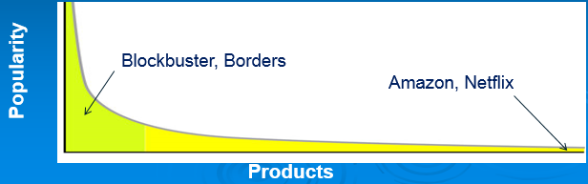
Niche Demand
On average, Barnes and Nobles stores carries 130 000 book titles. Amazon.com has approximately 2.3 million books. About 20% of Amazon’s sales come from outside its top 130 000 sales.
Socialnomics Impacts on Business
Microblogging and other forms of blog driven information are more common – leads to less demand for traditional news sources.
People consult online reviews before making purchases.
Quality and other information related issues still exist.
The “Systems” Perspective of IS
Environmental actors - such as customers, suppliers, competitors, stockholders, and regulatory agencies- interact with the organization and its information systems. This empowers customers because they have access to information and can exert an influence on the company.
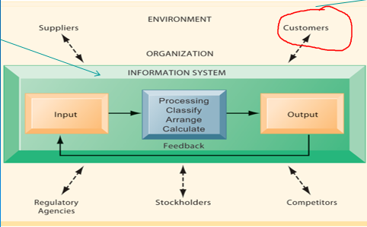
Twitter and Facebook are examples of IS.

Business Strategy and IT
- Business Processes and how IT supports these processes
- Changing paradigm of information and communication technologies
- How to leverage #2 to better do #1
Business Processes
Manner in which work is organized, coordinated, and focused to produce a valuable product or service.
Concrete work flows of material, information, and knowledge – sets of activities.
Unique ways to coordinate work, information, and knowledge.
Ways in which management coordinates work.
*Use social media to coordinate work and be more effective in these processes.
Examples of Business Processes:
- Manufacturing and Production
- Assembling product, checking quality, producing bills of materials
- Sales and Marketing
- Identifying customers, creating customer awareness, selling
- Cross-Functional Business Processes
- Transcend boundary between sales, marketing, manufacturing, and research and development (group employees from different functional specialties to a complete piece of work)
Systems and Complementary Assets
Investing in information technology does not guarantee good returns – considerable variation exists in the returns firms receive from systems investment.
Variations are caused by influencing factors including:
- Adopting the right business model
- Investing in complementary assets (organizational and management capital)
Complementary Assets – help businesses to work better, pulls value out of information systems
Assets required to derive value from a primary investment.
Complementary Assets include:
Organizational Assets – appropriate business model; efficient business processes
Managerial Assets – incentives for management innovation; teamwork and collaborative work environments
Social Assets – internet and telecommunications infrastructure; technology standards
Socio-Technical View of Information Systems
Socio-Technical View of Information Systems
- Includes issues and insights contributed from technical and behavioural disciplines
Technical Approach
- Emphasizes mathematically based models
- Computer science, management science, operations research
Behavioural Approach
- Behavioural issues (strategic business integration, implementation, etc.)
- Psychology, economics, sociology

January 14, 2014

Innovative Connectivity, Digitization, and Social Media Structure – Lecture 3
Innovative Connectivity
Social media tools connect people to processes and information. Apps are simply the means of doing that to help prevent information indigestion.
Business processes gain new perspectives – people and businesses become more productive.
Innovative connectivity accelerates the data to information cycle to make information usage more efficient.
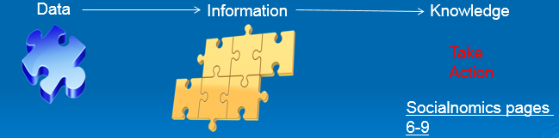
Digitization
Digitization means the replacement of physical tasks by digital means – Facebook is social digitization.
Significant business relationships have been digitally enabled. Supply chains are a good business example – we used to design products face to face but now we often do it piece by piece in different locations.
Digital Goods
Digital Goods – goods that can be delivered over a digital network (ex. Music tracks, video, software, newspapers, and books)
Industries with digital goods are undergoing revolutionary changes (publishers, record labels, etc…pg 14-26 of Socialnomics). These changes impact many other processes, like marketing and recruitment.
Changes to Business Processes
“Offline” avenues are also impacted by digital goods (ex. Social clubs, education, TV channels…pg 13).
Offline business – like postal service – become online.
Digitization Impacts
Bit Torrents and P2P changed what we do. These application required new laws to be created because of technology. Example: Online banking brought new security standards.
Competitive Advantage
To survive and thrive, an organization must create a competitive advantage.
Competitive Advantage – a product or service that an organization’s customers place a greater value on than similar offerings from a competitor
First-Mover Advantage – occurs when an organization can significantly impact its market share by being first to market with a competitive advantage
The Five Forces Model – Evaluating Business Processes and Strategy
Porter’s Five Forces Model determines the relative attractiveness of an industry.
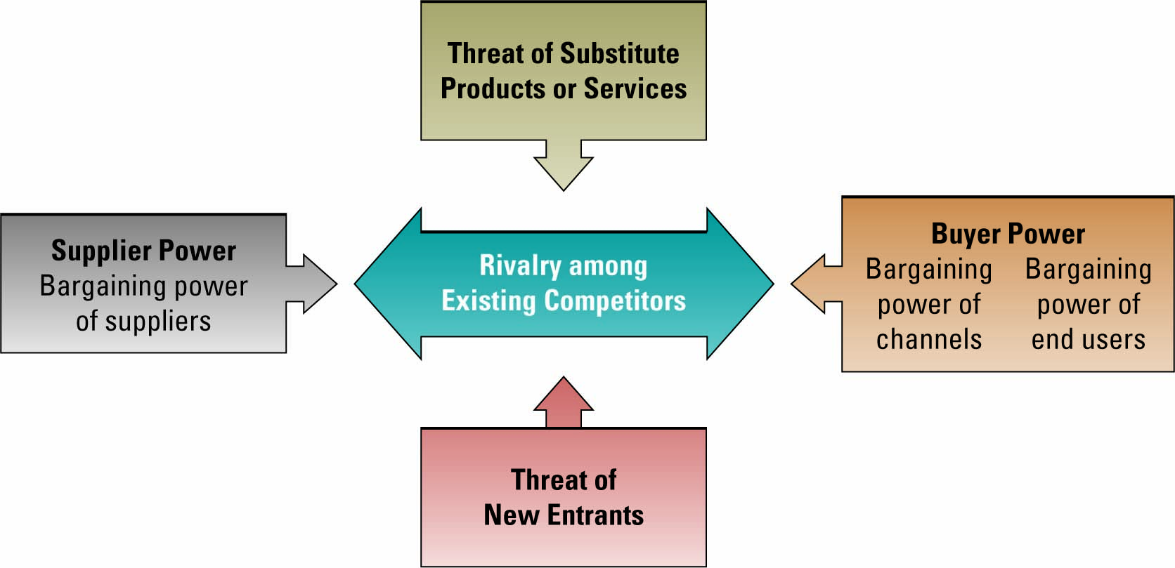
Buyer Power
- High when buyers have many choices of whom to buy from and low when their choices are few
- Use IT to reduce buyer power (creating a competitive advantage) through loyalty power
Loyalty program rewards customers based on the amount of business they do with a particular organization (Ex. Frequent flyer programs).
“Long tail” of social networking provides access to previously inaccessible market niches and customers.

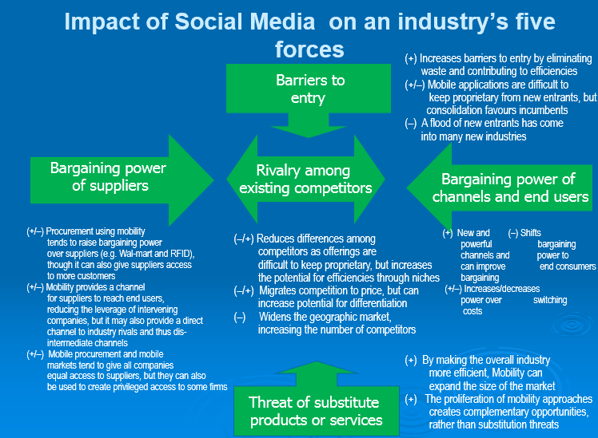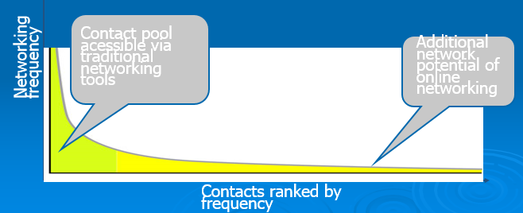
Factors to Consider when Assessing the Impact of IT on Business
- Internet growth and technology convergence
- Transformation of the business enterprise
- Growth of a globally connected economy
- Growth of knowledge and information-based economies
- Emergence of the digital firm

How Social Media Works
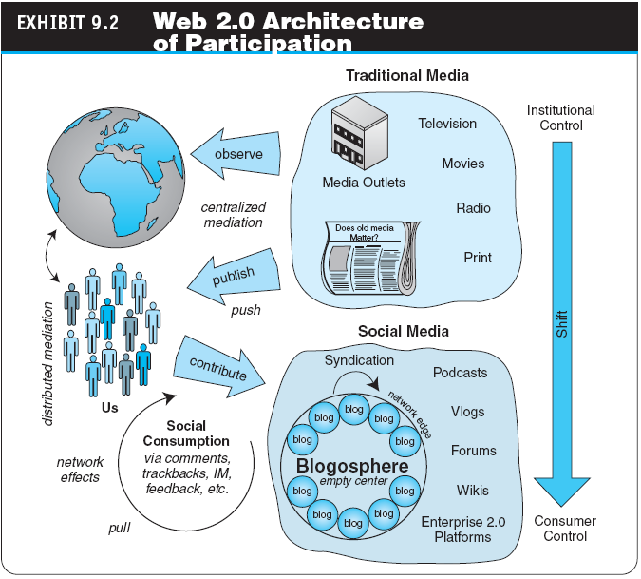
All social media tools are not the same but rather you need the right tool to ensure you achieve your objectives.
Social Media for Business
Google – cloud computing everything from anywhere with an Internet connection
LinkedIn – build a foster professional network and employee engagement
Facebook Pages – talk with loyal customers build new ones, create employee page
Twitter – brief communication with employees and customers
YouTube – marketing, education
Foursquare – presence, have employees check-in to geographic locations
Location based networking to identify and manage situations.
Honeycomb of Social Media
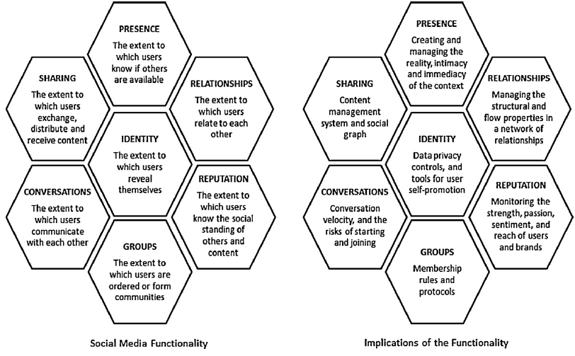
Why is it important to align social media and business strategy?
Failure to do so may result in surprising outcomes.
Economics of Digital Goods
Cost of producing first unit is almost the entire cost of the product: marginal cost of producing 2nd unit is almost zero.
- Costs of delivery over the internet are very low
- Marketing costs remain the same
- Consumer costs are also reduced
How to Make Money Using Web 2.0
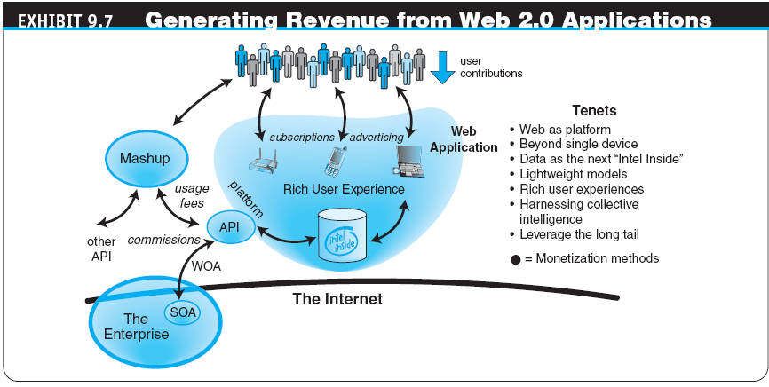
How Does YouTube Make Money? - The Business and Revenue Models
- Advertisements were launched on the site beginning in March 2006
- In April 2006, YouTube started using Google AdSense
- Recently, YouTube began ad revenue splitting with copyright holders
- Given its traffic level, video streams, and page views, YouTube’s potential revenues is millions per month
Social Networks and E-Commerce
Other Revenue Generation Strategies in Social Networks
- Offer premium service for monthly or per service fee
- Organizations partner with the social networks, paying them a monthly service fee
- Some social networks have a network of thousands of local physical venues where members can meet; these venues may pay a fee to be associated with the network
Basically, there are three strategies for generating revenue from Web 2.0 applications:
- Advertising
- Subscriptions
- Commissions
Micro Revenue
M-Revenue enables us to generate large dollars from many small contributions. (pg 30 Socialnomics)

January 16, 2014

Wikis and Flattening – Lecture 4
Wikis
A wiki is a website or similar online resource which allows users to add and edit content collectively.
“Wiki wiki” means quick in the Hawaiian language.
Wikis are collaboration tools; whereas blogs and chats turned more towards conversation. They are intended to maintain a series of unique documents as their content evolves.
Wikis have built-in version control:
- No changes can be made without creating a record of who made those changes
- Reversion to an earlier version is always possible
Flattening from Friedman (Module 1 – Unit 2)
The Overall Idea
- The global economic playing field has been leveled
- Competition is worldwide (benefit and burden from class 2)
- Few jobs or markets are constrained by geographic boundaries
- Successful managers must be able to leverage technology to be successful in this world
Organizational/Behavioural Impacts
IT broadens the distribution of timely information, increases the speed of decision making, empowers lower-level employees, and increases management span of control.
Flattening organizations, more virtual firms, and increasing flexibility.
Behavioural Impacts – Flattening Organizations
IT facilitates flattening of hierarchies by distributing information to empower lower-level employees and increase management efficiency (less number of middle managers).
Thomas Friedman’s “The World is Flat”: Stages of Globalization
Globalization 1.0 (from 1492-1800):
Agent of Change: Globalization 1.0 is focused on countries (ie Columbus connecting countries)
Globalization 2.0 (from 1800-2000):
Agent of Change: focused on cities (ie through boats and trains)
Globalization 3.0 (from 2000 to present):
Agent of Change: Globalization 3.0 focused on groups and individuals (ie connecting customers and businesses)

Globalization 3.0
Globalization 3.0 created a new world that is characterized by:
- Worldwide communication
- Worldwide collaboration without barriers (right area on long tail)
In Globalization 3.0, individuals and small groups play important roles as individuals who:
- Command more information
- Have more options
- Exchange information more conveniently
- Coordinate actions
- Influence (peers, companies, governments)
People are benefiting from Globalization 3.0; they are becoming more empowered.
Ten Flatteners (Thomas Friedman’s “The World is Flat”)
- Fall of the Berlin Wall
- Netscape goes public
- Development of workflow software
- Uploading/open sourcing
- Outsourcing
- Offshoring
- Supply Chaining
- In-sourcing
- In-forming
- The Steroids
(Relate flatteners back to the topics from classes 2-3 (connectivity, niche markets, customer controlled information, etc.))
Flattener #2: Netscape Browser

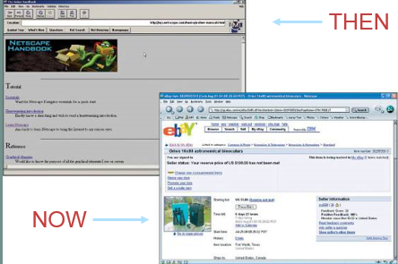
August 9, 1995
This was the first mainstream browser. It gave individual’s access to the Internet (mass connectivity).

Key Highlights from Friedman’s 10 Flatteners
Flattener #4 – Uploading/Open-Sourcing
- Self-organizing collaborative communities
- Individuals as consumers and producers of content
- Fast dissemination of information, news, and events
- Collaboration on open-source and free software
Example: Facebook or YouTube where people can upload and share content.
Implications for Individuals and Businesses:
- Companies use YouTube to market a product
- Individuals gain freedom to post things

January 21, 2014

Fundamentals of Web 2.0
Case Study Discussion 1
United Breaks Guitars
How could UAL have handled this crisis better? What types of strategies and tactics are recommended for other companies?
- Make a public apology as soon as possible
- Be more open and communicative rather than defensive
- Use social media as the defense
- Create advertising campaigns showing the positive effects of your company
- Respond to the negative posts, do not ignore them
Why did Dave Carroll’s song video go viral? What does it take for something to become successful viral content?
- People could relate to the video
- It was short, catchy, and innovative (got spread through word-of-mouth)
Additional Facts about the Case
Extensive and Deliberated Use of Social Media
- Carroll’s friend posted the video to YouTube around 10pm on Monday, July 6
- A small team of friends used Twitter to introduce their followers to the video
- They also tweeted to those on Twitter who had themselves tweeted about bad experiences with United Airlines, and to members of the media including Jay Leno, Jimmy Fallon, and Perez Hilton
- The video was immediately picked up by consumerist.com, a website affiliated with Consumers Union, America’s leading not-for-profit consumer advocacy organization and the publisher of Consumer Reports magazine
What the event did for Dave:
- Became famous, increased sales
- The New York Times labelled Dave as “the Everyman symbol of the aggrieved traveller”
- He formed many new business relationships with manufacturers like Taylor Guitars and Calton Cases, and service providers such as Mariner Partners and RightNow Technologies (customer experience software providers)
Social Media Crisis Management – Introduction
Social Media Crisis – a crisis issue that arises in or is amplified by social media, and results in negative mainstream media coverage, a change in business process, or financial loss
Characteristics
- Technology helps create a negative buzz around a brand, product or service
- Ground-up phenomenon that is largely out of the control of the business being affected
- Powered through emergent events: small low-level events, such as the interactions between a few consumers, can give rise to higher-level intensity, such as the development of new disparaging multimedia content and negative campaigns
Commercial Aspects of Web 2.0 and Social Networking Applications
Viral Marketing – marketing through word-of-mouth (marketing through viral blogging)
Companies gain leverage through viral marketing since it is a more effective and productive marketing tool.
Examples:
- Classified ads, job listings, and recruitment
- Special advertising campaigns (companies cater to the needs of specific groups)
- Mobile advertising increased sales can come from harnessing techniques based on personal preferences such as collaborative filtering
Web 2.0 Attitude
Groundswell – the spontaneous movement of people using online tools to connect, take charge of their own experience and get what they need – information, support, ideas, products, and bargaining power – from each other
The new way of thinking is captured in a list of 95 statements called the Cluetrain Manifesto.
- Markets are conversations
- These networked conversations are enabling powerful new forms of social organization and knowledge exchange to emerge
- As a result, markets are getting smarter, more informed, more organized
- Participation in networked market changes people fundamentally
- People in networked markets have figured out that they get far better information and support from one another than from vendors
Cluetrain Manifesto – the way social media and marketing are changing how we are doing things in the market
Job Roles of a Social Media Strategist
- Work closely with your already existing marketing staff to understand your marketing strategy and goals
- Research the most appropriate social media channels for your business
- Determine the best tools to manage your business and train internal staff how to manage those accounts using the tools
- Develop metrics and institute tracking devices to gauge return on investment
- Advise on how to deliver promotional content and campaigns through channels
- Monitor changes in social media technology, channels, and tools and make adjustments and provide training
Web 2.0 Apps
Blogs, wikis, social networking service (SNS), sharing sites, widgets and mashups, RSS, social bookmarking and tag clouds, AJAX technologies, and social media.
RSS Feeds
RSS (Really Simple Syndication) – used to publish frequently updated content such as blog entries and news headlines
An RSS feed contains either a summary of content from a website or the full text.
It enables people to keep up with their favourite websites in an automated matter. RSS content is read using software called “feed reader” or “aggregator”. The user subscribes to a feed by entering the feed’s link into the reader and the reader checks the users subscribed feeds regularly for new content, downloading any updates it finds.
Web 2.0 Definition and Applications (Examples)
- Software as a continually updates service that gets better the more people use it, consuming and remixing data from multiple sources, including individual users, while providing their own data and services in a form that allows remixing by others, creating network effects through an architecture of participation
- Salient Features of Web 2.0
- The Web as a Technology Platform in itself
- Information Sharing, Collaboration and Interactive Functionality of the web: interconnectivity and interactivity of web-delivered content
- Architecture based on Participation
- Popular Examples of Web 2.0 based Applications
- Social networking sites, video sharing sites, wikis, blogs, and folksonomies
- Mashups and APIs (Application Programming Interfaces)
Differences between Web 1.0 and Web 2.0
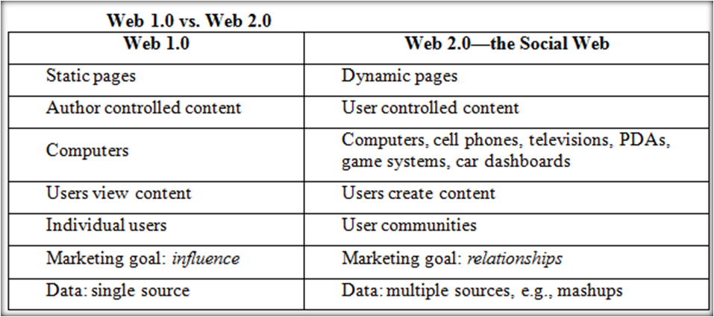
Influence – tell customers how great the company is
Relationships – understand needs and how companies can build relationships with them to come buy your product
Web 2.0 Components – Mashups
Mashups combine material from different sources to create new content. For example, Google Maps combines geographical data with data about businesses in a city to create a more functional tool.
A mashup is a web application that combines data or functionality from more than one source into a single integrated interface or tool: applications or interfaces generated by combining content, presentation, or application functionality from disparate sources.
Content used in mashups is typically sourced from a third party via a public interface or API (Application Programming Interface).
API – an abstraction that defines and describes an interface for interaction with a set of functions used by components of a software system
The word “mashup” originated in the music industry, where a mashup was a combination of two or more songs to create a new experience. The technology industry extended this definition to encompass a new class of applications that described the combination of two or more sources into an integrated application.
What are Mashups?
Web mashups are composite web applications partially constructed from the services and content from other websites.
Mashups have an emphasis on GUI and programming-less specification. The content of mashups originated from the understanding that the number of applications available on the web and the needs to combine them to meet user requirements are growing very rapidly.
Some mashups may not be characterized as Composite Applications:
- Mashups may also be used to access a single resource to mine data or migrate content (re-purpose existing data and information according to your needs)
Creating mashups is all about finding data, functionality, and services and using them to both solve problems and create opportunities.
Mashups and Web 2.0
Web 2.0 movement talks about cooperation instead of control.
The popularity of mashups stems from emphasis on interactive user participation.
Mashups offer an informal, quick, low-barrier and relatively effort-free integration that can be deployed with simple tools and techniques.
Mashups have been regarded as a Disruptive Technology.
Social Media and Business Disruption
One of the biggest forces changing business is the internet (it is the basis for all other flatteners).
Organizations must be able to transform as markets, economic environments, and technologies change. Focusing on the unexpected allows an organization to capitalize on the opportunity for new business growth from a disruptive technology.
Social Media as an Industry Disruptor
Industry and Market Disruptors
Disruptors – companies that introduce a significant change in their industries thus cause disruption in the way business is done
Questions to Identify Disruptors
- Is the service or product simpler, cheaper, or more accessible?
- Does the disruptor change the basis of competition with the current suppliers?
- Does the disruptor have a different business model?
- Does the product or service fit with what customer’s value and pay for?
(A company disrupts the industry because it changes how we do things, like iPod and Netflix)
Disruptors in Business
The internet has completely disrupted the way businesses operate, employees communicate, and products are developed and sold. Examples – expedia.ca, music downloads, and Dell.
What is Social Networking?
It involves relationships defined as:
An extended group of people with similar interests or concerns who interact and remain in informal contact for mutual assistance or support. A logical or natural association between two or more things: connection, correlation, interconnection, interdependence, interrelationship, link, linkage, relation, tie-in. It involves building social capital.
Social Capital
Social Capital – a core concept in business, economics, organizational behaviour, political science, and sociology, defined as the advantage created by a person’s location in a structure of relationships. It explains how some people gain more success in a particular setting through their superior connections to other people.
Business is about building relationships of all sorts to create social capital. These relationships can be with customers, suppliers, media etc.
The more social capital, the more contacts. It defines your place in a big web of relationships.
Information into Capital
The business challenge is analyzing and shaping the information to be meaningful from a business perspective and to be able to reach out to those billion users.

Social Networking Analysis (SNA)
SNA is the mapping and measuring of relationships and flows between people, groups, organizations, computers, or other information or knowledge processing entities.
How do we classify people and identify new business models?
Social Networking Analysis (SNA Software) – the mapping and measuring of relationships and information flows among people, groups, organizations, computers, and other information or knowledge-processing entities. The nodes in the network are the people and groups, whereas the links show relationships or flows between the nodes. SNAs provide both visual and mathematical analyses of relationships.
Examples of Network Classification
Aggregators – LinkedIn, Facebook
Geographic – “Link to” sites: Chicago, Charlotte, Nashville, New York
Industry – Wireless Factors, Wine & Spirits, Motor Sports, Entrepreneurs
Topical – Politics, Music, Sports Investments
Internet Business Models
Based on WHO is involved:
B2C – business to consumer
B2B – business to business
C2C – consumer to consumer
C2B – consumer to business; consumer indicates a need, businesses compete to fulfill it
Electronic Exchange – online B2B market with many buyers and sellers
B2E – business to employee; an organization delivers services and information to employees
G2C – government to citizen; government provides services or information to businesses or citizens (e-government)
Based on the MEDIUM:
M-commerce (mobile commerce) – e-commerce transactions conducted using handheld wireless devices
L-commerce (location commerce) – m-commerce transactions targeted to individuals in specific locations
Many of these models emerged because of the collaborative nature of Web 2.0 and the Flatteners from Friedman.

Different Models
Virtual Storefront – sells products directly to consumers (B2C) or businesses (B2B)
Information Broker – provides product, pricing, and availability information to individuals and businesses; revenue from advertising or from directing buyers to sellers
Transaction Broker – saves users time and money by processing online sales transactions; fee paid per transaction
Online Marketplace – buyers and sellers meet, search for products, display products and establish prices; revenue from transaction fees (ex. eBay – C2C)
Content Provider – provides digital content; customer pays for access; advertising can also provide revenue
Online Service Provider – provides a service; revenue from transaction fees, advertising, or by collecting marketing info from users
Virtual Community – provides chat room, online meeting place for people with similar interests
Portal – provides initial point of entry to the web, specialized content, services

January 28, 2014

Lecture 6 – Web 2.0 Innovations and Social Networking Services
Web 2.0 Innovations
Example – Mashups
The Obligatory Long Tail Slide.
Traditionally, application development dollars are directed toward those projects and enhancements demanded by the largest group of users. This practice of catering to the masses doesn’t necessarily lead to an outcome with the greatest positive impact on productivity.
Armed with powerful new tools that leverage existing data and application resources, developers and power users can quickly assemble products to target the Long Tail.

Social Networking Services
Social networking services represent a special type of virtual community and are now the dominant form of online community. With social networking, individual users maintain an identity through their profile and can be selective about which members of the larger community they choose to interact with.
Facebook dominates Social Networking: Facebook is the largest social networking service in the world, with more than 901 million monthly and 526 million daily active users.
Google is taking on Facebook with GooglePlus.
Microblogging with Twitter: Twitter is a social networking site where users send short messages called tweets of 140 characters or less to their network of followers.
Crowdsourcing at Starbucks: Embracing Customers
In 2008, the company started mystarbucksidea.com, a social media site designed to solicit ideas and feedback from its customers.
Other companies including BMW, Kraft, and others have used this approach too – look back at uploading/open sourcing – flattener #4
Facebook’s Open Graph
Connecting people via the internet – “Network Effect”.
Facebook becomes your common login to other sites (music, pictures, and directories).

Twitter
Twitter is microblogging. It is a tailored broadcast of messages including consumer messages. From basic Tweeting has emerged TweetDeck and Twitterfeed.
Addressing Social Media Privacy Concerns – ie. Facebook Expansion
Examples of Privacy Violations
- Posting pictures of people on social networking sites without their permission
- Tricking people into disclosing credit or bank account information or investing in “Work at Home” scams
- Sharing information about members with advertisers without the users’ knowledge or consent
- Disclosing an employer’s proprietary information or trade secrets on social networking sites
- Posting information on social networking sites that could compromise people’s safety or make them targets of blackmail
Philosophical Foundations of Enterprise 2.0
Organizations had communicated with their audiences using a broadcast model:
- Messages flowed from sender to receiver.
Newer model is the conversation model:
- Communication flows back and forth between sender and receiver.
Online communities (aka virtual communities) can be used as a platform for:
- Selling goods and services
- Promoting products to prospective customers
- Prospecting for customers
- Building relationships with customers and prospective customers
- Identifying customer perceptions by “listening” to conversations
- Soliciting ideas for new products and services from customers
- Providing support services to customers by answering questions, providing information, etc.
- Encouraging customers to share their positive perceptions with others
Enterprise 2.0 Tools
Enterprise 2.0 refers to Web 2.0 technologies used for some business purpose:
- Promote collaboration and knowledge exchange among employees, consultants and company partners
- Advertise and build brand awareness
Business use of Web 2.0 technologies:
- Recruiting and professional networking
- Marketing, promotion, and sales
- Internal collaboration and communication
- Supply chain management
Business Social Networks
- To build better customer relationships
- To improve knowledge and management
- To facilitate recruiting and retention
- To increase business opportunities
- To build a community
- To gain expert advice
- To improve tradeshow experiences
- To improve communication and collaboration
Enterprise Social Networks
- Allow employees to collaborate and communicate in an employee-driven system
- Promote the use of enterprise wikis via demonstrations
- Set up internal blogs and incorporate them into internal directories
- Set up enterprise social bookmarking systems
- CIOs involvement from the beginning to make sure the right infrastructure and tools are in place
Metrics and Evaluation
Answers the question how do we know this works?
Standard metrics are not always applicable. New metrics are needed to evaluate the contribution of social media to a company. Social concepts present new measurement difficulties.
Metrics
4 Basic Categories:
- Tool
- Tactic
- Strategic
- ROI
Social Media Metrics
Management depends on data-driven measurements, or metrics.
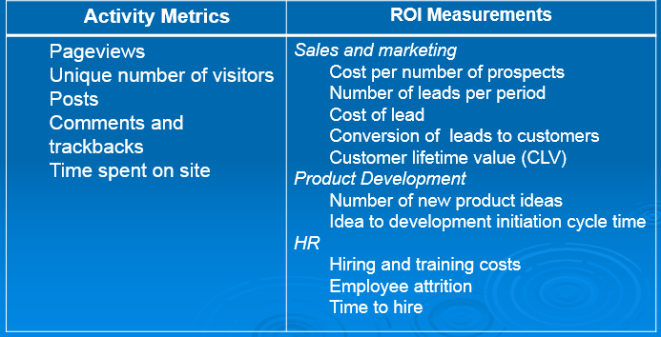
Social Media Monitoring and Measurement
Tool-Based Metrics
- Metrics a company uses are determined by what the company is trying to achieve
- In some cases, a company will define its objectives based on a specific Web 2.0 tool
Tactical Metrics
- Another way for organizations to define their objectives for social media by tactical objectives
- Based on these tactical objectives, companies can develop specific actions that support the objectives and then monitor progress
Examples of tactical objectives:
- Increase traffic to our website by 10%
- Increase requests for product information via our website by 15%
Strategic Metrics
- Aim to more fully capture the potential of social media than what is described by focusing on a specific Web 2.0 tool or tactical objectives
5 Categories of Social Media Use Objectives
- Listening: pay attention to what customers are saying online
- Talking: communicate with your customers by engaging in conversations
- Energizing: encourage customers and fans to spread the word through rating, reviews
- Support: provide information and online resources, such as user forums, knowledge bases, and other tools
- Embracing: invite customers to generate ideas for new products and services
Web and Social Media Future
Characteristics of Web 3.0
Web 3.0 = (4C + P + VS)
3C = Content, Commerce, Community
4th C = Content: defines the intent of the user; for example, trying to purchase music, find a job, or share memories with friends and family
P = Personalization: refers to the user’s personal characteristics that impact how relevant
VS = Vertical Search: refers to a search strategy that focuses on finding information in a particular content area, such as travel, finance, legal, and medical

Characteristics
- Semantic web `
- Languages of Web 3.0
- Artificial intelligence (AI)
- Mobility – pushes drive for new technologies
- Barriers – closed data sources, incompatible data structure and format, fractured web, lack of neutrality
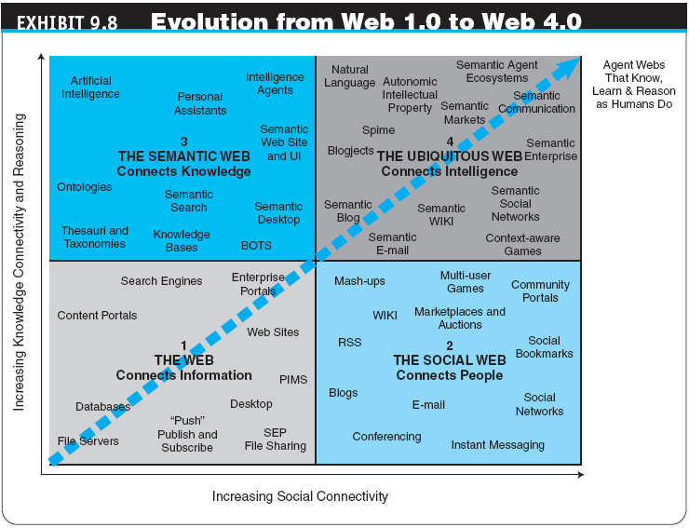
Chapter 3 - Determining Objectives and Background for Your Social Media Program
BUSINESS OBJECTIVES AND PROJECTED OUTCOMES
- You have to be very clear of what you want to achieve from social media.
- What the outcome would look like.
- How can you judge the return on investment (ROI) of your social media program.
- One way, is to map the current corporate annual strategy or a three- to five-year strategy to the key points in your strategy.
- If you don’t have any place to start—and you want to align your social media strategy objectives with clearly defined ROI metrics
Achieving SM strategy
- Increase Sales
  - Develop new business for new clients or new products.
  - Improve your customer retention rate. *
  - Increase your brand awareness in the market **
- Decrease Expenses
  - Use social media to recruit new employees or add to your talent pipeline.
  - Invest SM for CRM - This will potentially decrease customer expenses by providing more efficient support through this new platform.
  - Achieve cost benefit ratio of your SM

Determining Objectives and Background for Your Social Media Program
- The creation of any social media strategy starts with very thorough searching to determine the objectives or what you want to achieve through your social media program.
- Once the objective is decided, the first step is to explore other areas:
  - Target demographic group,
  - Market focus, and
  - branding guidelines,
The remainder of your strategy will be leveraging the above areas.

TARGET DEMOGRAPHIC GROUP
- Your current or potential customer
- People using social media channels
The more details you know about your target customers, the easier it will be for you to decide SM strategy.
FACTORS OF TARGET DEMOGRAPHIC GROUP
- Gender
- Age
- Language(s) spoken
- Location
- Education
- Profession
- Interests (related and not related to your product)
- Media consumed (Where do they go online/ offline for information?)
- Social media channels most active on
Ideally,
- your social media strategy should concentrate on only one strategic market.
- Then it is easier to widen your approach for additional markets, or
- Supplement your current strategy with additional instructions to optimize your strategy for other markets.

BRANDING GUIDELINES
Your social media strategy should be aligned with your the branding
Normally, your branding guidelines considered to the keystone of corporate consistency across channels.
Ways to modify guidelines
1. Tone of voice: To increase engagement in certain conversational social media channels, such as Facebook, using a more conversational voice might be worth considering individual posts.
You should also be aware of your target demographic group and ensure that the voice you use in social media is aligned with their expectations.
2. Imagery: The use of imagery (eye candy), specifically photography and illustration, should be a part of any strategic plan, because it is an effective way to engage with social media users.
3. Video: A social media strategy uses video as an embeddable technology— Ex: link to YouTube

Chapter 4 - Auditing Your Social Media Program
Ideas help in SM Auditing
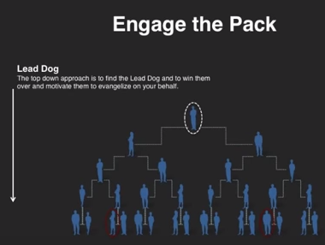
This approach called the Domino’s: This bottom up approach is based on strength in number. The key is to find individuals and motivate them to create a chain reaction in their personal networks.
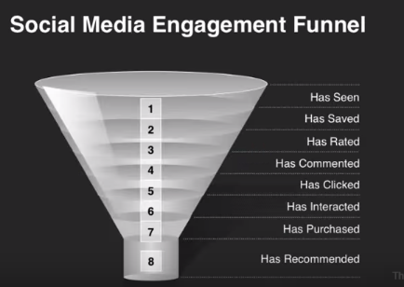
Very important to approach correct auditing to characterize customers engagement levels

A basic social media audit
An internal review which assesses:
  - What you’re already doing in the social media world,
  - Who’s doing it,
  - What the missing pieces might be,
  - Looks at some basic goals you may have in your social media.
An external review looks at:
- How well you’re doing social media compared to your key competitors
3 Major Goals
- Brand-building/market penetration, and
- Product showcase, which would optimally lead to sales
- A third goal could be market research:
Audit metrics
- Customer base/market share: Helps to conduct a comparative analysis of your social media with competitors
- Website rank: website traffic after implementing your social media strategy
- Reach: the number of fans/followers sign of a potential reach in to your particular social media channel
- Frequency: How often are you posting on each of your social media channels?
- Engagement: How often are you posting on each of your social media channels?
- Facebook tabs: what are your main calls to action for your Facebook fans?
- Influence: measure a brand’s influence in social media
- Social media presence on your home page: When looking at your home page, where are your social icons?

Chapter 5 – Core Elements and Concepts in Your Social Media Strategy
- BRANDING: Including Branding into social media consider in the following areas:
  - Naming
  - Color scheme and imagery
  - Voice
- Naming: Normally the SM takes the same name as your company
- Color Scheme and Imagery
- Voice: The voice of a company in social media is equivalent to the tone of its conversations in tweets, Facebook posts, and blog posts.
- Content:
  - New product, campaign
  - New events or highlights from recent events
  - Original blog post entries, which are ideally targeted articles based on a category/keyword strategy
  - YouTube videos from your channel, customers, or events
  - Photos of your latest products, customers, or events
  - Conversations from other social media channels (cross-posting), such as responses to questions or surveys
  - Engagement questions or quotes (especially for Facebook)
  - Crowdsourcing content from your customers (guest blog posts, photos, videos)
- CURATION
  - Digital curation is the selection, preservation, maintenance, collection and archiving of digital assets
  - Curation lets companies be viewed less as marketing entities and more as community resources.
- CHANNELS
  - Blog
  - Facebook
  - LinkedIn
  - Twitter
  - & so on
- FREQUENCY
- ENGAGEMENT
- LISTENING
- software that either archives or searches conversations from Twitter, Facebook, LinkedIn, YouTube, blogs, forums, and other social media channels in real time.
- CAMPAIGN: Social media campaigns are essential to continuously engage with fans, attract new ones
- INFLUENCERS
- If you already know who your influencers are, you simply need to find where they are on social media and on which platforms they are most active, this will lead to the right auditing of your SM

