Chemistry Assignment #3
- Lithium metal reacts with molecular fluorine gas to form lithium fluoride. A closed container of volume 5.00 x 10³ mL contains fluorine gas at 48.8 °C and 6.89 x 10³ Torr. Then 13.3 g of solid lithium is introduced, and the reaction goes to completion. What is the final pressure (in Torr) if the temperature rises to 97.3 °C?

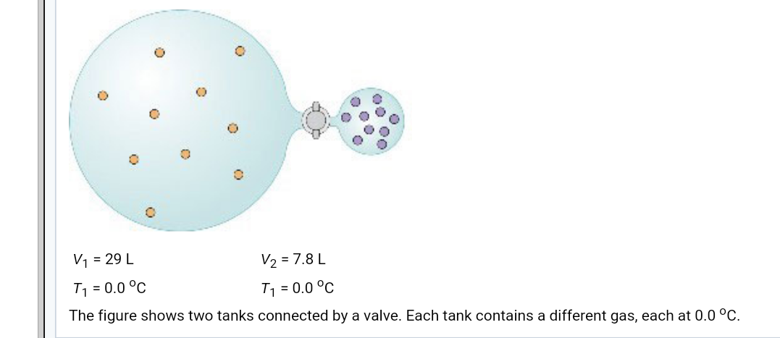

- If each molecule in the diagram represents 1.0 mol of gas, what is the system's total pressure (in bar) after the valve is opened? Assume that the valve has negligible volume.
- If all the gas is pumped into the smaller tank, what is the partial pressure (in bar) of the gas represented by the lighter coloured particles?
- If all the gas is pumped into the smaller tank, what is the partial pressure (in bar) of the gas represented by the darker coloured particles?

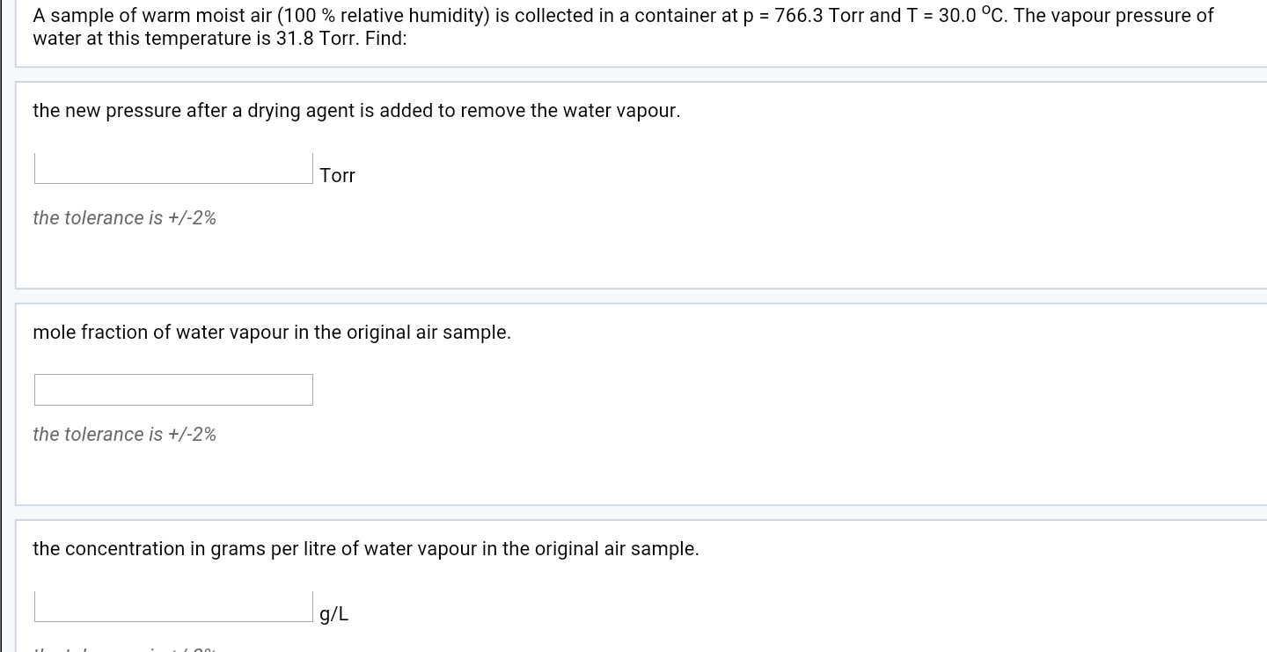

- Two chambers are connected by a valve. One chamber has a volume of 17 L and contains N₂ gas at 2.0 bar. The other has volume 1.7 L and contains O₂ gas at 3.0 bar. The valve is opened and the gases are allowed to mix thoroughly. The temperature is constant at 300 K throughout the process.

- What is the final partial pressure of N₂ (in bar)?
- What is the final partial pressure of O₂ (in bar)?
- What fraction of the O₂ is in the smaller chamber after mixing?

- At low temperature nitrogen dioxide molecules join together to form dinitrogen tetroxide.
NO₂ N₂O₄ (low temperature)

A sample of NO₂ sealed inside a glass bulb at 23 ºC gave a pressure of 644 Torr. Lowering the temperature to -5 ºC converted the NO₂ to N₂O₄. What was the final pressure (in Torr) inside the bulb?

- Suppose 1.00 metric tons of soft coal containing 3.64 % (by mass) sulphur is burned in an electric power plant.

- What volume (in L) of SO₂ is produced at 55ºC and 1.00 bar?
- What mass (in g) of CaO is required to "scrub" the SO₂?
- What mass (in g) of CaSO₃ must be dispose of?

