LAB 4: Lipids and Membranes

Purpose 5 / 5

Results and discussion: 89.4 / 92

Writing skills: 3/3

TOTAL: 97.4 / 100

March 20th, 2015

Department of Biology
University of Ottawa

Purpose

Two membrane fractions were prepared from a rat liver tissue: a microsomal enriched fraction and a mitochondrial enriched fraction. The lipids were extracted from the microsomal fraction, separated using 2D thin layer chromatography and were then compared with lipids extracted from the entire tissue. The 2D TLC plate is composed of mildly polar silica gel, which will bind polar compounds more tightly than non-polar ones. The first dimension of the plate was developed in a basic solvent and the second dimension was done in a basic solvent. The purpose of these 2 dimensions was to be able visualize the various polarities of the lipids and how they react on the silica gel in varying pH environments. In the second part of the experiment, the lipid/protein ratio in the mitochondrial fraction was analysed. Brilliant Blue Dye R was used to estimate the lipid concentration of the fraction and an absorbance assay was used to estimate the protein concentration.

Results and Discussion

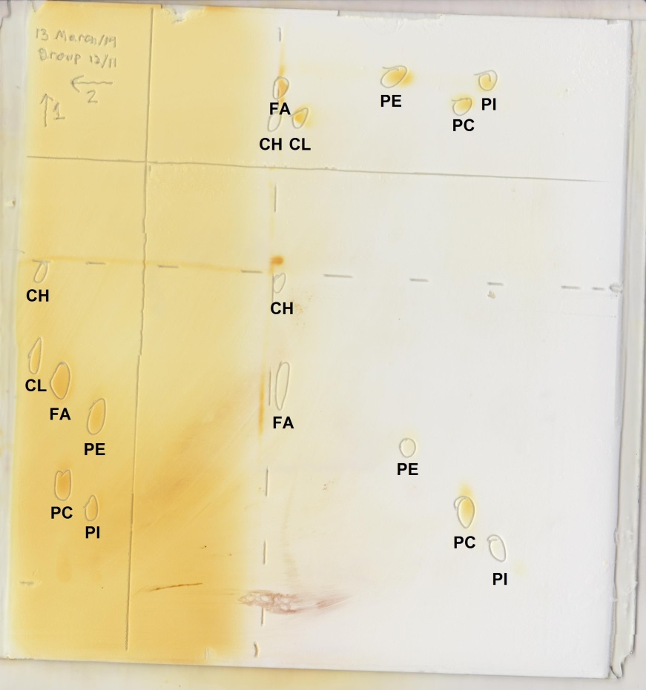
R1.

Figure 1: 2D TLC Separation of microsomal lipids using acidic and basic solvents. The TLC of a microsomal lipid sample was done on an activated 20 cm x 20 cm silica gel plate with a TLC template heated at 100℃ for 1-2 hours. Three 5 𝜇L sets of lipid standards and one 10𝜇L sample were used to spot the plate. The first standard contained cardiolipin (CL) and cholesterol (CH), the second standard contained phosphatidylcholine (PC) and fatty acid (FA) and the third sample contained phosphatidylinositol (PI), and phosphatidylethanolamine (PE). The plate was placed the plate in a tank containing the basic solvent system: CHCl3-MeOH-ammonia (65:35:5 v/v) and the first dimension was developed until the solvent reached 1 cm from the horizontal line (about 60 min). The plate was removed and the solvent front was immediately marked and then dried with a heat gun for 10 minutes. The plate was then rotated 90 degrees and placed in the second tank with the acidic solvent system: CHCl3-acetone-MeOH-acetic acid-H2O (10:4:2:2:1; v/v) and the second dimension was developed until the solvent reached 1 cm from the horizontal line. The plate was removed and the solvent front was immediately marked and then dried with a heat gun for 10 minutes. The plate was then placed in in an iodine saturated tank for 5 min to visualize the spots and then removed and each position of the spots was then marked.
Table 1: Retardation factors of lipid standards in the 2-D TLC. The TLC of a microsomal lipid sample was done on an activated 20 cm x 20 cm silica gel plate with a TLC template heated at 100℃ for 1-2 hours. Three 5 𝜇L sets of lipid standards and one 10𝜇L sample were used to spot the plate. The first standard contained cardiolipin (CL) and cholesterol (CH), the second standard contained phosphatidylcholine (PC) and fatty acid (FA) and the third sample contained phosphatidylinositol (PI), and phosphatidylethanolamine (PE). The plate was placed the plate in a tank containing the basic solvent system: CHCl3-MeOH-ammonia (65:35:5 v/v) and the first dimension was developed until the solvent reached 1 cm from the horizontal line (about 60 min). The plate was removed and the solvent front was immediately marked and then dried with a heat gun for 10 minutes. The plate was rotated 90 degrees and placed in the second tank with the acidic solvent system: CHCl3-acetone-MeOH-acetic acid-H2O (10:4:2:2:1; v/v) and the second dimension was developed until the solvent reached 1 cm from the horizontal line. The plate was removed and the solvent front was immediately marked and then dried with a heat gun for 10 minutes. The plate was then placed in in an iodine saturated tank for 5 min to visualize the spots and then removed and each position of the spots was marked. R_{f} values were calculated by dividing the distance travelled by the lipid spots by the distance the solvent front travelled.
Lipid standard | R_{f}
Lipid standard | Basic solvent system | Acidic solvent system
Cholesterol (CH) | 0.97 | 0.99
Cardiolipin (CL) | 0.84 | 0.95
Phosphatidylcholine (PC) | 0.44 | 0.48
Fatty acid (FA) | 0.69 | 0.97
Phosphatidylethanolamine (PE) | 0.60 | 0.68
Phosphatidylinositol (PI) | 0.38 | 0.42

R_{f} calculations for CH
Basic solvent
D_{CH} =8.8 cm  D_{solvent} = 9.1 cm | $$R_{f} =\frac{D_{CH}}{D_{solvent}}=\frac{8.8cm}{9.1cm}=0.97$$
Acidic solvent
D_{CH}= 7.8 cm  D_{solvent} = 7.9 cm | $$R_{f }=\frac{D_{CH}}{D_{solvent}}=\frac{7.8cm}{7.9cm}=0.99$$

The hydrogen bonding capacities are directly related to the distance the molecule is able to travel up the plate. The more capacity a molecule has to hydrogen bind, the slower it will travel up the plate and the lower it will be on the plate. Because the silica gel is mildly polar, it will bind polar compounds more tightly than less polar ones and so the more polar molecules will travel a shorter distance. As the solvent moves up the silica gel, the lipid molecules shuttle back and forth between stationary and mobile phases. Polar lipids that bind well to silica gel will remain in the stationary phase longer than less polar lipids. Therefore, the less polar the lipid, the further it will migrate on the plate. The distance the molecules travel up the plate can also be affected by the type of solvent used in the 2D TLC. The basic and acidic solvents used will have different pH environments, this mean that the molecules will differ in terms of their structure as they can be protonated and deprotonated depending on the solvent used.
All the lipids had similar R_{f} values in the basic solvent compared to the acidic solvent except for FA which had a significantly lower R_{f.} This can be explained by the fact that in a basic solvent, the carboxylic acid on the fatty acid can be deprotonated and will carry a formal charge. This will increase the polarity and will result in a shorter distance traveled on the plate. The opposite can be seen with the fatty acid in the acidic solvent, the fatty acid will be protonated and neutral, resulting in it traveling further up the plate as it interacts less with the silica gel.

R2.
Increasing order of polarity of lipids in basic solvent from left to right
PI – PC – PE – FA – CL - CH
Increasing order of polarity of lipids in acidic solvent from left to right
PI – PC – PE – CL – FA - CH

Standard 1
Cholesterol (CH) Cardiolipin (CL)
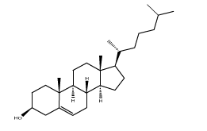
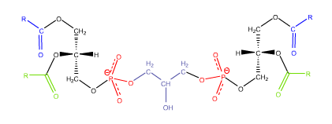

For the first lipid standard, cholesterol has a weakly polar hydroxyl group. Cardiolipin has a hydroxyl group in the middle, the two phosphate groups, and the four-ester groups. In both the basic and acidic solvents cardiolipin is more polar than cholesterol. This is because cholesterol only one hydroxyl group with 4 hydrocarbon rings, decreasing its overall polarity compared to cardiolipin which is the much more polar molecule overall.

Standard 2
Phosphatidylcholine (PC) Fatty acid (FA)
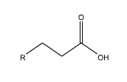
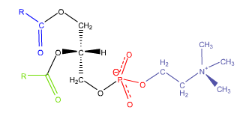
For the second lipid standard, phosphatidylcholine has an amine group, a phosphate group, and the two-ester groups. The fatty acid has one carboxyl group. In both the basic and acidic solvents phosphatidylcholine is more polar than the fatty acid. This is because phosphatidylcholine has a positive charge on the nitrogen of its choline head group and a charge on the phosphate group. These charges make it a much more polar molecule compared to the fatty acid and its long non-polar hydrocarbon chain and carboxyl group.

Standard 3
Phosphatidylethanolamine (PE) Phosphatidylinositol (PI)
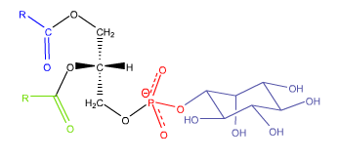
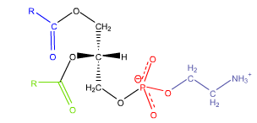

For the third lipid standard, phosphatidylethanolamine has an amino group, a phosphate group and the two ester groups. Phosphatidylinositol has 5 hydroxyl groups on the cyclohexane ring, a phosphate group, and the two ester groups. In both the basic and acidic solvents phosphatidylinositol is more polar than phosphatidylethanolamine. This is because of its much more polar hydroxyl groups compared to the less polar amino group on
phosphatidylethanolamine.

R3.

Table 2: Lipid assay. 2 g of rat tissue liver was minced and placed in 10 mL of homogenization buffer (10mM Tris, 0.25M sucrose, 1mM EDTA, 1 mM DTT, pH 7.5) and then homogenized. The tissue was then centrifuged at 4°C for 10 min at 1000 xg after being paired and balanced. The supernatant was filtered and then centrifuged at 4°C for 10 min at 25000 xg after being paired and balanced. After completion, the supernatant (microsomal fraction) was transferred to a 15 ml Falcon tube and the pellet was re-suspended in 10 mL of homogenization buffer and then sonicated. 5 assay tubes were then prepared with 50 μL of brilliant blue R (1.5g/L), 1 mL phosphate buffer (pH 11, 0.2M) and variable amounts of water and membrane suspension for a final volume of 2 mL per tube. The dilution fractions show the concentrations of the membrane suspension of each tube. All tubes were incubated for 15 mins at room temperature and then absorbance readings of each tube were taken with the spectrophotometer at 559 nm.
Sample | Dilution fraction | A₅₅₉
- Control | 0 | 0.635
- 1/200 | 0.005 | 0.576
- 1/100 | 0.01 | 0.504
- 1/50 | 0.02 | 0.408
- 1/20 | 0.05 | 0.175

Figure 2: Absorbance at 559 nm Vs. dilution fraction for the lipid assay. 2 g of rat tissue liver was minced and placed in 10 mL of homogenization buffer (10mM Tris, 0.25M sucrose, 1mM EDTA, 1 mM DTT, pH 7.5) and then homogenized. The tissue was then centrifuged at 4°C for 10 min at 1000 xg after being paired and balanced. The supernatant was filtered and then centrifuged at 4°C for 10 min at 25000 xg after being paired and balanced. After completion, the supernatant (microsomal fraction) was transferred to a 15 ml Falcon tube and the pellet was suspended in 10 mL of homogenization buffer and then sonicated. 5 assay tubes were then prepared with 50 μL of brilliant blue R (1.5g/L), 1 mL phosphate buffer (pH 11, 0.2M) and variable amounts of water and membrane suspension for a final volume of 2 mL per tube. The dilution fractions show the concentrations of the membrane suspension of each tube. All tubes were incubated for 15 mins at room temperature and then absorbance readings of each tube were taken with the spectrophotometer at at 559 nm. The linear trendline of the first four most dilute samples are shown. The linear trendlline equation is y = -11.411x + 0.6306 with an R² value of 0.9926. The slope of the trendline shows the overall decrease in absorbance in the samples as the dilution fraction increases.
Table 3: Proteins assay. 2 g of rat tissue liver was minced and placed in 10 mL of homogenization buffer (10mM Tris, 0.25M sucrose, 1mM EDTA, 1 mM DTT, pH 7.5) and then homogenized. The tissue was then centrifuged at 4°C for 10 min at 1000 xg after being paired and balanced. The supernatant was filtered and then centrifuged at 4°C for 10 min at 25000 xg after being paired and balanced. After completion, the supernatant (microsomal fraction) was transferred to a 15 ml Falcon tube and the pellet was suspended in 10 mL of homogenization buffer and then sonicated. 4 assay tubes were then prepared with 1 mL phosphate buffer (pH 11, 0.2M) and variable amounts of water and membrane suspension (mitochondrial membrane suspension) for a final volume of 2 mL per tube. The dilution fractions show the concentrations of the membrane suspension of each tube. All tubes were incubated for 15 mins at room temperature and then absorbance readings of each tube were taken with the spectrophotometer at 280 nm using a 1 mL plastic cuvette. The extinction coefficient of proteins is 2 Lg⁻¹cm⁻¹ at 280 nm.
Sample | Dilution fraction | A₂₈₀
- Blank | 0 | 0.014
- 1/100 | 0.01 | 0.035
- 1/25 | 0.04 | 0.147
- 1/5 | 0.2 | 0.643

Figure 3: Absorbance at 230 nm Vs. Dilution fraction for the proteins assay. 2 g of rat tissue liver was minced and placed in 10 mL of homogenization buffer (10mM Tris, 0.25M sucrose, 1mM EDTA, 1 mM DTT, pH 7.5) and then homogenized. The tissue was then centrifuged at 4°C for 10 min at 1000 xg after being paired and balanced. The supernatant was filtered and then centrifuged at 4°C for 10 min at 25000 xg after being paired and balanced. After completion, the supernatant (microsomal fraction) was transferred to a 15 ml Falcon tube and the pellet was suspended in 10 mL of homogenization buffer and then sonicated. 4 assay tubes were then prepared with 1 mL phosphate buffer (pH 11, 0.2M) and variable amounts of water and membrane suspension (mitochondrial membrane suspension) for a final volume of 2 mL per tube. The dilution fractions show the concentrations of the membrane suspension of each tube. All tubes were incubated for 15 mins at room temperature and then absorbance readings of each tube were taken with the spectrophotometer at 280 nm using a 1 mL plastic cuvette. The extinction coefficient of proteins is 2 Lg⁻¹cm⁻¹ at 280 nm. The linear trendlline equation is y = 3.1598x + 0.0123 with an R² of 0.9994. The slope of the trendline shows the overall increase in absorbance in the samples as the dilution fraction increases.

R4.

Protein concentration calculation
ε = 2.0 L g⁻¹ cm⁻¹  A = 3.1598  L = 1 cm | $$A=εCL$$
ε = 2.0 L g⁻¹ cm⁻¹  A = 3.1598  L = 1 cm | $$C=\frac{A}{εL}$$  $$C=\frac{3.1598}{(2.0Lg^{-1}cm^{-1})(1cm)}$$
 | $$C=1.58 g/L$$

Therefore, the concentration of proteins in the membrane preparation was$1.58 g/L$.
Absorbance slope of protein assay = M for this calculation

R5.
Lipid concentration calculation

$$A_{1}= 0.011$$  $$A_{2}=11.411$$  $C_{2}=$ $1 ug/ml$ | $$\frac{A_{1}}{C_{1}}=\frac{A_{2}}{C_{2}}$$  $$\frac{0.011}{1ug/ml}=\frac{11.411}{C_{2}}$$  $$C_{2}=\frac{(11.411)(1\frac{ug}{ml}) }{0.011}$$  $C_{2}=1037$ $ug/ml$  $$C_{2}= 1.037 g/L$$
Therefore, the concentration of lipids in the membrane preparation was $1.037$g/L
A₂ = the slope of the lipids assay for this calculation
R6.
Protein yield calculation
C = 1.58 g/L  m_{liver} = 2 g  V= 10 mL = 0.010 L | $$m_{protein}=C∙V=(1.58 g/L)(0.010L)$$
C = 1.58 g/L  m_{liver} = 2 g  V= 10 mL = 0.010 L | $$m_{protein}=0.0158g$$  $$m_{protein}=15.8mg$$
C = 1.58 g/L  m_{liver} = 2 g  V= 10 mL = 0.010 L | $$yield=\frac{m_{protein}}{m_{liver}}$$  $$yield=\frac{15.8mg}{2g}$$
 | $$yield=7.9 mg/g$$

Therefore, the yield for the mitochondria preparation was 7.9 mg/g

