(87.7/100)
LAB 2: Amino Acids and Proteins

February 13th, 2015

Department of Biology

University of Ottawa

Purpose: (4/5)

In this experiment, ion exchange chromatography was performed in order to separate a mixture of glycine, lysine, and aspartic acid. This was achieved by taking advantage of the amino acids’ molecular structures and ionic characters. Separation of these amino acids was accomplished by using a gradient of increasing pH that then was eluted in the order of their isoelectric point. A colorimetric assay was then used to test for the presence of the amino acids using Ninhydrin. As well, during this lab an unknown protein was analyzed by using its molecular weight with a technique known as SDS polyacrylamide gel electrophoresis (SDS-PAGE). The unknown protein was then compared with molecular weight markers and the weight of the unknown protein was calculated using a line of regression equation.

Results and Discussion:

R1. (15.5/17)

Glycine
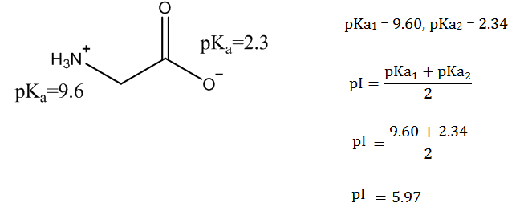

Aspartic Acid
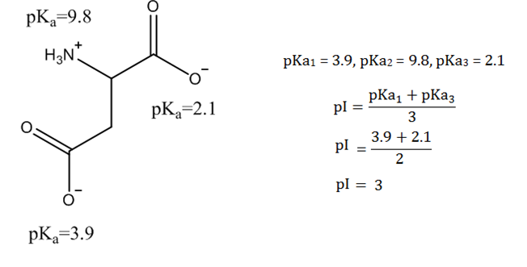

Lysine
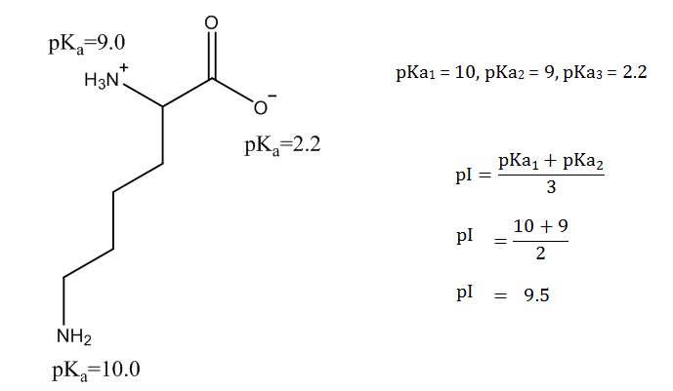
The isoelectric points for glycine, aspartic acid and lysine are 5.97, 3 and 9.5. pKa values from Mathews and Van Holde p 138

Structure (3/3)
Correct charge (4.5/6)
pKa (2/2)
Correct pI (3/3)
Calculations (3/3)

R2. (18.4/21)
Table 1: Column elution results of amino acid mixture. A 4mL mixture of 2.5mM glycine, 2.5mM aspartic acid, 2.5mM lysine and water was applied to a DOWEX-50W-X column and eluted with a pH gradient created with a pH 4.0 buffer and a pH 12.5 buffer. 120 drops were collected per fraction and the absorbance values were recorded using a spectrophotometer at 570 nm. The corrected absorbance values were calculated by subtracting the blank absorbance of 0.054. The corrected absorbance values of the standards are 0.694, 0.59 and 0.533 for glycine, aspartate and lysine. The V_{avg} was calculated to be 4.6mL.

Fraction # | Elution Volume (mL) | pH | A₅₇₀ | A₅₇₀ corrected | Concentration (mM) | μmole
1 | 4.6 | 5.63 | 0.051 | 0 | 0 | 0
2 | 9.2 | 4.02 | 0.027 | 0 | 0 | 0
3 | 13.8 | 4.04 | 0.086 | 0.032 | 0.054 | 2.5 x10⁻⁷
4 | 18.4 | 4.26 | 0.573 | 0.519 | 0.880 | 4.0 x10⁻⁶
5 | 23 | 3.89 | 0.302 | 0.248 | 0.420 | 1.9 x10⁻⁶
6 | 27.6 | 3.90 | 0.131 | 0.077 | 0.131 | 6.0 x10⁻⁷
7 | 32.2 | 5.30 | 0.295 | 0.241 | 0.347 | 1.6 x10⁻⁶
8 | 36.8 | 6.44 | 0.402 | 0.348 | 0.501 | 2.3 x10⁻⁶
9 | 41.4 | 6.79 | 0.253 | 0.199 | 0.287 | 1.3 x10⁻⁶
10 | 46 | 7.05 | 0.13 | 0.076 | 0.110 | 5.0 x10⁻⁷
11 | 50.6 | 7.41 | 0.113 | 0.059 | 0.085 | 3.9 x10⁻⁷
12 | 55.2 | 8.08 | 0.103 | 0.049 | 0.071 | 3.2 x10⁻⁷
13 | 59.8 | 10.69 | 0.373 | 0.319 | 0.598 | 2.8 x10⁻⁶
14 | 64.4 | 11.19 | 0.253 | 0.199 | 0.373 | 1.7 x10⁻⁶
15 | 69 | 11.49 | 0.154 | 0.1 | 0.188 | 8.6 x10⁻⁷
16 | 73.6 | 11.64 | 0.124 | 0.07 | 0.131 | 6.0 x10⁻⁷
Title: 2/2
Important information in the caption: 1.8/3
Quality of numerical values (3.5/4)

Elution volume calculation:

$$Elution vol=fraction \#∙V_{avg}=4\left(4.6 mL\right)= 18.4 mL$$

Aspartic Acid sample calculations from fraction 4

A570 corrected calculation
$$A_{F4 corrected }= A_{F4}- A_{blank}=0.573-0.054=0.519$$

Concentration and umole calculations:

Variables: A_{asp} = 0.59, c_{asp} = 1 mM, A_{F4} = 0.519, V_{avg} = 4.6 mL

$$\frac{A_{asp}}{c_{asp}}=\frac{A_{F4}}{c_{F4}}→{ A}_{asp}\left(c_{F4}\right)=(A_{F4})(c_{asp})$$

$$c_{F4}=\frac{\left(A_{F4}\right)\left(c_{asp}\right)}{A_{asp}}=\frac{\left(0.519\right)\left(1 mM\right)}{0.59}=0.880 mM=8.8∙{10}^{-5} M$$

$$c_{F4}=\frac{n}{V_{avg}}→ n=\left(c_{F4}\right)\left(V_{avg}\right)=\left(8.8∙{10}^{-5}M\right)\left(4.6∙{10}^{-3} L\right)=4∙{10}^{-6} mol$$

Glycine sample calculations for fraction 8

A570 corrected calculation
$$A_{F8 corrected }= A_{F8}- A_{blank}=0.402-0.054=0.348$$

Concentration and umole calculations

Variables: A_{glyc} = 0.694, c_{glyc} = 1 mM, A_{F8} = 0.348, V_{avg} = 4.6 mL

$$\frac{A_{glyc}}{c_{glyc}}=\frac{A_{F8}}{c_{F8}}→{ A}_{glyc}\left(c_{F8}\right)=(A_{F8})(c_{glyc})$$

$$c_{F8}=\frac{\left(A_{F8}\right)\left(c_{glyc}\right)}{A_{glyc}}=\frac{\left(0.348\right)\left(1 mM\right)}{0.694}=0.50 mM=5.0∙{10}^{-4} M$$

$$c_{F8}=\frac{n}{V_{avg}}→ n=\left(c_{F8}\right)\left(V_{avg}\right)=\left(5.0∙{10}^{-4}M\right)\left(4.6∙{10}^{-3} L\right)=2.3∙{10}^{-6} mol$$

Lysine sample calculations from fraction 13

A570 corrected calculation
$$A_{F13 corrected }= A_{F13}- A_{blank}=0.373-0.054=0.319$$

Concentration and moles calculations

Variables: A_{lys} =0.533, c_{lys} = 1 mM, A_{F13} = 0.319, V_{avg} = 4.6 mL

$$\frac{A_{lys}}{c_{lys}}=\frac{A_{F13}}{c_{F13}}→{ A}_{lys}\left(c_{F13}\right)=(A_{F13})(c_{lys})$$

$$c_{F13}=\frac{\left(A_{F13}\right)\left(c_{lys}\right)}{A_{lys}}=\frac{\left(0.319\right)\left(1 mM\right)}{0.533}=0.598 mM=5.98∙{10}^{-4} M$$

$$c_{F13}=\frac{n}{V_{avg}}→ n=\left(c_{F13}\right)\left(V_{avg}\right)=\left(5.98∙{10}^{-4}M\right)\left(4.6∙{10}^{-3} L\right)=2.8∙{10}^{-6} mol$$

The concentrations of aspartic acid, glycine, and lysine for their fractions are 8.8x10⁻⁵ M, 5x10⁻⁴ M, and 5.98x10⁻⁴ M. The umol for aspartic acid, glycine, and lysine in their fractions are 4x10⁻⁶ moles, 2.3x10⁻⁶ moles, and 2.8x10⁻⁶ moles.

Correct absorbances with blank: 0.9/1.8
Correct formula: 1.8/1.8
Correct variables: 2.4/2.4
Presence of units: 1.8/1.8
Correct answers: 2.4/2.4
Correct standard used: 1.8/1.8

R3. (14.75/16)

Aspartate

Glycine
Lysine

Figure 1. pH values and concentrations (mM) of the amino acids aspartic acid, glycine and lysine plotted against their elution volume (mL). 4mL of a 2.5mM glycine, 2.5mM lysine, 2.5mM aspartic acid mixture was applied to a DOWEX-50W-X column and eluted with an increasing pH gradient of 4 -12.5 created by a 0.1 M NaH2PO4, pH 4.0 and 0.1 Na2PO4, pH 12.5 buffer solutions. The average volume per fraction was calculated to be 4.6 mL; this value was used to calculate the elution volume for each fraction. After the fractions were collected they had had 100 uL of Ninhydrin reagent (20 mg/mL ninhydrin, 3 mg/mL hydrindantin, 75% DMSO, 1 M lithium acetate) added to the solution and then placed in an oven at 100 ℃ for 15 minutes. The absorbance values were then measured with a spectrophotometer at a wavelength of 570 nm. Standard concentrations of all three amino acids were 1 mM each. Three peaks in concentration can be seen on the graph, the peak for aspartate is at 0.88 mL which includes fractions 1-6, the peak for glycine is at 36.8 mL which includes fractions 7-12 and the last peak for lysine is at 59.8 for fractions 12-16.
Title: 2/2
Important information in the caption: 2.75/3
Graph format: 4/4

As can be seen in Figure 1, the 3 amino acids are separated quite well. Each peak is fairly obvious and well defined with no obscure data points. The resolution could have been improved by allowing the proteins to elute slower; this would have allowed better separation of the amino acids as a slower increase in pH would mean more separation time before reaching their respective isoelectic points. A slower elution would mean less blending of the fractions and more evident fraction curves. Another method to improve the resolution would be to use more fractions; this would also allow less blending of the fractions with one another.

Results (6/7)

R4. (13/16)
Recovery Yield for Aspartic Acid:

Variables: c_{asp} = 2.5 mM = 0.0025 M, V_{sample mix} = 4 mL = 0.004 L, n_{F1-F6} are from Table 1.

$$n_{theory}=c_{asp}\left(V_{sample mix}\right)=\left(0.0025 M\right)\left(0.004 L\right)=1∙{10}^{-5} mol$$

$$n_{actual}=n_{F1}+n_{F2}+n_{F3}+n_{F4}+n_{F5}+n_{F6}$$
=0 + 0 + 2.5 x10⁻⁷ + 4.0 x10⁻⁶ + 1.9 x10⁻⁶ + 6.0 x10⁻⁷
$$=6.83∙{10}^{-6} mol$$

$$Recovery yield=\frac{n_{actual}}{n_{theory}}∙100\%=\frac{6.83∙{10}^{-6}}{1.00∙{10}^{-5}}∙100\%=68.3\%$$

Recovery Yield for Glycine:

Variables: c_{glyc} = 2.5 mM = 0.0025 M, V_{sample mix} = 4 mL = 0.004 L, n_{F7-F12} are from Table 1.

$$n_{theory}=c_{glyc}\left(V_{sample mix}\right)=\left(0.002M\right)\left(0.004 L\right)=1∙{10}^{-1} mol$$

$$n_{actual}=n_{F7}+ n_{F8}+n_{F9}+n_{F10}+n_{F11}+n_{F12}$$
= 1.6 x10⁻⁶ + 2.3 x10⁻⁶ + 1.3 x10⁻⁶ + 5.0 x10⁻⁷ + 3.9 x10⁻⁷ + 3.2 x10⁻⁷
$$=6.4∙{10}^{-6} mol$$

$$Recovery yield=\frac{n_{actual}}{n_{theory}}∙100\%=\frac{6.4∙{10}^{-6}}{1.00∙{10}^{-5}}∙100\%=64.4\%$$

Recovery Yield for Lysine:

Variables: c_{lys} = 2.5 mM = 0.0025 M, V_{sample mix} = 4 mL = 0.004 L, n_{F13-F16} are from

$$n_{theory}=c_{lys}\left(V_{sample mix}\right)=\left(0.002M\right)\left(0.004 L\right)=1∙{10}^{-5} mol$$

$$n_{actual}=n_{F13}+n_{F14}+n_{F15}+n_{F16}$$
=2.8 x10-6 + 1.7 x10-6 + 8.6 x10-7 + 6.0 x10-7
$$=5.9∙{10}^{-6} mol$$

$$Recovery yield=\frac{n_{actual}}{n_{theory}}∙100\%=\frac{5.9∙{10}^{-6}}{1∙{10}^{-5}}∙100\%=59.3\%$$

Therefore the recovery yield for aspartic acid, glycine, and lysine are 63.8%, 64.4%, and 59.3%.

Correct equations: 2/2
Correct variables: 2/2
Correct theoretical amount of moles: 2/2
Correct experimental amount of moles: 2/2
Yield: 3/3

The recovery yields are what I expected; all three amino acids were measured to have yields under 100%. This was predicted as anything over 100% can only be explained by sources of error. It is much more probable to have under 100% as there is a good chance that all the solution was not recovered or a small portion of it was left in the column. This is perhaps what happened with these amino acid yields, they are all between 59-65% so this means that they all lost a significant portion of their respective yields during the experiment. Other sources of error could include pipetting errors or even incorrect absorbance measurements; these can also throw off yields.
Conclusion:
- Source of errors (1.5/3)
- Reasonable conclusion (0.5/2)

R5 (20/22)
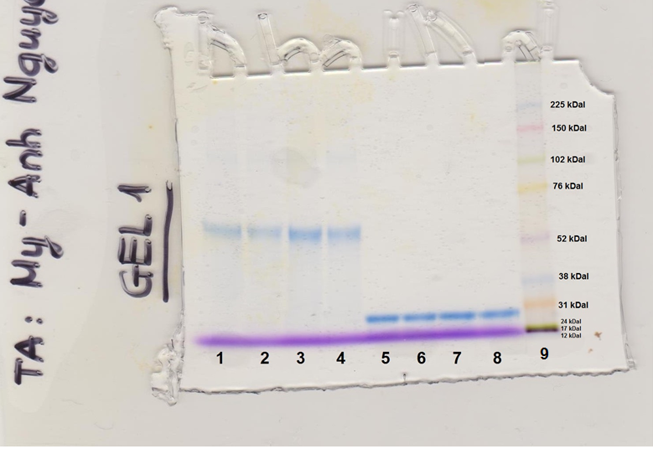
Figure 2. Gel 1 from the SDS polyacrylamide gel electrophoresis (SDS-PAGE) results. 10 μL of the molecular weight rainbow marker was loaded into well 9 and 15 μL of unknown protein sample #18 was loaded into wells 7 and 8. The molecular weight of the rainbow markers are shown on the right in kDa. Well number is indicated on the bottom. The slab gel was pre-polymerized with 10% acrylamide and the running buffer used is pH 8.3 (3.0 g/L Tris base, 14.4 g/L HEPES and 1 g/L SDS). The migration distance for our team’s unknown was measured to be 7.9 cm.

Title: 2/2
Important information in the caption: 2/2
MW marker be labelled on the gel (1.5/1.5)
Wells be numbered (1.5/1.5)

Correct migration distance (0/2)

Figure 3. LogMW of the SDS-PAGE standards plotted against migration distance. The molecular weight marker, which consists of dyed proteins of known molecular weight, was loaded into well 9 as seen in Figure 2. The distance each protein travelled in cm was measured and plotted against the logarithm of the molecular weight. The equation of the regression line is shown as well as the R² value. Data points for rainbow markers 17 kDal and 24 kDal were excluded from the graph to improve the regression equation for a better estimation the unknown protein’s molecular weight.
Title: 2/2
Important information in the caption: 2/2
Graph format (3/3)

Calculation for determining the MW of unknown protein:

Variables: y = -0.1305x + 2.4884 where y = logMW and x = migration distance of unknown polypeptide sample #18 = 7.9 cm

$$y = -0.1305x + 2.4884=y = -0.1305(7.9) + 2.4884=1.45$$

$$\log\left(MW\right)=1.45→MW={10}^{1.45}=28.1 kDa$$

Therefore my unknown sample #18 is predicted to have an approximate MW of 28.1 kDa.

Correct formula: 1.5/1.5
Correct variable: 1.5/1.5
Correct answers: 1.5/1.5
Correct unit (kDa): 1.5/1.5

References
- Petit, A. and Poitras, L. (2015). Introduction to Biochemistry Laboratory Component
- Mathews, C. and Van Holde, K. (2013) Biochemistry, 4th Ed. Pearson, p 138.

