LAB 1: CARBOHYDRATES

Department of Biology
University of Ottawa

Purpose:

This lab aimed to display a few of the fundamental properties that govern carbohydrates.
It was demonstrated how differences in molecular weight allow for the separation glucose monomers from starch polymers using a variety of separation techniques. Colorimetric assays were used to test for the presence of the glucose and starch in the fractions and for the analysis of these carbohydrates. A glucose oxidase assay was used to identify the presence of glucose and an iodine assay was used to identify the presence of starch. Valuable hands on skill was also gained from this experiment including use of dialysis bags to assess the permeability of a mixture of carbohydrates based on their size and using a gel filtration column resolve a mixture of carbohydrates based on their molecular size and finally to use colorimetric assays to assess the concentrations of carbohydrates.

Results and discussion:

R1. Estimating the glucose and starch content of the two dialysis compartments

Table 1: Dialysis results of glucose/starch mixture showing estimates of the glucose and starch content of the two dialysis compartments at both the initial (t=0 min) and the end point (t=45 min) of the dialysis. Dialysis tubing was used in this experiment, with a diameter of 1 cm this sack was used for the separation of large molecules from small molecules by selective diffusion of the small molecules through a semipermeable membrane (MW cut-off of 12,000-14,000 Da). Absorbance was measured at wavelengths of 420 nm (A₄₂₀) and 600 nm (A₆₀₀) for the internal and external solutions of starch and glucose. Glucose and starch standard concentrations are 2 g/L and 0.1 g/L.
t (min) | Glucose |  |  |  |  |  | Starch
t (min) | A₄₂₀ Internal Solution | c₁ (g/L) | m₁ (mg) | A₄₂₀ External Solution | c₂ (g/L) | m₂ (mg) | A₆₀₀ Internal Solution | c₁ (g/L) | m₁ (mg) | A₆₀₀ External Solution | c₂ (g/L) | m₂ (mg)
0 | 0.37 | 48.3 | 483 | - | 0 | 0 | 0.663 | 0.87 | 8.7 | - | 0 | 0
45 | 1.024 | 27.9 | 279 | 0.195 | 1.06 | 212.5 | 0.659 | 0.024 | 0.24 | 0.012 | 0.0026 | 0.53

Correction in absorbance reading:

$A_{b new}= A_{b}- A_{blank}=0.381-0.014=0.367$

Glucose concentrations and mass at t=0 min:
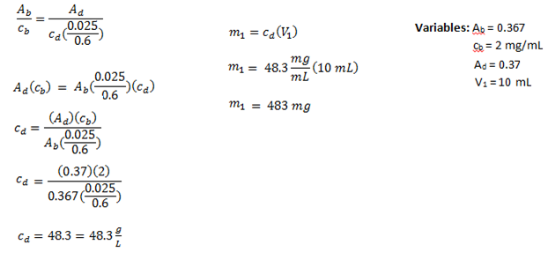
At t=0 min, the concentration and mass of glucose in the glucose/starch mixture is 48.3 g/L and 483 g.

Correction in absorbance reading:

$A_{c new}= A_{c}- A_{blank}=0.469-0.013=0.456$

Starch concentrations and mass at t=0 min:
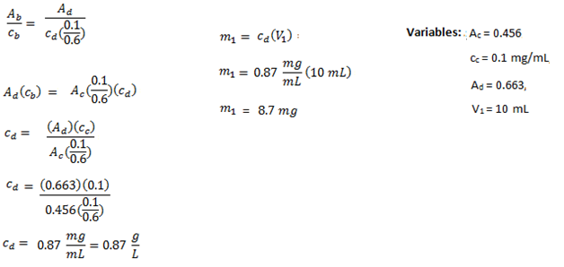
At t=0 min, the concentration and mass of starch in glucose/starch mixture is 0.87 g/L and 8.7 mg.

R2. Estimating glucose concentration at the equilibrium

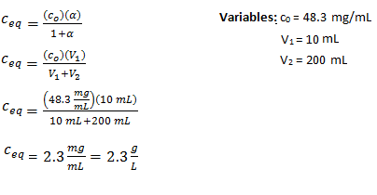
The concentration at equilibrium is 2.3 g/L.

R3. Estimating the diffusion coefficient D (cm2/min) of glucose across the dialysis membrane

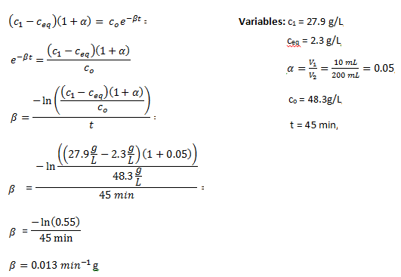

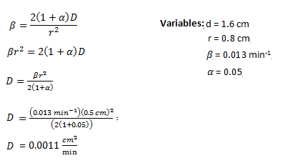

The diffusion coefficient across the dialysis membrane was estimated to be 0.0011 cm²/min

R4. Column elution results

Table 2: Column elution results which show the collection of 15 fractions over a 45 minute timespan with an average fraction volume of 3.9 ml per fraction. The separation technique used for this experiment was gel filtration chromatography; this separation is based on molecular size which makes use of hydrated beads with a highly controlled porosity. The column was loaded with pre-swollen Sephadex G-25 with a molecular weight cut-off of 5000 Da. 0.5 mL of the glucose/starch mixture was applied to the syringe which is connected to the column. Glucose oxidase and Iodine assays were performed on the fractions and were then measured for absorbance with the spectrophotometer at wavelengths of 420 nm for glucose and 600 nm for starch. Glucose and starch standard concentrations are 2 g/L and 0.1 g/L. The absorbance readings from all fractions have been subtracted by the blanks for each assay.
Fraction |  | Glucose |  |  | Starch
# | Elution Volume (mL) | A₄₂₀ | c (g/L) | Mass (mg) | A₆₀₀ | c (g/L) | Mass (mg)
1 | 3.9 | 0.005 | 0.027 | 0.106 | 0 | 0.00000 | 0.000
2 | 7.8 | 0.019 | 0.104 | 0.404 | 0.012 | 0.00263 | 0.010
3 | 11.7 | 0.013 | 0.071 | 0.276 | 0.001 | 0.00022 | 0.001
4 | 15.6 | 0.013 | 0.071 | 0.276 | 0.217 | 0.04759 | 0.186
5 | 19.5 | 0.017 | 0.093 | 0.361 | 0.439 | 0.09627 | 0.375
6 | 23.4 | 0.082 | 0.447 | 1.743 | 0.018 | 0.00395 | 0.015
7 | 27.3 | 0.367 | 2.000 | 7.800 | -0.009 | -0.00197 | -0.008
8 | 31.2 | 0.377 | 2.054 | 8.013 | 0 | 0.00000 | 0.000
9 | 35.1 | 0.139 | 0.757 | 2.954 | -0.01 | -0.00219 | -0.009
10 | 39 | 0.02 | 0.109 | 0.425 | 0.003 | 0.00066 | 0.003
11 | 42.9 | 0.01 | 0.054 | 0.213 | 0.005 | 0.00110 | 0.004
12 | 46.8 | 0.002 | 0.011 | 0.043 | 0.009 | 0.00197 | 0.008
13 | 50.7 | 0.016 | 0.087 | 0.340 | 0.012 | 0.00263 | 0.010
14 | 54.6 | 0.029 | 0.158 | 0.616 | 0.008 | 0.00175 | 0.007
15 | 58.5 | 0.029 | 0.158 | 0.616 | -0.012 | -0.00263 | -0.010
Calculating elution volume in table:

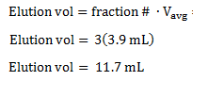
Glucose concentration and mass in fraction G1:

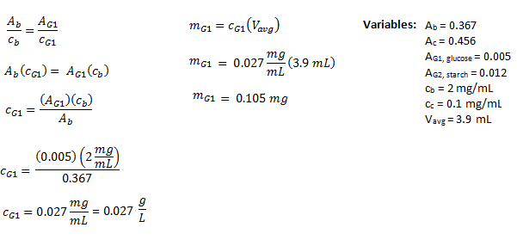

Starch concentration and mass in fraction G2:

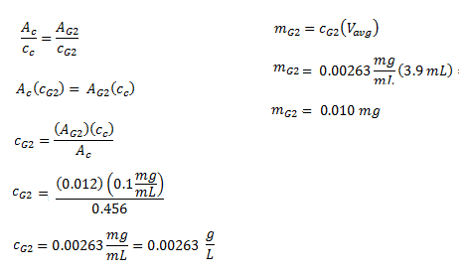

The concentration and mass of glucose fraction G1 is 0.027 g/L, 0.105 mg and in fraction G2 is 0.00263 g/L, 0.010 mg
R5.

Figure 1. Concentrations (g/L) of glucose and starch and their elution volumes (mL) through using the separation technique of gel filtration chromatography. Chromatography was performed by 2 teams of two and 15 fractions were collected in 45 minutes. 0.5 mL of the glucose/starch mixture was added to the column. The column itself was loaded with pre-swollen Sephadex G-25 with a molecular weight cut-off of 5000 Da in distilled water. The average volume per fraction was measured to be 3.9 mL. Glucose oxidase and Iodine assays were performed on the fractions and were then measured for absorbance with the spectrophotometer at wavelengths of 420 nm for glucose and 600 nm for starch. Glucose and starch standard concentrations are 2 g/L and 0.1 g/L.

Both glucose and starch each show one peak, the highest concentration points were found to be 19.5 g/L for the starch and 31.2 g/L for glucose. As seen in Figure 1, glucose was eluted first between 14 -20 mL and then Starch eluted in the 20-39 mL range. This trend is what I predicted as glucose is a much smaller molecule than starch and would be smaller than the pore size and retained in the column longer than starch. Starch being a much larger molecule than glucose cannot fit through the beads and must pass around them to get to the bottom of the column, so it will elute much faster. This can be seen very clearly in Figure 1 when comparing the 2 fraction curves.

R6. Calculating the average distribution coefficient (Kav) of the starch and glucose

V_{e} is read from the elution volume that corresponds to the highest concentration point on the graph.

Finding the total column volume:
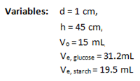
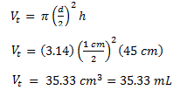

Total column volume is $35.33$ mL.

K_{av} for glucose:
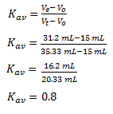

K_{av} for starch:

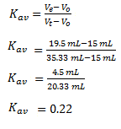
The average distribution coefficients for glucose and starch are 0.8 and 0.22.

The value for the average distribution coefficient (Kav) calculated is what was expected. The average distribution coefficient was calculated to be 0.8 for glucose and 0.22 for starch. Both of the values lie within the range of $0≤K_{av}≤1$. The average distribution coefficient for starch was calculated to be less than that of glucose. These results are as predicted as larger molecules such as starch would be expected to have a K_{av} value closer to zero and smaller molecules like glucose would have a K_{av} value closer to 1.The K_{av} of starch should be smaller than the K_{av} of glucose since starch is larger and does not enter the beads and therefore is eluted first. The coefficient for starch is nearly 0 which indicates that the starch did not enter the beads much at all whereas the coefficient for glucose is higher indicating that it did enter the beads.

R7. Estimating the recovery yield (%) of the column for glucose and starch.

Theoretical mass for glucose:

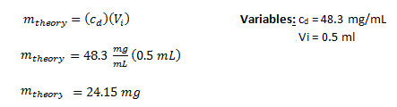

Experimental mass for glucose:

Sum up the mass of glucose in each fraction from G1-G15. Values for the masses are found in Table 2.

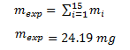

Recovery yield for glucose:

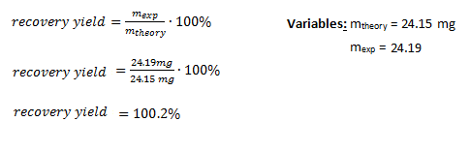

Theoretical mass for starch:

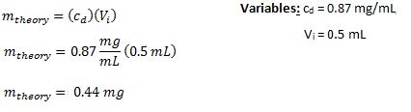

Experimental mass for starch:

Variables
Sum up the mass of starch in each fraction from G1-G15. Values for the masses are found in Table 2.
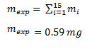

Recovery yield for starch:

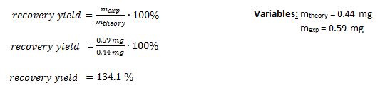

The recovery yield for glucose is 100.2 % and starch is 134.1%.

I can conclude that from the calculations of the recovery yields that glucose had a near perfect yield and that starch yield was higher than 100% which points to human error in the experiment. One source of error that could account for the high starch yield could be that one or a few of the test tubes could have contained impurities leftover from a previous lab group of students. Another explanation could be that we measured the solution incorrectly and added too much mixture to the syringe of the column, this would also explain why our glucose yield was near perfect, as a yield that close to 100% is difficult to achieve.

Purpose: 5/5
Results and Discussion: 78.9/92
Writing Skills: 3/3
Total: 86.9/100

References
- Petit, A. and Poitras, L. (2015). Introduction to Biochemistry Laboratory Component

