UNIVERSITY OF OTTAWA
Faculty of Science
Biochemistry

BCH 2333

INTRODUCTION TO BIOCHEMISTRY
LABORATORY COMPONENT
Winter 2016

LABORATORY MANUAL

Coordinators: Josée Coutu
Luc Poitras

Biosciences 211
30 Marie Curie

Table of Contents

Schedule iii
General information v
Overview v
Learning outcomes v
Lab coordinators vi
Course web site vi
Teaching assistants (TAs) vii
Course organization vii
Attendance viii
Safety in the Laboratory viii
E-mail etiquette rules for students x
Evaluation xi
Pre-lab quizzes xi
In Lab performance xi
Laboratory reports xii
Academic integrity xv

Introductory Laboratory
Basic techniques 1
Laboratory Class I : Carbohydrates
Separation Techniques Based on Molecular Size 9
Laboratory Class II : Amino acids and proteins
Electrophoresis and Ion-Exchange Chromatography 29
Laboratory Class III : Enzymes
The Kinetics of Acid Phosphatase 45
Laboratory Class IV : Lipids and membranes
Thin Layer Chromatography of Tissue Lipids 67
Laboratory Class V : Nucleic acids
Isolation and Characterization of Bacterial DNA 83
Appendices
Appendix
SI (Système International) units and prefixes 109
Appendix A
Laboratory notebook 110
Appendix B
Laboratory reports 115
Username for submitting reports using FTP 119
Appendix C: Calculations
Serial dilution 120
Beer-Lambert Law 122
Percentage of yield 124
Percentage difference 125
Estimation of length and amount of DNA bands 127
Appendix D: Supplementary figures
Lab 3 Figure S1 130
Lab 3 Figure S2 132
SECTION SCHEDULE
Section | Weeks | Day | Time
1 | 1, 2, 4, 7, 9, 11 | Monday | 8:30 – 11:30
2 | 1, 3, 5, 8, 10, 12 | Monday | 8:30 – 11:30
3 | 1, 2, 4, 7, 9, 11 | Monday | 13:00 – 16:00
4 | 1, 3, 5, 8, 10, 12 | Monday | 13:00 – 16:00
5 | 1, 2, 4, 7, 9, 11 | Tuesday | 8:30 – 11:30
6 | 1, 3, 5, 8, 10, 12 | Tuesday | 8:30 – 11:30
7 | 1, 2, 4, 7, 9, 11 | Tuesday | 14:30 – 17:30
8 | 1, 3, 5, 8, 10, 12 | Tuesday | 14:30 – 17:30
9 | 1, 2, 4, 7, 9, 11 | Wednesday | 8:30 – 11:30
10 | 1, 3, 5, 8, 10, 12 | Wednesday | 8:30 – 11:30
11 | 1, 2, 4, 7, 9, 11 | Thursday | 8:30 – 11:30
12 | 1, 3, 5, 8, 10, 12 | Thursday | 8:30 – 11:30
13 | 1, 2, 4, 7, 9, 11 | Thursday | 13:00 – 16:00
14 | 1, 3, 5, 8, 10, 12 | Thursday | 13:00 – 16:00
15 | 1, 2, 4, 7, 9, 11 | Friday | 13:00 – 16:00
17 | 1, 2, 4, 7, 9, 11 | Thursday | 17:30 – 20:30
18 | 1, 3, 5, 8, 10, 12 | Thursday | 17:30 – 20:30

DETAILED SCHEDULE
Please note – All labs (EXCEPT the INTRO) take place in BSC 211
Week |  | Laboratory sections  1, 3, 5, 7, 9, 11, 13, 15 and 17 | Laboratory sections  2, 4, 6, 8, 10, 12, 14, 16 and 18
1 | January 11-15 | 1) Intro lab: Basic Techniques  2) Info session | 1) Info session  2) Intro lab: Basic Techniques
2 | January 18-22 | Lab 1: Carbohydrates
3 | January 25-29 |  | Lab 1: Carbohydrates
4 | February 1-5 | Lab 2: Amino Acids and Proteins
5 | February 8-12 |  | Lab 2: Amino Acids and Proteins
6 | February 15-19 | Reading week
7 | February 22-26 | Lab 3: Enzymes
8 | February 29-March 4 |  | Lab 3: Enzymes
9 | March 7-11 | Lab 4: Lipids and Membranes
10 | March 14-18 |  | Lab 4: Lipids and Membranes
11 | March 21-24* | Lab 5: Nucleic Acids*
12 | March 29 –Apr 1** |  | Lab 5: Nucleic Acids**
13 | Apr 1 | Lab 5: Section 15 (Friday)
14  *Note – there are no labs on Friday this week (Good Friday).  ** Note – there are no labs on Monday this week (Easter Monday) | Apr 4 |  | Lab 5: Sections 2 & 4 (Monday)
INTRODUCTORY LAB
Lab sessions will take place during the first week of the semester (January 11-15th) during your scheduled lab time.
Please ensure that you come prepared with your lab coat, safety glasses, gloves, lab notebook and a fine-tip permanent marker (Sharpie).
INTRO LAB SCHEDULE

DAY | SECTIONS | ACTIVITY | ROOM #
Monday | 1, 3 | 1) Intro lab: Basic Techniques  2) Info session | BSC 211  BSC 140
Monday | 2, 4 | 1) Info session  2) Intro lab: Basic Techniques | BSC 140  BSC 211
Tuesday | 5, 7 | 1) Intro lab: Basic Techniques  2) Info session | BSC 211  BSC 140
Tuesday | 6, 8 | 1) Info session  2) Intro lab: Basic Techniques | BSC 140  BSC 211
Wednesday | 9 | 1) Intro lab: Basic Techniques  2) Info session | BSC 211  BSC 140
Wednesday | 10 | 1) Info session  2) Intro lab: Basic Techniques | BSC 140  BSC 211
Thursday | 11, 13, 17 | 1) Intro lab: Basic Techniques  2) Info session | BSC 211  BSC 140
Thursday | 12, 14, 18 | 1) Info session  2) Intro lab: Basic Techniques | BSC 140  BSC 211
Friday | 15 | 1) Intro lab: Basic Techniques  2) Info session | BSC 211  BSC 140

GENERAL INFORMATION
OVERVIEW

The laboratory component of the course, Introduction to Biochemistry BCH2333, introduces you to some of the techniques of macromolecular separation and characterization commonly used in biochemical and molecular biological research. The practical experiments illustrate basic properties of biological macromolecules presented in the lecture component of the course. We aim to give you hands-on experience and to develop your biochemical research skills.
LEARNING OUTCOMES
At the end of laboratory component, you should:
- have acquired essential laboratory skills and techniques in Biochemistry.
- have gained hands-on experience in several commonly used biochemical techniques of separation and characterization
- have further developed your ability to analyse results and to communicate your findings, in preparation for the scientific paper format of the 3rd year lab reports.
- be able to use experimental observations in conjunction with the course lecture material to explain the basic properties of the cell’s macromolecules.
- be better prepared for the Molecular Biology Laboratory and the Biochemistry Laboratory II courses, both offered in 3rd year.
- have developed a sense of ethical behaviour
LAB COORDINATORS
Morning sections
Josée Coutu josee.coutu@uOttawa.ca
Office: BSC103
Tel: x6803
Office Hours: Monday to Thursday, 1-2pm

Afternoon sections
Luc Poitras lpoitras@uOttawa.ca
Office: BSC104
Tel: x2039
Office Hours: Monday to Thursday, 2-3pm

COURSE WEB SITE

“BCH2333 - Biochemistry Laboratory I” is on the virtual campus of the University of Ottawa.
https://uottawa.blackboard.com/
There you will find this manual, video demonstrations of specific techniques, computer animations on key biochemical concepts, lab results as well as discussion forums.
TEACHING ASSISTANTS (TAs)
There will be three TA for each lab session. Each TA will supervise eight groups for a particular lab experiment. You will have a different TA for each of the five experiments. The TA will evaluate your lab performance, mark your lab reports and answer your questions through discussion forums. For any communication with TA and coordinators students should indicate their name, student number, section and team number.

A list containing the contact information for all TAs will be available in the Teaching assistants tab of the virtual campus.

COURSE ORGANIZATION
Each experiment runs over the course of two weeks, which means that you only come to the lab every other week, according to the schedule on page iii.
Introductory Session
The first laboratory session (Introduction) will take place on the week of January 11th. It consists of two different activities of 90 minutes each: an introductory lab and an info session. Please see the schedule on page iv for the room listings.

Since you will be performing lab work, please bring your lab coats, safety glasses, gloves, lab notebooks and a fine-tip permanent marker (Sharpie)!

  - Sections 1, 3, 5, 7, 9, 11, 13, 15 and 17 will start with the introductory lab whereas sections 2, 4, 6, 8, 10, 12, 14, 16 and 18 will start with the info session

- The first laboratory session is mandatory, a penalty corresponding to 5% of the laboratory component final mark will be applied if you are absent (unless it is a justified absence).

- During the Introductory lab session, you will be grouped in teams of two students (If you do not have a partner, we will help you find one). Your group number will determine the TA who will supervise your lab work (See TA contact list on the Virtual Campus).
Laboratory Session 1 to 5
Following the introductory session, there will be five sessions of 3-hours, in alternate weeks (See schedule on page iii). Odd-numbered sections, your lab sessions start the week of January 18th. Even-numbered sections, your labs start the week of January 25th.
ATTENDANCE
Attendance at the six laboratory sessions is compulsory (intro lab and info session included).
Missed Labs
- If you miss a laboratory session, you need to justify your absence to the course coordinator and provide the necessary documentation. Medical certificates issued by a licensed physician must be provided.
- For an unjustified absence, a mark of zero (0) will be automatically assigned for the corresponding laboratory session.
- Absences at two lab sessions or more, even if they are justified, will result in a final grade of “Incomplete” for the BCH2333 lab. If you have two justified laboratory absences, consult the lab coordinator as soon as possible in order to make up for the missed sessions on a different day.
SAFETY IN THE LABORATORY
It is extremely important to work safely in a laboratory environment. Please read carefully consult the following guidelines and rules for safe lab practices.
WHMIS
Federal legislation such as the Workplace Hazardous Materials Information System (WHIMIS) requires that all hazardous substances, including microorganisms, be labeled and that a Material Safety Data Sheet (MSDS) accompany each hazardous substance. An MSDS describes hazardous properties, handling and storage precautions, as well as decontamination procedures for a particular substance. Through different computers in the lab, you have online access to the MSDS for all reagents used during a laboratory session (Click on the MSDS Search icon on the desktop window). You can also use the links provided in the lab manual.

General Laboratory Guidelines
- Please refrain from using your cellphone while in the lab.
- There will be no drinking, eating or makeup application in the laboratory at any time.
- Long hair must be tied back.
- Never pipette anything by mouth.
- Your lab coat must be worn and properly fastened at all times. It must not be worn in non-laboratory areas. Failure to wear a lab coat will result in expulsion from the lab and loss of marks for that experiment. This rule will be strictly enforced.
- Wear latex or plastic gloves to protect your skin from exposure to chemicals or infectious materials. (This is normally indicated in the lab manual). Gloves will not be provided by the lab, you will have to buy them.
- You must remove your gloves and immediately wash your hands before leaving the laboratory and at any time after handling materials known or suspected to be contaminated. You may also have to remove your gloves to handle certain instruments. Gloves should be removed carefully and disposed with other laboratory waste. If you have, or think you are developing, a latex allergy, be sure to inform your TA or a member of the staff.
- Wear safety glasses for all procedures. Contact lenses should only be worn when other forms of corrective eyewear are not suitable. Contact lenses should not be worn when you are working with volatile solvents.
- Use a fume hood when working with volatile chemicals.
- Keep your work space clean and free from clutter. Personal belongings such as books, bags and coats should be left in lockers outside the lab.
- Familiarize yourself with the location of fire extinguishers, eye wash stations, showers and first aid stations.
- Dispose of waste in the appropriately labeled containers. If you are not sure, ask first.
- If an accident or a spill occurs, or if you believe that you have been exposed to hazardous materials, start a washing procedure and inform your TA or a member of the staff immediately.
E-MAIL ETIQUETTE RULES FOR STUDENTS

In order to foster constructive and proactive communication between yourself and the TAs or lab coordinators, we are asking you to follow these fives simple rules when composing your messages:

1. E-mail accounts:
• When corresponding with the coordinator/TAs, always use your official @uottawa.ca e-mail address. We reserve the right to refuse to answer any e-mails not originating from university-issued addresses.
2. Subject Line:
• Must include the course code “BCH2333”
3. Identify yourself:
• Include your full name (first and last name) and student number
• Identify your section number and TA name (if applicable)
4. Appropriate use of Language
• When e-mailing the Coordinator or TAs, make sure that you use appropriate and professional language and be mindful of your tone. Profanities, threats and aggression or disrespect are not tolerated. Remember, the first rule when it comes to composing e-mails is to be courteous and respectful.
5. Content
• Be clear and brief when writing your messages. Please realize that we receive many e-mails per day from students. By avoiding unnecessarily long e-mails, you demonstrate respect for our time and are most likely to receive a timely reply.
• If your issues are complex or you wish to discuss a particular matter more in-depth, please come see us during office hours instead of writing an extremely long message in an attempt to explain the situation.

EVALUATION
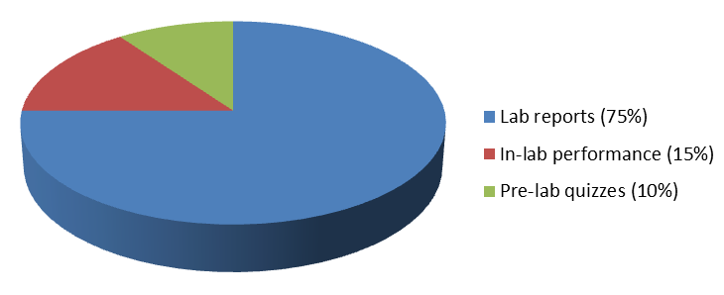
Your lab component mark accounts for 30% of the final mark for the course. Both components, lectures and lab, will require a higher than 50% mark to pass the course. The lab component will be marked according to the following scheme:

Your lab TA will be evaluating your lab reports, in-lab performance and pre-lab quizzes.

- Pre-lab quizzes (10%)
You will have to answer 5 short questions at the beginning of each lab session. These questions will evaluate the level your readiness for the lab session. They will deal with the content of the lab manual, videos and other support material posted on virtual campus.

- In-Lab performance (15%)
You will get a performance mark for each lab session. Members of a team will have different performance marks. This mark is assessed based on three criteria: your technical ability, your work habits as well as the quality of your lab notebook:

- Technical ability (5%): Your TA will evaluate your understanding of the experiment as well as your dexterity, precision, work organization and proper use of equipment. The quality of your results will also be taken into consideration for the assessment of your technical ability.
- Work habits (5%): Your TA will evaluate your compliance with the safety guidelines provided by the manual and staff members. You will not be responsible for cleaning glassware; however you will be required to complete the list of tasks posted in the lab and to leave a tidy work station. Ice buckets must be emptied and excess reagents disposed of according to the instructions of the demonstrators. Lack of punctuality at the beginning of the session will result in loss of marks
- Lab notebook (5%): You are expected to record all your experimental work in a personal lab notebook in pen, not pencil. As preparation for each lab session, you are asked in the manual to write/draw some formulas and reactions related to that session’s experiments. Tables in the manual are only models of the tables to be shown in the reports; they are not intended to be filled with data. Your demonstrator will sign and evaluate your lab-book at the end of each session. (See guidelines for your lab book format in Appendix A)

Evaluation of in lab performance should not be considered as a strict marking scheme since a number of marks may be subtracted every time an incorrect action or behavior is noticed.

- Laboratory reports (75%)

For each laboratory session, you will have to prepare a simplified laboratory report consisting of a title page, a short paragraph describing the goals of the experiments as well as the answers to a series of questions regarding the experiment.

- Title page: The following information must appear: name, student number, course code, lab section, team number, title of experiment, date and demonstrator. Your title page should follow the guidelines provided in Appendix B. Your report must be written in good English and in a clear, concise and logical manner. Your TA will assign 3 marks for your writing skills.

- Purpose of the experiments: One short paragraph (maximum 10 lines) describing the goals of the experiments. Description of the goals will account for 5 marks of the report final mark.

- Results and discussion: While answering questions from the corresponding section in the lab manual, pay attention to details such as significant figures, headings on tables and graphs, labelling of axes, etc. For instructions on presentation of tables and graphs, see Appendix B. (92 marks will be allowed for this section of your reports).
Report submission and marking:
- Reports should be submitted online to the corresponding file box by using a FTP (file transfer protocol) software such as FileZilla or native Windows FTP. (See Report Submission tab on the virtual Campus site of the course for the use of FileZilla or native Windows FTP).
- The recommended document format is Word, though you can prepare your graphics using Excel, or other compatible software.
- The file name should have the following format:
Year-performed lab – section - group (team) number – family name
eg: 2016L3S08G04Smith will correspond to a report for laboratory #3 submitted by Smith, a student from team 4 of section 8 (Tuesday afternoon).
If your report is not labelled properly or was sent to the wrong FTP box, a 10% penalty will be applied.

- The laboratory reports are due one week after completion of the corresponding session, regardless of statutory holidays, with an exception only for labs performed the week of February 8-12th. These reports will be due 2 weeks after completion of the session (to avoid submitting during reading week). For instance, if you perform a lab in the morning of February 2nd from 8:30 to 11:30, your report is due by Feb 9th at 11:30 a.m.
- Late reports will be penalized at the rate of 10% per day (you will received zero if you are late by more than 3 days). Please refer to the schedule on the following page for lab report submission dates.
- All reports should be prepared and submitted individually.
- The TA who supervised the corresponding lab session is supposed to mark and return the report with corrections within two weeks from its submission deadline.
- Technology issues (missing, deleted, corrupted or overwritten files, unable to connect to the FTP server, etc) are not acceptable excuses for late work. Protect yourself by managing your time and backing up your work often in different locations (e-mail, cloud storage, USB drive, hard drive, etc).
- Any document that cannot be opened by the TAs (ie. corrupted files) will be considered not turned in and may result in a mark of zero being awarded for the lab report in question.
Lab Report Submission Schedule

Week |  | Laboratory sections  1, 3, 5, 7, 9, 11, 13, 15 and 17 | Laboratory sections  2, 4, 6, 8, 10, 12, 14, 16 and 18
3 | January 25-29 | Lab 1: Carbohydrates
4 | February 1-5 |  | Lab 1: Carbohydrates
5 | February 8-12 | Lab 2: Amino Acids and Proteins
6 | February 15-19 | Reading week
7 | February 22-26 |  | Lab 2: Amino Acids and Proteins
8 | February 29- March 4 | Lab 3: Enzymes
9 | March 7-11 |  | Lab 3: Enzymes
10 | March 14-18 | Lab 4: Lipids and Membranes
11 | March 21-25 |  | Lab 4: Lipids and Membranes
12 | March 28 –March 31 | Lab 5: Nucleic Acids
13 | April 5-8 |  | Lab 5: Nucleic Acids
14 | April 8 | Lab 5: Nucleic Acids  SECTION 15
15 | April 11 |  | Lab 5: Nucleic Acids  SECTIONS 2 & 4
ACADEMIC INTEGRITY

As part of our objectives for this course, we aim to instil in students a sense of ethical behaviour. Scientific research, as well as its related disciplines (such as medicine) is deeply rooted in honesty and truthfulness when it comes to reporting experimental findings. We hope that by taking this course you will gain a better understanding of what constitutes plagiarism and academic fraud, and that you will work hard to produce material that is original and your own. As such, we take matters of academic integrity extremely seriously.
What is academic fraud?
- According to the Academic Regulations of the University, section 14.2 (http://www.uottawa.ca/about/academic-regulation-14-other-important-information), academic fraud includes (but is not limited to) falsifying experimental data, plagiarism, submitting work where you are not the author (in part or in whole) and submitting work that has previously been submitted elsewhere.
- When preparing your reports, you will use only your own data. Use of results, calculations or sentences from previous year reports, from other students’ reports or any other non-quoted sources is considered a form of academic fraud. Any explicit discordance between your report and the recorded data from the lab session will also be considered as evidence of academic fraud.

What are the sanctions for academic fraud?
- In the case of a first offence, a mark of zero will be assigned for the lab in question (the value of one formal lab report is 4.5% of the final mark). Any further instances of academic fraud will be reported to the Faculty of Science, where various sanctions can be applied, depending on the specifics of your particular case. Sanctions can include a mark of “F” for the course, loss of scholarship or even expulsion from the Faculty of Science.
- Academic fraud penalties can be applied retroactively, meaning that the course coordinator reserves the right to review all work submitted in the course once an act of academic fraud has been discovered (even if the incident occurs at the end of the semester, we can review all lab reports submitted to date.
INTRODUCTORY LAB
Basic Biochemical Techniques

OVERVIEW

This introductory laboratory quickly reviews some basic laboratory skills. These skills are crucial for successful experiments in biochemistry as well as in molecular biology. By the end of this introductory laboratory, you should feel comfortable with the hands-on skills listed in the Learning objectives.

At the beginning of this lab, groups of students (2 or 3 if needed) will be formed.
LEARNING OBJECTIVES

Underlying molecular principles
- Understand the concept of the Beer-Lambert law

Hands-On skills
- Use a pipette to transfer micro-volumes
- Mixing of solutions with different density
- Prepare serial dilutions
- Measure the UV absorbance of a solution

Analytical skills
- Apply the Beer-Lambert law in order to calculate the concentration of a chemical in solution
BACKGROUND
A biochemistry laboratory is regularly involved with an array of preparative and analytical procedures, from tissue fractionation to purification and characterization of lipids, nucleic acids, proteins and metabolites. During the six lab sessions of the experimental component of the BCH2333 course, you will perform multiple experiments that cover the spectrum of the most common techniques such as chromatography, centrifugation, electrophoresis, spectrophotometry, etc. The successful performance of these biochemical techniques requires a good proficiency in basic lab manipulations including precise transferring of liquids, proper mixing of reagents, measuring pH, separating insoluble materials by centrifugation, photometric measurement of solutions, etc. In this first lab session you will be introduced to some of those techniques.
The Beer-Lambert law
A UV-visible spectrum is a plot of the amount of light absorbed by a molecule versus the wavelength of the incident light in the range of 180 to 800 nm. A given band in a spectrum is characterized by the wavelength at which the absorbance intensity is a maximum (λ_{max}) and by the intensity of the absorbed light. The number, position and relative intensity of bands is characteristic of each molecule and can be used for the identification of compounds. Usually bands in the region of 200-340 nm (UV) are indicative of π electrons (aromatic groups or double bonds), whereas bands in the region 340-800 nm (visible) are representative of multiple double-bond conjugation.
Proteins absorb light strongly in two different regions of the UV spectrum. The C=O of the peptide bond absorbs strongly between 190 nm and 220 nm. Aromatic side chains, such as phenylalanine, tyrosine, and tryptophan absorb strongly around 280 nm. The purine and pyrimidine bases of DNA and RNA absorb strongly around 260 nm. The concentrations of protein and DNA in solution are often estimated from the A₂₈₀ and A₂₆₀ of the solution, respectively.
The absorbance intensity is related to the concentration by the Beer-Lambert law:
A = log (I_{o}/I_{t}) = ε c l
Where A is the absorbance at a specific wavelength, Io is the intensity of incident light, It is the transmitted intensity, ε is the absorption coefficient at the specified wavelength, c is the concentration of compound and l is the path length of cell (cuvette).
Any spectrophotometer shows optimal precision (minimal relative error) when the absorbance is 0.434. With many instruments, readings of absorbance above 2 are not reliable since the light reaching the detector approaches its sensitivity limit. Also, the relative contribution of stray light (light with a different λ from the one being measured) increases at high absorbance, thus the real value of the absorbance is underestimated.
The Beer-Lambert equation is an analytical tool used very often to measure the concentration of chemicals in solution. It is important to note that the absorption properties of most molecules can be affected by pH, solvent polarity, temperature etc. For example, both the εmax and λmax for tyrosine change substantially with a change in pH that leads to a change in the protonation state of the tyrosine hydroxyl group.

PROCEDURES
REVISION OF YOUR BASIC LABORATORY SKILLS

Performing experiments in a biochemistry lab involves basic skills such as pipetting, vortexing and preparing dilutions of concentrated solutions. In these exercises, we will teach you these basic laboratory skills and make sure that you are comfortable performing them.

Before performing these exercises, you should watch the following videos:

- Introduction to pipettes (10:04) or (http://www.youtube.com/watch?v=7DMPv6xJWRQ)
- Spectrophotometer (7:04) or (http://www.youtube.com/watch?v=qbxvGU1Jdsg)

You should also watch the animation:
- Pipetting introduction and techniques
- Serial dilution
These videos and animations are located in the Introductory Laboratory folder of the Laboratory sessions module of the course website on virtual campus.
Exercise 1: Vortexing (performed by the TA)

Mixing reagents properly to create a uniform environment is an essential operation for any reaction, especially when it involves an enzyme or liquids of different density.
- Add 10 μL of a glycerol/bromophenol-blue mixture (10X DNA loading buffer) to 3 mL of water in a glass test tube and observe what happens.
- Vortex by holding the tube at around ¾ high. (Observe the level reached by the liquid)
- Vortex again but now holding the tube from the top. (Observe the level reached by the liquid). Is the solution homogeneous?
Exercise 2: Pipetting (individual exercise)

Accurate transfer of small volumes of liquids is a frequent need in the biochemistry lab. In research laboratory, you may have to use different models of adjustable mechanical pipettors covering a range of volumes from 0.1 µL to 10 mL. These pipettes consist of a plunger moving inside a barrel that is open to the atmosphere and connected to a plastic tip. (When adapting the tip to the pipettor, push tightly the tip giving it a small turn at the same time).
- The plunger is pushed down thus displacing a determined amount of air from the barrel.
- At the first step, with the plunger still compressed, the tip is immersed into the sample liquid.
- The plunger is then slowly released and a spring brings it back up to the initial position creating a low pressure inside the barrel.
- The atmospheric pressure pushes the liquid inside the tip. This can take about one second. (The size of the tip can hold the maximum volume that the pipette can take, thus the liquid never contaminates the barrel’s interior).
- The pipette with its tip is then removed from the sample liquid. The liquid adhering to the tip’s surface should be wiped by touching the tube’s wall with the tip.
- To dispense the liquid, the end of the tip is placed touching the wall of the container receiving the liquid or, especially for very small volumes, is immersed in the liquid receiving the sample.
- The plunger is pushed down to the limit (2nd stop), displacing more air than at the first step and thus dispensing all the liquid.
- The pipettor is removed from the receiving solution and the plunger slowly released to its initial position.
Now, you will have to perform an exercise in which you will pipette different volumes of liquid using three pipettors covering the ranges 1 to 10 µL (white tips), 10 to 100 µL (yellow tips) and 100 to 1000 µL.
- Pipette the following volumes directly on your lab bench (use water): 1, 2, 5, 10, 50, 100, 250 and 500 µL.
- Now pipette 1 μL of water by misusing the pipettor (e.g. go to the second position) and put this droplet beside the true 1 μL volume. Try to do the same with 100 µL.
Exercise 3: Absorbance reading (performed by the TA)

When measuring absorbance with a spectrophotometer the following considerations should be kept in mind in order to obtain valuable readings:
- The cuvette should be placed in the sample compartment using the correct orientation. (The light should pass through the two clear surfaces separated by 1 cm). Obviously, the orientation is not an issue when the absorbance is read in a cylindrical test tube.
- The level of sample liquid in the cuvette should be high enough so that the light beam passes through the liquid.
- The cuvette’s material must be transparent to light at the chosen wavelength. (Glass and certain plexiglass cuvettes absorb UV light).

- After zeroing the instrument with water, your TA will read at 559 nm a 1 mL Brilliant Blue R solution using a semi-micro ordinary plastic cuvette. The reading will be repeated with the cuvette turned 90°. Observe the difference from the first reading.
- With the cuvette in the right orientation, your TA will perform readings following sequential removal of 300 µL aliquots. Observe what happens when the level of liquid reaches the height of the light beam.
- After zeroing the instrument with air, your TA will perform a reading at 260 nm (UV), with the same solution (1 ml) and without liquid. Observe the absorbance of the empty cuvette. Is that cuvette transparent to the UV light? (Repeat the readings using now a glass test tube, if the instrument allows it).
Exercise 4: Serial dilution and concentration measurement (performed as a team)

Many biochemical assays are based on the Beer-Lambert law. By measuring the absorbance of light at a determined wavelength of a compound X in solution, the concentration of the compound can be obtained. However, as mentioned above, the equation is not valid for very concentrated solutions, because of the lack of linearity of the instrument response and/or because of the interactions between sample components.

To measure a concentrated solution you will need to dilute your sample until the new solution falls within the linear range. Since it is often impossible to predict how much you need to dilute, it is convenient to prepare different dilutions over a wide range of concentrations. This is easily achieved by performing serial dilutions where each new diluted solution becomes the origin of the next dilution.

In this exercise you will measure the concentration of a solution of Brilliant Blue R in water by performing serial dilutions up to a factor of 1000. The absorption coefficient of this dye in water at 559 nm is 30 L.g-1.cm-1.
- By following the diagram below (see also Appendix C: Serial dilution), prepare serial dilutions 1/10, 1/100 and 1/1000 of the provided Brilliant Blue R solution in water to a final volume of 3 mL in glass test tubes.
- Read the absorbance of these dilutions at 559 nm, using water as a blank. (Do not force the test tubes in the spectrophotometer!)
- Calculate the dye concentration in the initial solution using the Lambert-Beer law. (Compare with the nominal concentration of the initial solution)

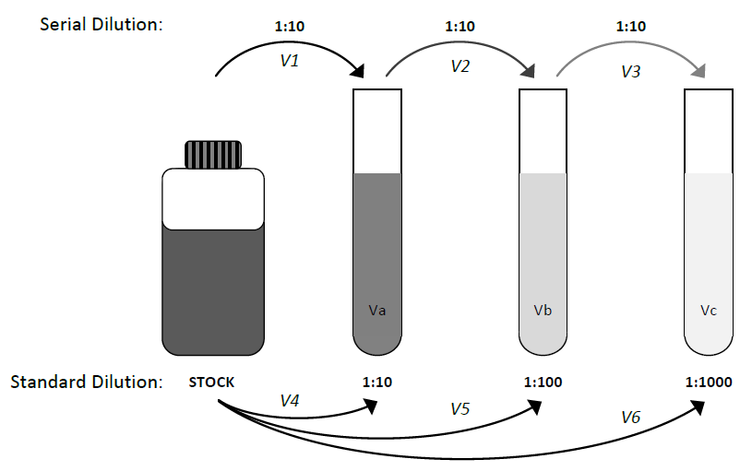

$$C_{1}V_{1} = C_{2}V_{2}$$

$$\left(\frac{\left[stock\right]}{10}\right)×V_{a} = \left[stock\right] ×V_{1}$$

$$V_{1} = \frac{\left(\frac{\left[stock\right]}{10}\right)×V_{a}}{\left[stock\right]}$$

$$V_{1} = \frac{V_{a}}{10}$$

$$\left(\frac{\left[stock\right]}{100}\right)×V_{b} = \left(\frac{\left[stock\right]}{10}\right) ×V_{2}$$

$$V_{2} = \frac{\left(\frac{\left[stock\right]}{100}\right)×V_{b}}{\left(\frac{\left[stock\right]}{10}\right)}$$

$$V_{2} = \frac{V_{b}}{10}$$
CARBOHYDRATES
Separation Techniques Based on Molecular Size

OVERVIEW

In this first lab, you will perform experiments that illustrate some of the fundamental properties of carbohydrates. Two different techniques, dialysis and gel filtration, will be used to demonstrate how differences in molecular weight allow separation of polymers from their monomers. You will also learn how different colorimetric assays are used to analyse carbohydrates.

LEARNING OBJECTIVES

Underlying molecular principles

- Identify the distinctive molecular features of common carbohydrates including mono-, di- and polysaccharides.
- Understand the underlying principles of analytical techniques used for the separation and analysis of carbohydrates: dialysis, gel filtration chromatography and various colorimetric assays (iodine reaction and glucose oxidase)

Hands-On skills

- Use of a dialysis bag to assess the differential permeability of a mixture of carbohydrates based on their molecular size
- Use of a gel filtration column to resolve a mixture of carbohydrates based on their molecular size
- Use of colorimetric assays to assess the concentrations of carbohydrates

Analytical skills

- Analyze the kinetics of diffusion through a dialysis membrane by comparing the internal and external concentrations of the different carbohydrates after a given incubation time.
- Evaluate the substrate specificity of the glucose oxidase
- Validation of colorimetric assays with positive and negative standards
  - Perform simple quantitative calculations relative to dilution problems and absorbance/concentration ratio (Beer’s law)

BACKGROUND

Carbohydrates and lipids are the main sources of energy in the organism. Carbohydrates occur most abundantly in plants, animals and microorganisms as polymers (polysaccharides or glycans), the polymerization conferring varying degrees of insolubility. The energy storage forms of glucose, starches of plants and glycogens of animal tissues, are homopolymers of glucose (glucans). Starch is composed of α-amylose and amylopectin. α-Amylose is a linear polymer of several thousand glucose units linked by α(1→4) glycosidic bonds. Amylopectin is a branched polymer of up to one million glucose residues. Units of linear polymer containing from 24 to 30 glucose residues with α(1→4) glycosidic bonds, are linked at branch points with α(1→6) glycosidic bonds (1).

The structural and functional carbohydrates are either homopolymers with "abnormal" linkages [β(1→4) cellulose; α(1→6) dextran] or heteropolymers of sugars, amino sugars, uronic acids, etc. (hyaluronic acid, mucoitin, chondroitin, etc.). Frequently they are also associated with proteins or lipids, where they play molecule-recognition roles in highly specific immunological and cell surface interactions. Depolymerization can be achieved not only by enzyme-catalysis (e.g. amylases, phosphorylases, hyaluronidase, etc.) but also hot-acid (but not by alkaline) hydrolyses (1).

The experiments performed here illustrate some of the fundamental properties of carbohydrates--properties by means of which they are recognized experimentally either in scientific investigation or routine analysis of living tissues and fluids. These properties are: the differences in molecular size between monomers and polymers, their susceptibility to specific enzymes action and their reactivity towards specific reagents. As an example, you will compare the reactivity of glucans from starch against iodine. Two different techniques, dialysis and gel filtration, are used here to illustrate how differences in molecular weight allow separation of polymers from their monomers.

A. Reducing Properties of Monosaccharides and Polysaccharides

Free aldoses and ketoses undergo the characteristic reactions of aldehydes and ketones. Thus, mild oxidation of glucose (aldose) produces the corresponding carboxylic acid (gluconic acid). However, if the anomeric carbon is blocked, i.e. involved in a glycosidic bond, as in amylose, the reaction will not take place. As a consequence, the reducing power of a polysaccharide diminishes with increasing degree of polymerization.

A variety of both inorganic (Cu++, Ag+, Fe+++) and organic (dinitrosalicylic acid, picric acid) oxidizing agents can be reduced by sugars. In addition, specific sugars, e.g., glucose, can be oxidized by molecular oxygen (O₂), catalysed by specific enzymes, e.g., glucose oxidase (2). The action of glucose oxidase (from Aspergillus niger) and O₂ produces gluconic acid and H₂O₂. The reaction is usually coupled with the action of a second enzyme, peroxidase, that catalyses the oxidation of o-tolidine by H₂O₂ that changes the dye colour to blue. Upon addition of strong acid, the oxidized dye turns to bright yellow (Figure 1). This is the basis of a highly specific enzymatic determination of glucose in physiological fluids.

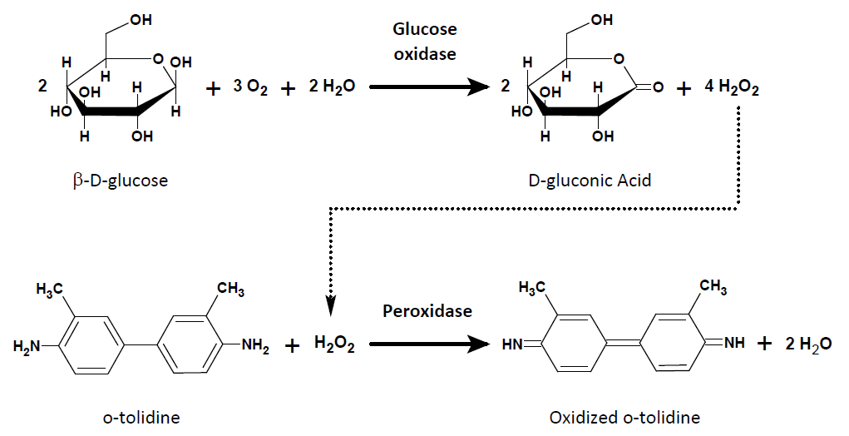

B. The Iodine Reaction
Figure 1. Glucose oxidase reaction. In the presence of oxygen (O₂), β-D-glucose is converted into D-gluconic acid and peroxide (H₂O₂) by the glucose oxidase. This peroxide is then used in a second coupled reaction to oxidize o-tolidine, allowing for the quantification of the first reaction due to the resultant color change.

(See animation in Virtual Campus Media Library)

Polysaccharides produce a characteristic colour when treated with a solution of iodine and potassium iodine (KI) (3). For example, amylose, which forms a left-handed helix with 6 glucosyl residues per turn, yields an intense blue colour upon binding of iodine atoms. A minimum chain length of 6 turns of the helix is required for formation of the complex with clusters of iodine atoms (penta-iodide anions, I₅⁻) lying within the helical cavity. Depolymerization of the amylose molecule leads to a gradual loss of its capacity to bind iodine as the molecule shortens. Furthermore, the amylose-I₂ complex is reversibly dissociated by heating. Branched polysaccharides, with interrupted helices (e.g., amylopectin), give less intense colours. Glycogen, which is highly branched, may give a reddish-brown colour depending on its source (3, 4).

C. Separation Techniques Based on Molecular Size
(See animation in Virtual Campus Media Library)

In this laboratory session, you will use two different techniques to separate carbohydrates of different sizes.

(A) Dialysis

Dialysis consists of the separation of large molecules from small molecules by selective diffusion of the small molecules through a semipermeable membrane (2, 5 and 6) (Figure 2). The technique involves sealing an aqueous solution of both macromolecules and small molecules in a sack of cellulose or other suitable material. The sealed sack is placed in a large volume of the aqueous medium.

The membrane pores are too small to allow diffusion of molecules greater than about 10,000 Da (for the standard membrane, though cellulose dialysis tubing is available with a molecular weight cut-off ranging from 1,000 to 50,000 Da). Smaller molecules leave the sack until the concentrations inside and outside the bag are equal. The equilibrium is reached faster when the outside medium is stirred and, usually, takes from 4 to 6 hours.

The diffusion velocity increases also with the temperature and with the surface/volume ratio of the solution being dialysed. Obviously, the volume ratio between the aqueous medium at both sides of the membrane determine the amount of small molecules removed from the sack.

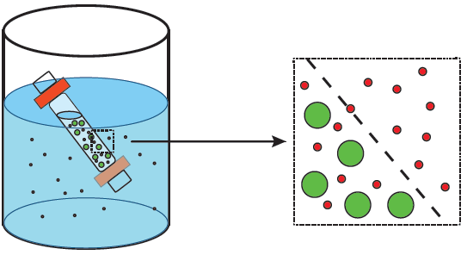
Figure 2. Dialysis system. Molecules that exceed the MW cut-off of the pores (green or light grey) remain trapped in the dialysis tubing. Those molecules, which are small enough to pass thorough the membrane pores (red or dark gray), diffuse to the external solution until equilibrium is reached between the internal and external solutions.

The kinetics of dialysis follows the exponential equations:

$c_{1}-c_{2}=c_{o}e^{-β t}$ [1]
$\left(c_{1}-c_{eq}\right)\left(1+α\right)=c_{o}e^{-β t}$ [2]
$\left(c_{eq}-c_{2}\right)=c_{eq}e^{-β t}$ [3]

where: c₁ and c₂ indicate the concentrations inside and outside of the bag at time t.

c₀ and c_{eq} indicate the concentrations at time zero and at equilibrium.

α = V₁/V₂ is the volume ratio between the two compartments at time zero.

t is the dialysis time in minutes.

β (a time constant) is a function of the apparent diffusion coefficient (D’, cm/min) and the bag radius (r, cm).

$β=2\left(1+α\right)D'/r$ [4]

D’ is characteristic of the porosity and thickness of the membrane, the temperature, the diffusing molecule and the liquid medium. It represents the moles of solute that diffuse through the membrane (thickness in cm),per minute, when there is a 1 molar gradient of concentrations.

It can easily be shown that:

$c_{eq}=\frac{c_{o}α}{\left(1+α\right)}=\frac{c_{o}V_{1}}{\left(V_{1}+V_{2}\right)}$ [5]

For a system with a β = 0.025 min-1 and V₁ / V₂ = 0.05, the change with time in concentration and mass in the two compartments will follow the plots in Figure 3.

Non-mediated transport of molecules across biological membranes by passive diffusion is governed by the same kinetics equations shown for dialysis.

A)
B)

Figure 3. Dialysis kinetics. A) Small molecules diffuse out of the dialysis bag decreasing their concentration inside the dialysis bag (c₁) with a proportional increase in the external solution (c₂) until an equilibrium is reached (c_{eq}). B) This process can be followed experimentally by measuring the product (m) of a colorimetric assay showing the direct relationship between the concentration of carbohydrates both inside (m₁) and outside (m₂) the dialysis bag as diffusion occurs.

(B) Gel filtration chromatography

Also called size exclusion chromatography, it is a separation technique based on molecular size (Stokes radius, radius of gyration) which makes use of hydrated beads with a highly controlled porosity (2, 5 and 7). (For a general introduction to chromatography see ref. 8).

A mixture of sample molecules is applied to the column of hydrated beads, and eluted with an aqueous buffer. Figure 4 shows how molecules within the sample mixture that are smaller than the pore size of the beads are free to enter the beads; once within the bead their migration relative to the flow of eluant outside the bead is greatly reduced. Thus molecules smaller than the pore size are retained in the column longer than those molecules that are excluded.

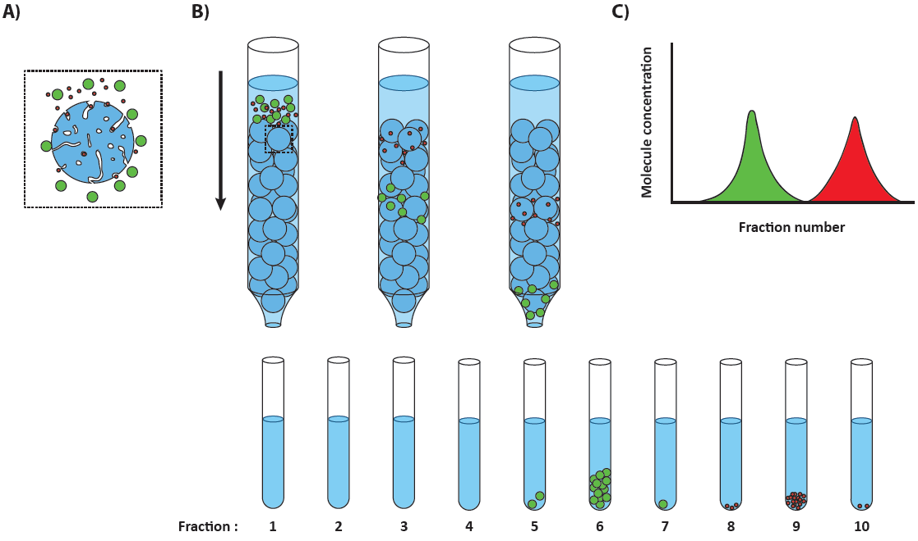

Figure 4. Gel filtration chromatography. Following the application of a mixture of molecules to a gel filtration column, molecules smaller than the pore size (dark gray or red) enter the beads (A) slowing their passage through the column, allowing the larger molecules (light gray or green) to be eluted in the earlier fractions (B). Assaying for carbohydrate concentration and plotting these values against their fraction number allows for visualization of this molecular separation (C).

The beads are generally of two different types; the first are plant polysaccharides (starch and agarose) which are branched-chain polymers interlinked by hydrogen bonds to give pores of specific dimension. The second, generally more useful, bead type consists of either natural dextran (polyglucose) fibres or synthetic (polyacrylamide) polymeric compounds in which the long chains are cross-linked at regular, chosen intervals. With these, one can obtain beads of defined porosity ranges so that separation can be optimized for a given application. You will use one of the most common dextran-based gels, known as Sephadex from the GE Healthcare life science.

Figure 5 shows the relationships that exist between the total volume (V_{t}) of a column, the internal volume (V_{i}) of the bead, the impermeable volume of the bead and the void volume (V_{o}) of the column, that is to say the volume between the beads after the beads are packed into the column:

$V_{t}= V_{i}+V_{o}+impermeable bead volume$ [6]

When using gel-filtration, the void volume must be known so that fractions of eluant containing only molecules larger than the pore size of the gel may be isolated from those containing the range of molecules that permeated the bead matrix. To do this, a marker molecule known to be large enough to be totally excluded from the gel is passed through the column and the volume of eluate (Ve) required to elute the marker is measured. Because the marker (often dextran blue, molecular weight 2,000,000) is unable to penetrate the pores,

$V_{e} for dextran blue= V_{o}$ [7]

From this relationship one can develop further relationships for molecules small enough to enter the pores of the beads; this demands the presence of a distribution coefficient (K_{d}) to correlate the size of the molecule and its ease of pore penetration. For a molecule small enough to enter the gel pores:

$V_{e}=V_{o}+V_{i}K_{d}$ [8]

therefore: $K_{d}=\left(V_{e}-V_{o}\right)/V_{i}$ [9]

If the molecule is very small, K_{d} = 1 so that the V_{e} = V_{o}+V_{i}; if the molecule is very large (K_{d} close to 0) so at the limit of the pore size V_{e} = V_{o}. Experimentally, it has been found that even for very small molecules K_{d} is smaller than 1 (about 0.8) because all of the volume V_{i} is never in fact available to the solute. If K_{d} is experimentally determined to be greater than 1, the molecule in question is being retarded by factors such as absorptivity to the matrix in addition to pore size effects. The value V_{e} for a given solute depends upon the column size (V_{o}, V_{i}, etc) whereas K_{d} depends only on gel type and solute.

Because all of the volume is never fully available to the solute, K_{d} is operationally replaced with K_{av}, the average distribution coefficient:

$K_{av}=\frac{\left(V_{e}-V_{o}\right)}{\left(V_{t}-V_{o}\right)} and 0≤K_{av}≤1$ [9]
and
$V_{t}=π{\left(d/2\right)}^{2}h$ (d, diameter, h, height) [10]

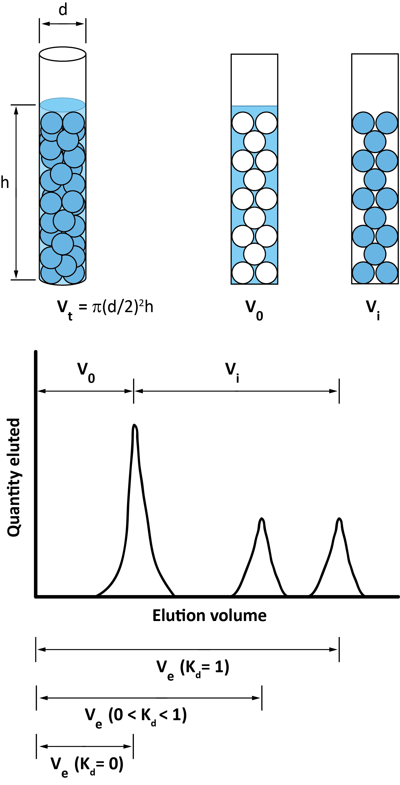

Figure 5. Gel filtration column. The total volume of a column (V_{t}) can be calculated mathematically based on the column dimensions and packing. It is the sum of the void volume (V_{o}, the total volume of the mobile phase when excluded from the beads), the internal volume of the beads (V_{i}) and the impermeable bead volume. Experimentally the volume of eluant (V_{e}) needed to elute a molecule from the column is a function of its distribution coefficient (K_{d}): where K_{d} = 0 represents complete exclusion from the beads (or V_{o}), K_{d} = 1 represents all molecules enter the bead.

A column is optimized using a set of standards to identify the specific size range over which a linear relationship between the log MW and K_{av} (Figure 6) is observed. This calibration curve can then be used experimentally to estimate the molecular weights for unknown globular macromolecules whose K_{av} fall within this linear range.

Figure 6. Molecular weight determination. A calibration curve generated using known standards identifies the linear range (blue diamonds) in which an experimentally determined K_{av} value can be used to estimate the MW of the eluted molecule.
PROCEDURES

In experiments 1 and 2 you will perform the separation of glucose (MW: 180) from starch, a mixture of two polymers of glucose: amylose and amylopectin, both with MW higher than 100,000. In experiments 3 and 4 you will assay the samples that you have prepared. Although the following protocol describes the different operations in a logical sequence, you can perform some operations in a different time sequence, for instance, you can determine the fractions to be tested (steps 11 and 12) before the chromatography is finished (step 10). We suggest the tasks distribution and sequence described in the flow chart following the protocol.

Before performing these experiments, you should watch the following videos:

- Chromatography (4:42) or (http://www.youtube.com/watch?v=qfJtmtpAJ_Q)
- Dialysis (1:36) or (http://www.youtube.com/watch?v=BDf52odj5b8)

You should also watch the animation:
- Dialysis
- Gel filtration chromatography
- Carbohydrates tests

They are located in the Media Library tool of the course website in the Carbohydrates Laboratory folder.

EXPERIMENT #1: Dialysis

- Fill a small 50 mL beaker with distilled water and soak in it the provided piece of cellophane dialysis tubing (1.6 cm diameter, 2.0 mL/cm, MW cut-off: 12000-14000 Da) for 5 min to remove the glycerol and other storage additives.

- Remove the dialysis tube from the water and make a dialysis bag by closing one end with an orange clip.

- Fill the bag with 10 mL of the starch, glucose solution. Put aside a 1 mL aliquot of the starch and glucose solution for glucose and starch analysis to be performed in experiments 3 and 4.

- Close the bag with a second clip, try to remove as much air as possible. Place the closed bag in a large beaker filled with 200 mL of distilled water and stir the water using a stirring plate for at least 45 min, until you finish the chromatography (experiment 2). Take note of the time of dialysis in minutes.

- Stop stirring, remove the dialysis bag from the beaker, and pour its content into a 25 mL cylinder.

- You will assay the internal (in the dialysis bag) and external (in the beaker) solutions for glucose and starch in experiments 3 and 4.

EXPERIMENT #2: Gel filtration chromatography

Prior to your starting the lab session, the technician has loaded a chromatography column with Sephadex to be used by two teams. The empty glass column (1.0 cm x 50 cm) was clamped in a VERTICAL position. Pre-swollen Sephadex G-25 (MW cut-off: 5000) in distilled water was poured inside the column, using a glass rod, in a smooth continuous motion to avoid trapping air bubbles.
Once the Sephadex had settled, the flow adaptor was adjusted on top of the gel, removing all air and liquid but without compressing the gel bed. The inlet of the column was then connected to the T valve. The other two channels of the T valve were connected to the elution buffer reservoir (the Mariotte flask) and to the sample syringe. The outlet tube from the column was connected to a fraction collector that was already loaded with a rack full of tubes (Figure 7).
Note: Two teams will perform the chromatography together, but they will do the measurements of glucose and starch separately, each team using half of the fractions content.
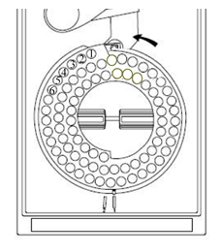
Figure 7. Fraction collector (top view). The tube rack rotates counter clockwise collecting each fraction in a new tube.

- Set the fraction collector to 100 drops (See User manual link in the reference section).

- Apply to the column 0.5 mL of the same starch - glucose solution that was used for the dialysis experiment: a) connect the sample syringe to the column with the T valve; b) open the stopcock valve at the exit of the column. Keep an eye on the syringe and close the stopcock valve before any air enters the line connecting the syringe to the column. (The syringe empties in about 15 seconds).

- Elute the column by a) connecting with the T valve the column and the Mariotte reservoir that contains distilled water and b) opening the stopcock in the outlet of the column.

- After 15 fractions have been collected, close the column stopcock and stop the fraction collector. (The collection of the 15 fractions takes about 40 minutes).

- Measure the average volume per fraction by measuring individually the volume of three random fractions in a 10 mL cylinder. (This value will be used to estimate the fraction numbers corresponding to V_{o} and V_{t}).
NOTE: The void volume of the column (V_{o}) has been previously determined by measuring the elution volume of blue dextran. Please get its value from your TA. The total volume of the column (V_{t}) can be calculated from the gel height (equation [10]). Make sure to measure the gel height of the column.

- Assay all 15 fractions for glucose and starch.

- After the analysis of fractions, dispose of used tubes and reload the carousel with new tubes.

EXPERIMENT #3: Glucose oxidase assay

Perform the test on:

Table 1. Glucose oxidase assays
Reagents |  | Volume (mL)
 |  | Sample | Water | Total
a | Blank | - | 0.6 | 0.6
b | Glucose standard (1.5 mg/mL) | 0.6 | - | 0.6
c | Starch standard (0.20 mg/mL) | 0.6 | - | 0.6
d | Initial starch/glucose mixture | 0.025 | 0.575 | 0.6
e | Final internal solution | 0.12 | 0.48 | 0.6
f | Final external solution | 0.6 | - | 0.6
g | Each fraction | 0.6 | - | 0.6

- Add 1.2 mL of glucose oxidase-peroxidase reagent (0.004 mg/mL glucose oxidase, 0.02 mg/mL peroxidase, 0.01 % tolidine in 0.15 M acetate buffer pH 5.0) to each test tube. Mix and Incubate for 10 min at room temperature. Observe if any blue colour develops.

CAUTION! o-tolidine may cause cancer and it is toxic to aquatic organisms. Wear gloves and safety glasses and discard solutions in indicated container. For more information see: http://www.sciencelab.com/msds.php?msdsId=9927299

- Stop the reaction by adding 0.1 mL of 2N H₂SO₄. Observe the colour change. Solution b is a positive control of your assay, sample a is the blank. Can you predict which samples will give a positive response?

- Determine the intensity of the yellow colour by reading the absorption at 420 nm (Zero the apparatus with water only). Subtract the reading for a (blank = water with reagents) from all the other readings.

- Since we are quantifying the same product in all our samples, the oxidized o-tolidine, the absorbance is proportional to the concentration in the assay. Therefore, using the sample b as a standard, the glucose concentration in solutions from d to g can be estimated from (see also Appendix C2):

$$\frac{A_{b}}{c_{b}}=\frac{A_{d}}{\left(\frac{0.025}{0.6}\right)c_{d}}=\frac{A_{e}}{\left(\frac{0.12}{0.6}\right)c_{e}}=\frac{A_{f}}{c_{f}}=\frac{A_{g}}{c_{g}}$$

NOTE: When the aliquot from the sample is different from the standard aliquot, the sample concentration must be multiplied by an aliquot factor (the fraction of the sample volume in the assay, 0.6 mL). For sample d, for instance:

concentrations of standard b and sample d: c_{b} and c_{d}

concentration of standard b in the 1.8 mL assay: (c_{b} x 0.6)/1.8

concentration of sample d in the assay: (c_{d} x 0.025)/1.8

so: A_{b} / (0.6 c_{b}/1.8) = A_{d} / (0.025 c_{d} /1.8) , A_{b} / 0.6 c_{b} = A_{d} / 0.025 c_{d}

or A_{b} / c_{b} = A_{d} / (0.025/0.6) c_{d}

EXPERIMENT #4: Iodine reaction

Perform the test on:

Table 2. Iodine assays
Reagents |  | Volume (mL)
 |  | Sample | Water | Total
a | Blank | - | 1.6 | 1.6
b | Glucose standard (1.5 mg/mL) | 0.6 | 1.0 | 1.6
c | Starch standard (0.20 mg/mL) | 0.6 | 1.0 | 1.6
d | Initial starch/glucose mixture | 0.1 | 1.5 | 1.6
e | Final internal solution | 0.1 | 1.5 | 1.6
f | Final external solution | 0.6 | 1.0 | 1.6
g | Each fraction | 0.6 | 1.0 | 1.6

- Add 75 μL of iodine solution (5 mM I₂, 10 mM KI). Observe the colour. Solution c is a positive control of your assay. Can you predict which samples will give a positive response?

CAUTION: Iodine is harmful for man and the environment. Wear gloves and safety glasses and discard solutions in indicated container. For more information see: http://www.sciencelab.com/msds.php?msdsId=9927547

- Determine the intensity of the colour by reading the absorption at 600 nm. (Zero the apparatus with water only). Subtract the reading for a (water with reagent) from all the other readings.

- As for the previous assay, using sample c as a standard, the starch concentration in solutions d to g can be estimated from the absorbance corrected by the blank, using the expression:

$$\frac{A_{c}}{c_{c}}=\frac{A_{d}}{\left(\frac{0.1}{0.6}\right)c_{d}}=\frac{A_{e}}{\left(\frac{0.1}{0.6}\right)c_{e}}=\frac{A_{f}}{c_{f}}=\frac{A_{g}}{c_{g}}$$

RESULTS AND DISCUSSION

Dialysis

- From the absorbance readings of experiments 3 and 4 estimate the glucose and starch content of the two dialysis compartments at both the initial and the end point of the dialysis. Present your results as in Table 3, below. Show an example of calculations for both. Write down a brief (not more than 10 lines) analysis of your data.
Table 3: Dialysis results
t (min) | Glucose |  |  |  |  |  | Starch
t (min) | A₄₂₀ Internal solution | c₁ (g/L) | m₁ (mg) | A₄₂₀ External solution | c₂ (g/L) | m₂ (mg) | A₆₀₀ Internal solution | c₁ (g/L) | m₁ (mg) | A₆₀₀ External solution | c₂ (g/L) | m₂ (mg)
0 |  |  |  | ----- | 0 |  |  |  |  | ----- | 0

- Using equation [5], estimate the glucose concentration at the equilibrium.

- From the final value of c₁ and using equations [2] and [4], estimate the apparent diffusion coefficient D’ (cm/min) of glucose across the dialysis membrane in your experimental conditions. Show your calculations.

Gel filtration

- Summarize your quantitative results from steps 17 and 20 in the following table (Table 4). Provide your full calculation details for one fraction.

Table 4: Column elution results
Fraction |  | Glucose |  |  | Starch
# | Elution Vol. (mL) | A₄₂₀ | c  (g/L) | Mass  (mg) | A₆₀₀ | c  (g/L) | Mass  (mg)

- Plot the concentrations of glucose and starch from Table 4 against the elution volume. How many peaks do you observe for glucose and for starch? Is that what you expected Explain.

- Calculate the average distribution coefficient (K_{av}) of the starch and glucose? Is it what was expected? Explain.

- Estimate the recovery yield (%) of your column for (1) glucose and (2) starch. Provide your full calculation details. What can you conclude from those two recovery yields assuming that in optimal conditions the recovery yield should be close to 100%? Provide two sources of error.

REFERENCES

- Voet, D. and Voet, J. (2004). Biochemistry 3rd Ed. John Wiley & Sons, 11.2, p 362.

- Robyt, J.F. and White, B.J. (1987). Biochemical Techniques. Theory and Practice. Waveland Press (Illinois), pp 88, 221, 263.

- Stenesh, J. (1984). Experimental Biochemistry. Allyn and Bacon (Boston), p 237.

- Saenger, W. (1984). Naturwissenschaften 71, 31-36.

- Boyer, R. (2000). Modern Experimental Biochemistry. 3rd edition. Benjamin Cummings (San Francisco), pp 48,79.

- Voet, D. and Voet, J. (2004). Biochemistry, 3rd Ed. John Wiley & Sons, 6.3Bc, p 139.

- Voet, D. and Voet, J. (2004). Biochemistry, 3rd Ed. John Wiley & Sons, 6.3B, p 136.

- Voet, D. and Voet, J. (2004). Biochemistry, 3rd Ed. John Wiley & Sons, 6.3, p 133.

- Bevilacqua, L. and Rodriguez, M. A. (2006). Chromatography. Tutorial notes V.

Web references for the materials used in the lab

Fraction Collector 2110: Instructions Manual. Bio-Rad Laboratories, M7318120 Rev G.
http://www.bio-rad.com/webroot/web/pdf/lsr/literature/M7318120G.pdf

Sephadex
http://www.gelifesciences.com/webapp/wcs/stores/servlet/catalog/en/GELifeSciences-CA/brands/sephadex/

AMINO ACIDS AND PROTEINS
Electrophoresis and Ion-Exchange Chromatography

OVERVIEW

This week, you will separate the three components of a mixture of glycine, aspartic acid and lysine by performing an ion-exchange chromatography. Using a gradient of increasing pH, these amino acids can be eluted in the order of their isoelectric point. During the second part of this laboratory session, you will determine the MW of an unknown protein by performing an electrophoresis on a polyacrylamide gel in the presence of SDS.

LEARNING OBJECTIVES

Underlying molecular principles

- Review the molecular structure of amino acids
- Discuss the underlying molecular principle of ion exchange chromatography
- Discuss the underlying principle of protein analysis by SDS polyacrylamide gel electrophoresis

Hands-On Skills

- Separate a mixture of amino acids by ion-exchange chromatography
- Set up of an electrophoresis box for protein analysis by SDS polyacrylamide gel electrophoresis

Analytical Skills

- Discuss the pH-dependent protonation of the amino and carboxylic functional groups of glycine, lysine and aspartic acid.
- Plot the log of the molecular weight of the proteins composing the protein markers vs migration distance of the same proteins to estimate the size of unknown protein band

BACKGROUND

Even an elementary knowledge of biochemistry emphasizes the tremendous importance of proteins to the living organism. They fulfill a variety of specific functions - all undoubtedly rooted in their specific physical and chemical properties. While highly specific proteins obviously differ one from another, there are general features which most have in common. This is due to the fact that they are polymers formed from the same amino acid monomers. It seems likely that the specificity of function of a given protein is based on a structure, conformation and associated properties which have been programmed into the molecule from the selection of amino acids of which it is composed and the precise sequence in which they are inserted into the molecular chain. The general properties of the protein molecule which are of biochemical and analytical interest are:

a) They are large "colloidal" molecules bearing prototropic groups and hence have a pH-dependent distribution of + and - charges as well as the possibility of interaction between them.

b) The large molecular surface can interact with small molecules. This can have considerable specific biological (enzyme-substrate, enzyme-coenzyme interactions, transport proteins, etc.) and analytical significance. It can also have considerable chemical significance, since some of the residues may be buried deep in the protein molecule and may only be experimentally "seen" when the molecule is denatured.

The chemical reactivity of the protein molecule is due to the component amino acids. The peptide bond exhibits a characteristic and useful reactivity that is not found in the free amino acids. For instance, proteins form coloured complexes with dilute alkaline Cu⁺⁺ solution (Biuret reaction). Other reactions are characteristic of the amino acid itself and are given both by the amino acid and the protein which contains it, provided that the reactive group is not masked in the interior of the protein molecule. For example, the thiol group of the cysteine residue can be alkylated by reacting with N-ethyl maleimide.

Finally, some reagents react only with free amino acids and not with those involved in peptide bonds. For instance, the α-amino group of amino acids (and possibly the ε amino of lysine residues, depending on the conditions) is oxidized by ninhydrin with the liberation of ammonia. The NH₃ liberated and the ninhydrin reduction-product then condenses with another molecule of ninhydrin to form a violet compound. This constitutes one of the most generally used amino acid reactions. Proline and hydroxy-proline do not give a violet colour (they lack the free α-amino group), but they do give a yellow colour.

A. Ionic Properties

All amino acids are ampholytes; that is, they contain at least one acidic (carboxyl) group and one basic (α-amino) functional group. Some amino acids contain other readily ionizable groups: amino, carboxyl, guanidium and imidazole groups. Since the basic structure of the polypeptide chain involves the linkage of the carboxyl group of one amino acid to the amino group of the adjacent amino acid, the ionic character of the polypeptide is due largely to these additional ionizable groups, together with the terminal amino and carboxyl groups. Accordingly, proteins and polypeptides are usually good polyelectrolytes and have characteristic titration curves and isoelectric points (pI).

B. pH Measurement

Modern pH meters use a combination electrode that, in fact, consists of two electrodes encased in a single probe (Figure 1). The pH sensitive electrode is coaxial with the probe, and is enclosed in a glass tube that ends in a glass bulb permeable to protons. The reference electrode is an annular chamber surrounding the pH-indicating electrode. In our case, the reference electrode is a silver/silver chloride electrode that consists of a silver wire in a chamber filled with a 4M KCl solution saturated with AgCl. The outside wall of the reference electrode is equipped with a membrane junction that closes the circuit between the two electrodes by establishing an electric contact through the sample solution. For a proper measurement, both the pH measuring glass bulb and the reference electrode junction must be immersed in the solution being measured. The amount of protons diffusing across the glass bulb and reaching the pH-measuring electrode is proportional to the H⁺ concentration in the sample. Therefore, the voltage difference between the two electrodes reflects the proton concentration in the sample.

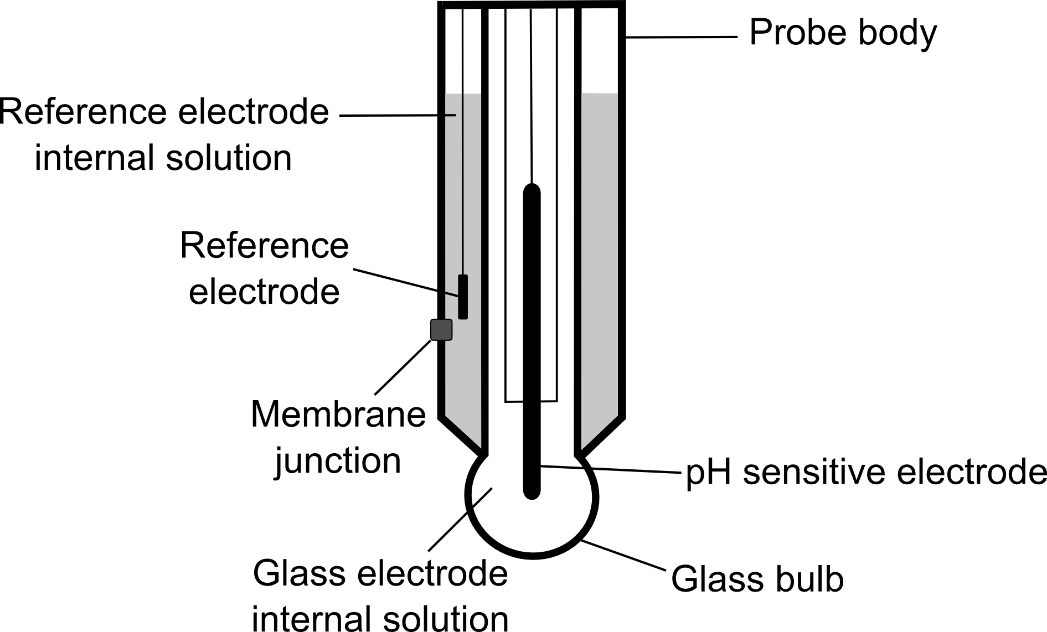
Figure 1. Combination electrode. This schematic of a combination pH electrode shows both the reference electrode and the pH sensing electrode in a single housing. The membrane junction allows an electrical circuit to be completed between the internal reference solution and the external sample of interest where the difference in electrical potential represents the pH.

C. Ion-exchange Chromatography

Ion-exchange chromatography (1-4) is a separation technique based on the affinity of a charged molecule for an oppositely charged support matrix. CATION EXCHANGE is a process by which a positively charged ion (cation) exchanges with another cation that is bound to a negatively charged immobile phase (Figure 2). The reverse process (negatively charged molecules exchanging binding to a positively charged matrix) is termed ANION exchange. The support matrix is an insoluble polymer (cellulose or polystyrene) into which are introduced acidic or basic functional groups; depending upon the intended usage of the support matrix, it will include varying proportions of strong and weak acids and/or strong and weak bases. The strong acids (usually -SO₃⁻) and bases (usually -NH(CH₃)⁺³) allow the ion exchanger to exchange ions over wide ranges of pH while the weaker functional groups (-COO⁻ and -CH₂CH₂NH(CH₂CH₃)⁺²) offer exchange only within the limited range of pH in which they are ionized.

Figure 2. Cation Exchange principle. A) A column is packed with negatively charged polymer beads. B) A sample is introduced into the column and the molecules interact preferentially with the beads based on their charge. C) As the pH is increased the charges on the functional groups of the sample of interest and the beads are changed, altering their interaction and leading to the elution of the sample. The neutral molecules (yellow) elute first, followed by the weakly positive molecules (red) and finally the most positively charged molecules (green). Measuring the protein concentration in each sample and plotting it against the pH allows for the visualization of the separation of molecules using this technique.

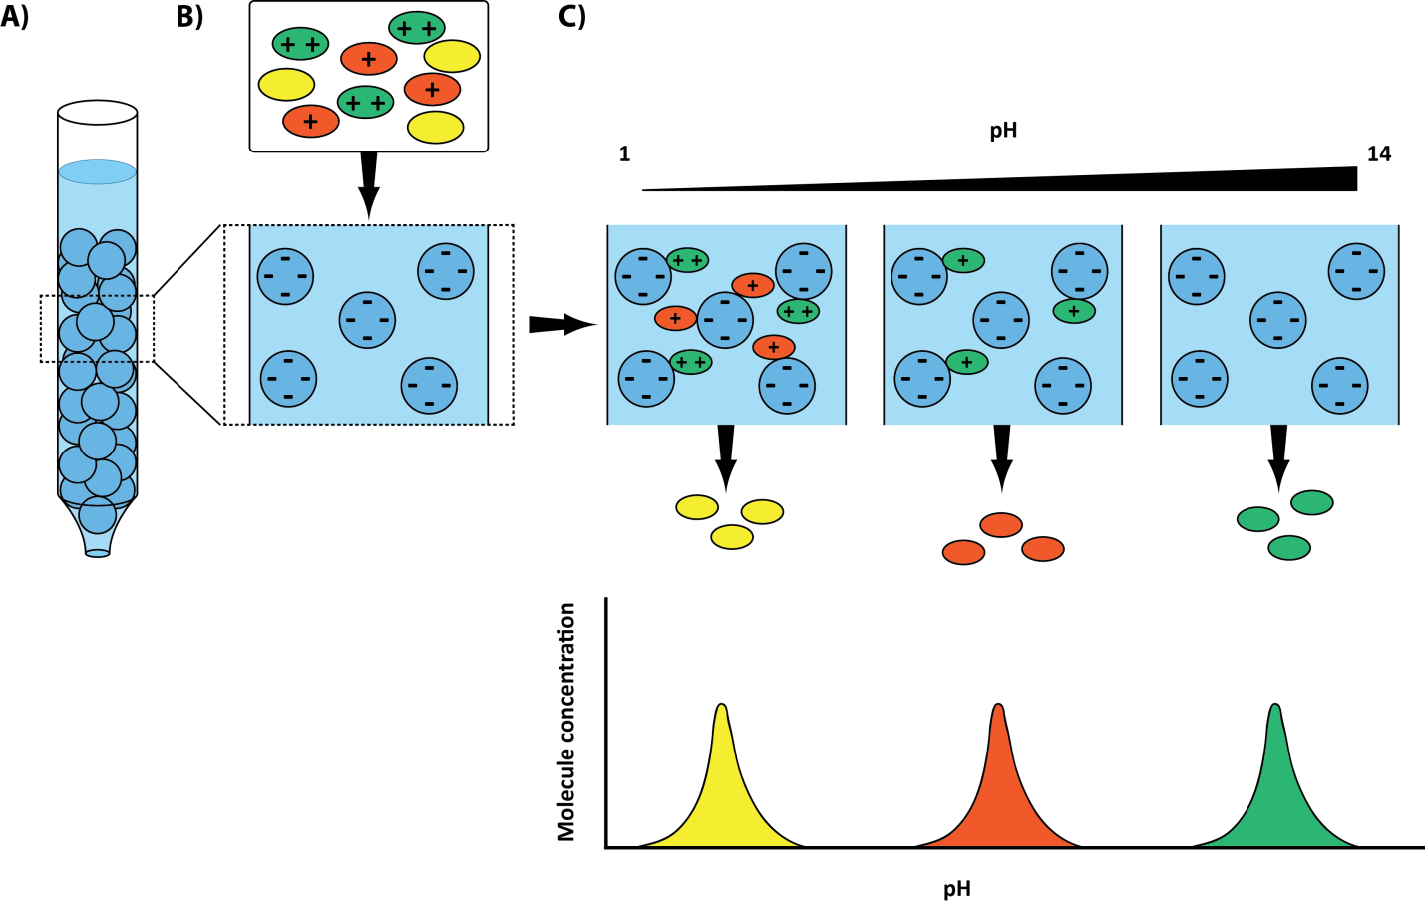

Ion-exchangers are typically used in columns; after equilibration in a buffer of a given pH, a sample is applied and the column washed with the same buffer. The first eluant will contain sample molecules bearing no net charge or a charge equal in sign to that of the ion exchanger at the chosen pH. The column-bound molecules may be eluted by changing one or both of two factors: buffer pH or ion concentration. By changing the buffer pH, the functional groups in the sample and the ion exchanger will change their charges and so will have less tendency to retain the sample molecules originally bound.

The second method of elution requires increasing the ionic concentration of the buffer. The ions in solution will compete with the matrix-bound functional groups for the binding of the sample molecules. Thus weakly charged molecules will be eluted first and strongly charged ones later. In practice, one often changes both pH and ionic strength (simultaneously or in sequence) so that after an initial washing of the column, a desired molecule can be selectively eluted by changing to a buffer whose pH/ionic strength will alter the charge of that specific molecule alone and allow its elution with little or no contamination.

Ion-exchangers are used in both preparatory batch processes and in analytical procedures with carefully controlled pH and ionic strength gradients.

D. PAGE (Polyacrylamide Gel Electrophoresis)

When an electric potential difference is applied to two electrodes immersed in a solution of substances whose molecules bear an electric charge, the electrostatic attraction causes movement of the charged particles towards the electrode of opposite charge. The phenomenon is called electrophoresis and may lead to discharge at the electrode, electrolysis, if the particle reaches it at the appropriate potential. The sample is usually applied to a porous solid support, such as a gel, wetted with the appropriate buffer. The porous support not only decreases diffusion but it also provides a ‘molecular sieving’ effect. For proteins separation, the most common support is a gel of polyacrylamide poured between 2 glass plates forming a very thin vertical slab (Figure 3).

Figure 3: Slab gel electrophoresis apparatus

Three kinds of polyacrylamide gels are commonly used: gels prepared with an uniform concentration of acrylamide, gels with an increasing gradient concentration of acrylamide and gels with a top band of low acrylamide concentration (stacking gel) and the rest of the gel with a higher concentration of acrylamide (resolving gel).

The porosity of the gel is inversely related to the acrylamide concentration. The rate of electrophoretic migration of a protein is a function of the pore size of the support matrix, the voltage gradient and the charge and "size" of the protein; the latter parameter combines molecular weight and conformational effects (5-8).

The overall size of a protein molecule is determined by the folding of the protein and by the presence of intra- or intermolecular disulphide bridges. These bridges can hold the folded molecule together or form polymers of protein molecules by linking different molecules together. To be able to distinguish between these folding and bridging effects, the sample can be treated to insure that all molecules have the same conformation, thereby making migration solely dependent upon molecular weight and electrical conditions.

This treatment involves dissolving the sample in a buffer containing 1-2% sodium dodecyl sulfate (SDS, a detergent) and 0.5-1.0 M β-mercaptoethanol (SHCH₂CH₂OH). Mercaptoethanol reduces -S-S- cross-linked polymers to monomers and SDS binds to all proteins at a high ratio (1.4 g SDS/ g protein) and unfolds the protein in doing so. Since at the pH used for the electrophoresis SDS is negatively charged, the complex SDS-protein becomes negative with a charge density that is independent of the protein size. Thus, the mobility in polyacrylamide gel electrophoresis (PAGE) is independent of the protein charge and is solely dependent on the protein molecular weight.

A linear relationship is obtained when the log molecular weight of standards is plotted against mobility, thus serving as one of the major means to determine protein molecular weight. This technique (SDS-PAGE) has become the most widely used technique for determining the molecular weight of a protein (7) and is now generally used to analyse proteins by the Western blot method.

Once separated, the components of the sample may be recognized by a variety of means such as staining with Coomassie Blue R or other stains.

PROCEDURES

Before performing these experiments, you should watch the following videos:

- Ion exchange overview (10:18) or (http://www.youtube.com/watch?v=uSeduA9Kz8U)
- How to use a pH meter (10:02) or (http://www.youtube.com/watch?v=dN4yOJaarpE)
- SDS-PAGE overview (6:17) or (http://www.youtube.com/watch?v=K_ohMfAISYU)

EXPERIMENT #1: Ion exchange chromatography of amino acids

In this experiment you will separate the three components of a mixture of glycine, aspartic acid and lysine by performing an ion-exchange chromatography on DOWEX-50W-X (http://www.sigmaaldrich.com/catalog/search/ProductDetail/FLUKA/44464), a cation ex-changer resin that behaves like a very strong acid so that at pH 3 it is fully ionized negative. At low pH most amino acids bear a net positive charge, the carboxylic groups being partly or totally protonated; hence they will bind to the resin. By using a gradient of increasing pH, the amino acids can be eluted in the order of their pI's (isoelectric point, 9), although other forces may also intervene (2-4). You will generate an increasing pH gradient from 4.0 to 12.5 by combining two phosphate buffers at these pHs. You will prepare the final phosphate buffer at pH 12.5 by neutralizing the acid form of the buffer (H₂PO₄⁻) with a strong base (NaOH). (At which pH(s) does phosphate have an optimal buffering capacity?)

The order of elution is based upon the differences in the relative number and strength of the basic and acidic groups in the amino acids. Aspartic acid is most acidic; glycine is intermediate; and lysine is the most basic. Both the pH and the ionic strength of the eluant affect the elution pattern. The pH determines the charge on the amino acids; the larger the charge, the more strongly is the amino acid held by the anionic resin. Increasing the ionic strength facilitates the elution of a charged compound. The eluted amino acids will be assayed by the ninhydrin reaction. (Can you predict the order of elution for the three amino acids in your sample?)

Procedure

The DOWEX column was pre-packed in the following way: The resin was thoroughly suspended in 0.1M NaH₂PO₄, pH 4.0, and poured into the column in one continuous motion to avoid trapping air bubbles that will form channels within the column. Opening the exit valve, the buffer was allowed to drain and the resin to settle. The flow adaptor was then adjusted, removing all the air and without compressing the resin bed. The column was connected to the gradient maker and the sample dispenser.

Note: Two teams will perform the chromatography together and share the same pH reading, but they will do separately the measurements of amino acid concentration, each team using half of the fractions content.

- Prepare 50 mL of 0.1M NaH₂PO₄, pH 4.0. (Dilute the right amount of the 0.5M NaH₂PO₄, pH 4.0, stock solution using a volumetric flask).

- Prepare 50 mL of 0.1M Na₂HPO₄, pH 12.5 in a 50 mL beaker, using the stock solutions of 0.5M NaH₂PO₄, pH 4.0, and 4.0M NaOH. Dilute the required amount of NaH₂PO₄ in a volume of about 30 mL of water. Titrate this solution to a pH of 12.5 with the NaOH, and then complete the volume to 50 mL with water in a volumetric flask.
CAUTION! You are using a concentrated solution of a corrosive base that can harm your skin or eyes.
Wear gloves and safety glasses.

- Adjust the fraction collector to 120 drops per fraction.

- Fill the capillary tube connecting the gradient maker and the T-valve with 0.1 M NaH₂PO₄, pH 4.0. First set the T-valve connecting the gradient maker with the syringe. Let the 10 mL phosphate solution already in the syringe run through the capillary tube by gravity to remove any air trapped in the tube. Close T-valve connection towards the gradient maker before the solution in the syringe runs out.

- Fill the communication tube between the two compartments of the gradient maker with 0.1 M NaH₂PO₄, pH 4.0. Make sure that the communication tube contains no air, then close the communication valve. Remove excess buffer from the gradient maker and the syringe. Fill the exit compartment of the gradient maker with 35 mL of 0.1M NaH₂PO₄, pH 4.0 (initial solution). Fill the second compartment with 35 mL of 0.1M Na₂HPO₄, pH 12.5 (final solution).

- Apply 4 mL of the amino acid mixture (3.0mM glycine, 3.0mM lysine and 3.0mM aspartic acid, in water) to the column through the syringe. Open the T (three-way) valve connector and the EXIT valve at the bottom of the column.
NOTE: To avoid trapping air bubbles in the connecting tube, make sure that the T-valve is connecting the syringe and the column. Start the chromatography by opening the EXIT valve at the bottom of the column. The exit valve must be closed again before the sample solution reaches the bottom of the syringe.

- Rinse the syringe twice with about 0.5 mL of 0.1M NaH₂PO₄, pH 4.0, buffer.
DO NOT ALLOW AIR INTO THE COLUMN! Stop/start the flow when needed by operating the EXIT valve.

- Start the elution with the pH gradient: (1) switch on the stirrer under the gradient maker, (2) open the T valve connector, (3) open the exit valve of the column and (4) open the communication between the two compartments of the gradient maker. Take note of the fraction number. Once the gradient is finished, close the exit valve of the column.

- Vortex all tubes from the fraction collector and measure the average volume per fraction by measuring separately the liquid volume in three to four tubes at random. (Do not combine them!).

- Transfer 100 μL of each fraction to new test tubes. Keep the remaining of each fraction for pH measurement at step 13.

- Prepare three standard tubes with 100 μL each of the provided amino acid solutions: a) 1.25 mM glycine, b) 1.25 mM aspartic acid and c) 1.25 mM lysine. Prepare also a blank tube (d) with 100 μL of NaH₂PO₄, pH 4.0.

- Add to each tube (standards and blank included) 100 μL of Ninhydrin reagent (20mg/mL ninhydrin, 3mg/mL hydrindantin, 75% DMSO and 1M lithium acetate). Vortex and heat for 15 minutes at 100°C in the oven.

CAUTION!
The ninhydrin solution (www.sciencelab.com/msds.php?msdsId=9926232) can irritate your skin and eyes. It will also stain your skin.

Gloves and safety glasses should be worn.

- Measure the pH of each fraction from the column. (Rinse the electrode before each reading).

- Remove the tubes from the oven, immediately add 2.5 mL ethanol-water (1:1 v/v), shake vigorously and allow cooling to room temperature.

- Zero the spectrophotometer at 570nm with water and read absorbance of your samples. If concentration of the amino acid is too high (above 1.5), dilute with a known volume of ethanol-water until absorbance is within the colorimeter range.

EXPERIMENT #2: SDS polyacrylamide gel electrophoresis (SDS-PAGE)

In this experiment you will separate the components of a mixture of MW marker proteins by performing an electrophoresis on a polyacrylamide gel in the presence of SDS. You will also determine the MW of an unknown protein. The process of running a polyacrylamide gel, from polymerization to final staining, cannot be completed within a 3 hour timeslot. You will thus begin this experiment with a polymerized slab gel with 10% of acrylamide, and you will use pre-stained protein samples so that the staining process will not be required. Protein samples were previously dissolved in sample buffer: 62.5 mM Tris-Cl (pH 6.8), 2% SDS, 5% 2-mercaptoethanol (or 0.5% DTT), 10% glycerol (to increase viscosity and prevent diffusion outside the well) and 0.002% bromophenol blue (tracking dye). To ensure denaturation and sulphydryl reduction, samples were heated at 100°C for 3 min.

The cross-linked polyacrylamide gel (5-8) was prepared by mixing a solution of 10% or 12% acrylamide (CH₂=CHCONH₂, the monomer) and bisacrylamide (CH₂=CHCONH-CH₂-NHCOCH=CH₂, a cross linking agent) with the polymerization initiator ammonium persulfate, (NH₄)₂S₂O₈, and TEMED (N,N-tetramethyl-ethylene-diamine). In a base catalyzed reaction, the persulfate decomposes in the presence of the base TEMED producing a sulfate free radical, SO₄⁻. This radical reacts with acrylamide and bisacrylamide creating the corresponding free radicals necessary for the polymerization of the CH2=CH- groups. The addition of acrylamide monomers extends linearly as a head-to-tail chain, whereas the incorporation of the bifunctional bisacrylamide results in the cross-linking of two chains.

CAUTION!

Unpolymerized acrylamide (www.sciencelab.com/msds.php?msdsId=9927422) is a severe NEUROTOXIN, suspected carcinogen and teratogen, and causes irritation of the eyes, skin (is readily absorbed) and respiratory tract.

Gloves must be worn whenever handling the stock reagents or solutions and even the polymerized gels, since gels contain traces of free monomer.

Also, handling the gels with bare hands will contaminate the gel with skin proteins which will show up when the gel is stained.

Procedure

Please make sure you are using gloves

- Using precast slab gels (10% acrylamide) assemble one or two clamped gel sandwiches with the inner cooling core to form the upper buffer chamber. Lower this assembly into the lower (outer) buffer chamber (Figure 3). (Your TA will assist with the assembly of the gel apparatus).

- Fill the outer chamber of the electrophoresis apparatus with the running buffer, pH 8.3 (3.0 g/L Tris base, 14.4 g/L HEPES and 1 g/L SDS), so that the end of the gel is at least 1 cm below the surface. Remove any air bubbles from the bottom of the gel.

- Fill the inner buffer chamber with running buffer until the buffer covers the edge of the gel and reaches a level halfway between the superior edges of the short and long glass plates.

- Using a micropipette, the TA will apply 10 μL of the mixture of the molecular weight markers Full range Rainbow (Figure 4.) into well #1 on each gel.
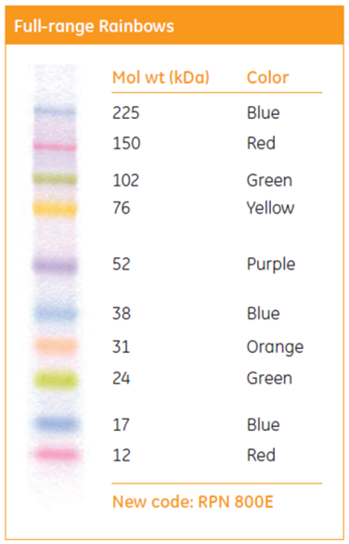

Figure 4. Rainbow colored protein molecular weight marker separated by SDS-PAGE (Full range). Molecular weight is expressed in kiloDaltons (e.g. 225 = 225 kDa or 225,000 Da) For a recommended loading volume of 10 μL, the different marker bands add up to a total of 15 μg. Image from GE Healthcare.

- Each student will carefully pipette 15 μL of the unknown sample corresponding to their team* into a well of the gel as a thin band on top of the gel and under the buffer (place the end of the tip just above the gel top surface). (There will be four teams per gel).

*Take note of the number of your unknown and the number of your well.

- Place the lid on top of the chambers. Notice that the colors of the plugs on the lid have to match the colors of the jacks on the inner cooling core or upper chamber.

- Make sure that the power supply is switched off and the dial set at 0. Attach the anode (red) connector of the chamber to the red socket of the power supply and the cathode (black) to the black socket.

CHECK THAT THE CONNECTIONS ARE THE RIGHT WAY ROUND!

- Switch on the power supply and adjust voltage to 150 volts. Run until the bromophenol blue approaches the end of the gel (about 25 min). Notice the production of gas bubbles on the electrodes as the electrophoresis proceeds. What is this gas?

- When the tracking dye reaches the bottom of the gel, set the current to zero, switch off and disconnect the power supply. Remove and empty the upper chamber.

- Remove the slabs and give them to your TA, he will scan the gel for you. Your picture will be saved as a jpg file. Pictures will be saved using the following nomenclature: L2S12(9-13); where S12 is the 2nd Thursday-morning section and 9-13 are the teams.

RESULTS AND DISCUSSION

Ion-exchange chromatography

- Draw the chemical structure for each of three amino acids at pH 3.9. Indicate the pKa of each functional group and calculate the pI for each amino acid. Show your calculations.

- Provide a summary of your ion-exchange chromatography results by preparing Table 1. Remember that you need to use a different amino acid standard for each peak of elution and therefore, you will need to identify the fractions corresponding to each amino acids. You should be able to do it by looking at the elution pH. Provide a sample of calculations for each amino acid.

Table 1: Column elution results
Fraction # | Elution volume | pH | A₅₇₀ | A₅₇₀  corrected | Conc.  mM | μmole

- Plot, on the same graph, both the pH and concentration versus the elution volume. Are the three amino acids well separated? Provide an explanation and suggestions to improve resolution.

- Estimate the recovery yield in percent for each of the three amino acids. Show your full calculation details for the recovery yield of one amino acid. Are these values what you expected? Indicate possible sources of error. What can you conclude from those recovery yields?

Gel electrophoresis of proteins

- Include a figure of your gel (step 26) with the corresponding labels for the MW markers and the wells with your sample. From the figure, estimate the migration distance (d) of the bands for the aliquot of your unknown and for the MW markers. Plot log MW of standards versus d and include the regression line, but only for the region of the graph giving a straight line. (You might need to exclude the marker at each of the two ends). Estimate from that plot the MW of the polypeptide in your sample (unknown). (Show your calculations).

REFERENCES

- Boyer, R.F. (2000). Modern Experimental Biochemistry, 3rd edition. Benjamin Cummings, p 74.

- Ninfa, A.J. and Ballou, D.P. (1998). Fundamental Laboratory Approaches for Biochemistry and Biotechnology. Fitzgerald Sciences Press (Mar), p 108.

- Bevilacqua, L. and Rodriguez, M. A. (2006). Chromatography. Tutorial notes V.

- Voet, D. and Voet, J. (2004). Biochemistry, 3rd Ed. John Wiley & Sons, 6.3, p 133.

- Bergeron-Wiper, N and Rodriguez M. (2004). Electrophoresis.Tutorial notes IV.

- Voet, D. and Voet, J. (2004). Biochemistry, 3rd Ed. John Wiley & Sons, 6.4, p 144.

- Hames, B.D. (1990). One-dimensional polyacrylamide gel electrophoresis. In “Gel Electrophoresis of Proteins”, 2nd Ed. (Hames & Rickwood). IRL Press (London), p 1.

- Ninfa, A.J. and Ballou, D.P. (1998). Fundamental Laboratory Approaches for Biochemistry and Biotechnology. Fitzgerald Sciences Press (Mar), p 127.

- Voet, D. and Voet, J. (2004). Biochemistry, 3rd Ed. John Wiley & Sons, 4.1, p 65.

Web references for the materials used in the lab

Fraction Collector 2110: Instructions Manual. Bio-Rad Laboratories, M7318120 Rev G.
http://www.bio-rad.com/webroot/web/pdf/lsr/literature/M7318120G.pdf

ENZYMES
The kinetics of acid phosphatase

OVERVIEW

Using a commercial acid phosphatase preparation from wheat germ, you will study several enzyme kinetics parameters. First, you will investigate the time dependence of the enzyme catalysed reaction. Following measurement of the initial rates of reaction with fixed amount of phosphatase and variable concentrations of substrate in the presence and absence of an unknown inhibitor, a Lineweaver-Burk plot will be constructed and K_{M} and V_{max} will be determined from this plot. The analysis of the effect of the inhibitor on the kinetic parameters of the enzyme will allow you to identify the type of inhibitor that you have used.

LEARNING OBJECTIVES

Underlying molecular principles

- Explain the reaction mediated by the acid phosphatase on p-nitrophenylphosphate
- Write the Michaelis-Menten equation to derive the Lineweaver-Burk equation
- List the three types of enzymes inhibitors
- Describe the molecular interference process of each type of enzymes inhibitors

Hands-On Skills

- Preparation of a reaction mixture necessary for an enzymatic assay
- Preparation of serial dilutions

Analytical Skills

- Interpret the absorbance values of the acid phosphatase assay to estimate the valid, linear range of the assay, and the concentration of enzyme that should be used for the determination of the Km and Vmax
- Interpret experimental results to estimate various kinetic parameters such as rate of product formation, Km, Vmax, inhibitor constants and specific enzyme activity

BACKGROUND

Enzymes are essential components of living organisms that catalyse specific reactions in the presence of the many chemical components of the organism. Enzymes are also a powerful tool in the biochemistry lab that allows a rapid and specific conversion of materials in an aqueous medium and in mild conditions of pH and temperature. They are frequently used for the quantitative assay of many chemicals. Their proper use requires a basic understanding of their function as catalysts, what is usually designated as enzyme kinetics. In this lab you will study the enzyme kinetics of a particular enzyme, acid phosphatase, but the concepts and methods are applicable to all enzymes.

A. Acid Phosphatase

Acid phosphatase (EC 3.1.3.2) and alkaline phosphatase (EC 3.1.3.1) are nonspecific phosphatases that catalyse the hydrolysis of a variety of phosphate monoesters to produce inorganic phosphate as shown in the following equation:

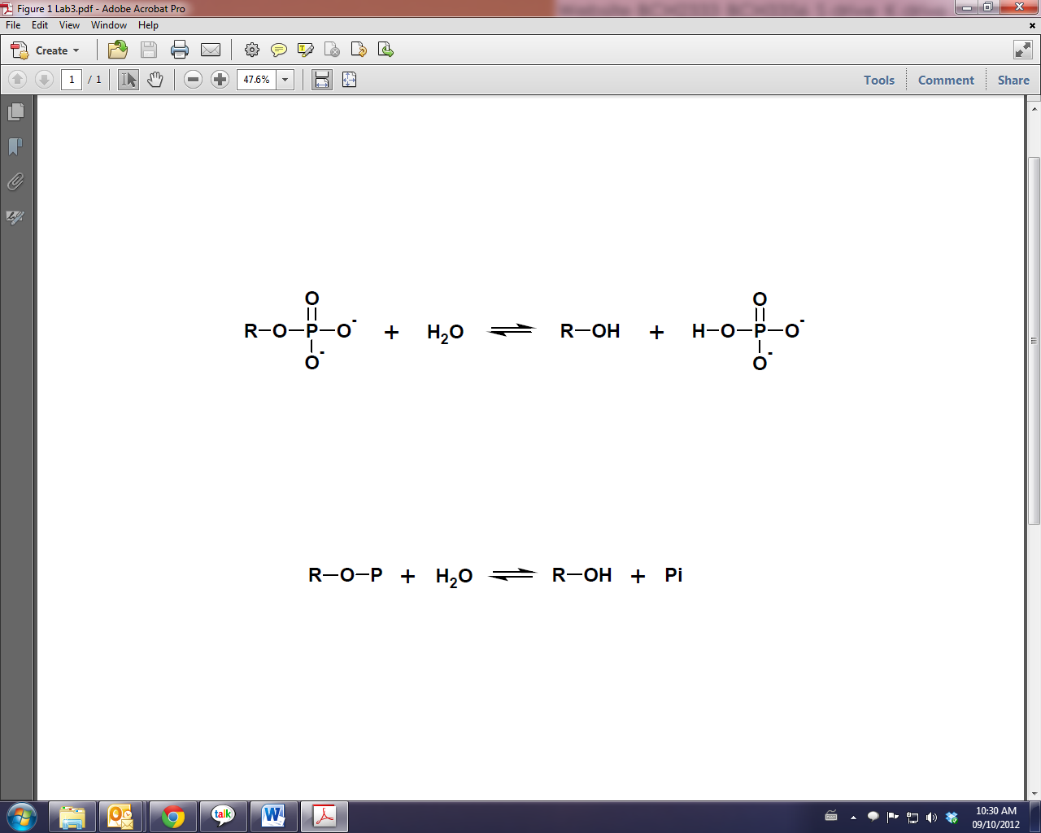

or schematically:

The two groups of enzymes differ in their pH optima; acid phosphatases have pH optima below 7 and alkaline phosphatases have pH optima above 7. Acid phosphatases occur in plants and animals; alkaline phosphatases occur in bacteria, fungi, and higher animals, but not in plants.

The assay of acid phosphatase utilizes the fact that the enzyme is nonspecific in its catalytic action. The substrate used here is p-nitrophenylphosphate which is converted to p-nitrophenol and inorganic phosphate as shown in the following equation:

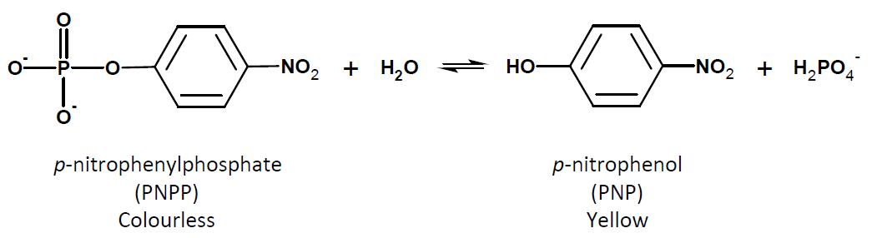

After incubation of enzyme and substrate, the reaction is terminated by the addition of KOH. This serves two functions. First, it terminates the reaction by changing the pH to one unsuitable for acid phosphatase and by denaturing the enzyme; second, it deprotonates the p-nitrophenol and the resulting p-nitrophenolate ion absorbs strongly at 405 nm due to resonance:

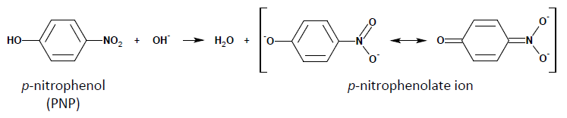

The reaction can then be conveniently followed by measuring the absorbance at 405 nm after addition of KOH to the incubation mixture. The absorbance readings can be converted into concentrations by using the law of Beer-Lambert:

$$A= εcl$$

B. Unit of Enzyme Activity

The actual molar concentration of an enzyme in a cell-free extract or purified preparation is seldom known. Only if the enzyme is available in a pure crystalline form, carefully weighed and dissolved in a solvent, can the actual molar concentration be accurately known. It is, however, possible to develop a precise and accurate assay for enzyme activity. Consequently, the amount of a specific enzyme present in solution is most often expressed in units of activity.

The International Union of Biochemistry Commission on Enzymes has recommended the use of a standard unit, the International unit, or just unit (U), of enzyme activity. One U of enzyme corresponds to that amount that catalyses the transformation of 1 μmol of substrate to product per minute under specified conditions of pH, temperature, ionic strength, and substrate concentration (usually at a saturating concentration). Example: If a solution containing an enzyme converts 10 μmol of substrate to product in 5 minutes, the solution contains 2 U.

Another useful quantitative definition of enzyme efficiency is specific activity. The specific activity of an enzyme is the number of enzyme units per milligram of protein. This is a measure of the purity of an enzyme, in a given assay, since removal of contaminating protein from the enzyme of interest should increase its specific activity up to a maximum corresponding to the specific activity of the pure enzyme.

C. Assay of Enzyme Activity

Enzymes are assayed by measuring the initial rate of reaction catalysed by a known amount of the enzyme preparation. All factors that might affect the rates other than the amount of enzyme must be kept constant. These factors include pH, temperature and the final concentrations in the assay of all other components (substrates, cofactors, buffers, etc.), including any substances such as complexing agents, stabilizers, etc., in the enzyme preparation, unless these have been shown to have no effect.

Control of the pH in the assay medium is often critical. Remember that the pK_{a}s of buffers are frequently markedly affected by temperature and concentration. Ideally, the buffers should be prepared at the temperature of the assay (or their pHs should be corrected accordingly) and substantial dilution should be avoided. Any acidic or basic substances added to the final reaction medium may change the pH if present in sufficient quantity unless the pHs of their stock solutions have been adjusted.

Two general types of assay are used:

(1) Fixed time assays in which samples of the reaction mixture are processed at fixed intervals of time.

(2) Continuous or "kinetic" assays in which the progress of the reaction is measured continuously. (These are usually limited to cases where the reaction causes some change in either the light absorbance or the pH of the medium).

With fixed time assays it is essential to study the time course of the reaction first if a single time point is to be used. This ensures that the time chosen is on the linear portion of the curve, where the amount of product formed is still proportional to the time of reaction and thus a true measure of the initial rate. In all cases, it is necessary to determine the range of enzyme concentration over which the initial rate is proportional to enzyme concentration and to work within this range only. This key standard curve is called the enzyme concentration curve.

Controls must be run to eliminate effects not due to catalysis of the reaction by the enzyme. Three types of control are common: a reagent blank, in which the enzyme solution is replaced by an equivalent volume of the medium in which the enzyme is dissolved; a non-incubated, zero time, complete assay; an incubated assay with inactivated enzyme. All three have their advantages and disadvantages, so the choice of control must be considered carefully: an invalid control is no better than no control at all. Generally, some preliminary experiments are necessary before one can decide which control would be best.

D. Kinetic Properties of Enzymes

The initial velocity, v, of an enzyme-catalysed reaction varies with the substrate concentration, [S] as shown in Figure 1A. The Michaelis-Menten equation has been derived to account for the kinetic properties of enzymes (1, 2).
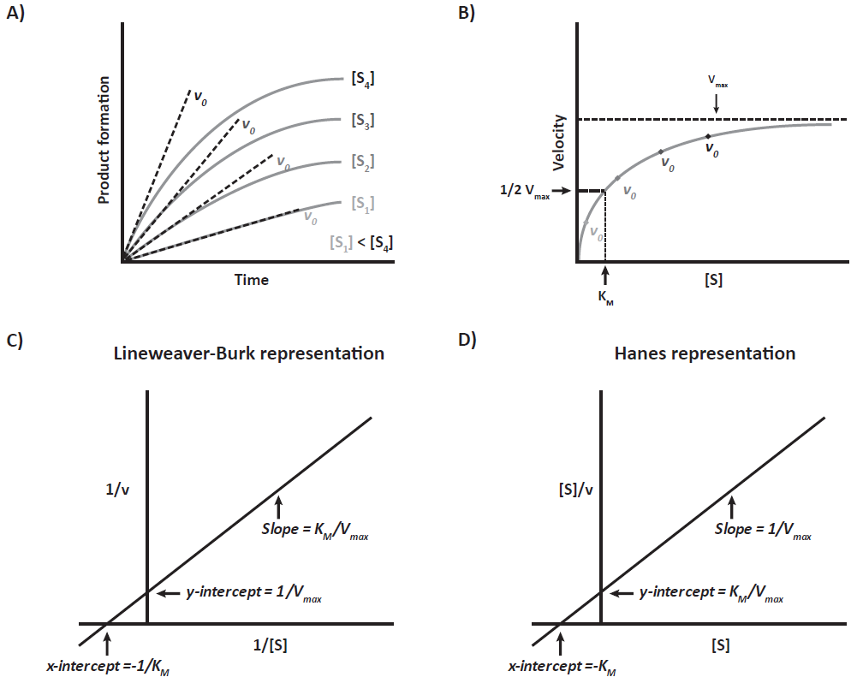
Figure 1. Enzyme Kinetics. A) The initial reaction velocity, v₀, of an enzymatic reaction varies with the substrate concentration, [S]. B) By plotting the different v₀ values obtained against [S], you can generate a plot known as a Michaelis-Menten plot. At higher concentration of substrate, v_{o} are getting closer to V_{max}. Half of the maximum velocity of the enzyme corresponds to K_{M}. This non-linear regression can be transformed into a linear regression by using the reciprocal of the Michaelis-Menten equation and plotting 1/v against 1/[S] (C). In this linear-regression representation, called a Lineweaver-Burk plot (or double reciprocal plot), the slope corresponds K_{M}/V_{max}, y-intercept to 1/V_{max} and x-intercept to -1/K_{M}. The Lineweaver-Burk equation can be further transformed by multiplying the equation by [S]. By plotting [S]/v against [S] you are now getting a second linear regression called the Hanes plot (D). In this linear-regression, the slope corresponds to 1/V_{max}, y-intercept to K_{M}/V_{max} and x-intercept to -K_{M}.

The steady state treatment for a simple enzyme catalysed reaction is as shown below:

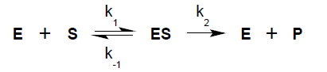

leads to the rate equation:

$v\text{=}\frac{{\text{V}}_{\text{max}}\left[\text{S}\right]}{{\text{K}}_{\text{M}}\text{+}\left[\text{S}\right] }$ Michaelis-Menten Equation

where: v = actual initial velocity of the reaction
V_{max} = maximum initial velocity of the reaction (v)
S = substrate concentration (moles/liter)
K_{M} = Michaelis constant = [S] giving V_{max}/2
K_{M} = (k₂ + k₋₁)/k₁

Note that the velocity at each substrate concentration (in Figure 1A) refers to the initial velocity. The optimal K_{M} and V_{max} parameters corresponding to best fit of the experimental data (Figure 1B) can be obtained by performing a nonlinear regression of v on [S] with the Michaelis-Menten equation (3). It is sometimes convenient to deal with linear transformations of the Michaelis-Menten equation. One is known as the Lineweaver-Burk equation (4) and can be written:

$$\frac{\text{1}}{\text{v}}\text{=}\frac{{\text{K}}_{\text{M}}}{{\text{V}}_{\text{max}}}\frac{\text{1}}{\left[\text{S}\right]}\text{+}\frac{\text{1}}{{\text{V}}_{\text{max}}}$$

A double-reciprocal plot of 1/v versus 1/[S] yields a straight line from which K_{M} and V_{max} are readily determined as indicated in Figure 1C.

Although this method is widely used, it does not always provide a good fit to the experimental data; the reason being that the points at lower substrate concentrations, which have the higher relative error (low velocities), have the higher effect on the slope of the plot and, thus, on the K_{M} value. An equation that gives a better fit is obtained by multiplying both sides of the Lineweaver-Burk equation by [S]:

$$\frac{\left[S\right]}{v}=\frac{K_{M}}{V_{max}}+\frac{\left[S\right]}{V_{max}}$$

A plot of [S]/v versus [S], Hanes plot (5), gives a straight line with slope 1/V_{max} and an intercept on the [S] axis of - K_{M} (Figure 1D). A third alternative is the Hofstee plot (6) of v against v/S. In this lab session, you will determine the kinetic parameters V_{max} and K_{M} by the Lineweaver-Burk method.

E. Enzyme Inhibition

Non-substrate molecules may interact with enzymes, leading to a decrease in enzymatic activity. In biological systems, a common way of controlling enzyme activity is through the action of endogenous inhibitors. The study of enzyme inhibition is of interest because it often reveals information about the mechanism of enzyme action. Also, many toxic substances, including drugs, act by enzyme inhibition.

The process of reversible inhibition is described by an equilibrium interaction between enzyme and inhibitor (1,7). Most inhibition processes can be classified as: competitive, uncompetitive and non-competitive, depending on how the inhibitor impairs enzyme action.

i) A competitive inhibitor binds reversibly to the free enzyme with an affinity given by the dissociation constant (K_{I}):

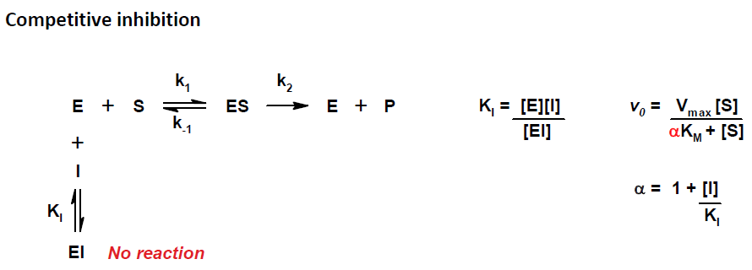
Competitive inhibition increases the K_{M}.

A competitive inhibitor is usually similar in structure to the substrate and binds to the enzyme active site. Thus, it competes with the substrate for binding to the enzyme, reducing the amount of free enzyme available for substrate binding and, hence, for catalysis of the reaction. This kind of inhibitor has no effect on the V_{max} of the enzyme (since a large amount of substrate can overcome the effect of the inhibitor) but increases its K_{M} for that substrate.

(ii) An uncompetitive inhibitor binds to the enzyme-substrate complex with an affinity given by the dissociation constant (K’_{I)} and blocks the substrate conversion into product.

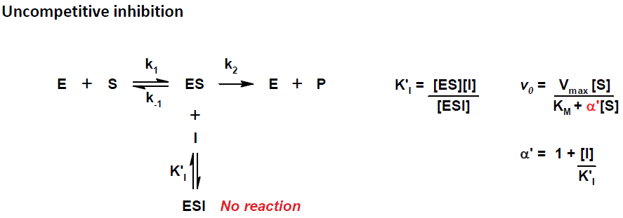

Uncompetitive inhibition decreases both the V_{max} and the K_{M}.
(iii) A non-competitive or mixed inhibitor binds to both, the free enzyme E and the enzyme-substrate complex ES, with different affinities, K_{I} and K’_{I}

Upon binding of the non-competitive inhibitor, the enzyme is reversibly converted to a non-functional conformational state, and the substrate, which is fully capable of binding to the active site, is not converted to product.

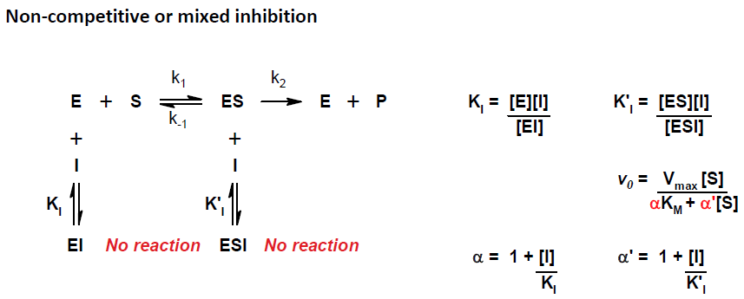
As a result, the V_{max} decreases and the K_{M} increases

The three kinds of reversible inhibitions are easily distinguishable using either a Lineweaver-Burk (reciprocal) plot or a Hanes plot of kinetic data (Supplementary Figure 2 in Appendix D). A summary of the effects of the different inhibitors on V_{max} and K_{M} is presented in the following table (Table 1).

Table 1: Effects of reversible inhibitors on kinetic parameters. By comparing your experimental plots (control reaction and reaction + inhibitor), it is possible identify the type of inhibitor present using the summary of the relevant parameters presented below. The “None” row corresponds to the control reaction whereas, the “Competitive”, “Uncompetitive” and “Mixed” rows represent the + inhibitor reaction. Observed V_{max} and K_{M} (also known as apparent V_{max} and K_{M}) correspond to the values found in presence of inhibitor.

Inhibition | Observed V_{max} | Observed  K_{M} | Reciprocal plot |  | Hanes plot
Inhibition | Observed V_{max} | Observed  K_{M} | Slope | y-intercept | Slope | y-intercept
None | V_{max} | K_{M} | K_{M} /V_{max} | 1/V_{max} | 1/V_{max} | K_{M} /V_{max}
Competitive | V_{max} | αK_{M} | increases | same | same | increases
Uncompetitive | V_{max}/α’ | K_{M}/α’ | same | increases | increases | same
Mixed | V_{max}/α’ | αK_{M}/α’ | increases | increases | increases | increases

where: α = 1 + [I]/K_{I} and α’ = 1 + [I]/K_{I}’.

PROCEDURES

Several aspects of the kinetics discussed above will be studied in this lab session, using a commercial acid phosphatase preparation from wheat germ. First of all you will investigate the time dependence of the enzyme catalysed reaction. Following measurement of the initial rates of reaction with fixed amount of phosphatase and variable concentrations of substrate in the presence and absence of an unknown inhibitor, Lineweaver-Burk plots will be constructed and K_{M} and V_{max} will be determined from these plots. The analysis of the effect of the inhibitor on the kinetic parameters of the enzyme will allow you to identify the type of inhibitor that you have used.

EXPERIMENT #1: Rate of product formation

As pointed out in the discussion of initial velocity the acid phosphatase assay must be carried out under conditions where the rate of product formation is constant over the incubation period. This is critical because the assay is a fixed time assay and the enzyme is subject to product inhibition. In order to check the rate of product formation, a time curve will be constructed. Each team will use different amounts of enzyme, thus with the results of the whole group, you will be able to analyze the dependence of the enzyme activity on the enzyme concentration.

In this experiment, you will be handling a rack with assay tubes, a water bath, a 1 mL pipette, a vortex, solutions of Na-Acetate and KOH at room temperature, solutions of PNPP and acid phosphatase on ice, a beaker with water and a stop watch. First, organize your working area. For instance, if you are right-handed, you may dispose the pipettes and solutions on the right side of your station, whereas you will keep the rack with tubes, the vortex and the water bath, on the left and center-back of your station.

- Prepare and label 6 test tubes, each containing 2.0 mL of 0.5 M KOH. Label them: 0, 2, 4, 6, 10 and 15 (corresponding to the point times of the assay).

CAUTION: This is a concentrated solution of a corrosive base that can irritate your skin and eyes. Wear gloves and safety glasses. For more info, consult the MSDS.

- Pipet into a 7th tube (tube R) the proper volumes of 1.0M sodium acetate buffer (pH 5.7) and water corresponding to your team number as described in Table 2. Mix with the vortex.
Table 2: Reaction mixtures with variable enzyme amount (tube R)
Reagent | Team number
Reagent | 1,9,17 | 2,10,18 | 3,11,19 | 4,12,20 | 5,13,21 | 6,14,22 | 7,15,23 | 8,16,24
1.0M Na-Acetate, pH 5.7 (mL) | 0.5 | 0.5 | 0.5 | 0.5 | 0.5 | 0.5 | 0.5 | 0.5
H₂O (mL) | 3.9 | 3.8 | 3.7 | 3.6 | 3.5 | 3.4 | 3.3 | 3.2
0.45 mg/mL Acid phosphatase (mL) | 0.1 | 0.2 | 0.3 | 0.4 | 0.5 | 0.6 | 0.7 | 0.8
25mM PNPP (mL) | 0.5 | 0.5 | 0.5 | 0.5 | 0.5 | 0.5 | 0.5 | 0.5
Total volume (mL) | 5.0 | 5.0 | 5.0 | 5.0 | 5.0 | 5.0 | 5.0 | 5.0

- Add the corresponding volume of acid phosphatase solution (0.45 mg/mL) to the same tube R. Mix and pre-incubate at 37°C for two or three minutes to pre-equilibrate the temperature before the reaction is initiated.

- Initiate the phosphatase reaction by adding 0.5 mL of 0.025M PNPP to tube R. Immediately mix and transfer 0.5 mL to the tube 0. The KOH that was added to the tube 0 will stop the reaction. Mix well and let the tube stand at room temperature. (This is the ZERO time sample. There is zero substrate conversion, so the reading represents the background absorbance of the reaction mixture).

CAUTION! PNPP and PNP solutions may irritate skin and eyes. Both products are toxic if absorbed through the skin. Use gloves and safety glasses.

http://www.neb.com/nebecomm/MSDSFiles/msdsP0757.pdf

http://ccinfoweb2.ccohs.ca/rtecs/Action.lasso?-database=rtecs&-layout=Display&-response=detail.html&-op=eq&RTECS+NUMBER=SM2275000&-search

- Withdraw 0.5 mL aliquots from the reaction mixture, tube R, at times 2, 4, 6, 10 and 15 minutes and transfer each of these aliquots to the appropriate test tube from step 1 containing 2.0 mL of 0.5 M KOH. Mix well and keep the tubes 2, 4, 6 etc at room temperature, but keep the tube R always at 37°C. (Each tube 2-15, represents the amount of substrate conversion at the corresponding time).

- Measure the absorbance of each tube 0-15, at 405 nm, zeroing the instrument on water.

- Subtract the reading for the ZERO time sample from all readings. Enter the absorbances into Table 4. Enter also the same values in an Excel spreadsheet provided by the TA. (The other teams from your group will enter their own data in the same spreadsheet). Using this spreadsheet, plot your corrected absorbances versus time (minutes) and verify whether the reaction is linear over a period of 10 minutes. Estimate the slope of the linear range of your plot.

- From all plots in the group and with the advice of your TA, select an enzyme concentration which will yield a constant rate of product formation over a period of 10 minutes and use the same concentration (but different amount) for experiment 2.

EXPERIMENT #2: Determination of K_{M} and V_{max}

As previously mentioned, the catalytic properties characteristic of an enzyme, reaction rate and specificity, are manifested in the two kinetic parameters K_{M} and V_{max}. In this experiment you will measure the two kinetic parameters of acid phosphatase. For the determination we will assume that the enzyme follows the Michaelis-Menten equation where the initial velocity is a function of the substrate concentration. Keeping the same enzyme concentration, you will measure the initial velocities corresponding to different concentrations of the artificial substrate PNPP, in optimal acid pH. Since you have already determined in Experiment 1 the concentration of enzyme for which the formation of the product PNP is linear with time beyond 10 min, you can easily determine the initial velocity by measuring the amount of product obtained after 10 min incubation with that amount of enzyme.
NOTE: The final volume of the reaction for experiment 1 is 5 mL whereas for this experiment 2 is 0.5 mL, therefore you have to add 10 times less enzyme.

As for experiment 1, the amount of product is measured by reading the absorption of the solution at 405 nm. As usual, a blank is required to estimate the background absorption of the reaction mixture in the absence of product formation. To this end, a series of reaction mixtures are prepared (ZERO time tubes) where the stopping solution (KOH) is added before the enzyme and thus no reaction takes place (Figure 4).

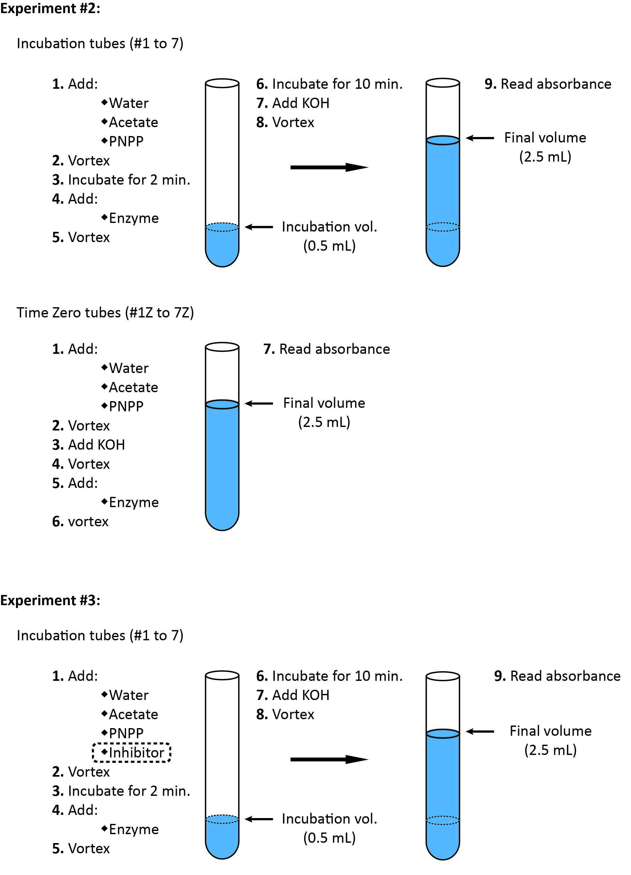

Figure 4: Kinetics experiment
Before you start pipetting, fill the cells with brackets in Table 3 and show these figures to your TA. The concentration of acid phosphatase solution was decided at the step 9. Calculate the amount for the new volume. The amount of water can be calculated from the amount of enzyme and a total incubation volume of 0.5 mL. The final concentration of PNPP substrate can be calculated from the amount of PNP added and the incubation volume.
- From a stock solution of 25 mM PNPP, prepare three 0.5 mL solutions of 5, 2.5 and 0.5 mM PNPP in water. (For the 0.5 mM solution, the error will be lower if you use either the 2.5 mM or the 5 mM solutions instead of the 25 mM stock).

- Label one set of 7 test tubes from 1 to 7 (incubation tubes) and another set of 7 test tubes from 1Z to 7Z (ZERO time tubes).

- Add to both series of tubes the corresponding volumes of water, Na-acetate buffer and PNPP solutions as indicated in Table 3. Vortex all tubes.

- Pre-incubate the incubation tubes for 2 min at 37°C (To make sure that the reaction takes place at that temperature).

Table 3: Reaction mixtures with variable [PNPP]
Reagent | Tube number
Reagent | 1 | 2 | 3 | 4 | 5 | 6 | 7
H₂O (μL): to complete 0.5 mL | ( ) | ( ) | ( ) | ( ) | ( ) | ( ) | ( )
1.0 M Na-Acetate, pH 5.7 (μL) | 50 | 50 | 50 | 50 | 50 | 50 | 50
0.5 mM PNPP (μL) | 50 | ----- | ----- | ----- | ----- | ----- | -----
2.5 mM PNPP (μL) | ----- | 25 | 50 | ----- | ----- | ----- | -----
5.0 mM PNPP (μL) | ----- | ----- | ----- | 50 | 75 | ----- | -----
25.0 mM PNPP (μL) | ----- | ----- | ----- | ----- | ----- | 25 | 50
0.45 mg/mL acid phosphatase (μL) | ( ) | ( ) | ( ) | ( ) | ( ) | ( ) | ( )
Time enzyme addition | 0 min | 1 min | 2 min | 3 min | 4 min | 5 min | 6 min
Time KOH (2 mL) addition | 10 min | 11 min | 12 min | 13 min | 14 min | 15 min | 16 min
Incubation time (min) | 10 | 10 | 10 | 10 | 10 | 10 | 10
PNPP concentration (mM) | ( ) | ( ) | ( ) | ( ) | ( ) | ( ) | ( )

- Add 2.0 mL of 0.5 M KOH to each of the ZERO time tubes. Vortex and leave at room temperature.

- Add the amount of enzyme indicated in Table 3 to each of the ZERO time tubes. Vortex and leave at room temperature.

- Initiate the reactions by adding the volume of the enzyme solution to the incubation tubes at the time indicated in Table 3. Mix well (vortex) after the addition.

- Stop the reactions, after 10 minutes of incubation, by adding 2 mL of 0.5 M KOH to each of the incubation tubes, at the time indicated in Table 3. Mix well and let the tube stand at room temperature.

- Read the absorbance in all tubes at 405 nm. (Zero the instrument with water).

- The ZERO time readings are the blank readings (background absorbance without any enzymatic reaction). Subtract the corresponding ZERO time reading from each incubation reading.

EXPERIMENT #3: Inhibitor

Repeat experiment 2 but now in the presence of an inhibitor. For the setup of the incubation tubes (Figure 4), modify Table 3 by decreasing the water in all of the tubes by 50 μL from that shown in the table, and adding 50 μL of a 8.0 mM solution of the unknown inhibitor before the enzyme. Since the inhibitor does not absorb at 405 nm, you do not need to repeat the series of Zero time tubes. For the correction of absorption by the blank, you will use the values obtained in experiment 2.

CAUTION: the inhibitor may be toxic!

(Take note of the number of your inhibitor).

RESULTS AND DISCUSSION
Rate of product formation
- Convert the corrected absorbances from step 7 into amounts of PNP. In your calculations, you should assume a molar absorptivity for PNP of 1.88x10⁴ M⁻¹cm⁻¹ (ε₄₀₅), a path length for the cuvette of 1 cm and a final assay volume of 2.5 mL (This final volume takes into consideration the 2 mL of KOH that was added for stopping the reaction). From the volume of the incubation mixture (0.5 mL aliquot: before the addition of KOH) and the substrate concentration, calculate the percentage of substrate converted. Show your calculations for a given time. From the concentration of the provided stock solution of enzyme, calculate the concentration of acid phosphatase in your assay. Summarize your results in the following Table 4.
Table 4: Time dependence of product formation
(Acid phosphatase in the assay: mg/mL)
Time (min) | A₄₀₅ | PNP(mM) | PNP ((μmol ) | Percentage of PNPP converted
0
2
4
6
10
15

- Plot the amount of product (μmol PNP) versus time (minutes) for your results in Table 4. Estimate the initial velocity of the reaction. For how long does the reaction rate remain constant? Indicate the highest level of substrate conversion (in %) that you can observe in the linear range. Can you explain why plots sometime deviates from the straight line (reach a plateau)?

Determination of K_{M} and V_{max}
- Use the [PNPP] values calculated for Table 3. Convert the corrected absorbances from step 19 for both experiments 2 (control) and 3 (inhibitor) into amounts of PNP as above. Calculate the corresponding reaction rates (v). Show all your calculations for one substrate concentration for the control (exp. 2). Summarize your results in two tables (Table 5/6) with the following format:

Tables 5/6: Substrate dependence
[PNPP]*  (M) | Control (experiment 2) |  |  |  | Inhibitor (experiment 3)
[PNPP]*  (M) | A₄₀₅ | [PNP]  (M) | PNP  (μmol) | v  (μmol/min) | A₄₀₅ | [PNP]  (M) | PNP  (μmol) | v  (μmol/min)

* Initial concentration of substrate.

- From Tables 5/6 complete Table 7 for the analysis of results by the Lineweaver-Burk method, a linear form of the kinetic equation.

Table 7: Data for the use of the Lineweaver-Burk equation
[S]* (M) | Control |  |  | Inhibitor
[S]* (M) | V  (μmol/min) | 1/V  (μmol/min)⁻¹ | 1/[S]  (M)⁻¹ | V  (μmol/min) | 1/V (μmol/min)⁻¹ | 1/[S]  (M)⁻¹
* Initial concentration of PNPP.

- From Table 7, construct the Lineweaver-Burk plot for the enzyme in the presence and absence of inhibitor. (Prepare one graphic with the two Lineweaver-Burk plots. Draw for each plot the best-fit straight line, also called the linear-regression trend line).

- From the linear equations of the two best-fit lines found in your Lineweaver-Burk plot, determine the K_{M} and V_{max} parameters corresponding to each condition. Show your full calculations for the control plot. Summarize your results in Table 8. Indicate the type of inhibitor that you have used. Justify your answer. Remember to use a 25% cut-off for your inhibitor identification.

Table 8: Kinetic parameters obtained from experiments 2 and 3
Method | Control |  | Inhibitor
Method | V_{max} (μmol/min or U) | K_{M} (M) | V_{max} (μmol/min or U) | K_{M} (M)
Lineweaver-Burk

- From the value of V_{max} and K_{M} for the control and the inhibitor (according to Table 8) and from the definitions of α and α’ in Table 1, estimate the constants K_{I} and/or K_{I}’ of your inhibitor and summarize your results in Table 9. Show an example of your calculations.

Table 9: Type of inhibitor

Inhibitor  number | [I] (M) | V_{max} (U) | K_{M} (M) | K_{I} (M) | K_{I}’ (M) | Type of  Inhibitor
------- | 0

- From the estimated value of V_{max} for the control (according to Table 9) and the protein concentration of the provided enzyme solution, calculate the specific activity of your phosphatase sample in U/mg. (Hint: the estimated V_{max} is the activity corresponding to the amount of enzyme that you used in the assay for experiment 2).

REFERENCES

- Fersht A. (1977). Enzyme Structure and Mechanism. Freeman (NY) p 84.

- Voet, D. and Voet, J. (2004). Biochemistry, 3rd Ed. John Wiley & Sons, 14.2, p 477.

- Cornish-Bowden, A. (1995). Fundamentals of Enzyme Kinetics. Portland Press (London). P 27.

- Lineweaver, H. and Burk, D. (1934). J. Amer. Chem. Soc., 56: 658.

- Hanes, C.S. (1932). Biochem. J., 26:1406.

- B.H. Hofstee, (1952). On the Evaluation of the Constants V_{max} and K_{M} in Enzyme Reactions. Science 116: 329.

- Voet, D. and Voet, J. (2004). Biochemistry, 3rd Ed. John Wiley & Sons, 14.3, p 482.

LIPIDS AND MEMBRANES
Thin Layer Chromatography of Tissue Lipids

OVERVIEW

In this week’s experiments, you will prepare two membrane fractions from rat liver tissue: an endoplasmic reticulum (ER) enriched fraction (microsomal fraction) and a mitochondrial enriched fraction. You will then extract the lipids from the microsomal fraction, separate them by TLC and compare them with lipids extracted from the entire tissue. In the second part of the laboratory, you will analyze the lipid/protein ratio in the mitochondrial fraction.
LEARNING OBJECTIVES

Underlying molecular principles
- Understand the molecular principle underlying the various steps required for the preparation of cell and mitochondrial membrane fractions (disruption and centrifugation)
- Understand the molecular principle of lipid extraction using the Bligh and Dyer method.
- Review the molecular structure of some of the most abundant lipids in cell and microsomal membrane fraction.
- Understand the molecular principle underlying lipid separation by thin layer chromatography.
- Review and understand the analytical techniques used to estimate protein and lipid concentration
- Discuss the relative lipid composition of the entire liver vs the microsomes.

Hands-On Skills
- Homogenize rat liver using a Teflon homogenizer
- Use differential centrifugation to prepare membrane and mitochondrial membrane fractions
- Use of 2D-Thin Layer Chromatography to resolve lipids
- Use of iodine staining to visualize lipids on TLC plate
- Use of colorimetric assays to estimate the protein and lipid content in the mitochondrial membrane fractions
- Preparation of a standard curve

Analytical Skills
- Identify the factors affecting the relative centrifugation force
- Discuss the effect of polarity on migration rate on TLC plate
- Perform simple quantitative calculations relative to dilution problems and absorbance/concentration ratio (Beer-Lambert’s Law)
BACKGROUND

Most naturally occurring lipids are esters or amides of long chain aliphatic carboxylic acids. Some of the most abundant are esters of glycerol (simple lipids) or of sn-glycerol-3-phosphoryl-choline, sn-glycerol-3-phosphoryl-serine or sn-glycerol-3-phosphoryl-ethanol-amine (complex lipids). The large ratio of C/O makes them insoluble in water, although the complex lipids containing P and N have a special behaviour in water: their amphiphilic character gives them a capacity for micelle and 'smectic' mesophase formation now recognized as being fundamental to the biological properties of membranous cell structures. They are usually characterized collectively by their solubility in the so-called fat-solvents (ether, chloroform, etc.). The classification also includes other compounds, referred to as the "non-saponifiable fraction" and consisting largely of sterols and steroids. Both the simple and complex glycerolipids occur naturally as mixtures and their partial separation by chromatography will be studied here.
The extraction of tissue lipids is usually done with mixtures of chloroform (in which the lipids are soluble) and methanol (to provide an aqueous-miscible mixture and to disrupt lipid- protein interactions). You will use the Bligh and Dyer method (1,2) for lipid extraction from an aqueous suspension containing a subcellular fraction of liver membranes. The method involves a first step in which CHCl₃, MeOH and H₂O are kept at a ratio of 1:2:0.8, in order to have a single phase with maximal contact between the lipids and the solvent. This is followed by a second step in which the solvent ratio is changed to 2:2:1.8 causing the mixture to separate into two phases thereby segregating the lipids from the other more polar compounds (Figure 1). You will compare the lipid content of your extract with a sample of liver total lipids provided by the lab.
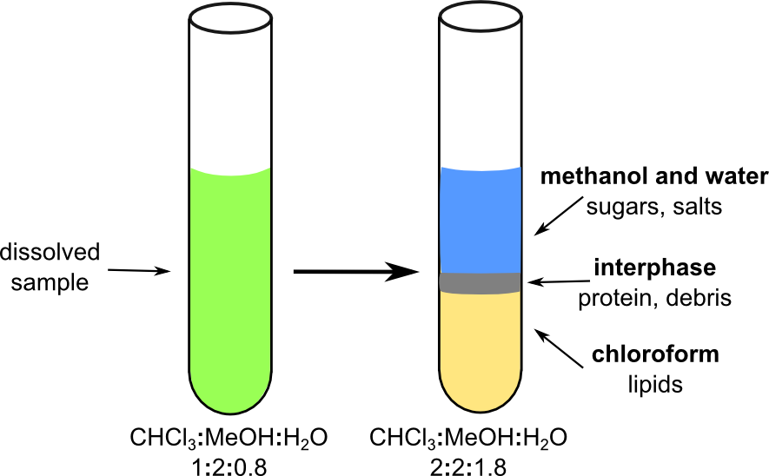
Figure 1. Bligh and Dyer lipid extraction. A mixture of chloroform, methanol and water is used to first dissolve an aqueous sample following which the solvent ratios are changed to separate the polar from the non-polar, lipid containing, phase.

This experiment will demonstrate the complexity of lipid fractions isolated from tissues. Ordinarily the preparation of tissue lipid fractions requires a number of fairly elaborate precautions to prevent auto-oxidation and other damage to the lipids (ie. inert atmosphere). For the purpose of this lab, such precautions will be waived, but should be kept in mind.
A. Cellular Membrane Fractionation
(See animation in Virtual Campus Media Library)
The fractionation of membranes from different cellular compartments and/or organelles requires the rupture of cells by tissue homogenization in a buffer containing, typically: ~ 0.2M sucrose, 1 mM EDTA and 1 mM DTT, at physiological pH and at low temperature. The sucrose provides the same osmolarity than the cellular cytosol, thus the organelles do not swell with water and burst. The EDTA (ethylene-diamine tetraacetate) is a chelating agent that binds divalent cations preventing the fusion of membranes and the action of proteases and lipases. The DTT (dithiothreitol) is a reducing agent that prevents oxidation and denaturation of lipids and proteins by oxygen. The cold temperature also slows down the action of membrane degrading enzymes. The buffer at pH around 7.5, with low ionic strength, such as tris-(hydroxymethyl)-aminomethane-Cl (Tris-Cl), provides an environment where proteins are stable in solution.
Upon cell disruption, subcellular particles can be separated by differential centrifugation (3, 4). Centrifugation of rat liver homogenate at 1000g (Figure 2) gives a pellet containing nuclei and plasma membrane. The centrifugation at 25,000g of the previous supernatant yields a pellet containing, mitochondria, lysosomes and peroxisomes, and a supernatant with membrane vesicles from the Golgi and the endoplasmic reticulum (microsomes) in suspension. These different subcellular fractions can be identified by the presence of marker enzymes that are specific of the corresponding organelle or membrane. For instance, the presence of mitochondria can be detected by measuring the activity of malate dehydrogenase (MDH), the tricarboxylic acid cycle enzyme that catalyzes the interconversion of malate and oxaloacetate in the mitochondrial matrix.
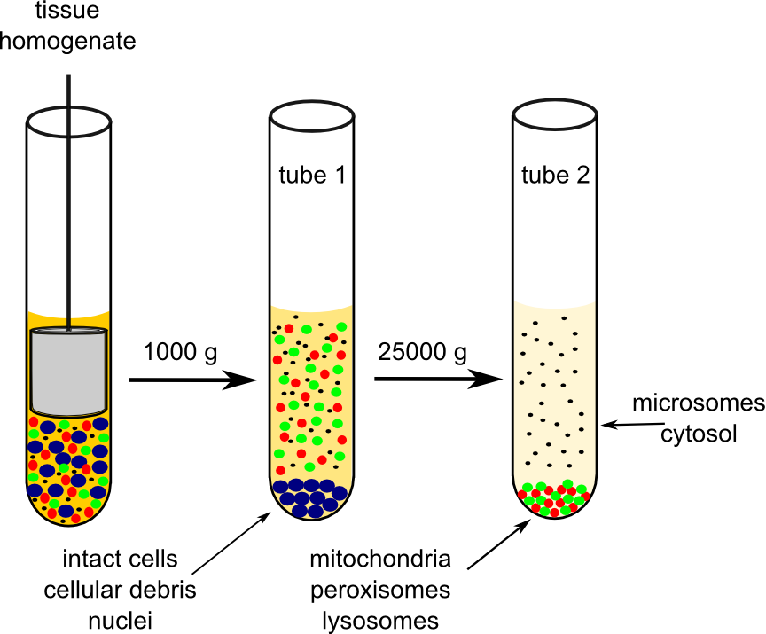

Figure 2. Differential centrifugation. A series of sequential centrifugations at increasing speeds allows for the separation of a whole cell lysate into its cellular components based on their size and density.

Although neutral lipids such as triacylglycerols and cholesterol esters are usually found in cytoplasmic droplets (especially in adipose tissue where triacylglycerols are stored), most complex lipids are components of the different cellular membranes (5). The specific lipid and protein composition of each cellular membrane confers to the membrane the properties required for its particular physiological functions. Thus, even though most of these lipids are present in all membranes (e.g. phosphatidylcholine, phosphatidylethanolamine and cholesterol) their relative content varies between organelles, organs and organisms. Lipid distribution in various rat membranes has been well studied and is presented below in Table 1. For today’s lab, you will be extracting lipids from calf liver. Although the same types of lipids are present, their distribution varies somewhat from that of rat liver.

Table 1. Lipid composition of representative biological membranes. Lipid composition varies between organisms, organs and even individual organelles thereby conferring specific functionality to each membrane. (CH = cholesterol, PC = phosphatidylcholine, PE = phosphatidylethanolamine, PS = phosphatidylserine, PI = phosphatidylinositol, CL = cardiolipin SM = sphingomyelin, Glyc = glycolipids)

Organism | Organ | Membrane | Lipid (% weight of total lipid)
Organism | Organ | Membrane | CH | PC | PE | PS | PI | CL | SM | Glyc
Rat | liver | plasma | 25 | 28 | 17 | 9 | 5 | -- | 15 | --
Rat | liver | nuclear | 9 | 55 | 20 | 3 | 8 | -- | 3 | --
Rat | liver | mitochondrial | 3 | 39 | 33 | 1 | 5 | 18 | 1 | --
Rat | liver | lysosomal | 19 | 35 | 13 | 1 | 6 | 3 | 22 | --
Rat | liver | golgi | 8 | 45 | 20 | 5 | 8 | -- | 9 | --
Rat | liver | microsomal | 6 | 20 | 18 | 3 | 8 | -- | 4 | --
Rat | brain | myelin | 22 | 11 | 14 | 8 | -- | -- | 7 | 24
Rat | blood | erythrocyte | 24 | 30 | 15 | 7 | 2 | -- | 10 | 3
E. coli | N/A | cytoplasmic | -- | -- | 72 | -- | -- | 9 | -- | --

B. Assay of Membrane Lipids and Proteins

Each cellular membrane has a characteristic protein/lipid ratio (5). In this laboratory you are going to measure the protein/lipid ratio of the membranes present in the mitochondria enriched fraction; the 25000g pellet. The protein content will be estimated from the characteristic light absorption of proteins at 280 nm. The extinction coefficient ε₂₈₀ of a protein depends on the number of aromatic residues present in the protein. However, for an unknown protein or for a mixture of proteins, it can be assumed that the average ε₂₈₀ is about 1 to 2 Lg⁻¹cm⁻¹.

The membrane lipid concentration can be estimated from their quenching of the light absorption at 559 nm of the dye Brilliant Blue R (also called Coomassie Blue R, Figure 3). At alkaline pH, the dye slowly loses its blue colour by reaction with the OH⁻. This process is highly accelerated by membrane lipids and other amphipathic molecules. Under optimal conditions, the A₅₅₉ decrease correlates linearly with the amount of membrane lipids.

Figure 3. Brilliant Blue R. The structure of Coomassie blue R; a dye that loses its blue color in the presence of lipids, altering the absorption of light at 559 nM.

C. Thin Layer Chromatography (TLC)
(See animation in Virtual Campus Media Library)

Adsorption chromatography relies on the reversible binding of substances to a variety of adsorbents (Al₂0₃, Si0₂, starch etc.). These adsorbents can be spread in a thin layer on an inert support (usually glass plates) or can be used as filling material in columns. The former arrangement offers maximum resolution and ease of compound accessibility for identification and is often used analytically while the latter offers greatly increased sample capacity in a preparative role (6-8). (For a general introduction to chromatography see refs. 7- 8).

In this laboratory, lipids will be separated by TLC on Silica G plates (6-8).

Silica gel (Si0₂) is mildly polar and will bind polar compounds more tightly than non-polar ones. As the mobile phase or developing solvent moves by capillarity up the plate, lipid molecules shuttle back and forth between the stationary and mobile phases. Polar lipids that bind well to silica gel will reside in the stationary phase for a longer time than less polar lipids. Hence the less polar the lipid, the farther it will migrate on the plate. The separation is therefore based on polarity. Obviously, the mobility of lipids depends on the solvent composition of the mobile phase. The relative mobility of each lipid is expressed as its retardation factor, R_{f}:

R_{f} = distance moved by the lipid spot (center) / distance moved by the solvent front

Because of the large variety of lipids in a tissue, it is almost impossible to find a developing solvent that can separate all of them in one TLC. Usually two TLC with widely different solvent systems are required for a good separation of polar and non-polar lipids respectively. In this experiment the two separations are performed on the same plate in a two-dimensional chromatography, 2D-TLC (4). Two solvent systems have been chosen to optimize the separation of phospholipids, the main components of cellular membranes. With these systems, neutral lipids (cholesterol, cholesterol esters, triacylglycerols, diacylglycerols, etc) are not well resolved and will run together to the upper left corner of the plate. Better resolution of non-polar lipids could be obtained by decreasing the polarity of one of the two solvent systems, but that would compromise the separation of the polar lipids.

(See Ref 2, p 552 for the relative mobility (R_{f}) of lipids with different developing systems).
PROCEDURES

In experiment 1 you will prepare two membrane fractions from rat liver tissue: an endoplasmic reticulum (ER) enriched fraction (microsomal fraction) and a mitochondrial enriched fraction. You will extract the lipids from the microsomal fraction, separate them by TLC and compare with lipids extracted from the entire tissue. A sample of microsomal lipids will be provided so that you can start the TLC separation early in the lab session. A sample of lipids from the entire tissue has been previously separated by TLC in the lab and is posted the course website. In experiment 2 you will analyze the lipid/ protein ratio of the mitochondrial fraction.

Before performing these experiments, you should watch the following videos:

- Overview Homogenization (0:51) or (http://www.youtube.com/watch?v=NsYRQg40ZSQ)
- Homogenization (3:34) or (http://www.youtube.com/watch?v=mZnLdYSV830)
- Centrifugation (3:57) or (http://www.youtube.com/watch?v=5wCBHlAeoNw)
- Rotovapour (2:42) or (http://www.youtube.com/watch?v=PPmITKfBwOo)
- TLC (14:06) or (http://www.youtube.com/watch?v=IbU5l0DZD_Q)

You should also watch the animations:

- Centrifugation
- 2D-TLC

They are located in the Media Library tool of the Virtual Campus in the Lipids Laboratory folder.

EXPERIMENT #1: Lipids from the microsomal fraction of the liver
a) Lipid extraction

- Mince 2 g of rat liver tissue with scissors and place it in 10 mL of ice-cold homogenization buffer (10mM Tris, 0.25M sucrose, 1mM EDTA, 1 mM DTT, pH 7.5).

- Homogenize the tissue on ice with a glass-teflon homogenizer. Pass the pestle up and down about 10 times. (Consult your TA).

- Transfer the homogenate to a 15 mL Corex tube and centrifuge at 1,000xg for 10 min at 4°C. CAUTION! Tubes should be paired and their weight balanced with homogenization buffer.

- Filter supernatant 1 through mira-cloth to remove lipid granules. Collect the filtrate in a 25 mL cylinder, measure its volume and transfer it into a new 15 mL Corex tube. Discard pellet 1 which consists mostly of tissue debris, unbroken cells and nuclei (Figure 2).

- Centrifuge supernatant 1 in the Corex tube at 25,000xg for 10 min at 4°C.
CAUTION! Tubes should be paired and balanced.

- Transfer supernatant 2 into a 15 mL Falcon tube. This supernatant contains the microsomes (Figure 2). Set aside pellet 2 for lipid and protein assay in experiment 2 (steps 22-27).

- Transfer 3.2 mL of supernatant 2 from step 6 into a 50 mL Falcon tube and add 12mL of CHCl₃:MeOH (1:2 v/v). Mix well using a Vortex. (In the fume-hood!).

CAUTION! Chloroform and methanol are toxic, especially CHCl₃; they may irritate skin, eyes and respiratory tract. Use gloves and safety glasses. Avoid inhalation.

(http://www.sciencelab.com/msds.php?msdsId=9927133
Methanol MSDS)

- Centrifuge at 3000xg for 5min in a Sorvall Legend centrifuge (swinging bucket). (Tubes should be paired!).
- Transfer supernatant to a new 50 mL Falcon tube. (Discard the pellet). Add 4 mL of CHCl₃ and 4 mL of water. Mix well using the Vortex. (In the fume-hood!).
CAUTION! All handling of chloroform in this lab should be done, when possible, in the fume-hood, using proper gloves.

- Centrifuge at 3000xg for 5 min using the Sorvall Legend centrifuge (swinging bucket). (Tubes should be paired!)

- Using a transfer pipette, transfer the lower phase into a 100 mL round bottom flask. (Do not take any liquid from the top phase).

- Evaporate the chloroform in a rotary evaporator. (Consult your TA). Dissolve the residue in 0.5 mL CHCl₃ and transfer to a 1.5 mL microtube. Label the tube with the date, your lab section and group number, and hand it to your TA.

Total lipids can be extracted in a similar way using the liver homogenate from step 2. Alternatively you can perform the tissue homogenization in CHCl₃:MeOH (1:2 v/v). By adding 1/3 volume of water and 1/3 volume of CHCl₃ the mixture separates in two phases. As before, the bottom phase (CHCl₃) contains the lipids.

b) Two-dimensional TLC

- Groups of TWO teams will perform a 2D-TLC separation of a microsomal lipids sample. The sample will be provided at the beginning of the lab session so that you can start the TLC separation right away and finish it within the lab period.

- Label an activated (heated at 100°C for 1-2 hours) 20 x 20 cm Silica G plate using a TLC template and a pencil. Mark only the spots, lines and traveling direction of the two developing solvents as seen in Figure 3. On the top left corner label your plate with the date, your sections and group numbers.

- Pipet 5 μL of the standards and 10 μL of the sample at the positions indicated in Figure 3. Keep the spots as small as possible to increase resolution.

Lipid standards: 1) PI (phosphatidylinositol) and PE (phosphatidylethanolamine)
2) CL (cardiolipin) and CH (cholesterol)
3) FA (fatty acid) and PC (phosphatidylcholine)

Which standard in each couple will run further?

3
2
1

1
3
2
1
standards
2.5 cm
sample
standards
5 cm
5 cm
2.5 cm
ID
2nd dimens.
1st
dimens.

Figure 3. TLC Template. Schematic depicting the labeling and loading of the 2D-TLC plate for experiment 1.

- Place the plate in a tank containing the basic solvent system: CHCl₃-MeOH-ammonia (65:35:5 v/v). Develop the first dimension until the solvent reaches 1 cm from the horizontal line (about 60 min).

- Remove the plate, mark the solvent front immediately and dry with a heat gun for 10 minutes.

- Turning the plate 90 degrees, place it in the second tank with the acidic solvent system: CHCl₃-acetone-MeOH-acetic acid-H₂O (10:4:2:2:1; v/v). Develop the second dimension until the solvent reaches 1 cm from the horizontal line.

- Remove the plate, mark the solvent front immediately and dry the plate with a heat gun.

- Place the plate in an iodine saturated tank for 5 min. Remove the plate, leave it in the fume-hood and mark the position of each spot. Read the position of each spot with the plate ruler.

CAUTION! Iodine is harmful for man and the environment. Avoid inhalation and contact with skin. Do not leave the iodine tank open, wear gloves. (http://www.sciencelab.com/msds.php?msdsId=9927547 )

- Your TA will scan your TLC plate. Your file will be named as per the following example: L4S2(11); where L4 is lab 4, S2 is the 2nd Monday-afternoon section and 11 is the team number. Add the appropriate legend to this figure and submit it with your report.

EXPERIMENT #2: Assay of mitochondrial lipids and proteins

- Resuspend the pellet from step 5 in 10 mL of homogenization buffer. Sonicate the suspension at 50% power for 10 sec, twice, to accelerate the suspension process. This suspension contains the mitochondrial membranes.

- Calculate the missing values (?) in Table 2 and 3; this should be completed prior to your arrival in the lab. Verify your calculations with your TA before starting the experiment.

- Prepare five assay tubes containing increasing amounts of the mitochondrial membrane suspension in 2 mL of 0.1 M (final concentration) phosphate buffer, pH 11, according to Table 2. Upon addition of the last reagent, the dye Brilliant Blue R, vortex thoroughly and incubate for 15 min at room temperature. (During this incubation, start the protein assay, step 26).
CAUTION! Brilliant Blue R solutions may cause eye, skin, and respiratory tract irritation and it will dye your skin. Use gloves and safety glasses.
(http://www.sciencelab.com/msds.php?msdsId=9925778 )

Table 2: Lipids assay
Sample | Dilution fraction | Phosphate pH 11, 0.2M (mL) | Water (mL) | Membrane suspension (μL) | Brillant blue R 1.25g/L  (μL) | A₅₅₉
1) Control | ? | 1 | 0.95 | 0 | 50
2) 1/250 | ? | 1 | ? | 8 | 50
3) 1/125 | 0.008 | 1 | ? | 16 | 50
4) 1/50 | ? | 1 | ? | 40 | 50
5) 1/25 | ? | 1 | ? | 80 | 50

- After incubation, read the absorbance at 559 nm using test tubes, zeroing the apparatus with water. Record these readings on Table 2.

- Prepare four assay tubes containing 1/4, 1/20 and 1/100 dilutions of the mitochondrial membrane suspension, and a blank, in 2 mL of 0.1 M phosphate buffer, pH 11, according to Table 3.
Sample | Dilution fraction | Phosphate pH 11, 0.2M (mL) | Water (mL) | Membrane suspension (mL) | A₂₈₀
1) Blank | 0 | 1 | 1 | 0 | 0
2) 1/100 | 0.01 | 1 | ? | ?
3) 1/20 | ? | 1 | ? | ?
4) 1/4 | ? | 1 | ? | ?

Table 3: Protein assay

- Mix well and read the absorbance at 280 nm (in order of increasing concentration) using a 1 mL plastic cuvette (transparent to UV). Zero the apparatus with the “Blank” sample. Record these readings on Table 3.
RESULTS AND DISCUSSION

Two-dimensional TLC of microsomal lipids
- Attach a figure of your TLC plate with corresponding labels for all of the lipids. Prepare a summary table providing the Rf values of the lipid standards for each of the two solvent systems. Are the Rf values of all standards identical for both solvent systems? If not, explain why some differences were observed.

- From your results, rank the standard lipids by increasing order of polarity for each of the two chromatographic conditions that were assessed. Include the chemical structures of all lipids standards and, for each one, identify the polar groups. For each pair of standards, compare the polarity ranking within members of the pair. Explain your reasoning.

Lipid and protein assay of mitochondrial suspension
- For each assay prepare:

- a table containing the dilution fraction and the absorbance.
- a plot of the absorbance at 559 nm (lipid assay) and at 280 nm (protein assay) against the dilution fraction, including a point for the blank (reagent alone, no sample). In the protein assay plot, your control sample should be at zero. For the lipid assay plot, the linear region of the plot is normally found within the three or four most dilute samples. These slopes represent the decrease/increase in absorbance corresponding to a dilution factor of one, that is, the undiluted sample.

Remember that the slope is equal to ΔY/ΔX or (Y₂-Y₁)/(X₂-X₁), if you are using the values from the reagent alone reaction (0, 0), as well as the values from the reaction using the undiluted sample (1, Y), you will get the following relation :

Slope = (Y-0)/(1-0) where Y correspond to the absorbance of the undiluted sample.

- Assuming an absorptivity (or extinction coefficient) at 280 nm of ε = 2.0 Lg⁻¹cm⁻¹ for membrane proteins, calculate the protein concentration of your membrane preparation from the increase in absorption corresponding to your undiluted sample. Show your calculation.

- Assuming that 1.0 μg/mL of membrane lipids causes a decrease in Brilliant Blue R absorption at 559 nm of 0.013, calculate the concentration of lipids in the mitochondria-enriched fraction from decrease in absorption corresponding to your undiluted sample. Show your calculation.

- From your results, estimate the yield for your mitochondria preparation in mg of mitochondrial proteins per gram of liver tissue (mg/g).

REFERENCES

- Bligh, E.G. and Dyer, W.J. (1959). A rapid method of total lipid extraction and purification. Can. J. Biochem. Physiol. 37: 911.

- Kates, M. (1986), Techniques in Lipidology. Revised 2nd edition. Elsevier Bio-medical Press. (Amsterdam, New York), pp 349, 428, 552 and 553.

- Voet, D. and Voet, J. (2004). Biochemistry, 3rd Ed. John Wiley & Sons, p 152.

- Baenziger, J. (2004). Ultracentrifugation.Tutorial notes VI.

- Voet, D. and Voet, J. (2004). Biochemistry, 3rd Ed. John Wiley & Sons, p 382 and 394.

- Boyer, R.F. (2000). Modern Experimental Biochemistry, 3rd edition. Benjamin Cummings, pp 61 and 357.

- Bevilacqua, L. and Rodriguez, M. A. (2006). Chromatography. Tutorial notes V.

- Voet, D. and Voet, J. (2004). Biochemistry, 3rd Ed. John Wiley & Sons, 6.3, p 133.

NUCLEIC ACIDS
Isolation and Characterization of Bacterial DNA

OVERVIEW

For today’s experiment, you will extract DNA from lyophilized E. coli cells. In the second part of the laboratory, you will analyze the effect of salt on the structure of DNA isolated from a commercial source of E. coli. Using the same “melting” technique, you will compare the homogeneity and integrity of the in-lab prepared DNA with a commercial source of E. coli DNA. Finally, in experiments 3 and 4, you will be introduced to the techniques of plasmid mapping by restriction digest and DNA electrophoresis on agarose.

LEARNING OBJECTIVES

Underlying molecular principles

- Review the molecular organization of double-stranded DNA
- Understand the molecular principle of each of the different steps necessary for the preparation of genomic DNA fractions
- Explain the molecular interactions that are affected when DNA is (re) denatured and (low) high temperatures
- Describe the molecular basis of the hyperchromic effect
- Discuss and understand the underlying principles of restriction digestion and DNA gel electrophoresis

Hands-On Skills

- Complete a restriction digest of an unknown plasmid
- Perform agarose gel electrophoresis
  - Preparation of agarose gel
  - Preparation of DNA samples and mixing with loading buffer
  - Use of micropipettors for loading DNA aliquots onto the agarose gel
  - Take a picture of the agarose gel under UV light

Analytical Skills

- Assess the relative purity of DNA solutions based on their absorbance values at 260nm and 280nm
- Discuss the structural and stabilization effects of different concentrations of sodium perchlorate on double stranded DNA
- Plot the log bps vs migration distance of DNA markers to estimate the size of unknown DNA fragments
- Generate a plasmid map of an unknown plasmid, indicating the relative location of the restriction sites for EcoRI and HindIII
BACKGROUND
A. Isolation of DNA

The isolation of DNA from bacteria (1-4) requires that one rupture the bacterial cell wall. In this experiment, a gram negative bacterium (Escherichia coli) is used whose cell wall can be broken down by treatment with EDTA (ethylene-diamine tetraacetate) which chelates divalent cations. The resulting spheroplasts (cells without external wall) are then disintegrated with sodium dodecyl sulfate (SDS) an anionic detergent that binds strongly to proteins. Oligomeric proteins are dissociated in the presence of SDS to the individual, denatured polypeptide chains. The SDS-protein complex lacks secondary structure and has a random coil type configuration.

The above reaction is carried out at 60°C. Incubation at this elevated temperature aids in the denaturation of the proteins. As a result of the interaction of membrane proteins with SDS, the cells are lysed. The detergent also denatures undesirable proteins such as nucleases.

Since DNA is a polyelectrolyte, having a large number of negative charges due to the phosphate groups in the sugar-phosphate backbone of each strand, it binds tightly to positively charged (basic) proteins. Disruption of these electrostatic interactions (ionic bonds, salt linkages) between DNA and protein, and removal of the protein (deproteinization) represents the major problem in DNA isolation following cell lysis. The problem is tackled in this experiment (Marmur procedure) in a number of ways.

A concentrated solution of NaClO₄ is added. High salt concentrations (high ionic strengths) tend to minimize charge effects between macromolecules as a result of the general increase in the concentration of positive and negative ions. The concentrated NaClO₄ solution thus tends to weaken DNA-protein interactions and thereby aids in dissociating the protein from the DNA.

The presence of SDS, which coats proteins with a negative charge, also favours their dissociation from the negatively charged backbone of the DNA. A high pH is used so that the basic groups of the proteins are closer to their pK values and begin losing bound protons. As a result, the net positive charge of the bound proteins will decrease, thereby reducing the extent of DNA-protein binding. The relatively high pH also decreases DNA-protein interactions by denaturing some proteins.

Lastly, the extract is shaken with a chloroform-isoamyl alcohol mixture. This solvent further denatures and coagulates the proteins so that they collect at the interface between the aqueous and the organic phases upon centrifugation. Upon addition of alcohol, the DNA precipitates out in the form of fibres which are collected by spooling on a stirring rod.

In this way other macromolecules, such as RNA and proteins, which do not precipitate out
as fibres, are excluded from the collected DNA. If high quality DNA is to be isolated, the entire deproteinization sequence has to be repeated a number of times and additional purification steps are required to remove residual RNA, proteins and polysaccharides.

B. Spectroscopic Characterization of DNA Purity

Ultraviolet (UV) spectrophotometry can be used to quantitate the amount of DNA and its degree of purity in a given sample (3-4). Due to the aromatic characteristics of the bases (purines and pyrimidines), nucleic acids (both DNA and RNA) show characteristic UV absorption spectra with maximum absorbance at 260 nm. The UV spectra of bases, nucleosides, and nucleotides often shift markedly with pH. These spectra can be characterized by the ratio of absorbances at 260 nm and 280 nm. For instance, at pH 7.0, the 5'-deoxyribonucleotides show the following A₂₆₀/A₂₈₀ ratios: 7.14 (dAMP), 1.52 (dTMP), 1.49 (dGMP) and 1.01 (dCMP). Thus, the A₂₆₀/A₂₈₀ ratio is a function of the relative amounts of the different nucleotides in a specific DNA. Most preparations of pure double-stranded DNA show a A₂₆₀/A₂₈₀ ratio between 1.8 and 1.9. Higher ratios are often due to RNA contamination.

Proteins absorb UV light, with a maximum absorbance at 280 nm, due to the presence of the aromatic amino acids, Trp and Tyr. Although the extinction coefficient of proteins at 280 nm (ε₂₈₀ ~ 1.0 g⁻¹.L.cm⁻¹) is much lower than the extinction coefficient of nucleic acids, contamination by proteins causes a decrease in the A₂₆₀/A₂₈₀ ratio of DNA samples. However a better indicator of protein contamination is the A₂₃₄/A₂₆₀ ratio. Nucleic acids have an absorbance minimum at 234 nm, and protein causes an increase of absorption at this wavelength. Usually a A₂₃₄/A₂₆₀ ratio higher than 0.50 is indicative of protein contamination. Protein contamination can also be determined by direct assay of protein content in the DNA sample using the Bradford method.

C. Hyperchromic Shift

Native DNA exists in a double helix held together by base-base interactions of two kinds: a) hydrogen bonding between the complementary bases on opposite strands, and b) hydrophobic interaction of the stacked bases of each strand. When DNA is exposed to denaturing agents (heat, alkali, salts, urea, formamide and some organic solvents) which disrupt these interactions, the two polynucleotide strands separate adopting a random coil configuration. The bases are no longer stacked together and consequently their environment becomes more polar. The process of DNA dissociation or unwinding is accompanied by a significant increase in absorbance at 260 nm, called the hyperchromic shift, which is due to the change in the polar environment of the aromatic chromophore groups (3, 5). Hydrolysis of DNA to free nucleotides is also accompanied by a similar hyperchromic effect which can be used to monitor the activity of deoxyribonucleases.

DNA dissociation can, therefore, be followed by measuring its UV absorbing properties under various conditions. Though many agents have been evaluated as potential denaturants of DNA, heat has received the most attention (3, 5). Figure 1 shows the effect of heat on the absorption of DNA at 260 nm. The curve in the upper panel shows the characteristic sigmoidal shape corresponding to a phase transition and reflects the cooperativity involved in the dissociation process. Once the dissociation of the two strands has started, the stability of the double helix decreases, further dissociation requires less energy and the amount of dissociation per degree of temperature (slope of the curve at each T) increases to a maximum at the inflexion point, as shown in the lower panel of Figure 1.

A)

B)
B)

Figure 1: DNA melting curve. A) The absorbance of DNA at 260 nm as a function of increasing temperature illustrates the hyperchromic shift which occurs as double stranded DNA dissociates. This is a cooperative process; as the stability of the double helix decreases the energy required to dissociate the strands decrease until a maximum which occurs at the inflection point on this graph. This point also represents the DNA’s characteristic melting temperature (T_{m}). The energy requirement to dissociate the 2 strands increases after this point due to the reduction in double stranded segments. B) The inflection point and energy requirements can be more easily visualized by plotting the slope of curve A (dA/dT) as a function of increasing temperature.

At higher temperatures the slope decreases as there are less and less nucleotides in the double strand configuration. The total increase in absorption is usually on the order of 40% and occurs over a small temperature range (ΔT). The plot is called a thermal denaturation curve, a temperature profile, or a melting curve. The temperature corresponding to the inflexion point of the curve is called the transition temperature or melting temperature (T_{m}). (This should not be confused with melting point, the state transformation of a substance from solid to liquid, as is generally defined in chemistry and physics). Each species of DNA has a characteristic T_{m} value that can be used for identification and characterization purposes. The T_{m} for most DNA is in the range from 80ºC to 100ºC.

Salts in the range 0.01 to 1 M increase the T_{m} value because cations shield the negative charges on the phosphate backbone and reduce the interchain repulsion that destabilizes the double-stranded DNA. At higher salt concentrations (from 1 to 4 M), the anions break the hydrogen bonds between the complementary strands causing a destabilization on the double helix and a decrease in the T_{m} value. The decrease depends on the nature of the anion and is particularly pronounced with perchlorate. Similarly, urea, formamide and other denaturing agents which can form hydrogen bonds with the unpaired bases of a single-stranded DNA, also decrease the T_{m} value.

The stability of the DNA double helix depends upon the base composition of the DNA because G-C pairs make a higher contribution to the stabilizing effect of base-base interactions in the double strand. Therefore, the greater the guanine plus cytosine content (% G-C base pairs), the more stable the double helix and the higher the T_{m}. A linear relationship has been described that correlates the T_{m} value for a DNA sample with the % G-C content (5).

% G-C = 2.44 (T_{m} - 69.3) [1]

This has been derived by measuring the T_{m} for numerous DNA samples for which the base composition was known. This equation is valid for DNA with G-C percentages from 30 to 70% in a high ionic strength buffer.

The greater the purity of a DNA sample, the greater the extent of hyperchromicity (h).

h% = 100 (A_{s} - A_{d} )/ A_{d} = 100 ΔA/A_{d} [2]

where A_{d} and A_{s} represent the absorbance for the double and single strand, respectively.

A hyperchromic shift of less than 40% indicates relatively impure DNA. This could also mean that the DNA is already partially denatured, shortened or contaminated with UV absorbing materials. The shape of the temperature profile can also be used as an indication of integrity and homogeneity. Heterogeneous, partially denatured or shortened DNA often yields a broad temperature profile, with the hyperchromic effect occurring over a wide temperature range (large ΔT). By contrast, a pure and intact DNA is characterized by a steep melting curve with a high h /ΔT ratio.

D. Renaturation and Hybridization

Cooling of a melted DNA sample is accompanied by a hypochromic effect that reflects the reassociation of the two complementary strands into a double helix. This process of renaturation is also called annealing. Because the two single strands can form many different dimers with only partial complementarity, the transition occurs over a broader interval of temperature than the melting, and the native helical structure will not be reached even after hours of cooling. Thus, the absorbance only returns to the original level after a very long waiting period. Also, when two melting experiments are performed in sequence over the same DNA sample, the second melting curve is less steep and the corresponding hyperchromic effect is lower than for the first melting curve. The optimal temperature for renaturation (annealing temperature) is about 25ºC lower than the T_{m}.

Any single stranded fragment of DNA can anneal with a complementary region of another single strand of DNA or RNA. This process is called hybridization and has multiple applications in Molecular Biology techniques. Though, as mentioned above, many dimers with only partial complementarity are possible, the dimer exhibiting maximum complementarity (maximum number of paired bases) will show the highest stability. Thus, hybridization conditions, such as temperature, can be chosen to allow only the formation of specific hybrids with perfectly matched complementary sequences. The level of specificity in a hybridization reaction is called stringency. High concentration of anions, urea, formamide and other denaturing agents can be used to increase the medium stringency in a hybridization reaction. Under conditions of high stringency, dimers with mismatched sequences are not formed.

E. Thermodynamic Parameters

The DNA melting curve provides the information required for the estimation of the enthalpic and entropic contributions to the stability of the double helix.

Since:

ΔGº = ΔHº - T ΔSº = - R T ln K [3]

by defining: K = (fraction in single strand state) / (fraction in double strand state)

at: T = T_{m} , K = 1 and ΔHº - T_{m} ΔSº = 0

so: ΔSº = ΔHº / T_{m} [4]

where T_{m} is expressed in Kelvin.

The enthalpic contribution ΔHº can be obtained from the van’t Hoff’s equation:

ln K = - (ΔHº / RT ) + ( ΔSº / R) [5]

By estimating the K values for two points of the melting curve, the following expression will allow the calculation of ΔHº :

R ln (K₁ / K₂) = ΔHº (1/T₂ - 1/T₁ ) [6]

where T₁, T₂ correspond to two well separated points on the linear part of the curve, around the T_{m} , and are expressed in Kelvin. In this equation, the gas constant R is equal to 1.986 x 10⁻³ kcal K⁻¹ mol⁻¹.

The K values can be obtained from the definition of the equilibrium constant:

K₁ = (A₁ - A_{d}) / (A_{s} - A₁) = (T₁ - T_{i}) / (T_{f} - T₁) [7]

and similarly for the point (A₂,T₂) (Figure 1):

K₂ = (A₂ - A_{d}) / (A_{s} – A₂) = (T₂ - T_{i}) / (T_{f} - T₂) [8]

Using the equations [4] and [6-8] the two parameters ΔHº and ΔSº can be obtained.

F. Plasmid

Plasmids are circular, double-stranded DNA molecules that exist independently of chromosomal DNA in bacterial cells and can range in size from 1-200 kilobases. These plasmids can be stably inherited by the daughter cells following replication or transferred to other bacteria by a process known as horizontal gene transfer (HGT). A common form of HGT is called “conjugation”, where bacteria can transfer plasmids by direct cell-to-cell contact. Most naturally occurring plasmids carry genes that provide an advantage to its host, such as antibiotic resistance or the production of specific enzymes.

Scientists have taken advantage of plasmids in order to manipulate genes. These experimental plasmids, also referred to as vectors, have undergone a variety of modifications in order to make them more useful to scientists. They can be used to clone and transfer genes, as well as for the expression of recombinant proteins. In the laboratory, plasmid transfer is achieved by temporarily rendering cells permeable to small DNA molecules, using chemicals (such as calcium chloride, a source of divalent cations) or electrical shock. Plasmids under “relaxed” replicative control may be present in anywhere from 10 to over 500 copies/cell, thus allowing the host to produce a large amount of plasmid DNA from a given number of bacterial cells, which is especially useful for cloning purposes.
The types of plasmids used in the lab usually contain at least the following features (Figure 2):

i) Origin of replication: Allows the plasmid to replicate independently of the bacterial cell’s chromosomal DNA . This is the DNA sequence that will be recognized and bound by the replication machinery.

ii) Multiple cloning site (MCS): A short stretch of DNA that contains recognition sequences for several different restriction enzymes. This allows us to insert fragments DNA, such as our genes of interest, into the plasmids. It is important to note that the restriction enzyme recognition sequences found within the MCS are unique and are not found elsewhere on that same plasmid. When the plasmid is replicated, so is the inserted DNA, allowing for amplification of this newly introduced sequence.

iii) Selectable marker: It is impossible to visually tell the difference between a bacterial cell that carries a plasmid and one that does not. That is why plasmids used in the lab have been engineered to contain a selectable marker, a gene that imparts a certain trait to the bacteria and allows us to tell whether the cells contain our plasmid of interest. A gene that confers antibiotic resistance (ampicillin-resistance is commonly used) is often found on these types of plasmids. Only the bacteria that contain the plasmid will express the antibiotic-resistance gene, allowing them to survive and replicate in an environment containing ampicillin. Bacteria that do not contain the plasmid will not survive.
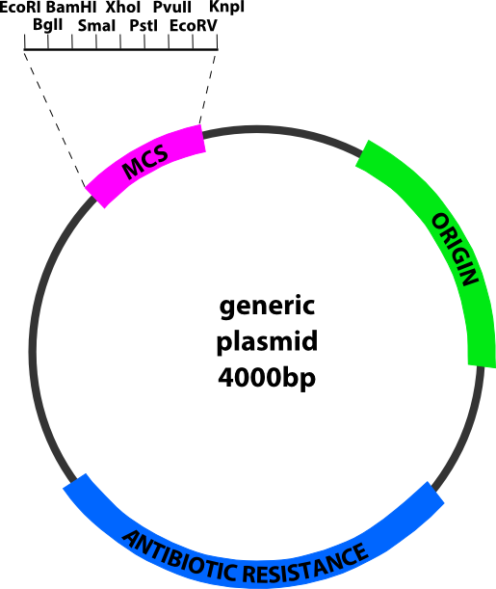

Figure 2. Plasmid DNA. Schematic of a generic plasmid depicting their common features: an origin of replication, the multiple cloning site (MCS) with a density of unique recognition sites for restriction endonucleases and a gene conferring antibiotic resistance, the most commonly used selectable marker.

G. Agarose Gel Electrophoresis of DNA

Gel electrophoresis is a technique used to separate macromolecules - especially proteins and nucleic acids - that differ in size, charge or conformation (6, 7). When charged molecules are placed in an electric field, they migrate toward either the positive (anode) or negative (cathode) electrode according to their charge. In contrast to proteins, which can have either a net positive or net negative charge, nucleic acids have at neutral pH a negative charge, due to the phosphate groups of their backbone. The relative migration distance of each molecule is determined by the charge density of the molecule and the resistance of the matrix (or gel) media to the passage of the molecule.

In DNA/RNA agarose electrophoresis (8), a gel of agarose is cast in the shape of a horizontal thin slab, with wells for loading the sample close to the cathode (usually connected to the black wire). The gel is immersed within an electrophoresis buffer that provides ions to carry a current and some type of buffer to maintain the pH at a relatively constant value.

Agarose is a polysaccharide extracted from seaweed. Agarose gels are prepared by mixing agarose powder with buffer solution to a final concentration of 0.5 to 2%, followed by heating until a clear solution is obtained. Most commonly, ethidium bromide (final concentration 0.5 μg/ml) is added to the gel at this point to facilitate visualization of DNA after electrophoresis. However, as ethidium bromide is a toxic mutagen, we will use a safer DNA stain instead, known as SYBR safe® (Invitrogen).

After cooling the solution to about 55°C, it is poured into a casting tray containing a sample comb and allowed to solidify at room temperature or in the cold. The porosity of the gel is inversely related to the agarose concentration. By varying the concentration of agarose, fragments of DNA from about 200 to 50,000 bp can be separated. The higher the agarose concentration, the "stiffer" the gel and the smaller the size of the DNA or RNA fragments that can be separated.

Following separation, DNA fragments are visualized by staining with SYBR-safe. This fluorescent dye intercalates between bases of DNA and RNA. It is often incorporated into the gel so that staining occurs during electrophoresis, but the gel can also be stained after electrophoresis by soaking in a dilute solution of SYBR-safe. DNA or RNA bands appears in red-orange color when the gel is exposed to UV light.

Fragments of linear DNA migrate through agarose gels with a mobility that is inversely proportional to the log of their molecular weight. Circular forms of DNA migrate in agarose differently from linear DNAs of the same mass. Several factors have important effects on the mobility of DNA fragments in agarose gels, and can be used to advantage in optimizing separation of DNA fragments. Among these factors are: agarose concentration, voltage (as the voltage applied to a gel is increased, larger fragments migrate proportionally faster than small fragments), electrophoresis buffer and SYBR-safe (when present in the gel). The molecular weight of a linear DNA sample can be determined by running a mixture of linear DNA fragments of known size under the same conditions (Figure 3).

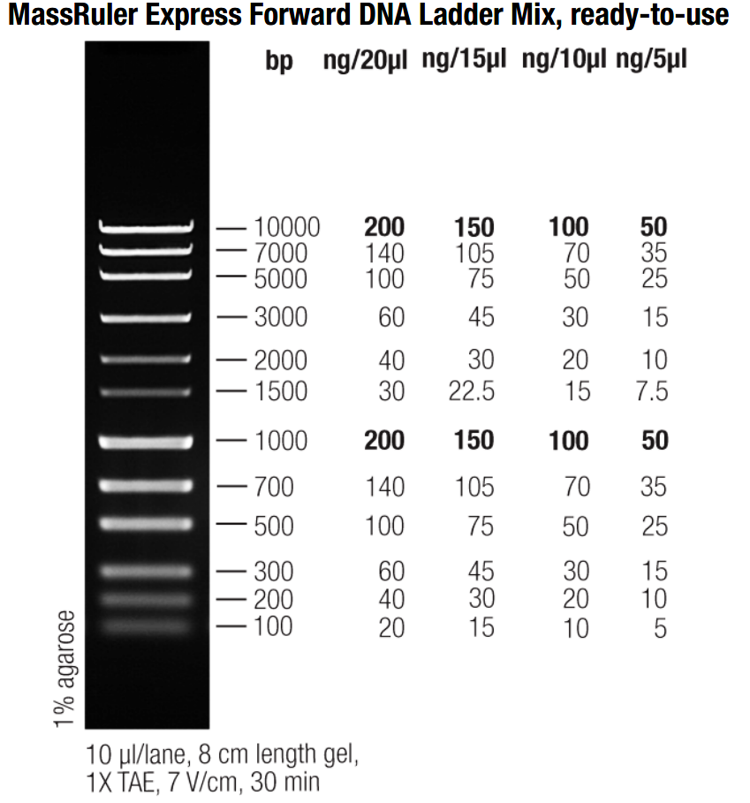

Figure 3: MassRuler Express Forward DNA ladder marker. The MassRuler Express Forward DNA ladder is constituted of 12 DNA fragment varying in size from 100 base pairs (bp) to 10,000 bp. Predetermined quantity of each fragment were mixed to produce this marker. These quantities are dependent on the volume of marker to be loaded on the agarose gel. For example, 5 microlitres (μL) of the marker contains 50 ng of the 1000 bp fragment whereas 10 μL of the same marker will contains 100ng of the same fragment. It is important to remember that linear DNA fragments migrate through agarose gels with a mobility that is inversely proportional to the log of their molecular weight.
H. Restriction Endonuclease Mapping of a Plasmid

Restriction endonucleases are a family of site-specific endonucleases that cleave the phosphodiester bond in the phosphate back bone of DNA. This cleavage is a hydrolysis reaction, adding a molecule of water across the phosphodiester bond, breaking it and generating a 5’ phosphate and a 3’ hydroxyl end (Figure 4).
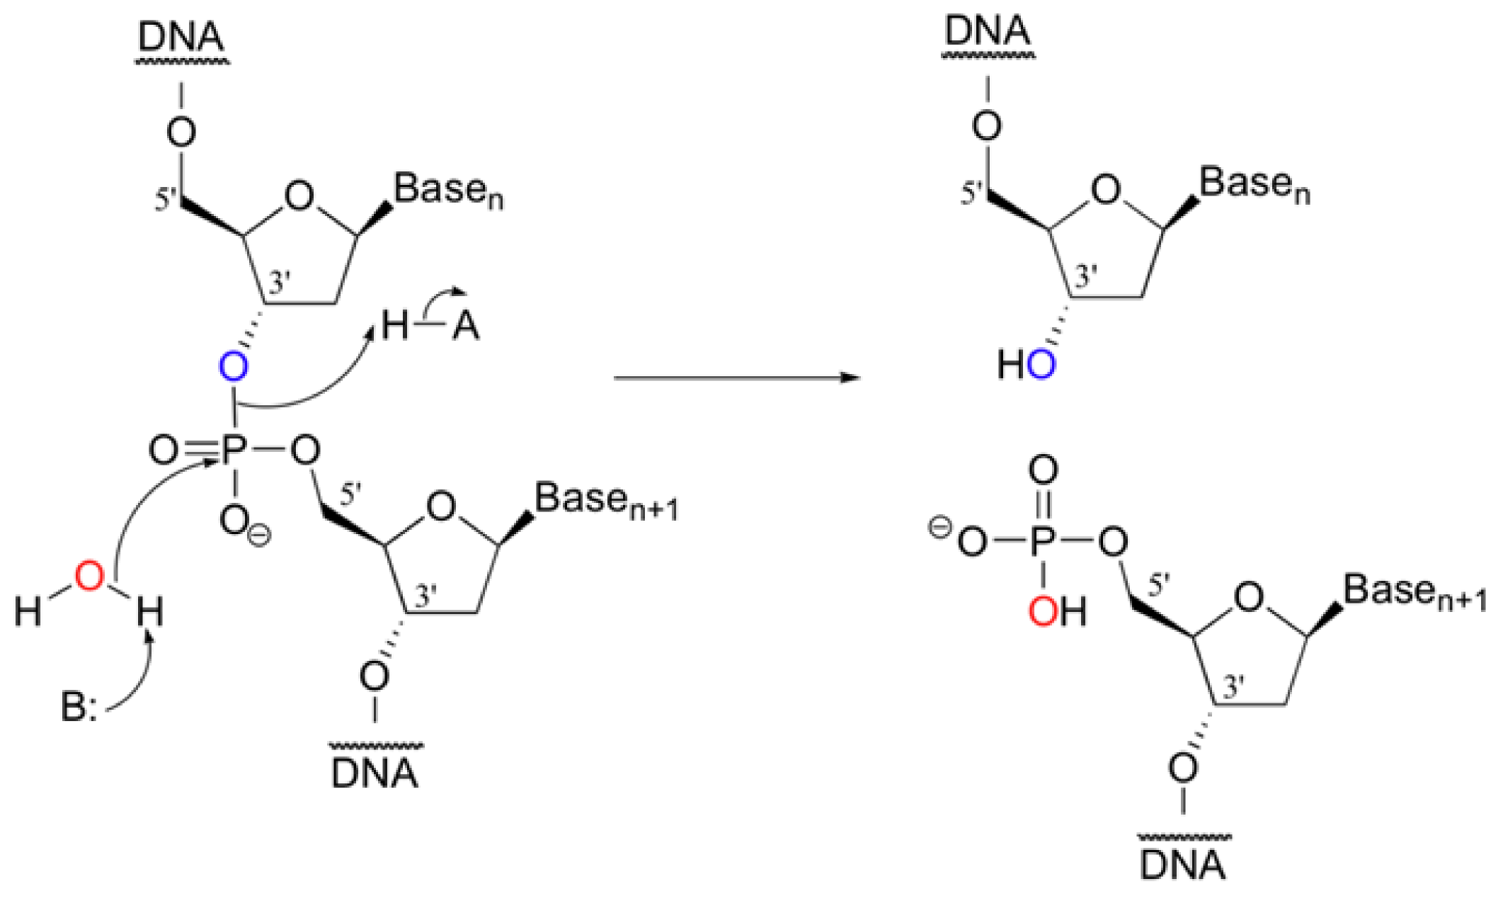

Figure 4. DNA cleavage by restriction enzymes. Adding a molecule of water across the phosphodiester bond breaks the phosphate backbone of the DNA, generating a 5’ phosphate and a 3’ hydroxyl end on the resultant DNA fragments (figure modified from http://chem wiki.ucdavis.edu)

These enzymes recognize short (4-8bp), often palindromic (identical when read 5’ to 3’ on each strand) sequences. The cleavage of both strands of the DNA backbone generates either blunt or sticky ends, depending on the specific enzyme used (Figure 5). These ends are exploited for many molecular biology used to manipulate DNA, most notably cloning.
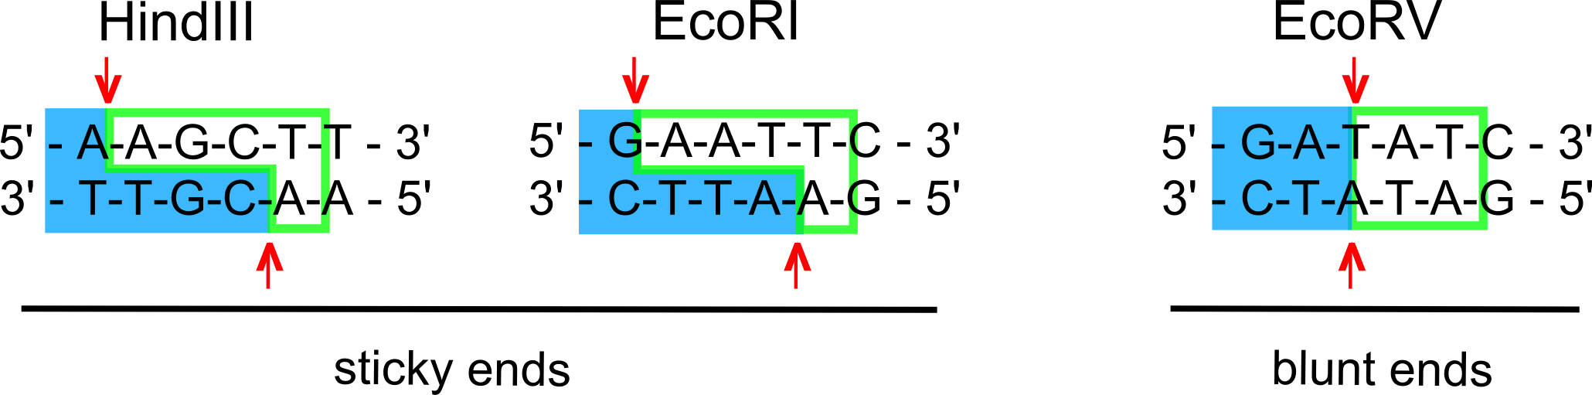

Figure 5. Restriction digest. Digestion with restriction enzymes may result in sticky ends, as seen for HindIII and EcoRI or blunt ends, as seen with EcoRV.

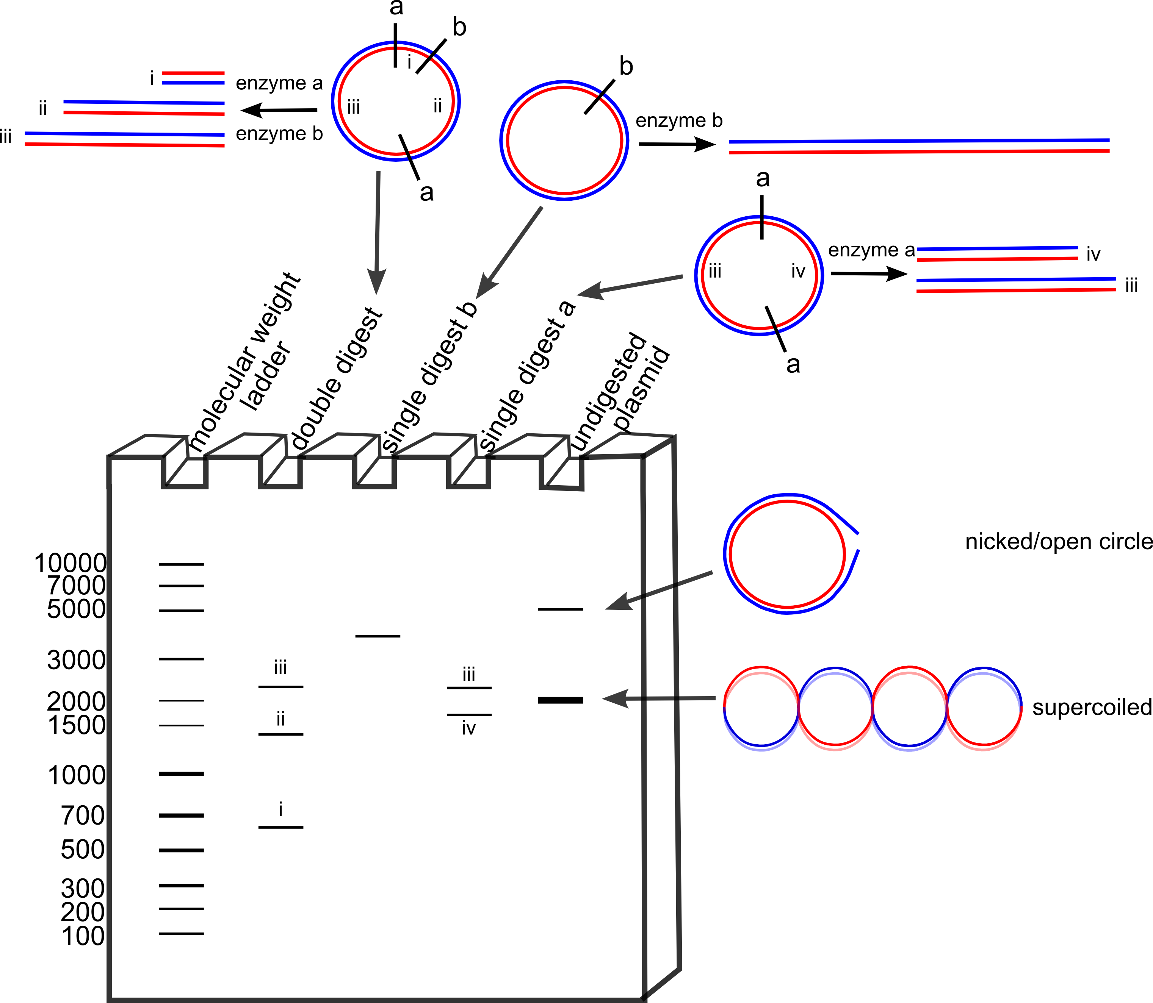
When plasmid DNA is isolated and run on an agarose gel, several bands may be seen. The predominant form a plasmid takes is a supercoil, often likened to an over twisted telephone cord, the double helix twists on itself yielding a compact piece of DNA that migrates faster than its linear form. A plasmid may be damaged or in the process of being replicated at the time of isolation resulting in a nicked formation, likened to a big floppy circle, being adopted. The nicked format migrates slowly mimicking a DNA fragment longer than its linear form. Finally, during alkaline lysis it is possible to use overly harsh conditions resulting in a permanently denatured intact single strand of the plasmid, this form migrates the fastest on an agarose gel (Figure 6). Following a restriction digest it is often helpful to run both a digested aliquot and an undigested control on an agarose gel to confirm that the digestion is complete based on the banding pattern observed.

Figure 6. Restriction digestion and plasmid mapping. Schematic depicting the restriction digest of a plasmid using two enzymes: where a single digest with each enzyme and a double digest were completed and compared with the undigested plasmid, in all its possible conformations and a molecular weight marker.

With each restriction enzyme having a unique recognition sequence, each time an identical piece of DNA is digested with the same enzyme, a characteristic fragmentation pattern will be observed. Exploiting this reproducibility, restriction mapping consists of digesting DNA with a series of restriction enzymes and separating them on an agarose gel to visualize the resulting fragments (Figure 6). These fragmentation patterns are then be used to characterize the relative location of the restriction sites be it on an unknown piece of DNA, as will be done in this experiment or to track and confirm the results of manipulating DNA (such as when inserting of a gene of interest in to a plasmid).

PROCEDURES

In experiment 1 you will extract the E. coli DNA. For experiment 2, a stock solution of E. coli DNA from a commercial source will be provided by the lab technician so that you can start the first “melting” curves (step 16) early in the lab session. In this experiment, you will analyze the effect of salt at low and high concentrations on DNA structure. Using the same “melting” technique, you will compare the homogeneity and integrity of the in-lab prepared DNA with a commercial source of E. coli DNA. In experiments 3 and 4 you will be introduced to the techniques of restriction digestion and DNA electrophoresis on agarose.

Before performing these experiments, you should watch the following videos:

- Gel electrophoresis Part 1 (13:05) or (http://www.youtube.com/watch?v=3ukaT_Ih9d8)

- Gel electrophoresis Part 2 (8:13) or (http://www.youtube.com/watch?v=_QxxB65Gi78)

EXPERIMENT #1: Isolation and characterization of bacterial DNA
a) DNA extraction

- You are provided with 60 mg of Escherichia coli, strain B, (a gram negative bacterium) suspended in 4 mL of cold Standard saline-EDTA (0.15 M NaCl in 0.1 M ethylene-diamine tetra-acetate – EDTA, pH 8.0) in a 50 mL Falcon tube.

- Add 375 μL of 25% sodium dodecyl sulfate (SDS) and mix gently by inversion. (SDS is a detergent and will foam extensively; you could also easily shear the DNA).

CAUTION! The SDS solution may irritate the skin and eyes. Use gloves and safety glasses.

(http://ccinfoweb2.ccohs.ca/msds/Action.lasso?-database=msds&-layout=Display&-response=detail.html&-op=eq&MSDS+RECORD+NUMBER=5502925&-search )

- Incubate the mixture in a 60°C water bath for 10 minutes and then cool to room temperature.

- Add 0.725 mL of 6.0 M NaClO₄ and mix gently.
CAUTION! The perchlorate solution may irritate the skin and eyes. Use gloves and safety glasses. (http://www.sciencelab.com/msds.php?msdsId=9925018 )

- Add 5.0 mL of chloroform:isoamyl alcohol (24:1, v/v) in the fume hood.
CAUTION! Chloroform and isoamyl alcohol are toxic and irritate skin, eyes and respiratory tract. Keep away from sparks and flame. Use gloves and safety glasses. Avoid inhalation. Work in the fume hood.
(http://www.sciencelab.com/msds.php?msdsId=9927133 )
(http://www.sciencelab.com/msds.php?msdsId=9927550 )

- Mix gently on a waver for 5 minutes.

- Centrifuge at 12,000 xg for 5 minutes. (Tubes should be balanced!).

- Carefully remove 70% of the upper aqueous phase by aspirating the liquid off with a plastic pipette and transfer it to a 15 mL Falcon tube. Avoid contaminating your sample with the denatured protein that collects at the interface between the aqueous and organic phases. Dispose of the chloroform phase in the appropriate waste container.

- Gently layer 10 mL of 70% ethanol over the aqueous phase in the tube. Seal the tube with its cap and mix gently and continuously until the ethanol becomes fully mixed with the aqueous phase (Observe the precipitation of the DNA).

- Retrieve the DNA using a glass rod and immerse it into a microtube containing 1 mL of 70% EtOH. Mix it gently in this solution to remove the salts.

- Squeeze out as much liquid as possible from the spooled mass by lightly pressing the stirring rod against the side of the tube. Place the glass rod in an upright position and allow it to drain for at least 10 min. Failure to remove the alcohol effectively will lead to difficulties in dissolving the DNA in the next step. Further removal of ethanol can be achieved with a stream of air.

- Dissolve a fraction of the crude DNA on the glass rod by stirring the DNA into 2 mL of 15 mM citrate buffer (sonicated), pH 7.0 in a 15 mL centrifuge tube. Gently swirl the glass rod back and forth until the DNA becomes detached from the rod. Seal the tube and place it on a waver for 5 min.

- Transfer 1 mL to a 1.5 mL microtube and centrifuge it for 1 min at 13,000 rpm.

b) DNA characterization

You will determine your DNA yield as well as the degree of purity and integrity of a DNA sample prepared as above.

- Pipette 200 μL of your dissolved DNA from step 13 into a quartz cuvette containing 800μL of 15 mM citrate buffer. Mix by inversion. Read and record the absorbance at 234, 260 and 280 nm of your sample with the UV-spectrophotometer, using the 15 mM citrate buffer as the blank.

- Prepare a dilution of your DNA sample with a final volume of 1mL in 15 mM citrate buffer, pH 7.0 in order to have an A₂₆₀ between 0.4 and 0.5. Calculate and record your dilution factor. This solution will be used for the DNA melting curve experiment (step 18).

EXPERIMENT #2: DNA melting curves

For a melting experiment, you will follow the change in absorbance at 260 nm of the DNA in function of the temperature. You will use the Cary100 Bio system that can analyse 12 DNA samples simultaneously.

Melting experiments will be performed on the following DNA samples:

a) E. coli DNA from a commercial source,
b) E. coli DNA from a commercial source, in the presence of salt at low concentration,
c) E. coli DNA from a commercial source, in the presence of salt at high concentration,
d) E. coli DNA from step 15.

Each team will perform one of the three melting experiments (a-c) plus its own sample (d).

- Prepare 1 mL of a 1:20 dilution from the stock commercial DNA solution as indicated below: (Take 50 μL of the stock solution and add it to 950 μL of the corresponding buffer).

Note: All buffers have been de-aerated by sonication. This will prevent bubble formation during the heating process.

solution a: commercial E. coli DNA in 15 mM citrate buffer, pH 7
(Teams 1, 2, 3, 8, 9, 13, 14, 15, 17, 19, 20 and 21)
solution b: commercial E. coli DNA in 15 mM citrate, pH 7, 0.03M NaClO₄
(Teams 4, 5, 10, 11, 22 and 23)
solution c: commercial E. coli DNA in 15 mM citrate, pH 7, 4.75M NaClO₄
(Teams 6, 7, 12, 16,18 and 24)

- Once samples from all teams are loaded into the Cary 100Bio spectrophotomer (as directed by your TA), the technician will start the melting experiment.

- Once experiment 1 is completed, each team will set up a second melting experiment with your own extracted DNA sample. Samples from teams 1 to 12 will be run in one apparatus and samples from teams 13 to 24 in the second apparatus. Please record the cell number in which your sample is loaded.

- Once the melting is finished, you will see the two plots of the absorbance and the 1st derivative on the same graphic. The output from the instrument (BTM file) will be saved and posted on the course’s web site in the Virtual Campus as a CSV file. (Excel can open this file and save it as a XLS file which is the Excel format). For convenience, the files will be named in the following format: L5S12(1-12)abc.csv or L5S12(1-12)d.csv; where S12 is the second Thursday afternoon section and (1-12) indicate samples from teams 1 to 12.

For your report you will need the results corresponding to your sample plus any set of the three commercial samples in different conditions (control, low and high concentration of salt) that were analyzed the same day. You are to incorporate the four graphics (a - d) in your report showing the two plots for the absorbance and the 1st derivative.

EXPERIMENT #3: Restriction Endonuclease Mapping of a Plasmid

In this experiment, an unknown plasmid (100 ng/µL) will be digested with a combination of two different restriction enzymes: EcoRI (10 U/µL) and HindIII (10 U/µL). You will be supplied with H₂O, a solution of 10X digestion buffer (Buffer O) and an unknown plasmid (100 ng/µL). Each team will be digesting a different plasmid.

- Prepare the following reaction mixtures in 4 labelled 0.5 mL microcentrifuge tubes by adding the following reagents in the order they are listed. Ask your TA for the EcoRI and HindIII restriction enzymes, adding them to the mixture last; rinse the pipette tip with the solution at least 5 times. Always keep your tubes on ice until loading it into the water bath.

Reagents | EcoRI | HindIII | EcoRI + HindIII | Control
H2O (brown tube) | 11 µL | 11 µL | 10 µL | 12 µL
10X Buffer (blue tube) | 2 µL | 2 µL | 2 µL | 2 µL
Unknown plasmid (100 ng/µL)  (Orange tube) | 6 µL | 6 µL | 6 µL | 6 µL
EcoRI (10 U/µL) (see TA) | 1 µL | ---- | 1 µL | ----
HindIII (10 U/µL) (see TA) | ---- | 1 µL | 1 µL | ----
Total volume | 20 µL | 20 µL | 20 µL | 20 µL
Table 1. Plasmid digestion mixture

- Mix the solutions by tapping the bottom of the tubes with your finger. To bring all the reagents to the bottom of the tube, centrifuge for 15 seconds. (Make sure your tubes are balanced!)

- Incubate your tubes in the 37⁰C water bath for 1 hour.

- Once the digestion is completed, add 2.2 µL of 10X DNA-electrophoresis loading buffer to each sample. Mix thoroughly.
Proceed now with electrophoresis on the provided gel (step 29).

EXPERIMENT #4: Agarose gel electrophoresis

N.B. To avoid waiting time, a gel for every four groups is provided. Your TA will demonstrate how to prepare a gel (steps 24-28). Groups of 4 teams will load a gel and perform the electrophoresis as described in steps 29-34. Before loading the sample, you can practice with loading buffer and the demo gel.

- In a 250 mL bottle, prepare 100 ml of a 1% (w/v) agarose solution in TAE (40 mM tris-acetate, 1.0 mM EDTA) buffer. Check calculation with your TA before proceeding.

- Heat the agarose suspension in a microwave oven. To prevent pressure from building up inside the bottle, loosen the cap before heating. Use high setting 3 x 1 min, mixing after each minute. Make sure agarose is completely melted.

- Once dissolved, allow to cool to 50-55°C (agarose solidifies at about 40°C); any hotter than 55°C will melt the gel casting mold.

- When the gel solution is at 50-55°C, add 10 µL of SyBr Safe DNA Stain.

- Place the gel running tray in the gel casting mold and pour the cooled (50-55°C) agarose solution into the casting mold. Pour slowly to avoid making bubbles. Place a 20 well comb at 1 cm from one end of the casting tray. Dislodge any bubbles with a pipet tip. Allow the gel to solidify for at least 20 min.

- Remove the comb by slowly lifting one end, making sure not to suck the agarose out of the bottom of the well.

- Lift the gel tray from the casting mold and place in the electrophoresis chamber. Pour in the TAE buffer until the gel is covered by 4-8 mm of buffer.

- Load 10 µL of provided MassRuler Express Forward DNA ladder marker (M) and 15 µL of the samples from step 23 in wells 1 to 20 as described in the template below. Place the end of the tip below the surface of the running buffer immediately above the desired well. Expel the sample slowly (taking care not to allow any air bubbles to form under the tip), the high concentration of glycerol in the loading buffer will cause the entire sample to sink to the bottom of the well.

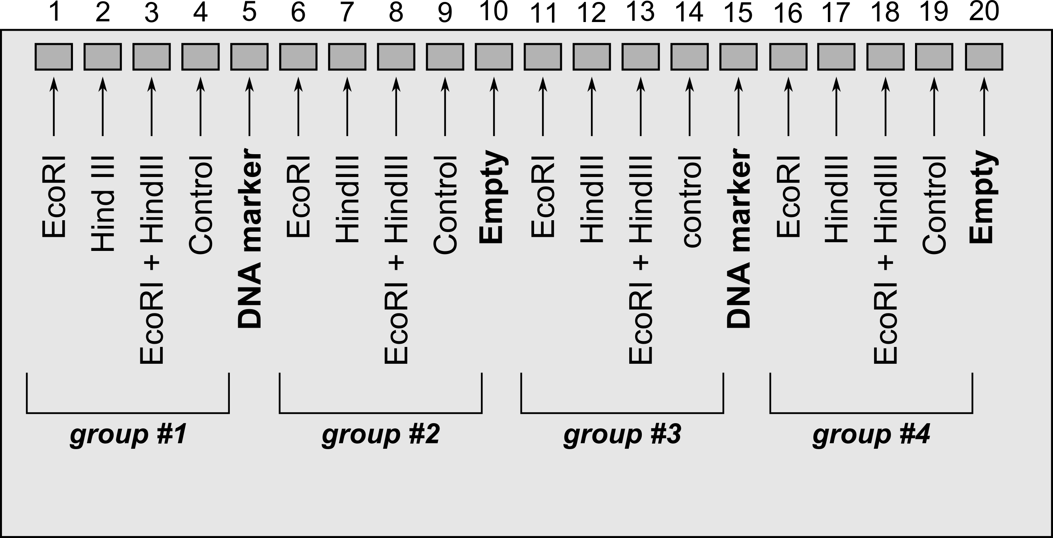
Gel loading template

- Place the lid on the electrophoresis unit and connect the electrodes such that migration proceeds towards the RED (positive, anode) electrode. Connect the leads to the power supply and apply 100 V for 45 min.

- Turn the power supply off, disconnect both ends of the electrodes and remove the gel tray. (WEAR GLOVES)

- Place the gel and running tray on the UV Gel Doc System and take a picture. (Ask your TA for help). For convenience, name the file in a similar way as for the melting data by giving the lab number, the section and the number of the teams with samples on the gel (e.g. L5S2(5-8)).

RESULTS AND DISCUSSION

- From the UV absorption data comment on the purity of your DNA preparation.

DNA melting curves

- Show the 4 graphics with the melting curves (absorbance and 1st derivative) for DNA in different conditions (samples a to d). From the 1st derivative plots, estimate the corresponding Tm values. From the absorbance plots, estimate the values of h(%) and ΔT. Show your calculations. Summarize your results in the following table.

Table 2. DNA melting results

DNA sample | T_{m} (°C) | ΔT (°C) | h (%) | h/ΔT (°C⁻¹)
a) Commercial
b) Commercial + 0.03M NaClO₄
c) Commercial + 4.75M NaClO₄
d) Extracted DNA (step 15)

- From your results R2, discuss the effect of salt at low and high concentration on the DNA structure. T_{m} and hyperchromicity (h) should be discussed.

- From your results R2, comment on the purity and integrity of the extracted DNA. T_{m} and hyperchromicity (h) should be discussed.

Restriction Digestion and Gel Electrophoresis

- Show a figure with the picture of your gel (step 33) and the corresponding labels. Estimate the migration distance of all bands. Plot logMW (bp) of the MassRuler DNA ladder (Figure 3 and Appendix C) vs. the migration distance (show the figure). Estimate the MW (bp) of all DNA fragments in your four samples.

- From the number and size of the fragments observed in your three digested samples, create a map of the plasmid showing the relative location of the restriction sites for EcoRI and HindIII.

- Looking at your gel electrophoresis identify the conformation(s) that your undigested plasmid has adopted. Were your digestions (EcoRI and HindIII) complete? Why or why not?

REFERENCES

- Marmur, J. (1961). A Procedure for the Isolation of DNA from Microorganisms. J. Mol. Biol. 3: 208.

- Voet, D. and Voet, J. (2004). Biochemistry, 3rd Ed. John Wiley & Sons, 6.6A, p 155.

- Boyer, R. (2000). Modern Experimental Biochemistry. 3rd Ed. Benjamin Cummings, p 399.

- Winfrey, M.R., Rott, M.A. and Wortman, A.T. (1997). Unraveling DNA. Molecular Biology for the Laboratory. Prentice Hall (N.J.), pp 42 and 56.

- Voet, D. and Voet, J. (2004). Biochemistry, 3rd Ed. John Wiley & Sons, 5.3C, p 90.

- Bergeron-Wiper, N and Rodriguez M. (2004). Electrophoresis.Tutorial notes IV.

- Voet, D. and Voet, J. (2004). Biochemistry, 3rd Ed. John Wiley & Sons, 6.4, p 144.

- Voet, D. and Voet, J. (2004). Biochemistry, 3rd Ed. John

SI (système international) units and prefixes

SI Units:
Length: meter (m)
Mass: kilogram (kg)
Time: second (s) [lower case]
Electric current: ampere (A)
Amount of substance: mole (mol)

Non-SI units sometimes used:
liter (L or l) used to measure volume.
Dalton (Da) or unified atomic mass unit (u). One dalton is equal to 1.66×10⁻²⁷ kg.
Minute (min), hour (h), day (d) as units of time.

SI prefixes:

SI prefix | SI symbol | Decimal value | 10^{x} (scientific) value
pico- | p | 0.000000000001 | 10⁻¹²
nano- | n | 0.000000001 | 10⁻⁹
micro- | µ | 0.000001 | 10⁻⁶
milli- | m | 0.001 | 10⁻³
centi- | c | 0.01 | 10⁻²
deci- | d | 0.1 | 10⁻¹
(no prefix) |  | 1 | 10⁰
deca- | da | 10 | 10¹
hecto- | h | 100 | 10²
kilo- | k | 1,000 | 10³
mega- | M | 1,000,000 | 10⁶
giga- | G | 1,000,000,000 | 10⁹
tera- | T | 1,000,000,000,000 | 10¹²
References:
SI units: http://www.bipm.org/en/si/base_units/
SI prefixes: http://www.bipm.org/en/si/si_brochure/chapter3/prefixes.html
Tips for maintaining a laboratory notebook
One important skill that you will acquire in this laboratory course is the proper use and maintenance of a laboratory notebook. Your lab notebook should help keep you organized, but skillful notebook use is developed by most students only through continued special effort. Don’t hesitate to ask your TA for advice on the maintenance of your laboratory notebook.
For the purpose of BCH2233 you will be working in pairs. The maintenance of your lab notebook is therefore crucial for effective communication with your partner. Guidelines for the maintenance of your laboratory notebook are listed below. Please remember that each member of a team should have their own laboratory notebook, complete with all the results and calculations.

- Notebook preparation and general rules
  - Find a durable hard-bound notebook; do not use a spiral bound notebook as sheets can be removed. We recommend the blue notebook “lab notes” that is sold by the bookstore in the University Center.
  - Write your full name, the course code, your section and group number, as well as your email, on the front and/or first page of your notebook.
  - If your notebook is not already numbered, number all pages (one side is enough).
  - Devote pages 2 to 4 to a Table of Contents.
  - Use a pen, not pencil, for all entries. Write legibly!
  - If you make a mistake, draw a line through the word or number rather than obliterating the error with an ink blob. Never use correction liquid/tape.
  - Write down everything, even if it seems insignificant. It could later become extremely useful to better understand what happened.

- Before the laboratory session
- Start a new page indicating the date, the title of the lab session, the purpose of the experiments, the techniques to be used, prelab calculations required by the lab manual and any questions that you may have about the performance of the experiment or the corresponding theoretical background.
- Prepare a flow chart showing your time management during the labs and the coordination of the workload with your partner. You need to plan ahead of time how to divide and share tasks with your partner. Break the lab session into blocks and indicate the experimental steps you expect to be performing during each time interval. The WHEN and WHO aspects should be emphasized in your flow chart. Time management will be critical when each member of the team will have to execute different tasks in parallel. Flow charts should be prepared in pairs and before attending each laboratory class.
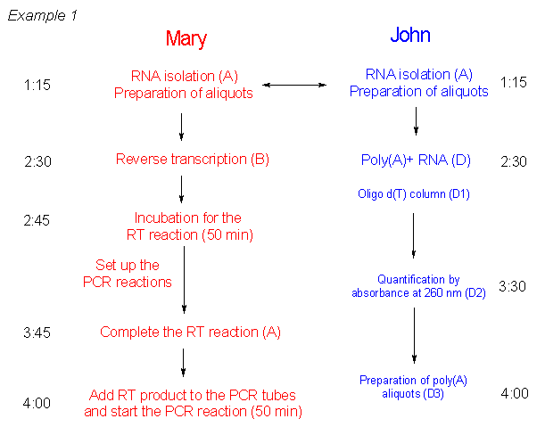

- Get your notebook initialed by the TA before you start your lab.

- During the lab session
- Annotate any required calculations, any variation from the manual protocol, all your readings from instruments (like a spectrophotometer). Remember to always include units.
- Record equipment details such as brand and model.
- Record all your observations
- Record your measurements, in a table format when appropriate.
- Have your notebook initialed before you leave.

- After the lab session
- Further analysis of your results, graphics and calculations when preparing your lab report. (Not all final graphics and tables need to appear in your lab-book).
- All printout containing experimental results (gel pictures …) should be included in your lab manual along with a descriptive annotation. (Make sure that added printouts do not cover or obscure other entries).
- You should write a small conclusion at the end of each laboratory.

- Examples of lab-book recordings
a) Good and bad (missing titles, page numbers...) table of contents.

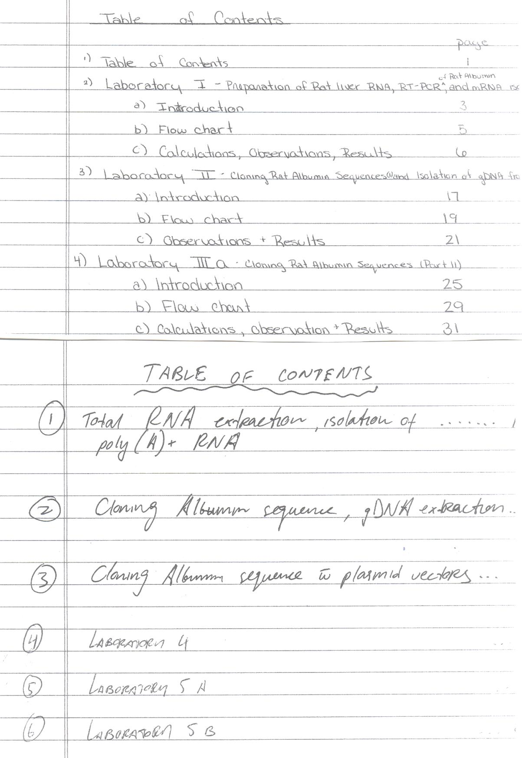
b) Good and bad (missing information) results recording
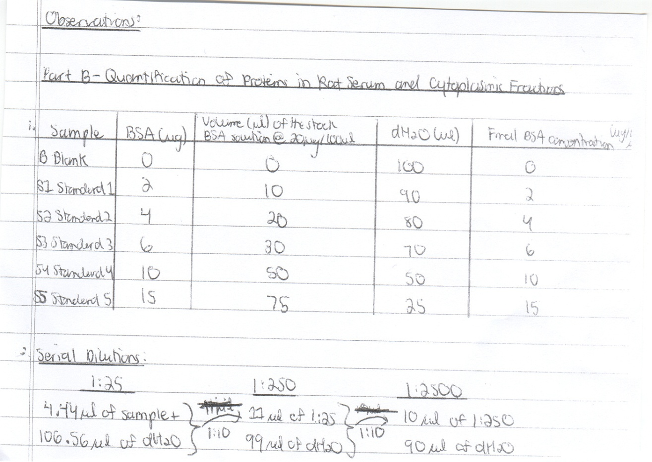

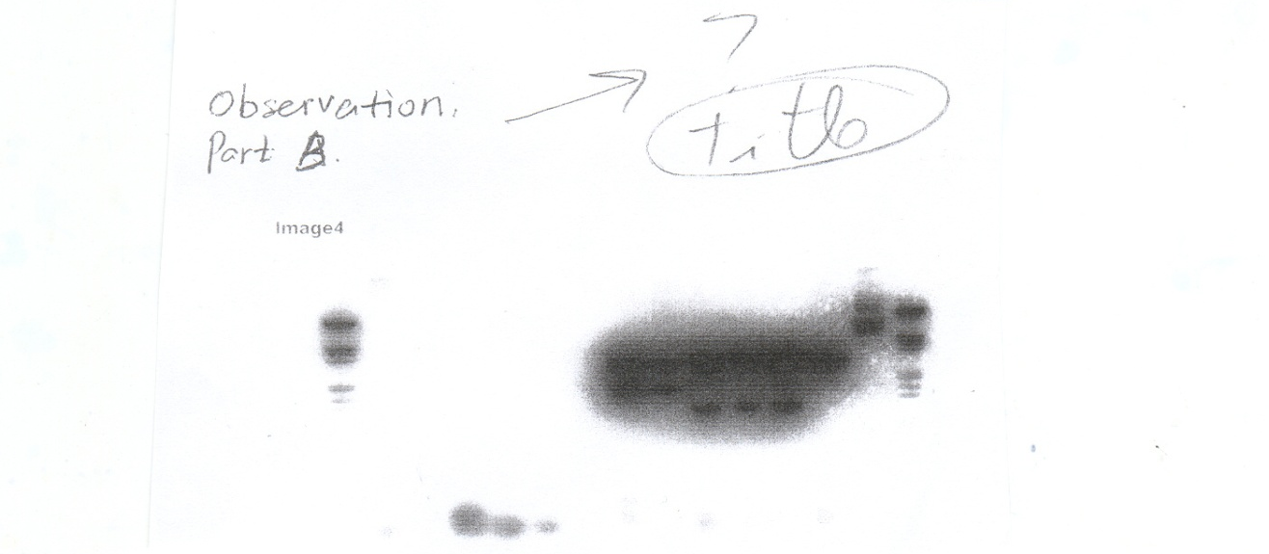
c) Good (pointing specific protocol steps, equation provided, variables identified, as well as units...) and bad (difficulty to understand what was done, no units for final result...) calculations recording.
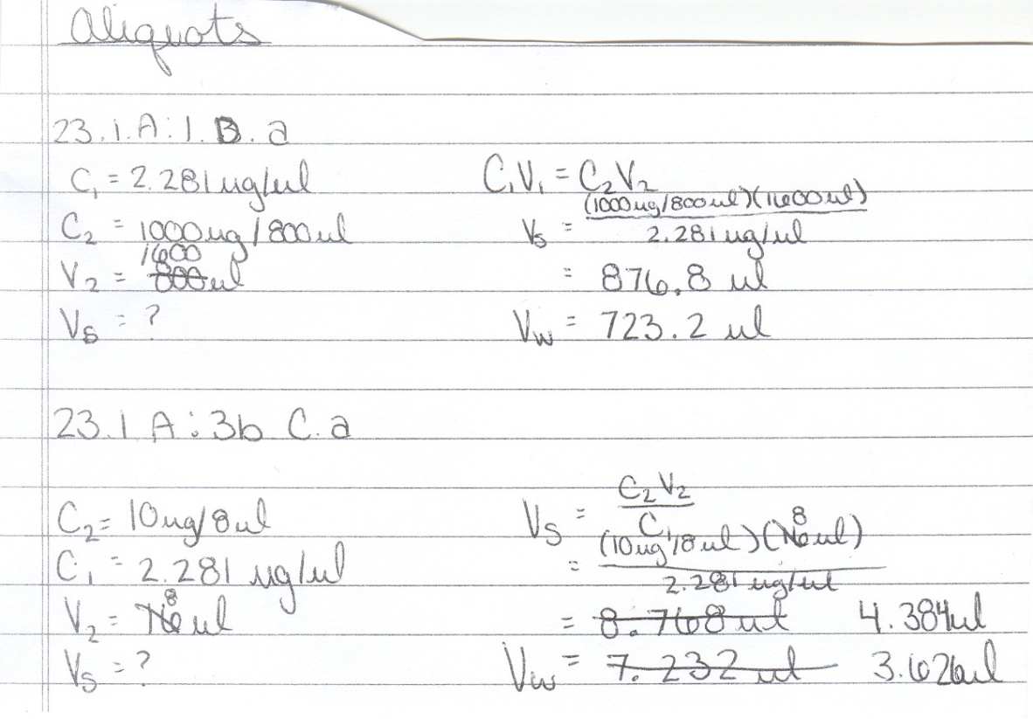

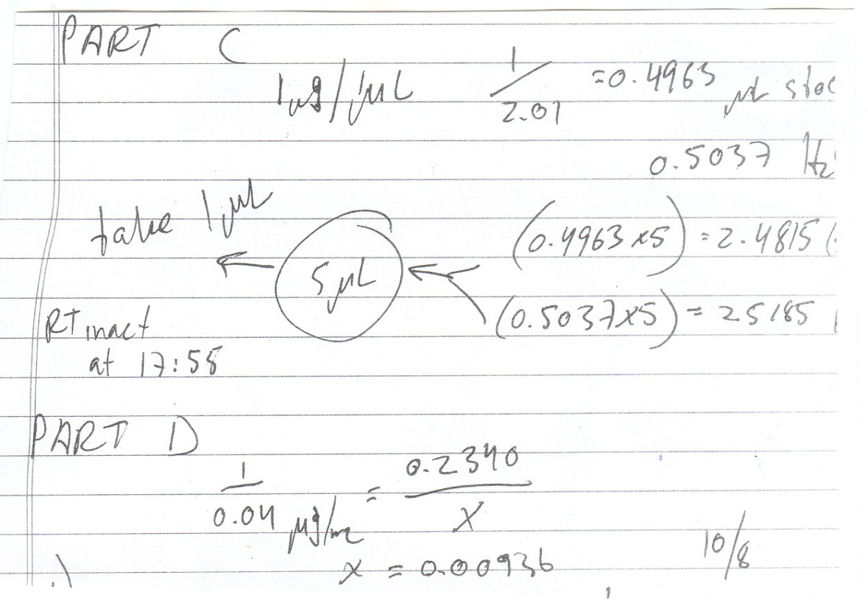

Appendix B1
General guidelines for the preparation of a laboratory report

1) Example of Report Title Page

Lab BCH2333

SECTION: 14 (Thursday morning 2nd week)

LAB 1: CARBOHYDRATES

Name of TA

Date of Performed Experiment

TEAM #

Student Name & Student #

2) Instructions and Examples of Tables and Figures.
By browsing through the literature, you can observe that different scientific journals have different requirements when it comes to the preparation of tables and figures. In the context of a question-based lab report, you will need to include more information your table and figure legends since there is no text to describe them.
Tables
Tables should have table numbers, titles and explanatory legends containing sufficient experimental detail to be understandable. Your table title and legend should be located on top of your table. For this course, we ask you to write first the table number in bold (ex: Table 1.). It will be followed by a general title in bold again (ex: Purification of the acyl-CoA esterase activity associated with fatty acid reductase). Following this title, you will include a descriptive legend. Readers should have enough experimental detail to understand your table. For the table itself, each column must have a heading, and abbreviations, when necessary, should be defined in the legend. If you are using a standard to calculate the values presented in your table, you have to have to mention it. Units should always be mentioned in the heading of each section. If you want to discuss one of the values in your table, for example an outlier value, put a symbol in subscript next to this value and write a footnote at the bottom of the table. Here an example modified from the Journal of Biological Chemistry, Vol. 259, No. 16, pp10216-10221, August 25, 1984:
Table 2. Ester hydrolysis measured by the fatty acid reductase-luciferase coupled assay. The complete assay system contained 5 μM ester, 2.5 μg of 50K protein, 1 μg of 34K protein, 5 μg of 58K protein, 100 μM NADPH, 1 mM ATP in 1 mL of 50 mM phosphate buffer, pH 7.0, containing 20 mM mercaptoethanol and 10 mM MgSO₄. After 15 min, 5 μg of P. phosphoreum luciferase was added and then 1.0 mL of 50 μM FMNH₂ was injected. The luminescence response was converted into picomoles of aldehyde based on the response of tetradecanal.

Ester | Aldehyde  (pmol)
None | 16
Tetradecanoyl-S-mercaptoethanol
Complete | 94
- ATP | 10.4
- 34K protein | 36
Tetradecanoyl-S-mercaptoethanol
Complete | 31
- ATP | 1.2
- 34K protein | 8.0

Figures
Figures should have figure numbers, titles and explanatory legends containing sufficient detail to make the figure easily understood. This information should be located under your actual figure. Do not insert the title of your figure on top of the figure (even for a graph). When your figure is a graph, the abscissa and ordinate should be clearly labeled, and units of measurement must be given. When appropriate, include the equation corresponding to your trendline. Use standard symbols found in MS Word, with symbols and curves identified in the legend and not on the figure. Here is an example of figure (from the Journal of Biological Chemistry, Vol. 280, No. 46, pp38160-38169, November 18, 2005):
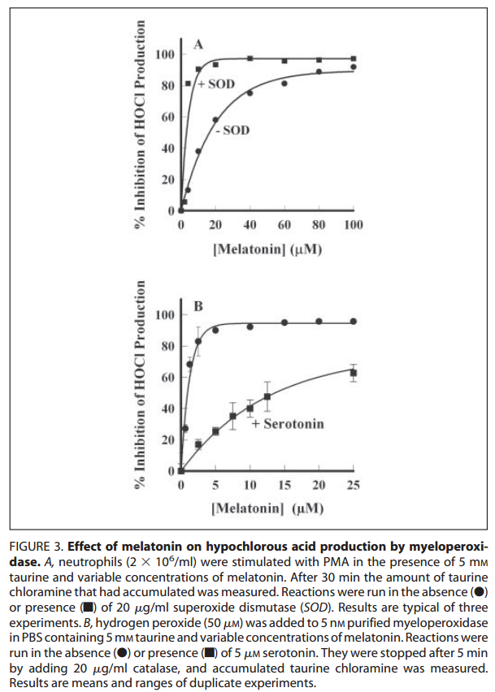

3) Example of calculation

Often this semester, you will be asked to provide a sample of your calculations. Here are some basic rules to follow:
- Provide a list of the variables you will use for this calculation.
- When applicable, write the equation you are trying to solve.
- In some occasions, you will have to do more than one example of calculation. A sample calculation is valid as long as I can input a number and get the correct answer at the end of the process. If you need to change one variable in the equation, you should do a new example of calculation. For example, if you are using a different standard, you can’t use the same sample of calculation, you have to change one of the variables in your sample of calculation.
- Units should always be present.
- Your final answer should never be a simple number; you should put a concluding statement. In fact, this tip should also be applied to any calculation question you will have to answer this semester. A single number (even if it’s the correct answer) is not a valid answer. It has to be put in context with a concluding statement. (ex: The recovery yield of this purification is 12%).

Here is an example:

Question: Prepare 1 mL of a 1.0 μg/µL DNA solution in water from a 2.14 mg/mL DNA solution.

Variables:

C₁ = 1.0 μg/µL or 1.0 mg/mL C₂ = 2.14 mg/mL
V₁ = 1mL V₂ = ?

C₁V₁ = C₂V₂

V₂ = C₁V₁/C₂

V₂ = 1.0 mg/mL * 1mL
2.14 mg/mL

V₂ =0.47 mL

We need to take 0.47 mL of the stock DNA solution to prepare 1 mL of a 1.0 μg/µL DNA solution.

Appendix B2

List of usernames for the submission of lab reports using FTP

Appendix C1
Serial Dilution:
1:10
1:10
1:10

V1
V2
V3

Va
C₀/10

VbStudent 2
C₀/100

Vc
C₀/1000
STOCK: C₀ C₀/100
CCCCCCCCCC CC

C_{i}V_{i} = C_{f}V_{f} where i refers to the initial solution and f to the final solution

1st dilution: 2nd dilution:
C₀ x V1 = (C₀/10) x Va (C₀/10) x V2 = (C₀/100) x Vb
V1 = (C₀/10) x Va V2 = (C₀/100) x Vb
C₀ (C₀/10)
V1 = Va/10 V2 = Vb/10

Example

You want to do a 1/5 serial dilution of a 2 mM solution of compound A. You decide to do 3 dilutions in a 1ml volume. What will be the final concentration of compound A in each dilution? What will be the values of V1, V2 and V3 (in fact it should be the same value)?

See next page for the solution.
V1
V2
V3
1:5
1:5
1:5

Va
C₀/5

Vb
C₀/25

Vc
C₀/125
STOCK: 2mM C₀/100
CCCCCCCCCC CC

If C₀ = 2mM and Va, Vb , Vc = 1mL:

Concentration of your three dilutions should be:

Stock solution: 2 mM
1st dilution: C₀/5 = 0.4 mM
2nd dilution: C₀/25 = 0.08 mM
3rd dilution: C₀/125 = 0.016 mM

Value of Va, Vb and Vc:

1st dilution: 2nd dilution: 3rddilution:
C₀ x V1 = (C₀/5) x Va (C₀/5) x V2 = (C₀/25) x Vb (C₀/25) x V2 = (C₀/125) x Vc
V1 = (2 mM/5) x 1 mL V2 = (2 mM/25) x 1mL V2 = (2 mM/125) x 1mL
2 mM (2 mM/5) (2 mM/25)
V1 = (2 mM/5) x 1 mL V2 = (2 mM/25) x 1mL V2 = (2 mM/125) x 1mL
2 mM (2 mM/5) (2 mM/25)
V1 = 1 mL/5 V2 = 1 mL/5 V2 = 1 mL/5
V1 = 0.2 mL V2 = 0.2 mL V2 = 0.2 mL
Appendix C2
The Beer-Lambert law

A UV-visible spectrum is a plot of the amount of light absorbed by a molecule versus the wavelength of the incident light in the range of 180 to 800 nm. A given band in a spectrum is characterized by the wavelength at which the absorbance intensity is a maximum (λmax) and by the intensity of the absorbed light. The number, position and relative intensity of bands is characteristic of each molecule and can be used for the identification of compounds. Usually bands in the region of 200-340 nm (UV) are indicative of π electrons (aromatic groups or double bonds), whereas bands in the region 340-800 nm (visible) are representative of multiple double-bond conjugation. Proteins absorb light strongly in two different regions of the UV spectrum. The C=O of the peptide bond absorbs strongly between 190 nm and 220 nm. Aromatic side chains, such as phenylalanine, tyrosine, and tryptophan absorb strongly around 280 nm. The purine and pyrimidine bases of DNA and RNA absorb strongly around 260 nm. The concentrations of protein and DNA in solution are often estimated from the A280 and A260 of the solution, respectively.
The absorbance intensity is related to the concentration by the Beer-Lambert law:

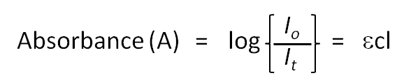

Where A is the absorbance at a specific wavelength, I_{o} is the intensity of incident light, I_{t} is the transmitted intensity, ε is the absorption coefficient at the specified wavelength, c is the concentration of compound and l is the path length of the cell (cuvette). Any spectrophotometer shows optimal precision (minimal relative error) when the absorbance is 0.434. With many instruments, readings of absorbance above 2 are not reliable since the light reaching the detector approaches its sensitivity limit. Also, the relative contribution of stray light (light with a different λ from the one being measured) increases at high absorbance, thus the real value of the absorbance is underestimated.
The Beer-Lambert equation is an analytical tool used very often to measure the concentration of biochemicals in solution. It is important to note that the absorption properties of most molecules can be affected by pH, solvent polarity, temperature etc. For example, both the εmax and λmax for tyrosine change substantially depending on the pH of the solution. These changes are due to alterations in the protonation state of the tyrosine hydroxyl group.
Experiment standards (of known concentrations of a specific compound) are often used to measure the concentration of an experimental solution containing the same compound. This could be achieved by doing the following transformation on the Beer-Lambert law:

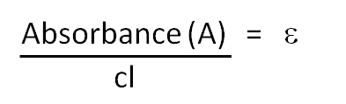

Since the ε is the same for the standard and the unknown (we are measuring the absorbance of the same specific compound), we can further transform our Beer-Lambert equation:
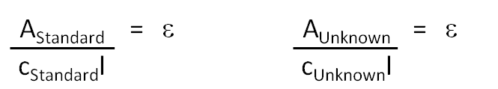

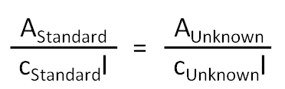

Therefore, if you have the concentration of the standard solution (c_{Standard}) as well as its absorbance (A_{Standard}), you can determine the concentration of your solution of unknown concentration by using its absorbance:
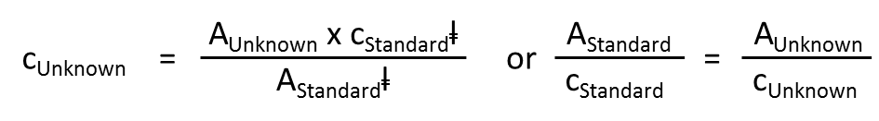

Appendix C3
Percentage of yield.

The percentage of yield can be useful to explain if your experiment was done properly or not. In this formula (see below), the experimental value is the value that you experimentally got in the lab (if you kept a good record of your experimental results, this information should be in your lab notebook). Sometime the theoretical value will be given to you; but in most occasions you should have an idea of what you are supposed to get at the end of the procedure (in theory). If you get a percentage of yields close to 0%, it means that you lost most of you were trying to purify. If you get a value that is close to 100%, it means that everything went well; experimental value is close to theoretical value. If your experimental value is higher than your theoretical value, it means that you have made an error in your calculations. If you’re doing a purification, you can’t purify more molecules than the loading amount and therefore, you may have done something wrong; overestimation of a volume (fraction volume), a pipetting mistake, a mistake in the absorbance reading, etc…).
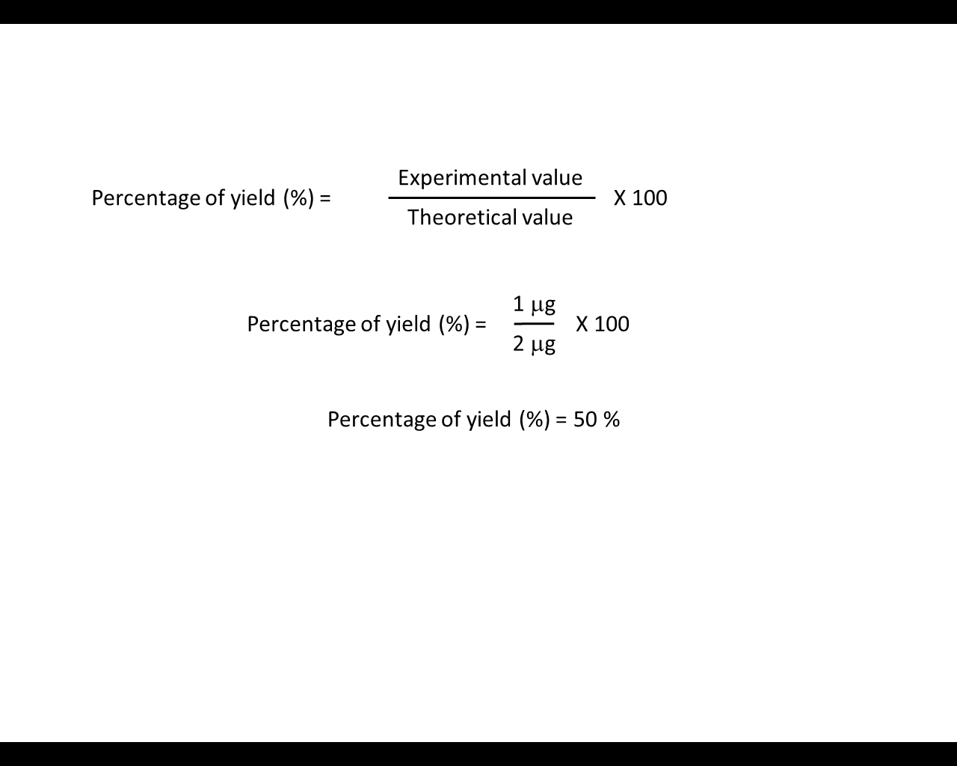

Example:

You have to purify 2 μg of DNA using a purification procedure. At the end of the procedure, you quantify your DNA and you found that you have 1 μg. What is the percentage of yield?
First, you can determine easily the theoretical value: If everything works perfectly, you should get 2 μg at the end of the purification. Therefore, your theoretical value is 2 μg.

You can now assume that you have purified 50% of the initial 2μg of DNA.
Appendix C4
Percentage difference

The percentage difference shows a difference between two values as a percentage of one (or both) values. In lab 3, we are asking you do compare two trendlines and to tell us if there are same or not. Obviously, it is almost impossible to get two identical slope numbers. This is why it was mentioned that anything under 25% difference should be considered as equal. Here an example:

You are plotting two set of data and you are ask to determine if the slope and the y-intercept values are the same by comparison to the control slope (black line in the graph). The question states that you should use a 25% cut-off to justify your answer.
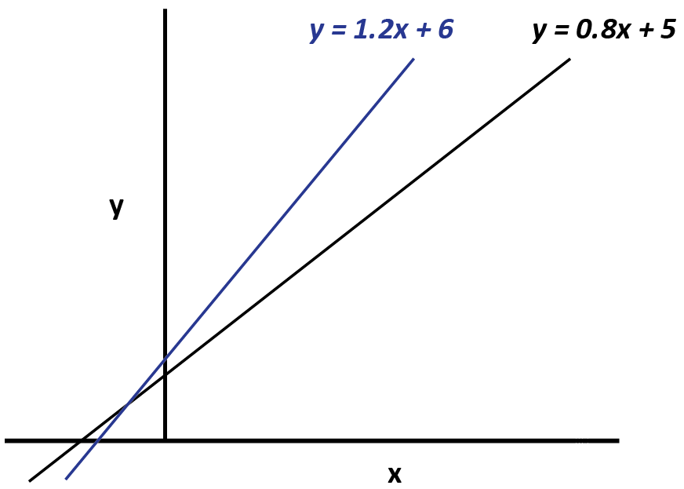

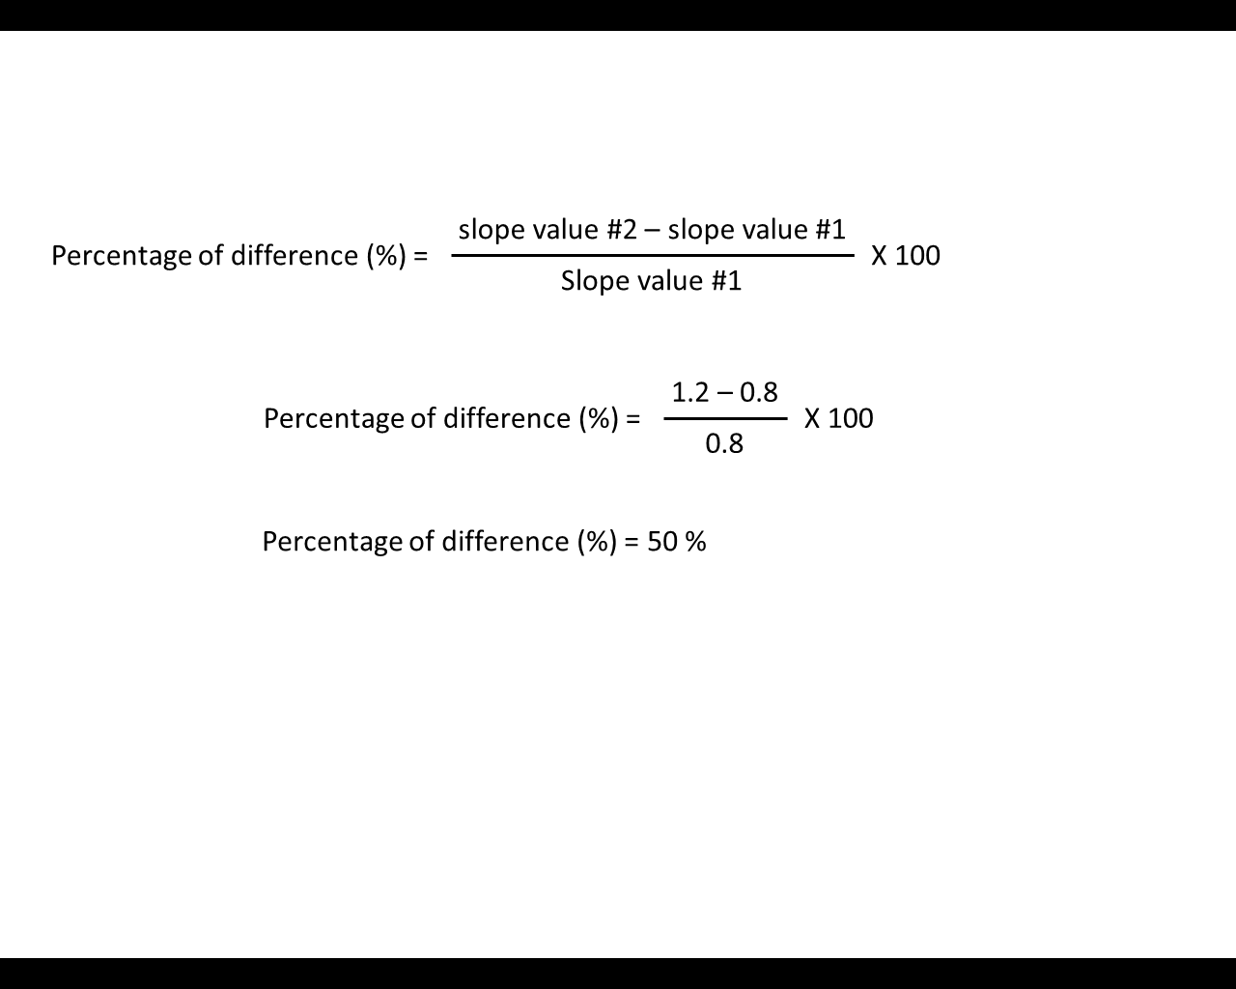
Percentage difference of the slope:

There is a 50% difference between both slopes and therefore, you can state that there is a slope increase when compare to the control slope since the difference you observe is well above the 25% cut-off.
Now, let us check if the same apply to the y intercept:
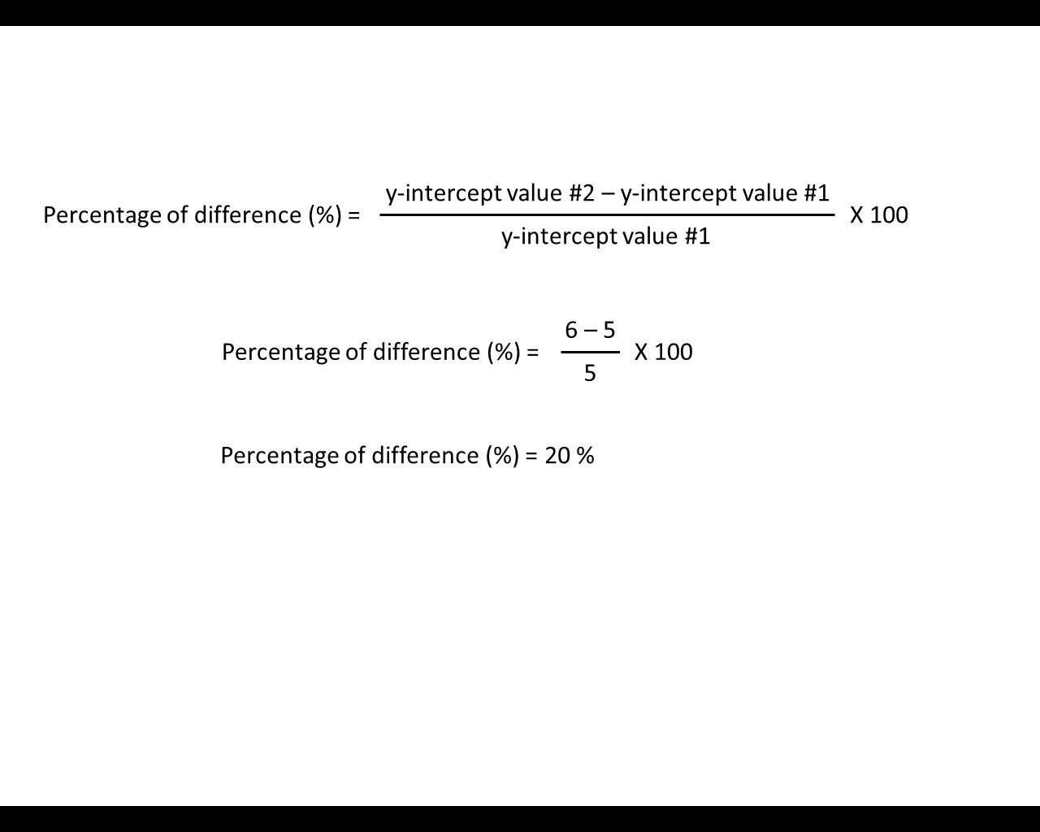

There is a 20% difference between both y-intercept values and therefore, you can state that there is no difference in the y-intercept values when compare to the control y-intercept value since the difference you observe is below the 25% cut-off.
Appendix C5
Quantitative DNA Ladder and estimation of length and amount of DNA bands
A quantitative DNA ladder contains known amounts of DNA molecules of different lengths. It serves as a reference to estimate the size and amount of an unknown DNA band. A quantitative DNA ladder must be used each time you are loading sample on and agarose gel; it must be loaded at the same time as your samples.
Length of an unknown
One of the first information you can draw from the use of a DNA ladder is the estimation of the length of an unknown DNA band. By quickly comparing the length of your unknown band to the bands of the molecular ladder, you can estimate its length (Figure 1A). If you want to be more precise, one can a plot describing the log(length) vs mobility for the different bands of a marker, and then use the equation derived from the trendline to predict the length of an unknown. Here is how you can achieve that:
- Measure the travelling distance of each band of the marker by using a ruler (from the well to the middle of each DNA band). See Figure 1B.
- Plot the log of the length of the DNA fragments against their travelling distances (Scatter plot in Microsoft Excel). See Figure 1C.
- Create a linear regression line (Linear trendline option in Excel and check the Display Equation on chart option. See Figure 1C.
- You can now measure the travelling distance of your unknown and input this value in the linear regression equation to get a prediction of the length of your unknown sample.
As you can see in the presented example, high molecular weight fragments sometimes affect the results of the linear regression. Large DNA molecules (10,000bp +) have a really hard time migrating through the molecular mesh of a 1% agarose gel and therefore, it becomes more difficult to measure the migration distance of these fragments with precision. If you notice outlier values on your linear regression line, you can eliminate some of them to improve your R² as I did for the example presented.
Amount of an unknown
You can also quantify (estimate) the amount of DNA that was loaded on gel by direct comparison to the DNA ladder. The intensity of a band is proportional to the number of SYBR Safe molecules bound onto the DNA and therefore, this intensity will vary with the number of bp and the amount of the DNA fragment that was loaded on gel. There are two rules to this type of estimation, first, always try to use a band of the marker that is closely related in size to your unknown since larger fragments will intercalate more dye than small fragments, which in turn, will give them greater band intensity. Secondly, once you have selected a band of the marker for your comparison, use the information given by the manufacturer (amounts of DNA by loading volume) to know how much DNA is present in that band. Knowing the amount of DNA present in the marker band (from the manufacturer information sheet), you can then apply the intensity ratio to this number. For example, if you look at gel presented in Figure 1A, the unknown band is 3 times more intense that the 3000 bp marker band. If 30 ng of this DNA fragment was loaded on gel (10 μL of the marker), I can say that I have loaded ~90 ng of my unknown.

Figure 1. Quantitative DNA Ladder and estimation of length and amount of DNA bands. A) Estimation of a DNA fragments length using the MassRuler Express Forward marker (Fermentas). DNA quantity presented on the right side of the marker description sheet correspond to amounts of DNA loaded for each fragment of the marker in relation to the volume of marker used (top line). B) Determination of the DNA fragments length by plotting the logarithm of the length of the DNA fragments of the marker against their migration distances. C) Linear regression of the log (fragments length) against the migration distance. Points located at the end of the regression line were eliminated to improve the R² value of the line.
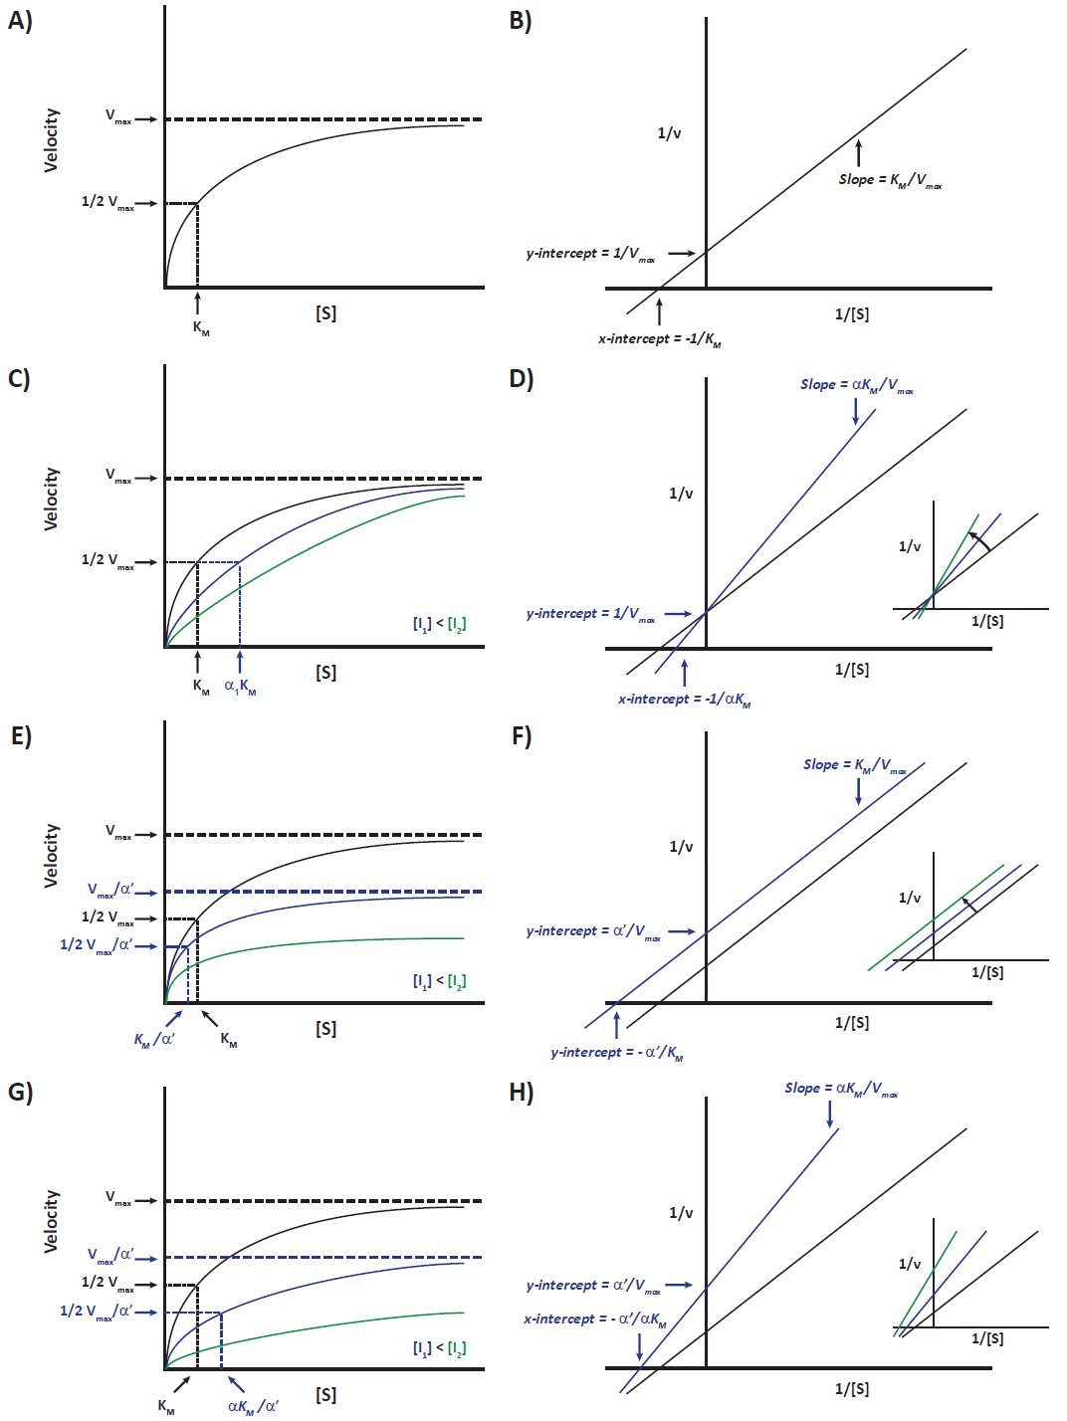
Lab 3 Supplementary Figure 1. Enzyme inhibition effects observed using Lineweaver-Burk (LWB) representation. A) Michaelis-Menten plot of v₀ against increasing [S], where v_{o} approaches V_{max} at high [S] and half of this maximum velocity corresponds to K_{M}. B) Taking the reciprocal of the Michaelis-Menten equation and plotting 1/v against 1/[S] allows for analysis by linear regression, where the slope = K_{M}/V_{max}, y-intercept = 1/V_{max} and x-intercept = -1/K_{M}. In the case of COMPETITIVE inhibition, V_{max} is unaffected but the amount of substrate needed to achieve it increases. This is graphically visible by a change in the shape of the curve for the Michaelis-Menten plot due the increase in K_{m} by factor of α; where : α = 1 + [I]/K_{I} (C) and an increase in the slope ((αK_{m}/V_{max}) of the LWB plot along with an increased x-intercept (-1/αK_{m}) (D). In the case of UNCOMPETITIVE inhibition the both the K_{m} and V_{max} are decreased by a factor of α’, where α’ = 1 + [I]/K_{I}’. This results in an overall lowering of the Michaelis-Menten curve (E) and an upward shift of the LWB plot. While the slope of the LWB remains unchanged, the y-intercept (α’/V_{max}) increases and the x-intercept decreases ((-α’/K_{m}) (F). Finally in the case of mixed inhibition the V_{max} decreases (V_{max} /α’) while the K_{m} increases (αK_{m}/α’). This is observed as a lowering and flattening of the Michaelis-Menten plot (G) and an increase in the slope (αK_{m}/V_{max}) of the LWB plot due to the increased y-intercept (α’/V_{max}) and decreasing x-intercept (-α’/αK_{m})(H).

Lab 3 Supplementary Figure 2. Enzyme inhibition effects observed using the Hanes representation. A) Michaelis-Menten plot of v₀ versus increasing [S], where v_{o} approaches V_{max} at high [S] and half of this maximum velocity corresponds to K_{M}. B) The Hanes plot is an alternative linear model that can be obtained by multiplying the Lineweaver-Burk equation by [S] and plotting [S]/v against [S]. In this linear-regression, the slope corresponds to 1/V_{max}, y-intercept to K_{M}/V_{max} and x-intercept to -K_{M}. In the case of COMPETITIVE inhibition, V_{max} is unaffected but the amount of substrate needed to achieve it increases. This is graphically visible by a change in the shape of the curve for the Michaelis-Menten plot due the increase in K_{m} by factor of α; where : α = 1 + [I]/K_{I} (C). The slope of the Hanes plot remains unchanged, while the y-intercept (αK_{m}/V_{max}) increases and the x-intercept decreases (-αK_{m}). (D). In the case of UNCOMPETITIVE inhibition the both the K_{m} and V_{max} are decreased by a factor of α’; where α = 1 + [I]/K_{I}’. This results in an overall lowering of the curve in the case of the Michaelis-Menten plot (E) an increase in the slope (α’/V_{max}) of the Hanes plot due to an increased x-intercept (-K_{m}/α’) (F). Finally in the case of mixed inhibition the V_{max} decreases (V_{max} /α’) while the K_{m} increases (αK_{m}/α’). This is ovserved as a lowering and flattening of the Michaelis-Menten plot (G) and an increase in the slope (α’/V_{max}) of the Hanes plot due to the increased y-intercept (αK_{m}/V_{max}) and decreasing x-intercept (-αK_{m}/α’)(H).


