Module 1: Levels of Analysis
November-18-11
9:24 PM
Unit 1: What is Psychology?

  - Psychology is cutting edge research with the common goal of understanding human thought and behaviour

Unit 2: Brief History of Psychology

  - Psychology: "psyche" means "soul"
  - Descartes: suggested that mind and body are causally linked in a dualistic relationship
  - Muller: proposed that messages transmitted by nerves are encoded as electrical impulses
  - Helmholtz: measured the speed of nerve impulses (found to be much slower than electrical impulses).
  - Muller: proposed that certain brain parts play different roles in functioning
  - Flourens: supported Muller's proposition by experimentally destroying parts of animals' brains to study the effects of the damage. These experiments uncovered information on the brain's control over heart rate, breathing, and visual and auditory reflex processing

  - Wundt: opened the first lab devoted to the study of psychology (1879)

Unit 3: Levels of Analysis

  - 3 basic levels of analysis:

Psychological Analysis

Most intuitive level; asks the question, "what lies within a subject's mind?"

Biological Analysis

Physiological mechanisms that underlie thoughts and behaviour

Unit 4: Intro to Perspectives in Psychology

Developmental Perspective (refer to Unit 7)

  - How behaviours develop over a life span
  - Difficulty in studying special groups of people (e.g. babies, children, special needs individuals)

Behaviourist Perspective

  - Watson: "overt behaviour is the ONLY valid means of measure in psychology"
  - Nurture > Nature
  - Highlights importance of Environmental Analysis
  - The mind = a black box
  - Behaviour modification: an organism will repeat a behaviour if it leads to something pleasant

Socio-Cultural Perspective (refer to Unit 8)

  - Looking at factors that influence the behaviour of the individual and the group
  - How is one's behaviour influenced by the group they are surrounded by (and vice versa)?

Evolutionary Perspective (refer to Unit 7)

  - Looking at influence of environmental and genetic factors on behaviour across MANY generations

Unit 5: Cognition

  - Cognitive revolution: internal events must not be overlooked; they are necessary to fully understand behaviour
  - Model: abstract representations of how the mind functions; can be used to make testable predictions
  - Any bit of contradictory evidence forces us to either revise or abandon a present model

Unit 6: Biological Perspective and Reductionism

  - Reductionism: all human behaviour can be reduced to the biology of the brain

Neuroimaging

  - Structural MRI: allows us to see the physical make-up of the brain
    - See whether there are gender differences in the size of a certain brain region

  - Functional MRI: allows us to see what the brain is actually doing
    - See whether men and women use the same area to perform a certain task

Unit 7: Evolutionary and Developmental Perspectives

Different Perspectives:

  - Example: men and testosterone
    - Neuroscientists say testosterone is the cause of male aggression
    - Evolutionary psychologists ask: "does it make adaptive sense for males to be aggressive?"

  - Developmental and evolutionary psychologists focus on the same factors that influence thoughts and behaviour, but development psychologists focus on these changes across a LIFE SPAN, whereas evolutionary psychologists look at MANY life spans

Measuring Infant Response

  - Habituation: showing the same picture to a baby until he/she stops acknowledging it. If a different picture is then shown and the baby shows newfound interest, it is proof that babies have the ability to distinguish between faces

Unit 8: The Socio-Cultural Perspective

  - Focus on 3 different influences:
    - Influence of the individual on a group
    - Influence of a group on an individual
    - Influence of one group one another

Unit 9: Connection to Case Study

  - Behaviourist perspective of depression (using the "black box" theory):

  - Learned helplessness: subjects have learned through repeated trials that they are unable to escape an unpleasant stimulus. In the future, even if there is a way to avoid the stimulus, the subject does not take it

Textbook Review

  - Structuralist school: focus on the study of sensory perceptions, and introspection
  - Introspection: we must analyze and break down our experiences through self-reflection
  - Principle of totality: any conscious experience must take into account all mental and physical aspects of the individual
  - Gestalt school: promoted the study of perception and problem-solving
  - Cognitive Revolution: introduced the rejection of the behaviourist idea
  - Basic research: conducting research for the sake of research; there need not be an immediate application for the knowledge gained
  - Applied research: application of knowledge of psychological phenomena for the solution of problems

Module 2: Research Methods I
December-05-11
7:39 PM
Unit 1: Intro to Scientific Research

The Scientific Method

  - Theory: a general set of ideas about the way the world works
  - Hypothesis: a testable statement guided by theories; a specific prediction about a phenomenon
  - Research method: way in which hypothesis will be tested
  - Collect data: the experiment is a way to examine the effect of one variable (the IV - independent variable, which is manipulated) on another (the DV - dependent variable, which is observed)
  - Analysis: discovering trends in the data
  - Report findings: publish articles in scholarly journals
  - Revise theories: to include new information

Unit 2: Conducting an Experiment

  - Paradigm shift: dramatic change in the way of thinking (example: Copernicus and the centre of the universe)
  - Anecdotal evidence: evidence gathered from self-experience of the experience of others
    - Problems include:
      - Single experience is not representative of reality
      - Personal experiences are not universally representative
      - Confounding factors
  - Experiment: scientific tool used to measure the effect of one variable on another. The independent variable must be properly manipulated for optimum results

Unit 3: Control Groups

  - Experimental group receives manipulation of the IV; control group does not
  - Experimental and Control groups should vary ONLY in the IV (everything else should be the same)

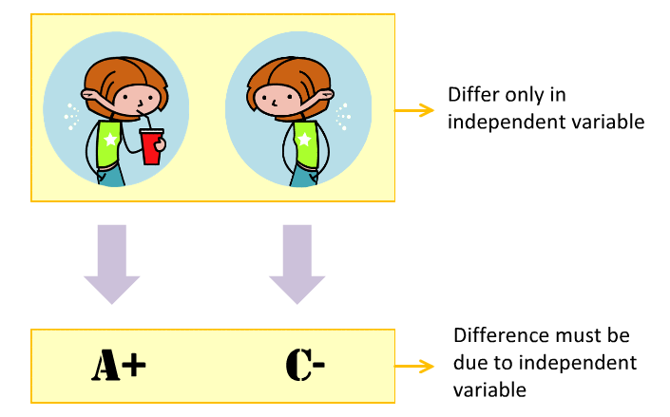

Participant Designs

  - Within-Subject design: manipulating the IV within each participant to minimize effect of external variables on the DV
    - Costly and time-intensive; subjects may CHANGE over the course of the experiment
    - Practice effect: improved performance over the course of an experiment due to experience
  - Between-Subject design: one group of subjects receives experimental manipulation; control group does not
    - Confounding variable: a variable other than the independent variable that has an effect on the results (also called extraneous variables [EVs])

Unit 4: Sampling

  - Limited sampling: sampling from a specific group of participants; results cannot be generalized to entire population
  - Samples should accurately represent the population so that results CAN be generalized
  - Random sampling: choosing a random sample from entire population
  - Random assortment: assigning subjects randomly to either the experimental or control group to avoid biases

Unit 5: Conducting an Experiment

  - Placebo effect: effect that occurs when an individual exhibits a response to a treatment that has no related therapeutic effect (example: sugar pill)
  - Subject biases: subject knows he is being tested; influences his performance
  - Blind studies: subjects do not know if they are in control or experimental group
  - Experimenter bias: experimenter deliberately of unintentionally influences events because he/she expects a certain result
  - Double-blind studies: experimenter doesn't know who belongs to the control or experimental group

Module 3: Research Methods II
December-06-11
4:07 PM
Unit 1: Intro to Scientific Research

  - Histogram: type of graph used to report the number of times groups of values appear in a data set
  - Frequency distribution: illustrates the distribution of how frequent values appear in the data set (the curved line going through a histogram)

  - Normal distribution: smooth, symmetrical, bell-shaped curve around a single peak (aka "bell curve")

Measures of Central Tendency

  - Mean: average value of a data set
    - Affected by outliers (extreme values distant from others in a data set)
  - Median: central value in a data set when the set is arranged numerically (if there is an even number of values, take the mean of the middle 2 values)
  - Mode: value that appears most frequently (only thing that can be used for non-numerical values as well)

Measures of Variability

  - Standard deviation: average distance of each data point from the mean (wider spread = larger StDev)

Unit 2: Inferential Stats

  - Inferential statistics: stats that allow us to use results from samples to make inferences about overall, underlying populations

  - T-test: test that considers each data point from both groups to calculate the probability of getting the results by chance if there is indeed only one distribution underlying both groups in the experiment. The T-test gives us a P-value.
    - If P-value<0.05, results are statistically significant (which means less than 5% chance of obtaining data by chance)
    - If P-value>0.05, results are not significant
    - A P-value of x means that the experimenter would have found the same result x% of the time even if the hypothesis is incorrect (the lower the value of x, the better)

Unit 4: Observational Research

  - Correlation: a measure of the strength of the relationship between 2 variables
    - Correlation coefficient (r) indicates strength and direction of correlation
      - -1<r<1 (negative correlation means the presence of one variable is related to the absence of the other)
      - r = 0 means NO correlation between variables
    - Correlation =/= causation!

Textbook Review

  - Operation definition: describes the actions or operations that will be made to objectively measure or control a variable
  - Ob-ob mouse: they are not fat because they eat a lot; they eat a lot because they are fat (genetic mutation)
  - Inductive reasoning: allows us to build theories based on various incidents of observed phenomena converging on a hypothesis
  - Deductive reasoning: allows us to make predictions about certain phenomena based on the testable claims of a particular theory
  - Social desirability bias: responding in experiments in ways that reflect well on us, because we want to be socially accepted
  - Response sets: a tendency to respond to questions in an arbitrary, particular manner regardless of the content

Type I and Type II Errors:
- Type I errors are made when you conclude that manipulation of the IV caused a change in the DV, when in reality the change was due to confounding variables
- Type II errors occur when you conclude that the IV manipulation had no effect on the DV, when in reality it did have an effect

Module 4: Classical Conditioning I
December-06-11
4:38 PM
Unit 1: Intro to Learning

  - Learning is important for survival
    - Conscious learning (such as reading)
    - Unconscious learning (natural instincts)

Unit 2: Classical Conditioning

  - Classical conditioning: the learning of a contingency between a particular signal and a later even that are paired in time and/or space
    - Contingency: association of a signal to an event
  - Contiguity, the proximity in time and/or space of the US and CS is extremely important in the formation of a contingency

Unit 3: Terminology



Occurs NATURALLY

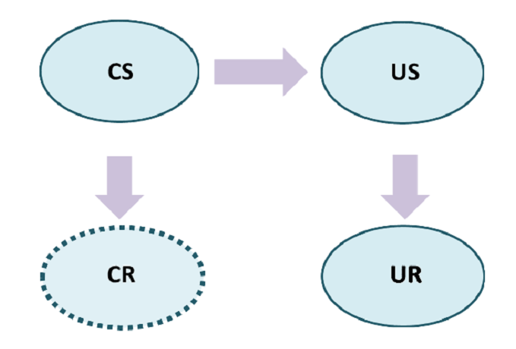

Paired with the US to form a contingency

Any stimulus that occurs naturally prior to learning

Contingency

Response that occurs once a contingency has formed between the US and CS

A response that occurs after the US, prior to learning

  - Rate of acquisition: most learning occurs in the first few trials
    - On a graph, it is a negatively accelerated increasing function (logarithm)

Unit 4: Extinction

  - Contingencies can break once the CS is not a reliable cue for the presence of the US
  - Extinction: loss of the CR when the CS no longer predicts the US
  - Evidence for inhibition: retraining of the CS with the Us occurs at a faster rate than the original training (suggests that contingencies are not just "unlearned")

  - Spontaneous recovery: after extinction occurs, presentation of the CS after a period of rest results in a CR of considerable strength
    - Proof that contingencies are not "unlearned"; rather, extinction involves inhibitory learning
  - Reacquisition: reintroducing the CS and US after extinction can reform the acquisition faster than originally
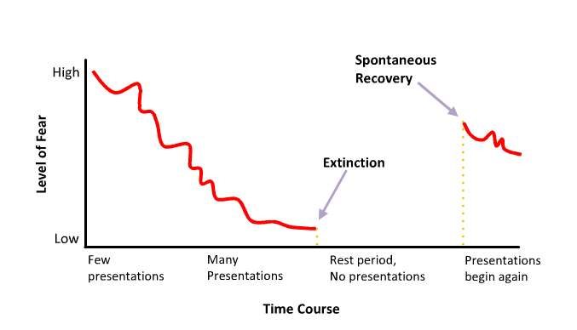

Module 5: Classical Conditioning II
December-06-11
4:38 PM
Unit 2: Generalization and Discrimination

  - Stimulus generalization: presentation of a stimuli similar, but not identical, to the CS elicits a CR nonetheless
    - Example: child was bitten by a Doberman Pinscher, but will still show fear towards a German Shepherd or Great Dane (similar enough to a Doberman in terms of species and size)
  - Generalization gradient: the more similar a stimulus is to the CS, the more powerful the CR (as the stimulus differs more and more from the CS, the CR is weakened proportionately)
    - Follows a normal distribution (refer to picture)

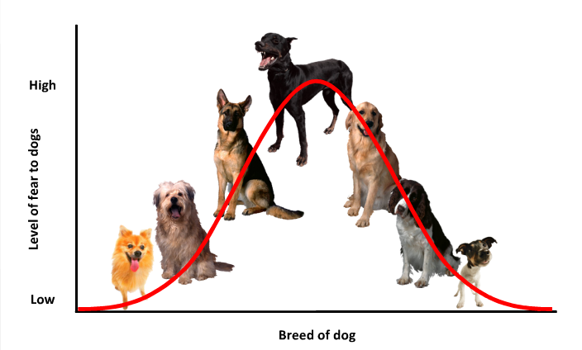

  - Extinction occurs through training in which the CS is presented WITHOUT the US; the contingency gradually breaks
  - Generalization and Extinction: along the generalization gradient, the largest loss of CS strength (during extinction training) occurs with the original CS, and decreases as the stimulus gets less and less similar to the original CS

Discrimination Training

  - Restricts the range of CS's that can elicit the CR
    - Referring to the dog example, DT can be used to lessen the child's fear of dogs that are dissimilar to the Doberman Pinscher (such as a Cocker Spaniel)

  - CS+: predicts the presence of the US
  - CS-: predicts the absence of the US

------->

  - Example: showing the child a Cocker Spaniel (a CS-) repeatedly with no US (dog bite) will reduce the child's fear of that particular CS-
    - Alternating presentation of a CS- with the CS+ (in this case a Doberman) will lead to an increased training effect (child's fear of the CS- disappears even faster)
    - If a CS- and CS+ (Cocker Spaniel and Doberman) are shown TOGETHER, and intermediate fear response is shown (an "average" of the two fear responses)

  - Importance in everyday life:
    - Generalization: efficiency and flexibility
    - Discrimination: refines the learning process

Unit 3: Phobias and Therapies

  - Implosive therapy: person with phobia is encouraged to confront the fear CS that evokes anxiety (CS without US --> CR fades away)
  - Systematic desensitization: more gradual version of implosive therapy; patient tackles CS's along the generalization gradient until he/she gets to the original CS (each CS- along the gradient is harder to make extinct)
  - Antabuse: for alcoholics, it is a drug that causes extreme nausea when taken with alcohol
    - Sickness/nausea leads to avoidance through conditioning;
      - Alcoholics may eventually just choose NOT to take the drug, nullifying its benefits

Unit 4: Homeostasis and Compensatory Responses

  - Homeostasis: maintenance of several physiological processes in the body within strict parameters; made stronger through conditioning
  - Compensatory response: process which counteracts a challenge to homeostasis
    - An example of compensatory responses:
      - Drink sugary drink --> blood glucose rises --> insulin is released for excess blood glucose uptake
  - Through conditioning, just the flavour of cola (sweet taste) can cause a release of insulin:

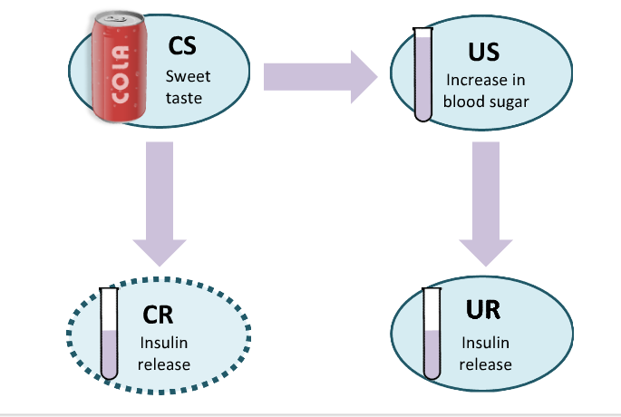

Addictions

  - Environmental cues affect chemical changes from drug use
  - Through conditioning, a contingency is formed between the drug user's familiar environment and the effects of the drug
    - The effects of the drug result in compensatory physiological responses (to maintain homeostasis)
      - For example, a compensatory response associated with morphine use is heightened heart rate and pain sensitivity (since morphine reduces these two things)
    - Once a contingency has been formed, the mere presence of a certain environment can cause compensatory response symptoms
    - These compensatory responses are a main cause of drug tolerance rising with frequent use
      - However, heightened drug tolerance is EXCLUSIVE to the familiar environment in which the drug is usually taken (unbeknownst to most drug users)
      - When the drug is taken in a new environment, the CR (in this case, the compensatory responses associated with the environment) is absent
        - As a result, there is a higher probability of overdose when doing the drugs in a new environment, due to the lack of adequate compensatory responses

Textbook Review

  - Latent learning:
    - Group 1 rats put in a maze with food at the end quickly learned the correct route to the food
    - Group 2 rats put in a maze with no food at the end wandered around lazily (although some would occasionally wander into the goal box)
    - Group 3 rats were put in the maze with no food at the beginning: they behaved similarly to the Group 2 rats
      - After 10 days food was introduced, and the Group 3 rats found the goal box even quicker than the Group 1 rats
        - Suggests that the rats were actually learning the layout of the map continuously (cognitive map). Highlights distinction between performance and learning
  - Habituation: a decrease in response to a stimulus as it is repeatedly presented without any consequence
    - Dishabituation: increase in responding following a change in the stimulus to which habituation occurred
  - Orienting response: an automatic shift of attention toward a stimulus
  - Tactile stimulation: when wearing clothes, we lose awareness of the sensation of pressure on certain areas because the sensory input is constant over time and we have unconsciously learned that this stimulation is harmless and can be avoided
  - Reflex: process that takes place independently of the subject's conscious experience
  - Higher-order conditioning: letting a contingency form between a US and CS, then forming another contingency between this CS and another CS (CS1 and CS2). As a result, either CS can elicit a CR

Module 6: Instrumental Conditioning I
December-06-11
4:38 PM
Unit 1: Intro

  - Instrumental conditioning: the learning of a contingency between behaviour and consequence
    - Differs from classical conditioning, in which a contingency is formed between two events

Unit 2: Instrumental Conditioning

Thorndike's Experiment

  - Measured time it took cat to learn to open door by pulling string (with the reward of food at the end)
  - His hypothesis was: "following the discovery of the correct solution, the cat would escape immediately when placed in the same puzzle box on any subsequent trials"
  - His hypothesis differed from the results:
    - Gradual decrease in response time
      - Animals follow a simple stimulus-response process with little credit for consciousness
      - With animals, there is no distinct "AHA!" moment like with humans

The Law of Effect

  - "behaviours with positive consequences are stamped into the brain"
    - Pulling on the rope is gradually stamped into the brain because it leads to food
    - Any other random behaviours are gradually stamped out
      - Eventually, a contingency between the reward and the stamped-in behaviour is formed

Unit 3: Types of Instrumental Conditioning

  - Reinforcer: any stimulus which, when presented after a response, leads to a change in that response
    - 2 reinforcers: positive and negative
    - 2 actions: presentation and removal

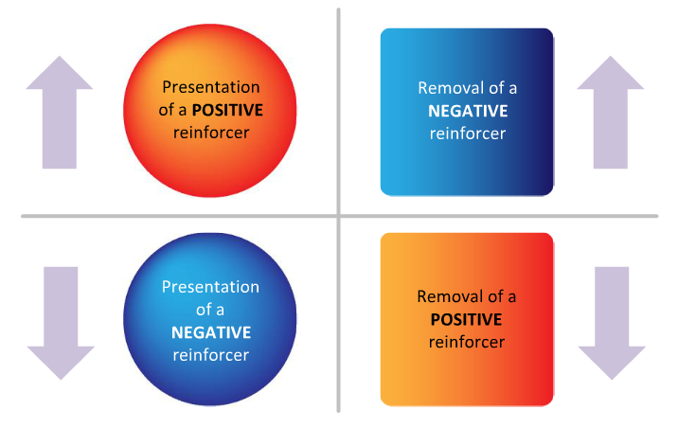

Reward training

Escape training

Punishment training

Omission training

  - Timing is very important in instrumental conditioning
    - Works best when consequence IMMEDIATELY follows behaviour

Graphing Responses:
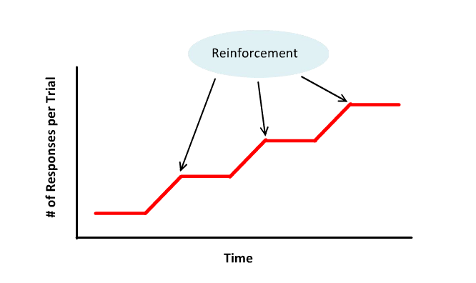

Horizontal line = no response
Positive slope = response has been made

Shaping: complex behaviour can be organized into smaller steps which gradually build up to the full response that is desired (used by animal trainers)
Module 7: Instrumental Conditioning II
December-06-11
4:38 PM
Unit 2: Generalization and Discrimination

  - The Discriminative Stimulus (SD) signals when a contingency between a particular response and reinforcement is VALID ("turned on")
    - For example, a behaviour may lead to reward in certain conditions (dessert after dinner at Grandma's house) but the same behaviour may not lead to a reward under other conditions (no dessert after dinner at Uncle's house)
  - The S-Delta (Sδ) is the opposite of the SD; indicates when a contingency is INVALID

  - Generalization is similar to the generalization gradient in classical conditioning
    - Example: SD is parents, response is behaviour, and reinforcement is praise
      - In order to get praise, the child may generalize the SD to other adults
      - As the stimulus gets more different from the original SD (parents), responses may also correspondingly change

  - Discrimination and Extinction
    - Extinction: parents used to praise child for good behaviour but not anymore
    - Discrimination: parents praise good behaviour, but other relatives do not. As a result, child restricts the SD to the parents only

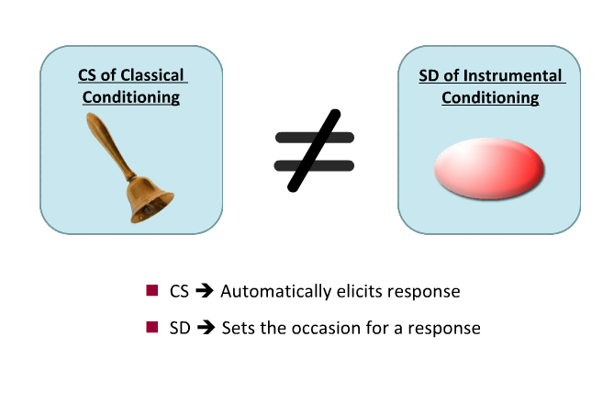

  - In instrumental conditioning, response is always voluntary

Unit 3: Schedules of Reinforcement

  - Continuous vs. partial reinforcement:
    - Continuous - response leads to reinforcer every single time
    - Partial - some good deeds go unrewarded while some bad deeds go unpunished
      - Conditioning for behaviours learned through partial reinforcement are most robust and ergo more resistant to extinction training than those learned through continuous reinforcement

Ratio vs. Interval

  - Ratio schedule: based on the number of responses made by a subject, which determines when that reinforcement is given

FR-1 (Fixed Ratio - 1) - pigeon is rewarded food after every pecking response
FR-10 (Fixed Ratio - 10) - pigeon is rewarded food after every 10th pecking response

  - Interval schedule: based on the time the last response was reinforced

F1-1 min (Fixed Interval - 1 min) - pigeon is rewarded for the first pecking response after 1 minute from the last reward (it has to wait AT LEAST 1 minute between rewards)

Fixed vs. Variable

VR-10 (Variable Ratio - 10) - pigeon must peck an average of 10 times for a food reward, but this number changes each time (must average 10 pecks)
VI-10 min (Variable Interval - 10 min) - first response following an average of 10 minutes will be rewarded. Time changes between trials (but averages 10 minutes)

  - There are four schedules for instrumental conditioning

Fixed Ratio | Fixed Interval
Variable Ratio | Variable Interval

Textbook Review

  - Chaining: involves adding on increasingly complex behavioural requirements to the original requirements in order to receive the original reinforcer

Module 8: Language
December-06-11
4:38 PM
Unit 1: Intro to Language

What separates language from other forms of communication?
- Regular:
  - Has rules
  - A sentence can be reorganized and still retain its meaning because a system of rules dictates how each word fits with the ones around it
- Arbitrary:
  - Lack of resemblance between words and their meaning
    - Exception: onomatopoeia
- Productive:
  - Almost limitless ways to combine words to describe objects, situations and actions (we can describe anything with language)

Whorf-Sapir Hypothesis

  - "language influences our thoughts and the way we perceive and experience the world around us" (we think in our native language)
  - Proof: the Piraha tribe, whose language has one word for a group of many objects (not three, four, or five, but "blahsasd" which describes either a group of 3, 4 OR 5 objects), had trouble distinguishing between a group of 3 objects and a group of 5 objects
  - Counter-evidence: Arapaho tribe, whose language has one word for "an older male relative", is still able to distinguish between a father and an uncle
    - Another example of counter-evidence: English speakers have one word all uncles (which happens to be "uncle") regardless of which side of the family or whether it is a blood uncle or not. Despite this, English speakers have no trouble distinguishing between uncles

Unit 2: The Structure of Language

  - Morpheme: the smallest unit of sound that contains information
    - Often a word, but some words can contain multiple morphemes
      - Example: "tables" contains 2 morphemes --> "table" identifies the object, and "s" indicates there is more than one of that object
  - Phoneme: constituent sounds of a morpheme (smallest unit of language)
    - Each language has its own rules on which phonemes can be combined
  - Syntax: rules that govern how sentences are put together (grammar)
  - Semantics: the meaning of a word or sentence

  - Note: a sentence can be syntactically plausible, yet have no semantic meaning
    - Example: "the blue ideas whisper in the pillow"

Unit 3: Development and the Segmentation Problem

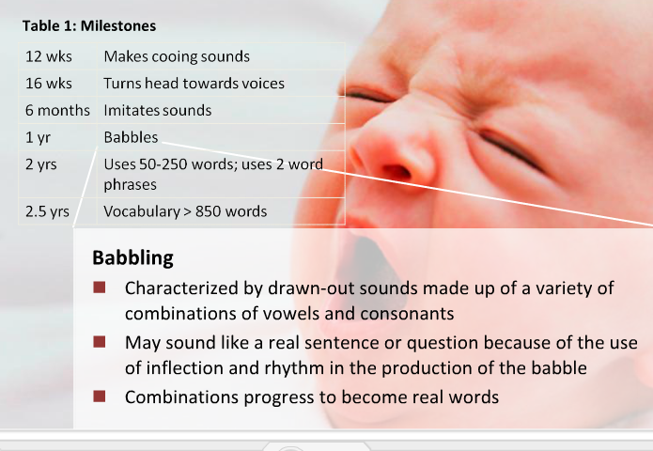

Language Explosion

  - Time-course: vocabulary increases very rapidly and the child has basically mastered the major aspects of language

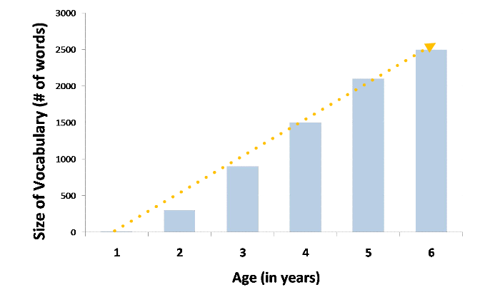

Production vs. Comprehension

Comprehension skills grow more quickly than production skills because of factors such as vocal immaturity
- An infant who cannot yet speak may still be able to understand language to a certain degree
- Such methods as the head-turning procedure are used to test comprehension in babies

The Segmentation Problem

  - Segmentation: difficulty segmenting speech stream into word units

Study:

  - Researchers familiarized infants with a target word (e.g. "dog")
  - Experiments tested whether infants could segment the target word from a stream of speech
  - Findings: strong positive correlation between segmentation ability and expressive vocabulary at 2 years of age

Implications:
  - Could lead to infant screening tests to predict later problems in language development and allow for treatment interventions

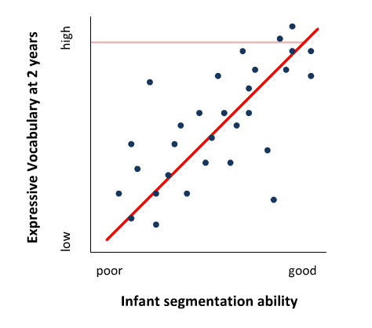

  - Infant-directed speech: tendency for adults to use higher pitch and exaggerated changes in pitch when speaking to infants
    - This may help infants learn to segment speech

Unit 4: Universal Phonetic Sensitivity

Different Phonemes

  - Infants can discriminate more phonemes than adults can
    - Example: Japanese adults say "herro" but Japanese infants don't have this problem

  - Universal phoneme sensitivity: the ability of infants to discriminate between any sounds, including sounds from non-native languages

Werner's Head-Turn Experiment

  - Findings:
    - English babies can discriminate Hindi language sounds almost as well as Hindi-speaking adults
    - Phoneme sensitivity disappears at around one year of age
      - Around this age, English babies in the study were no longer able to discriminate between similar Hindi sounds
  - Implications:
    - Learning a different language at a young age leads to superior mastery of all aspects of language

Unit 5: Accents

  - Accent: phonemic variation within a language
    - Subtle differences in phoneme use
  - Foreign accent syndrome: following brain injury or stroke, patients spontaneously develop what we perceive to be a foreign accent
    - Theories about this syndrome:
      - Broca's area: area in the brain responsible for speech production (most sufferers had damage to this area)
      - Motor control problems related to damage to the cerebellum
        - Patients are unable to pronounce phonemes native to their language
        - In an attempt to make speech less difficult, they may alter the rhythm with which they speak
          - We perceive this as a foreign accent

Unit 6: Theories of Language Development

Social Learning Theory

  - Two mechanisms for Social Learning Theory:
    - Imitation
    - Operant conditioning
  - Evidence for:
    - Example of children who grow up isolated from humans
      - They have no language skills whatsoever
  - Evidence against:
    - Two abilities of infants that contradict the theory:
      - Once infants learn words, they combine them in novel ways that could not have been reinforced
      - Infants make interesting language errors that would never be heard in adult speech (over- and under-extensions)

Overextensions and Underextensions

  - Underextension: when children apply a rule to a specific object only
    - Example: calling a pet Labrador a "dog", but not referring to any other canines as "dogs"
  - Overextension: occurs when children generalize a rule incorrectly to other objects
    - Example: calling any animal a "dog", even those that are not canines

Innate Mechanism Theory

  - Chomsky said that all languages follow fundamental, underlying rules
  - Language Acquisition Device: an innate mechanism that helps language develop rapidly according to universal rules
  - Evidence for:
    - Congenitally deaf infants spontaneously "sign" (hand gestures) in such a way that adheres to grammatical rules
    - Infants prefer to listen to speech than non-speech sounds, suggesting a predisposition to expose themselves to language

Unit 7: Animal Communication

Bees

  - Use of a waggle dance
    - Limited flexibility, simple
    - Used to get to flowers for pollination
    - Looks like a figure-8 pattern

Birds

  - Birds use different "songs" to convey different meanings
    - More complex and flexible

Chimpanzees

Washoe

  - Used signs to communicate requests (sign language)
  - Did not seem to use systematic grammar though

Sarah

  - Taught to use symbols for communication
  - Large vocabulary; could answer questions
  - Could not generate new sentences

Kanzi

  - Immersion used, instead of classical conditioning
  - Could communicate some novel requests
  - Used lexigrams to communicate

Textbook Review

  - Still-face procedure: consists of an adult looking at an infant with a still-face for a few minutes
    - Infants who are only 2-3 months old will become distressed because they already have an understanding of how social interactions should proceed
  - Holophrastic phase: using a single word to indicate the meaning of an entire sentence
  - Word spurt/naming explosion: vocabulary expansion hits a rapid increase around 18-24 months of age

