Experiment 1: Thin Layer Chromatography

By: Michael Wang
8040728

CHM1321
(Even Week - Wednesday AM)

TA: Shaan Rashid

Partner: Quinn McConnell

January 27, 2015

Department of Chemistry

University of Ottawa

Introduction
The purpose of this lab was to identify an unknown compound and determine its composition using the method of Thin Layer Chromatography (TLC). In this method, a stationary phase of silica gel is placed on top of an aluminum strip. The mobile phase passes over the strip of aluminum (plate) and through the stationary phase. The mobile phase differs throughout the experiment.
Silica is a polar material and the mobile phase is an organic solvent. Polar compounds will stick to the silica and have a lower Rf value. The Rf value is a representation of the polarity of each component and it is calculated by the displacement of a compound (d₁) divided by the displacement of the solvent (d_{s}). Since polar molecules will attach to the silica layer, they travel slowly through the silica and appear at the bottom of the plate, resulting in a low Rf value. The opposite is true for non polar compounds--they will not stick to the silica as much and thus travel further up the plate resulting in a higher Rf value.

Procedure
Part A: Identifying the components of an unknown mixture using TLC.
- Add approximately 10 mL of a 2:8 mixture of ethyl acetate (EtOAc) and hexanes to your developing jar and place the lid on the jar.
- Prepare two TLC plates by lightly drawing a pencil line approximately 1 cm from the bottom of each plates (be careful not to touch the silica with your fingers). Draw three equally spaced tic marks on this line. The outside lanes should be at least 5 mm from each edge. Make sure to keep track of what will be spotted in each lane (you may wish to draw identifying marks on each lane).
- Obtain unknown sample #17 from your demonstrator and record the identification number in your lab report
- In a small test tube, dissolve approximately 10 mg of your sample in 1 to 2 mL of dichloromethane. Be sure to label the test tube so that you know it contains your sample.
- Spot this sample solution onto both of the plates you prepared in step 2 on the sample lane and on the co-spot lane. To apply a spot, dip a capillary in the solution. Touch the end of the capillary to the TLC plate at the appropriate lane. You will see the solution expand on the plate into a small spot (about 2 mm wide). Wait a few seconds for the solvent to evaporate.
- Place approximately 2 mL of the reference solution of benzophenone in a separate test tube. Spot this sample solution onto ONE of the plates you prepared in step 2, on the reference lane and on the co-spot lane. Ensure that you apply the solution to the co-spot lane last. Use a fresh capillary for each sample.
- Place approximately 2 mL of the reference solution of biphenyl in a separate test tube. Spot this sample solution onto the other plate you prepared in step 2, on the reference lane and on the co-spot lane.
- Carefully place the TLC plates into the developing jar, ensuring that the pencil line is above the top of the solvent level. Make sure that the silica layer faces up. Place the cover on the developing jar. Allow the solvent to elute until the solvent front is approximately 1 cm from the top of the plate (3–5 min).
- Remove the plates from the jar and mark the solvent finish line with a pencil. After allowing the solvent to evaporate from the plate (30 seconds), visualize your TLC plate by illuminating it under a UV light. Gently circle the visible spots with a pencil. Measure the RF of each spot on the plate (remember to measure to the center of each spot) and draw an exact replica of the TLC plate in your lab report. Using the RF values, identify the compounds that are in your mixture.

Part B: Effect of solvent on TLC
- Empty the solvent from your developing jar into the solvent waste. Add approximately 10 mL of ethyl acetate (EtOAc) to your developing jar and place the lid on the jar.
- Prepare two new TLC plates, using the procedures described above (part A steps 2–7).
- Develop these plates in the jar containing EtOAc as the eluant. Visualize your TLC plates with UV light, and mark the spots with a pencil. Draw a replica of the TLC plates in your lab report. Be sure to make a note of the RF of each compound in your lab discussion.
- Empty the solvent from your developing tank into the solvent waste. Add approximately 10 mL of hexanes to your developing jar and place the lid on the jar.
- Prepare two new TLC plates, using the procedures described above (part A steps 2- 7).
- Develop these plates in the jar containing hexanes as the eluant. Visualize your TLC plates with UV light, and mark the spots with a pencil. Draw and label a replica of the TLC plates in your lab report. Be sure to make a note of the RF of each compound in your lab discussion.
- Describe the effects of each solvent system on the RF of the compounds, and account for the appearance of your plate taking into consideration the polarity of the solvent used.

Part C: Ratio of compounds
- A vial labeled ZZ was collected from the TA. It consists of a mixture of compounds. It is a clear and yellowish liquid. Using a clean 50mL beaker, obtain 2mL of the unknown from the appropriate burette in the small fumehood.
- Using a solvent system of 9:1 Hexanes: Ethyl Acetate, determine the identity of each component of your mixture, through TLC comparison with reference compounds: bromobenzene, o-bromonitrobenzene, m-bromonitrobenzene, and p-bromonitrobenzene. DO NOT circle the spots on your TLC plates or discard them yet. You can label them at the bottom or top to remind yourself of what each one represents.
- Once the lab is completed and you have cleaned up your area, turn off the light in the fumehood and take a photo of each TLC plate from this part under UV. Once you have taken the photos, lightly mark the spots with a pencil.
- Use ImageJ and the appropriate calibration curves to determine the ratio of compounds in your mixture. The software and instructions on using it can be found on Blackboard.

Observations
Sample calculation for an Rf value (TLC #1, sample spot):
d_{s} = 5.20 cm d₁ = 3.90 cm
Rf = $\frac{d1}{ds}$
= $\frac{3.90}{5.20}$ = 0.75
ImageJ Peak Areas Sample Calculation:
Meta-bromonitrobenzene:
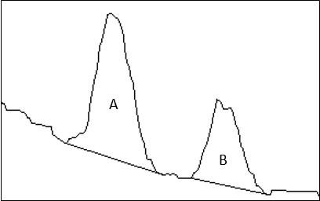

TLC Lane 2
Area of Peak A: 4887.296
Area of Peak B: 2523.740
% Peak A = $\frac{Area Peak A}{Area Peak A+Area Peak B}$ x 100%
= 65.9%
% Peak B = 34.1%
Para-bromonitrobenzene:
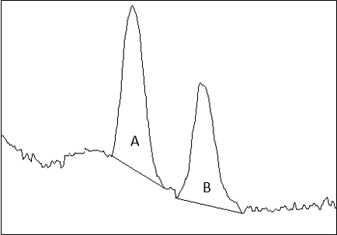

TLC Lane 2
% Peak A: 55.8%
% Peak B: 44.2%
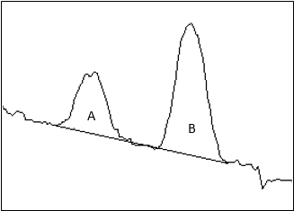
Ortho-bromonitrobenzene:

TLC Lane 2
% Peak A: 31.3%
% Peak B: 68.7%

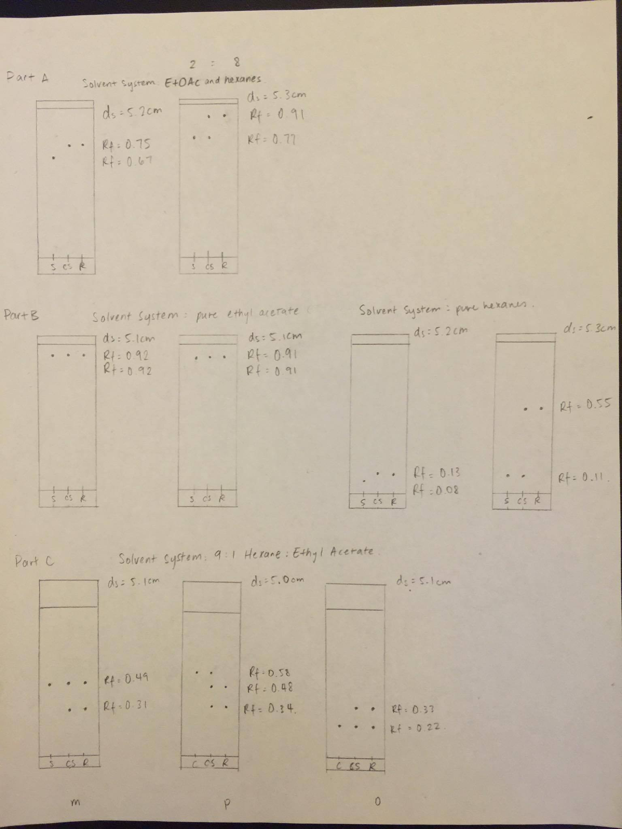
Discussion (Refer to TLC diagrams)
For each TLC plate, they were placed under a UV light in order to visualize the spots and to see how far they travelled. The silica gel fluoresced under the UV light and the dark spots appeared on the plate. By circling the spots, it was possible to measure the distance that the spots travelled as well as the distance of the solvent front. Using these two values, the Rf value of each spot was calculated. On TLC #1, the sample had an Rf value of 0.77 which was lower than the reference and the co-spot. This means that the sample was slightly less polar than the reference compound (Benzophenone). However, Benzophenone and the sample had relatively the same distance traveled which would indicate that the sample contained traces of Benzophenone. In the second TLC plate, the sample's Rf value was 0.67 and this was more polar than the reference compound Biphenyl (Rf =0.75). Since there wasn't a common spot located in the reference and sample lane, this would mean that the sample did not contain Biphenyl.
For TLCs #3 and #4 (the solvent used was 100% EtOAc), the three spots were in a straight horizontal line relative to each other. The spots all had relatively high Rf values (TLC#3 was 0.91 and TLC #4 was 0.92). This is because when the mobile phase is very polar (100% EtOAc), the Rf values increase.
On TLC #5 and #6, hexanes were used as the solvent system. The Rf value for the sample spot on TLC #5 was 0.08 - thus it did not travel much from the starting line. On TLC #6, the spots had not moved far from the beginning line, thus the Rf values were 0.11. This may have been due to hexanes not being very polar. When the polarity of the solvent decreases, the Rf value of the spots also decrease.
The last three TLC plates were results from part c of the lab. By using ImageJ and the calibration curve "Amount of the ortho isomer in an ortho-para mixture of bromonitrobenzene", it was found that the mole percentage of the ortho isomer (which was 48.3%). Thus, it was calculated that the compound ZZ contained approximately 49.0% of ortho and 51.0% of para. The ortho:para ratio is approximately 49:51, or 0.96:1.
The three TLC plates that were used for part c all had slightly different percentages for the peak areas. The numbers should be the same for each TLC plate since it is the same sample being tested. This discrepancy may have been a result of not spotting accurate amounts in the three lanes on each TLC plate (such as spotting too heavily). Another possibility is that the areas of the peaks were not accurately found.
Multiple precautions had to be kept in mind throughout the experiment. One would be that the developing jar should always be closed in order to prevent the solvent system from evaporating or particles in the air getting into the jar. This could have slightly changed the composition of the solvent and thus changed the results of the spots. Also, when the TLC plate was placed into the jar, the side with silica gel had to be facing towards the center of the jar. This was to ensure visibility of when the solvent front reached near the edge of the plate and that the solvent level/height in the jar was less than the starting line of spots on the plate. The solvent volume level had to be less than the line because that way the solvent would start eluting upwards, carrying the spots with it. It was also important to keep in mind that during the spotting portion of the lab, the reference lane was always spotted before the co-spot lane. If it was done the other way, then the capillary tube would have traces of the sample (on the co-spot lane) on the tip when it spotted the reference lane. That would have mixed the two compounds together and the results would be inaccurate.

Questions
- By increasing the polarity of the solvent system in a TLC, the Rf values for everything increases and it is closer to the solvent front. In Part B where we used the ethyl acetate the polarity was the highest so the spots were closest to the solvent front whereas the hexanes were the lowest polarity so the spots were the furthest from the solvent front. The sample spot can either stick to the stationary phase or be eluted by the mobile phase/solvent system. If the solvent is highly polar (compared to the sample compound), it dissolves the sample and carries it further down the TLC plate which results in a higher Rf value.
- From what I observed in the lab, the most polar compound will travel the least on the silica gel, thus having the smallest R_{f}.
a) Benzyl alcohol would have the smallest Rf value. This is because of its hydrogen bonding capabilities and the presence of an oxygen atom. Most polar out of the three
b) N,N-dimethylaniline would have the smallest Rf value. It has the greatest ability to form hydrogen bonds.
c) Benzoic acid would have the smallest Rf value. It is the most polar compound due to its carboxylic acid functional group and thus it has a great ability to form hydrogen bonds and it has two electronegative atoms (oxygen).



