Student Name: Sheli

Student Number:

Partner’s Name and Student #:

Demonstrator's Name:

PLEASE NOTE: If ANY of the above information is UNCLEAR or not provided, your grade will NOT be recorded!!

Lab Day (circle): Tues aft Tues night Wed Thurs aft Thurs night Fri

Lab Week (circle): 1 2

Laboratory Report Form

Experiment 5.

Acid/Base Titrations

Checklist:

- Raw Data Sheet written in pen, signed by TA AND Raw data from LabQuest attached
- Data tables and graphs (12 minimum!) made in Logger Pro attached
- Report Form attached

Student’s Initials: S.G
Data Tables

Table 1. Formation of a stock solution of NaOH

Volume of concentrated NaOH solution (mL) | 4mL
Concentration of concentrated NaOH solution (M) | 6 mol/L
Volume of stock solution after dilution (mL) | 254mL
Approximate concentration of stock solution (M) | 0.09449

Table 2. Standardization of Stock Solution of NaOH

Data | Trial 1 | Trial 2l | Trial 3
Concentration of Standard Acid solution (M) | 0.1000 mol/L | 0.1000mol/L | 0.1000mol/L
Volume of Standard Acid solution (mL) | 10mL | 10mL | 10mL
Volume of stock solution of NaOH (mL) | Visual: 8.262mL  FD: 9.905mL | Visual: 11.42mL  FD: 11.67mL | Visual: 8.473mL  FD: 8.464mL
Concentration of stock solution of NaOH (M) | Visual: 0.121 mol/L  FD: 0.110 mol/L | Visual: 0.0876 mol/L  FD: 0.0857 | Visual: 0.118mol/L  FD: 0.118 mol/L
Average Concentration of stock solution of NaOH (M) | Visual: 0.104 mol/L (using only Trails #1 and #2)  FD: 0.0987 mol/L (using only Trails #1 and #2)

Table 3. Determination of the Concentration of an Unknown Acid

Data | Trial 1 | Trial 2 | Trial 3
Sample Number of Unknown Acid | 2 | 2 | 2
Volume of Unknown Acid solution (mL) | 10mL | 10mL | 10mL
Volume of stock solution of NaOH (mL) | Visual: 5.381 mL  FD: 5.333 mL | Visual: 4.607mL  FD: 4.500 mL | Visual: 4.674mL  FD: 4.286 mL
Concentration of stock solution of NaOH (M) | 0.0987 mol/L | 0.0987 mol/L | 0.0987 mol/L
Concentration of Unknown Acid Solution (M) | Visual:0.0917mol/L  FD: 0.0926 mol/L | Visual: 0.107 mol/L  FD: 0.110 mol/L | Visual: 0.106 mol/L  FD: 0.150 mol/L
Average Concentration of Unknown Acid solution (M) | Visual: 0.1065 mol/L (using only Trails #2 and #3)  FD: 0.130 mol/L (using only Trails #2 and #3)

Table 4. Determination of the Mass Percentage of Acid in a Juice

Data | Trial 1 | Trial 2 | Trial 3
Sample Number of Juice | 1 | 1 | 1
Volume of Juice (mL) | 10mL | 10mL | 10mL
Volume of stock solution of NaOH (mL) | Visual: 6.654 mL  FD: 6.036 mL | Visual: 6.607 mL  FD: 6.571 mL | Visual: 7.786 mL  FD: 7.000 mL
Concentration of stock solution of NaOH (M) | 0.0987 mol/L | 0.0987 mol/L | 0.0987 mol/L
Concentration of acid in Juice (M) | Visual:0.0494mol/L  FD: 0.0545 mol/L | Visual:0.0498mol/L  FD: 0.0501 mol/L | Visual:0.0422mol/L  FD: 0.0470mol/L
Average Concentration of Acid in Juice (M) | Visual: 0.0471 mol/L (using only Trails #1, #2 and #3)  FD: 0.0505 mol/L (using only Trails #1, #2 and #3)
Density of Juice (g/mL) | 0.9974 g/cm³
Molar Mass of acid in Juice (g/mol) | 192.124 g/mol
Mass Percent of Acid in Juice (%) | 0.973%

Observations (all parts of the experiment):

Part 1:
- NaOH: clear with no distinct odor
- HCl: clear with no distinct odor

Part 2:
- HCl: clear with no distinct odor
When a sufficient quantity (approximately 9mL) of the stock solution was added to a solution containing HCl, the pH of the solution drastically rose until it reached a pH of approximately 12 after which it plateaued. This drastic rise was observed after the equivalence point was reached as the colour of the solution suddenly turned pink due to the presence of phenolphthalein.

Part 3:
- Unknown acid (#2) solution: clear with no distinct odour
When a sufficient quantity (approximately 4.5 mL) of the stock solution was added to a solution containing the diprotic unknown acid, the pH of the solution drastically rose until it reached a pH of approximately 12 after which it plateaued. This drastic rise was observed after the equivalence point was reached as the colour of the solution suddenly turned pink due to the presence of phenolphthalein.

Part 4:
- Juice (#1) containing acid: slightly green and clear with no distinct odour
When a sufficient quantity (approximately 4.5 mL) of the stock solution was added to a solution of juice containing an acid, the pH of the solution drastically rose until it reached a pH of approximately 12 after which it plateaued. This drastic rise was observed after the equivalence point was reached as the colour of the solution suddenly turned pink due to the presence of phenolphthalein.

Table 5: Three trials measuring the pH and Volume (in mL) of the Standardization of a Stock Solution of NaOH as well as a calculated column of the First derivative of the pH
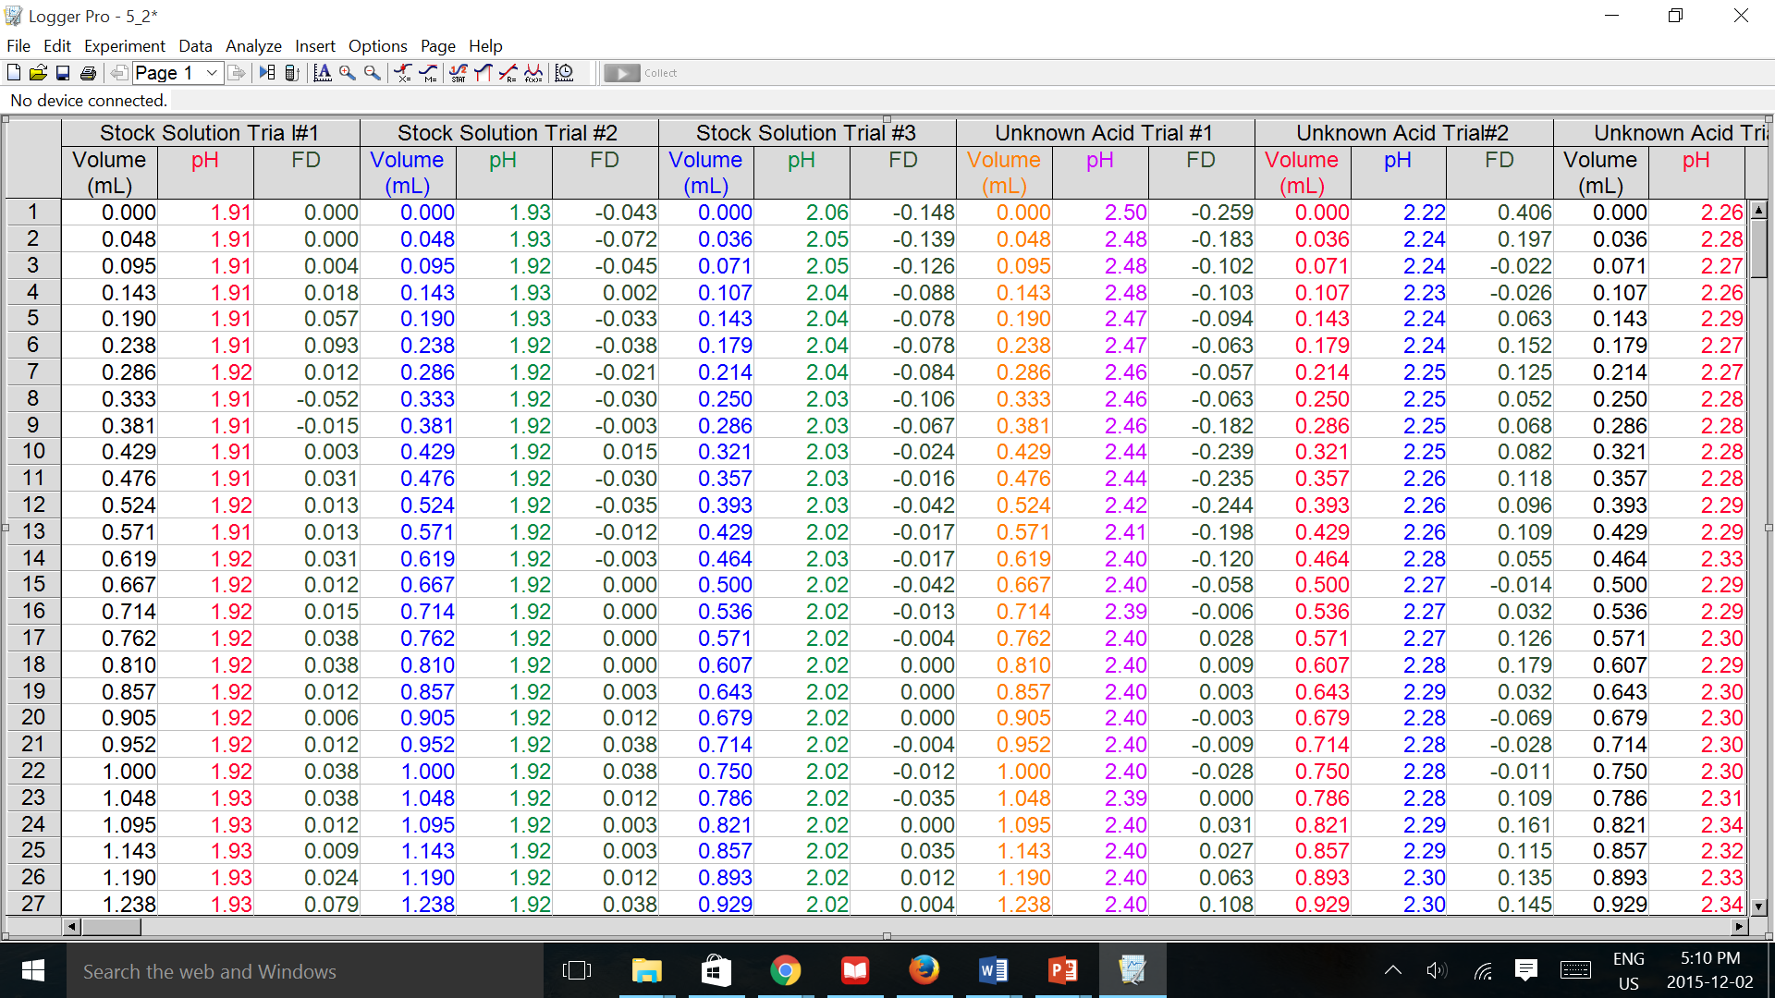

Table 6: Three trials measuring the pH and Volume (in mL) of a Solution containing an Unknown Acid as well as a calculated column of the First derivative of the pH
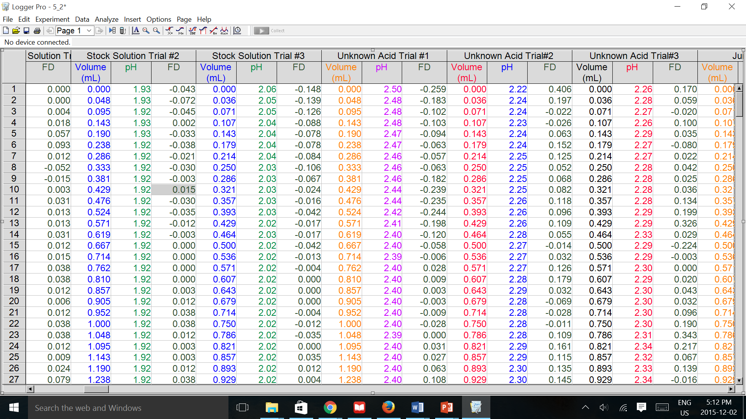

Table 7: Three trials measuring the pH and Volume (in mL) of solution of juice containing an acid as well as a calculated column of the First derivative of the pH
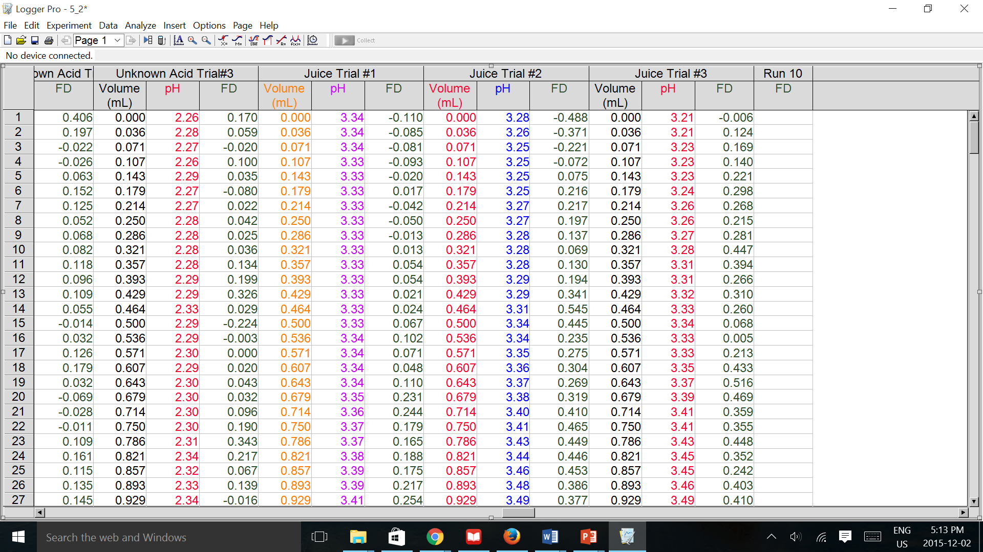

GRAPHS:

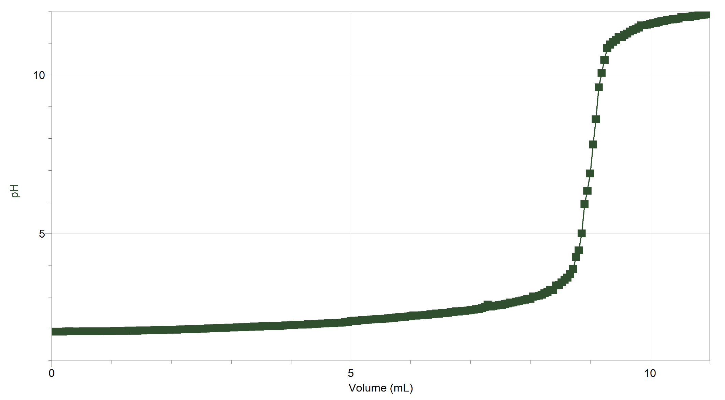

Figure 1: Graphical representation of the first trial of the standardized stock solution of NaOH measured using pH as a function of Volume (mL).
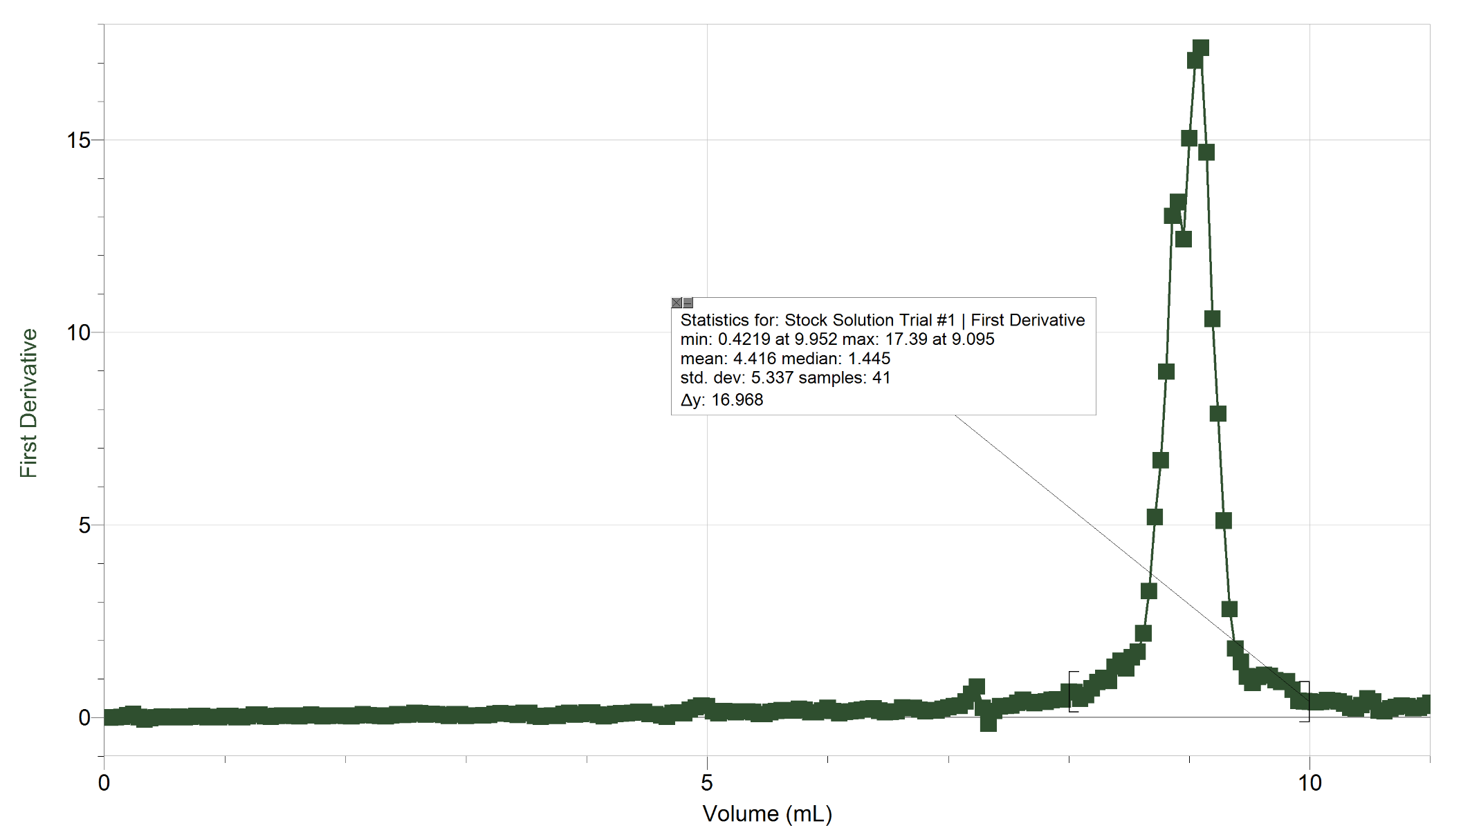

Figure 2: Graphical representation of the first trial of the standardized stock solution of NaOH measured using the first derivative of the pH as a function of Volume (mL). This graphical representation displays the volume of the stock solution of the NaOH at which the maximum pH occurred. A maximum pH of 17.39 occurs at 9.095mL.
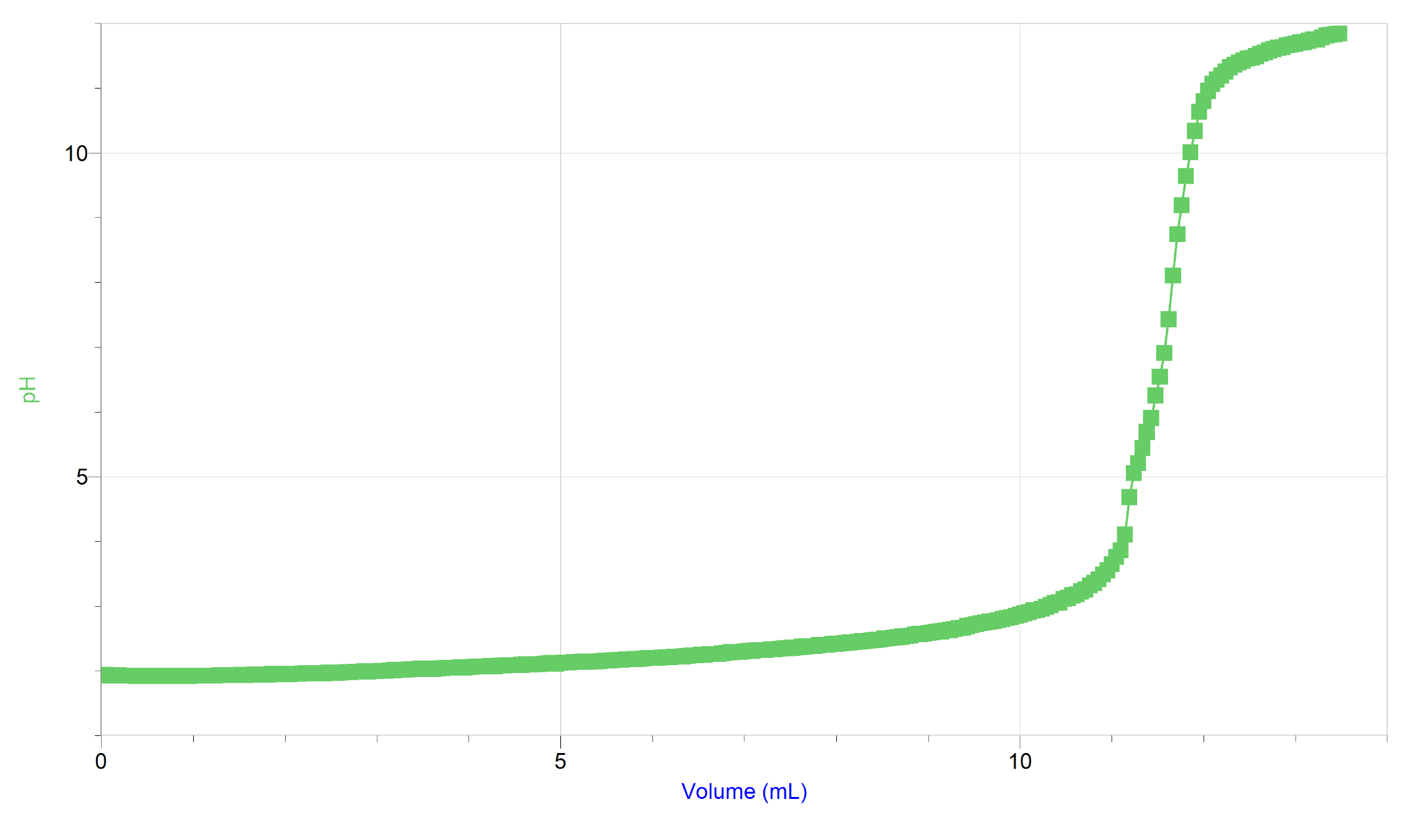
Figure 3: Graphical representation of the second trial of the standardized stock solution of NaOH measured using pH as a function of Volume (mL).
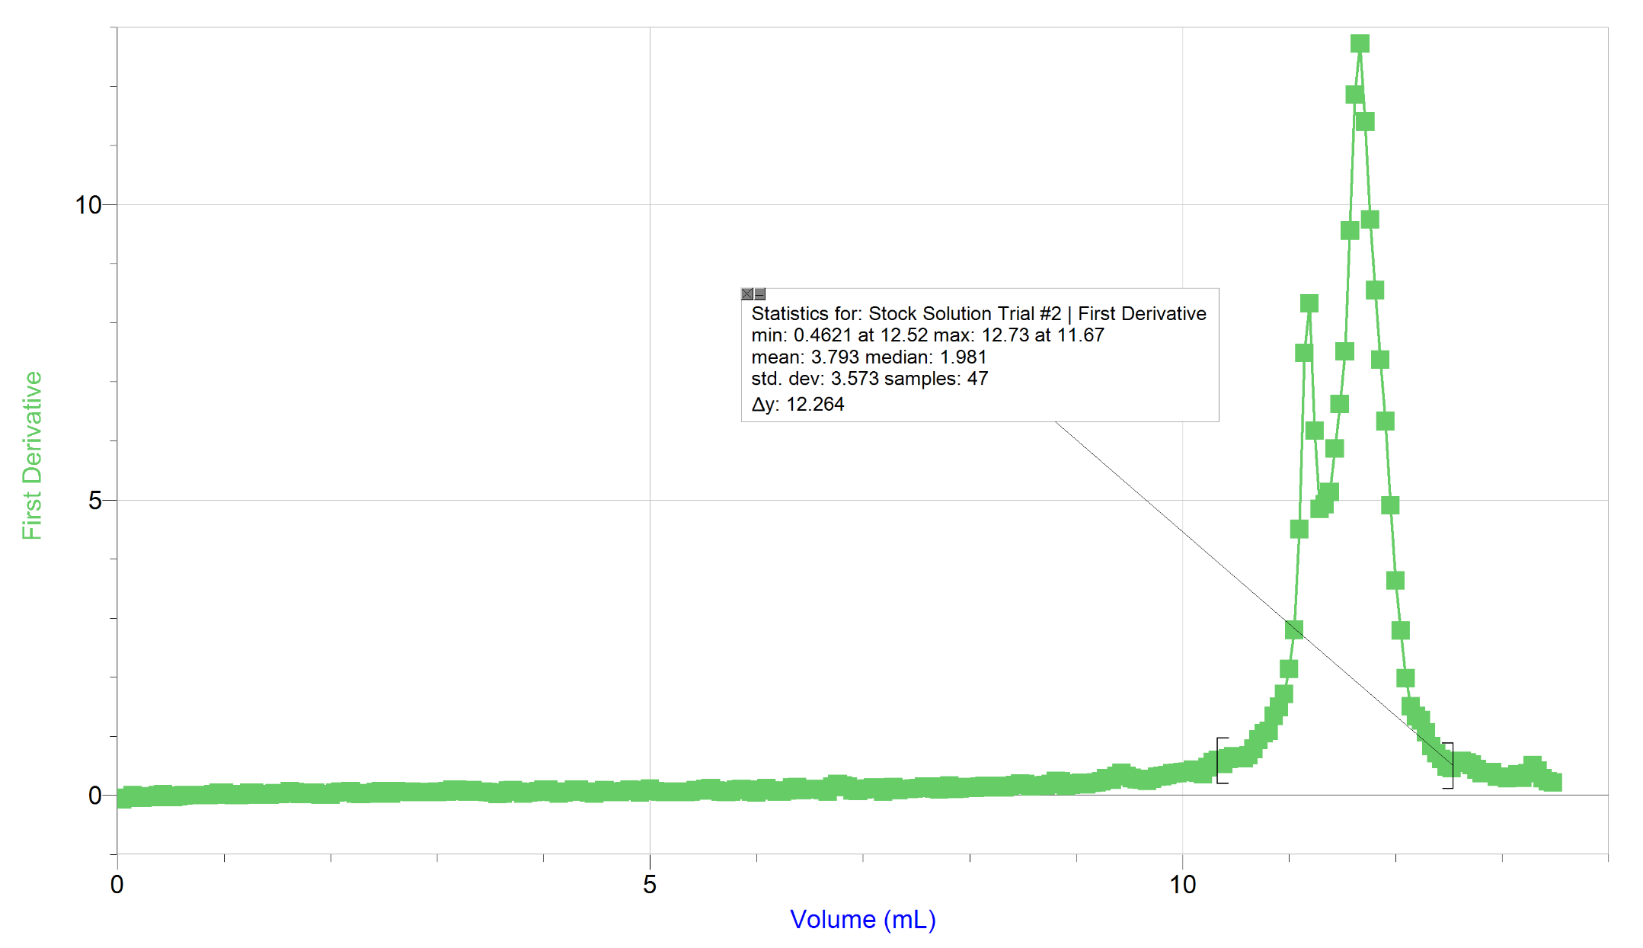

Figure 4: Graphical representation of the second trial of the standardized stock solution of NaOH measured using the first derivative of the pH as a function of Volume (mL). This graphical representation displays the volume of the stock solution of the NaOH at which the maximum pH occurred. A maximum pH of 12.73 occurs at 11.67.
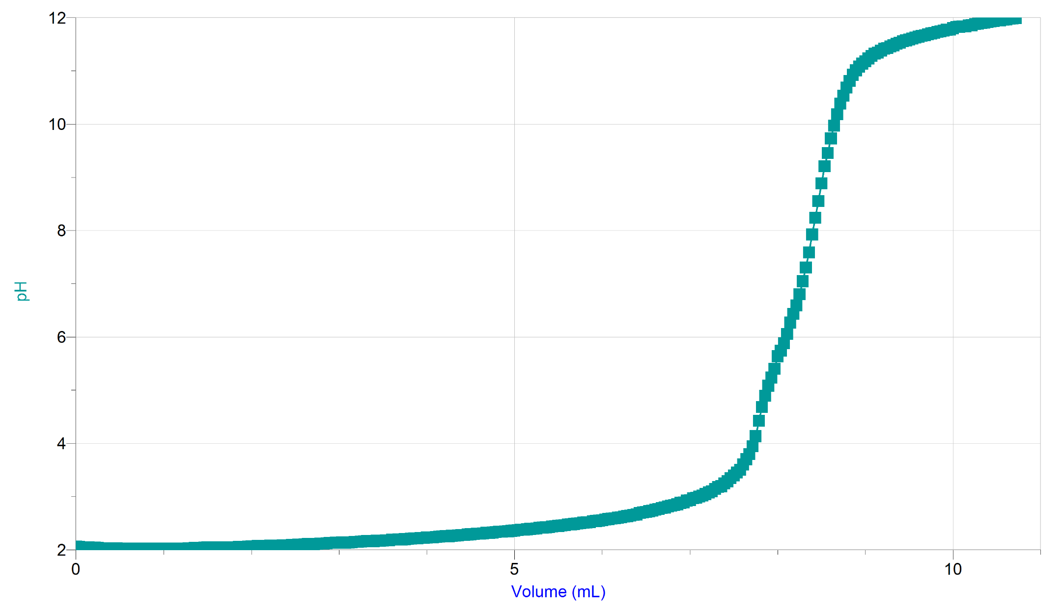
Figure 5: Graphical representation of the third trial of the standardized stock solution of NaOH measured using pH as a function of Volume (mL).

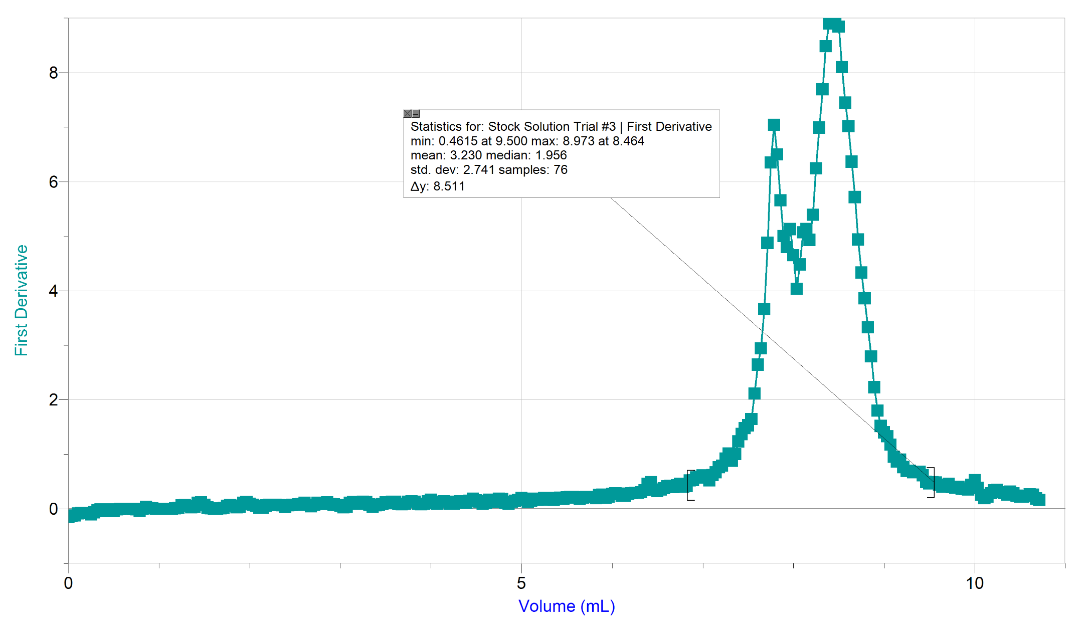

Figure 6: Graphical representation of the third trial of the standardized stock solution of NaOH measured using the first derivative of the pH as a function of Volume (mL). This graphical representation displays the volume of the stock solution of the NaOH at which the maximum pH occurred. A maximum pH of 8.973 occurs at 8.464.
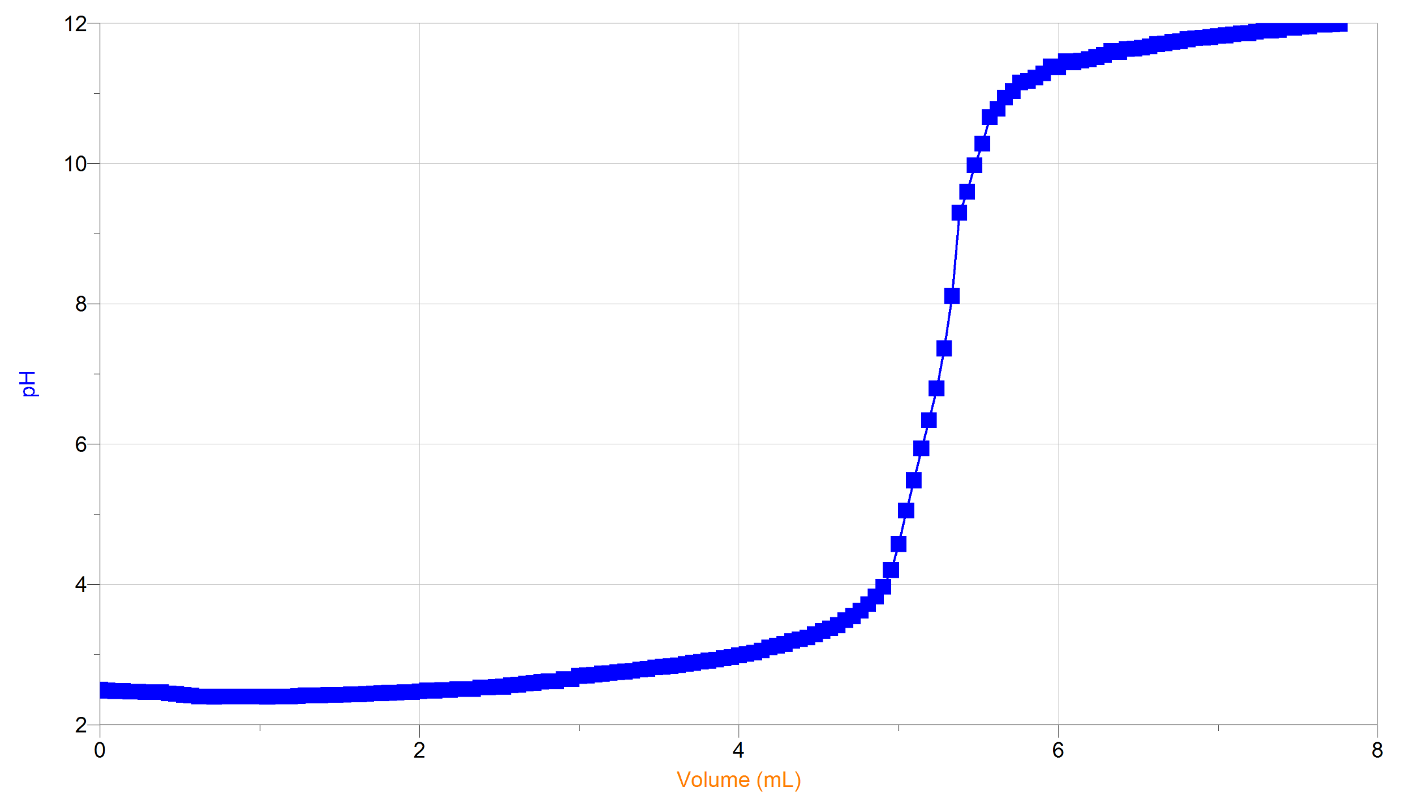 Figure 7: Graphical representation of the first trial of the unknown acid (2) measured using pH as a function of Volume (mL).
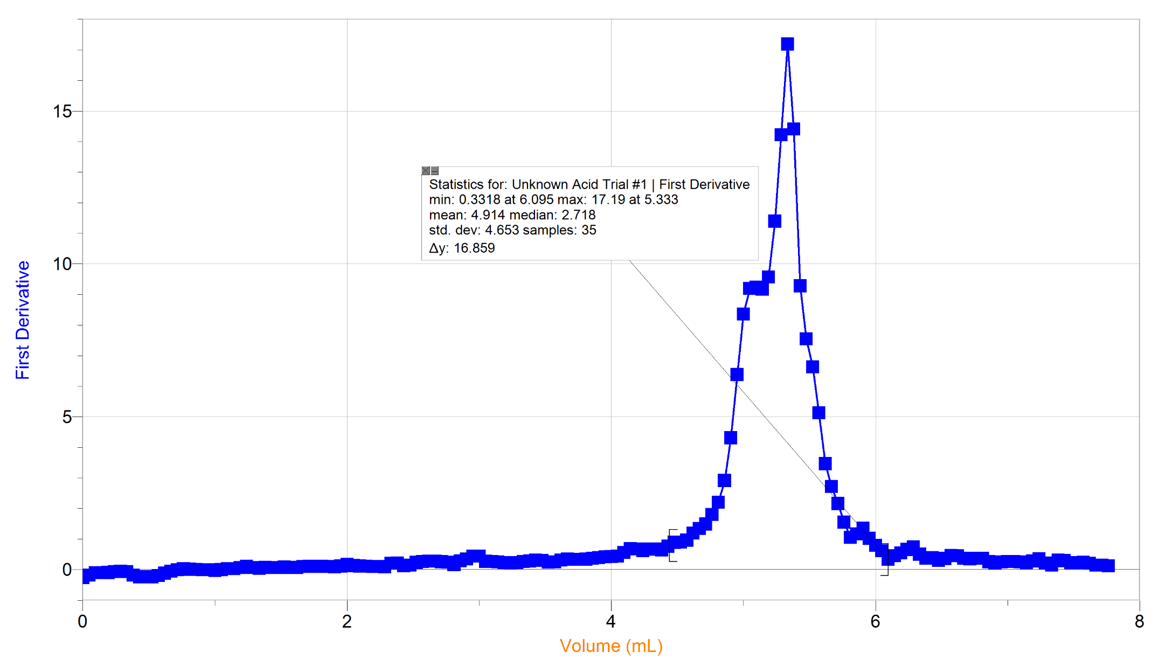
Figure 8: Graphical representation of the first trial of the unknown acid (2) measured using the first derivative of the pH as a function of Volume (mL). This graphical representation displays the volume of the stock solution of the NaOH at which the maximum pH occurred. A maximum pH of 17.19 occurs at 5.333.

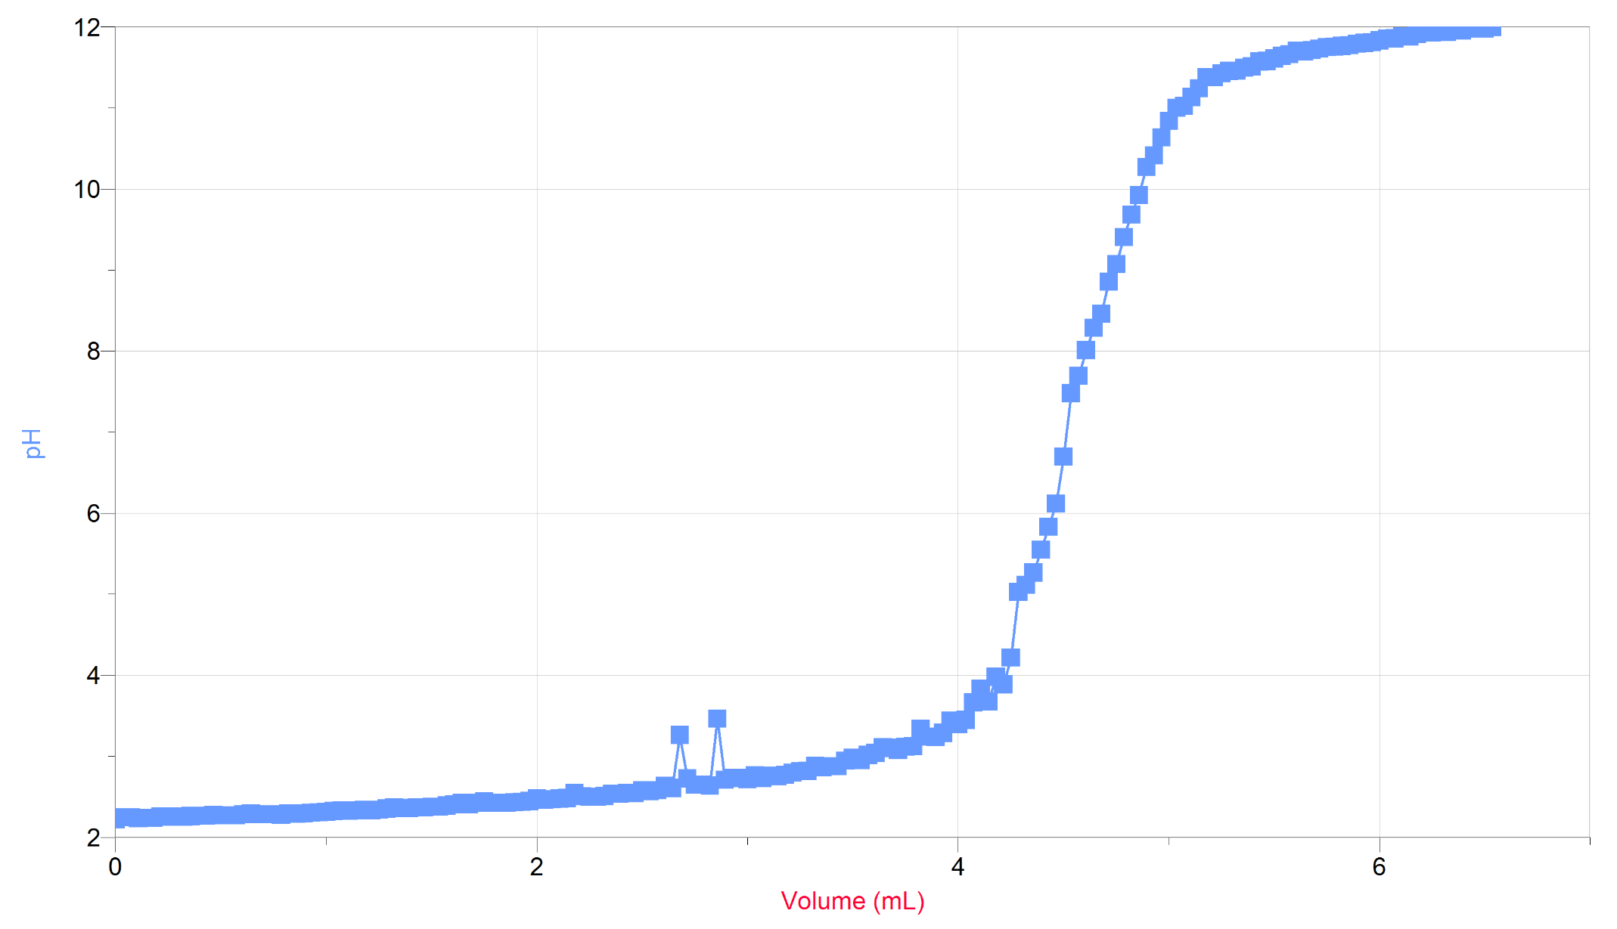
Figure 9: Graphical representation of the second trial of the unknown acid (2) measured using pH as a function of Volume (mL).

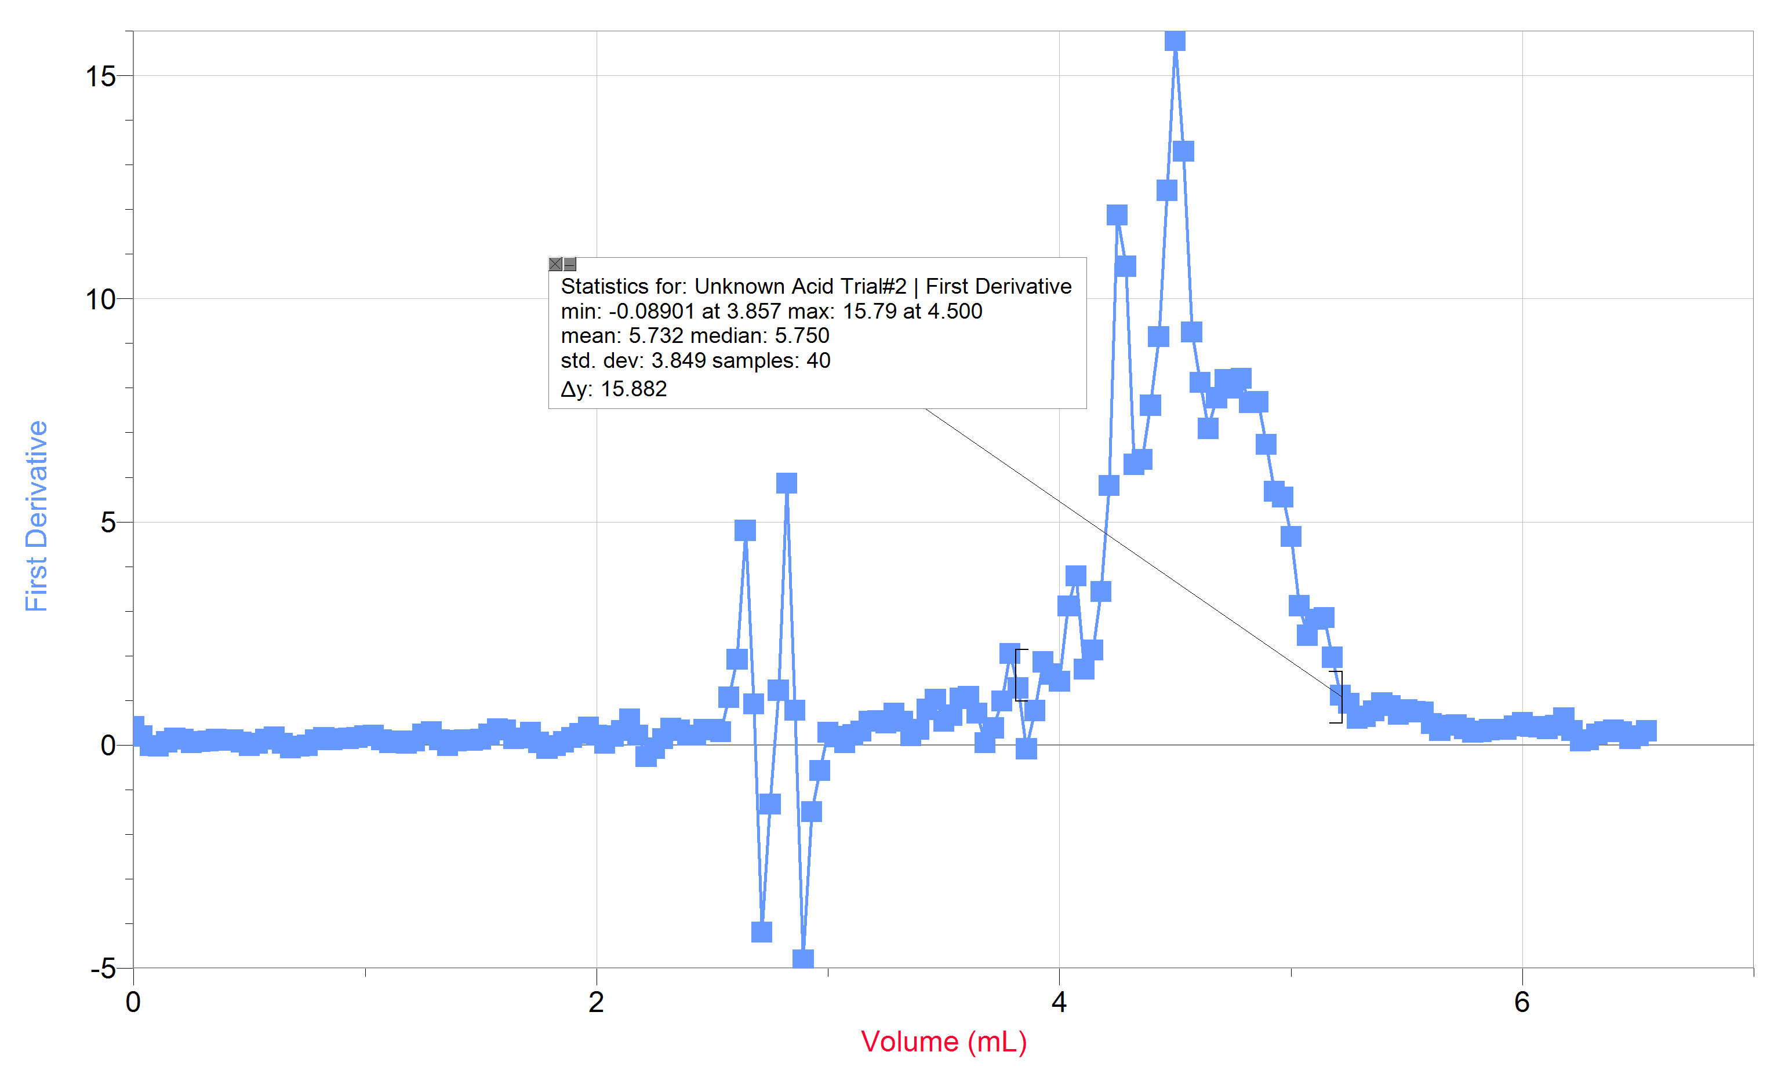
Figure 10: Graphical representation of the second trial of the unknown acid (2) measured using the first derivative of the pH as a function of Volume (mL). This graphical representation displays the volume of the stock solution of the NaOH at which the maximum pH occurred. A maximum pH of 15.79 occurs at 4.500.

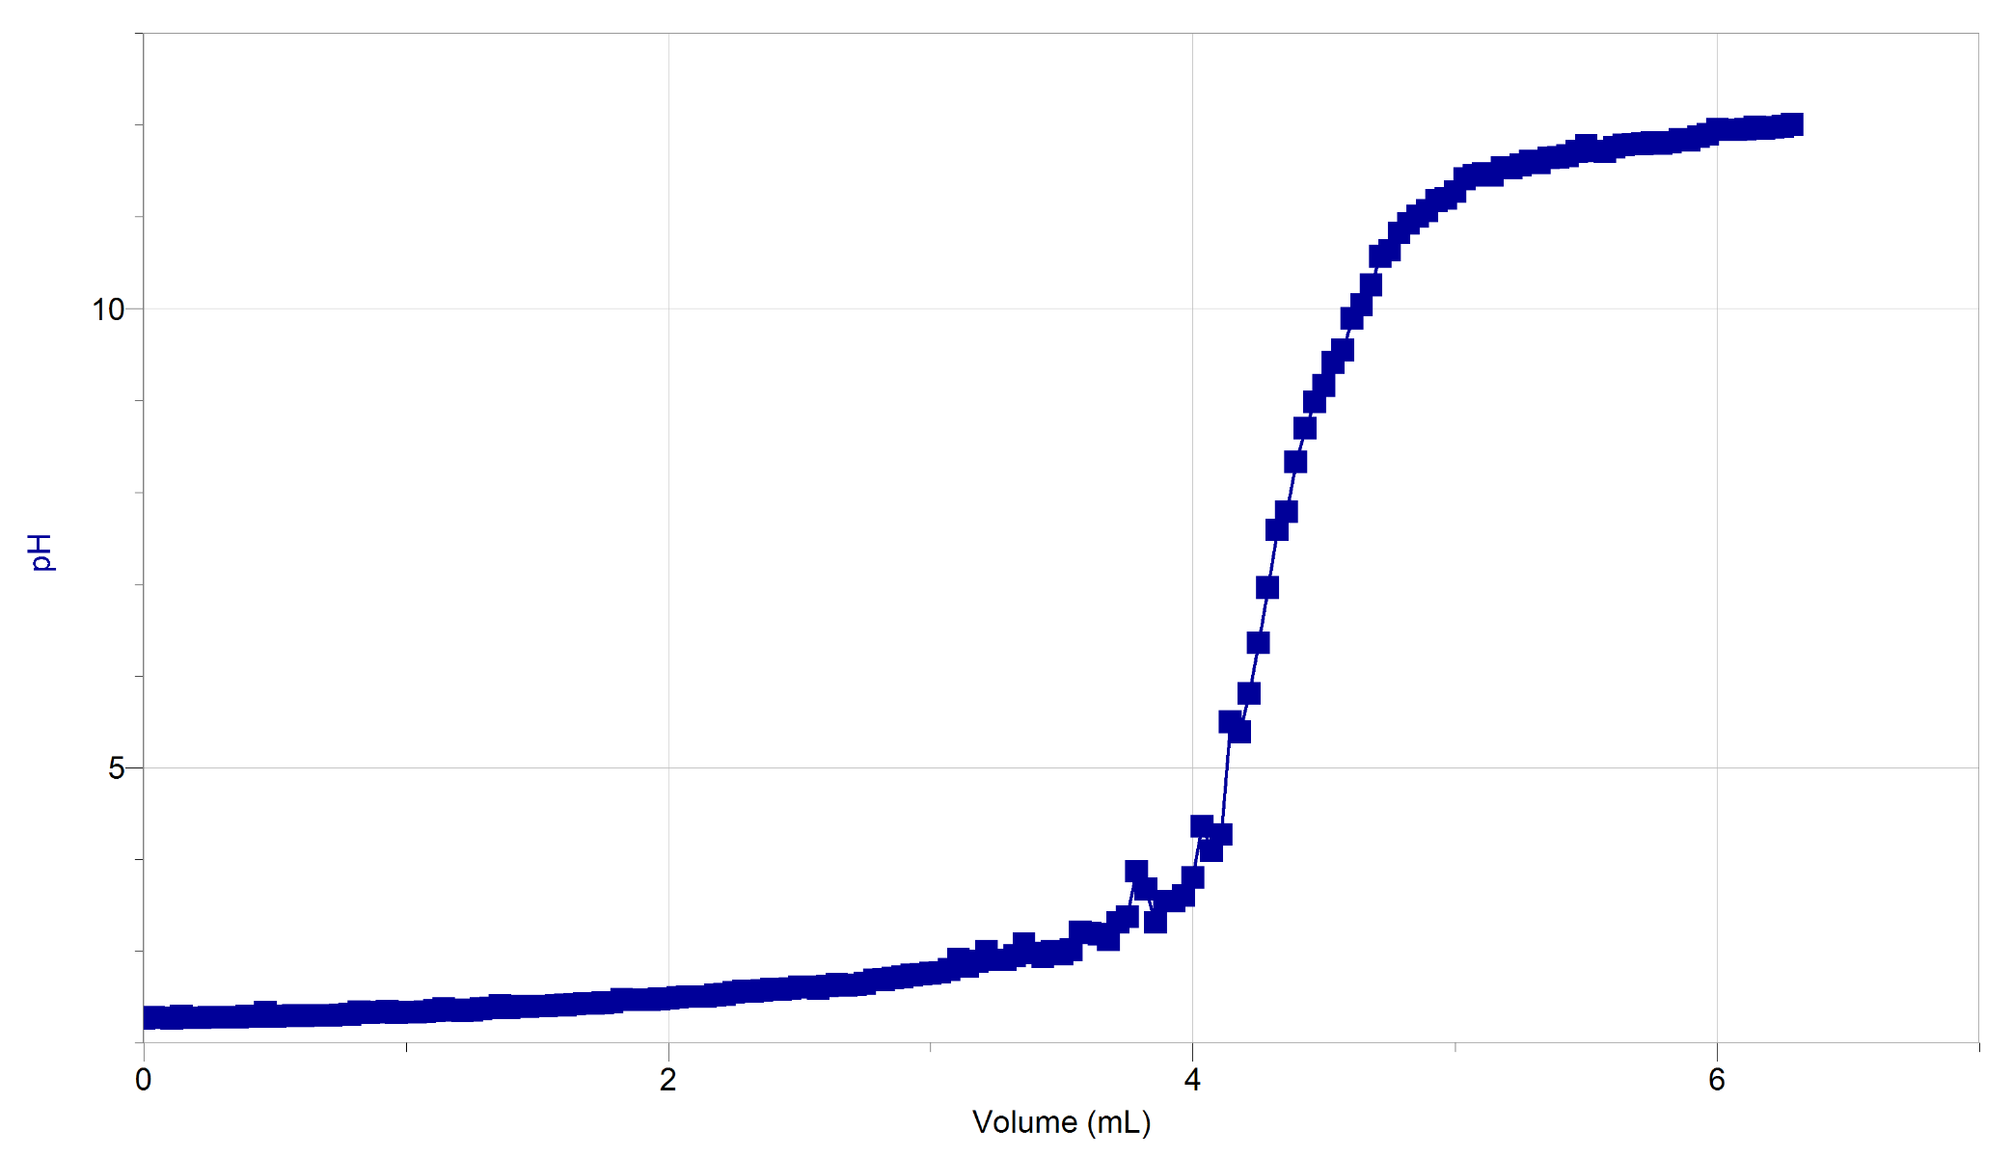
Figure 11: Graphical representation of the third trial of the unknown acid (2) measured using pH as a function of Volume (mL).

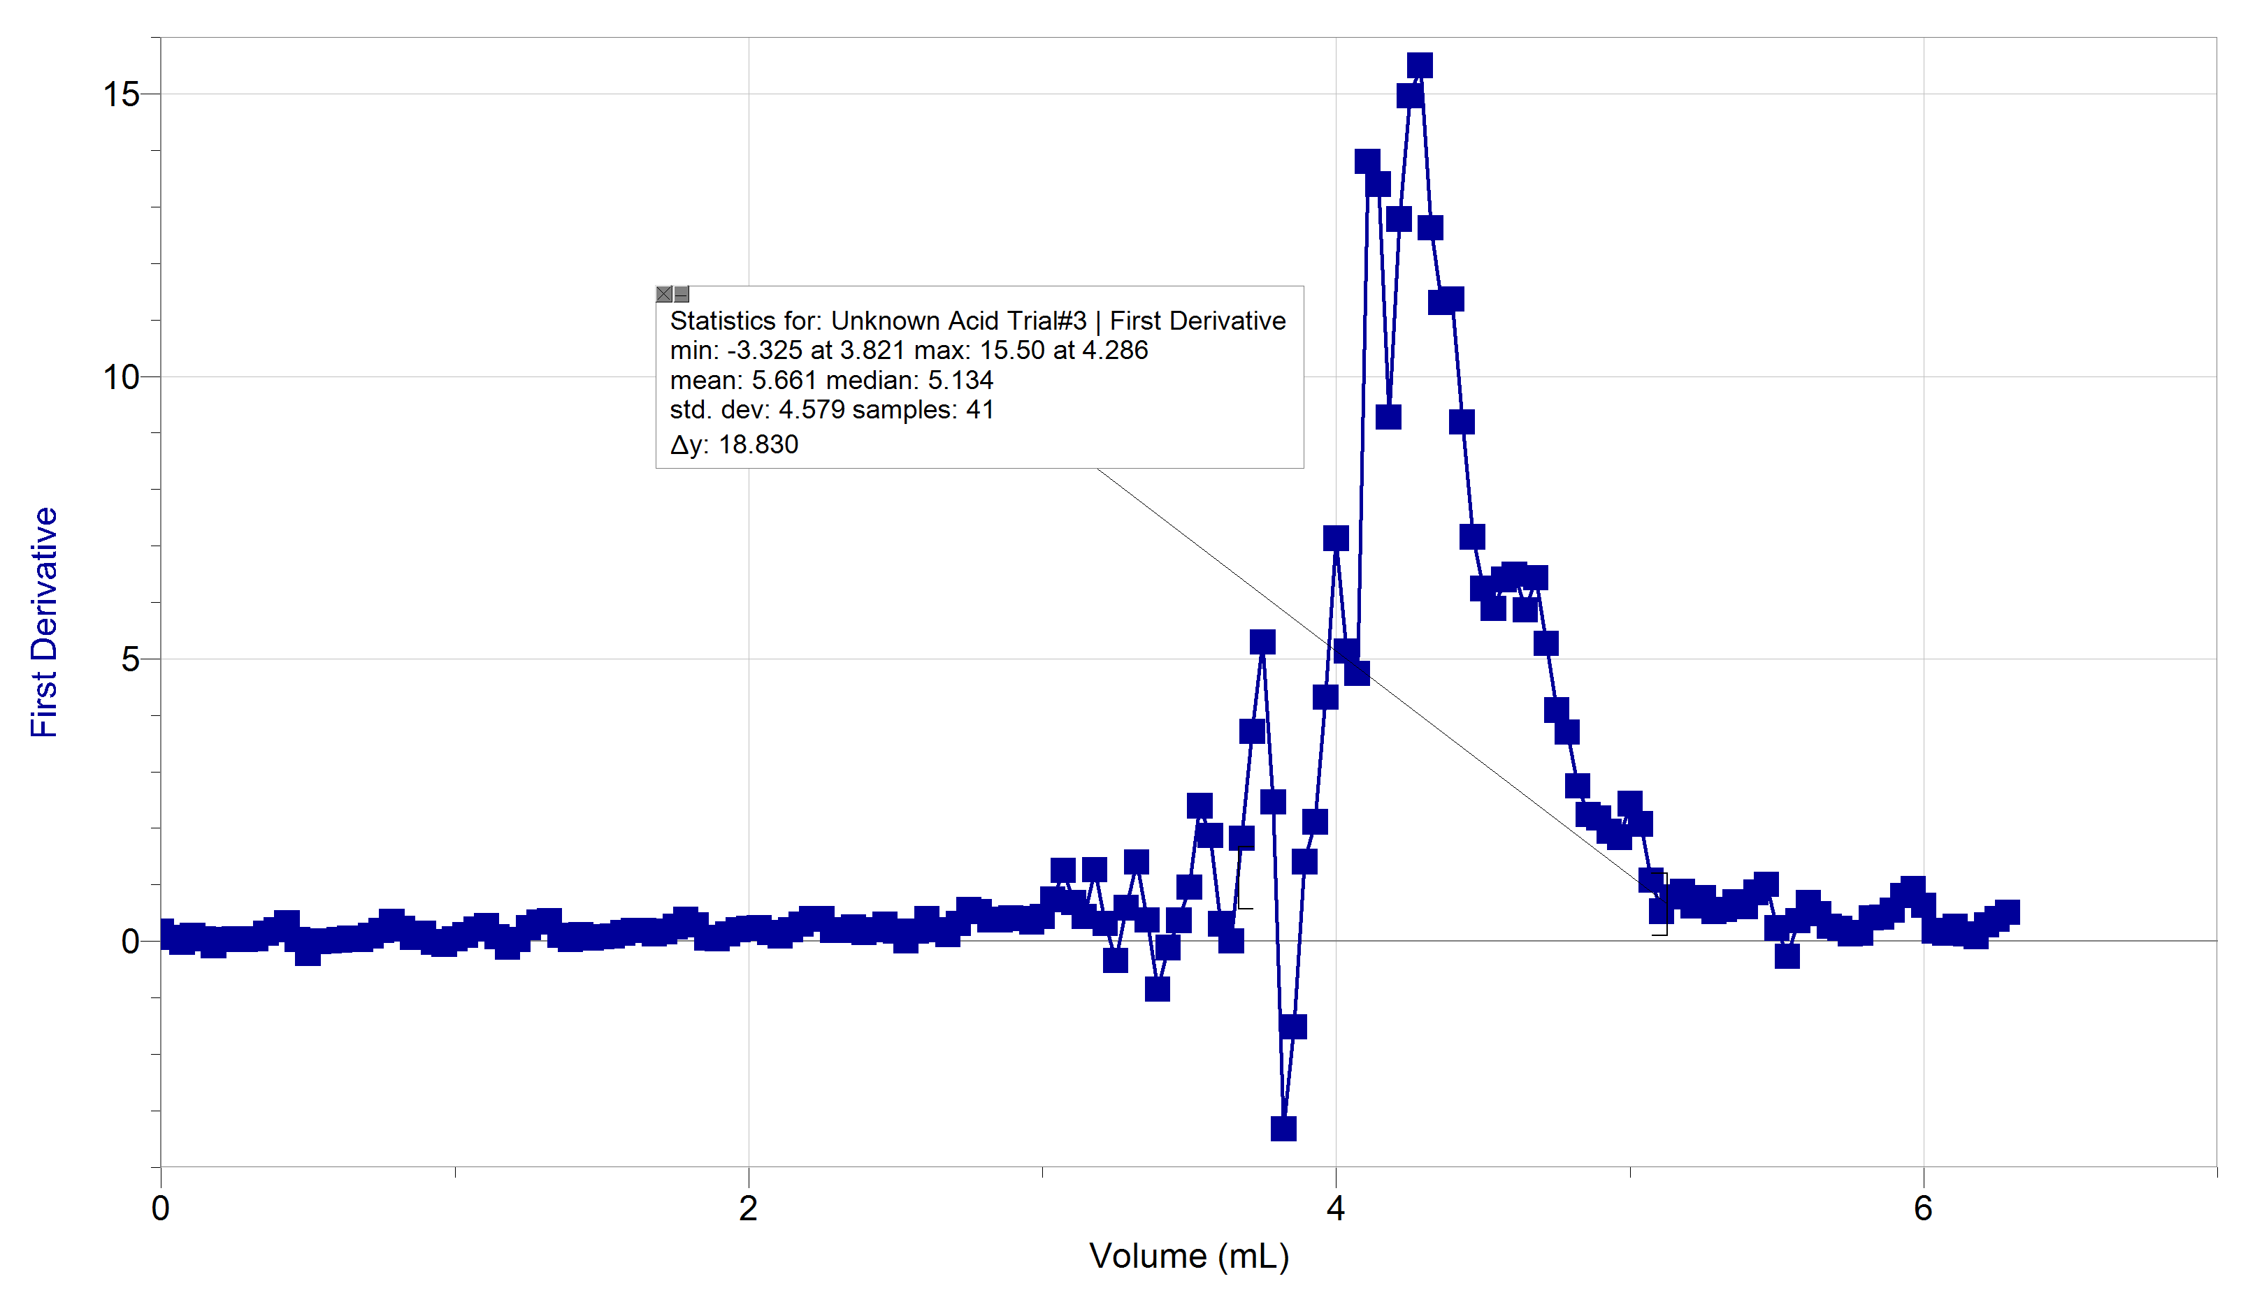

Figure 12: Graphical representation of the third trial of the unknown acid (2) measured using the first derivative of the pH as a function of Volume (mL). This graphical representation displays the volume of the stock solution of the NaOH at which the maximum pH occurred. A maximum pH of 15.50 occurs at 4.286.
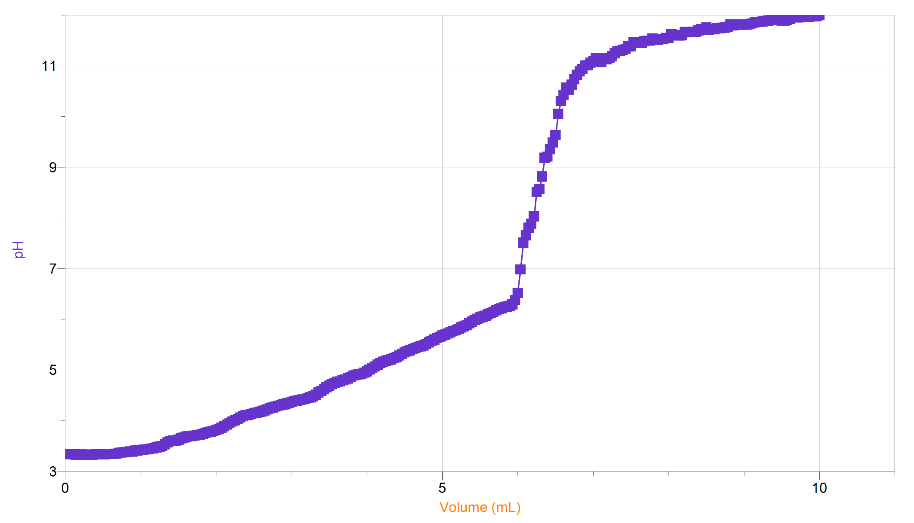
Figure 13: Graphical representation of the first trial of the juice solution containing acid measured using pH as a function of Volume (mL).

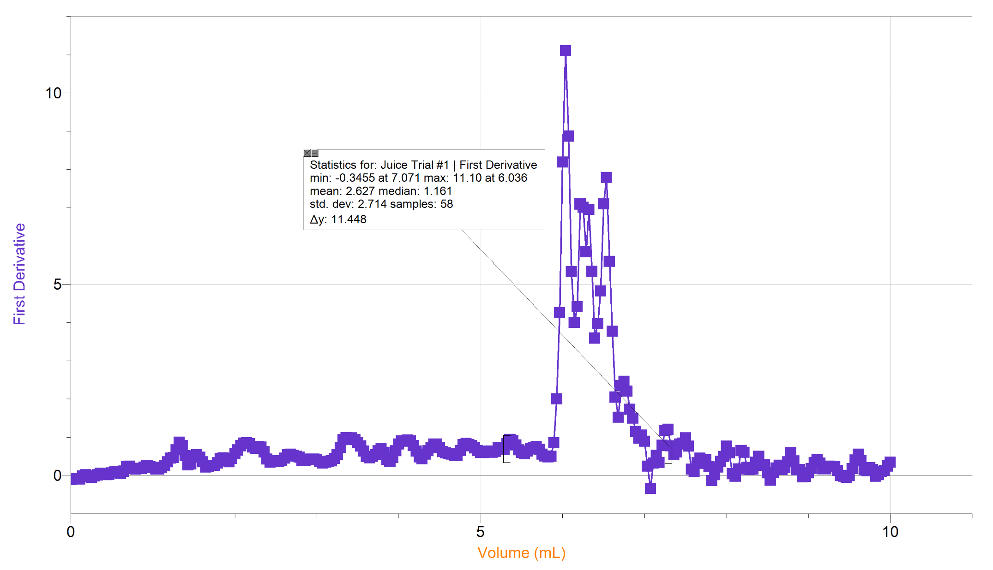
Figure 14: Graphical representation of the first trial of the juice solution containing acid measured using the first derivative of the pH as a function of Volume (mL). This graphical representation displays the volume of the stock solution of the NaOH at which the maximum pH occurred. A maximum pH of 15.50 occurs at 4.286.

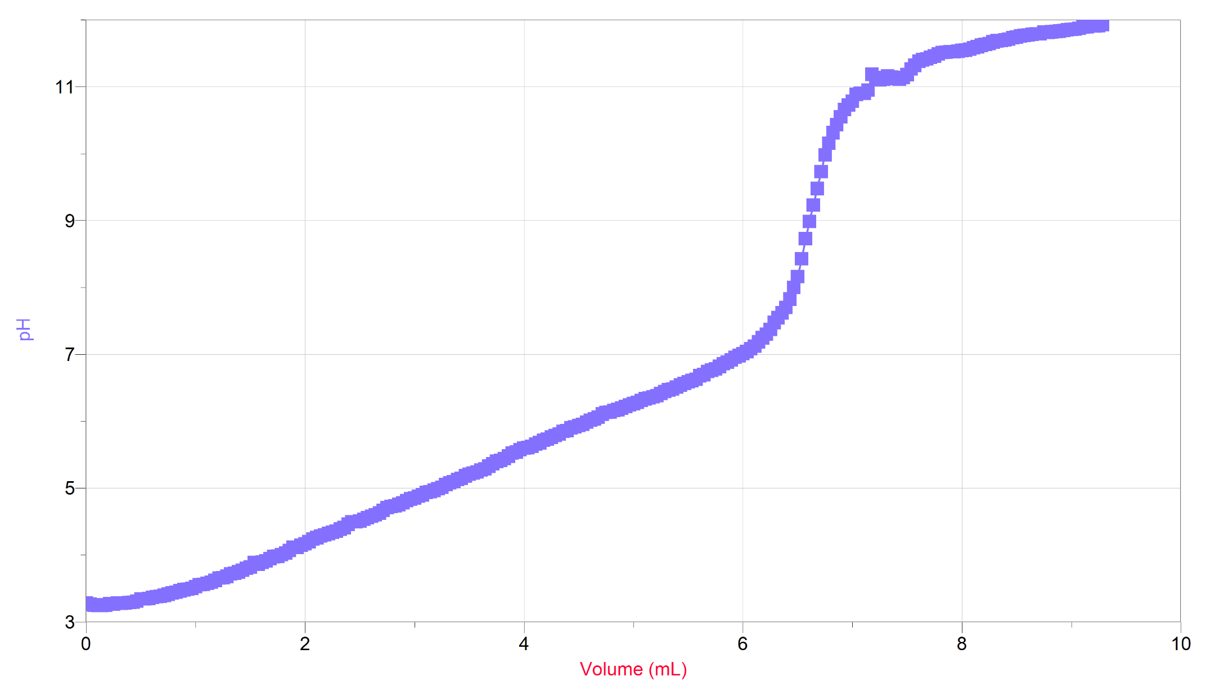
Figure 15: Graphical representation of the second trial of the juice solution containing acid measured using pH as a function of Volume (mL).

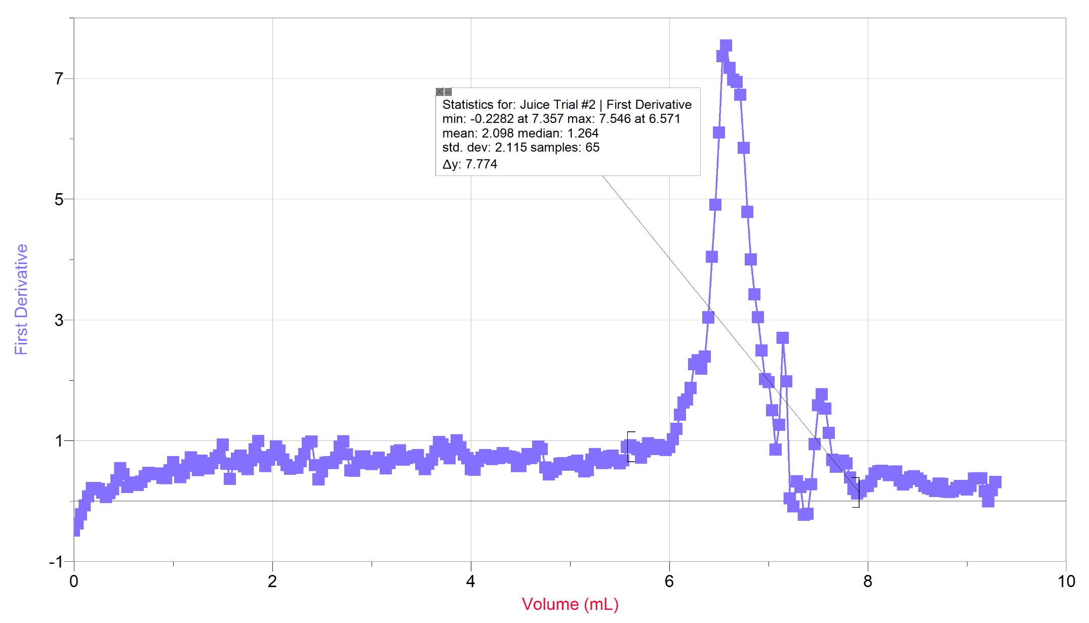
Figure 16: Graphical representation of the second trial of the juice solution containing acid measured using the first derivative of the pH as a function of Volume (mL). This graphical representation displays the volume of the stock solution of the NaOH at which the maximum pH occurred. A maximum pH of 15.50 occurs at 4.286.

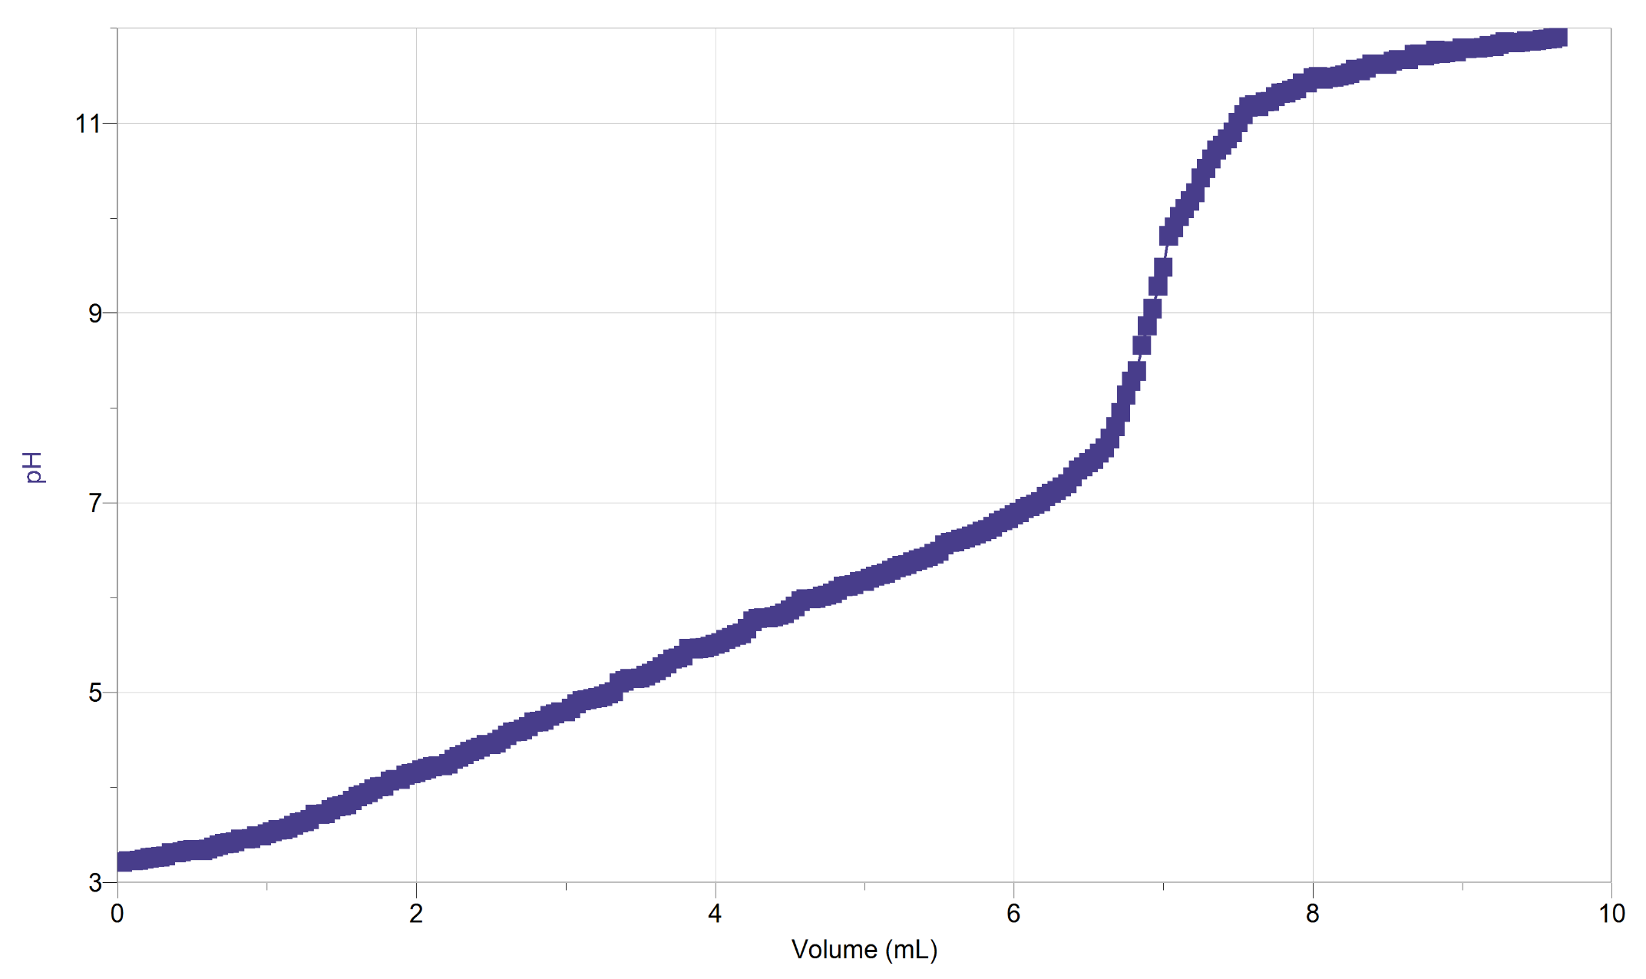
Figure 17: Graphical representation of the third trial of the juice solution containing acid measured using pH as a function of Volume (mL).

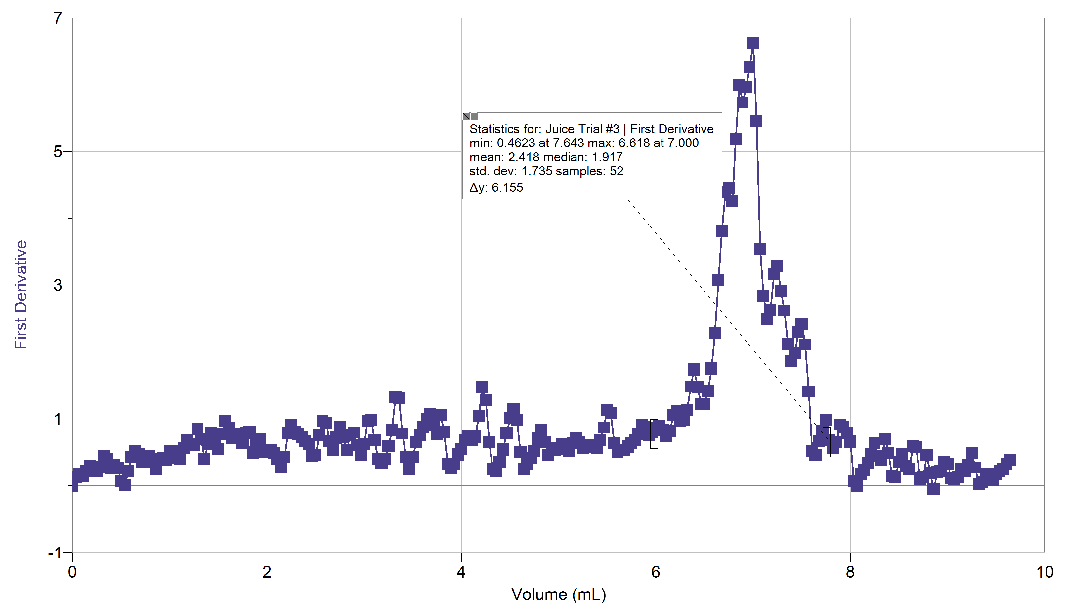
Figure 18: Graphical representation of the third trial of the juice solution containing acid measured using the first derivative of the pH as a function of Volume (mL). This graphical representation displays the volume of the stock solution of the NaOH at which the maximum pH occurred. A maximum pH of 15.50 occurs at 4.286.

Sample Calculation: (Part 1)

- Approximate concentration of stock solution

$$V_{Conc. NaOH}=4.0mL$$
$$C_{Conc. NaOH}=6.0M$$
$V_{Stock after dilution}=$ 254mL

$$C_{NaOH}V_{NaOH}=C_{dilution}V_{dilution}$$
$$C_{dilution}=\frac{C_{NaOH}V_{NaOH}}{V_{dilution}}$$
$$=\frac{4.0mL×6.0\frac{mol}{L}}{254}$$
$$=0.09449$$

Sample Calculation: (Part 2)

- Exact concentration of stock solution (from visual endpoint and cV calculations AND by first derivative from titration curve using LabQuest 2 data):

$$C_{HCl}=0.1000M$$
$$V_{HCl}=10.0mL$$

Concentration of Stock Solution Using Visual Endpoint (for trails #1 and #2)

Trial #1
$V_{Stock Visual}=$ 8.262mL

$$n_{NaOH}=n_{HCl}$$
$$C_{NaOH}V_{NaOH}=C_{HCl}V_{HCl}$$
$$C_{NaOH}=\frac{C_{HCl}V_{HCl}}{V_{NaOH}}$$
$$=\frac{0.1000\frac{mol}{L}×10.0mL}{8.262mL}$$
$$=0.121$$

Trial #2
$V_{Stock Visual}=11.42mL$

$$n_{NaOH}=n_{HCl}$$
$$C_{NaOH}V_{NaOH}=C_{HCl}V_{HCl}$$
$$C_{NaOH}=\frac{C_{HCl}V_{HCl}}{V_{NaOH}}$$
$$=\frac{0.1000\frac{mol}{L}×10.0mL}{11.42mL}$$
$$=0.0876$$

Concentration of Stock Solution First Derivative (for trails #1 and #2)

Trial #1
$V_{FD}=$9.095mL
$$n_{NaOH}=n_{HCl}$$
$$C_{NaOH}V_{NaOH}=C_{HCl}V_{HCl}$$
$$C_{NaOH}=\frac{C_{HCl}V_{HCl}}{V_{NaOH}}$$
$$=\frac{0.1000\frac{mol}{L}×10.0mL}{9.095mL}$$
$$=0.110\frac{mol}{L}$$
Trial #2
$V_{FD}=$11.67mL
$$n_{NaOH}=n_{HCl}$$
$$C_{NaOH}V_{NaOH}=C_{HCl}V_{HCl}$$
$$C_{NaOH}=\frac{C_{HCl}V_{HCl}}{V_{NaOH}}$$
$$=\frac{0.1000\frac{mol}{L}×10.0mL}{11.67 mL}$$
$$=0.0857\frac{mol}{L}$$

- Average concentration of stock solution:

$$Average Cocentration of Stock Solution= \frac{\left[Trial \#1\right]+[Trial \#2]}{2}$$

$$Visual$$
$$Average Cocentration of Stock Solution= \frac{0.121\frac{mol}{L}+0.0876\frac{mol}{L}}{2}$$
$=0.104\frac{mol}{L}$

$$Graphical (Based in First Derivative)$$

$$Average Cocentration of Stock Solution= \frac{0.110\frac{mol}{L}+0.0857\frac{mol}{L}}{2}$$
$=0.0987\frac{mol}{L}$

Sample Calculation: (Part 3)

- Concentration of Unknown Acid (from visual endpoint and cV calculations AND by first derivative from titration curve using LabQuest data):

$$C_{NaOH stock}=0.0987\frac{mol}{L}$$
$$V_{HCl}=10.0mL$$

${H_{2}A }_{(aq)}+ 2{NaOH }_{\left(aq\right)}→ {Na}_{2}A_{(aq)}+H_{2}O_{(aq)}$
$$n_{NaOH}={2n}_{H_{2}A}$$
$${C_{NaOH}V}_{NaOH}={2(C}_{H_{2}A}V_{H_{2}A})$$

Concentration of Stock Solution Using Visual Endpoint (for trails #2 and #3)

Trial #2
$V_{Stock Visual}=$ 4.607mL
$${C_{NaOH}V}_{NaOH}={2(C}_{H_{2}A}V_{H_{2}A})$$
$$C_{H_{2}A}=\frac{C_{NaOH}V_{NaOH}}{2V_{H_{2}A}}$$
$$=\frac{0.0987\frac{mol}{L}×10.0mL}{2( 4.607mL)}$$
$$=0.107\frac{mol}{L}$$
Trial #3
$V_{Stock Visual}=$ 4.674mL
$${C_{NaOH}V}_{NaOH}={2(C}_{H_{2}A}V_{H_{2}A})$$
$$C_{H_{2}A}=\frac{C_{NaOH}V_{NaOH}}{2V_{H_{2}A}}$$
$$=\frac{0.0987\frac{mol}{L}×10.0mL}{ 2(4.674mL)}$$
$$=0.106\frac{mol}{L}$$
Concentration of Stock Solution First Derivative (for trails #2 and #3)

Trial #2
$V_{FD}=$ 4.607mL
$${C_{NaOH}V}_{NaOH}={2(C}_{H_{2}A}V_{H_{2}A})$$
$$C_{H_{2}A}=\frac{C_{NaOH}V_{NaOH}}{2V_{H_{2}A}}$$
$$=\frac{0.0987\frac{mol}{L}×10.0mL}{ 2(4.500mL)}$$
$$=0.110\frac{mol}{L}$$
Trial #3
$V_{Stock Visual}=$ 4.674mL
$${C_{NaOH}V}_{NaOH}={2(C}_{H_{2}A}V_{H_{2}A})$$
$$C_{H_{2}A}=\frac{C_{NaOH}V_{NaOH}}{2V_{H_{2}A}}$$
$$=\frac{0.0987\frac{mol}{L}×10.0mL}{ 2(4.286mL)}$$
$$=0.115\frac{mol}{L}$$

- Average concentration of unknown acid:

$$Average Cocentration of unknow acid solution= \frac{\left[Trial \#2\right]+[Trial \#3]}{2}$$

$$Visual$$
$$Average Cocentration of unknow acid solution= \frac{0.107\frac{mol}{L}+0.106\frac{mol}{L}}{2}$$
$=0.1065\frac{mol}{L}$

$$Graphical (Based in First Derivative)$$

$$Average Cocentration of unknow acid solution= \frac{0.110\frac{mol}{L}+0.150\frac{mol}{L}}{2}$$
$=0.130$

Sample Calculation: (Part 4)

- Concentration of acid in juice (from visual endpoint and cV calculations AND by first derivative from titration curve using LabQuest data):

${H_{3}A }_{(aq)}+ 3{NaOH }_{\left(aq\right)}→ {Na}_{3}A_{(aq)}+H_{2}O_{(aq)}$
$$n_{NaOH}={3n}_{H_{3}A}$$
$${C_{NaOH}V}_{NaOH}={3(C}_{H_{3}A}V_{H_{3}A})$$

Concentration of Stock Solution Using Visual Endpoint (for trails #1, #2 & #3)

Trial #1
$V_{Stock Visual}=$ 6.654mL
$${C_{NaOH}V}_{NaOH}={3(C}_{H_{2}A}V_{H_{2}A})$$
$$C_{H_{2}A}=\frac{C_{NaOH}V_{NaOH}}{3V_{H_{2}A}}$$
$$=\frac{0.0987\frac{mol}{L}×10.0mL}{ 3(6.654mL)}$$
$$=0.0494\frac{mol}{L}$$

Trial #2
$V_{Stock Visual}=$ 6.607mL
$${C_{NaOH}V}_{NaOH}={3(C}_{H_{2}A}V_{H_{2}A})$$
$$C_{H_{2}A}=\frac{C_{NaOH}V_{NaOH}}{3V_{H_{2}A}}$$
$$=\frac{0.0987\frac{mol}{L}×10.0mL}{ 3(6.607mL)}$$
$$=0.0498\frac{mol}{L}$$
Trial #3
$V_{Stock Visual}=$ 7.786mL
$${C_{NaOH}V}_{NaOH}={3(C}_{H_{2}A}V_{H_{2}A})$$
$$C_{H_{2}A}=\frac{C_{NaOH}V_{NaOH}}{3V_{H_{2}A}}$$
$$=\frac{0.0987\frac{mol}{L}×10.0mL}{ 3(7.786mL)}$$
$$=0.0422\frac{mol}{L}$$
Concentration of Stock Solution First Derivative (for trails #1, #2 & #3)

Trial #1
$V_{FD}= 6.036mL$
$${C_{NaOH}V}_{NaOH}={3(C}_{H_{2}A}V_{H_{2}A})$$
$$C_{H_{2}A}=\frac{C_{NaOH}V_{NaOH}}{3V_{H_{2}A}}$$
$$=\frac{0.0987\frac{mol}{L}×10.0mL}{ 3(6.036mL)}$$
$$=0.0545\frac{mol}{L}$$
Trial #2
$V_{FD}=$ $6.571mL$
$${C_{NaOH}V}_{NaOH}={3(C}_{H_{2}A}V_{H_{2}A})$$
$$C_{H_{2}A}=\frac{C_{NaOH}V_{NaOH}}{3V_{H_{2}A}}$$
$$=\frac{0.0987\frac{mol}{L}×10.0mL}{ 3(6.571mL)}$$
$$=0.0501\frac{mol}{L}$$
Trial #3
$V_{Stock Visual}=$ 7.000mL
$${C_{NaOH}V}_{NaOH}={3(C}_{H_{2}A}V_{H_{2}A})$$
$$C_{H_{2}A}=\frac{C_{NaOH}V_{NaOH}}{3V_{H_{2}A}}$$
$$=\frac{0.0987\frac{mol}{L}×10.0mL}{ 3(7.000mL)}$$
$$=0.0470$$

- Average concentration of acid in juice:

$$Average Cocentration of Acid in Juice= \frac{\left[Trial \#1\right]+\left[Trial \#2\right]+[Trial \#3]}{3}$$

$$Visual$$
$$Average Cocentration of Acid in Juice= \frac{0.0494\frac{mol}{L}+0.0498\frac{mol}{L}+0.0422\frac{mol}{L}}{3}$$
$=0.0471\frac{mol}{L}$

$$Graphical (Based in First Derivative)$$

$$Average Cocentration of Acid in Juice= \frac{0.0545\frac{mol}{L}+0.0501\frac{mol}{L}+0.0470\frac{mol}{L}}{3}$$
$=0.0505\frac{mol}{L}$

8. Mass percentage of acid in juice:

$C_{acid}=0.0505\frac{mol}{L}$
${MM}_{acid}= 192.124\frac{g}{mol}$
${Density}_{juice}=0.9974\frac{g}{{cm}^{3}}$
$$Mass percentage of acid in juice= \frac{(0.0505\frac{mol}{L})(192.124\frac{g}{mol} )}{(0.9974\frac{g}{{cm}^{3}})×1000}×100\%$$
$$=0.973\%$$
Discussion (in space provided):
This experiment used volumetric titration in order to measure the concentration of a stock solution that is required to titrate a monoprotic, diprotic and diprotic acid. This allowed for the determination of the concentration of an unknown diprotic acid (part 3) as well as the mass percent of citric acid in juice.

The equivalence points in the experiment were determined both visually and graphically. The experimental and graphic values were both used in the calculations in order to make comparisons between the two. For the second part of the experiment, the average concentration of the stock solution that was determined visually was 0.104 mol/L while the graphically determined concentration was 0.0987 mol/L. Although the visual average does not deviate far from the experimental average, the fact that the visual one is higher demonstrates that on average, that the visual equivalence point was recorded slightly sooner than it actually occurred. For the third part of the experiment, the average concentration of the unknown acid that was determined visually was 0.1065 mol/L while the experimentally determined concentration was 0.130 mol/L. The difference between the visual and graphically concentration values can be accounted for the fact that the visual equivalence point was recorded slightly later than it actually occurred. For the last part of the experiment, the average concentration of the acid in the juice that was determined visually was 0.0471 mol/L while the experimentally determined concentration was 0.0505 mol/L. The difference between the visual and graphically concentration values can be accounted for by the fact that the visual equivalence point was recorded slightly sooner than it actually occurred.

In order to ensure accuracy and increase the validity of the experiment, multiple trials were conducted. However, when the average concentrations were calculated, not all of the trials were taken into account. For the second part of the experiment, where the concentration of the stock solution was calculated, only trials one and two were taken into account. This is because the average of these two trails yielded the closest possible concentration value to the approximate concentration value that was determined in the first part of the experiment. In the third part of the experiment, where the concentration of the diprotic unknown acid was calculated, only trials two and three were taken into account because the concentration obtained in trail one deviated somewhat significantly from the other two concentrations. In the last part of the experiment, where the concentration of citric acid in the juice was calculated, all three trials were taken into account because all three on them were relatively close and thus appeared to be valid.

During this experiment, there was potential for several experimental errors to occur. First of all, the solutions of the monoprotic, diprotic and diprotic acids as well as the solution of NaOH may have been contaminated. This was not a foreseeable nor was it a preventable error; however, it would yielding inaccurate concentrations thereby altering the results. Second, the burrete was rinsed with distilled water after every part of the experiment. This likely caused the acid to be slightly diluted as it was being transferred into the beaker before the titration. This would inherently result in a less concentrated acid.In spite of these experimental errors, using logger-pro a well as conducting several trials for each part of the experiment reduced the effect that these errors had on the results.

The volume of concentrated NaOH that is used in the beginning of the experiment is important because it determines the concentration of the diluted solution which is used as the stock solution all throughout the experiment. It is important to find the concentration of the NaOH stock solution before it is used because determines the concentration of the unknown acid and the citric acid in the juice (using C₁V₁=C₂V₂ relationship).

In order to determine the mass percent of the juice an equation was used which included a factor of 1000 in the denominator. This factor of 100 accounted for the fact that the density was in units of g/mL in the equation while the concentration of the acid was in mol/L. The factor of 1000 converted the density of the juice from g/mL to g/L so that the units cancel out when calculating the mass percent of the juice.

Conclusion:
The concentration of unknown acid #2 is 0.130 mol/L.
The mass percent of acid in the juice#1 is 0.973%.

Raw Data


