MOS 1023 notes – Exam #1

Pgs. 1-27

The Purpose and Use of Financial Statements

Users and Uses of Accounting
- Internal Users
- External users
- Ethical Behaviour by users
Forms of Business Organization
- Proprietorships
- Partnerships
- Corporations
Business Activities
- Financing Activities
- Investing Activities
- Operating Activities
Communicating with Users
- Sierra’s financial statements
- Eastplat’s financial statements
- Elements of an annual report

Users and Uses of Accounting

Accounting is the information system that identifies and records the economic events of an organization, and then communicates them to a wide variety of interested users.
- The world’s economic systems depend highly on transparent, reliable, and accurate financial reporting
- Accounting is the language of business
- Users of accounting information can be divided broadly into two types: internal users and external users

Internal Users
- These users plan, organize, and run companies
- Includes finance directors, marketing managers, human resource personnel, production supervisors, and company officers
- Finance: Is there enough cash to pay the bills?
- Marketing: What price should we sell iPads for to maximize profits?
- Human Resources: How many employees can we afford to hire this year?
- Production: Which product line is the most profitable?
- Users need detailed accounting information on a timely basis; that is, it must be available when it is needed.

External Users
- INVESTORS ARE ALSO KNOWN AS SHAREHOLDERS AND CREDITORS ARE ALSO KNOWN AS LENDERS
- Investors use accounting information to make decisions to buy, hold, or sell their ownership interest
- Lenders, such as bankers, use accounting information to evaluate the risks of lending money.
- Other creditors, such as suppliers, use accounting information to decide whether or not to grant credit (sell on account) to a customer
- Investors, lenders, and other creditors are considered to be the primary or key external users of accounting information

Ethical Behaviour by Users
- In order for financial information to have value to its users, it must be prepared by individuals with high standards of ethical behaviour
- Accountants and other professionals have extensive rules of conduct to guide their behaviour with each other and the public
- When you analyze ethical situations, you should follow the steps outlines below:
- Recognize and ethical situation and the ethical issues involved
- Identify and analyze the main elements in the situation
- Identify the alternatives, and weigh the impact of each alternative on various stakeholders

Forms of Business Organization

Businesses can be organized in different ways. There are three common forms of business organization: proprietorships, partnerships, and corporations.

Proprietorships
- Proprietorship is a business owned by one person
- Simple to set up, gives the owner control of the business
- The owner (proprietor) receives any profits, suffers any losses, and is personally liable (responsible) for all debts of the business
- ^This is known as unlimited liability
- No legal distinction between the business as an economic unit and the owner
- The life of the proprietorship is limited to the life of the owner
- Business profits are reported as self-employment income and taxed on the owner’s personal income tax return
- Business records of the proprietorship must be kept separate from owner’s personal activities
- Reporting Entity Concept requires that the economic activity that can be identified with a particular company be kept separate and distinct from the activities of the owners and of all other economic entities
- This concept applies to all three types of businesses

Partnerships
- This is a business owned by more than one person
- Very similar to a proprietorship, except that there is more than one owner.
- Partnerships are often formed because one person does not have enough economic resources to initiate or expand the business, or because partners bring unique skills or resources to the partnership
- Normally formalized in a written partnership agreement that outlines the formation of the partnership, partners’ contributions, how profits and losses are shared, and provisions for withdrawals of assets and/or partners, dispute resolution, and partnership liquidation
- Each partner generally has unlimited liability for all debts of the partnership, even if one of the other partners created the debt, however, there are certain situations where partnerships can be formed with limited liability for selected partners
- Assets are resources that provide future economic benefits
- The profits of the partnership are reported as self-employment income and taxed on each partner’s personal income tax return
- The reporting entity concept requires that partnership records be kept separate from each partner’s personal activities

Corporations
- Is a business organized as a separate legal entity owned by shareholders
- As a shareholder, your personal finances are not reported in a corporation’s financial statements because you are separate reporting entities under the reporting entities concept
- A corporation’s life in indefinite, which means that it continues on regardless of who owns its shares.
- It is not not affected by the withdrawal, death, or incapacity of an owner, as is the case in a proprietorship or partnership
- As a proprietor or a partner, you are personally liable for all debts of the business, while corporate shareholders are not responsible for corporate debts unless they have personally guaranteed them.
- Shareholders only risk losing the amount they have invested in the company’s shares.
- Proprietors and partners pay personal income tax on their respective shares of the profits, while corporations pay income tax as separate legal entities on any corporate profits
- Public Corporations distribute their financial statements to investor, lenders, other creditors, other interested parties, and the general public.
- Consolidated means that the financial results include not only the corporation’s but also all the companies that this corporation owns or controls
- It has to be possible to distinguish each company’s activities from the transactions of any other company, even if the companies are related.
- Private Corporations issue shares, but they do not make them available to the general public nor are they traded on public stock exchange
Generally Accepted Accounting Principles for Corporations (GAAP)
- These principles are a general guide for financial reporting purposes
- GAAP include broad policies and practices as well as rules and procedures that have substantive authoritative support and agreement about how to report economic events
- These principles are different for publicly traded and private corporations.
- Publicly traded corporations must use International Accounting Standards (IFRS), a set of global accounting standards developed by the International Accounting Standards Board.
- Private corporations, whose users can have different needs than publicly traded corporations, have a choice between using IFRS or Accounting Standards for Private Enterprises (ASPE), developed by the Canadian Accounting Standards Board
- Most private corps choose to use ASPE(exceptions though; McCain uses IFRS)
- Proprietorships and partnerships do not have to choose between IFRS and ASPE as their statements are generally prepared only for internal use of the owners.

Business Activities

All businesses are involved in three types of activity; financing, investing, and operating.

Financing Activities
- Two primary ways of raising outside funds for corporations are (1) borrowing money (debt financing) and (2) issuing (selling) shares (equity financing) in exchange for cash
- Liabilities are amounts owed to lenders and creditors, in the form of debt and other obligations
- Bank Indebtedness is when a company uses its operating line of credit to cover cash shortfalls and overdraws its bank account.
- Loan Payable (note payable) is a short-term loan
- Long-Term Debt, which can include mortgages payable, bonds payable, finance lease obligations, and other types of debt securities borrowed for longer periods of time
- Common Shares is the term used to describe the amount paid by investors for shares of ownership in a company (this is only one type of share)
- As a creditor, you have a legal right to be paid at the agreed time, and in the event of nonpayment, you may force the company to sell assets to pay its debts
- Shareholders have no claim to corporate resources until the claims of lenders and creditors are satisfied

Investing Activities
- After a company raises money through financing activities, it then uses that money for investing activities.
- Investing activities involve the purchase (or sale) or long-lived assets that a company needs in order to separate.
- Assets are resources that a company owns or controls
- Property, Plant, and Equipment is also known as capital assets or fixed assets
- Cash is one of the more important assets owned by a business, if a company has excess cash that it does not need for a while, it might choose to invest it in debt securities or equity securities or other corporations or organizations – these are called investments.
- Investments can be either short-term or long-term
- Short term – operating activities; incurred for the purpose of trading as part of the company’s revenue-producing activities.
- Long-term – investing activities; investing in long-lived assets necessary to run the company and not just purchasing an investment on which to earn a return for the long-term, such as interest or dividends.

Operating Activities
- Once a business has the finances and has made the investments it needs to get started, it can begin its operations
- Revenue is the amounts earned from the sale of goods, in accounting language, revenues are increases in economic benefits – normally an increase in an asset but sometimes a decrease in a liability – that result from the sale of a product of service in the normal course of business
- Sources of revenue that are common to many businesses are sales revenue (often just called sales), service revenue, interest revenue, and rent revenue.
- Account Receivable is the right to receive money in the future
- Interest receivable, rent receivable, and income tax receivable (aka deferred tax assets) are due from the federal government
- Inventory is the asset that is ready for future sale to customers
- Expenses are the cost of assets that are consumed or services that are used in the process of generating revenues.
- When an expense is incurred, an asset will decrease or a liability will increase
- Production costs, general and administrative expenses (such as salaries, advertising, utilities, professional fees, rent, and other costs associated with running the business), depreciation expense and depletion expense (ie; allocation of the cost of using the mine equipment and property), finance costs (amounts of interest paid on various debts), and income tax. All these expenses are necessary to produce and sell their products.
- Accounts Payable obligations to pay for materials and supplies, when bought on credit
- Interest Payable on the outstanding (unpaid) amounts owed to various lenders, dividends payable to shareholders, salaries payable to employees, property tax payable to the provincial government, and sales tax payable to the provincial and federal governments.
- To determine whether your company earned a profit or not, you compare the revenue of a period with the expenses of that same period.
- When revenues are more than expenses, a profit results
- When expenses exceed revenues, a loss results

- Financing Activities include borrowing cash from lenders by issuing debt, or conversely, using cash to repay debt. Cash can also be raised from shareholders by issuing shares, or paid to shareholders by repurchasing shares or distributing dividends
- Investing Activities include purchasing and disposing of long-lived assets such as property, plant, and equipment and purchasing and selling long-term investments
- Operating Activities result from day-to-day operations and include revenues and expenses and related accounts such as receivables, supplies, inventory, and payables.

Communicating with Users

Users, especially external users, are interested in a company’s assets, liabilities, shareholders’ equity, revenues and expenses. For external reporting purposes, it is customary to arrange this information in four different financial statements that are the backbone of financial reporting:
- Income Statement: An income statement reports revenues and expenses to show how successfully a company performed during a period of time.
- Statement of changes in equity: A statement of changes in equity shows the changes in each component of shareholders’ equity, as well as total equity, during a period of time.
- Statement of Financial Position (Balance Sheet): A statement of financial position presents a picture of what a company owns (its assets), what it owes (its liabilities), and its net worth (its shareholders’ equity) at a specific point in time
- Statement of Cash Flows: A statement of cash flows shows where a company obtained cash during a period of time and how that cash was used.

- Notes to the financial statements are explanatory notes that clarify information presented in the financial statements and provide additional detail. They are essential to understanding a company’s financial performance and position.
- Financial statements are produced annually, quarterly, or monthly depending on the nature and purpose of the company
- Publicly traded companies must make their financial statements available to shareholders both quarterly and annually
- An accounting time period that is one year in length is called a fiscal year
Income Statement
- The income statement reports the success or failure of the company’s operations for a period of time – annually, quarterly, or monthly
- The income statement lists the company’s revenues first and then its expenses
- Expenses are deducted from revenues to determine profit (or loss) before income tax
- Income tax expense is usually shown separately, immediately following the profit (or loss) before income tax line
- Profit (or loss) is determined by deducting the income tax expense
- Profit is also commonly known as net income, especially by those companies following ASPE
- Investors are interested in a company’s past profit because these numbers provide information that may help predict future profits
- When a bank loans money to a company, it does this because it believes it will be repaid in the future, if it thought it was not going to be repaid, it would not loan the money
- Amounts received from issuing shares are not revenues, and amounts paid out as dividends are not expenses
- Both of the above transactions are reported in the statement of changes in equity

Statement of Changes in Equity
- The statement of changes in equity shows the changes in total shareholders’ equity for the period, as well as the changes in each component of shareholders’ equity, during the period.
- The ownership interest in a company is known as shareholders’ equity
- Total shareholders’ equity includes:
- Share Capital
- Retained Earnings
- Share capital represents amounts contributed by the shareholders in exchange for shares of ownership
- Two classes of shares: common and preferred – these classes of shares combine to form the company’s share capital
- Retained Earnings represent the cumulative profit that has been retained in the corporation, or in other words, it is the profit that has not been paid out to shareholders that has accumulated since the company’s date of incorporation
- Deficit is when the retained earnings are negative, that is, there have been more losses than profits
- In addition to showing the changed in share capital during the period, the statement of changes in equity also shows the amounts and causes of changes in retained earnings

Statement of Financial Position (Balance Sheet)
- The statement of financial position reports assets and claims to those assets at a specific point in time, also known as the balance sheet
- Accounting Equation: Assets = Liabilities + Shareholders’ (or Owner’s) Equity
- Lenders and other creditors analyze a company’s statement of financial position to determine the likelihood that they will be repaid, and carefully evaluate the nature of the company’s assets and liabilities
- Managers use the statement of financial position to determine whether inventory is adequate to support future sales and whether cash on hand is sufficient for immediate cash needs, and look at the relationship between total liabilities and shareholders’ equity to determine whether they have the best proportion of debt and equity financing

Statement of Cash Flows
- The main function of a statement of cash flows is to provide financial information about the cash receipts and cash payments of a business for a specific period of time
- This statement reports the effects on cash of a company’s:
- Operating Activities
- Investing Activities
- Financing Activities
- The statement of cash flows provides answers to these simple but important questions:
- Where did cash come from during the period?
- How was cash used during the period?
- What was the change in the cash balance during the period?

Elements of an Annual Report
- Publicly traded companies must produce an annual report each year
- The annual report is a document that includes useful nonfinancial information about the company, as well as financial information
- Non financial information normally includes a management discussion and analysis, a statement of management responsibility for the financial statements, an auditors’ report, financial statements reported for at least two years (these are called comparative statements), notes to the financial statements, and a historical summary of key financial ratios and indicators.
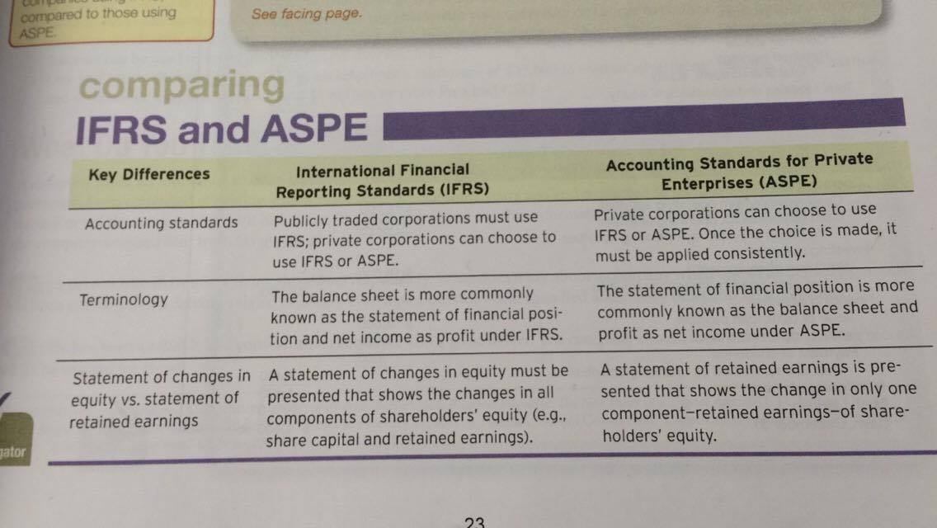

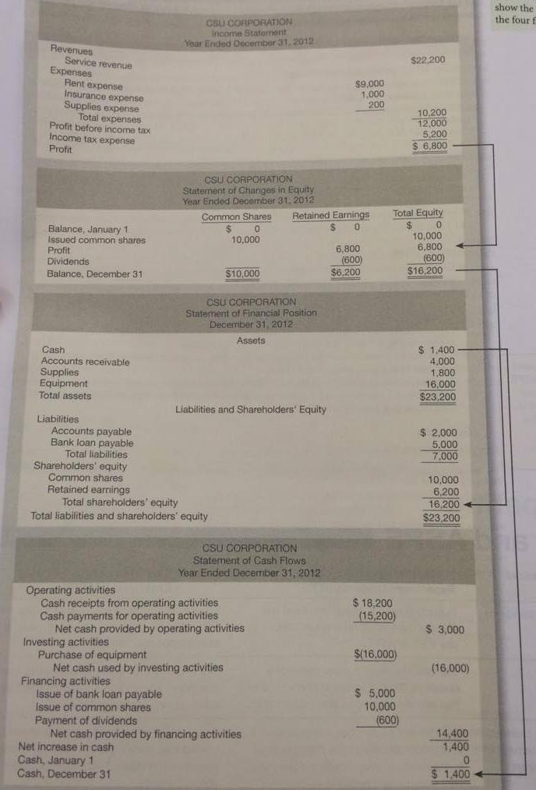

**The arrows in this pic show the relationships among the four financial statements

Pgs. 28-74

Conceptual Framework

A conceptual framework is like a constitution; it is a “coherent system of interrelated objectives and fundamentals that can lead to consistent standards and that prescribes the nature, function, and limits of financial accounting and financial statements.”

Rationale for Conceptual Framework
- To be useful, standard setting should build on an established body of concepts and objectives
- It’s important that such framework increase financial statement users’ understanding of an confidence in financial reporting, and that it enhance the comparability of different companies’ financial statements
- With the help of a universally accepted conceptual framework, it is hoped that accountants will be able to decide against certain alternatives quickly and to focus instead on a logical and acceptable treatment

Development of the Conceptual Framework
- Many individuals have developed and published their own conceptual frameworks, but no ingle framework has been universally accepted and relied on in practice
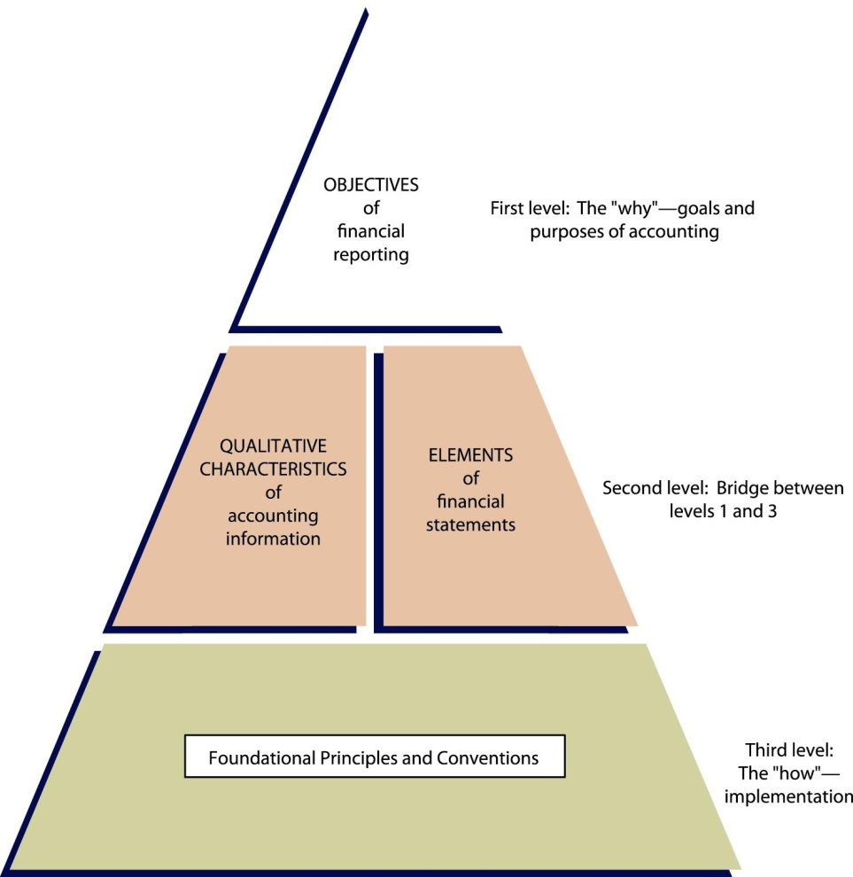
- At the first level, the objectives identify accounting’s goals and purposes: these are the conceptual framework’s building blocks
- At the second level are the qualitative characteristics that make accounting information useful and the elements of financial statements (assets, liabilities, equity, revenues, expenses, gains and losses)
- At the third and final level are the foundational principles used in establishing and applying accounting standards

Information Asymmetry Revisited
- Though investors and creditors need information in order to make sound resource decisions, information in the capital marketplace is not always evenly accessible or available to investors and creditors
- Financial statements play a large part in helping to ensure that investors, creditors, and others have access to information they need to make decisions
- Due to adverse selection and/or moral hazard, problems may arise. The moral hazard issue is worse where certain stakeholders such as accountants and bankers have expert knowledge that the rest of the capital marketplace does not

Objective of Financial Reporting

- According to the conceptual framework, the objective of financial reporting is to communicate information that is useful to investors, creditors, and other users
- Financial information that is useful in making decisions about how to allocate resources (including assessing management stewardship)
- Companies provide information to users of financial statements through general-purpose financial statements, which are basic financial statements that give information that meets the needs of key users
- These statements are intended to provide the most useful information possible in a manner whereby benefits exceed costs to the different kinds of users

Qualitative Characteristics of Useful Information
- Choosing an acceptable accounting method, the amount and types of information to be disclosed, and the format in which information should be presented involves determining which alternative gives the most useful information for decision-making purposes (decision usefulness)
- The conceptual framework’s second level has identified the qualitative characteristics of accounting information that distinguish information that is better (more useful) for making decisions form information that is inferior (less useful)

Fundamental Qualitative Characteristics
- Relevance and representational faithfulness (sometimes referred to as faithful representation) are fundamental qualities that make accounting information useful for decision-making.
- To be relevant, accounting information must be capable of making a difference in a decision
- Relevant information helps users make predictions about the final outcome of past, present and future events; that it, it has predictive value
- This information also helps users confirm or correct their previous expectations; it has feedback/confirmatory value
- Materiality refers to how important a piece of information is, and it generally thought to be material if it would make a difference to the decision-make
- Accounting information is representationally faithful to the extent that it reflects the underlying economic substance of an event or transaction
- This notion of representing economic reality is sometimes referred to as transparency
- Information that is representationally faithful is complete, neutral, and free from material error
- Completeness refers to the fact that the statements should include all information necessary to portray the underlying events and transactions
- Neutrality means that information cannot be selected to favour one set of interested parties over another
- Neutrality in standard setting is another aspect to neutrality
- Some observers argue that standards should not be issued if they cause undesirable economic effects on an industry or company (the economic consequences argument)
- Standards must be free from bias or we will no longer have credible financial statements
- Freedom from material error means that the information must be reliable

Enhancing Qualitative Characteristics
- Enhancing qualitative characteristics include comparability, verifiability, timeliness, and understandability
- Information that has been measured and presorted in a similar way is considered comparable
- Comparability enables users to identify the real similarities and differences in economic phenomena because these have not been obscured by accounting methods that cannot be compared
- It is important to remember that resource allocation decisions involve evaluations of alternatives and it easier to make a valid evaluation if comparable information is available
- Verifiability exists when knowledgeable, independent users achieve similar results or reach consensus regarding the accounting for a particular transaction
- Timeliness is also important because information should be available to decision-makers before it loses its ability to influence their decisions
- Understandability. Users need to have reasonable knowledge of business and financial accounting matters in order to understand the information in financial statements

Trade-Offs
- Preparers of financial information should identify all relevant information, then consider how best to ensure that the financial statements are presented such that they reflect the economic substance (representational faithfulness)
- Cost-benefit relationship must be considered: the costs of providing the information must be weighed against the benefits that can be had from using the information
- There are several kinds of costs:
- collecting and processing
- distributing
- auditing
- potential litigation
- disclosure of proprietary information to competitors
- analysis and interpretation

Elements of Financial Statements
- At present, accounting uses many terms that have specific meanings and these terms make up the language of accounting and business
- There are many elements that users expect to find on the financial statements, including assets, liabilities, equity, revenues, expenses, gains, and losses

Assets
- Assets have three essential characteristics:
- There is some economic benefit to the entity
- The entity has control over that benefit
- The benefits result from a past transaction or event

Liabilities
- Liabilities have three essential characteristics
- They represent a present duty or responsibility
- The duty or responsibility obligates the entity, leaving it little or no discretion to avoid it
- The transaction or event results from a past transaction or event
- Constructive obligations are obligations that arise through past or present practice that signals that the company acknowledges a potential economic burden
- Equitable Obligations arise due to moral or ethical considerations. For instance, a company might feel a moral obligation to retrain an employee who is being downsized

Equity
- Equity is a residual interest in an entity that remains after deducting its liabilities from its assets. This is also known as its net worth. In a business enterprise, the equity is the ownership interest. Equity would normally consist of common or ordinary shares, preferred shares, retained earnings, and under IFRS, accumulated other comprehensive income

Revenues
- Revenues are increases in economic resources, either by inflows or other enhancements of an entity’s assets or by settlement of its liabilities, which result from an entity’s ordinary activities. For instance, assume that a real estate company owns 10 buildings and leases them out under long-term leases. For this company, revenues would include rental income.

Expenses
- Expenses are decreases in economic resources, either by outflows or reductions of assets or by the incurrence of liabilities that result from an entity’s ordinary revenue-generating activities. For instance, for the real estate company above, this would include heating and property taxes

Gains/Losses
- Gains are increases in equity (net assets) from an entity’s peripheral or incidental transactions and from all other transactions and other events and circumstances affecting the entity during a period, except those that result from revenues or investments by owners.
- Losses are decreases in equity (net assets) from an entity’s peripheral or incidental transactions and from all other transactions and other events and circumstances affecting the entity during a period, except those that result from expenses or distributions to owners.
The financial statements include the following items:
- Income statement and/or statement of comprehensive income (IFRS only)
- Statement of financial position
- Statement of retained earnings or changes in shareholders’ equity (IFRS only)
- Statement of cash flows
- The term comprehensive income is a relatively new income concept and includes more than the traditional notion of net income. It includes net income and other comprehensive income (all other changes in equity except for owners’ investments and distributions)
Foundational Principles

- The conceptual framework’s third level consists of foundational principles that implement the basic objectives of the first level
- These concepts help explain which, when and how financial elements and events should be recognized, measured, and presented/disclosed by the accounting system
- Basic foundational principles underlying the financial accounting structure also include assumptions and conventions
- We will discuss the 10 foundational principles and assumptions under the groupings of recognition/derecognition, measurement, and presentation and disclosure as follows:

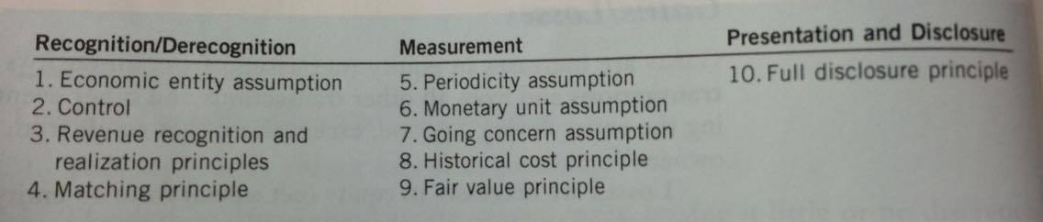

Recognition/Derecognition
- Recognition deals with the act of including something on the entity’s statement of financial position or income statement
- Elements of financial statements have been recognized when:
they meet the definition of an element (for ex; a liability)
they are probable
they are reliably measurable
- Derecogition is the act of taking something off the statement of financial position or income statement

Economic Entity Assumption and Control
- The economic entity assumption (or entity concept) allows us to identify an economic activity with a particular unit of accountability (for example, a company, division, or individual).
- This concept helps accountants determine what to include or recognize in a particular set of financial statements (as well as what not to recognize)
- For tax and legal purposes, the legal entity is the relevant unit for a company
- A parent and its subsidiaries are separate legal entities, but merging their activities for accounting and reporting purposes gives more meaningful information
- Thus, the consolidated financial statements are prepared form the perspective of the economic entity
- This allows the company to recognize and group together assets, liabilities, and other financial statement elements that are under the parent’s control into one set of statements
- The standard notes that an investor has control over an investee when it has the following:
- Power over the investee
- Exposure, or rights, to variable returns from its involvement with the investee
- The ability to use its power over the investee to affect the amount of the investors’ returns
- This new standard is principles-based and broadens the concept so that control is assessed not only through ownership of common shares but through other means as well, including exposure to the risks and rewards of the entity
- Under ASPE, control is defined as the continuing power to determine strategic decisions without the co-operation of others – a similarly broad concept
- In assessing whether the investee is “demonstrably distinct” from the company, the company looks at the following (as well as other factors):
whether the entity in question can be unilaterally dissolved by the company
whether orders have more than a 10% ownership interest
- Many companies use what are known as special purpose entities (SPEs), which are sometimes referred to as variable interest entities or structured entities
- They are often separate legal entities set up for a specific purpose, such as to hold leases, pension funds, or perhaps certain investments and/or to create investment opportunities for investors

Revenue Recognition and Realization Principles
- A crucial question for many enterprises is when revenue should be recognizes, an this is governed loosely by what is known as the revenue recognition principle
- Although this is a principle in transition, historically, revenue has generally been recognized when the following three conditions are met:
- Risks and rewards have passed and/or the earnings process is substantially complete (significant acts have been performed and there is no continuing involvement);
- The revenue is measurable; and
- The revenue is collectible (realized or realizable)
- Revenues are realized when products (goods or services), merchandise, or other assets are exchanged for cash or claims to cash
- Revenues are realizable if the assets received or held can be readily converted into cash or claims to cash
- Assets are readily convertible if they can be sold or interchanged in an active market at prices that are readily determinable and there is no significant additional cost
- The balance sheet approach recognizes that a transaction has occurred when the entity enters into a contract
- Collectible revenues are recognized when performance obligations are settled (when control over goods/services pass to the customer)

Matching Principle
- Assets such as property, plant, and equipment contribute to a company’s ability to generate revenues, therefore, accounting attempts to match these costs with the revenues that they produce.
- This practice is called matching because it dictates that effort (expenditures) be matches with accomplishment (revenues) whenever this is reasonable and can be done
- It also illustrates the cause and effect relationship between the money spent to earn revenues and the revenues themselves
- GAAP requires that a rational and systematic allocation policy be used that will approximate the asset’s contribution to the revenue stream
- Operating expenditures incurred during the year are often classified into two groups depending on whether they are seen to be part of the inventory production process or not. These two groups are labeled product costs and period costs
- If a cost or expenditure does not meet the definition of an asset, it is expensed (matching notwithstanding)
- Care should be taken also to ensure that only costs directly related with the creation of assets such as inventory or property, plant, and equipment are included

Measurement
- Because accrual accounting is followed, many estimates must be used when preparing financial statements
- As a general rule, elements cannot be recognized in the financial statements if they cannot be measured
- They key for accountants is to determine an acceptable level of uncertainty, use measurement tools that help deal with the uncertainty, and disclose enough information to signal the uncertainty
- Measurability is a big issue for many financial statement elements. When there is a variance between the recognized amount and another reasonably possible amount, this is called measurement uncertainty
- Accountant are continually working to develop and make sure of measurement tools such as option pricing and discounted cash flow models, as well as others

Periodicity Assumption
- The most accurate way to measure the results of an enterprise’s activity would be to do the measurement at the time of the enterprise’s eventual liquidation
- Users need to be informed about performance and economic status on a timely basis so that they can evaluate and compare firms
- The periodicity assumption (or time period assumption) implies that an enterprise’s economic activities can be divided into artificial time periods
- The shorter the time period, the more difficult it becomes to determine the proper net income for the period
- Many observers believe that, given the advances in technology, more on-line, real-time financial information needs to be provided to ensure that relevant information is available

Monetary Unit Assumption
- The monetary unit assumption means that money is the common denominator of economic activity and is an appropriate basis for accounting measurement and analysis
- The monetary unit is relevant, simple, universally available, understandable, and useful. Applying this assumption depends on the even more basic assumption that quantitative data are useful in communicating economic information and in making rational economic decisions
- In Canada and the United States, accountants have chosen generally to ignore the phenomenon of price-level change (inflation and deflation) by assuming that the unit of measure, the dollar, remains reasonable stable

Going Concern Assumption
- Most accounting methods are based on the going concern assumption, which is the assumption that a business enterprise will continue to operate for the foreseeable future; that is, it will not be forced to end its operations
- The historical cost principle would have limited usefulness if liquidation were assumed to be likely
- Under a liquidation approach, for example, asset values are better stated at net realizable value (sales price less costs of disposal) than at acquisition cost
- If a liquidation approach were adopted, the current versus non-current classification of assets and liabilities would lose much of its significance
- Labelling anything a fixed or long-term asset would be difficult to justify
- The only time when the assumption does not apply is when there is intent to liquidate the company’s net assets and cease operations or cease trading in the company’s shares or when the company has no realistic alternative but to liquidate or cease operations
- A total revaluation of assets and liabilities can provide information that closely approximates the entity’s net realizable value.

Historical Cost Principle
- Transactions are initially measured at the amount of cash (or cash equivalents) that was paid or received or the fair value that was ascribed to the transactions when they took place, which is called the historical cost principle
- The historical cost principle has three underlying assumptions that support its value and usefulness:
- It represents a value at a point in time
- It results from a reciprocal exchange (in other words, a two-way exchange)
- The exchange includes an outside arm’s-length party

- Initial Recognition. For non-financial assets, the value includes any laid-down costs; that is, any cost that is incurred to get the asset ready (whether for sale or for generating income by using)
- Inventory, for instance, might include the cost of material, labour, and a reasonable allocation of overhead
- Similarly, for a self-constructed asset, cost would include any expenditure made to get the asset ready for its intended use; including transportation and installation costs
- Transaction that have some or all of the following characteristics present challenges:
Nonmonetary or barter transactions where no cash or monetary consideration is exchanged. Here it may be more difficult to determine the value of the assets exchanged
Nonmonetary, non-reciprocal transactions where there is no exchange, such as donations
Related party transactions where the parties to the transaction are not acting at arm’s length (in other words, there is no outside party). In these cases, the exchange price may not reflect the true value of the assets exchanged
- As a default, an attempt may be made to estimate the fair value if possible, and this may become the cost basis going forward
- Subsequent Remeasurement. Historical cost has an important advantage over other valuation methods and because it generally comes from an arm’s-length transaction or exchange, it represents a bargained, fairly arrived-at value at a specific point in time.
- Overtime, however, it often becomes irrelevant in terms of predictive value
- They can be based on different measurement values, such as fair value, and give information that is more relevant, but they often involve measurement uncertainty
- Furthermore, because there is often no external exchange (exchange with an outside party), the values may be subjective.
- Despite these limitations, the trend is toward an increasingly mixed valuation model
- What used to be primarily a historical cost-based model, modified by the application of conservatism (that is, revaluations occurred if the asset’s value declined below cost), is moving more toward a market valuation model

Fair Value Principle
- IFRSS has increasingly called for the use of standardized fair value measurements in the financial statements
- This is an emerging principle that we will call the fair value principle.
- Fair value is defined under IFRS as “the price that would be received to sell an asset or paid to transfer a liability in an orderly transaction between market participants at the measurement date.”
- Accordingly, fair value is an exit price
- According to the definition, fair value is also a market-based measure, as opposed to an entity-specific measure. 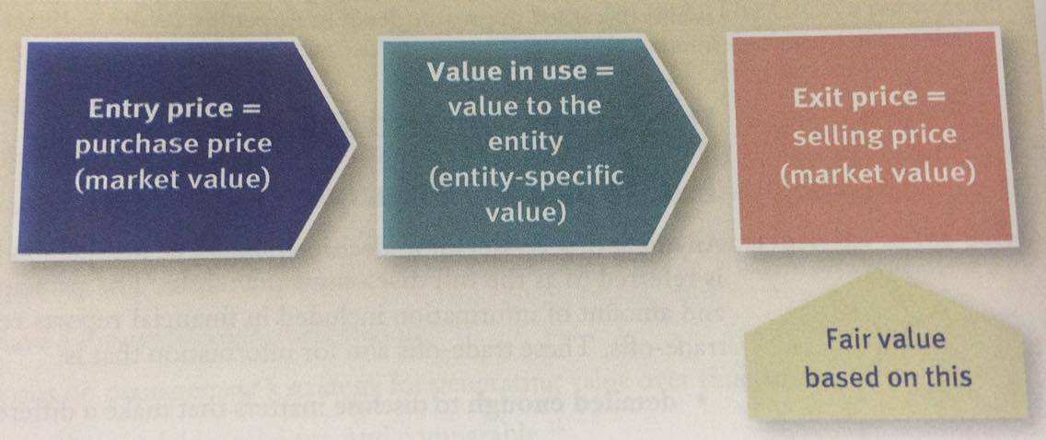
- In order to encourage increased use to fair value and to simplify accounting, standard setters have given companies the option to use fair value for most financial instruments (such as cash, receivables, non-strategic investments, and payables) as an accounting policy choice.
- This is referred to as the fair value option under both IFRS and ASPE
- Certain standards under IFRS explicitly allow the use of fair value for non-financial assets (such as investment properties and property, plant, and equipment) or require it for others (such as biological assets).

Presentation and Disclosure

Full Disclosure Principle
- Anything that is relevant to decisions should be included in the financial statements
- This is referred to as the full disclosure principle
- The principle recognizes that the nature and amount of information included in financial reports reflects a series of judgmental trade-offs. These trade-offs aim for information that is:
detailed enough to disclose matters that make a difference to users but
condensed enough to make the information understandable, and also appropriate in terms of the costs of preparing and using it
- More information is not always better. Too much information may result in the user being unable to digest or process the information
- This is called information over-load
- Information about a company’s financial position, cash flows, and investments can be found in one of three places:
- The main body of financial statements
- The notes to the financial statements
- As supplementary information, including the Management Discussion and Analysis (MD&A)
- The financial statements are a formalized, structured way of communicating financial information
- The notes to financial statements generally amplify or explain the items presented in the main body of the statements. If the information in the main body of the statements gives an incomplete picture of the enterprise’s performance and position, additional information that is needed to complete the picture should be included in the notes.
- Notes can be partially or totally narrative. Examples of notes are:
Descriptions of the accounting policies and methods used in measuring the elements reported in the statements
Explanations of uncertainties and contingencies
Details that are too voluminous to include in the statements
- Supplementary information may include details or amounts that present a different perspective from what appears in the financial statements
- MD&As should:
enable readers to view the entity thorough management’s eyes;
supplement and complement the information in the financial statements
be complete, fair and balanced, and provide information that is material to the decision-making needs of users
have a forward-looking orientation
focus on management’s strategy for generating value over time
be understandable, relevant, and comparable
- The guidance also includes a framework that identifies five key elements that should be included in the MD&A:
- The company’s vision, core businesses, and strategy
- Key performance drivers
- Capabilities (capital and other resources) to achieve the desired results
- Results (historical and prospective)
- Risks that may shape and/or affect the achievement of results
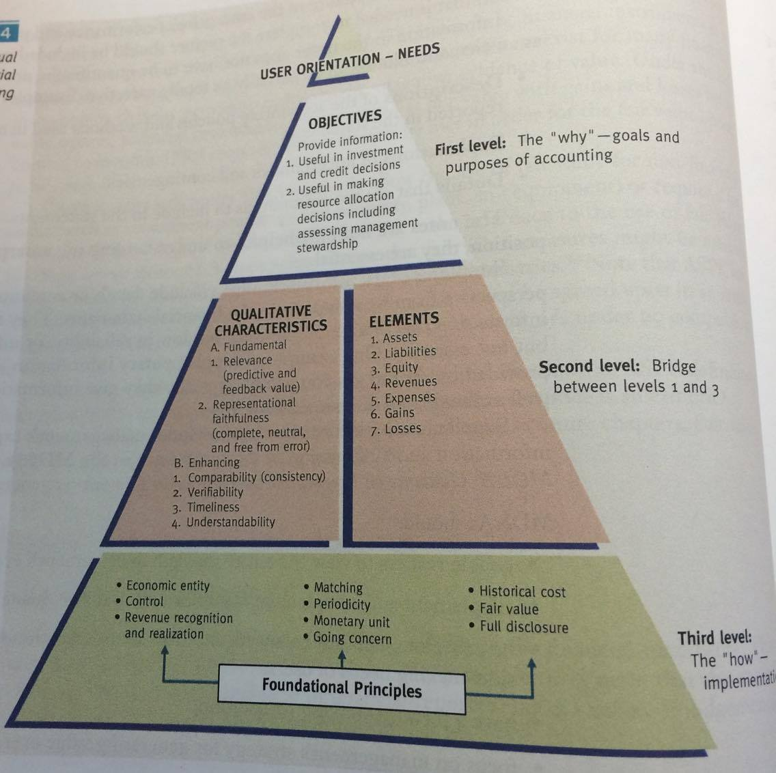

Financial Reporting Issues

- Making financial reporting decisons is complex
- The main objective of financial reporting is to provide reliable, decision-relevant financial information to users so that they can make well-informed capital allocation decisions
- Accounting principles and rules must be selected and interpreted and professional judgment must be applied
- Accounting is influenced by its environment (in many cases in a negative way) and by decisions made by individuals who often act in self-interest or in the interests of the company (at the expense of other stakeholders)
- It is unrealistic to believe that the financial reporting system will always work properly, and instead of wealth creation in the capital markets and the economy, financial reporting decisions sometimes lead to wealth and value destruction

Principles-Based Approach
- IFRS and ASPE are principles-based; that is, they are based on a few foundational principles and concepts like those in the conceptual framework
- The benefit of this approach is that all decisions should theoretically be consistent if they start from the same foundational reasoning
- Another benefit is that principles-based GAAP is flexible, and the most appropriate accounting for any new situation or novel business transaction may be arrived at through reason by going back to these principles (sometimes referred to as first principles)
- However, principles-based GAAP is sometimes criticized for being too flexible and some critics feel that it allows too much choice and therefore results in lack of comparability
- The conceptual framework developed in this chapter is the anchor that should ground all financial reporting decisions
- In the absence of specific GAAP guidance, an entity should adopt accounting policies that are:
- consistent with specific GAAP guidance and
- developed through exercising professional judgment and applying the conceptual framework

Financial Engineering
- A practice known as financial engineering became more visible during the past two decades. Financial engineering is the process of legally structuring a business arrangement or transaction so that it meet the company’s financial reporting objective (such as maximizing earnings or minimizing a debt to equity ratio)
- This is often done by creating complex legal arrangements and financial instruments
- Many financial institutions develop and market these financial instruments to their clients, and these arrangements are often called structured financings

Fraudulent Financial Reporting
- The role of accountants who are responsible for preparing a company’s financial records is to capture business and economic events and transactions as they occur and communicate them to interested parties
- Good financial reporting should be a result of well-reasoned and supported analysis that is grounded in a conceptual framework

Economic or Business Environment
- Sometimes a company experiences sudden drops in revenue or market share, and the underlying reason may be unique to the company and due to some poor strategic and business decisions or it may result from an industry or economic downturn
- Some companies use and industry or economic downturn as an opportunity to clean up their financial statements and generally take large writedowns on assets such as inventory or goodwill

Other Pressures
- Budgets put tremendous pressure on company management
- Since bonuses and even jobs depend on meeting budgets, sometimes this negative influence leaks inappropriately into accounting decisions
- In order to lessen the chances of fraudulent financial reporting, various controls and a sold governance structure may be put into place by a company These could include:
Vigilant, knowledgeable top management
An independent audit committee
An internal audit function
Other internal controls at lower levels

A Further Look at Financial Statements
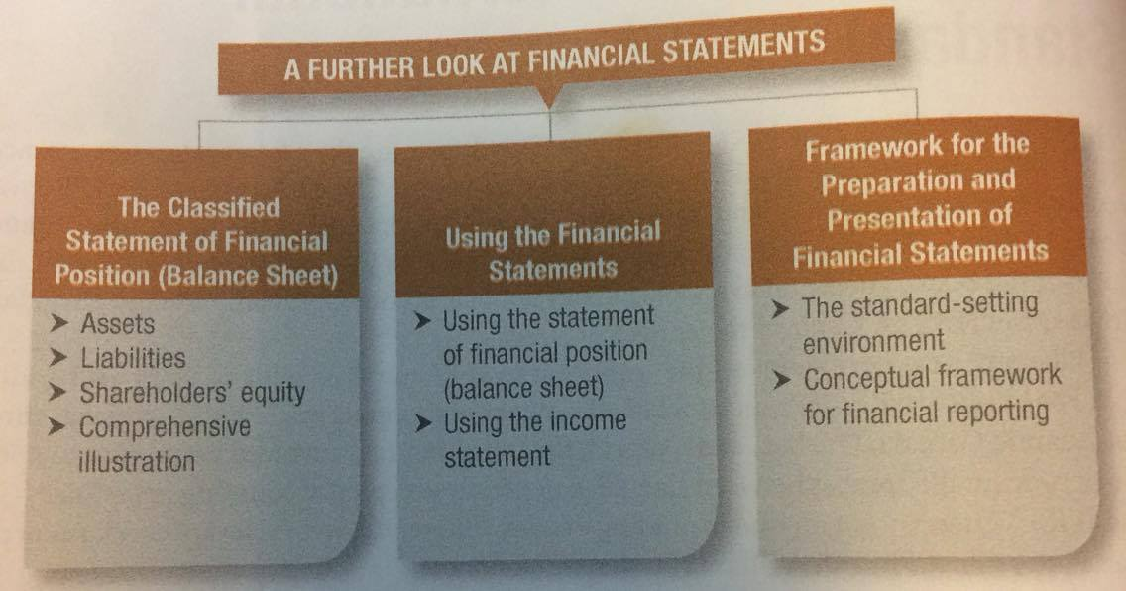

The Classified Statement of Financial Position (Balance Sheet)

- The statement of financial position, also commonly known as the balance sheet, presents a snapshot of a company’s financial position – its assets, liabilities, and shareholders’ equity – at a point in time.

Assets
- Assets are the resources that a company owns or controls that will provide future economic benefits

Current Assets
- Current assets are assets that are expected to be converted into cash or will be sold or used up within one year of the company’s financial statement date or its operating cycle, whichever is longer
- The operating cycle of a company is the average time it takes to go from cash to cash in producing revenue
- Common types of current assets include:
- Cash
- Short-Term Investments
- Accounts Receivable
- Accrued Receivables are amounts owed to the company for interest, sales tax, rent and like items
- Notes receivable are amounts owed to the company by customers or other that are supported by a written promise to repay

Non-Current Assets
- Non-current assets are not expected to be converted into cash, sold, or used up by the business within one year of the financial statement date or its operating cycle
- Common types of non-current assets include:
- Investments
- Property, Plant, and Equipment
- Intangible assets and goodwill
- Long-term investments include (1) multi-year investments in debt securities (loans, notes, bonds, or mortgages) that management intends to hold to earn interest, and (2) equity securities (shares) of other companies that management plans to hold for many years to generate investment revenue or for strategic reasons
- Property, plant, and equipment are tangible assets with relatively long useful lives that are currently being used in operating the business
- These items are normally listed in the statement of financial position in their order of permanency
- Most companies record their property, plant, and equipment at cost, however, some companies may choose to record these assets at fair value instead, which is known as the revaluation model
- Because property, plant, and equipment benefit future periods, their cost is allocated over their estimated useful lives through a process called depreciation
- Accumulated depreciation shows the amount of depreciation taken so far over the life of the asset. It is a contra asset account; that is, its balance is subtracted form the balance of the asset that it relates to
- The difference between cost and accumulated depreciation is referred to as the carrying amount, also commonly known as net book value or just simply book value
- Reitmans uses the term net book value rather than carrying amount, as do many companies
- Many companies have assets that cannot be seen but are valuable. Intangible assets are non-current assets that do not have physical substance and that represent a privilege or a right granted to, or held by, a company
- IFRS for publicly traded companies recommends the use of the term depreciation to refer to the allocation of cost over the useful lives of depreciable property, plant, and equipment and the term amortization to refer to the allocation of the cost of certain kinds of intangible assets
- Goodwill results from the acquisition of another company when the price paid for the company is higher than the fair value of the purchased company’s net identifiable assets.
- Goodwill is a calculated amount – simply the difference between the price paid for and the fair value of the assets acquired of the purchased company

Liabilities
- Liabilities are obligations that result from past transactions
- Similar to assets, they are also classified as current (due within one year) and non-current (due after more than one year)

Current Liabilities
- Current liabilities are obligations that are to be paid or settled within one year of the company’s statement date or its operating cycle, whichever is longer
- Common examples of current liabilities include:
- Bank indebtedness
- Accounts Payable
- Accrued Liabilities
- Notes payable, including bank loans payable
- Current maturities of long-term debt
- Bank Indebtedness is a short-term loan from a bank, typically occurring when a company uses an operating line of credit to cover cash shortfalls
- Accounts payable represents amounts owed by the company to suppliers for purchases made on credit (account)
- Accrued Liabilities are amounts owed by the company for salaries, interest, sales tax, rent, income tax, and like items
- Notes Payable are amounts owed, often to banks but also to suppliers or others, that area supported by a written promise to repay
- When a company has a non-current or long-term note or loan payable (for example, a five-year bank loan), a portion of the loan is often repayable each year, and the portion of the payment due to be made within the current year is classified as current maturities of long-term debt

Non-Current Liabilities
- Obligations that are expected to be paid or settled after one year are classified as non-current liabilities, or, as they are commonly known, long-term liabilities
- Examples of non-current liabilities include:
- Notes payable, including bank loans payable, mortgages payable, and bonds payable
- Lease obligations
- Pension and benefit obligations
- Deferred income tax liabilities
- Mortgages payable are similar to long-term notes but have property (eg; a house or a building) pledged as security for the loan
- Bonds Payable are used by large corporations and governments to borrow large sums of money
- Lease obligations include amounts to be paid in the future on long-term rental contracts used for equipment or other property
- Pension and benefit obligations are amounts companies owe past and current employees for retirement benefits
- Deferred income tax liabilities represent income tax that is expected to be payable in a later year or years when a company prepares its future corporate income return

Shareholders’ Equity
- Shareholders’ equity is divided into two parts: share capital and retained earnings
- For some companies, there may also be other parts to this section, such as accumulated other comprehensive income

Share Capital
- Shareholders purchase shares in a company by investing cash (or other assets)
- These investments are recorded as either common or preferred shares
- If preferred shares are issued in additional to common shares, the total of all classes of shares issued is classified as, or titled, share capital

Retained Earnings
- The cumulative profits that have been retained for use in a company are known as retained earnings
- The ending balances of share capital and retained earnings, determined on the statement of changes in equity, are combined and reported as shareholders’ equity on the statement of financial position

Comprehensive Illustration
- Within shareholders’ equity, common shares are commonly known as ordinary shares
- The liabilities section presents non-current liabilities before current liabilities, and current liabilities are listed in reverse order of liquidity similarto current assets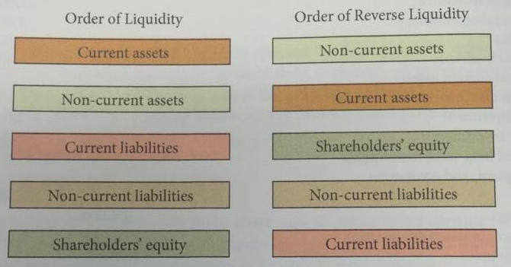
Using the Financial Statements
- Ratio analysis expresses the relationships between selected items of financial statement data
- Liquidity, solvency, and profitability ratios are the three general types of ratios that are used to analyze financial statements
- Liquidity Ratios measure a company’s short-term ability to pay its maturing obligations and to meet unexpected needs for cash
- Solvency Ratios measure a company’s ability to survive over a long period of time
- Profitability Ratios measure a company’s operating success for a given period of time
- Ratios can give clues about underlying conditions that may not be easy to see when the items of a particular ratio are examined separately
- Comparisons:
- Intracompany comparisons covering two years for the same company
- Intercompany comparisons based on comparisons with a competitor in the same industry
- Industry average comparisons based on average ratios for particular industries

Using the Statement of Financial Position (Balance Sheet)
- You can learn a lot about a company’s financial health by evaluating the relationships between its various assets and liabilities

Liquidity
- Liquidity is a company’s ability to pay obligations that are expected o become due within the next year
- Liquidity ratios measure a company’s short-term ability to pay its maturing obligations and to meet unexpected needs for cash
- One measure of liquidity is working capital, which is the difference between current assets and current liabilities
- An important liquidity ratio is the current ratio, which is calculated by dividing current assets by current liabilities.
- The current ratio is a more dependable indicator of liquidity than working capital, and two companies with the same amount of working capital may have significantly different current ratios
- The current ratio is only one measure of liquidity, it does not take into account the composition of the current assets

Solvency
- Solvency ratios measure a company’s ability to survive over a long period of time
- The debt to total assets ratio is one source of information about long-term debt-paying ability, which measures the percentage of assets that is financed by lenders and other creditors rather than by shareholders

Profitability
- Profitability ratios measure a company’s operating success for a specific period of time
- Earnings per Share (EPS) measures the profit earned on each common share
- EPS is only reported for common shareholders
- It is calculated by dividing the profit available to the common shareholders by the weighted average number of common shares
- Earnings per Share is such an important measure that it must be presented in the financial statements for publicly traded companies
- Although we cannot compare earnings per share, we can use this amount to calculate the price-earnings ratio, which can be compared across companies
- The price-earnings ratio is a frequently quoted statistic that measures the ratio of the stock market price of each common share to its earnings per share, and it is calculated by dividing the market price per share by earnings per share

Pgs 75-101

The Accounting Information System
Accounting Transactions
- Analyzing Transactions
- Summary of Transactions

The Account
- Debits and Credits
- Summary of debit and credit effects

Steps in the Recording Process
- The journal
- The ledger
- The recording process illustrated

The Trial Balance
- Limitations of a trial balance

Accounting Transactions

- The system of collecting and processing transaction data and communicating financial information to decision-makers is known as the accounting information system
- An accounting information system begins with determining what relevant transaction data should be collected and processed
- An accounting transaction occurs when assets, liabilities, or shareholders’ equity items change as a result of some economic event

Analyzing Transactions
** read on page 78 for clarification

The Account
- An account is an individual accounting record of increases and decreases in a specific asset, liability, or shareholders’ equity item.
- In its simplest form, an account consists of three parts: (1) the title of the account, (2) a left or debit side, and (3) a right or credit side, and because the alignment of these parts of an account resembles the letter T, it is referred to as a T account

Debits and Credits
- The term debit means left, and the term credit means right, these terms are commonly abbreviated as Dr. for debit and Cr. for credit.
- The act of entering an amount on the left side of an account is called debiting the account, and making an entry on the right side is crediting the account
- The equality of debit and credits is the basis for the double-entry accounting system, in which the dual (two-sided) effect of each transaction is recorded in appropriate accounts

Assets
- If we apply the accounting equation to a T account for assets, we can see that increases in assets must be entered on the left or debit side, and decreases in assets must be entered on the right or credit side
- Asset accounts normally show debit balances. That is, debits to a specific asset account should exceed credits to that account
- Normal balance for assets is on the left side (debit for increase)

Liabilities and Shareholders’ Equity
- Liability and shareholders’ equity accounts are increased by credits and decreased by debits
- Increases are entered on the right or credit side of the T account, and decreases are entered on the left or debit side of the T account.
- Just as asset accounts normally show debit balances, liability and equity accounts normally show credit balances (on the right side)
- Common shares and retained earnings both increase shareholders’ equity. Common shares are issued in exchange for the shareholders’ investments.
- The normal balance in these accounts is a credit balance.
- Dividends and expenses both decrease retained earnings, which then decreases shareholders’ equity. Since decreases in shareholders’ equity are recorded by debits, it makes sense that dividend and expense accounts would have a normal debit balance

Steps in the Recording Process
- The procedures used in the recording process are part of what is called the accounting cycle, which consists of nine steps in total
- In step 1, each transaction is analyzed to determine if it has an effect on the accounts. Evidence of the transaction comes from a source document, such as a sales slip, cheque, bill, or cash register tape.
- In step 2, the transaction information is recorded as a journal entry in the general journal
- In step 3, the information is transferred from the general journal to the appropriate accounts in the general ledger

The Journal
- Transactions are first recorded in chronological order in a journal and then transferred to the accounts
- The general journal makes several contributions to the recording process
- It discloses the complete effect of a transaction in one place, including an explanation and, where applicable, identification of the source document
- It provides a chronological record of transactions
- It helps to prevent and locate errors, because the debit and credit amounts for each entry can be quickly compared
- Entering transaction data in the general journal is known as journalizing

The Ledger
- The entire group of accounts maintained by a company is referred to as the ledger
- A general ledger contains all the asset, liability, shareholders’ equity, revenue, and expense accounts
- Most companies list their ledger accounts in a chart of accounts, which is the framework for the accounting database and lists the accounts and the account numbers that identify where the accounts are in the ledger

Posting
- The procedure of transferring journal entries from the general journal to the general ledge accounts is called posting
- Posting should be done in chronological order, that is, all the debits and credits of a journal entry should be posted before going on to the next journal entry

The Trial Balance
- The basic steps of the recording process are the first three steps in the accounting cycle. The fourth step is to prepare a trial balance.
- A trial balance is a list of general ledger accounts and their balances at a specific time, and is prepared at the end of an accounting period, which is usually monthly, but could also be quarterly or annually
- A trial balance is also useful in the preparation of financial statements, and the procedure for preparing a trial balance is as follows:
- List the account titles and their balances in the same order as the chart of accounts. Debit balances should be entered in the debit column and credit balances in the credit column
- Total the debit column and the credit column
- Ensure that the debit and credit column totals are equal

Limitations of a Trial Balance
- The trial balance may balance even when (1) a transaction is not journalized, (2) a correct journal entry is not posted, (3) a journal entry is posted twice, (4) incorrect accounts are used in journalizing or posting, or (5) errors that cancel each other’s effect are made in recording the amount of a transaction

